What is reflection and reflective practise?  Reflection is the method of revisiting previous experiences with the intention of developing upon the scenario and using your findings to improve overall performance in the future. Using this technique allows the practitioner to successfully develop upon their prior knowledge and analyse weaknesses within their performance.  Reflection also allows us to analyse the effectiveness of our techniques and encourages professional growth. (Johnston et al., 2018, p.470)  Using reflection ensures that the professional practitioner is able to maintain the expected standards, remain relevant with current protocol and procedures, develop new and improved methods of action as well as encourage change and discovering new approaches to their current methods. | Why is reflective practise important to EY practise?  Reflection is a vital skill for Early Years practice as it allows the practitioner to successfully maintain and uphold their professional standards as well as providing them with an opportunity to develop upon relevant growth and necessary changes needed within the workplace. (Brock, 2015, p.34).  Another reason supporting the importance of reflection within the early years practice is the ability the maintain and implement policies in the workplace, using reflection means the practitioner is frequently educating themselves on the current and new policies that they are expected to follow and maintain, leaving little room for error and a great space for development as an educator. (Hallet, 2012, p.2).  Communication also demonstrates the importance of reflection in early years practice as positive communication develops strong and lasting relationships with pupils and parents. This aids the child's development and positively influences their learning and self-esteem. (Wilson, 2025, p.12) Communication also greatly influences the home learning – by making effort to bond with parents they are able to implement effective and relevant learning at home.
The theory of reflective practise:

John Dewey is a key theorist within the reflective practice. Dewey’s theory of reflection outlines the process of successfully monitoring and developing consideration for the reasons and actions behind an experience. This displays how the use of foresight can be used to learn and improve for future circumstances. Dewey's theory requires active and careful consideration upon all situations to ensure that the conclusions are supported by the findings. Dewey highlighted the importance of 2 key factors in effective reflection:
Routine action – guided by habitats, authority and behaviour.
Reflective action – the careful consideration, active and persistent evaluation.
Donald Schon is an example of another important theorist of the reflective practice. Schon’s theory of reflective practice proposes that there are 2 main actions that take place when successfully implementing reflective practice.
In action – refers to the process of reflecting during practice. This includes closely considering the situation, making quick decisions and taking immediate action all during the experience.
On action – The process of reflection after living the experience. This process entails using foresight to effectively reconsider the situation and developing reasonable changes for the future.
Gibbs’ model  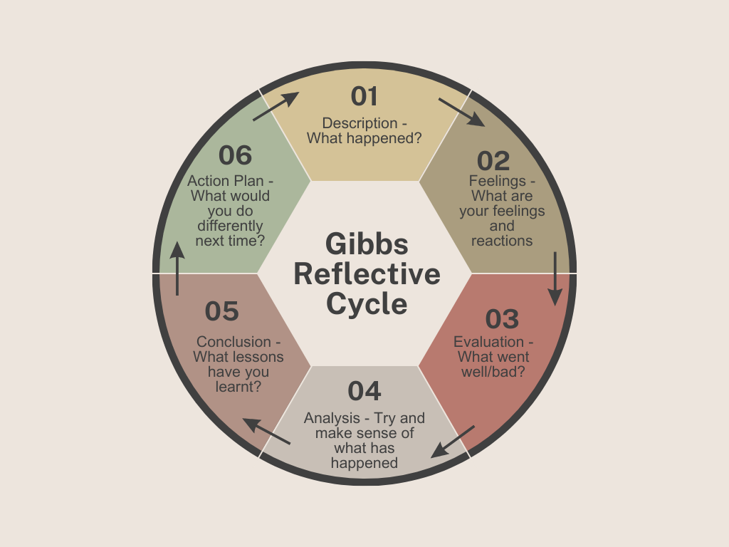  Figure 1: Model of Gibbs’ cycle of reflective practice. | ERA cycle  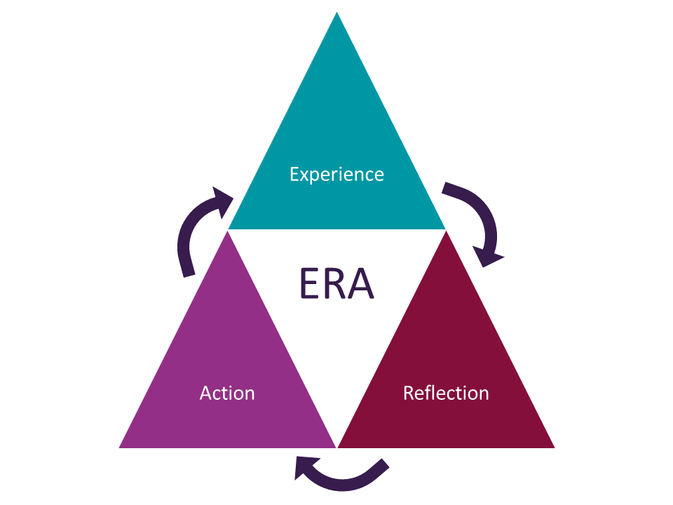  Figure 2: Model of the ERA cycle of reflective practice.
Analysis of models – compare/contrast/pros/cons:
Gibbs’ Reflective cycle (figure 1) is used to aid our learning and development on past experiences by following a six-step model. This model allows us to search for improvements and weaknesses within our performance and provides guidance for a successful development plan. The model follows the structure of: Description, feelings, evaluation, analysis, conclusion and action.
The ERA cycle (figure 2) is also used as a guide towards understanding and learning through past experiences and using foresight to develop upon experience. This model has a simpler structure which entails: experience, reflection and action.
Gibbs’ cycle has great focus on the individual's thoughts and feelings and allows space for them to be expressed. While the ERA cycle leaves very little room for personal expression and is focussed on theory and practice alone.
The ERA cycle's structure allows room for freedom and personal developments whereas Gibbs’ model has a sturdier structure that does not leave room for personal modifications. However, this could also be viewed as a positive as Gibbs’ model is easier to follow, is more descriptive and keeps the practitioner on track, unlike the ERA cycle that can allow too much freedom where the practitioner will lack structure.
None the less, Gibbs’ structure is also heavily reliant on the honesty of the practitioner, if the practitioner is not honest the reflection will be useless and inaccurate. Whereas the ERA cycle is under simplified and does not require as much detail and honesty, but suffers from a lack of critical thinking.

Conclusion
To conclude, Reflection is a vital method of improvement and personal development within the early years practice due to its flexibility and ability to adapt to each circumstance a professional practitioner may face. Without reflection, many practitioners would struggle and suffer due to lack of ability to generate relevant growth within their field and would likely underperform within their role due to a lack of personal feedback.
The two key theorists, John Dewey and Donald Schon provide practitioners with a wider outlook on the reflective practice and explains the relevant use of foresight in development and education. Both theorists explain the process of reflecting during and reflection after the experience which ultimately suits the practitioner's role well as we are frequently making immediate decisions under circumstance and require reflection on conclusion of the situation.
Both models of reflection prove to be great structures and guidelines for a successful reflection. Each has different strengths and weaknesses that can be used and developed upon by the practitioner based on scenarios, places of work and personal opinions.

Reference list
- Brock, A. (2015) The early years reflective practice handbook. London: New York: Routeldge.
- Hallet, E. (2012) The reflective early years practitioner. London: SAGE publications.
- Johnston, J. Nahmad-Williams, L. Oates, R. and Wood, V. (2018) Early childhood studies: principles and practice. 2nd edn. London: Routledge.
- University of Derby. Gibbs reflective cycle. Available at: https://libguides.derby.ac.uk/develop-at-derby/resilience/gibbs-reflective-cycle (Accessed: 20th October 2025)
- University of Hull. The ERA cycle. Available at: https://libguides.hull.ac.uk/reflectivewriting/era (Accessed: 20th October 2025)
- Wilson, T. (2025) Working with parents, carers and families in the early years: the essential guide. 2nd edn. London: Routledge.

