Name: ENTREPRENEURSHIP BMIH5001

Business Plan for: Eco Harmony Retreats

Lecturer: | Charlotte Joyner
Date: | 28/02/2024
Team members: | Melis Ahmed Shaban-ID:2212035 ( Vision),Lorella Mihut- ID:2214491 (Running a business),Alexandra Paunescu- ID:2125393(Marketing), Gina Stefanuta – ID:2120011 (Finance).
Business plan contents
Executive Summary…………………………………………………………………………………………………………….3
1 Executive summary 3
2 Business details 4
3 Key personnel 5
Vision 6
4 The business idea 6
5 Business goals 6
6 What the business does 7
7 What makes the business different 7
8 Legal requirements 7
Marketing 8
9 Market research 8
10 Profiling customers 8
11 Profiling competitors 9
12 Managing market risks 9
13 Pricing 9
14 Promotion and advertising 10
Running the business 11
15 Staff 11
16 Premises 11
17 Suppliers 11
18 Equipment 12
19 Managing operational risks 12
Finance 13
20 Start-up costs 13
21 Profit and loss forecast 15
22 Sourcing finance 16
23 Managing financial risks 16
24 Cash flow forecast 17

1 Executive summary (We suggest you complete this section after you have completed the other sections of the Business Plan).

Eco Harmony Retreats aims to create a high-end boutique hotel in Brighton, England, that combines luxury with sustainability. We aim to offer environmentally conscious travellers a unique lodging experience that prioritises environmental sustainability, community involvement, and personal wellness.
Vision and Mission: To transform the hospitality sector by providing a sustainable luxury experience and promoting connections among guests, local communities, and the natural environment. Our goal is to establish higher benchmarks for environmentally sustainable practices in high-end lodging.
Market Analysis: Our target demographic comprises eco-conscious travellers, luxury enthusiasts, and individuals seeking distinctive, genuine experiences. Market research shows an increasing inclination towards sustainable tourism, especially in destinations that support conservation and community well-being.
Marketing Strategy: We aim to utilise digital marketing channels, social media platforms, and collaborations with environmentally conscious brands to connect with our desired audience. We will focus our marketing on highlighting our distinctive value proposition of sustainable luxury and our dedication to creating a beneficial influence on the environment and local community.
Running the business will prioritise sustainability by implementing energy-efficient buildings, water conservation systems, and sourcing organic, local produce for the restaurant. We will establish an extensive training programme for our staff to guarantee the highest levels of environmentally friendly service.
Financial Projections: The initial financial projections show promise, including a detailed breakdown of startup costs, revenue streams, and profitability analysis. Our financial strategy involves obtaining funds through green investment programmes and using profits to back local environmental initiatives.
Eco Harmony Retreats is positioned to emerge as a frontrunner in sustainable luxury hospitality. We will provide guests with a significant and environmentally aware travel experience by using our innovative methods, all while supporting the conservation and enhancement of local and global environments.

2 Business details

Company name:
Eco Harmony Retreats

Address: Brighton

Primary contact method
info@ecoharmonyretreats.com
Phone: 07787652333
Website: www.ecoharmonyretreats.com

The business will: (Provide a brief description of what your business will do)

Eco Harmony Retreats will operate as a boutique hotel in the vibrant city of Brighton, England, focusing on providing luxury accommodations that are deeply integrated with sustainability and community engagement. Our mission is to offer guests unique experiences that resonate with their personal preferences while promoting eco-friendly practices and supporting the local culture. The hotel will feature rooms and suites that blend luxury with eco-conscious design, renewable energy sources, and locally sourced materials. In addition to accommodations, we will offer personalized services such as sustainability workshops, cultural events, and curated local experiences, all aimed at connecting our guests with the environment and the community of Brighton. Our approach combines the comfort and exclusivity of a boutique hotel with the sustainability and community engagement of a social enterprise, redefining the norms of hospitality in the new normal.

3 Key personnel

Details of owner(s):
Name: Melis Ahmed Shaban
Position/main responsibilities: CEO & Founder
Responsible for overall strategic direction, sustainability initiatives, and community engagement.
Experience and knowledge of our industry: While still pursuing my academic studies, I have immersed myself in extensive research and practical projects focused on sustainable and boutique hotels. My passion for eco-conscious living and hospitality management drives me to stay informed about industry trends and sustainability practices
Previous employment: As a dedicated student, my focus has been on academia and practical learning through projects and internships related to hospitality
Key skills brought to the business: Leadership, strategic planning, sustainability expertise, community engagement, and hospitality management
Business experience and any training undertaken: Participation in university
Academic/professional qualifications: Currently pursuing a Bachelor’s Degree in Hospitality Management
Salary expectations £

Name:
Position/main responsibilities:
Experience and knowledge of our industry:
Experience and knowledge of our industry:
Previous employment:
Key skills brought to the business: .
Business experience and any training undertaken:
Academic/professional qualifications:

Salary expectations £

Name:
Position/main responsibilities:
Experience and knowledge of our industry:
Previous employment:
Key skills brought to the business:
Business experience and any training undertaken:
Academic/professional qualifications:
Salary expectations £
Name:
Position/main responsibilities:
Experience and knowledge of our industry:
Experience and knowledge of our industry:
Previous employment:
Key skills brought to the business:
Business experience and any training undertaken:
Academic/professional qualifications:
Salary expectations £

Vision

4 The business idea

Sum up your business idea:

Eco Harmony Retreats aims to revolutionize the boutique hotel experience in Brighton, England, by blending luxury accommodations with a deep commitment to sustainability and community engagement. Our vision is to create a sanctuary for eco-conscious travelers who seek not just a place to stay but a meaningful connection with their surroundings. At Eco Harmony Retreats, guests will find themselves immersed in a world where every aspect of their stay – from the design of our eco-friendly rooms to the curated sustainability workshops and local cultural experiences – is thoughtfully aligned with our core values of environmental stewardship and social responsibility.
We envision a retreat that not only serves as a gateway to Brighton's vibrant culture and natural beauty but also as a catalyst for positive change, inspiring our guests to embrace sustainable living during their stay and beyond. Our target audience, primarily consisting of Gen Z and Millennials, will discover in Eco Harmony Retreats a unique blend of authenticity, personal growth, and environmental consciousness. Through strategic online and local partnerships, we will ensure our retreat is seamlessly integrated into the fabric of Brighton, offering guests an unparalleled experience that enriches both them and the community.
In essence, Eco Harmony Retreats is not just a hotel; it's a movement towards a more sustainable and connected way of traveling, where luxury meets responsibility, and guests leave with a heightened sense of purpose and belonging.

5 Business goals
- What do you want to achieve in your first year of business? (for example, turnover of £100,000 or trading at breakeven) (SMART Target as the basis)
Aim to reach a turnover of £500,000 in the first year of operations through room bookings, events, workshops, and sales of locally sourced products. This target is specific and measurable, providing a clear financial benchmark to aim for. It's ambitious yet achievable with a strong marketing strategy and unique value proposition, highly relevant to our business model, and time-bound to the first year of operations.
- Reach an Occupancy Rate of 60%: Strive for an average occupancy rate of 60% throughout the year. This goal is specific to our core business of accommodations, measurable through daily and monthly occupancy reports, achievable with targeted marketing efforts, relevant as a key indicator of our hotel's appeal and operational success, and time-bound within the first year.
- Host 12 Sustainability Workshops: Organize monthly sustainability workshops or events that align with our eco-conscious ethos, aiming for a total of 12 in the first year. This goal supports our value proposition of engaging guests with sustainability practices, is measurable by the number of events hosted, achievable with proper planning, relevant to our brand identity, and time-bound within the first year.
- Establish 5 Key Local Partnerships: Form at least five significant partnerships with local artisans, businesses, or environmental organizations to enrich our guests' experiences and support the local economy. This goal is specific to our commitment to community engagement, measurable by the number of partnerships formed, achievable through networking and local outreach, relevant to enhancing our service offering, and time-bound to the first year of operation.
- Achieve a Guest Satisfaction Rate of 90% or Above: Aim for a guest satisfaction rate of 90% or higher, as measured by feedback surveys and online reviews. This target is specific to customer experience, measurable through quantitative feedback, achievable by providing exceptional service and unique experiences, relevant to our mission of exceeding guest expectations, and time-bound within the first 12 months of operation.
- Attain Break-even Status: Target to reach or exceed the break-even point within the first year of operation. This financial goal is specific and measurable via our accounting and financial reporting, achievable with diligent cost management and revenue generation strategies, relevant to our long-term viability, and time-bound to our first year.
- These goals provide a clear roadmap for what Eco Harmony Retreats aims to achieve in its first year, focusing on financial health, operational success, guest satisfaction, and community engagement. Each goal is designed to be SMART guide to efforts and resources effectively to establish boutique hotel as a leading choice for eco-conscious travelers in Brighton.

- Where do you see your business in 3-5 years’ time?

(Use Klofstens business platform to explain)
(Vision statement)
In the next 3-5 years, Eco Harmony Retreats envisions becoming a leading innovator in sustainable luxury hospitality. Guided by Klofsten's Business Platform model—which emphasizes the importance of Market Focus, Product Offer, Resource Base, Organizational Structure, and Entrepreneurial Competence (Klofsten, 2000)—our strategy is to evolve into a globally recognized brand that exemplifies the successful integration of sustainability and luxury in the hospitality industry.
Market Focus: Expand our presence to become a top choice for eco-conscious travelers worldwide, leveraging Brighton's unique cultural and environmental assets to offer unparalleled experiences (Klofsten, 2000).
Product Offer: Innovate our service portfolio to include a broader range of sustainability-focused and culturally immersive activities, setting new industry standards for eco-friendly luxury accommodations (Klofsten, 2000).
Resource Base: Strengthen our commitment to sustainability by optimizing the use of renewable resources and sustainable materials, aiming for carbon neutrality and leading by example in environmental stewardship (Klofsten, 2000).
Organizational Structure: Develop a supportive and dynamic organizational culture that empowers employees, encourages innovation, and enhances our capacity to deliver exceptional guest experiences, rooted in our core values of sustainability and community engagement (Klofsten, 2000).
Entrepreneurial Competence: Foster a culture of continuous learning and adaptation, ensuring that our leadership and team are equipped with the skills and knowledge to drive our vision forward and influence the broader industry towards more sustainable practices (Klofsten, 2000).
By closely aligning our growth strategy with Klofsten’s model, Eco Harmony Retreats aims to not only elevate our position in the hospitality market but also contribute meaningfully to the sustainability movement, enriching our community and ecosystem. Our vision is a testament to the belief that luxury and environmental consciousness can coalesce to create a transformative guest experience that also serves the greater good.

6 What the business does

Product/service | Features | Benefits
Eco-Friendly Luxury Accommodations: Sustainable, luxurious stays. | Minimized carbon footprint (https://www.carbontrust.com/what-we-do/assurance-and-labelling/route-to-net-zero-standard, 2021) | Support sustainability and reduce carbon footprint.
Sustainability Workshops and Events: Educational and cultural engagement. | Sustainable materials and natural lighting. | Deeply connect with Brighton's culture.
Local Experience Packages: Curated local exploration. | Tailored guest experiences. | Enjoy stays tailored to individual preferences.
Community Engagement Initiatives: Active participation in local projects. | Technology-enhanced service and information. | Access services and local insights easily.
 | Locally sourced, organic meals. | - Benefit from fresh, local cuisine while supporting the community.

7 What makes the business different (Value Proposition)
Your product/service is unique or different compared with the competition because:
- Eco Harmony Retreats stands out in the competitive landscape of hospitality through its unique value proposition that integrates luxury accommodations with a deep commitment to sustainability and community engagement. Here's a concise outline of what makes Eco Harmony Retreats different:
- Sustainability at Heart: Unlike many competitors, Eco Harmony Retreats is built from the ground up with sustainability in mind, utilizing renewable energy sources, eco-friendly building materials, and operating practices that minimize environmental impact (Energy Saving Trust).
- Cultural and Community Integration: Our boutique hotel goes beyond just offering a place to stay; it immerses guests in the local culture and community through curated experiences, workshops, and events that celebrate and contribute to the local heritage and sustainability efforts (UKHospitality, 2019).
- Personalized Eco-Conscious Experiences: We offer personalized services that cater to eco-conscious travelers, providing them with unique opportunities to engage in sustainability practices, learn from local artisans, and explore Brighton's natural landscapes in an eco-friendly manner.
- Local Partnerships for Authentic Experiences: Our strong partnerships with local artisans, businesses, and environmental organizations allow guests to enjoy authentic experiences that are not available elsewhere, from farm-to-table dining to exclusive workshops and tours (The Sustainable Restaurant Association, 2018).
- Commitment to Carbon Neutrality: Eco Harmony Retreats aims to achieve carbon neutrality, setting it apart from competitors by not only reducing its own carbon footprint but also by actively participating in local environmental initiatives to offset emissions.
- This value proposition ensures that Eco Harmony Retreats is not just a hotel but a destination that offers a luxurious, culturally rich, and environmentally responsible experience, making it a preferred choice for travelers seeking meaningful and sustainable stays.

8 Legal requirements (including regulations and licences particular to your business)
The legal and insurance requirements that apply in your business are:
- Hotel Operating License: Required for running accommodation services.
- Food Hygiene License: Necessary for providing food and beverage services (Food Standards Agency, 2022).
- Liquor License: If alcohol is served on the premises.
- Health and Safety Compliance: Adherence to the Health and Safety at Work Act (Health and Safety Executive, 1974).
- Fire Safety Certificate: Compliance with fire safety regulations, including adequate escape routes and fire alarms (Fire Safe, 2010).
- Planning Permissions: For any building modifications or signage (www.brightonco.gov, n.d.).
- Environmental Permits: Eco Harmony Retreats will secure environmental permits aligned with its use of renewable energy and sustainable practices, ensuring compliance with UK environmental regulations (www.nqa.com, n.d.).
- Employment Laws: Adherence to employment rights, wages, and working conditions (Group, C. (n.d.). ACAS (Advisory, Conciliation and Arbitration Service).
- Insurance Requirements: Public liability insurance, property insurance, employer’s liability insurance, and business interruption insurance (Insurance for your small business abi.org.uk @BritishInsurers).
You will meet your legal and insurance requirements by:
- Engage a Solicitor: Specializing in hospitality to ensure all legal documents and licenses are accurately prepared and submitted.
- Consult with Local Authorities: To understand specific local regulations and obtain necessary licenses.
- Regular Compliance Checks: Implementing regular health, safety, and fire compliance checks to meet Health and Safety and Fire Safety regulations.
- Environmental Assessments: Conducting environmental impact assessments to ensure compliance with environmental permits and sustainability goals.
- Employee Training: Providing regular training for employees on health and safety, food hygiene, and customer service to comply with employment laws.
- Insurance Broker Consultation: Work with an experienced insurance broker to secure comprehensive coverage that meets all business insurance requirements.
- Documentation and Record Keeping: Maintain detailed records of compliance activities, licenses, permits, and insurance policies for auditing purposes.

By meticulously addressing these legal and insurance requirements, Eco Harmony Retreats will not only ensure compliance with UK laws and regulations but also foster a safe, responsible, and sustainable business environment for its guests and employees.

Marketing

9 Market research

Trends in your chosen market are:

- UK's tourism recovery plans boost boutique hotel prospects.
- Government efforts aim for pre-pandemic tourist numbers.
- Boutique hotels' success is tied to innovative, unique offerings.
- B2B and B2C demand blend creates a diverse customer base.
- Local experiences, like dining, see rising popularity.
- Online platforms open new avenues for service delivery.
- Eco Harmony Retreats capitalizes on sustainable travel trends.
- The market is pivoting towards eco-friendly hotel operations.
- Sustainable practices are key in meeting new market demands.
- Official support emphasizes sustainability in tourism recovery.

How you know this: (Provide examples with references)
- The travel and tourism industry in the UK is a favourable and promising market for boutique hotels, which are being propelled by the government's efforts to recover the economy and the greater influx of tourists. Boutique hotels must innovate to stand out in the evolving B2B and B2C landscapes. Trends in food service and a focus on sustainability highlight areas for expansion and alignment with Eco Harmony Retreats' mission, emphasizing the importance of unique offerings and sustainable practices (Travel & Tourism in the United Kingdom, Page 2; Foodservice in the United Kingdom, Page 3)

10 Profiling customers

The customer groups you will be selling to are: (4 x Customer profiles minimum)
- Sophisticated Leisure Traveler (55-64): Prefers luxury and unique experiences.
- Mid-age Professional (45-54): Seeks balance of work amenities and relaxation.
- Young, Eco-conscious Traveler (25-34): Values sustainability and cultural connection.
Each profile guides tailored marketing and product development, aligning with insights on preferences for sustainable and cultural experiences (SimilarWeb).

Your customer research has shown what your customers want is:
- SimilarWeb data for "Eco Harmony Retreats" indicates strong UK market potential, interest from mature demographics, tech-savvy behavior, cultural engagement, and eco-friendliness, shaping targeted marketing strategies for the boutique hotel industry (What research did you undertake and what were the results?)

How you know this:
- Customer preferences and profiles derived from SimilarWeb analytics indicate a predominance of UK visitors with diverse demographics, suggesting targeted marketing for "Eco Harmony Retreats" in domestic and specific international regions. The data reveals interest in sustainability and culture, guiding content and service offerings to attract eco-conscious travellers, with strategic insights for market segmentation and campaign focus (What evidence can you offer)

Number of customers you expect to win in each group and what they might pay:
Group | Number of customers | Price they might pay per unit
Sophisticated Leisure Traveler | 30 | 220
Mid-age Professional | 25 | 180
Young, Eco-conscious Traveler | 20 | 150
Tech-Savvy & Cultural Explorer | 15 | 200
International Visitor (US&France) | 10 | 240
 |  | £
 |  | £

11 Profiling competitors

Competitor name | Strengths | Weaknesses
Hotel du Vin | Extensive wine selection, premium locations, strong brand recognition | Higher price point, limited appeal to budget-conscious travelers
Harbour Hotels | Prime coastal locations, wellness amenities, luxury focus | Limited market reach, premium pricing excludes certain segments
Artist Residence Brighton | Unique artistic decor, central location, boutique experience | Smaller size, may lack some amenities found in larger hotels
Hotel Pelirocco | Themed rooms, music culture integration, unique guest experiences | Niche market, not appealing to all demographics
Snooze | Ppersonalised service, quirky and distinctive style, intimate setting | Small scale, limited facilities compared to larger hotels

How you can improve on their offer and/or price(s) unique offerings:
- Hotel du Vin:
- Strengths: Wine expertise, premium locations.
- Weaknesses: Higher prices.
- Harbour Hotels:
- Strengths: Coastal luxury, wellness amenities.
- Weaknesses: May exclude budget travellers.
- Artist Residence, Hotel Pelirocco, Snooze:
- Strengths: Unique themes, personal touch.
- Weaknesses: Limited size and amenities.
- Eco Harmony Retreats Differentiation: Offering sustainable luxury at competitive prices, Eco Harmony Retreats leverages Brighton's culture and green practices, filling a market gap and aiming for leadership in sustainable hospitality.

- Eco Harmony Retreats can differentiate itself in the boutique hotel market by offering competitively priced, sustainable luxury experiences that combine the unique attributes of its competitors with a strong commitment to eco-friendly practices.

12 Managing market risks

Write down the risks you have identified:
- The market research indicates that while competition is strong, there is a significant opportunity for Eco Harmony Retreats to capture market share by focusing on sustainability and local experiences. The key to success will be innovative offerings that stand out from competitors and effective risk management strategies. The business can leverage Brighton's unique cultural assets and growing eco-tourism trends to create a compelling value proposition that aligns with the desires of the Sophisticated Leisure Traveler, the Mid-age Professional, and the Young, Eco-conscious Traveler.

How will you manage these risks so that they become less of a threat:
- Supply Chain: Diversify suppliers to mitigate dependency risks.
- Innovation: Offer distinct eco-friendly experiences to stand out.
- Pricing: Use dynamic pricing to cater to different customer segments.
- Community Feedback: Utilize local insights for service refinement.
- Market Analysis: Continually monitor competitors to stay competitive.
- Industry Dynamics: Regularly assess the market using Porter's Five Forces.

13 Pricing

How you can calculate your prices:
- 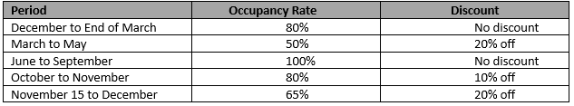
- 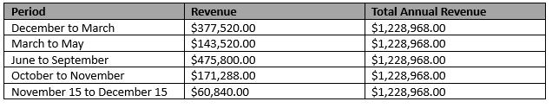
- The hotel's expected annual revenue of $1,228,968.00 was calculated by dividing the year into separate periods, each with its own occupancy rate and applicable discounts. The revenue for each period was calculated by multiplying the adjusted room rates (after discounts) by the occupancy rate and the number of rooms available, while taking into account the duration of each period. The total annual revenue estimate was calculated by adding all period revenues.

How your prices compare whit competition:
Product/service | Your price(s) | Range of competitor prices (per unit)
Locally sourced takeaway organic food and beverages | £2 – 80 | £ -
Accommodation in sustainable and eco-friendly rooms | £180 - 240  (free beds for babies) | £99-480
Organic and locally sourced dining options | £3- 100 | £ 3.5 – 109
Event hosting, such as eco-friendly weddings or corporate retreats | £60-100/person | £75-125\person
Sustainable merchandise like reusable water bottles, tote bags, and clothing | £5-60 | £ -
Art and decor crafted by local artists. | £5-70 | £-

Reasons for the difference between your price(s) and your competitors’ price(s):
- "Eco Harmony Retreats" aligns prices with its sustainability focus, appealing to eco-conscious consumers.
- Offers luxury experiences at more accessible prices than high-end competitors.
- Caters to broad audiences with diverse, unique experiences beyond niche markets.
- Bundles services for better value, contrasting with competitors' a la carte pricing.
- Adopts dynamic pricing for flexibility, countering competitors' static rates.
- Leverages local partnerships for cost-effective sourcing, enhancing its unique selling proposition.
- Personalizes services, particularly in event hosting, to justify its pricing structure.

14 Promotion and advertising

How and where will you promote your product/service?
Eco Harmony Retreats' marketing strategy is intricately tailored to its various customer profiles. SEO-optimized, luxury-focused content and influencer collaborations appeal to sophisticated leisure travellers. Tailored LinkedIn campaigns are used to engage middle-aged professionals. Young, eco-conscious travellers respond well to social media tactics and content about the environment. Innovative app features and immersive virtual tours attract tech-savvy and cultural explorers. International visitors, particularly those from the United States and France, are targeted with geo-specific ads and bilingual information, resulting in a comprehensive and inclusive marketing approach.

Running the business

15 Staff

Role | Total Cost (£) | Necessary Experience | Specialist Skills/Qualifications
- General Manager | - £60,000 | - 5+ years in hotel management | - Hospitality management degree or equivalent
- Sustainability Coordinator | - £40,000 | - 3+ years in sustainability roles | - Enviromental science or sustainability degree
- Head Chef | - £50,000 | - 5+ years as a chef with a focus on local sourcing | - Culinary arts degree, experience in sustainable cooking (Zerbino, Stefanini and Aloini, 2021).
- Events Coordinator | - £45,000 | - 3+ years in event planning | - Event management or related qualification
- Marketing Specialist | - £45,000 | - 4+ years in marketing, preferably in hospitality | - Marketing degree or equivalent
- Receptionist | - £25000 | - 2+ years | - Communication and work experience
- Housekeeper | - £23000 | - 1+ years | - Knowledge about cleanliness and time management

16 Premises

Type of Premises | Cost (£)
Premises required at start-up | £500,000
Premises required in the future | £0.00

17 Suppliers
Supplier | What You'll Buy | Number of Days' Credit
- Renewable Energy Provider | - Renewable energy sources | - 0 days
- Local Furniture Manufacturer | - Eco-friendly furniture | - 0 days
- Organic Food Suppliers | - Locally sourced organic food | - 0 days
- Sustainable Merchandise Suppliers | - Reusable products and clothing | - 0 days
- Local Artists and Decor Crafters | - Local art and decor items | - 0 days
- Cleaning Supplies Vendor | - Eco-friendly cleaning supplies | - 0 days
- Event Equipment Rental | - Event hosting materials | - 0 days
- Linen and Bedding Supplier | - Sustainable bedding and linen | - 0 days
- Eco-friendly Toiletries Supplier | - Environmentally friendly toiletries | - 0 days
- Water Conservation System Provider | - Water-saving technology solutions | - 0 days
- Local Floral and Greenery Supplier | - Sustainable floral arrangements | - 0 days

18 Equipment
Resource | When | How Funded | Cost (£) per Unit
- Sustainable Energy Systems | - Start-up | - Business Capital | - £50,000
- Eco-Friendly Furniture | - Start-up | - Business Loan | - £10,000
- Kitchen Equipment | - Start-up | - Business Capital | - £20,000
- Event Hosting Materials | - Start-up | - Business Loan | - £15,000
- Linen and Bedding | - Start-up | - Business Capital | - £8,000
- Eco-Friendly Cleaning Supplies | - Start-up | - Business Capital | - £5,000
- Audio-Visual Equipment | - Within 6 months | - Operating Revenue | - £12,000
- Sustainable Water Systems | - Within 6 months | - Operating Revenue | - £25,000
- Local Art and Decor Items | - Within 3 months | - Business Capital | - £7,000
- IT Infrastructure | - Within 3 months | - Business Capital | - £15,000
- Sustainable Floral Arrangements | - Within 3 months | - Operating Revenue | - £3,000
- Environmental Toiletries | - Within 6 months | - Operating Revenue | - £2,000

19 Managing operational risks

Risk | Solution
- Staff | - Train people extensively to increase skills and expertise.  - To ensure critical team members can manage tasks, cross-train (Sahoo, 2021).  - Develop a robust communication strategy to quickly resolve internal issues.
- Suppliers | - Diversify suppliers to reduce reliance.  - Regularly evaluate supplier performance and reliability.  - Stay in touch with vendors to prevent problems.

Finance

20 Start-up costs

Calculate how much money you need before you start trading

21 Profit and loss forecast

22 Sourcing finance

Total borrowing requirement for the business

23 Managing financial risks

The risks that you have identified for your financial forecast are:
- Market Volatility: Demand, economy, and market volatility may affect revenue predictions (Pandey, 2015). A quick consumer preference change or economic slump could hurt the hotel.
- Operational Cost Escalation: Unexpected material, labour, or utility costs might slash earnings. Cost control must limit this risk.
- Interest Rate Fluctuations: Businesses that borrow face interest rate volatility. Interest rate fluctuations could raise borrowing costs, affecting finances (Madura, 2018).
- Currency Exchange Exposure: International commerce involves currency exchange concerns. Financial uncertainty might result from forex swings.
- Regulatory Dynamics: New laws and compliance requirements may demand operational process changes and unexpected costs. Monitor regulatory developments to reduce risk (Johnson, 2023).
- Supply Chain Vulnerabilities: Material shortages or higher prices might result from natural catastrophes and geopolitical crises. Supply chain risk management requires diversity and contingencies.

How you will minimise their impact:
- "Eco Harmony Retreats" must actively manage financial risk to succeed. Market volatility may affect demand, therefore the researcher analyses trends (Chang, McAleer and Wong, 2020). The organisation diversifies offerings to fulfil consumer needs and lessen market volatility using market data.
- Because of operating costs, "Eco Harmony Retreats" limits spending. Cost stability will be achieved through operating expense reviews and significant supplier agreements. A dual approach protects business margins against unexpected operational expenditure spikes.
- To mitigate interest rate risk, the corporation will balance fixed and variable loans (Lima, Crema and Verbano, 2019). Monitor interest rate patterns to quickly refinance, hedge against rate volatility, and optimise borrowing costs.
- Currency options and forward contracts lower forex risk. A wide currency portfolio and robust price agreements mitigate exchange rate risk.
- The "Eco Harmony Retreats" regulatory compliance staff will manage regulations. This team will monitor rules, audit compliance, and quickly adjust operations (Pandey, 2015).
- Finally, evaluating alternative suppliers lowers supply chain risks. To establish a resilient, flexible supply chain with fewer interruptions, invest in supply chain visibility tools. These strategies help "Eco Harmony Retreats" stabilise finances and reduce risks.

24 Cash flow forecast (Click on the tabs within the Microsoft Excel sheet to view the second 6 months and summary)

25 Conclusion
Eco Harmony Retreats' boutique hotels are luxurious, eco-friendly, and community-minded. Market data and client preferences support a £500,000 first-year revenue plan. After analysing rivals' strengths and shortcomings, the differentiation strategy fills a market gap with affordable, sustainable luxury experiences. Eco Harmony Retreats attracts Sophisticated Leisure Travellers, Mid-age Professionals, and Young, Eco-conscious Travellers with Brighton's culture and eco-tourism trends. Risk management requires supplier diversification, unique products, dynamic pricing, community feedback, market analysis, and industry dynamics monitoring. These tactics reduce risks and keep the company flexible in a changing market. Competitive prices reflect eco-conscious consumers' environmental concerns. Eco Harmony Retreats bundles services, use dynamic pricing, and connects with local businesses to create affordable, unique experiences. Company viability is shown by profit and loss estimations, cash flow forecasts, and start-up cost evaluations. Finance comes from personal donations, start-up contributions, and loans; risk management decreases financial uncertainty. Sustainable luxury brand Eco Harmony Retreats will boost Brighton's culture, environment, and hospitality. Based on careful planning and strategic insights, the business model aims for financial success and environmental and community progress.

26 References
- ‌Bytestart. (n.d.). Bytestart – How to start a small business in the UK. [online] Available at: https://www.bytestart.co.uk/ [Accessed 8 Feb. 2024].
- ‌Chang, C.-L., McAleer, M. and Wong, W.-K. (2020). Risk and Financial Management of COVID-19 in Business, Economics and Finance. Journal of Risk and Financial Management, 13(5), p.102. doi:https://doi.org/10.3390/jrfm13050102.
- Energy Saving Trust. Renewable energy. [online] Available at: https://energysavingtrust.org.uk/business/renewable-energy/ [Accessed 8 Feb. 2024].
- Fire Safe (2010). Regulatory Reform (Fire Safety) Order 2005 : Firesafe.org.uk. [online] Firesafe.org.uk. Available at: https://www.firesafe.org.uk/regulatory-reform-fire-safety-order-2005/ [Accessed 8 Feb. 2024].
- ‌Food Standards Agency (2022). Key regulations. [online] Food Standards Agency. Available at: https://www.food.gov.uk/about-us/key-regulations#:~:text=Food%20Safety%20Act%201990 [Accessed 8 Feb. 2024].
- GOV.UK (2020). Business and self-employed - GOV.UK. [online] Www.gov.uk. Available at: https://www.gov.uk/browse/business [Accessed 8 Feb. 2024].
- Group, C. (n.d.). ACAS (Advisory, Conciliation and Arbitration Service). [online] Croner. Available at: https://croner.co.uk/resources/business-advice/acas-advisory-conciliation-and-arbitration-service/#:~:text=What%20is%20ACAS%3F [Accessed 8 Feb. 2024].
- Health and Safety Executive (1974). Health and Safety at Work Act 1974. [online] Hse.gov.uk. Available at: https://www.hse.gov.uk/legislation/hswa.htm [Accessed 8 Feb. 2024].
- https://www.carbontrust.com/what-we-do/assurance-and-labelling/route-to-net-zero-standard. (2021). Route to Net Zero Standard. [online] Available at: https://www.carbontrust.com/what-we-do/assurance-and-labelling/route-to-net-zero-standard [Accessed 8 Feb. 2024].
- Insurance for your small business abi.org.uk @BritishInsurers. (n.d.). Available at: https://www.abi.org.uk/globalassets/sitecore/files/documents/publications/public/2014/business-insurance/insurance-for-your-small-business-abi-guide.pdf [Accessed 8 Feb. 2024].
- Johnson, R.W. (2023). Financial management. Boston: Allyn And Bacon.
- ‌Lennox, S. (2024). ‘Loud Budgeting’: How to Apply 2024’s New Trend to Your Business. [online] Startups.co.uk. Available at: https://startups.co.uk/news/loud-budgeting/ [Accessed 8 Feb. 2024].
- Lima, P., Crema, M. and Verbano, C. (2019). Risk Management in SMEs: a Systematic Literature Review and Future Directions. European Management Journal, 38(1), pp.78–94. doi:https://doi.org/10.1016/j.emj.2019.06.005.
- Madura, J. (2018). International financial management. 13th ed. South Melbourne, Australia: Cengage Learning Australia.
- MarketLine. (2023a). Meat & Livestock in Europe. Available at: https://advantage-marketline-com.ezproxy.uwtsd.ac.uk/Analysis/ViewasPDF/europe-meat-livestock-192126
- MarketLine. (2023b). Foodservice in the United Kingdom. Available at: https://advantage-marketline-com.ezproxy.uwtsd.ac.uk/Analysis/ViewasPDF/united-kingdom-foodservice-185399
- MarketLine. (2023c). Hotels & Motels in the United Kingdom. Available at: https://advantage-marketline-com.ezproxy.uwtsd.ac.uk/Analysis/ViewasPDF/united-kingdom-hotels-motels-184289
- MarketLine. (2023d). Travel Intermediaries in the United Kingdom. Available at https://advantage-marketline-com.ezproxy.uwtsd.ac.uk/Analysis/ViewasPDF/united-kingdom-travel-intermediaries-189818
- MarketLine. (2024e). Travel & Tourism in the United Kingdom. Available at: https://advantage-marketline-com.ezproxy.uwtsd.ac.uk/Analysis/ViewasPDF/united-kingdom-travel-tourism-ml-194638
- Pandey, I.M. (2015). Financial management. New Delhi: Vikas Publishing House Pvt Ltd.
- Sahoo, S. (2021). Big data analytics in manufacturing: a bibliometric analysis of research in the field of business management. International Journal of Production Research, 60(22), pp.1–29. doi:https://doi.org/10.1080/00207543.2021.1919333.
- SimilarWeb. (2024). https://www.similarweb.com
- ‌Small Business. (n.d.). Advice and ideas for UK small businesses. [online] Available at: https://smallbusiness.co.uk/ [Accessed 8 Feb. 2024].
- Statista (2024). Hotel industry in the United Kingdom (UK). [online] Statista. Available at: https://www.statista.com/topics/3146/hotel-industry-in-the-united-kingdom-uk/#topicOverview.
- Statista Research Department. (2023). Hotel Industry in the United Kingdom. [online] Statista. Available at: (Statista, 2023) [Accessed 20 Dec 2023].
- The Sustainable Restaurant Association (2018). The Sustainable Restaurant Association. [online] The Sustainable Restaurant Association. Available at: https://thesra.org/ [Accessed 8 Feb. 2024].
- UKHospitality (2019). UKHospitality. [online] Ukhospitality.org.uk. Available at: https://www.ukhospitality.org.uk/ [Accessed 8 Feb. 2024].
- Whaley, S. (n.d.). 12 Eco-Friendly Luxury Hotels. [online] Forbes. Available at: https://www.forbes.com/sites/forbestravelguide/2023/04/07/12-eco-friendly-luxury-hotels/?sh=2ff6fc64ecf3 [Accessed 8 Feb. 2024].
- ‌www.brightonco.gov. (n.d.). Business Licensing | Brighton Colorado. [online] Available at: https://www.brightonco.gov/1481/Business-Licensing [Accessed 8 Feb. 2024].
- ‌www.nqa.com. (n.d.). ISO 14001 Certification - Environmental Management | NQA. [online] Available at: https://www.nqa.com/en-us/certification/standards/iso-14001#:~:text=ISO%2014001%3A%20Environmental%20Management%20Systems%20(EMS)&text=ISO%2014001%20is%20the%20principal [Accessed 8 Feb. 2024].
- Zerbino, P., Stefanini, A. and Aloini, D. (2021). Process Science in Action: A Literature Review on Process Mining in Business Management. Technological Forecasting and Social Change, 172, p.121021. doi:https://doi.org/10.1016/j.techfore.2021.121021.

‌

‌

‌

27 Appendix
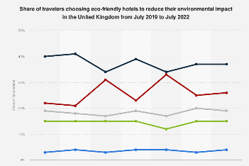
Figure 1: Demand for eco-friendly hotel
Source: (Statista, 2024)
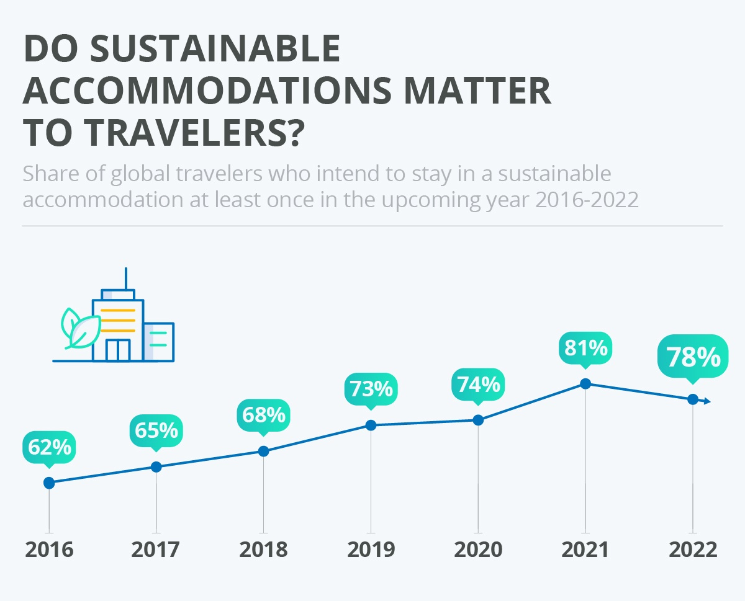
Figure 2: Eco-friendly hotel
Source: (Statista, 2024)

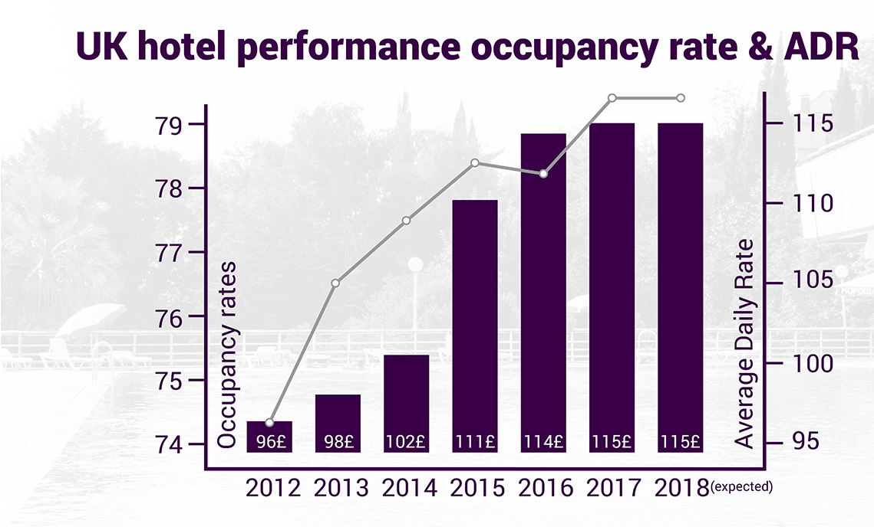
Figure 3: Eco-friendly hotel
Source: (Statista, 2024)

9. Market research
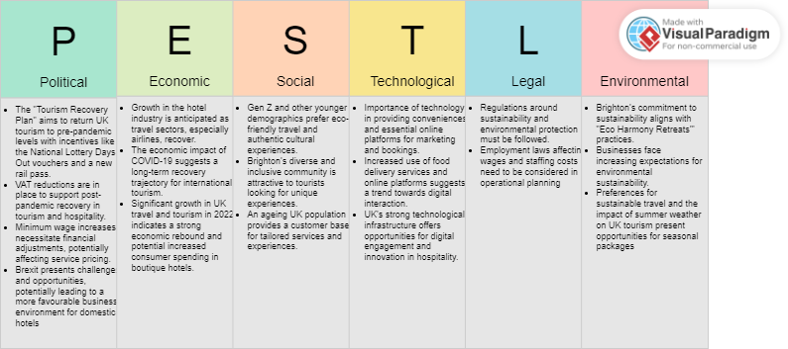
Trends in the Boutique Hotel Market:
The analysis shows that the growth of the travel and tourism industry, supported by government recovery efforts, provides a favourable setting for boutique hotels to succeed in the face of increasing domestic and international tourist numbers (MarketLine, 2024e).
Boutique hotels must innovate and provide unique services to meet the needs of both corporate and individual customers in the competitive market that combines B2B and B2C sectors (MarketLine, 2024e).
MarketLine (2023b) indicates that the rise in popularity of pubs, clubs, and bars, as well as online delivery platforms, presents opportunities for growth in local dining experiences and convenient dining choices.
Eco Harmony Retreats' mission aligns strategically with industry trends by emphasising sustainability in the travel sector, providing a marketing advantage.
The report on "United Kingdom Hotels & Motels" and "United Kingdom Travel & Tourism" analyses market trends and sustainability efforts, highlighting the industry's shift towards sustainable practices. It emphasises the challenges and opportunities that boutique hotels may face in meeting changing market requirements (MarketLine, 2023c; MarketLine 2023e).
These insights can be found in the UK government's published resources the VisitBritain organization's information on the Tourism Recovery Plan
10 Profiling customers
The customer groups you will be selling to are: (3 x Customer profiles minimum)

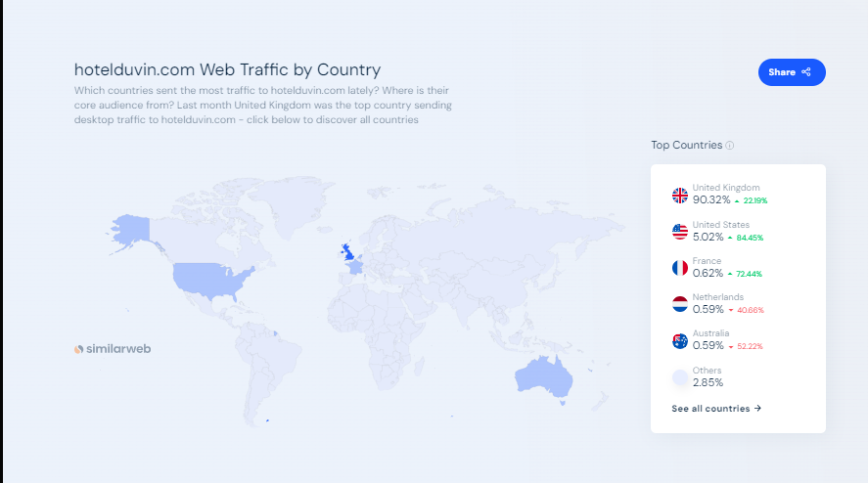
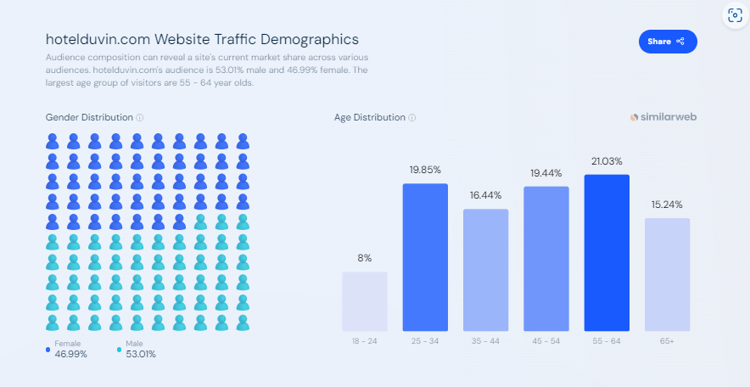
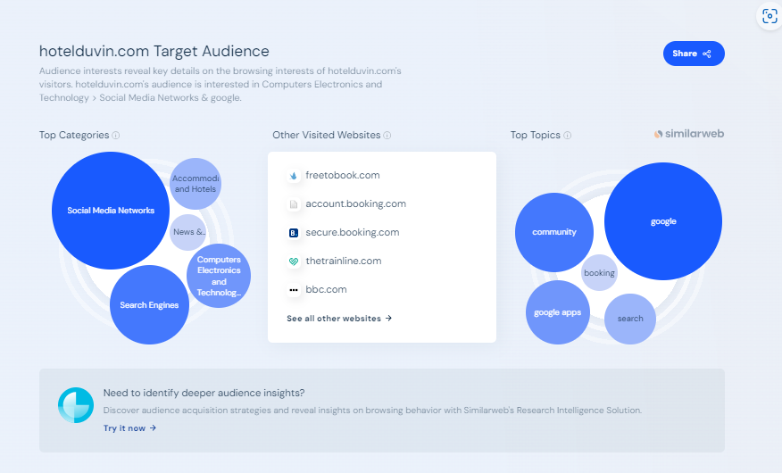
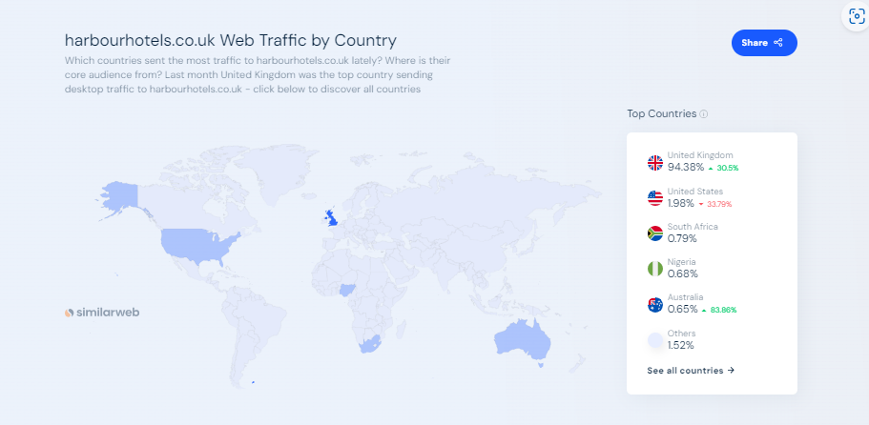
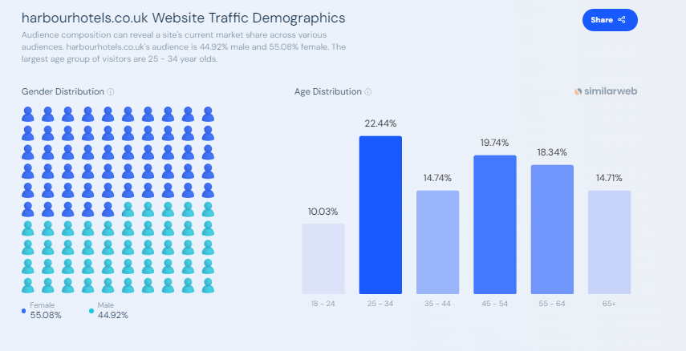
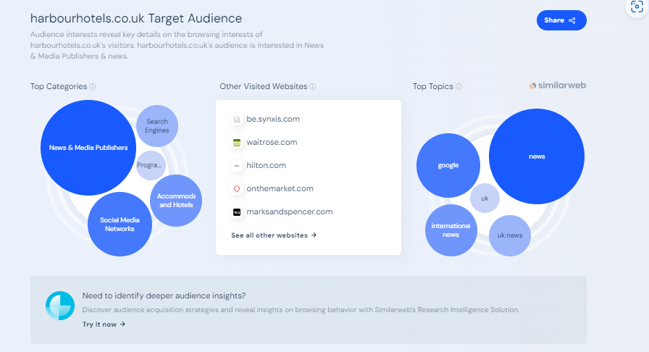
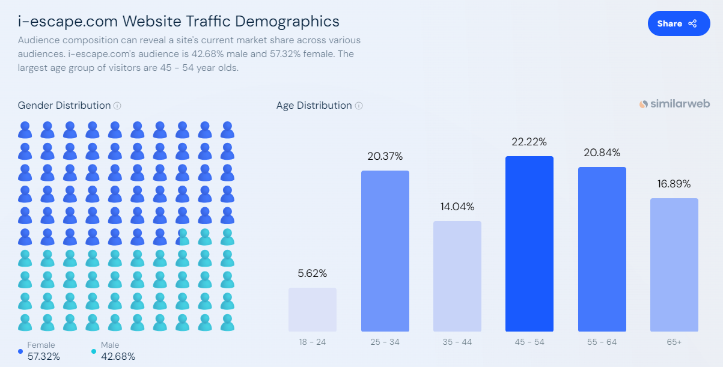
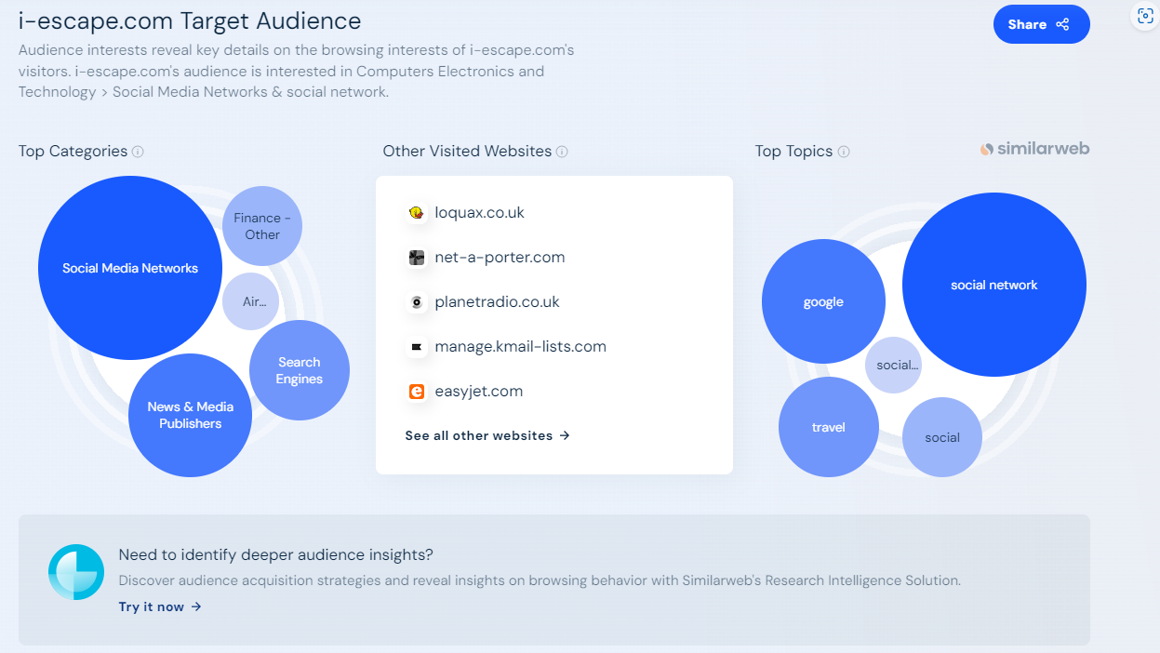

Using web analytics data from SimilarWeb for boutique hotels such as Hotel du Vin and Harbour Hotels, as well as a general search engine for boutique hotels like i-escape, three customer profiles have been developed for the "Eco Harmony Retreats" boutique hotel. Each profile is created based on the demographic and behavioural data provided, following the customer profile framework previously uploaded.

Profile 1: The Sophisticated Leisure Traveler
- Demographics: Mainly from the UK, aged 45-64, with a slight female majority.
- Interests/Attitudes: Esteems genuine experiences and sustainable choices. Enjoys lively community gatherings and values luxury along with eco-consciousness.
- Behavioral: The individual demonstrates behavioural traits of actively seeking boutique hotels and making informed decisions through thorough research on different travel websites before booking.
- Preferred Content: Interested in travel news and sustainable practices. Interested in content that showcases distinctive local experiences, sustainable tourism, and high-end travel choices.
Profile 2: The Tech-Savvy Professional
- Demographics: The visitor mix consists of individuals from the UK and international locations, with notable contributions from the USA and Australia. Primarily targeting a younger demographic, specifically individuals aged 25-44, with an equal distribution between genders.
- Interests/Attitudes: Inclined towards utilising technology to improve travel experiences. Probable engagement on social media platforms and interest in staying updated on travel technology and digital advancements.
- Behavioral: Utilises search engines frequently and engages on social media, indicating a preference for digital methods when planning and booking travel. May utilise platforms such as Google and booking.com.
- Preferred Content: Engages with content on accommodation and hotels, travel news, and the latest developments in computers and electronics.
Profile 3: The Culturally Curious Explorer
- Demographics: The majority are female, aged 25-34, from the UK. Significant traffic from countries such as France and the Netherlands suggests a European interest in boutique hotel experiences.
- Interests/Attitudes: Enjoys exploring new cultures and is inclined to pursue experiences that provide cultural immersion. Enthusiastic about regional arts, music, and community gatherings.
- Behavioral: Engages with news and media publishers to stay informed about destinations and cultural offerings.
- Preferred Content: Interested in social media content that highlights the liveliness of the local community, cultural events, and sustainable efforts in the travel sector.
The profiles are customised to appeal to the primary audience of "Eco Harmony Retreats," focusing on individuals who are seeking both accommodation and a connection with the local community and culture through sustainable methods. The profiles are created to direct the marketing strategy and content creation for "Eco Harmony Retreats," ensuring that the offerings appeal to the identified customer segments. The information has been obtained from Similar Web's analytics for Hotel du Vin, Harbour Hotels, and i-escape.com.
Your customer research has shown what your customers want is:
1 (What research did you undertake and what were the results?)
Customer research for "Eco Harmony Retreats" was carried out by analysing web traffic data from SimilarWeb for the boutique hotel industry. This study analysed web analytics for two competitors in the boutique hotel industry, Hotel du Vin, and Harbour Hotels, along with a general boutique hotel search engine, i-escape.com. The results unveiled the subsequent customer preferences:
- Geographic Interest: The majority of web traffic originates from the United Kingdom, suggesting a robust domestic market for boutique hotels. Significant interest has been observed from the United States and other English-speaking countries, indicating a potential market among international travellers from these regions.
- Demographics: The majority of the audience is between the ages of 45 and 64, with slightly more females than males. This indicates that the customer base appreciates maturity and stability, possibly showing a preference for top-notch, dependable, and refined travel experiences.
- Technological Engagement: Data indicates that customers are proficient in technology, utilising search engines and social media networks extensively to find travel information. This indicates a favouritism towards hotels that have robust online visibility and advanced digital reservation features.
- Cultural Interests: Visitors to these sites display a cultural interest and a preference for hotels that provide local cultural experiences or connections to the community.
- Sustainability and Eco-Friendliness: The audience is interested in eco-friendly practices and sustainable travel options, as shown by their browsing habits. This indicates a specific group of consumers interested in a hotel's sustainability credentials and environmentally responsible actions.
This study has helped create three unique customer profiles by integrating demographic information, behavioural patterns, and content preferences to match the identified trends and interests. The profiles influence the marketing strategy for "Eco Harmony Retreats" by aligning offerings with the target audience's preferences for authenticity, sustainability, and cultural richness.
SimilarWeb data offers insights into customer behaviour and preferences. When integrated with the hotel's distinct value proposition and service offerings, it can be used to create customised marketing campaigns and make strategic decisions to effectively meet customer expectations.
SimilarWeb's analytics data offers detailed information on web traffic by country, website traffic demographics, target audience interests, and other visited websites.

How you know this:
(What evidence can you offer)
Customer preferences and profiles are determined using web traffic and demographic analytics from SimilarWeb. SimilarWeb is a digital intelligence provider that provides detailed information on website performance, such as traffic sources, demographic data, visitor behaviour, and engagement on the internet. Analysing data from SimilarWeb can provide us with a snapshot of:
- Visitor Geography: Analysing the distribution of website visitors by country can reveal the geographic locations of a hotel's potential customers. This can be especially beneficial for pinpointing where marketing endeavours should be focused.
- Demographic Breakdown: By examining the age and gender distribution of website visitors, businesses can identify the main demographics they are attracting and adjust their marketing strategies accordingly.
- User Behavior: Examining the pages and websites users visit before and after accessing a hotel's website can provide valuable information about customer preferences, their journey, and opportunities for strategic advertising partnerships or platforms.
- Interests and Preferences: Visitors' categories and topics of interest, like sustainability or local culture, can guide content creation, service offerings, and promotional campaigns.
The customer profiles were created by analysing data with Amazon Marketing Cloud, a web analytics tool provided by Amazon, which reveals customer behaviours and preferences. Each profile was created to mirror the patterns seen in the data, serving as a foundation for strategic marketing and service design choices for "Eco Harmony Retreats."
The profiles are analyses of the combined data using Amazon Marketing Cloud. The website provided references to analytics data from SimilarWeb, offering detailed information on web traffic by country, website traffic demographics, target audience interests, and other visited websites. These images provide evidence for the profiles that were created.

Number of customers you expect to win in each group and what they might pay:

Customer profiling and potential revenue for Hotel du Vin and Harbour Hotels, as well as i-escape can be deduced based on the SimilarWeb data of competitors.
Hotel du Vin Analysis:
- The majority of web traffic comes from the UK, with significant interest from the US and France.
- The demographic leans slightly towards males, with the majority of visitors aged 55-64.
- Visitors use search engines and social media to find hotels and accommodations.
Harbour Hotels Analysis:
- The majority of web traffic comes from the UK, followed by the US and South Africa.
- The target audience is primarily female, aged 25-34 years old.
- Interested in news, search engines, and social networking sites.
i-escape Analysis:
- The audience is gender-balanced, with the majority of visitors aged 45-54 years old.
- Interests include finance, social media, and search engines, indicating a preference for premium experiences and value deals.
Using this data to fill the table that reflects the potential market segments "Eco Harmony Retreats" might attract based on web traffic data from similar businesses:
Group | Number of customers (%) | The price they might pay per unit
Sophisticated Leisure Traveler | 30 | 220
Mid-age Professional | 25 | 180
Young, Eco-conscious Traveler | 20 | 150
Tech-Savvy & Cultural Explorer | 15 | 200
International Visitor (US&France) | 10 | 240

Sophisticated Leisure Traveler: This group, which is willing to pay a premium for upscale experiences, is probably the main customer base for Hotel du Vin and could be a sizable market for "Eco Harmony Retreats."
Mid-age Professional: i-escape's core demographic seeks quality experiences and may account for a significant market share.
Young, Eco-conscious Traveler: Harbour Hotels' target demographic suggests a market segment for "Eco Harmony Retreats" that values sustainability and is willing to pay midrange prices.
Tech-Savvy & Cultural Explorer: This group values online engagement and cultural events and may be willing to pay more for unique experiences.
International Visitor: The US and French markets represented by Hotel du Vin and Harbour Hotels' web traffic may represent a segment willing to pay a premium, particularly if they are looking for unique international experiences.
Price Estimates:
These are based on the demographic's average spending power and the types of experiences they seek, with adjustments for seasonality and market demand.
Percentage Estimates:
These percentages are calculated using web traffic data, assuming that the largest represented age group will be the largest customer segment, with the remaining percentages distributed among the other identified segments.
Sophisticated Leisure Traveler (55-64): "Indulge in tranquil luxury and eco-elegance at Eco Harmony Retreats, Brighton's premier sustainable escape."
Mid-age Professional (45-54): "Blend productivity with peace at Eco Harmony Retreats, where business meets pleasure in a sustainable setting."
Young, Eco-conscious Traveler (25-34): "Adventure sustainably at Eco Harmony Retreats and connect with Brighton's vibrant culture, eco-style."
Each message is designed to highlight the aspects most appealing to the customer’s interests:
- The Sophisticated Leisure Traveller values luxury, relaxation, and exclusive experiences that prioritise comfort and quality.
- Middle-aged professionals often need to balance work and leisure, so the message should emphasise efficiency and the ability to connect and relax seamlessly.
- The Young, Eco-conscious Traveller values sustainability, local culture, and adventure, so the message focuses on these values.

11 Profiling competitors
Table: Competitor Profiling
Competitor name | Strengths | Weaknesses
- Hotel du Vin | - Extensive wine selection, premium locations, strong brand recognition | - Higher price point, limited appeal to budget-conscious travellers
- Harbour Hotels | - Prime coastal locations, wellness amenities, luxury focus | - Limited market reach, premium pricing excludes certain segments
- Artist Residence Brighton | - Unique artistic decor, central location, boutique experience | - Smaller sizes, may lack some amenities found in larger hotels
- Hotel Pelirocco | - Themed rooms, music culture integration, unique guest experiences | - Niche market, not appealing to all demographics
- Snooze | - Personalized service, quirky and distinctive style, intimate setting | - Small scale, limited facilities compared to larger hotels

Detailed Findings:
Hotel du Vin offers premium hospitality with luxurious settings and a diverse wine selection. However, its higher price point and emphasis on wine and dining experiences may not appeal to younger or more cost-conscious travellers.
Harbour Hotels, located along the coast, provides guests with stunning sea views and wellness amenities like spas and fine dining, making them a popular choice for luxury retreats. The brand's emphasis on the high end of the market may not be accessible to everyone.
Artist Residence Brighton Hotel offers a boutique experience for culturally inclined guests thanks to its unique artistic decor and central location. However, due to its small size, it may not provide all of the amenities that larger competitors do.
Hotel Pelirocco is known for its themed rooms and integration with music culture, providing unique guest experiences. Its niche appeal, while appealing to some, may not cater to more traditional tastes.
Snooze offers personalised service and a unique style, creating an intimate setting for its guests. However, as a smaller establishment, it may not have the same range of amenities as larger hotels, which could be a disadvantage for some visitors.
Market Gap: Eco Harmony Retreats could stand out by focusing on sustainable luxury, which combines eco-friendly practices with an upscale experience at a competitive price. This strategy targets a growing group of environmentally conscious travellers who do not want to sacrifice comfort or quality.

How you can improve on their offer and/or price(s) unique offerings:
A brief analysis of each competitor's strengths and weaknesses, as well as a differentiation strategy for Eco Harmony Retreats:
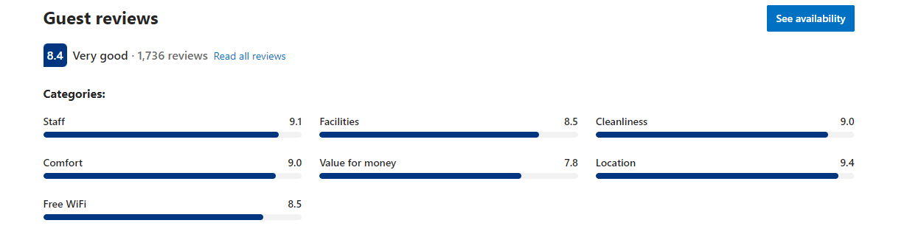
Hotel du Vin is a collection of boutique hotels with a focus on wine experiences and fine dining. Their locations are desirable, and they are frequently housed in historic structures. According to reviews, customers appreciate the attentiveness of the staff and the hotel's facilities. However, prices may be higher, making them less appealing to budget-conscious travellers. Their strength is their unique wine and dining experience, while a weakness could be the higher price point, which may deter a segment of the market. Eco Harmony Retreats could fill a potential gap by offering comparable quality experiences at a lower cost, emphasising sustainability as a unique selling point.
1TripAdvisor, Review Analytics for Hotel du Vin
Harbour Hotels is known for its coastal locations and luxury amenities, which include wellness-focused options. They cater to an audience looking for high-end experiences and are frequently located in prime, picturesque settings. However, their emphasis on the upper end of the market may alienate budget-conscious travellers. While coastal luxury is a strength, their narrow market focus may be viewed as a weakness. Eco Harmony Retreats could capitalise on this by offering competitive pricing for wellness experiences and appealing to a broader demographic, including those who are environmentally conscious but also price-sensitive.
All provide distinct boutique experiences, with Artist Residence emphasising artistic decor, Hotel Pelirocco focusing on themed rooms and cultural integration, and Snooze offering a quirky, personalised service. Their strengths are their distinct themes and intimate guest experiences, but their weaknesses may include limited size and amenities. Eco Harmony Retreats could stand out by combining these elements - artistic themes, cultural immersion, and personal touch - with a broader range of amenities and eco-friendly practices that appeal to a diverse range of customers.
Finally, Eco Harmony Retreats can distinguish itself in the boutique hotel market by providing competitively priced, sustainable luxury experiences that combine the distinctive features of its competitors with a strong commitment to environmentally friendly practices. This strategy not only fills a market gap but also establishes the retreat as a leader in sustainable tourism.
2TripAdvisor, Customer review of Artist Residence
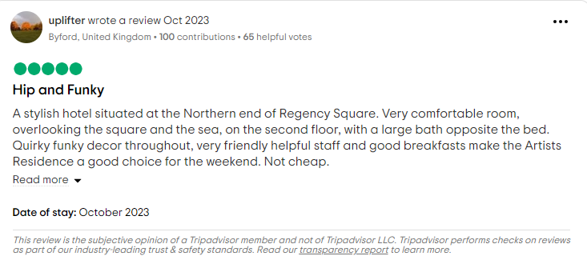
3TripAdvisor, Customer Review of Hotel Pelirocco
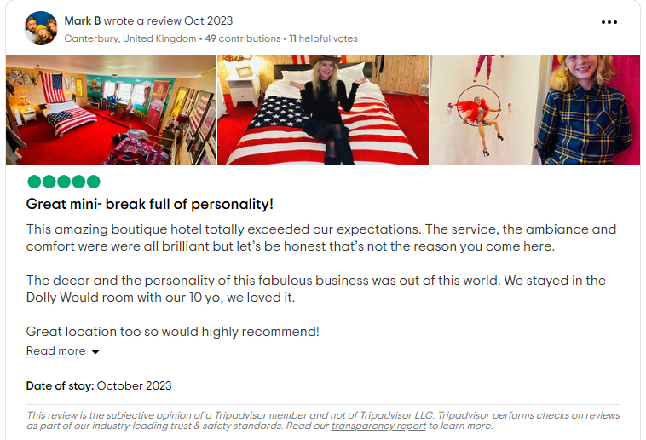

4TripAdvisor, Customer Review of Snooze Hotel
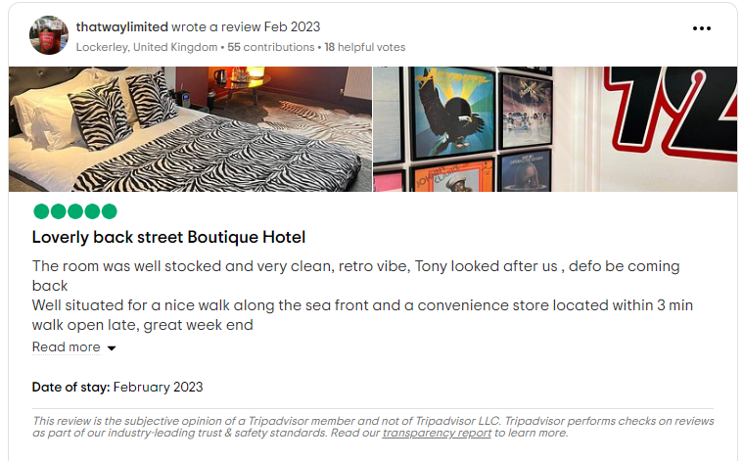

12 Managing market risks

Write down the risks you have identified:

The risks listed below can be identified by analysing the competitive environment using tools such as PESTLE and Porter's Five Forces.
Opportunities and Threats:
Face-to-face discussions with local community members and management from other firms yielded insights indicating a strong demand for sustainable and environmentally conscious hospitality options. These insights were cross-referenced with the PESTLE analysis and our market research to determine the following:
Opportunities:
- Travellers are becoming more eco-conscious, particularly among the mid-age and younger demographics.
- There is a growing demand for boutique, personalised lodging experiences.
- Brighton's reputation as a cultural and artistic hub presents an opportunity to provide unique local experiences.
Threats:
- Competition from established boutique hotels like Hotel du Vin and Harbour Hotels may lead to price wars.
- Economic instability could impact discretionary travel spending.
- The evolving regulatory environment for sustainability and hospitality.
Managing Risks:
To mitigate these risks, Eco Harmony Retreats intends to establish a network of local suppliers to ensure a consistent supply of eco-friendly amenities, as well as diversify its offerings to cater to various customer profiles, reducing reliance on a single customer segment or market trend.
Five Forces Analysis:
Threat of New Entrants: The boutique hotel market's high capital investment and unique characteristics can create barriers to entry, reducing the threat of new entrants.
Bargaining Power of Suppliers: Partnerships with local organic suppliers can reduce bargaining power through mutually beneficial agreements.
Bargaining Power of Buyers: Offering tiered pricing and personalised experiences can reduce buyer power and increase customer retention.
Threat of Substitutes: Innovation in customer experience and sustainable practices can reduce the appeal of substitutes.
Rivalry Among Existing Competitors: Rivalry among existing competitors can be reduced by focusing on sustainability and cultural immersion.

How will you manage these risks so that they become less of a threat:

- Diversification of the Supply Chain: To balance supplier bargaining power and the risk of new entrants, Eco Harmony Retreats will develop relationships with a number of local suppliers. This approach ensures competitive pricing and a consistent supply of environmentally friendly products, lowering the risk of supplier dominance.
- Innovation and Differentiation: In light of the threat of substitutes, Eco Harmony Retreats will prioritise innovative offerings such as exclusive local experiences and sustainable practices that cannot be easily replicated at home or by other services, resulting in a distinct selling point.
- Dynamic Pricing Strategies: To address buyer bargaining power, Eco Harmony Retreats will use dynamic pricing strategies, such as early-bird discounts and loyalty programmes, to retain customers and encourage repeat business, thereby reducing buyer influence over pricing.
- Community Engagement and Feedback: Eco Harmony Retreats will remain responsive to market demands and preferences through ongoing engagement with customers and the local community, including in-person discussions and online feedback systems. This will allow the company to effectively tailor its services to the needs of its customers.
- Competitive Analysis and Monitoring: Eco Harmony Retreats can maintain industry competitiveness by reviewing competitor pricing and service offerings on a regular basis.
- Porter's Five Forces Analysis: Using this framework, the company will regularly assess the competitive landscape, keeping track of potential new entrants, the threat of substitutes, and the balance of power with buyers and suppliers in order to maintain a competitive advantage.

13. Pricing
Based on Google Trends information, the occupancy rate was structured to reflect the demand the business can have. The discounts for different periods were taken into consideration.
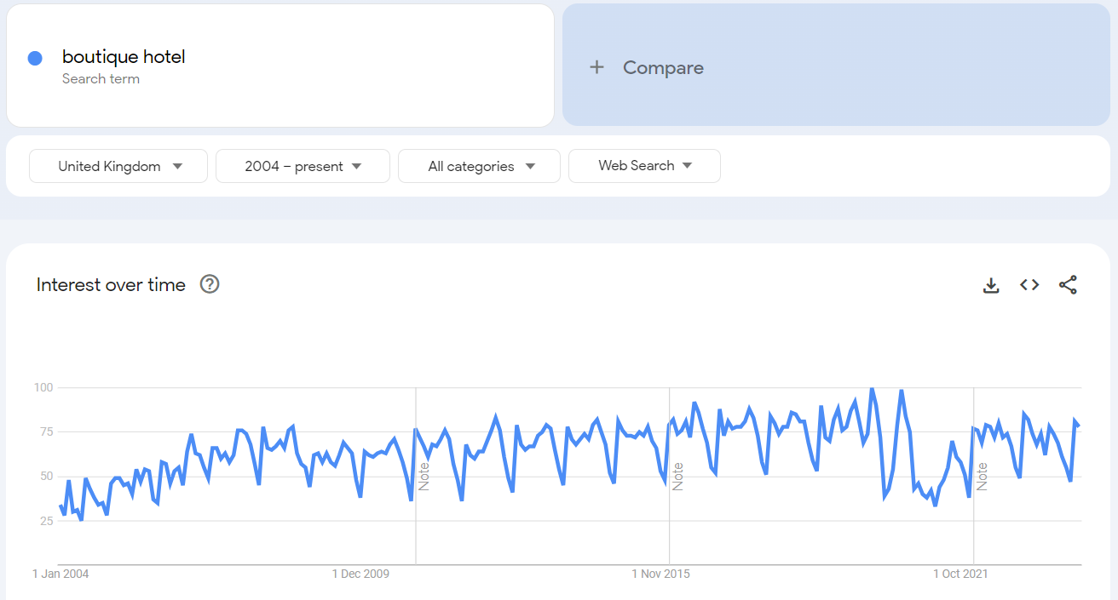
Period | Occupancy Rate | Discount
December to End of March | 80% | No discount
March to May | 50% | 20% off
June to September | 100% | No discount
October to November | 80% | 10% off
November 15 to December | 65% | 20% off

The expected revenue for each period, based on the specific occupancy rates and discounts provided, is as follows:
Period | Revenue | Total Annual Revenue
December to March | $377,520.00 | $1,228,968.00
March to May | $143,520.00 | $1,228,968.00
June to September | $475,800.00 | $1,228,968.00
October to November | $171,288.00 | $1,228,968.00
November 15 to December 15 | $60,840.00 | $1,228,968.00

How your prices compare with the competition:

How your prices compare with the competition:
Product/service | Your price(s) | Range of competitor prices (per unit)
- Locally sourced takeaway organic food and beverages | £2 – 80 | £ -
- Accommodation in sustainable and eco-friendly rooms | £180 - 240  (free beds for babies) | £99-480
- Organic and locally sourced dining options | £3- 100 | £ 3.5 – 109
- Event hosting, such as eco-friendly weddings or corporate retreats | £60-100/person | £75-125\person
- Sustainable merchandise like reusable water bottles, tote bags, and clothing | £5-60 | £ -
- Art and decor crafted by local artists. | £5-70 | £-

Suppliers are local big farms like: High Barn Community Farm, Park Farm Shop, The Avenue Orchard and smaller passionate farmers and artisans, so the suppliers are not limited.

The prices have been set to be competitive in the market. One of the biggest advantages the business has is that the competitors do not serve organic food and beverages, and more importantly, are sourced locally.

Reasons for the difference between your price(s) and your competitors’ price(s):

The price difference between Eco Harmony Retreats and its competitors is due to a strategic market positioning that capitalises on unique selling points while also addressing some of the competition's weaknesses. Here's the breakdown:
- Sustainability as a Core Value:
Eco Harmony Retreats places a high value on sustainability, which is becoming increasingly important to customers, particularly the Young, Eco-conscious Traveller demographic. By focusing on this area, the retreat can justify a premium within a certain price range, especially if competitors are less committed to environmentally friendly practices.
- Competitive Pricing for Luxury Experiences:
While competitors such as Hotel du Vin and Harbour Hotels provide premium locations and luxury amenities, they charge a higher price. "Eco Harmony Retreats" can provide a competitive advantage by offering luxury experiences with a sustainable focus at a more affordable price point, potentially capturing market share from budget-conscious travellers.
- Catering to Niche Markets:
Competitors like Hotel Pelirocco and Snooze cater to niche markets with themed rooms and unique styles. "Eco Harmony Retreats" can reach a larger audience by providing a variety of experiences that appeal to both niche and general markets, rather than focusing on specific demographics.
- Bundled Services and Incentives:
Eco Harmony Retreats can create value-added packages by bundling services such as lodging with organic dining options or event hosting with environmentally friendly practices. Unlike competitors who may charge separately for each service, "Eco Harmony Retreats" can position itself as providing better value for money.
- Dynamic and Flexible Pricing:
Using a dynamic pricing strategy enables "Eco Harmony Retreats" to adjust prices based on demand, seasonality, and occupancy rates, as specified in the promotion and advertising plan. This flexibility can make pricing more appealing during off-peak periods, as opposed to competitors who may use more static pricing models.
- Local Partnerships and Sourcing:
Local partnerships that enable cost-effective sourcing of organic and artisanal products may influence the prices of food and beverages, as well as art and decor. This local focus can provide a distinct selling point when compared to competitors who may not have as strong local ties.
- Customization and Personalization:
By providing a more personalised service, "Eco Harmony Retreats" can charge prices that reflect the tailored experiences it offers. This is especially important for event hosting, where personalisation is critical.
To summarise, Eco Harmony Retreats' prices reflect the company's strategic positioning as a sustainable luxury option that provides value through personalised experiences, competitive pricing, and a strong commitment to environmentally friendly practices. This approach not only justifies the retreat's price point, but also distinguishes it from competitors in the boutique hotel market.

14 Promotion and advertising

How and where will you promote your product/service?

The marketing plan for Eco Harmony Retreat is detailed for the 3 profile customers:
The Sophisticated Leisure Traveller
- SEO & Google Ads: Will target luxury and sustainability keywords to capture this market.
- Influencer Partnerships: Partnering with luxury travel influencers can increase visibility among sustainable travellers.
- Content & Email Marketing: The content will focus on sustainable luxury, with an email campaign to promote community events and exclusive offers.
The Mid-Age Professional
- LinkedIn Campaigns: Professional networks are an excellent way to reach this demographic, as they combine environmental awareness with professional development.
- Content for Work-Life Balance: The content will offer insights into integrating wellness into a professional lifestyle, establishing us as the ideal escape for the busy professional.
The Young, Eco-conscious Traveler
- Social Media Focus: Engaging this demographic on platforms like Instagram and leveraging blogger partnerships will help us gain visibility.
- Interactive Content: The strategy will include user-generated content campaigns, as well as quizzes and infographics about our eco-practices.
The Tech-Savvy & Cultural Explorer
- Tech Integration: A mobile app will function as a direct booking and information portal, enhancing our tech-savvy image.
- Virtual Experiences: Will invest in virtual tours and cultural content that highlight our technologically advanced environment and vibrant local culture.
International Visitor (US & France)
- Geo-targeted Campaigns: Tailored SEO and SEM campaigns will target these visitors, with ads running on popular platforms in their respective regions.
- Bilingual Content & Itineraries: Creation of travel guides and bilingual content aimed specifically at the US and French markets.
This strategy is intended to not only attract target customers, but also to provide them with a personalised experience that matches their interests and preferences, thereby encouraging bookings and fostering loyalty to Eco Harmony Retreats.



