Unit name: Marketing Management

Module code: BMMB7012

Research on the influence of fast fashion clothing brand marketing on Chinese clothing
Prepared for:
Written by:LILI WU
Student ID: 2212429
Date submitted: 16 December 2022

Executive Summary
With the rapid development of apparel companies, fast fashion companies have emerged and are gaining momentum. Fast fashion, also known as 'fast fashion', was first introduced in the US in the 1980s and is an emerging supply model for the apparel industry. With economic globalisation and network intelligence deepening, the pace of people's lives and demand preferences are changing at an increasingly rapid pace, so it is inevitable that the traditional clothing production model will not be able to meet consumer demand. In this way, the success of fast fashion brands is inevitable as they are sought after and supported by consumers.

Table of Contents
Executive Summary 2
1. Introduction 3
2. PRIMARK's STP analysis 5
3. Analysis of the application of 4P theory in PRIMARK marketing strategy 6
4. SWOT and Porter's Five Forces analysis in PRIMARK marketing 11
5. Conclusion 13
6. PRIMARK marketing model brings inspiration to China's apparel industry 13

Introduction
The global economy has been in a slump this year, which has made people more rigorous about consumer spending(Qerimi et al., 2017). Causing many companies in the apparel industry to experience a decline in sales and difficulties in their operations.Reported by Statista (2021), PRIMARK net capital value in the UK has been growing steadily from 2010 to 2021.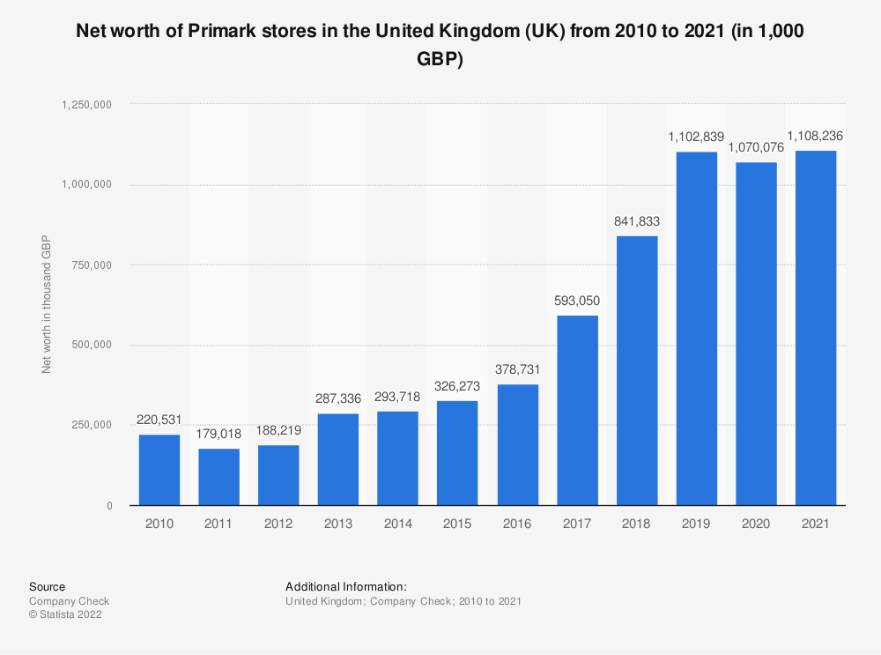
Source: Statista 2022
PRIMARK is a fast fashion retailer specialising in clothing, accessories and footwear. The company was founded in Dublin, Ireland in 1969 by the Weston family(Ucar, 2017). It has over 360 shops worldwide, including the UK, Republic of Ireland, Portugal, Spain, Germany, Netherlands, Belgium, Austria, France, Italy and the USA, and employs over 78,000 people.
From a small clothing store to a global fast fashion clothing industry model, primark took only a few decades(Gilibets Parés, 2020). The success of the fast fashion brand PRIMARK is due to many factors, such as professional data network, complete supply system and efficient modern logistics dynamic system, but also to the unique marketing strategy of a successful and leading brand(Buzzo and Abreu, 2019).
PRIMARK's outstanding performance in the market is due to its unique marketing strategy. This article takes PRIMARK as an example, and by studying the marketing strategy of this fast fashion clothing brand, we can then explore the successful experience of PRIMARK in marketing and make a guide for the fast fashion clothing industry.

PRIMARK's STP analysis
In today's society, the market competition is fierce, to want to survive and develop in it, the company needs to understand its own environment and its own positioning. Only in this way can the company develop a development strategy and product sales strategy suitable for itself and the market during its further development(Stokes, 2000).
It consists of three steps: Segmentation, Targeting and Positioning, and is the basis for the entire marketing process.
  - Market segmentation
In terms of the apparel market, it can be divided into the infant and child apparel market, the children's apparel market, the youth apparel market and the middle-aged and elderly apparel market by customer age, the men's apparel market and the women's apparel market by customer gender, and the sports apparel, casual apparel, formal apparel, semi-professional apparel and apparel with special functions by function. In terms of regions, they can be divided into developed country markets and developing country markets. Different markets have different characteristics as consumers' buying habits, desires and preferences vary from region to region or country to country. By dividing the apparel market into different perspectives and regions, the PRIMARK brand has gained a deep understanding of the characteristics of the apparel market and has thus identified its target market(Schultz, 2017).
2.2 Selection of target markets
PRIMARK believes that the current the middle and high-end clothing market has been unable to fully meet the needs of customers, and the clothing market is not yet saturated, so it chooses the market positioning is to provide fast and updated fashion. PRIMARK's clothing is reasonably priced and its consumers are mainly young people, aged about 20 to 35 years old, an age group that is characterised by a low to medium level of consumption and the pursuit of a relatively fashionable clothing styles. This consumer convergence also allows PRIMARK to meet the needs of consumers when entering a brand new area with a few minor adjustments, for example, in order to save design costs, it can be adjusted according to the weather when the clothing is new 2.3 Market Positioning
Once the target market has been identified, all that remains to be done is to position the market. Firstly,how to build the PRIMARK brand and make it become a leading enterprise in the global fast fashion clothing industry. It pursues to quickly design and produce cutting-edge fashion clothing for consumers, and then create its consumers to become more loyal customers with more fashion literacy(D’Mello, 2017). PRIMARK's products requirement within two weeks to implement the design to production until the launch of the product, timely add fashion elements to the clothing market and keeping up with consumer demand, thus satisfying consumers' need to follow fashion trends(Lotti, 2009). To a certain extent, most enterprises will sacrifice the existing market in pursuit of higher profits or a larger market, but PRIMARK will not. Because it has a complete modern logistics dynamic system and supply chain, greatly reduced the company's product costs, offering relatively better and more reasonable prices for the same quality of products, which is why PRIMARK has been able to quickly capture the middle and lower end of the market(Taplin, 2014).
PRIMARK has a unique and timely analysis of the current economic environment and form, which makes it occupy a place in the clothing market, thus laying the foundation for the implementation of its 4P strategy.

Analysis of the application of 4P theory in PRIMARK marketing strategy
The 4Ps strategy proposed by Jerome McCarthy, namely Product, Price, Place and Promotion, is the basis of every company's marketing strategy and in marketing, it plays a significant role.
3.1 Product strategy
3.1.1 More styles, less quantity PRIMARK tends to focus on variety of styles and does not aim to produce more than one item of clothing. In each PRIMARK shop, there are only about ten pieces of the same style, and these include five different sizes XS, S, M, L and XL - which means that there are only two or three pieces of each size in each shop. The PRIMARK shops have a fast turnover of products, which makes it possible for consumers to shop more frequently. For those who are looking for the latest fashions and trends, they are more likely to be able to find the right fit. It is therefore possible to say that the marketing strategy of having more items in smaller quantities gives consumers more choice and makes PRIMARK even more irresistible to them.
3.1.2 Imitating big brands and pursuing fashion
In its quest for fashion, a word that is difficult to control, PRIMARK has chosen to imitate it(Hayes and Jones, 2006). In order to reduce reaction time, PRIMARK employs experienced fashion buyers who travel around the world to catwalk shows and fashion fairs and feed PRIMARK headquarters with the latest fashion trends. This enables PRIMARK to capture the latest fashion trends in its clothing products. As a result, it takes PRIMARK only ten to fifteen days to identify trends and to produce fashionable, consumer-pleasing garments in its shops in imitation of major brands. This allows PRIMARK to capture fashion trends in a much quicker time frame than clothing brands that operate in a traditional way, which allows it to cater to the tastes of consumers and to build a better brand image.
3.2 Price strategy
3.2.1 Precise and rapid pricing
In addition to the design of the garment, PRIMARK has the designer work with the sourcing and marketing experts to determine the price of the garment. The prices are then converted into currency in different countries, labeled with prices and bar codes and delivered to the sales area. So, instead of pricing and labelling the new garments,the factory clothes were sent to the stores for sale.
3.2.2 Reasonable and realistic pricing
PRIMARK's main consumers are the young, fashion-conscious and individualistic 20 to 35 year olds who have the ability to spend but do not always have the means to spend on high-end luxury brands.PRIMARK Follow the current popular trend and to keep prices affordable is therefore a good fit for its target group.
PRIMARK believes that if the clothing is not sold, it will lead to excessive inventory in the warehouse, thus increasing the company's storage costs(Zhou et al., 2021). While domestic clothing brands tend to attach high design and production costs to their products when marketing, PRIMARK tries to reduce these costs as much as possible, with PRIMARK products taking just two weeks from design to production and then onto the shelves, compared to six to nine months for traditional clothing companies. It rarely spends a lot on advertising, because PRIMARK is cheap through its complete clothing processing and supply system and transportation system(Thompson and McLarney, 2017). As a result, PRIMARK products are priced more affordably and attractively than products of similar quality. In PRIMARK shops, the prices are low, yet the selection is always in line with the latest fashion trends, which makes PRIMARK a very profitable proposition for the budget-conscious consumer who visits the shop frequently and buys several pieces or multiple pieces at once.
3.3 Channel strategy
PRIMARK controls the entire process from the design and production of the garments to their distribution, i.e.PRIMARK Has a unique vertical supply and distribution system, allowing it to clearly control every part of the supply chain(Cole et al., 2019.).
PRIMARK attaches great importance to the speed of product launch and For the logistics dynamic system, it has been making huge investment, this purpose is not only to effectively reduce the management costs of the company, but also to ensure that the new clothing launched by the company can quickly flood the market and occupy business opportunities so that stocks in shops are replenished quickly and so that it sell out relatively quickly with little stock, thus reducing inventory costs(Ivanov et al., 2021). PRIMARK has a well-established distribution system, a large number of PRIMARK branches and shops, a global presence, and a globally uniform product range, which facilitates the globalisation of its sales.
PRIMARK offers an innovative fashion-oriented strategy of leading fashion and low-cost. This way achieves its desired low-cost strategy through higher sales, but the strategy is to achieve it through its efficient distribution system and full economies of scale(MacCarthy et al., 2010.). The company itself does not produce clothing, and its source of goods is obtained through working with suppliers around the world. PRIMARK The main purchasing countries are Bangladesh, India, and China(Balchin and Calabrese, 2019.).
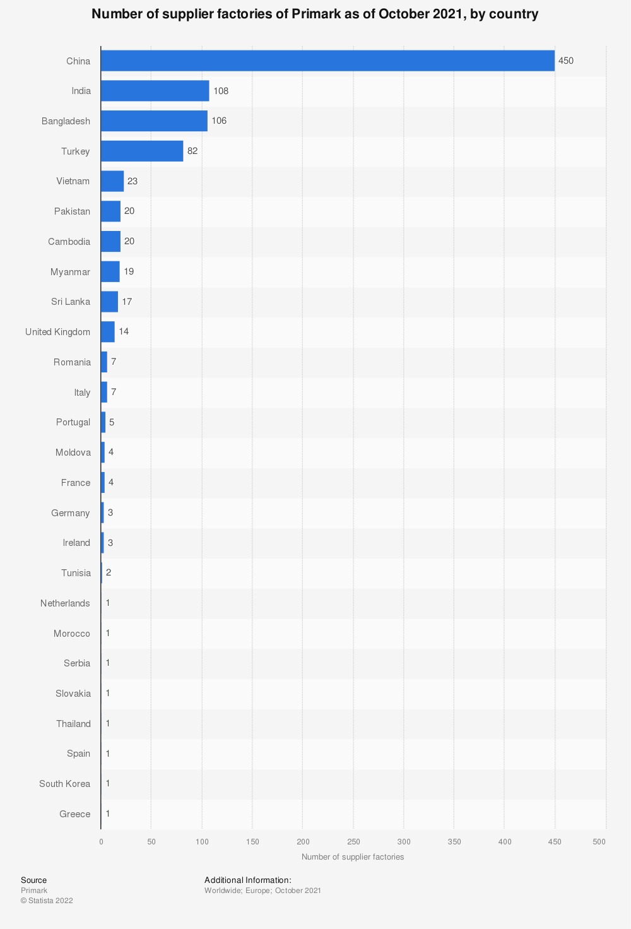
Source: Statista 2022
Each store has a information system, which can clearly know the inventory of its own store. Through this system, the store manager can know the sales situation and the orders of the head office according to the data of the system. Through this system, the sales of each PRIMARK store are summarized to the head office, which can shorten the production and delivery times. After that, the missing goods in the store can be packaged and transported to the out-of-stock store by the headquarters professionals. With such an efficient system, the distribution center is not a backlog warehouse as before, but a transfer center for products.
PRIMARK It has a complete sales data system and a sales system that can quickly respond to, such a system can quickly grasp any information of the company, to a certain extent to save the time of product delivery to stores(Taplin, 2014.).
3.4 Promotion strategy
PRIMARK is also unique in terms of promotion. Rather than advertising, they use discounts on bulk purchases as a way to benefit their customers and get them to advertise for them. Although PRIMARK rarely advertises its brand through the media, it still has other ways of building a good brand image. Firstly, PRIMARK always chooses the best locations in the city for its shops. Secondly,PRIMARK Think that attention should also be paid to the decoration of clothing stores and the layout of the internal environment, as it believes that they are the best advertisement for its brand(Hines et al., 2007). It provides a comfortable and beautiful shopping environment for consumers, allowing them to experience a fashion show while shopping and attracting them to come back for more. Again, PRIMARK is in constant communication with its customers, for market research, PRIMARK uses telephone visits and contacts customers by email to ask for suggestions for the improvement of the brand to further meet the needs of various types of customers(Harris and Rae, 2009).
PRIMARK also rarely discounts its products. In general, PRIMARK's new products are snapped up within a short time of hitting the shelves, with only a small percentage of the garments in stock and only a small percentage of the stock being sold at a discount(Eisenberg, 2019). Only products that are not quite to the taste of the consumer are slightly discounted and the number of discounted products is a small proportion of the total. The small number of discounts and the small quantity of stock, which arouses the consumer's desire to buy, allows the products to be sold quickly and at the right price. This is closely related to PRIMARK's strategy of having a small number of items in stock, as most of its clothing products cater to the tastes of consumers, giving them the impression that it is difficult to buy them now or later, so that most of the clothing products can be sold at their original price level, reducing the cost of discounting and ensuring PRIMARK's sales and profitability(Arriaga et al., 2017).

SWOT and Porter's Five Forces analysis in PRIMARK marketing
  - PRIMARK Marketing SWOT Analysis
SWOT analysis is a method of analysing a company's competitive situation by evaluating its own strengths, weaknesses, opportunities and threats to external competition. In this way, the company can understand the positioning of its own development when making strategies, and make a comprehensive analysis of its own development so as to make the developed development strategy more competitive(Kuratko and Audretsch, 2009).
s
  S1: The goods cheaper than other stores.
  S2: Compared with other brands, PRIMARK's products are complete and its fashion style follows the trend.
  W1: In the production of clothing, the choice of different processing plants, the production of different technical levels of different commodity quality is also different
  W2: The slow global economic growth because of the COVID-19 pandemic has hindered the overall profits of the global group
  w
  O1: PRIMARK should pay attention to its supply, for technical issues for suppliers. At the same time to make the clothing more affordable, have more fashion elements
  o
  O2: In terms of costume learning, PRIMARK should learn a variety of styles. For example, in addition to the current popular clothing can also learn formal suits and other styles
  T1：Since most of PRIMARK's stores are located in Europe, although the UK has left the EU, it still needs to keep an eye on the changes in various EU policies
  t
  T2: Product specialization problem, the lack of specialization can not achieve to further expand the market

  - PRIMARK MARKETING PORTER'S FIVE FORCES MODEL
The Porter's Five Forces model was developed by Michael Porter in the early 1980s. He believes that in each industry, there are five forces that compete with each other on a certain scale, and that these five forces make the competitive strategy decisions of existing companies(Porter, 2008).Here is an analysis of the five forces:
- Bargaining power of suppliers.
Suppliers in the fast fashion industry usually have low bargaining power because they are dependent on customers like PRIMARK.
(2) Bargaining power of customers.
In the fast fashion industry, the price of clothing is generally low, and the pricing of merchants is favored by customers for most of the time, so the bargaining power of customers is relatively weak,
(3) Threat of new entrants.
PRIMARK In the clothing industry is famous for the production of cheap fashion clothing, which itself is very challenging if there is no mature system. So, it naturally forms a very high barrier to entry. Finally, there is a situation in which the threat of new entrants is greatly reduced
(4) Threat of substitute products or services.
PRIMARK There is a great substitute threat. Because the fast fashion industry has long had the same fashion and relatively price-related and acceptable clothing brands, such as ZARA, there are a large number of alternatives to such fashionable clothes
(5)Industry rivalry
Since the clothing industry is a fully market-oriented industry, the competition is quite fierce for the fast fashion clothing market. Whether it is enterprise labor or raw materials, in order to reduce the product and one by one means of competition. Another is the competition of product sales, that is, there is the competition of clothing design and investment.

Conclusion
After the above comprehensive analysis of PRIMARK's marketing strategy, we can conclude that PRIMARK's successful experience includes: firstly, it has identified the target consumer group and its market positioning is extremely clear(Sanzo et al., 2003); secondly, it has made full use of information technology to respond quickly to fashion and update its products very quickly; thirdly, it has adopted a small number of products and a more affordable price strategy, which is oriented to consumer needs; fourthly, it has paid attention to brand image building, using tasteful store decoration, professional store display and layout to enhance its brand image; fifthly, PRIMARK's good business condition and online sales are linked and efficiently integrated. PRIMARK's good business situation and development trend also show to a certain extent that PRIMARK's unique marketing strategy is effective(Jones et al., 2009).
PRIMARK The initial success depends on its own initial accurate market positioning, so as to develop the right marketing strategy, which includes several important factors(Ortega et al., 2017).Such success is inseparable from the complete company information sales management system used in the process from the initial clothing design to the sales to the hands of each customer(Gabrielli et al., 2013). The supply of PRIMARK's raw materials, as well as its processing plants and external suppliers with whom the group has a long-standing relationship, has resulted in some savings in purchasing costs(KUPPUSAMY and SENTHIL KUMAR, 2019). Thirdly, the efficient distribution and logistics system saves time in the distribution and transport of goods and increases the efficiency of logistics and distribution. If products produced in Europe are to be transported to PRIMARK shops in Europe, PRIMARK chooses to transport them by truck over short distances at low cost and at high speed, while if they are to be transported outside Europe to other regions such as America and Asia, PRIMARK chooses to transport them by air, so that the goods can reach the shops in these regions at a faster speed. PRIMARK's choice of shipping method is also a reflection of its marketing philosophy. Although the cost of shipping by air is higher over long distances, the resulting maintenance of PRIMARK's trendy and up-to-date products brings in more sales and profits.

PRIMARK marketing model brings inspiration to China's apparel industry
6.1 Early access to market information and rapid response
The aim of reducing lead time is achieved through rapid imitation, which is the fundamental condition for companies to make a quick response(Bruce and Towers, 2004). Chinese clothing companies can achieve rapid imitation in two ways.
The first is to hire well-known foreign designers or designers with a good reputation in these fast fashion industries. This approach can solve the problem of poor innovation in the Chinese garment industry(Ye and Lau, 2018). However, it is only a temporary solution to the problem. If we want to tackle the problem from the surface to the inside, we need the second method.
Secondly, train our own country's fashion designers. This requires a national effort on many fronts. Firstly, colleges and universities should pay more attention to the fashion design industry, and make reasonable improvement to their courses after real-time investigation. The most important thing is to design practical courses for students and build a team of teachers to improve students' innovation ability. Train staff to go abroad for training, attend major fashion fairs and large exhibitions around the world, and get the opportunity to interact with the world's top designers. I believe that through years of hard work, China will have the world's top designers.
6.2 Develop a scientific service model with a consumer orientation
In terms of service mode and concept, we should be consumer-oriented and focus on understanding the psychology of consumers and meeting their needs. The importance of the product itself is decreasing, and more and more consumers are paying attention to the soft needs of the shopping environment and shopping experience(Soars, 2009).

Qerimi, Q. and Sergi, B.S., 2017. The nature and the scope of the global economic crisis impact on employment trends and policies in South East Europe. Journal of International Studies, 10(4), pp.143-153.
Ucar, S., 2017. The Possibility of Global Business Ethics Policy.
Gilibets Parés, J., 2020. The true cost of Fast Fashion model.
Yoon, N., Lee, H.K. and Choo, H.J., 2020. Fast fashion avoidance beliefs and anti-consumption behaviors: The cases of Korea and Spain. Sustainability, 12(17), p.6907.
Buzzo, A. and Abreu, M.J., 2019. Fast fashion, fashion brands & sustainable consumption. In Fast fashion, fashion brands and sustainable consumption (pp. 1-17). Springer, Singapore.
Stokes, D., 2000. Putting entrepreneurship into marketing: the processes of entrepreneurial marketing. Journal of research in marketing and entrepreneurship.
Schultz, C.D., 2017. Proposing to your fans: Which brand post characteristics drive consumer engagement activities on social media brand pages?. Electronic Commerce Research and Applications, 26, pp.23-34.
D’Mello, S., 2017. The impact of fashion activism on gen viz. Unpublished master dissertation, Istituto Marangoni & Manchester Metropolitan University, London, United Kingdom.
Ozdamar-Ertekin, Z., 2016. Conflicting perspectives on speed: Dynamics and consequences of the fast fashion system. Markets, Globalization & Development Review, 1(1).
Lotti, E., 2009. The value of fast fashion system.
Taplin, I.M., 2014. Global commodity chains and fast fashion: How the apparel industry continues to re-invent itself. Competition & Change, 18(3), pp.246-264.
Hayes, S.G. and Jones, N., 2006. Fast fashion: a financial snapshot. Journal of Fashion Marketing and Management: An International Journal, 10(3), pp.282-300.
Zhou, L., Chen, Q. and Xu, Q., 2021. Joint Pricing and Inventory Control Decisions for Fashion Apparel with Considering Fashion Level and Partial Backlogging. Mathematical Problems in Engineering, 2021.
Thompson, J. and McLarney, C., 2017. What effects will the strategy changes undertaken by next Plc have on themselves and their competition in the UK Clothing Retail Market?. Journal of Commerce and Management Thought, 8(2), p.234.
Cole, R., Stevenson, M. and Aitken, J., 2019. Blockchain technology: implications for operations and supply chain management. Supply Chain Management: An International Journal.
Ivanov, D., Tsipoulanidis, A. and Schönberger, J., 2021. Operations and supply chain strategy. In Global supply chain and operations management (pp. 87-124). Springer, Cham.
MacCarthy, B.L. and Jayarathne, P.G.S.A., 2010. Fast fashion: achieving global quick response (GQR) in the internationally dispersed clothing industry. In Innovative quick response programs in logistics and supply chain management (pp. 37-60). Springer, Berlin, Heidelberg.
Balchin, N. and Calabrese, L., 2019. Comparative country study of the development of textile and garment sectors: lessons for Tanzania. ODI Report.
Taplin, I.M., 2014. Global commodity chains and fast fashion: How the apparel industry continues to re-invent itself. Competition & Change, 18(3), pp.246-264.
Hines, T., Cheng, R. and Grime, I., 2007. Fashion retailer desired and perceived identity. In Fashion Marketing (pp. 254-282). Routledge.
Harris, L. and Rae, A., 2009. Social networks: the future of marketing for small business. Journal of business strategy.
Eisenberg, P., 2019. Financial Analysis of Primark Stores Ltd. with regard to a Stock Exchange Floatation (IPO). International Journal of Management, 7(1), pp.91-112.
Arriaga, J.L.D.O., Domingo, D.A. and Silvente, V.B., 2017. Facebook in the low-cost fashion sector: the case of Primark. Journal of Fashion Marketing and Management: An International Journal.
Kuratko, D.F. and Audretsch, D.B., 2009. Strategic entrepreneurship: exploring different perspectives of an emerging concept. Entrepreneurship theory and practice, 33(1), pp.1-17.
Porter, M.E., 2008. On competition. Harvard Business Press.
Sanzo, M.J., Santos, M.L., Vázquez, R. and Álvarez, L.I., 2003. The effect of market orientation on buyer–seller relationship satisfaction. Industrial Marketing Management, 32(4), pp.327-345.
Jones, B., Temperley, J. and Lima, A., 2009. Corporate reputation in the era of Web 2.0: the case of Primark. Journal of marketing management, 25(9-10), pp.927-939.
Ortega, A.M.G. and Okechukwu, C.U.U., 2017. Strategic means to launch business-Primark in Denmark.
Gabrielli, V., Baghi, I. and Codeluppi, V., 2013. Consumption practices of fast fashion products: a consumer‐based approach. Journal of Fashion Marketing and Management: An International Journal.
KUPPUSAMY, G.K. and SENTHIL KUMAR, I.N.I.Y.A.N., 2019. Applying sustainable development on supply chain in apparel industries.
Ye, Y. and Lau, K.H., 2018. Designing a demand chain management framework under dynamic uncertainty: An exploratory study of the Chinese fashion apparel industry. Asia Pacific Journal of Marketing and Logistics.
Bruce, M., Daly, L. and Towers, N., 2004. Lean or agile: a solution for supply chain management in the textiles and clothing industry?. International journal of operations & production management.
Soars, B., 2009. Driving sales through shoppers' sense of sound, sight, smell and touch. International Journal of Retail & Distribution Management, 37(3), pp.286-298.

