BMIH5006

Taxi Transport and Its Environmental Impact in the Hospitality Industry

Student name: Ella Daniela Mirea
Student ID: 2246573
Lecturer Name: Lisa Knight, Kathryn Roberts,
Christopher Wilkin5

I herby confirm I did not use AI
Executive Summary

This report assesses the environment effect of taxi transport in the hospitality and tourism industry where taxi is an integral part of urban mobility. While convenient for tourists and business travelers, taxi fleets still use fossil fuels for transport and therefore contribute to carbon emissions, air and noise pollution, traffic congestion and over exploitation of resources. A study indicates that because traditional taxis operate across high mileage and around the clock, the resulting exhaust of greenhouse gasses is unbalanced against private cars. Located throughout cases from secondary cities, such as London, New York, Paris and Shenzhen, these impacts are shown to be severe. For instance, research suggests that urban taxi operations can make a significant contribution to emissions of a city as a whole and contribute to increasing traffic congestion during peak tourism seasons.
The report also outlines novel methods of overcoming these challenges. Major strategies include transitioning to electric and hybrid taxis, ride sharing and pooling services as well as integration of renewable energy charging stations. Also, smart taxi management systems using AI and GPS technology for adoption can improve route and fuel consumption. Government incentives and the kind of regulations seen in London and New York also help in pushing towards sustainable taxi operation. In conclusion, the results suggest recommendations for industry stakeholders to create a greener, more efficient urban mobility community for people.

Table of contents

1. Introduction 4
2. Main Findings 4
2.1. The Role of Taxi Transport in Hospitality 4
2.2. Impacts of Taxi Transport 5
2.2.1. Carbon Emissions and Air Pollution 5
2.2.2. Traffic Congestion 5
2.2.3. Noise Pollution 6
2.2.4. Resource Consumption and Waste 7
2.3. Possible Solutions to Reduce the Environmental Impact of Taxis 8
2.3.1. Transition to Electric and Hybrid Taxis 8
2.3.2. Implementation of Ride-Sharing and Pooling Services 9
2.3.3. Integration of Renewable Energy Charging Stations 9
2.3.4. Adoption of Smart Taxi Management Systems 9
2.3.5. Incentives and Regulations for Green Taxi Initiatives 10
2.3.6. Partnerships Between Hospitality Businesses and Sustainable Transport Providers 10
3. Conclusion and Recommendations 11
4. References 12

Introduction
Hospitality transport plays a crucial role in the global tourism and hospitality industry, facilitating the movement of guests from one location to another. It encompasses various modes of transportation, including taxis, shuttle services, buses, and private vehicles, among others (Buhalis et al., 2019). However, despite its necessity, hospitality transport has significant environmental implications, particularly in terms of carbon emissions, air pollution, and congestion.
In this report, there is emphasis on the taxi transport mode of transport as one of the most utilized transport modes in the hospitality sector. Taxis are a convenient mode of transportation for the tourists, business travelers, and hospitality guests and personal and required on-demand transportation. But they continue to rely on fossil fuels and emit high amounts of emissions, which are making the environment deteriorate. The purpose of this report is to investigate main damage impacts caused by taxi transport and to offer up the feasible solutions of it, and especially in the field of industry, suggestions of sustainable initiatives that can be applied to taxi transport.

Main Findings

The Role of Taxi Transport in Hospitality
According to Afsari et al. (2024), Taxi transport is the key factor in on-demand transportation for urban mobility to the people and tourists. But taxi fleets operating in big cities and with a high level of tourism are of great environmental impact. Among these, the major environmental issues associated with taxi transport are carbon emissions, air pollution, traffic congestion, noise pollution, and excessive resource consumption. The survival of these issues is contributing to creation of unhealthy air quality, more greenhouse gas emissions and long-term ecological deterioration, and therefore immediate mitigation is required (Ghahramani & Pilla, 2021).

Impacts of Taxi Transport

Carbon Emissions and Air Pollution
Most traditional taxis use internal combustion engines fueled by gasoline or diesel to operate leaving behind much of the greenhouse gases (GHGs), including carbon dioxide (CO2) and nitrogen oxides (NOₓ), as mentioned by Agency (2025). However, studies find that taxis disproportionately contribute to urban emissions that are caused by continuous operation and high mileage of taxis when compared to private vehicles. has reported that ride hailing services, from traditional taxis to taxis, account for 515 kilotons of CO₂ in European cities, the equivalent of the annual produced by 250,000 extra cars on the road (Environment, 2021).
Air quality degradation is also created by taxi fleets in cities with a lot of tourism, for example in London and New York. In 2022, approximately 40% of all urban emissions for New York City’s taxis and ride hailing services resulted (Commission, 2022). Likewise, the Bos et al. (2021), research in London revealed that taxis were responsible for almost 9% of all vehicles on the road but less than 0.5% of all vehicles, representing nearly 9% of all total vehicle emissions. Additional to the problem of taxi vehicles being used for long periods (over 100,000 miles per year in many major urban centers), creates further environmental impact (Michelle Meyer, 2024).

Traffic Congestion
Taxis are also a major factor in urban congestion leading to more fuel consumption and more idling times that are adding to the pollution levels. With the arrival of ride hailing, more vehicles have come to the roads, and this has led to gridlock especially in city centers (Agarwal et al., 2023). Sheldon and Dua (2024) concluded that the number of additional miles generated per time ridden in a ride hailing service was 2.6 per mile driven of that service. It increases fuel consumption and generates more unused emissions.
Extreme reliance on taxis during peak tourist seasons forces the disproportionately heavy use of taxis, which in turn causes great traffic congestion locally and contributes to significant emissions from stationary vehicles. For example, research revealed that in Paris traffic congestion increases by 20% in summer months when tourism is at its height with taxis playing a big role therein (Statista, 2024b). Another, data from (UCTC) (2021) suggested that cities with a high abundance of taxis can have up to 25% more congestion than those that luxuriate with public mixing substitutions.
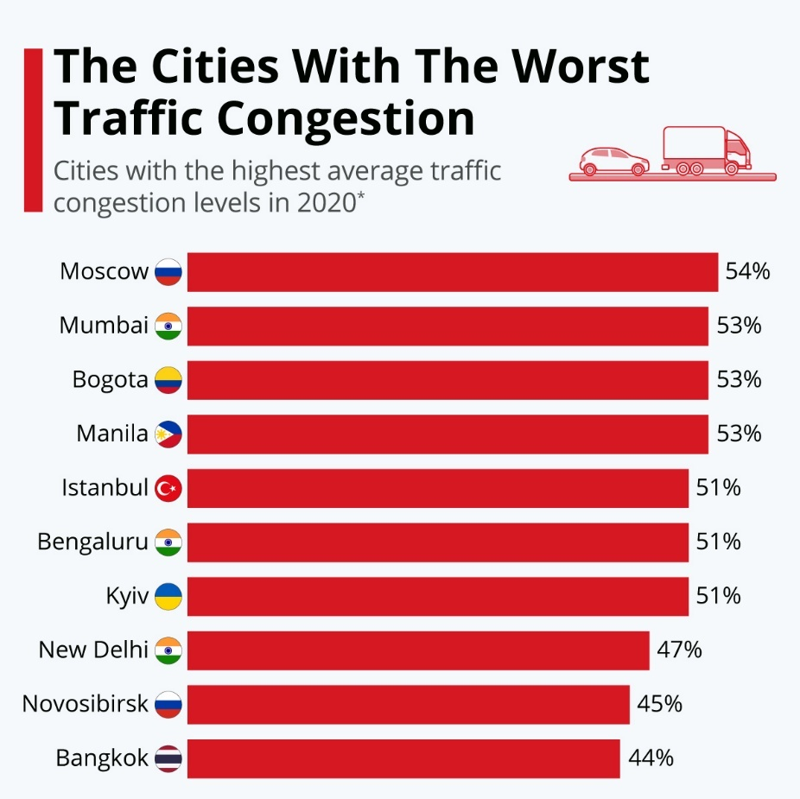
Figure 1: The cities of different countries with worst traffic congestion (McCarthy, 2021)A

Noise Pollution
The third major environmental issue relating to taxi transport is noise pollution. Continuous noise pollution is a problem for residents and for tourists that infests urban areas that are rich in taxi density. Earlier studies show that noise pollution from taxis especially engine noise and horn are stressful, causes sleep disturbance and have general reduced quality of life (Koehler et al., 2021).
According to a study conducted in London back in 2021, noise pollution was above 75 decibels in areas frequented by a lot of taxis and over the recommended 55 decibels limit, established by World Health Organisation (Authority, 2022). Moreover, Authority (2022) observed that noise pollution levels in urban areas are 30% higher in areas with a high frequency taxi traffic than in residential areas with low taxi presence. The findings indicate that these sustainable quieter taxi solutions, like the electric vehicle, do significantly less noise pollution than they do today.

Resource Consumption and Waste
Much of the natural resources required for manufacturing, maintenance and resultant disposal of taxis are also wasted. Taxis have shorter operational lifespans than private vehicles, meaning taxis inspire more replacement of vehicles and more demand of raw materials, such as steel, aluminum, rare earth metals, and so on. The industry that is responsible for most of the impact on the environment is the automotive industry, in particular vehicle production acounts for almost 12% of the global industrial CO₂ emissions (IEA, 2021).
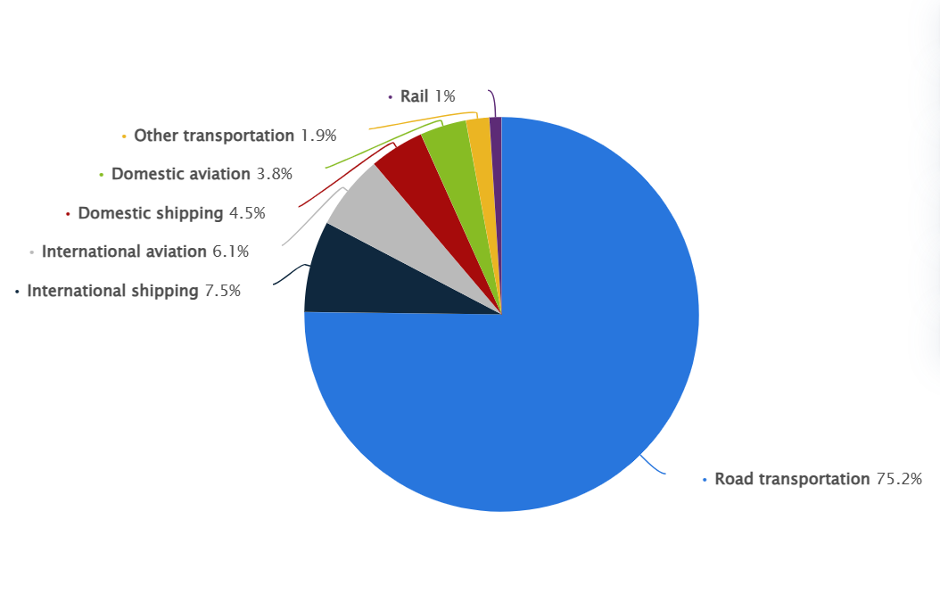

Figure2 : Breakdown of CO₂ emissions in the transportation sector worldwide 2023 (Tiseo, 2023)

Furthermore, traditional taxis involve regular oil changes, tire replacements, and repairs, resulting in great waste. (EPA) (2024) in a study ascertained that taxi fleets in the big cities churn out about 1.8 million liters of waste oil annually, with much of it incinerated improperly which leads to soil and water contamination. Furthermore, Laboratory's (2021) performed a lifecycle assessment study and found that converting fleet taxi to hybrid or electric vehicles would allow for reduction of the taxies’ environmental footprint by as much as 47%.

Possible Solutions to Reduce the Environmental Impact of Taxis

Transition to Electric and Hybrid Taxis
Using electric and hybrid taxis to the transport of taxis is one of the most effective ways to reduce environmental impacts associated with taxi transport (Hassouna & Assad, 2020). London and Amsterdam are cities that have introduced policies to make taxis transition from being powered by conventional fuel to electric vehicles (EVs).
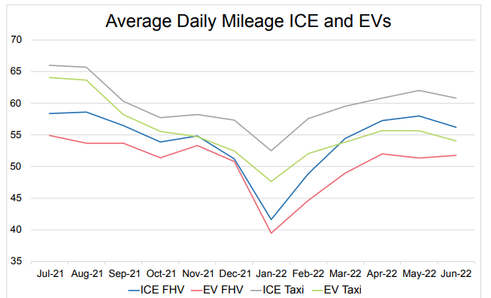

Figure 3: Shift of conventional engines to electric vehicle (Commission, 2022)
One such case study is London Electric Vehicle Companies’ (LEVC) Electric Taxi Initiative, depicted by the TX Electric Taxis. Tailpipe emission is zero from these vehicles, thus they decrease urban air pollution significantly (Ulahannan et al., 2021). Supporting taxi operators in transition has enticed the UK government into providing incentives—to the point of offering grants and lowered licensing fees. As of 2022, the UK Department for Transport indicated that there were more than 6,000 electric taxis operating in London, which is down to 30 percent less of taxi related CO2 emissions (GOV.UK, 2025). In Amsterdam, strict regulations have also been introduced whereby all taxis working at Schiphol Airport had to be used electrically by 2030 (Statista, 2024a).

Implementation of Ride-Sharing and Pooling Services
Ride-sharing and taxi-pooling services offer another practical solution to reducing emissions and congestion. This is because by having multiple passengers share a single taxi, the number of vehicles on the road is lowered, which in turn leads to lower consumption of fuel and less that is traffic congestion (Chen et al., 2024). UberPOOL and Lyft Shared Rides are two successful examples of this approach, and they have been introduced so far in some of the largest metropolitan areas including New York, Los Angeles and London (Morris et al., 2020). If ride sharing services were adopted universal, they can lower emissions from urban transport up to 20% down (Tikoudis et al., 2021). Nonetheless, non-pooled ride hailing rides have been shown to increase congestion and pollution, indicating that the promotion of shared rides is vital (Scientists, 2020).

Integration of Renewable Energy Charging Stations
To make electric taxis more sustainable, it is important that charging infrastructure expand with renewable energy source. Electric taxis decrease emissions but their benefit to the environment is optimized by charging them using clean energy such as solar or wind power to generate the electricity (Kashem et al., 2024). Solar powered charging stations for taxis are now being invested into by governments and private companies. In Shenzhen, China, which has virtually replaced all its taxis with electric vehicles, renewable energy powered charging stations have eliminated much of the taxi fleet’s dependence on fossil fuels (Fang et al., 2023). As an example, Shenzhen has a 48% reduction in annual carbon emissions from taxis in its electric taxi fleet. European cities such as Oslo and Berlin are also exploring similar initiatives (IEA, 2023).

Adoption of Smart Taxi Management Systems
Smart Taxi management system implementation by using artificial intelligence (AI), GPS technology can minimize taxi routes, minimize idle time, and minimize the consumption of fuel (Abduljabbar et al., 2019). An example of such demand prediction is AI powered dispatch systems that is able to predict demand patterns thereby allocating taxis in efficient manner, thus minimizing excessive mileage. Singapore's Smart Taxi Dispatch System is a prime example of how AI can improve transport efficiency (JI, 2023). Real time data analytics are employed by the system to optimize the distribution of taxis, lessening wait time for the passengers and unnecessary mileage to fuel costs.

Incentives and Regulations for Green Taxi Initiatives
Government incentives and policies toward the eco-friendly taxis are paramount during quickening the transition to such types of taxis. Tax incentives, subsidies and various congestion charged on high emission taxis have been introduced in several cities to encourage the adoption for green transport solutions (Campus & Campus, 2022). For instance, New York City has set an ambitious goal of transitioning 50% of its taxi fleet to electric vehicles by 2030. NYC Department of Transportation (2023) notes that the city government provides financial incentives for taxi owners opting to switch to EVs (taxi owners are offered grants of up to $12,500). For example, London’s Ultra Low Emission Zone (ULEZ) charges taxis with high emissions daily frequency to drive them to electric or hybrid vehicles (London, 2024). However, according to these measures the number of electric taxi registrations have increased by 40 percent in London from 2021 to 2023 (TfL, 2023).

Partnerships Between Hospitality Businesses and Sustainable Transport Providers
Hospitality organizations such as hotels and resorts can integrate with ecofriendly taxi services and be an important advisor in promoting the use of this transport in sustainability. Urban mobility has its environmental footprint, which is why hotels can help in reducing similar footprint through prioritizing green transport options for its guests (Kanwal et al., 2024). Marriott Green Transport Initiative is one of the examples that are notable. Marriott Hotel has partnered electric taxi providers in major metropolitan areas to provide guests with sustainable transportation options. Marriott (2024) reported that in 2021, Marriott’s corporate travel carbon footprint was reduced by 25% (with EV taxi fleets).

Conclusion and Recommendations
In conclusion, taxi transport is vital part of the hospitality industry and they offer a very important service to the world travel. But its ability to affect the environment in carbon emissions, congestion and depletion of resources poses environmental concerns to its sustainability. To mitigate these effects, the industry must prioritize the transition to electric and hybrid taxi fleets, invest in ride-sharing technologies, and expand renewable energy charging infrastructure. Smart taxi management systems and government subsidies can also speed up the pickup of sustainable taxi solutions. Eco friendly transport integration should also be implemented by hospitality businesses in a primary shape to integrate efficient, convenient, but of minimum carbon footprint for travelers.
Recommendations:
- Governments should provide financial incentives to accelerate the transition to electric taxis.
- Hospitality businesses should partner with sustainable transport providers to enhance green travel options.
- Technology-driven solutions, such as AI and GPS tracking, should be implemented to optimize taxi operations.
- Public awareness campaigns should promote ride-sharing and alternative transportation methods.
- Investment in renewable energy-powered taxi charging stations should be prioritized to support sustainable transport initiatives.

References

(EPA), U. S. E. P. A. (2024). Managing, Reusing, and Recycling Used Oil https://www.epa.gov/
(UCTC), U. o. C. T. C. (2021). App-Based, On-Demand Ride Services: Comparing Taxi and Ridesourcing Trips and User Characteristics in San Francisco
Abduljabbar, R., Dia, H., Liyanage, S., & Bagloee, S. A. (2019). Applications of artificial intelligence in transport: An overview. Sustainability, 11(1), 189.
Afsari, M., Ippolito, N., Miristice, L. M. B., & Gentile, G. (2024). Environmental benefits of taxi ride-sharing in New York City. Transportation Research Procedia, 78, 345-352.
Agarwal, S., Mani, D., & Telang, R. (2023). The impact of ride-hailing services on congestion: Evidence from indian cities. Manufacturing & Service Operations Management, 25(3), 862-883.
Agency, E. E. (2025). Transport and mobility. https://www.eea.europa.eu/en
Authority, G. L. (2022). Noise Pollution in London.
Bos, B., Lim, S., Hedges, M., Molden, N., Boyle, S., Mudway, I., & Barratt, B. (2021). Taxi drivers’ exposure to black carbon and nitrogen dioxide in electric and diesel vehicles: A case study in London. Environmental Research, 195, 110736.
Buhalis, D., Harwood, T., Bogicevic, V., Viglia, G., Beldona, S., & Hofacker, C. (2019). Technological disruptions in services: lessons from tourism and hospitality. Journal of service management, 30(4), 484-506.
Campus, A. P. K., & Campus, P. K. (2022). Sustainable transportation in the taxi industry in Johannesburg: The opportunities, challenges, and solutions towards achieving sustainable transport. Annals of Spiru Haret University. Economic Series, 22(4), 353-380.
Chen, W., Ke, J., & Chen, X. (2024). Quantifying traffic emission reductions and traffic congestion alleviation from high-capacity ride-sharing. Transportmetrica B: Transport Dynamics, 12(1), 2423235.
Commission, N. T. L. (2022). Charged Up! TLC’s Roadmap to Electrifying the For-Hire Transportation Sector in New York City.
Environment, T. (2021). Unlocking Electric Trucking in the EU: long-haul trucks.
Fang, Z., Wang, X., Zhuang, Y., & Liu, X. (2023). Estimating optimal substitution scale of urban gasoline taxis by electric taxis in the era of green energy: a case study of Zhengzhou City. Geo-spatial Information Science, 26(3), 514-539.
Ghahramani, M., & Pilla, F. (2021). Analysis of carbon dioxide emissions from road transport using taxi trips. IEEE access, 9, 98573-98580.
GOV.UK. (2025). £120 million to roll-out more electric vans, taxis and motorbikes. Retrieved from https://www.gov.uk/
Hassouna, F. M., & Assad, M. (2020). Towards a sustainable public transportation: replacing the conventional taxis by a hybrid taxi fleet in the West Bank, Palestine. International journal of environmental research and public health, 17(23), 8940.
IEA. (2021). Global Energy Review 2021: Assessing the effects of economic recoveries on global energy demand and CO2 emissions in 2021. https://www.iea.org/
IEA. (2023). Global EV Outlook 2023. https://www.iea.org/
JI, M. (2023). Analyzing taxi drivers’ decision-making and recommending strategies for enhanced performance: A data-driven approach.
Kanwal, N., Meng, C. S., Watabe, M., Zainal, N., & Siew, J. K. K. (2024). Carbon Footprint of Tourism Activities Including Transportation, Accommodation, and Infrastructure: A Critical Analysis. In The Need for Sustainable Tourism in an Era of Global Climate Change: Pathway to a Greener Future (pp. 95-120). Emerald Publishing Limited.
Kashem, M. A., Shamsuddoha, M., & Nasir, T. (2024). Sustainable Transportation Solutions for Intelligent Mobility: A Focus on Renewable Energy and Technological Advancements for Electric Vehicles (EVs) and Flying Cars. Future Transportation, 4(3), 874-890.
Koehler, M., Baader, F., & Brandstätt, P. (2021). Noise prediction for urban air taxi operation. INTER-NOISE and NOISE-CON Congress and Conference Proceedings,
Laboratory's, N. R. E. (2021). Life Cycle Greenhouse Gas Emissions from Electricity Generation: Update. https://www.nrel.gov/
London, T. f. (2024). Ultra Low Emission Zone.
Marriott. (2024). Sustainability and Social Impact. http://www.marriott.com/default.mi
McCarthy, N. (2021). The Cities With The Worst Traffic Congestion. https://www.statista.com/
Michelle Meyer, L. P., Carlos Jimenez, Tim Dallmann. (2024). Assessment of real-world passenger vehicle and taxi emissions in Mexico City.
Morris, E. A., Zhou, Y., Brown, A. E., Khan, S. M., Derochers, J. L., Campbell, H., Pratt, A. N., & Chowdhury, M. (2020). Are drivers cool with pool? Driver attitudes towards the shared TNC services UberPool and Lyft Shared. Transport Policy, 94, 123-138.
Scientists, U. o. C. (2020). Ride-Hailing’s Climate Risks steering a Growing Industry toward a Clean Transportation Future. https://www.ucsusa.org/sites/default/files/2020-02/Ride-Hailing%27s-Climate-Risks.pdf
Sheldon, T., & Dua, R. (2024). Impacts of ride-hailing on energy and the environment: A systematic review. Environmental Research Letters.
Statista. (2024a). Annual number of passengers transported by the urban bus system in Amsterdam, Netherlands from 2014 to 2023. https://www.statista.com/
Statista. (2024b). Tourism in Paris - statistics and facts. https://www.statista.com/
Tikoudis, I., Martinez, L., Farrow, K., Bouyssou, C. G., Petrik, O., & Oueslati, W. (2021). Ridesharing services and urban transport CO2 emissions: Simulation-based evidence from 247 cities. Transportation Research Part D: Transport and Environment, 97, 102923.
Tiseo, I. (2023). Distribution of carbon dioxide emissions produced by the transportation sector worldwide in 2023, by sub sector. https://www.statista.com/
Ulahannan, A., Knight, M., Doel, R., & Birrell, S. (2021). Look, No Cables! An Interview Study into Guiding the Practical Implementation of Wireless Chargers for Electric Taxis. International Conference on Applied Human Factors and Ergonomics,

