University of Wales Trinity Saint David, London, Campus: Oval

Report: Structure and culture in Apple inc.
Lecturer: Dr. Jhon-Paul Okeke
Student: Ivan Georgiev ID:1914979 | 8/15/20 | IMW LCBB4003

- Introduction…………………………………………………………... page 2
- Main body……………………………………………………………… page 2-4
- The fundamental structure………………………………….…. page 2
- Spoke and wheel hierarchy…………………………………….. page 3
- Product-based Divisions………………..……………………….. page 3
- Functional Matrix……………………………………….………..… page 3-4
- The behavioural approach to management….………… page 4-5
- Conclusion……………………………………………………….……… page 5
- References……………………………………………………….……… page 6

Introduction
The organisational structure is a critical aspect that ensures there is increased the performance of the organisation in the context of promoting the culture (Galbraith, pp.9-10 2014). The success of Apple is associated with several factors that are practices within the organisation. Organisational composition which influences the culture of the organisation. The culture is a critical component that determines the performance of the organisation. Various organisations are set to illustrate specific behaviour in the organisation, and thus, it should be underestimated at any given point. Several organisations that have emerged to be successful in the market or their respective industries are said to have good organisational structure and behaviour. Apple has an excellent corporate structure that has influenced both the practice and the culture that has led to being effective in the market (O’riordan, pp. 8-12, 2015). Apple inc is a leading international organisation in the technology industry, via the production of original products such as Macintosh in 1984. The company has been running through a series of collapses and triumphs, till the moment where they become the leaders in the sells and the production of smartphones and Ipads.
Main body
The fundamental structure.
Apple Inc. has a hierarchical organisational structure, with notable divisional characteristics and a weak functional matrix. The hierarchy is a traditional structural element in business organisations. The divisional types refer to the product-based grouping within Apple, such as for iOS and macOS. The structure within the time when Steve Jobs, the CEO in Apple, was autocratic. He was the person who takes all decisions by himself. He does support the collaborative teamwork, but the final word was his (Agrawal, CEO, Alumnify, 2016). According to Steve Jobs, the former CEO of Apple said that collaboration opened the doors for innovation and thus increased productivity in the organisation. Steve Jobs used to give his employees additional than two hours to think innovatively and come up with strategies that can benefit the organisation to achieve its aims in the market (Filloux, 2011). They are three main characteristics of Apple’s corporate structure:
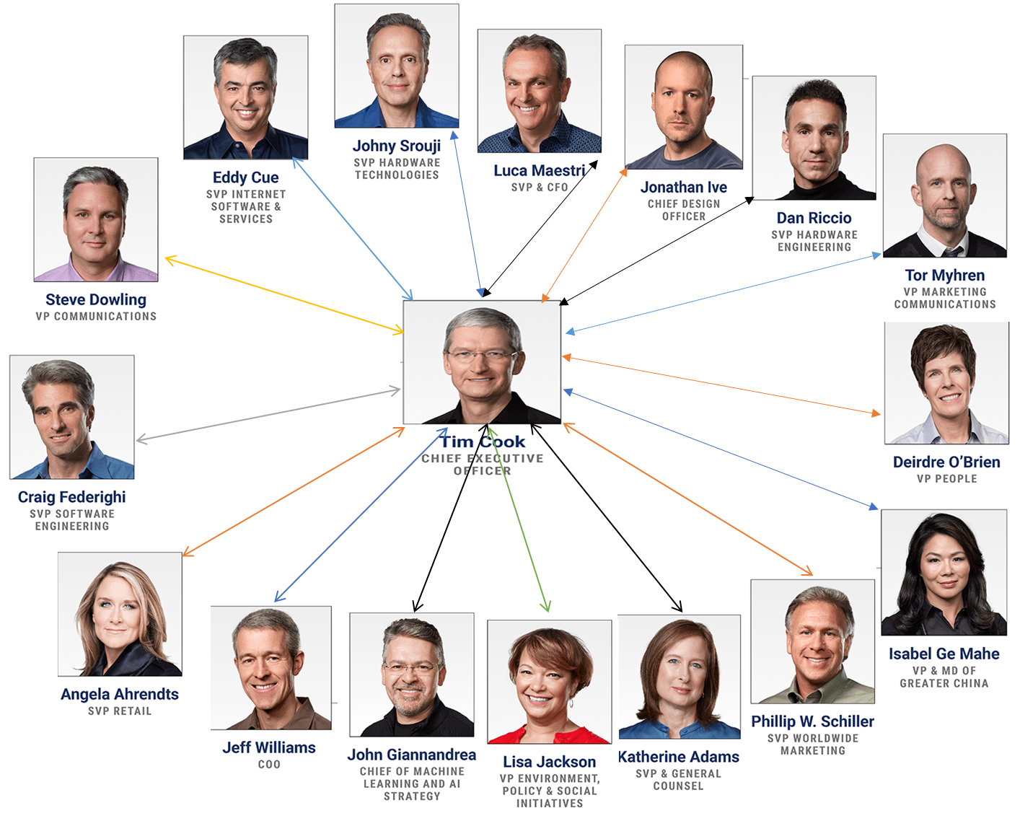
Apple’s spoke and wheel inner cycle hierarchy: Made by Ivan Georgiev ID: 1914979 ‘University of Wales Trinity Saint David.’

- Spoke and wheel hierarchy
- Product-based divisions
- Functional matrix
- Spoke and wheel hierarchy: A overview of Apple’s organisational structure shows a significant hierarchy. In the near past, Steve Jobs made all the most important strategic management choices. However, under Tim Cook’s leadership, this chain of command in Apple’s corporate structure has marginally changed. Tim Cook proved to be effective in producing the Apple watches, first developed under his leadership. Furthermore, Tim Cook has been complimented by employees for motivating leadership. He has been helping his dependents to develop to a better human being. At the same time, Cook is occasionally criticised by analysts and industry watchers for lack of ambition and motivation, compared to former runner Steve Jobs. The Apple Watch launched in April 2015 it is the number one spot to watch at home music which debuted in 2015 as well also increased rapidly to 15,000,000 subscribers when working for Apple. The company now has more co-operation among different parts of the organisation, for instance software teams and hardware teams. The vice presidents in Apple now have more independence, which was limited or even minimal under Jobs. Thus, the company’s organisational structure is now less rigid but still has a spoke-and-wheel hierarchy where. Tim Cook is at the centre. The upper tier of the corporate structure has function-based grouping, which is an element developed from the functional type of organisational structure. The Senior vice presidents who report to Tim Cook, cope with the business tasks. In this structural aspect, the company’s highest leaders address business needs in terms of business purpose fields (Mayer, 2019).

- Product-based Divisions: The high and lower layers of Apple’s corporate structure has product-based sections, which is an element resulting from the divisional type of organisational composition (Blarr, Wulf, 2011, pp. 20-21). There are senior vice presidents and vice presidents for various productions or products. Apple has a Senior Vice President also for Hardware Engineering (Mac, iPhone, iPad and iPod), a Software Engineering (iOS and macOS), and a Senior Vice President for Hardware Technologies (hardware components). This phase of the corporate structure is used to supervise certain products or product components that the company delivers to its target customers (Apple, 2020).

- Functional Matrix: Apple Inc have soft or weak functional matrix refers to the cooperative collaborations between various elements of the company. In the functional matrix model, top management determines project direction. But in the case of Apple, the project heads have limited influence and control. For example, the corporate structure permits hardware teams to work together with software teams. As A Result, the company accelerates information reaching that is essential for innovation processes. This structural feature contributes to successful and rapid innovation processes. By way of collaboration, numerous ideas are shared, and this is aimed on attaining the most significant innovation levels influenced by the latest technology. Apple inc is an organisational structure simple and not complicated as in different companies that have been seen globally. The simple organisational structure has been said to promote workers collaborative abilities aimed at achieving specific goals in the organisation. The organisational structure has remained to the surest strategy that has enhanced the company to exploit its capabilities in the market. Apple is at present one of the best company in the white goods industry, but its success has closely been linked with the organisational structure is implemented. Organisational structure dictates certain behaviours and culture in an organisation that controls all the operations of the organisation. Apple ensures it hires its workers who have high ability in collaboration and thus increase the innovation. The human resource management of Apple is very keen on hiring employees, and the behaviours of the employees are a line of the culture and structure of the organisation (Morancie, 2018). The human resource of the company has been involved with the close management of its employees as this ensures employees behave in a particular desired behaviours. Various policies have been put in place in ensuring there is increased profitability and productivity in the market. Apple has provided that its organisational design is in a manner suggesting integration of people technology and information within an organisation. Apple collaborative structure is a critical part that ensures the organisation has a good design that enhances increased innovation efforts of the company in an organisation (Gupta, Prinzinger, 2013, pp. 215-200 ). Through this characteristic of the organisational structure, the company maintains stable innovation processes that support brand development and the use of premium-pricing strategies. Apple has a collaborative organisational structure that is praised for bringing its employees together in a long terms relationship to achieve desired objectives. Collaborative teamwork conditions are critical because they improve employee and cooperative performance. The collaborative organisational structure in Apple has been able to increase efficiency and effectiveness, and that leads to increased implementation in the organisation. Collaboration among employees is essential because it brings about sharing ideas that are channelled to provide particular objectives. Through close integration of workers, innovation is prevalent through mind sharing and focused worker suggestions in an organisation (Morancie, 2018).
The structure can be used by anyone passionate about Apple’s products have specialised tasks that they can offer I believe that Apple’s employees are highly motivated and they are delivering the best outcome, and this accounts for their success overall. Apple and its organisational structure generate energetic and motivated managers and employees because the employees that they hire are passionate and self-reliance to business manages to run smoothly without providing intrinsic and extrinsic rewards. Everyone is motivated and producing the best product possible.

The behavioural approach to management
After the analysis of the managerial approach in Apple, I can consider that there have slight changes in managerial style. It is understandable that both Steve Jobs and Tim Cook, have a contemporary approach, and it has a logical reason for it. The classical approach is concentrated on productivity, output and efficiency on workers, which is not compatible with the organisational culture of Apple, where people are encouraged to be innovative, inspired and creative. That is why I conclude that both Steve Jobs and Tim Cook, have a contemporary approach in managerial behavioural point of view, despite that I found significant sings that their modern approach is entirely different. To be able to give a more accurate description of both behavioural methods, I will use McGregor (1960) theory X and theory Y.
The managerial approach in Steve ‘s Jobs era was autocratic, which is typical for managers who are supporting theory X. He always talked about trust in people, but on a controversial side, he never allowed someone to take full control over his duties. It is believed that managers who support theory X do not have trust in their workers, however in every interview that it has with Jobs he always talked about trust. Still, I cannot connect autocratic leadership and trust in one complete behavioural approach. Steve Jobs was a unique person, and he leads Apple to success because his adapted balanced behavioural approach and he manage to balance between autocratic and team behavioural approach. That is how he manages to drive Apple to the top in its industry (Hattangadi, 2015, p.20).
Till I can find difficult to say clearly that Steve Jobs has just type X behavioural approach, I can easily consider that Tim Cook has the type ‘Y’ approach in his work. It is typical for managers with this approach to give the people more autonomy, what is actually happened when Tim Cook takes the leadership of Apple, and it is notable in his way of ruling. Teamwork is the hallmark of this type of behavioural approach, which is also described as democratic. It is believed that company, that adopt theory ‘Y’ gives to the workers more freedom and every individual in this organisation becomes more productive because of it, you can find evidence for my evaluation here in my work at the beginning of the main body (Hattangadi, 2015, p.21).
Conclusion
Apple has its own structural and culture mix with elements of spoke and wheel, product-based, functional matrix composition in its structure. Which allowed them to become one of the most recognisable brand names in nowadays, but nothing of this would become possible without their unique cultural mix, which is a mixture of the foundation culture of Steve Jobs and the collaborative, democratic approach of Tim Cook. Apple showed to the world that the inspiration and the teamwork could achieve everything, and innovation and creativities can change the world in one better way. The innovations of Apple not only bring them a profit, its change the face of the whole industry and give a better future and opportunities its customers. As every other organisation in this world and this one is not perfect, it has its own weaknesses videlicet, by fighting with his own vulnerabilities Apple became what we see today, a place of innovation and collaboration.

References
Agrawal, AJ, CEO, Alumnify, (2016) ‘Jobs or Gates: Differences in Leadership’ Icons & Innovators 5th May 2016, Available at: https://www.inc.com/aj-agrawal/jobs-or-gates-differences-in-leadership.html#:~:text=Steve%20Jobs%20offers%20a%20more%20autocratic%20leadership%20style.,based%20on%20their%20ideas%20rather%20than%20solid%20evidence. (Accessed 12th August 2020)
Blarr, W and Wulf, (2011) ‘Organizational Ambidexterity: Implications for the Strategy- Performance Linkage’ Published by: Springer Gabler, Leipzig, Germany
Filloux, F (2011) ‘Steve Jobs: seven lessons from Apple’s founder.’ The guardian 10th October 2011. Available at: https://www.theguardian.com/technology/blog/2011/oct/10/steve-jobs-seven-lessons (Accessed: 9 August 2020)
Galbraith, J (2014) ‘Designing Organisations’ 3th edition Published by: Jossey-Bass A Wiley Imprint, San Francisco USA.
Gupta, A, Prinzinger, J. (2013) ‘Apple, Inc.: Where Is It Going From Here?’ Journal of Business Case Studies (JBCS), 9(3), 215-220.
Ghiselli, E and Singel, J (1972) ‘Leadership and Managerial Success in Tall and Flat Organization Structures’ Vol.25 (4), p.617-624 Published by: Blackwell Publishing Ltd Personnel Psychology, 1972 Oxford, United kingdom
Hattangadi, V (2015). ‘Theory X & Theory Y’ International Journal of Recent Research Aspects. 2: 20–21.
McGregor, D (1960) ‘The Human Side of Enterprise’ Published by: McGraw-Hill Book Co, New York
Morancie, N (2018) ‘Comparing Strong, Weak & Balanced Matrix Organizations’ Chapter 6, Lesson 5 Available at: https://study.com/academy/lesson/comparing-strong-weak-balanced-matrix-organizations.html (Accessed: 13 August 2020)
Meyer, P (2019) ‘Apple Inc.’s Organizational Structure & Its Characteristics (An Analysis)’ Panmore Institute, 14 February 2019 Available at: http://panmore.com/apple-inc-organizational-structure-features-pros-cons#:~:text=Spoke-and-Wheel%20Hierarchy.%20A%20bird%E2%80%99s-eye%20view%20of%20Apple%E2%80%99s%20organizational,hierarchy%20in%20Apple%E2%80%99s%20corporate%20structure%20has%20slightly%20changed. (Accessed: 13 August 2020)
O’riordan, J (2015) ‘Organisational culture and the public service’ Research paper, Published by An foras riarchain institute of public administration

