
dissertation proposal
Topic: Evaluating the impact of Digital Marketing on Consumer Behavior: Case study of Samsung and Apple
July 26, 2024
NAME: shyam sunder singh thakur
student ID: 2313141
SUPERVISOR: GLADIUS DAVID KULOTHUNGAN

Contents
Introduction 2
Understanding Consumer Behavior in the Digital Age: A Crucial Factor 2
Aims 2
Objectives 2
Research Questions: 3
Literature Review 4
Digital Marketing: A Multifaceted Approach 4
Existing research 5
Samsung vs. Apple: A Digital Marketing Dissection 5
Gap in Knowledge and Research Importance in our Dissertation 7
Gap in Knowledge: 7
Importance of our Research: 7
Research Methodology 8
Data Collection Methods: 8
Data Analysis: 8
Ethical Considerations: 9
Limitations 9
Conclusion 10
Research Timeline 10
References 11

Introduction
Digital marketing operates in an environment that is both dynamic and constantly evolving. The term encompasses all of the many online platforms and strategies that businesses use in order to engage with and interact with the consumers they are trying to reach. In addition to more conventional methods such as search engine optimisation (SEO), content marketing, and social media marketing, such as influencer marketing, targeted advertising, and automation technology, this encompasses more contemporary advancements such as these. The power of digital marketing is certainly growing, and this cannot be denied. When it comes to marketing strategies, companies need to make adjustments in order to accommodate the changing nature of client behaviour in relation to the internet.

Understanding Consumer Behavior in the Digital Age: A Crucial Factor
Consumers are more powerful than they have ever been in the digital age because they have access to more information than ever before. It is possible for them to swiftly examine things, analyse pricing, and read reviews before to making a potential purchase. Given this change of power, it is necessary to have a comprehensive understanding of the behaviour of consumers. In this context, doing research of a scholarly kind is fundamental.
An investigation that was carried out in 2014 by Cummins and colleagues highlights how important it is to have this understanding. According to their argument, in order for businesses to design focused marketing strategies that resonate with their target audience, they need to investigate the preferences and patterns of online engagement.
The purpose of this research is to investigate the ways in which digital marketing influences consumer behaviour, with a specific focus on Apple and Samsung consumers. These two prominent technology businesses are at the forefront of creative digital marketing, using a broad range of methods across a number of different online platforms.
Case studies and questionnaires will be included in this study, which will be conducted using a blend of different research methodologies. By conducting a comprehensive investigation, the study endeavours to provide a better understanding of the ways in which digital marketing impacts the behaviour of customers within the increasingly competitive technology industry.

Aims
The primary aim of our dissertation is to investigate the ways in which digital marketing strategies influence the behaviour of customers over an extended period of time, with a specific focus on the different digital marketing strategies used by Apple and Samsung.

Objectives
The objective of our dissertation is to:
- Analyse the ways in which Apple and Samsung have adapted their strategies for digital marketing throughout the course of time.
- Determine the extent to which the multi-channel digital marketing strategies of these companies have impacted the behaviour of customers at different stages of the procedure for making a purchase decision.
- Investigate the ways in which Apple and Samsung use A/B testing and customisation tactics in order to effectively target certain market segments and influence consumers' purchasing decisions.
- Conduct research on the ways in which digital marketing may help both companies promote their brands and user-generated content.

Research Questions:
Longitudinal Impact:
- Evaluating the impact of Digital Marketing on Consumer Behaviour: Case study of Samsung and Apple
- What kinds of changes have occurred in the digital marketing strategies that Samsung and Apple have used over the course of the last few years?
- What kind of impact have these shifting strategies had on the amount of time and money that consumers spend on both brands?

Multi-Channel Effectiveness:
- To what degree do companies like Samsung and Apple utilise their websites, social media, influencer marketing, and other digital marketing channels to influence the behaviour of their customers?
- To what extent are the various digital channels that Samsung and Apple use effective in terms of their ability to influence customers at various stages of the decision-making process (awareness, deliberation, choice, and action)?
Brand Advocacy and User-Generated Content:
- What strategies do Apple and Samsung use in their digital marketing strategies to create online communities for their brands?
- In what ways may user-generated content, such as reviews and posts on social media platforms, influence the purchasing decisions of consumers for Samsung and Apple products?

Literature Review

Digital Marketing: A Multifaceted Approach
Through the utilisation of various online platforms and strategies, digital marketing is the process of establishing connections with specific audiences, boosting companies, and heightening conversion rates. It offers a strategy that is both more engaging and measurable than traditional marketing tactics, and it enables businesses to tailor their content to specific groups depending on the interests and demographics of those people.
Within the realm of digital marketing, the following is a synopsis of some of the most significant components:
- Search Engine Marketing (SEM): Both organic search engine optimisation (SEO) and paid search advertising (PPC) are included in search engine marketing (SEM), which is also known as search engine marketing. According to Chaffey and Chadwick (2019), in order for websites to get a higher ranking for relevant keywords in search engine results pages (SERPs), it is necessary for web pages to have their content and structure optimised for search engines. According to Alhaddad (2015), pay-per-click (PPC) advertising involves placing adverts on search engines that are specifically customised to attract consumers who are actively seeking for related products or services.
- Content marketing: The objective of this strategy is to attract and maintain the attention of a certain audience by creating and sharing content that is of value and helpful (for example, blogs, articles, videos, and so on). According to Bubphapant and Brandão (2023), the leads that are created by this content have the potential to be fostered and ultimately transformed into clients of the company.
- Social Media Marketing (SMM): Using social media platforms to connect with customers, build brand awareness, and boost website traffic is an example of social media marketing (SMM), which is also known as social media platform marketing. It is possible for social media marketing to include paid advertising, the creation of original content, as well as messaging and commenting on the posts made by followers (Fan, 2023).
- Email marketing: Direct and concentrated connection with both existing and potential customers may be achieved via the use of email marketing, which involves the creation and maintenance of an email list. Increasing sales and nurturing leads are two goals that may be accomplished by businesses via the dissemination of updates, instructional materials, and promotional offers (Chaffey and Chadwick, 2019).
The area of digital marketing is comprised of a number of fundamental components, some of which are already mentioned here. Businesses may also use mobile marketing, influencer marketing, and other techniques in order to expand their audience and boost the amount of interaction they get.
By gaining an understanding of these many components and tailoring them to meet certain aims, businesses have the ability to construct an all-encompassing digital marketing plan that accelerates success in the world of the internet.

Existing research
The method in which consumers interact with businesses and make decisions about what to purchase has been fundamentally revolutionised as a result of the advent of digital marketing. The following is a list of significant research fields that investigate this impact:
- Information Access and Purchasing Decisions: As a result of the internet, customers now have access to information in a manner that was before unattainable. A research study conducted by Chopra (2024) reveals how interactions on social media platforms, influencer marketing, and online reviews all have an impact on the purchase decisions of customers.
- Personalisation and tailored Advertising: Digital marketing provides highly targeted advertising that is based on online behaviour, hobbies, and demographics. Personalisation and bespoke advertising are two of the benefits of digital marketing. In the study that Lamichhane (2022) conducted, he investigated the ways in which targeted marketing and personalised content may potentially affect the choices that customers make.
- Social media and brand engagement: in recent years, social media websites have evolved into communication centres that facilitate interactions between businesses and their target audiences. Mundra (2023) carried out a study that explores the ways in which social media influences word-of-mouth marketing, shapes brand perception, and cultivates communities that are associated with brands.
- Convenience and Mobile Shopping: The advent of mobile commerce has drastically altered the method in which purchasing decisions are made by individuals. An essay written by Alanmi and Alharthi (2023) investigates the ways in which mobile marketing strategies, such as geolocation services and personalised advertisements, may influence the decisions that customers make about their purchases when they are out and about.

Samsung vs. Apple: A Digital Marketing Dissection
The two most dominant companies in the information technology industry, Samsung and Apple, use distinctive digital marketing strategies that have a significant impact on the behaviour of its customers. The following is a summary of prior research that was published in journals in order to assist in comprehending these various approaches:
Samsung: Innovation, Value, and Broad Appeal
- Focus on Innovation:
According to the findings of study, Samsung places a high focus in its digital marketing efforts on showcasing technological advances and features that highlight the most advanced technology. An analysis is being carried out by Za et al. (2021) to investigate Samsung's use of emotional storytelling in order to promote product advancements during the introduction of the Galaxy S8.
- Value-Driven Messaging:
In its advertising, Samsung seems to lay a significant amount of importance on value propositions, according to research that was conducted in 2021 by Vladimirov Ivanov and colleagues. According to the findings of their research, consumers feel that Samsung phones provide a higher level of functionality than Apple products at a price that is more affordable.
Apple: Exclusivity, Brand Image, and Curated Experience
- Emotional Connection and Lifestyle Appeal:
Apple, on the other hand, places a considerable amount of importance on establishing a profound emotional connection with its consumers by placing a focus on lifestyle, sleek design, and user experience. The methodology is discussed in further detail in (Wrigley and Straker, 2016).
- Premium Value and Exclusivity:
Research conducted by Rakib et al. (2022) examines the ways in which Apple use user experience curation to communicate premium value and exclusivity in their marketing communication. Because of its focus on providing a faultless user experience, Apple is positioned as a brand that caters to people who are picky about their purchases.
Contrasting Approaches on Social Media:
- Content Creation and User Engagement:
In their 2023 article, Al-Fikri and Roostika assert that Samsung makes advantage of social media for the purpose of generating meaningful material and interacting with users. The use of this technique makes it feasible to create a brand experience that is more community-oriented and participative.
- Brand Storytelling and Curated Content:
Apple, on the other hand, puts a substantial amount of importance on particular content and the story of the brand when it comes to social media platforms. According to the findings of study conducted by McVetty in 2021, Apple places a high priority on communications and pictures that are carefully selected to boost its brand image.
Through the examination of these research samples, we will be able to find out how Samsung and Apple use digital marketing in various ways.

Gap in Knowledge and Research Importance in our Dissertation
In spite of the fact that the existing corpus of research offers instructive information on the ways in which digital marketing effects the behaviour of customers, further research is required when taking into consideration Samsung and Apple. In the following respects, our dissertation has the potential to be able to fulfil this requirement and progress the field:

Gap in Knowledge:
- Longitudinal Studies: The bulk of the research that is being done right now is that which focuses on specific campaigns or fleeting trends. There is a dearth of longitudinal research that investigate how the digital marketing strategies used by Samsung and Apple influence the manner in which customers behave over time. This may demonstrate how these strategies evolve over time and how they influence the loyalty of customers.
- Multi-Platform Analysis: Studies often concentrate on certain digital platforms, such as social media or advertising, as their primary areas of investigation. Our investigation may be able to bridge this gap by analyzing the ways in which Samsung and Apple mix their digital marketing operations across a variety of channels, such as their websites, social media platforms, and influencer marketing respectively. It is possible that using a comprehensive strategy might assist in demonstrating how these companies construct a unified and significant experience for their customers.
- Measuring Brand Advocacy: Although past research has focused on brand image and loyalty, there is a lack of knowledge on how digital marketing works to increase the amount of advocacy that consumers have for businesses like Apple and Samsung. The ways in which these companies make use of digital platforms to cultivate brand communities, encourage user-generated content, and influence consumer recommendations might be the subject of our investigation.

Importance of our Research:
Our dissertation will make a significant contribution to the field by fixing these knowledge gaps, which will allow us to make the following contributions:
- Understanding Long-Term Effects: In a technological world that is always evolving, longitudinal research may demonstrate how digital marketing strategies evolve over time in order to maintain client engagement and loyalty.
- Optimising Multi-Channel Campaigns: When marketers look at cross-platform strategies, they may find key information that may help them develop a coherent and successful digital marketing campaign that encompasses a wide range of touchpoints.
- Building Brand Advocacy: Brands that are aiming to boost customer loyalty and capitalise on the spread of word-of-mouth marketing may get valuable insights from understanding how digital marketing leads to the development of brand advocacy.
Our dissertation topic has the potential to be groundbreaking since it will investigate the long-term consequences, multi-channel integration, personalisation strategies, and brand advocacy that are pushed by the digital marketing efforts of Apple and Samsung. This research may assist organisations that are trying to optimise their digital marketing efforts in the quickly changing technological environment with good practical guidance. In addition to giving insightful theoretical knowledge, this study may also provide organisations with useful practical advice.

Research Methodology
The purpose of this research is to give a comprehensive understanding of the ways in which digital marketing influences consumer behaviour in the context of Samsung and Apple by using a mixed-methods approach. This approach will include the collection of data using both quantitative and qualitative analysis approaches.

Data Collection Methods:
Quantitative Data:
- Analysis of Secondary Data: In order to get an understanding of the patterns that have emerged in Samsung and Apple's digital marketing strategies, we will investigate the data that is now accessible from many sources, including industry journals, market research studies, and social media analytics platforms. A few examples of sources are the Pew Research Centre, Forrester, and Gartner, as well as social media analytics dashboards that are made specifically for businesses.
- Analytics for Websites and Applications: In order to get a deeper comprehension of user activity across a variety of digital platforms, we will analyse the traffic data from both businesses' websites and applications (provided that permission is made available). These analytics include things like bounce rates, conversion rates, and user engagement metrics, to name a few examples. It is possible to make use of this information in order to get an understanding of how customers interact with the different platform marketing components.
Qualitative Data:
- Focus Groups: We will organise focus groups including consumers who already own Samsung and Apple products or are contemplating making a purchase of either of those brands. We are going to explore how customers feel about these companies, how they perceive digital marketing activities (such as influencer marketing and brand storytelling), and how these initiatives impact the decisions that they make about their purchases. The use of focus groups allows for the collection of a wealth of qualitative data on the mental processes and decision-making processes of consumers.

Data Analysis:
- Quantitative Data: These quantitative data will be evaluated using statistical techniques in order to discover links between digital marketing strategies and consumer behaviour metrics that have been collected from secondary data sources and website/app analytics (where permission has been granted).
- Qualitative Data: Thematic analysis will be performed on focus groups in order to identify significant themes and patterns in the experiences and choices of consumers.
Survey
- Survey Design:
In order to collect data from a larger sample of customers, we will create an extensive online poll. Targeting those who possess cellphones or are thinking about purchasing one, the study will look at the following topics:
- Age, gender, and income demographics;
- Smartphone ownership and brand preferences
- Knowledge of and recollection of recent advertising efforts from Apple and Samsung
- Perceptions of product qualities (innovation, value, and user experience) and brand image
- Impact of online, social media, and ad-supported digital marketing platforms on purchasing choices
- Utilising user-generated content (UGC) for analysis and research on brands
Survey Data: Utilising statistical tools, we will conduct an analysis of the survey data in order to discover any correlations that may exist between digital marketing strategies and KPIs that measure consumer behaviour. We will test hypotheses in order to identify the influence that certain marketing methods have on the intention to make a purchase and the loyalty to a brand.

Ethical Considerations:
All individuals who are being interviewed and participants of the focus group will provide their informed consent. The confidentiality of the participants will be ensured, and participation will be completely voluntary.
Throughout the whole of the inquiry, the confidentiality of the data and information will be preserved. Both the transcripts and the video recordings of the interviews will be stored in a secure and confidential manner.
Prior to analysing any data obtained from websites or applications, authorization from Apple and Samsung will be taken into consideration.

Limitations
The findings of this research may have to rely more heavily on secondary sources and information that is easily available to the general public. This is because there is a possibility that access concerns may arise with Samsung and Apple's internal data. As an additional point of interest, social desirability bias may have an effect on focus groups and other qualitative approaches, and response bias may have an effect on the survey questionnaire itself. The use of a mixed-methods approaches and the implementation of these limitations, on the other hand, will result in the findings of the research being much more trustworthy and valid in general.

Conclusion
This dissertation research investigates the long-term consequences of multi-channel digital marketing approaches on consumer behaviour, with a particular focus on digital marketing strategies used by Apple and Samsung. The purpose of this study is to give a comprehensive understanding of the ways in which these companies employ digital marketing to impact customer decisions and brand advocacy. This will be accomplished via the use of a mixed-methods approach, which combines qualitative and quantitative elements of data analysis. Those companies who are wanting to make the most of their digital marketing efforts in the always shifting technological environment will discover that the results provide a great deal of value.

Research Timeline
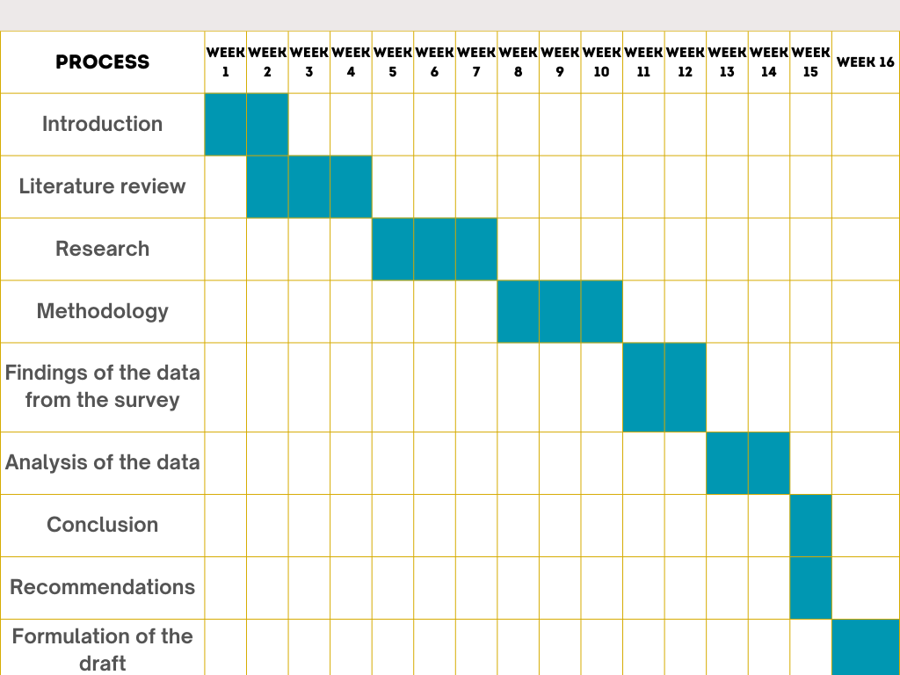

References
Ajzen, I. (1991). The Theory of Planned Behavior. [online] ResearchGate. Available at: https://www.researchgate.net/publication/272790646_The_Theory_of_Planned_Behavior.
Al-Fikri, I. and Roostika, R. (2023). The influence of social media communication on perspectives towards the Samsung brand. International Journal of Business Ecosystem and Strategy. [online] doi:https://doi.org/10.36096/ijbes.v5i3.427.
Alanmi, M. and Alharthi, S. (2023). The Impact of Digital Marketing on Consumer Buying Behavior in Saudi Arabia: Brand Popularity as a Mediator. [online] Available at: https://www.researchgate.net/publication/372039345_The_Impact_of_Digital_Marketing_on_Consumer_Buying_Behavior_in_Saudi_Arabia_Brand_Popularity_as_a_Mediator.
Alhaddad, A.A. (2015). The Effect of Advertising Awareness on Brand Equity in Social Media. [online] ResearchGate. Available at: https://www.researchgate.net/publication/279923917_The_Effect_of_Advertising_Awareness_on_Brand_Equity_in_Social_Media.
Blumler, J.G. and Katz, E. (1974). The Uses of Mass Communications. SAGE Publications, Incorporated.
Bubphapant, J. and Brandão, A. (2023). Content marketing research: A review and research agenda. International IJC. [online] doi:https://doi.org/10.1111/ijcs.12984.
Chaffey, D. and Chadwick, F.E. (2019). Digital Marketing. 7th ed. Pearson UK.
Chopra, A. (2024). The Effects of Digital Marketing on Consumer Behavior Aarav Chopra Student GD Goenka world school. International Journal of Novel Research and Development, [online] Volume 9(Issue 2). Available at: https://www.ijnrd.org/papers/IJNRD2402138.pdf.
Cummins, S., Peltie, J.W., Schibrowsky, J. and Nill, A. (2014). (PDF) Consumer behavior in the online context. [online] ResearchGate. Available at: https://www.researchgate.net/publication/265969362_Consumer_behavior_in_the_online_context.
Fan, X. (2023). Social Media Marketing Strategies. Advances in Economics Management and Political Sciences. [online] Available at: https://www.researchgate.net/publication/373896254_Social_Media_Marketing_Strategies.
Lamichhane, B. (2022). Impact of Digital Marketing on Consumer Behavior in Pokhara. KIC International Journal of Social Science and Management. [online] Available at: https://www.academia.edu/98120698/Impact_of_Digital_Marketing_on_Consumer_Behavior_in_Pokhara.
McVetty, H. (2021). Selling cool: a visual analysis of Apple’s brand identity. www.academia.edu. [online] Available at: https://www.academia.edu/77499784/Selling_cool_a_visual_analysis_of_Apples_brand_identity.
Mundra, L. (2023). How Digital Marketing Affects Consumer Behavior . [online] IIM SKILLS. Available at: https://iimskills.com/how-digital-marketing-affects-consumer-behaviour/.
Nabavi, R.T. and Bijandi, M.S. (2023). Bandura’s Social Learning Theory & Social Cognitive Learning Theory. [online] Available at: https://www.researchgate.net/publication/367203768_Bandura's_Social_Learning_Theory_Social_Cognitive_Learning_Theory.
Petty, R.E. and Cacioppo, J.T. (1986). The Elaboration Likelihood Model of Persuasion. [online] ResearchGate. Available at: https://www.researchgate.net/publication/270271600_The_Elaboration_Likelihood_Model_of_Persuasion.
Rakib, Md.R.H.K., Pramanik, S.A.K., Amran, Md.A., Islam, Md.N. and Sarker, Md.O.F. (2022). Factors affecting young customers’ smartphone purchase intention during Covid-19 pandemic. Heliyon, [online] 8(9), p.e10599. doi:https://doi.org/10.1016/j.heliyon.2022.e10599.
Vladimirov Ivanov, A., Adam, E., Akiba, G., Krasimirov, K. and Jönköping, K. (2021). The Smartphone Consumer Decision-Making Process of University Students in Sweden: The Case of iPhone. [online] Available at: https://www.diva-portal.org/smash/get/diva2:1562253/FULLTEXT01.pdf.
Wrigley, C. and Straker, K. (2016). (PDF) The role of emotion, experience and meaning: the comparative case of Apple and Samsung. [online] ResearchGate. Available at: https://www.researchgate.net/publication/306256355_The_role_of_emotion_experience_and_meaning_the_comparative_case_of_Apple_and_Samsung.
Za, S.Z., Tricahyadinata, I., Robiansyah, R. and Darma, D.C. (2021). Storytelling Marketing, Content Marketing, and Social Media Marketing on the Purchasing Decision. [online] Available at: https://www.researchgate.net/publication/353307526_Storytelling_Marketing_Content_Marketing_and_Social_Media_Marketing_on_the_Purchasing_Decision.

