1700hrs 1ST May PSC 999 CALL TAPE

BURGLARY AT 8 WEST VIEW

Recording of the telephone call

Reporting person Mrs Jayne Evans, reports that she has returned home from work and has found that she has been burgled.
She reports that someone has entered the house through the kitchen door and has made an untidy search of the house.
Mrs Evans doesn’t believe there is anyone still in the house.
Operator tells Mrs Evans that a unit will be with her as soon as possible.



1

Dwelling Burglary at 8 West View

1700hrs 1st May Mrs Jane Evans of 8 West View returned home from work to discover that her home had been burgled. She had left for work at 0800hrs that morning leaving the premises secure.

PC 4343 Jones, response officer, attended initial call, recorded crime details etc. The burglar had entered through rear kitchen door and before carrying out an untidy search of premises.
Following items were stolen;
- Approx £300 in cash – various denomination notes from kitchen draw and bedroom dressing table.
- Gold ring (identifiable)
- Sapphire engagement ring
- Ingot pendant

CSI Jenny Bridges attended and photographed a footwear mark recovered kitchen floor POE. JB/1. A number of fingerprints were lifted all but 3 have been eliminated.

OEL – lists all house to house enquiries



2

Attended initial report of Burglary at 8 West View

Reporting person Mrs Jane Evans 8 West View

Description of scene Initial account of IP:
1700hrs 1st May I/P returned home from work to discover that her home had been burgled. She had left for work at 0800hrs that morning leaving the premises secure.

The burglar had entered through rear kitchen door and before carrying out an untidy search of premises. Following items were stolen;
- Approx £300 in cash – various denomination notes from kitchen draw and bedroom dressing table.
- Gold ring (identifiable)
- Sapphire engagement ring
- Ingot pendant

Initial house to house at neighbour – no reply. Area search – negative
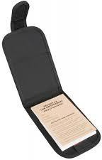

3

West View and Main Road

0730hrs to 1700hrs 1st May

Male fitting Jevens description seen leaving West View at 1400hrs 1st May

Red t-shirt, blue jeans, trainers

Male turned left away from direction of Town Square – no further CCTV coverage

Exhibit Reference: MW/1

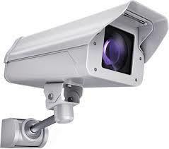

4

8 West View Complied by IP Mrs Evans

- Approx £300 in cash – various denomination notes from kitchen draw and bedroom dressing table.
- Gold ring (identifiable)
- Sapphire engagement ring
- Ingot pendant



5

Statement from Mrs Eves

Occupier 1 West View who saw a male walking from West View to Main Road at 1400hrs 1st May

Evidence:
Description of person: not able to identify face Description of clothing: red t-shirt, blue jeans, thinks wearing trainers

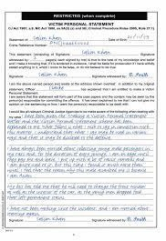

6

Attendance at 8 West View 1st May

Footprint recovered at POE Various Fingerprints lifted from a number of
locations within premises.



7

CSI

Statement regarding footmark recovered at 8 West View.

Describes mark and process of recovery and photograph.



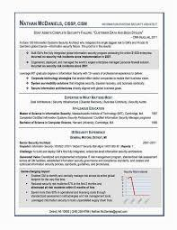

8

Photograph of footwear mark From 8 West View

Produced by CSI Jenny Bridges Exhibit Reference: JB/1

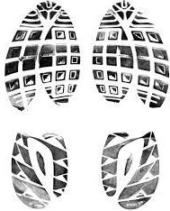

9

Injured party

Mrs Evans 8 West View

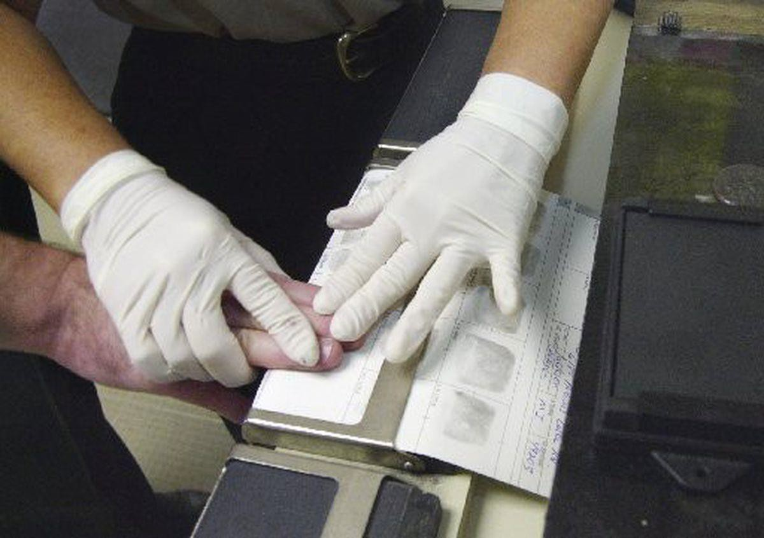

10

48 finger marks lifted from the scene at 8 West View.

39 marks identified as matching occupier.

6 marks identified as PC 4343 Jones – first officer at scene.

3 unidentified marks – recovered from kitchen worktop not POE.

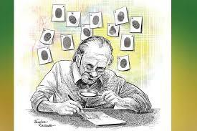

11

Statement from burglary victim Mrs Evans

Describes:

Leaving for work at 0800hrs Arrives home 1700hrs Damage to rear door Lists property stolen (Cash and Jewellery)

Identifies exhibits S/1, S/2, S/3 as her jewellery Victim Impact Statement

12

Grade - B2P

Jason Jevens, nickname Creeper, responsible for breaking into a house on 1st May and stealing cash and jewellery.
Jevens still has jewellery at his home address.

Originator – LIO

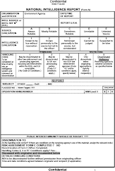

13

Jason Jevens
H/A Flat 5 Lower Terrace

Pre-cons

June (last year) – possession Cannabis – fine

Nov (2 years ago) – dwelling burglary – 6 months imprisonment



14

Flat 5 Lower Terrace H/A Jason Jevens Dated 5th May
Intelligence case details the 3 intelligence reports regarding Jevens.

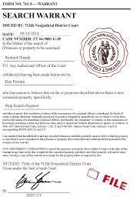

15

Flat 5 Lower Terrace H/A Jason Jevens Dated 6th May

16

warrant at Flat 5 Lower Terrace H/A Jason Jevens
Dated 6th May

Lists jewellery recovered by DC Smythe- Gold ring S/1
Sapphire engagement ring S/2 Ingot pendant S/3
And
Trainers recovered from Jevens at time of arrest by DC Underwood DU/1

PC 567 King

17

Statement of searching officer DC 897 SMYTHE

Recovery of; Gold ring S/1
Sapphire engagement ring S/2 Ingot pendant S/3

18

Statement of DC 312 Underwood

Investigating Officer Arresting Officer
Recovered trainers from Jevens at time of arrest DU/1

Identification of jewellery by IP S/1, S/2, S/3 Interviewing officer
Charging officer

19

- Pair of trainers DU/1
- Photo of Footwear mark from crime scene JB/1
- Gold ring S/1
- Sapphire engagement ring S/2
- Ingot pendant S/3
- Copy of Council CCTV covering junction of West View and Main RoadMale fitting Jevens description seen leaving West View at 1400hrs 1st May- MW/1


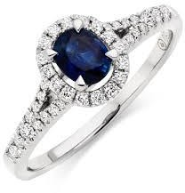
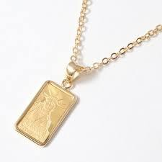




20

Jason JEVENS

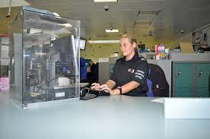

21

Jason Jevens

During interview he stated the following;

  - He didn’t know anything about the burglary
  - He may have been in West View as it was a short cut to town Square
  - No knowledge of jewellery found in his flat
  - He has lots of people back and forth to his flat
  - The trainers had been left in his flat by one of these many visitors and he had only been wearing them for 2 days.

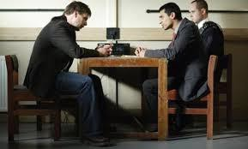

22

Jason Jevens

Charged with Burglary

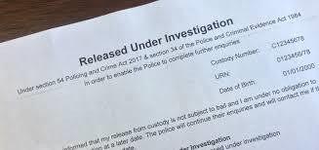

23

Notes made by DS Louise BLAKE

During interview of Jason Jevens

24

DC Underwood blue note book recording actions taken re burglary at
8 West View



25

MG11

Forensic Scientist

Positively identifying Footwear mark recovered at
8 West View matching the trainer recovered by DC Underwood DU/1

26

Property Store Register

Entry no. 125/AA

Lists

- Copy of Council CCTV covering junction of West View and Main Road MW/1
- Gold ring S/1
- Sapphire engagement ring S/2
- Ingot pendant S/3
- Trainers recovered from Jevens at time of arrest by DC Underwood DU/1



27

Evidence

28

Unused Material

29

Relevant

30

Non Relevant

31

MG 6C

32

MG 6D

33

MG 6E

34

