Class Charts
Resource Pack

Contents Page
What is Class charts? ……………… Page 3-9
Theories……………………………. Page 10 – 11
Rationale …………………………...Page 12
Instructions for use …………………Page 13
Reference List……………………….Page 14

What is Class Charts?
Class Charts is a resource that is used in many different schools across the United Kingdom and possibly further. This resource has many different benefits and uses, that most schools would not know about, unless they use this resource within the school. As well as promoting positive behaviour, Class charts can provide children with the necessary tools to keep themselves organised and motivated when they are in school. However, this resource is also available to parents in order to stay updated on what they are doing in schools, whether they are doing well, or are struggling in certain areas, as well as being able to see their children’s timetable whilst they are in school. (Alec Reed Academy, No Date)
As mentioned above we first have the benefits of being able to view a child’s behaviour in a whole view. This is due to the fact that teachers are able to add positive points for children and what they have accomplished during their day, whilst also allowing for negative points and adding comments on what exactly has happened, therefore allowing parents and students to understand why they have received those negative points.
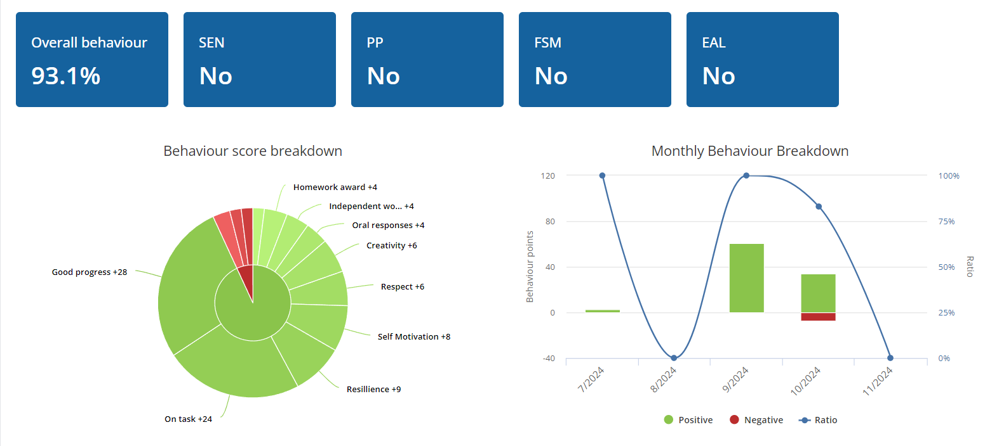

Next, we have the ability to view a child’s attendance, in terms of whether they have attended school. As well as whether or not they have attended their lessons whilst being in school, which then allows us to notify parents of any absences.


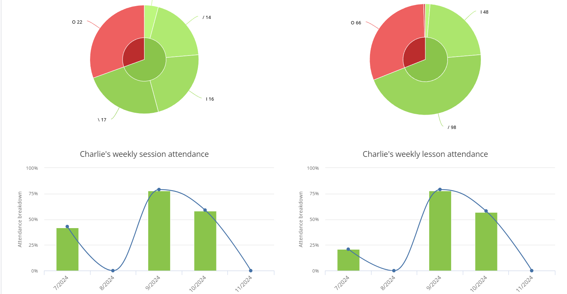
Class charts also allows for teachers to assign homework, which in turn makes the homework accessible to parents. Allowing parents then to encourage their children to get the homework completed by the due date, or even help their children complete it if there is something they are not sure about what they must do to complete their work.
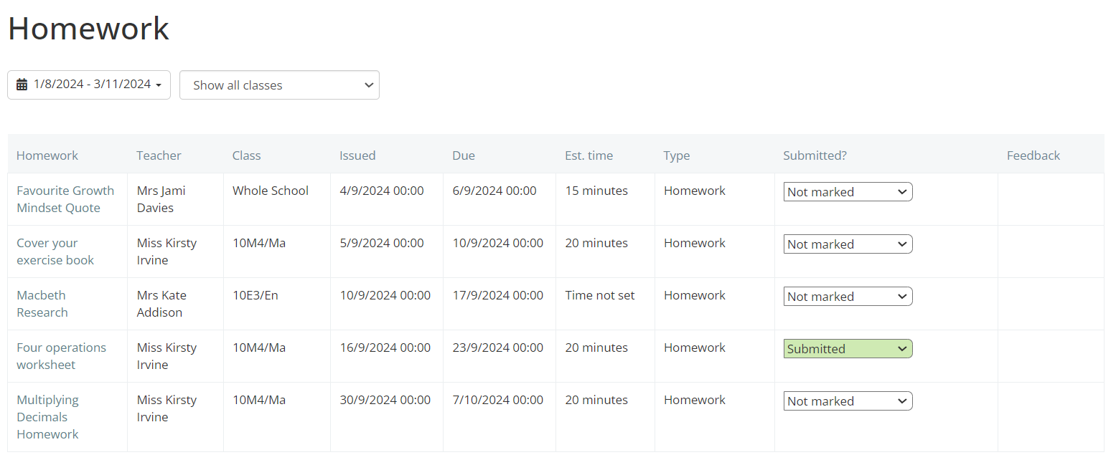
Another section within a pupil’s profile, includes an activity page. The activity page on class charts allows teachers and parents to view the positive points or negative points a child may receive. As well as the notes that can be attached to any positive or negative points and who gave them, whilst also showing them all throughout the day on one page.
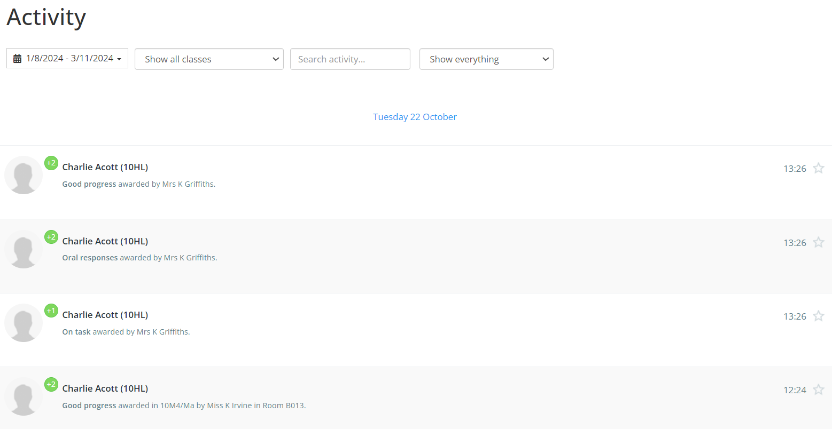
On class charts we are also provided with a list of classes, along with information about said classes. First we are told what set a student is in dependant on the number, then there is the name of what subject the child is in. Paired with what room number a child is in, as well as what teacher is teaching them in a certain subject.
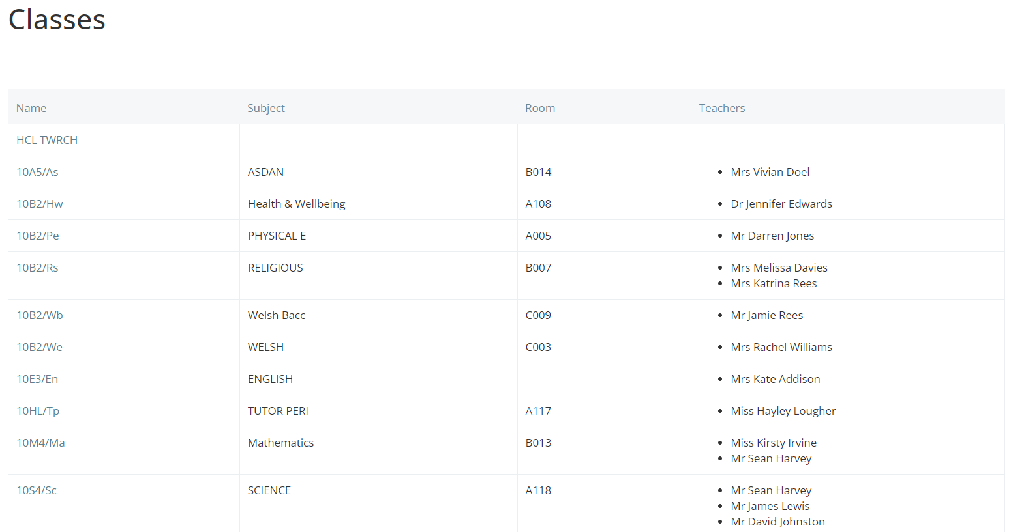

Next, we have a page that shows when and where a student has been given detention. As well as what detentions have passed, which ones they may have on a regular day in school, future detentions that are planned. Whilst also showing us what ones were missed and which ones have been left unscheduled.
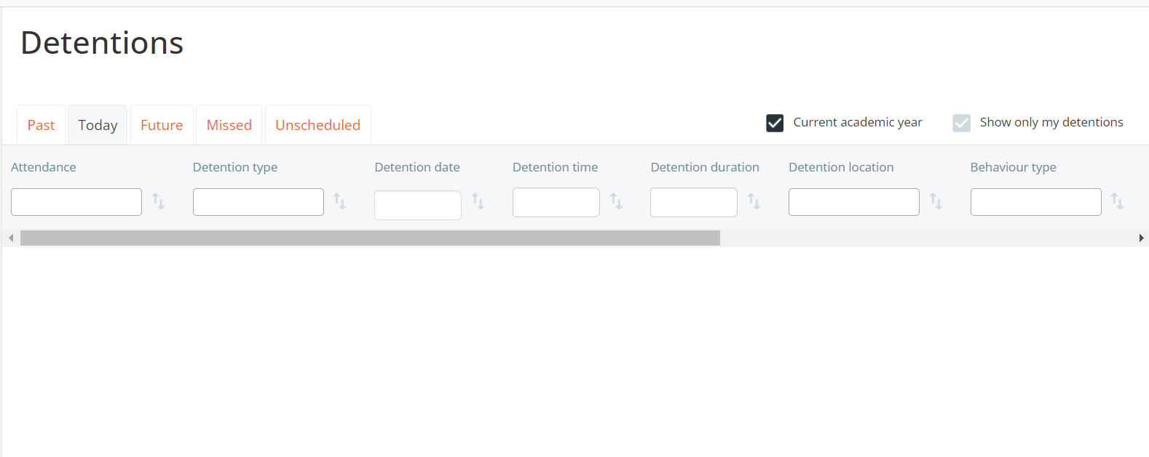

As mentioned above, all Teachers, Students and Parents are able to view the timetable to determine what lessons they have on certain days. And more often tha not many student tend to use class charts for this purpose alone, as they find it much more conveniant than a paper copy.
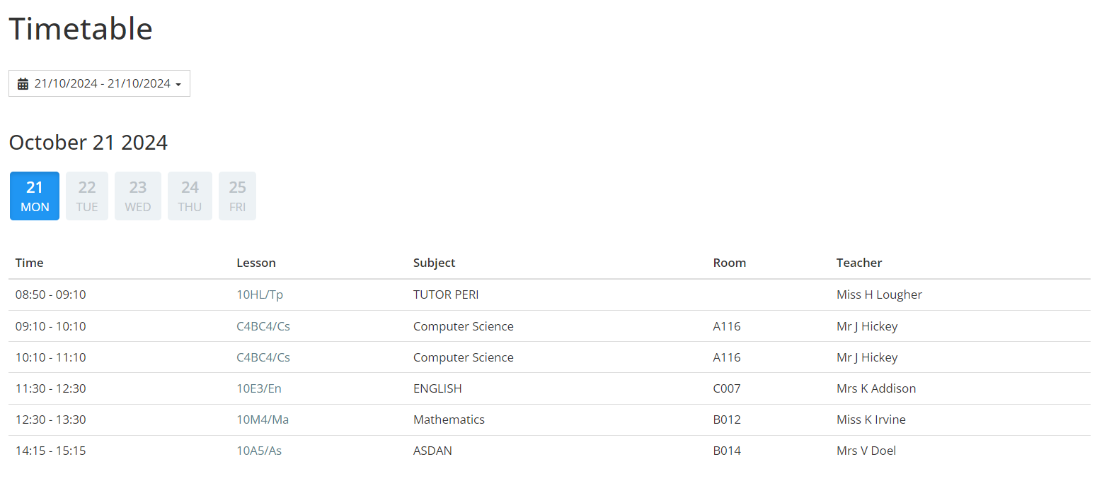
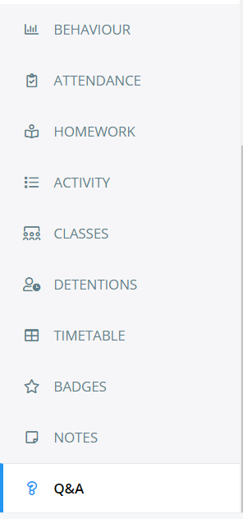
Now that we have gone through most of the pages on a
students profile. We have three more tabs, one for badges and
achievements that students earn. Notes for teachers to post,
whether that be for homework assignments or updates for any
school trips and such.

Although, we have gone through what is included in a students documents page. We have not yet looked into the main page on class charts, as it does have ssimilar tabs to a students profile however, there are differences. On the main page we are able to find different classes that a teacher may have created, in order to provide positive points to multiple children at one time. When clicking on to these classes, we are able to assign a room for the class and therefore assign children seats within the class.
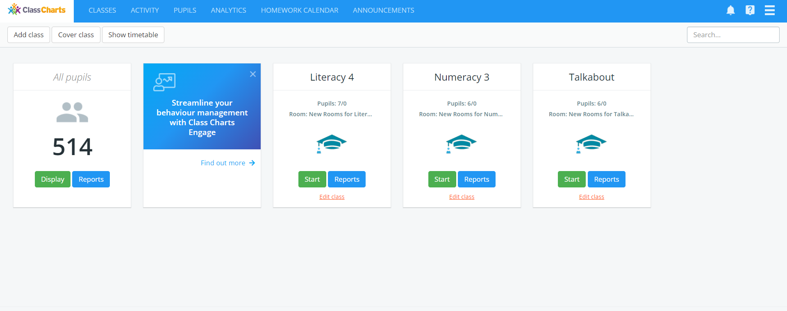
Next we then have the activities tab, where teachers are able to view activity of any positive and negative points that could have been made. The newest and most recent points appear at the very top, with previous positive or negative points being pushed further from the recent ones.
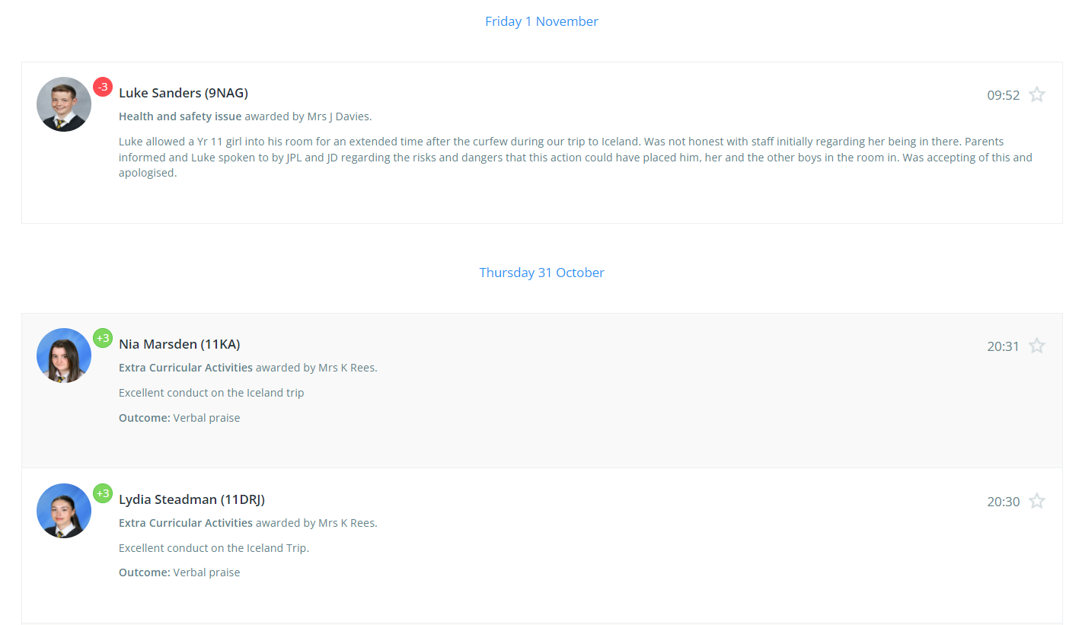
Next, we have a pupils page where we are able to search for pupils to access any documents that are needed. As well as this we are able to see certain imformation just from searching a pupils name, such as the gender of the child. What form they are in, what year they are in, what house they are in for school events, their ID’s, behaviour points and lastly, how many points they are able to spend in the class charts shop.
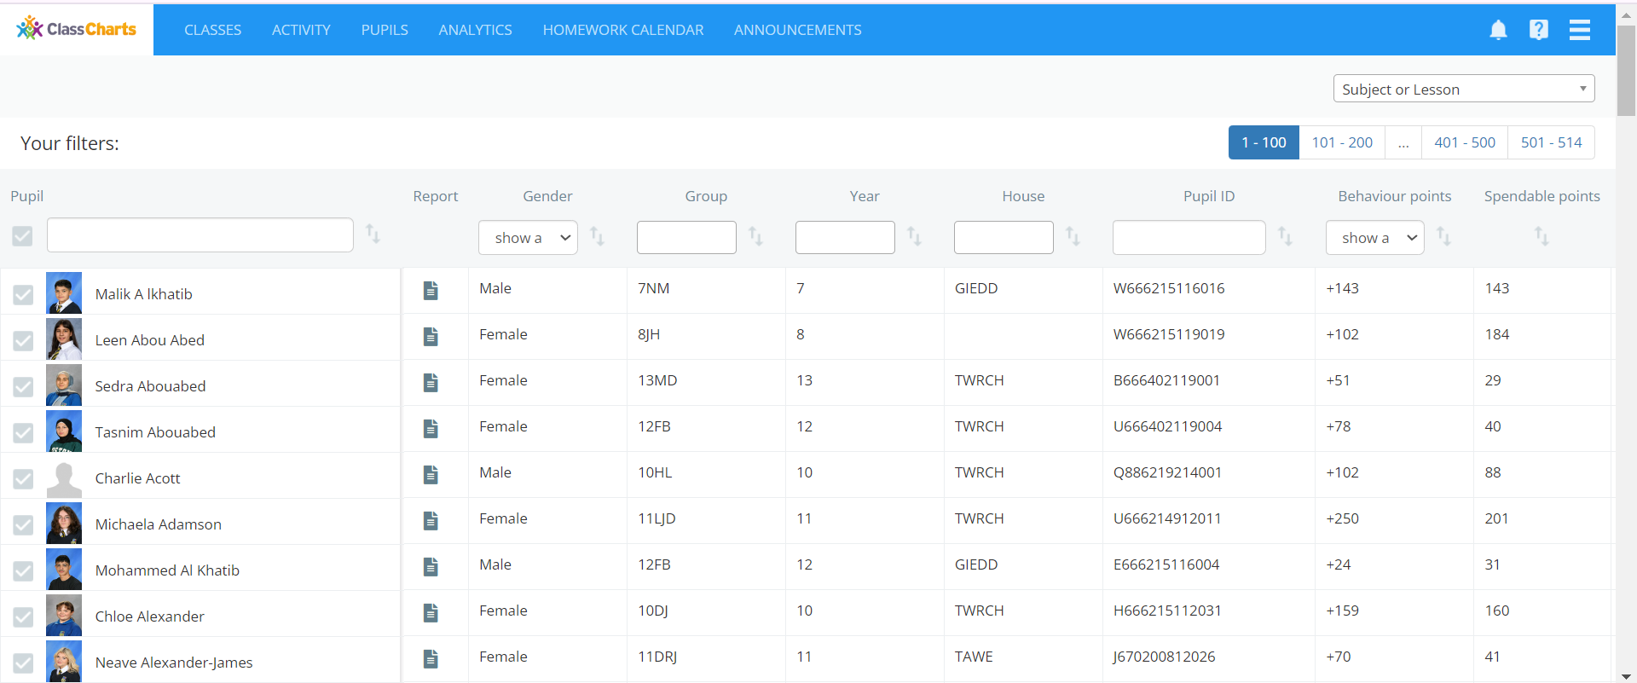

In our next tab, we have a homework calander, where we are able to view a list of the different homework tabs that have been set for children. A calander for viewing in a simple manner, which homework tasks are due on certain days. As well as a tab for templates, this 8involves any homework tasks that include a template that could help children to complete their homework.
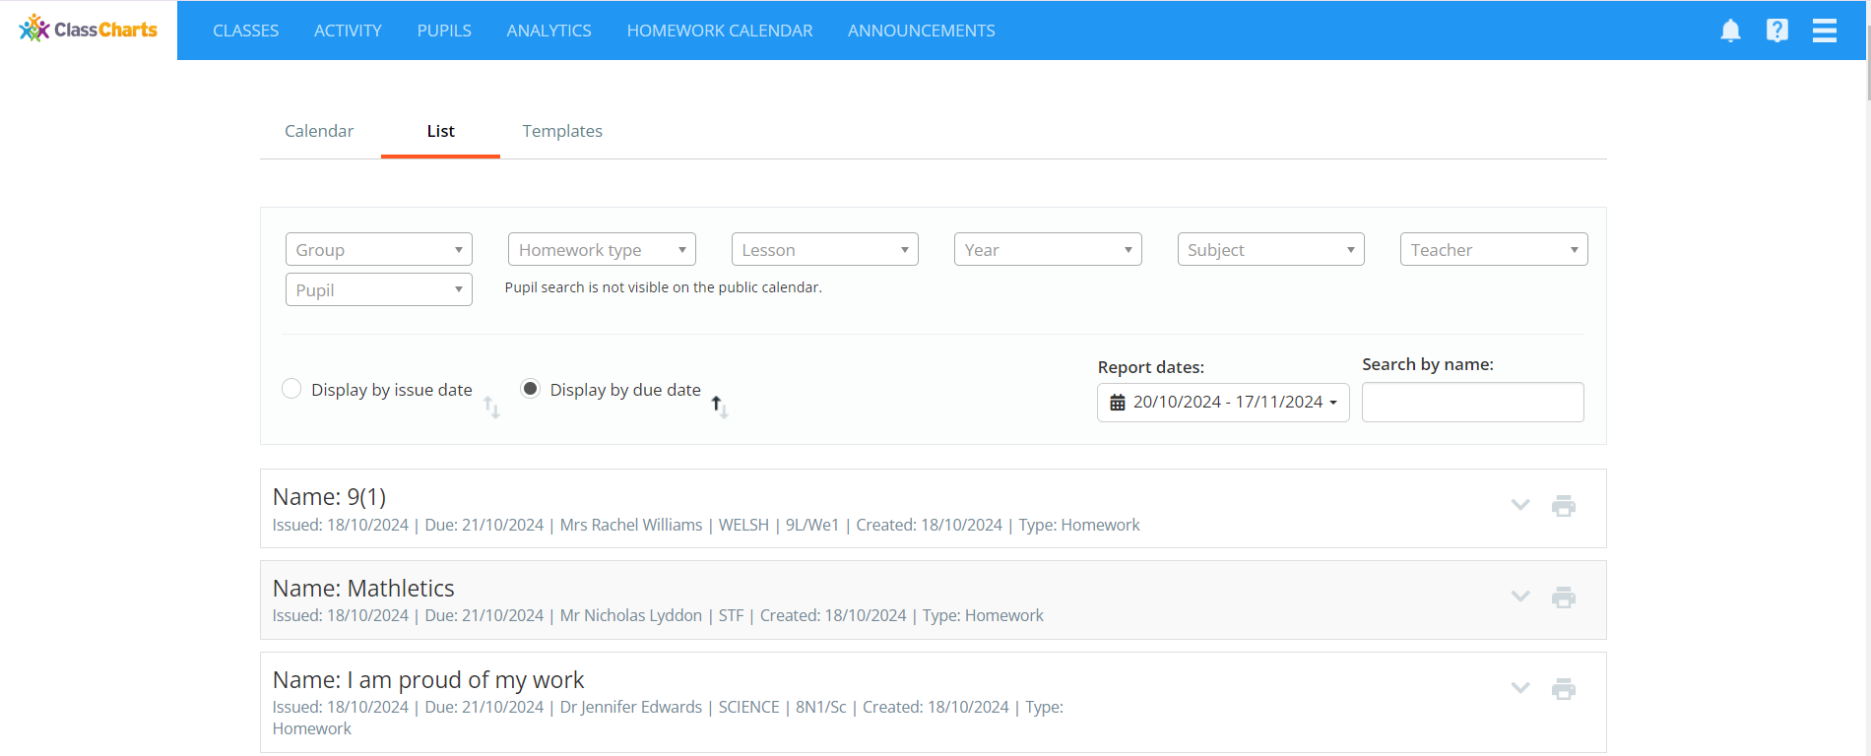

And last but certainly not least, we have the last tab which allows teachers and the school to post any important announcements that both students and parents ought to know as soon as possible.
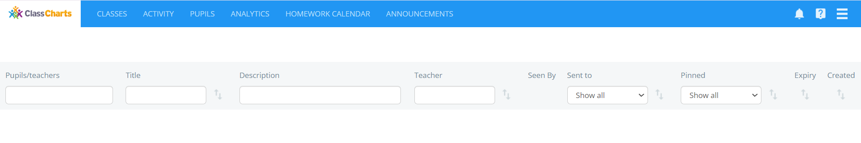
Although Class charts is mostly used for behaviour and providing children with positive and negative points. As is clearly shown, it is also used as an important educational tool as it allows us to communicate with all parents about any homework a child has. As well as being able to inform parents of any absences in lessons when a parent has sent their child into school, or even if a child has not shown up to school. All in all this resource allows schools to communicate effectively with parents and carers.

Theories
Although Class charts does not follow a specific theory, it does however tie in with 2 different theories that are quite popular. These include, B.F Skinner and his Positive reinforcement model, whilst also looking into the theories behind seating plans. And what their benefits are?
B.F Skinner was known for his theories around behaviour, for example skinner found that there was power in using positive reinforcement within education. It was proposed that “ A response is strengthened by reinforcement, as it increases the likelihood that a desired behaviour will be repeated again in the future” (Main, 2023) As well as this Skinner suggested 5 steps that could be taken to execute change in behaviour. The first step that was suggested to be taken was setting a goal dependant on the behaviour a teacher would wish to see in their students. Step 2 would be to come up with rewards or things to encourage children to behave in a positive way rather than negatively. Our third step would be to choose the techniques that could possibly change behaviour within the class. During the fourth step a teacher would be implementing the techniques chosen and recording the progress of the technique. The last step would be to evaluate the techniques that were used and make any changes that are deemed necessary. (Main, 2023)
When researching this model there are contradictory opinions on whether Skinner’s theory has positive effects or not. As Main in 2023 mentions after an explanation of the model, it was also said that the theory had not had any proven positive effects (Main, 2023) However, again there are others that say that there are positive aspects as practitioners are able to use the theory to earn the desired behaviours that practitioners wish to see from children. (Early Years TV, No Date)
It is clear that some research has been conducted in terms of seating plans and whether or not they are beneficial to school, although we have not quite been able to determine where this theory stems from. As Busch has said, “Recent studies have found that it does, with students behaviours and academic performance improving with a better seating plan” (Busch, No Date)
Therefore, why is a seating plan so important? A seating plan is certainly not something easy to create, as teachers need to determine who are the best people to sit together during classes. Some of the benefits that have been proven include students being able to keep their focus on the work they have to complete during their lessons. It improves positive behaviours within an academic setting, for example a student raising their hand when they are in need of support. Lastly, students are able to experience better relationships with other students their own ages, whilst also allowing for group work to run smoother as they are used to working next to each other. (Busch, No Date)
There are also many different types of seating plans that can be used. One seating plan that I have researched would be arranging the desks in rows, this allows for structure and keeps the classroom in an organised manner. It also has been proven that students tend to respond well to this seating plan, as it improves a students focus from 35% to 70%. This seating plan especially beneficial for children with Additional Learning Needs (ALN) as it decreases the possibility of distractions. (Busch, No Date)
We then have a seating plan that involves grouping the students, this type of seating plan improves the quality of work that is completed, whilst also encouraging group work during lessons, as well as promoting brainstorming when completing the work. However, it has been said that due to children sitting close to each other they become more sociable and this can lead to disruptions during lessons. Lastly, we have the semi-circle seating plan, this includes the tables and chairs being moved into a U shape. This seating plan was proved to encourage students to be more interactive, which leads to more questions being asked during lessons, as it allows children to face each other whilst also providing the teacher with flexibility. However, similar to a group seating plan, there is a possibility for children to become disruptive, although it is easier in a U-shaped seating plan to obtain attention as the children are still facing the teacher. (Busch, No Date)

Rationale

I have chosen to look into this resource in more depth, due to the fact that it is a resource that I must use in my every day life when working in a school. We use this resource in every aspect, as we do our best to communicate as effectively as possible with the parents or carers of the students within our school. In my own experience I have also observed that many children dread the thought of a negative point on their account as there tend to be consequences made from parents. As well as this we also use it to gain prom points for the year 11s, therefore positive behaviour is promoted as they wish to go to prom.

Instructions for use:
- Creating a Class: Log into class charts – click on new class – choose the pupils within the class – select a name – select a room (If applicable) – click save
- Awarding positive point: Log into class charts – click on all pupils – search for pupil – choose positive point – make note (if applicable)
- Awarding negative point: Log into class charts – click on all pupils – search for pupil – click on negative – choose negative point – make note (If applicable)
- Setting Homework: Log into class charts – click on the class – click on homework – fill in all information – Publish homework.
- Viewing Pupil’s documents: Log into class charts – click on pupils – search for pupil – click on document shaped icon.

Reference List:
Alec Reed Academy. (No Date) What Is Class Charts. Available at: https://www.alecreedacademy.co.uk/page/?title=WHAT+IS+CLASS+CHARTS%3F&pid=242#:~:text=Class%20charts%20is%20used%20to,View%20assigned%20homework%20tasks%E2%80%8B (Accessed: 01/11/2024)
Busch, B. (No Date) The Psychology Behind a Great Seating Plan. Available at: https://www.innerdrive.co.uk/blog/psychology-of-seating-plans/ (Accessed: 01/11/2024)
Class Charts. (2024) Class Charts. Available at: https://www.classcharts.com/ (Accessed: 01/11/2024)
Early Years TV. (No Date) B.F Skinner: Operant Conditioning and Behaviourism Theories. Available at: https://www.earlyyears.tv/b-f-skinner-operant-conditioning-and-behaviourism-theories/#:~:text=Positive%20reinforcement%3A%20Practitioners%20can%20use,approximations%20of%20the%20desired%20behaviour. (Accessed: 02/11/2024)
Main, P. (2023) Skinner’s Theories. Available at: https://www.structural-learning.com/post/skinners-theories#:~:text=There%20is%20very%20little%20evidence,in%20his%20operant%20conditioning%20theory. (Accessed: 02/11/2024)

