University of Wales Trinity Saint David


Wales Institute of Science and Art

Engineering Materials
Materials and Manufacturing (ACHA4025)

Dafydd Pughe
2401243
Date (04/2026)
Word Count : 2054

Contents
1. Introduction: 1
2. Literature review: 2
3. Methodology 3
4. Test results 5
4.1. Equations used 5
4.1.1 Force 6
4.1.2. Extension 6
4.1.3. Stress 6
4.1.4. Nominal Strain 6
5. Analysis 8
5.1. Yield Strength 9
5.2. Ultimate Strength Test 10
5.3. Young Modulus. 10
6. Conclusion 11
7. References &/or Bibliography 12
7.1. List of Figures 13
7.2. List of Tables 13

Introduction:
This report presents an engineering problem that needs investigating to discover the root of the problem on how the part has failed. The situation consists of a failure with the driveshafts on both Dakar rally in which cars have broken, although the driveshafts have been manufactured using detailed and well research design specifications and also testing. The aluminium supplier has introduced uncertainty regarding the material supplies. The driveshafts on these vehicles are known to be made out of aluminium alloy, however the specific grade and temper of the material and unconfirmed.
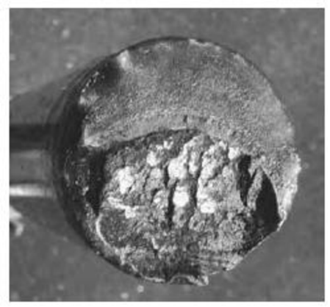
Figure 1 - Image displaying the failed material
The image above displays the failed driveshaft of the vehicles. (Rogers, 2026). By running a tensile test on a material sample will help determine key mechanical features such as yield strength, ultimate strength and young modulus. The results of the test will be analysed with the known operational stress conditions. Due to the Dakar rally being one of the most demanding motorsport events, the mechanical parts on the vehicles and under constant stress such as uneven surfaces, rocky and sandy terrain, also sand dunes which could result in pressure on the parts. By having these characteristics in the event, durability in parts is essential but when the cars reached stage 4 and 5, the parts gave way.
The findings of the testing will be investigated to try and discover the real reason behind the failure of the driveshafts. By investigating the results, the correct changes could be made such as material specification changes, improved quality control procedures and design modification as preparation for the next event.

Literature review:
A driveshaft for a Dakar Rally vehicle doesn’t necessarily have be made out of the strongest metal, there are a lot more factors that need to be considered for them. Fatigue strength one of these factors. The material must survive the peak torque that the engine is producing but also much have the strength to handle the shock loads for the duration of the event. Fatigue strength is the materials ability to withstand constant load and unloading cycles without failing, with Dakar rally being held in deserts and the whole vehicle being on a constant uneven surface the materials that are chosen for the vehicle should be able to deal with any surface. (Tjong, 2003). There are many different ways that the material can be tested for fatigue strength, one way of testing is the low cycle testing. This conducts at high stress level to determine how much stress the material would have to undergo in order to brake (Costa, n.d.). This test is a good test for parts of a Dakar car as it tests high stress but at low amount of cycles representing shock loads and heavy impacts.
Another factor to be considered is that the material chosen has a high ductility. This factor is important to have, considering the surface that is being driven on. By having a high ductility, the material will not snap when absorbing energy. With the Dakar road being full of rocky surfaces and sand dunes, these impacts would create a shock load through the wheels which could have an impact on the driveshafts of the vehicle. By having a high ductility material as a driveshaft, the risk of having a problem with constant shock loads will be reduced. By having high ductility, the material can absorb the energy load and can also undergo plastic deformation without the part braking (Chemical Times, 2025), this is important for a part such as a driveshaft because the driveshaft rotates and flexes during operation and whilst undergoing stress through the event. Ways to test for increased toughness material is do proceed a impact test, by applying sudden force onto the material during the impact test it will be clear to see how the material takes the shock during impact and see the reaction of the material. (Smith, 2024).

Methodology
The procedure of the experiment was carried out using a TecQuipment Tensile Tester Kit to measure the strength of the materials. The first step that needed doing was constructing the testing kit together, by following the guidance notes given the construction was easy to understand the procedure of the experiment that was being carried out.
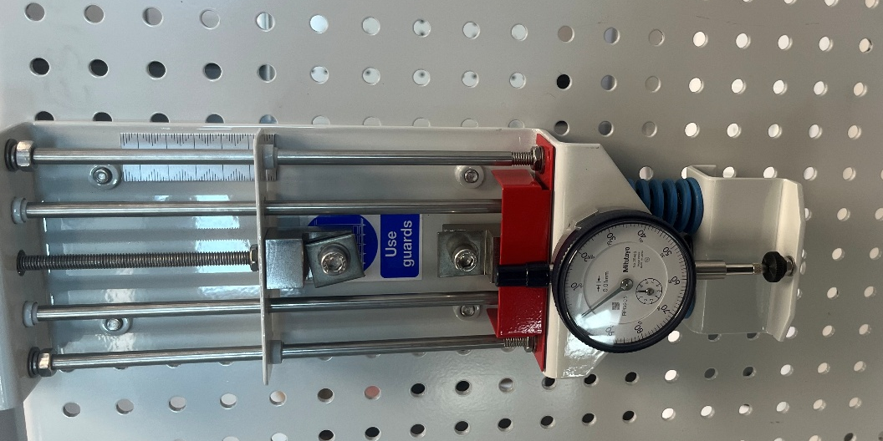
Dial Indicator
Top and Bottom Chuck
Figure 2 - Image displaying the equipment used
As seen in figure 1 above, the material that was testing are connected top and bottom chuck that keep the material in position during the test. The dial indicator had to be adjusted to 0 before starting the experiment to provide accurate results. The dial indicator provide the reading of the stress that the piece of material is going through when extended . To extend the force of the material, the load nut on top of the equipment is turned 2 increments. 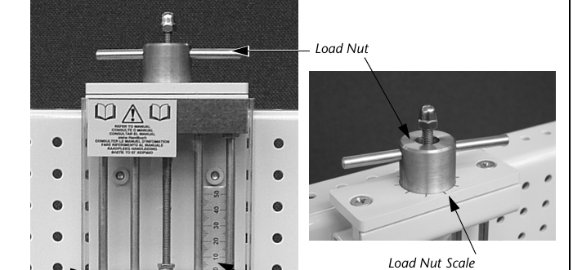
Figure 3 - Image displaying Load Nut and Scale
By using the Load Nut Scale in figure 2 (TecQuipment, 2012), each increment of the cale is measured to 0.1mm of extension on the materials. Meaning for the experiments the load nut must be turned 2 increments to provide the correct reading for the experiment. All of the steps above were provided in the guidance notes made by TecQuipment. (TecQuipment, 2012).

Test results
Table 1 - Table of Results
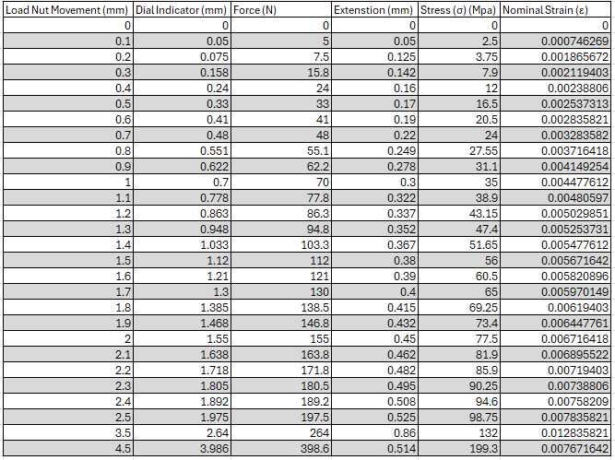
Table 2 - Additional figures for calculations
The table above displays the test results following the tensile test. In the lab, the only measurement that was recorded was the load nut movement and the dial indictor, both measured in mm. Using both of data columns, the following set of data could be calculated.

Equations used
To get the values for force, extension, stress and nominal strain, there were calculations that were used for the values.

4.1.1 Force
To get the value of force, using the value of the dial indicator that was recorded in the lab session, the value got multiplied by 100.
$$Force=Dial Indicator ×100$$

4.1.2. Extension
To determine the value for the extension, using the value of the load nut movement and the dial indicator, taking away those values from each other gave to value for extension of the material.
$$Extension=Load Nut Movement-DIal Indicator$$

4.1.3. Stress
To get the value for stress, using the value of force and the value of the Cross Sectional area.
$$Cross Sectional Area=Gauge Length ×Width ×Thickness$$
By dividing the value of force and the cross sectional area, it gave the value for stress.
$$Stress=Force ÷Cross Sectional Area$$

4.1.4. Nominal Strain
To determine the value for nominal strain, using the values of the extension and the length of the aluminium specimen, dividing both values with each other gave the value for nominal stress.
$$Nominal Strain=Extension ÷Length of Speciman$$

Figure 4 - Graph displaying Strain against Stress
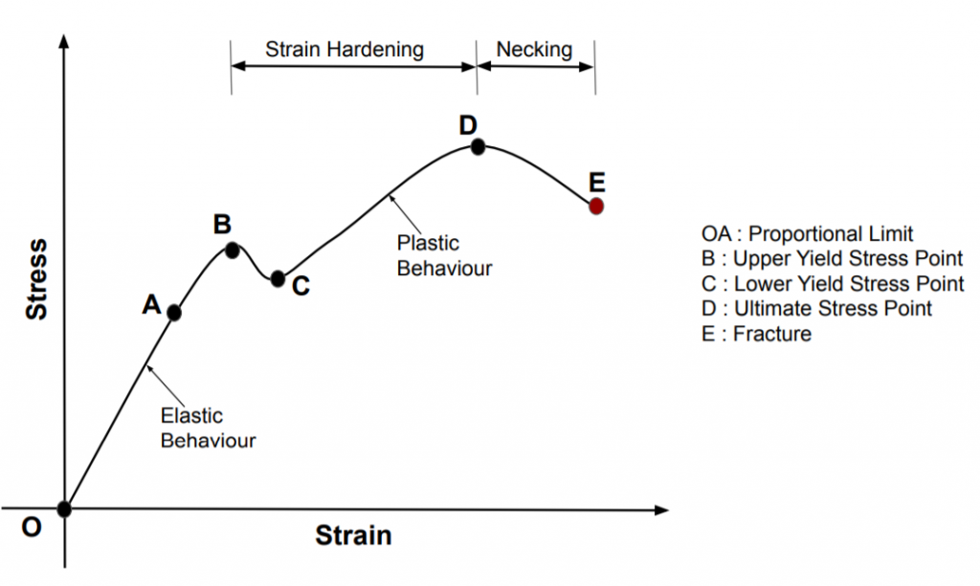
Figure 5 - Stress strain graph

Analysis
By looking at figure 4, the graph represents the results that were measured in the lab and calculated. Comparing figure 4 and figure 5, there isn’t a clear similarity between both the graph. There is no clear point regarding the yield stress points and proportional limit. By not having clear points, this could indicate that the results measured in the lab wasn’t accurate due to the mistakes made while testing. By looking at the graph in figure 4, its clear to see where the material was under the most strain when reaching 3,5 mm on the load nut and under 264 Newtons of force. After reaching the peak of strain, the strain the reduces when under the peak amount of force which was 396.6 Newtons.

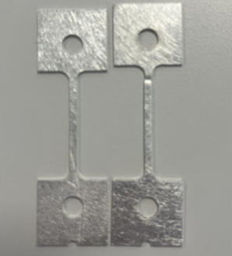
Figure 6 - Image displaying the result of a tensile test
In figure 4, above, its clear to see where the piece of aluminium failed the tensile test and snapped. By having a tensile test, its easy to discover weak points in the material due to the constant force that the material is being pulled apart from. (wfhanyong, 2025). By comparing the material on the left, before tensile test, to the material on the right, after the tensile test, its clear to see that the piece snapped below where the material is clapped onto the top chuck.
Due to a miscalculation that was made during the experiment, the results were changed from 0.2 mm increments to 0.1 mm. This mistake will have some difference in results due not performing the experiment 100% correctly.
From 0.1 to 1mm load nut movement, the increasement in force raised to 70N and resulting in 0.3 mm of extension of material. Stress on the material raised to 35 n/m² with a steady increase from the 0.1 mm. Nominal strain reached 0.00447 from 0 during these changes. During these increments, the material extended 0.3 mm. Increments from 1.1 and 2 mm had a similar result with the force more than double after reaching 2mm, the force measured was 155N. There wasn’t a vast amount of extension between 1 and 2 mm of load nut movement from 0.3 mm to 0.45 mm, increasement of 40%. The nominal strain raised to 0.00671 with a 40.7% increase. Stress increased to 77.5 N/m² during the increment increase. 2 mm to 2.5 mm had a similar increase in results with the force increasing to 197.5N with stress increasing to 98.75 N/m² . From 2mm to 2.5 mm in load nut movement, the material extended from 0.45mm to 0.525mm.
After reaching 2.5mm in load nut movements, there was an increase between reach test reading, raising from 0.1 mm increments to 1mm. During the movement between each reading, the load and stress would have a big part in seeing the material brake with there being less time between each reading and a bigger movement in each reading. From 2.5 mm to 3.5 mm, the force reading reached 264 N which was a 30.7% difference with stress level reaching 132 N/m². Nominal strain level reached 0.0128. The extension of the material reached 0.86mm during this reading. During these difference in load nut movement, the material extended from 0.525mm to 0.86mm. The final reading of the experiment was 4.5 mm of load nut movement as the material snapped between these readings. The force that applied for the material to snap reached 398.6 N and a stress level of 199.3 N /m² which was the peak level of stress the material could take.

Yield Strength
The yield strength of the aluminium came to 60-65 MPa, by using the values just before the offset line, being 0.00582 and 0.00597. By finding these values on the graph, the yield strength comes to 60-65 MPa. By comparing the results that were calculated to results that were found on the website DSW diecasting, the yield strength for aluminium that are used on automotive parts come to 200-350 MPa, (Zhangjiebo, 2025), showing that the results that were measured and calculated are very low in comparison.

Ultimate Strength Test
The ultimate strength test results came to 103.69 calculating using the equation of maximum force/cross sectional area. The aluminium alloy strength ranges from 69 to 570 meaning that the results calculated are in the mid range of these results. (Matmake, 2025).

Young Modulus.
By using the graph (figure 3), using the value of the linear trendline, the young modulus can be calculated. The young modulus result came to 14239 GPa, comparing to young modulus reading of aluminium, the result was that calculated using the test results wasn’t close. The reading of aluminium normally comes to 70 which is a big difference in between (Amesweb, 2013). A factor to be considered in the results is that there was a mistake that took place when measuring in the lab which could interfere with the results calculated.

Conclusion
To conclude, by comparing the results that were taken and calculated from the lab, there are difference in results. The value with the biggest difference when comparing is the young modulus result where the different is major. By using a range of results to compare the ultimate strength, the value that was measured in the lab fitted in the range. The results for the yield strength are very low in comparison. Meaning that the mistake that happened during the lab session could’ve impacted the results massively with a vast difference in many of the data.
The driveshaft failure was caused by a fatigue failure, due to the vehicle having a repeated torsional load while driving on extreme off road conditions. The driveshaft is under constant variations of torque while driving due to uneven terrain and shock loading which can cause cracks which will grow overtime to a final fatigue failure.
To prevent similar circumstances in the future, factors to consider is material change and design change to make the driveshafts stronger and being at a lower risk to fail during a event. A change in material would benefit the part to make it stronger and more durable during the hard driving on extreme conditions. High strength alloy steel would be a good change due to the alloy steel having a much higher fatigue resistance and toughness, also a more predictable behaviour when failing. (SSL, 2025).

References &/or Bibliography
Amesweb, 2013. Amesweb. [Online]
Available at: https://amesweb.info/Materials/Youngs-Modulus-of-Aluminum.aspx
[Accessed 20 04 2026].
Chemical Times, 2025. Chemical Times. [Online]
Available at: https://chemicaltimes.in/2025/03/23/shock-resisting-steels-properties-importance-and-applications/
[Accessed 23 March 2025].
Costa, M. M., n.d. Biopdi. [Online]
Available at: https://biopdi.com/fatigue-testing/
Matmake, 2025. Matmake. [Online]
Available at: https://matmake.com/properties/tensile-strength-of-aluminum-alloys.html
[Accessed 20 04 2026].
Rogers, K., 2026. Materials_and_Manufacturing_CW_2025_26, s.l.: s.n.
Smith, G. M., 2024. DEWEsoft. [Online]
Available at: https://dewesoft.com/blog/impact-testing-explained
[Accessed 17 September 2024].
SSL, 2025. SSL. [Online]
Available at: https://www.ssl-cvjoint.com.tw/blog/data/comparing-advanced-driveshaft-materials?
[Accessed 21 4 2026].
TecQuipment, 2012. In: Engineering Science Guidence Notes Tensile Tester Kit KS6. s.l.:s.n., pp. 7-10.
TecQuipment, 2012. In: Enginering Science Guidence Notes Tensile Tester Kit KS6. s.l.:s.n., p. 8.
Tjong, M., 2003. Science Direct. [Online]
Available at: https://www.sciencedirect.com/topics/materials-science/fatigue-strength-of-metal
wfhanyong, 2025. Metal Casting. [Online]
Available at: https://metal-castings.com/comparison-of-yield-strength-vs-tensile-strength-in-aluminum-alloys/
[Accessed 19 04 2026].
Zhangjiebo, 2025. DSWdiecasting. [Online]
Available at: https://www.dswdiecasting.com/yield-strength-of-aluminum-alloys/
[Accessed 20 4 2026].

7.1. List of Figures
Figure 1 - Image displaying the failed material 1
Figure 2 - Image displaying the equipment used 3
Figure 3 - Image displaying Load Nut and Scale 4
Figure 4 - Graph displaying Strain against Stress https://www.tutoroot.com/blog/what-are-stress-and-strain-definition-stress-strain-curve/ 6
Figure 5 - Image displaying the result of a tensile test 7

7.2. List of Tables
Table 1 - Table of Results 6
Table 2 - Additional figures for calculations 6

