Architecture in your home town – Lee Harries (1700012)
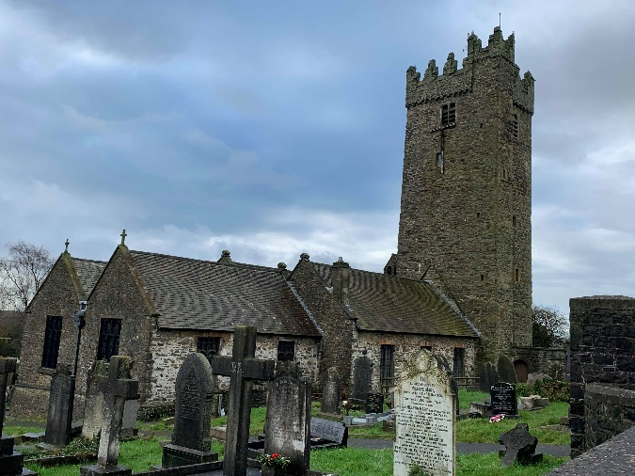
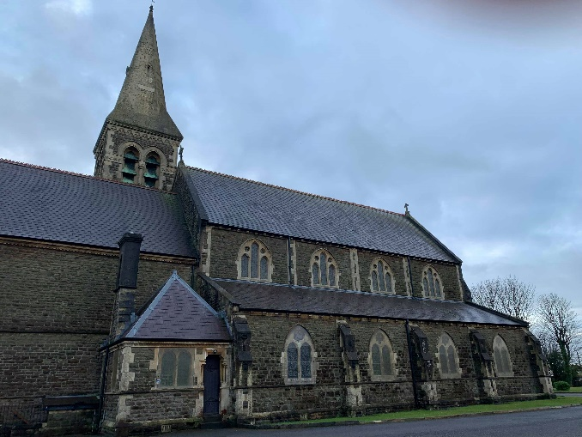
The two buildings within my local area that I have chosen to discuss are St. Illtyd’s Church, Pembrey and St. Mary’s Church, Burry Port.

Figure 1 - St. Illtyd’s Church (Harries, 2019) Figure 2 - St, Mary’s Church (Harries, 2019)
Context and historical background
St. Illtyd’s Church Pembrey is a parish Church, from the mediaeval period. The earliest recorded date of the church’s construction is 1120, however, it is believed that there has been a church of some capacity on the site since the seventh century. The church is centrally located, allowing ease of access to the residents of the village. St. Illtyd’s is a grade 2 listed building, which has been renovated and expanded over the centuries (See appendix 1), resulting in what stands today.
St. Mary’s Church came to fruition with the rapid expansion of Burry Port from its origins in 1850, when records show Burry Port became a town. The church was a gift from the Elkington Family of Birmingham, designed by Wilson, Wilcox and Wilson from Bath, in the French Gothic style during the Revival period. The rapidly growing town needed a church to both serve the rising population of Burry Port and the workers moving to the area who could not speak Welsh. The church opened on December 9th, 1877 and was considered both a landmark and the finest building in the town.
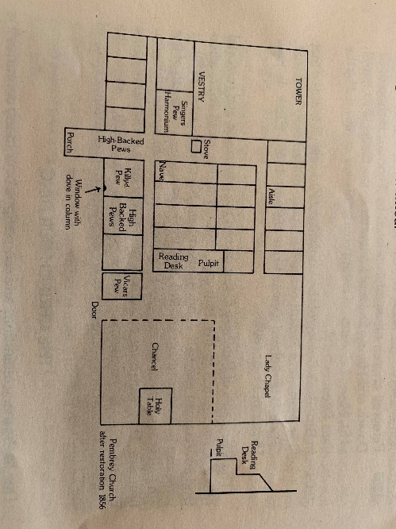
Plan and section
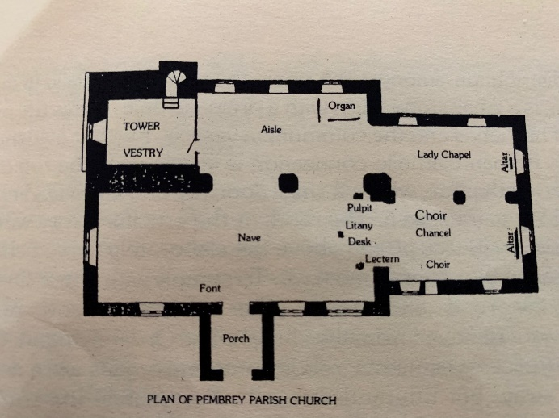
Figure 3 (Left)

Figure 4 (Right)

(Nicholson, 1978)
Figure 1 shows the plan of St. Illtyd’s Church post 1910, whereas figure 2 shows the church prior to the major renovation in 1910 (right). The renovation in 1910, carried out by Carew and partners, transformed the church into a place of worship that fit the needs of the community. The aisles within the church are non-central and situated on both right and left sides. Pews are situated centrally along either side of the aisles. It was stated by current vicar, Canon G. Davies, (previously practising architect) that he would invite change into the layout of the seating within the church and would like to remove the central aisle of pews and in place have individual seating, to allow adaptation and flexibility for larger gatherings.
St Mary’s plan and layout (Appendix 3) is notably different to that of St. Illtyd’s. The church is much larger in scale (around 500 seating capacity) with the layout of the building being designed intentionally to allow ease of access and open space for gatherings. The noticeable modernisation of the church in 2011, which converted unused pews into a communal area, is now used for gatherings after congregations for refreshments. Along with a communal area, a kitchen has been added as well as toilet facilities with disability access available. Above is a mezzanine with glass balustrades, allowing a view directly down the nave into the chancel. The design of a central aisle flowing directly into the chancel was intentional as stated by the residing vicar as it allows good acoustics. The interior and exterior of St. Mary’s appear more developed and considered than that of St. Illtyd’s. There is, however, 700 years between the two and both have required adaptation to fit the changing needs of the community.
Materials and Light
St. Illtyd’s exterior is constructed using local rubble stone. Slate roofing was used with coped gables and projecting eaves. Despite being renovated key historical features within the interior such as the thirteenth century depressed Tudor arch window, dedicated to the Butler family of Court farm, adorned with 8 crests and coats of arms (Appendix 2) and the squint within one of the central columns used as both a viewing space through to the Chancel have been preserved. The squint, at one point, was used to give communion to lepers. The seventeenth century barrel roof with ornate wooden boss accents was revealed after having a plaster covering removed during the 1910 renovations. The walls along with equilateral arches are rendered with a lime plaster (Appendix 5) which allows the church to be flooded with light coming through the windows situated on every face of the building.
Wilson, Wilcox and Wilson chose for St. Mary’s church to be constructed using local rock-faced brown stone along with bath stone dressings. The exterior is adorned with characteristically gothic features. The north east tower and octagonal bath stone spire rise to 130ft. Buttresses are used on the ground floor of the church as both stabilisers and decoration. Notable trefoil and quatrefoil accents are within the mostly lancet shaped windows. (Appendix 4) Much like St. Illtyd’s, St. Mary’s interior is rendered in lime plaster. The church is flooded with natural light as the windows mentioned are present on two of the three stories. Large equilateral arches (Appendix 5) span the length of the interior on both sides, allowing not only support but the light entering from the plethora of windows to traverse into other parts of the church. With the renovation of 2011 modern elements such as large expanses of glass, metal railings and light oak merge with the existing to allow a more efficient use of space and aesthetically eye-catching design.
Use
St. Illtyd’s church is a walled parish church with its own graveyard and family tombs. The building has been through many changes over time to cater to the growing needs of the community. The vestry has a separate entrance via the base of the 70ft tower and is the only private area of the church. St. Mary’s, however, has no place of rest. Both churches hold weekly services as well as family gatherings. St Mary’s recent renovations enables the church to cater for community meeting and events. St. Mary’s is now a multipurpose community building, allowing religion and social interaction to intermingle.
Conclusion
It has been eye-opening to study buildings that are within my local area. Gaining an understanding of buildings being seen in day-to-day life allows a greater appreciation for their placement and historical significance within the community. I am now questioning if methods of construction and material choices from these time periods would still allow structural integrity and design flexibility presently. Both churches evidently accommodate the needs of their community and evolve and adapt when needed.

Bibliography
Davies, R.P. (2011) Living Stones – The Story of St Marys Burry Port Burry Port: The Vicar & Churchwardens of Burry Port
Harries, L (2019) – Available at: Lee Harries Personal photos (Accessed 20th January 2019).
Nicholson. J.A. (1978) Pembrey St.Illtyds Church with Llandyry Great Britain: Walters

Resources
Coflein (2019) St Mary’s Church, Burry Port Available at: https://www.coflein.gov.uk/en/site/414578/details/st-marys-church-bury-port (Accessed 19 January 2019)
British Listed Buildings (2019) Church of St Mary Available at: https://britishlistedbuildings.co.uk/300082065-church-of-st-mary-pembrey-and-burry-port-town (Accessed 19 January 2019)
British Listed Buildings (2019) Church of St Illtyd Available at: https://britishlistedbuildings.co.uk/300011872-church-of-st-illtyd-pembrey-and-burry-port-town#.XET9N1z7SUk (Accessed 19 January 2019)
Coflein (2019) St Illtyd’s Church, Pembrey Available at: https://coflein.gov.uk/en/site/101623/details/st-illtyds-church-pembrey (Accessed 19 January 2019)
https://parish.churchinwales.org.uk/d383/history-en/a-brief-history-of-st-marys/
Pembrey & Burry Port Town Council (2017) About Pembrey & Burry Port Available at: http://pembreyburryport-tc.gov.uk/about-pembrey-and-burry-port.html (Accessed 20 January 2019)

Appendix 1
St. Illtyd’s church expansion and restoration dates.
C = Century
- Nave – constructed 13C
- Chapel – constructed 14C
- Porch – constructed 15C
- North aisle and tower (three storeys) – constructed 16C
- Large window in Nave wall – constructed 16C
- Church restoration – 1856 – 1857
- Further church restoration – 1910 – 1911

Appendix 2
- Arms of the Butlers of Coedganllys and Sir William Flemming.
- Arms of Butler and Basset of Beaupere.
- Arms of Butler and Sir John Monnington.
- Emblems of the passion.
- Arms of the Beauforts and Plantagenents.
- Crest of the Beauforts (Portcullis).
- Arms of Butlers and Sir William de Londres.
- Arms of Butler
(Nicholson J.A. 1978)
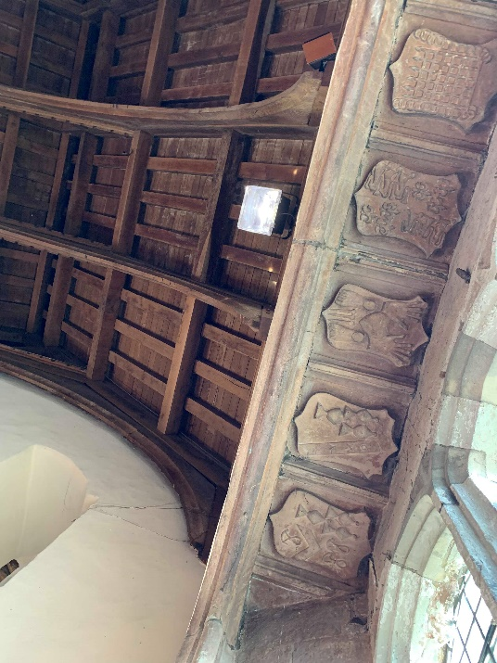
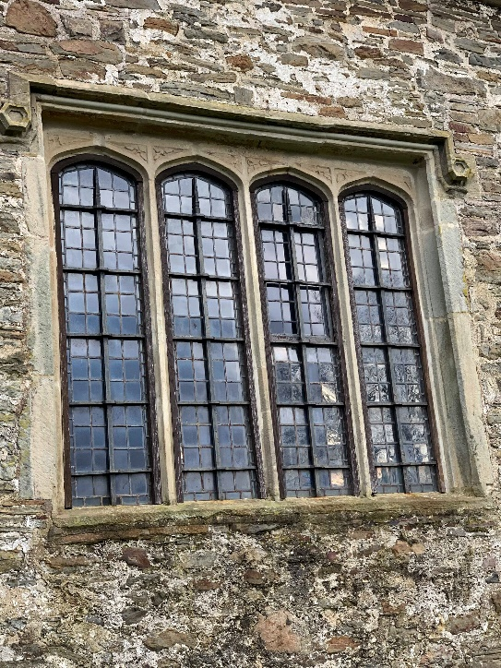

Images of 13th century window – St. Illtyd’s church.
(Harries, 2019)

Appendix 3

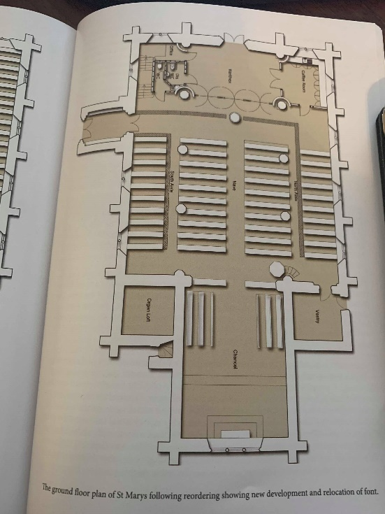
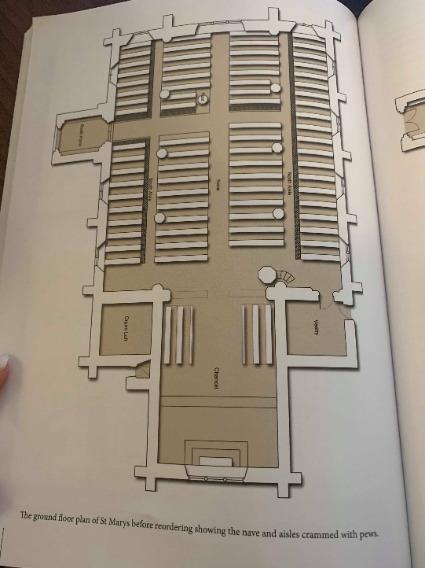

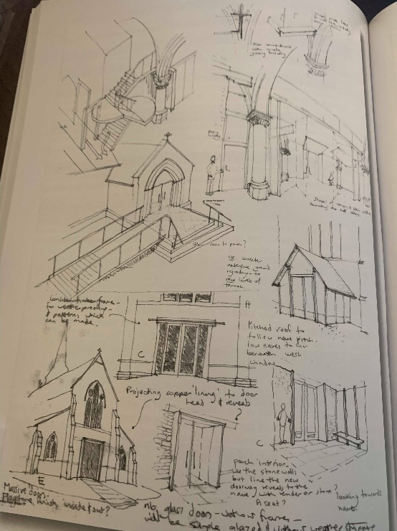
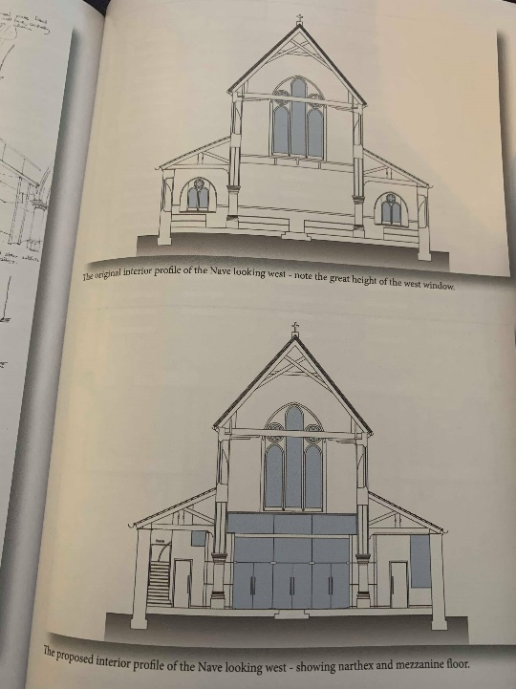

Plan, section and sketch views of St. Mary’s church. (Davies R.P. 2011)

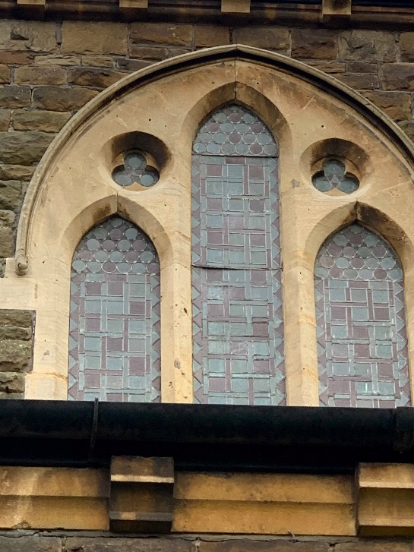
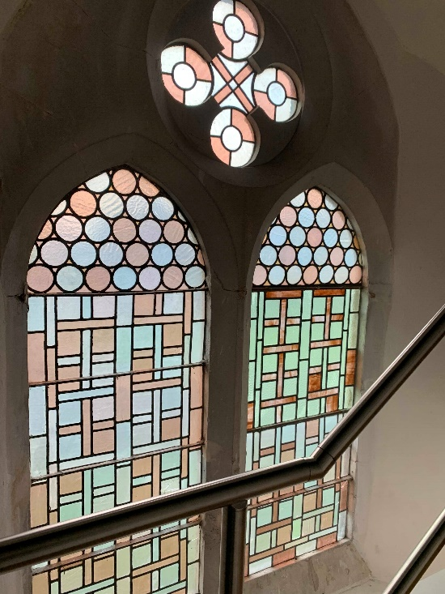
Appendix 4

Windows of St. Mary’s church. (Harries, 2019)
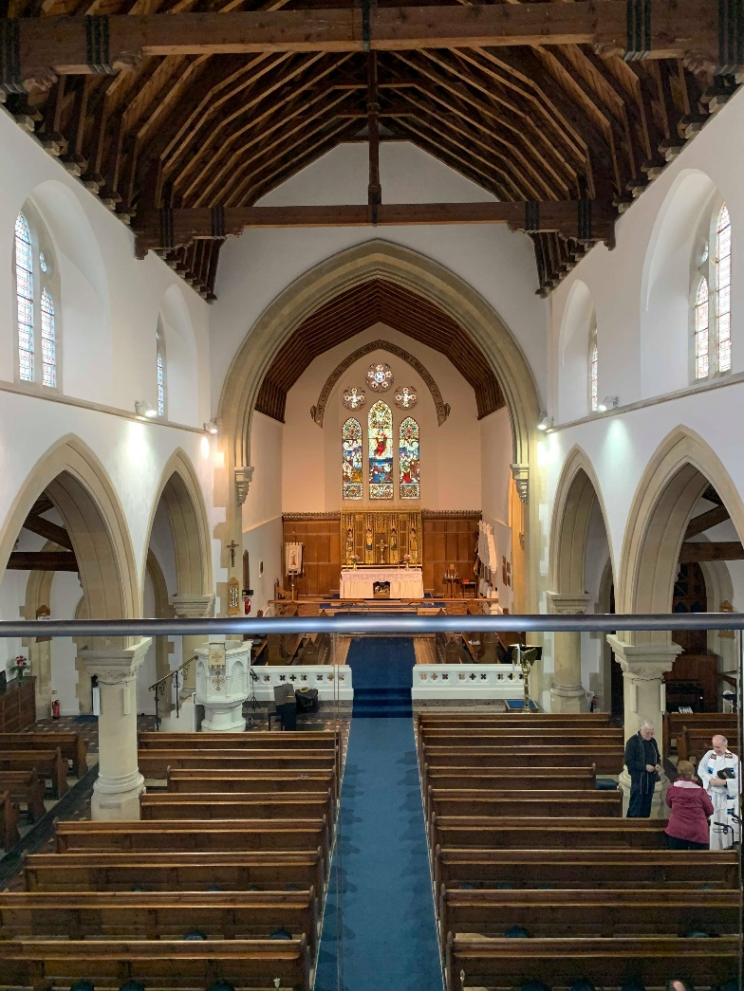
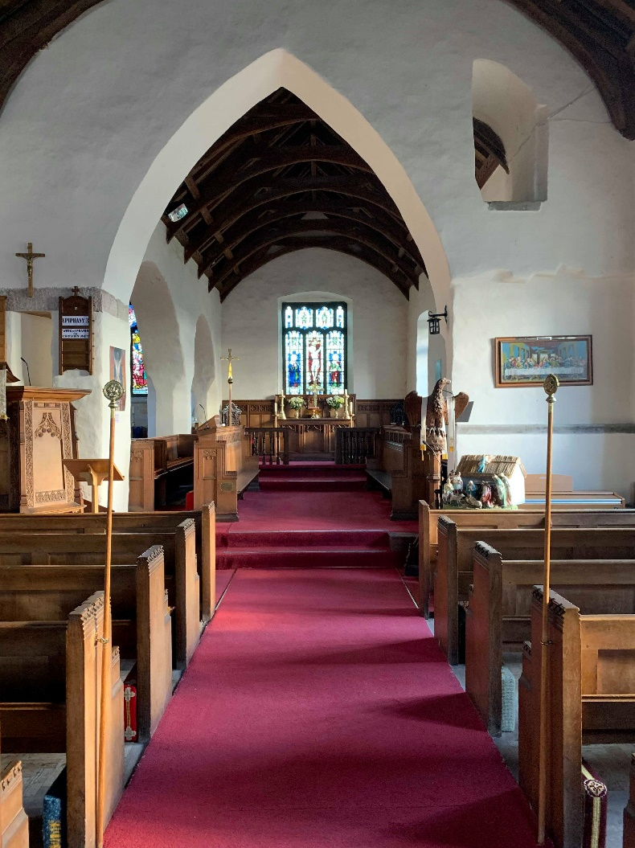
Appendix 5

Interior spaces of St. Illtyd’s church (left) and St. Mary’s church (right). (Harries, 2019)

