

Developing Workplace Critical Thinking (BMSK5001)

Lecturer: Ernest

Student: Titu Miah (17088002)

Contents
Introduction 2
Beliefs 3
Attitudes 4
Values 4
Values and Workplace Behavior 7
Core Values of Amazon.Com 10
Management Theories 13
Bibliography 15

Introduction
The three most important dimensions of experience in the workplace are beliefs’, attitudes and values. This is a complex issue that is facing a lot of businesses and organizations at the present time. To understand what effects and how to manage workplace behavior, its necessary to be able to understand the impact of beliefs, attitudes and values of individuals in the workplace. This report will highlight and explore such impacts and examine how different values effect workplace behaviors. This report will also examine the core values of organizations and look at how its effects workplace behaviors. Also included in this report will be an evaluation of a scientific management theory which is still being used in some organization and also will include an assessment on how such theories work in workplace behaviors. Workplace behavior is the interactions and a series of actions which happens between members of a business that may directly or indirectly effect the organization. In a workplace individual can have an impact to the organization from their personal behaviors in their beliefs, values and attitudes. Organizations that are successfully operating would have a good foundation in place for workplace behaviors. This would help to understand how beliefs, attitudes, values are interlinked in a way that contributes in the behavior that is displayed by individuals in a working environment. The management theory will be included to show how it is either successful or unsuccessful in helping employee with their beliefs, values and attitudes in their workplace. The management theories were developed through various experimental ideas to help manage and run their organizations. The report will start with explaining the definitions of the aspects involved which are the beliefs, attitudes and the values. Management theory of Elton mayo was created by performing several studies in the united states of America. Elton mayo was known as the person who laid the foundation for the human relations movement and also he was known for his research including the Hawthorne studies and his book The Human Problems of an Industrial Civilization.

Beliefs
“A belief is an internal feeling that something is true” according to Anderson & De Silva(2009).There are various reason behind a belief which involves factors such as cultural, religious ,superstitious and also core beliefs. As beliefs govern nearly every aspect of our lives (Shealy, Shealy and Shealy, 2015). Once you have established your beliefs, its rarely challenged for validity. Even when other people disagree with it. An individual can hold his or her belief to be true without having to give proof or evidence to prove it. Also, scientific reasoning is not needed to prove it to be true either. Some examples of individual beliefs are there is one god, is its bad luck to open your umbrella indoors, the world is dangerous or not safe or knowledge is power. The personal beliefs can influence individuals’ personalities and behavior. Individuals beliefs can come from different sources such as personal experience, religious practices, background culture and educations. Every individual in their way may seek reasons or evidence to evaluate for their potential beliefs. If the individual accepts a belief as the truth then they will defend it, this can form part of their belief system. There are various sources that individuals’ beliefs come from:
. cultural (religion)
. educational or mentoring
. environmental
. events
. knowledge
. past and future results

Attitudes
The definition of attitude is a settled mode of thinking according to Armstrong (2009). Attitude can be of how an individual reacts or behaves towards certain situations or with others. Attitude is developed through socialization with other individuals, but it can also be subject to change from new experiences or new information that they learn, and this could be advantageous. attitude can reflect how you think, respond, feel and behave towards others at work or social situations. The formation of attitudes is through these three components. The first is cognitive, second one is affective/emotion and the third is behavior. Cognitive is the process associated with thinking, knowledge, remembering, judgement, memory, understanding and then to apply the incoming information. Affective is a way of expressing your emotions or feelings. Behavior is how you act upon in conjunction with oneself or within the environment that you are. Behavior also reflects how the attitude affects the way you behave and act. So, an attitude is like an evaluation statement which can either be positive or negative depending on the course of actions that is taken by individuals. Individuals will behave according to how they think, feel and belief.

Values
A value is something that is of importance to an individual. It can reflect the way individuals live their life’s. The values and beliefs that individuals have reflect on decisions that are made in organizations which has a direct action towards a function. Values can help define individual’s behavior and actions. Values gives a person motivation, a purpose, importance and what is worthwhile. Values can differ due to different background, individual’s, cultures, interpretations, religion, languages and different personal core values. A person must be a clear about their values to make rational, consistent and responsible decisions. There are various sources of values that can affect individual’s behavior and actions. Types of sources of values:
. peer pressures (social)
. religion (spiritual)
. Family (tradition and customs)
. Events
. monetary (money)
. professional
. behavior
. personal
The illustration below shows the influence on us that can lead to a person’s beliefs to behavioral traits. The diagram outlines the different sources of our beliefs. It also shows the relationship between the beliefs, values and to our attitudes and to our resulting behavior.

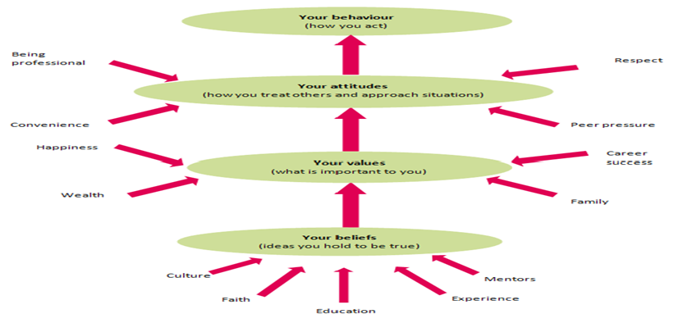
Values do sometimes have barriers for individuals to overcome but many people still struggle to live according to their values. It could be sometimes about lack of knowledge or not knowing what exactly their values are. Another barrier to consider is what if your personal values came into conflict with your family or the society that you live in? For example, you adopt a value for tolerance but what if the society doesn’t value tolerance and is against it? These are some of the barriers which you may come to face but it would mean you have to make a choice of how to handle these situations. There are many ways that you can create to improve and address your personal values. It’s not necessary to reject all compromises and it would be negative to ignore practical considerations. Compromising will lead towards a long-term solution which will be in line to your own values. Your values are not all fixed, but it may change according to your age because you will have different opinions to which value is important.

Values and Workplace Behavior

Workplace values are important in any organization because to create a wining outcome its significant to identify individuals and companies’ values. This will help individuals in any organizations to be successful in seeking meaning in their work and the organization will be able to create a work force which functions well and correctly. Values play an important factor in the performance of an organization. If an organization has excellent values in place, it will help outperforming more effectively when competing with other companies. This will display revenues growing, the profit performance increases and the stock growth increases(Kotter,1999).Value led organizations tend to attract individuals that have similar or even the same values. This is an advantage for the organization, and it helps them to be able to keep those individuals who show full commitments. Individuals workplace values serve as guiding principles that are most significant to the way that people work (Hogg,2011).
Most organizations will have diversity within the employees, that is why there are multiple personal values in the workforce. This is the reason why it’s necessary for individual values and beliefs that may conflict with individuals’ professional lives should be kept separate. To have values that are in line to organizations will allow individuals in a group or team to understand each other, increase performances, perform the correct actions needed for the right reasons, these actions will aide individuals in developing and build on their working relationships. This would bring all employees closer to each other. This in return helps the organization to be able to achieve its mission and objectives. It’s important that individuals’ values align with the organizations. When the values are aligned it helps the organization to achieve their core mission.
When an organizations values are out of alignment it creates negative outcomes, which damages work relationship, less productivity and doesn’t have job satisfaction.
Individuals may sometimes have conflicted values within a workplace. These values may be workstyle conflict, personality clashes, poor communications, misunderstandings, different interests and poor performance contribute to workplace conflicts.
When recruiting new employees, understanding individual’s workplace values is highly significant. This is due to being necessary to help individuals to achieve experience and fill the skill gap. The most difficult part is to make someone change their values according to what you want. Under appropriate conditions values are important determinants of social behavior (Rokeach, 2014).Understanding human behavior at work and effective management of the people resources is even more important for organizational survival success (Mullins and McLean, 1985).Individuals workplace beliefs, values, attitudes have effects on the organizations behavior and success. Also, the core values of an organization can lead to effecting work ethics and behavior. Core values can be used in helping to mitigate conflicts that may arise and also to prevent conflict. Organizational behavior study is beneficial in understanding how most employees work in organizations, so there is a need to understand, to predict and influence the behavior of others. The example below will help to understand organizational behaviors:

Organizational behavior influences individuals to understand themselves and others better. This helps to improve interactions between individuals and relationships between each other. To be able to precipitate there is a need to map out organizational events, also why organizational events occur and to be able to predict the future. Organizational behavior helps management to understand how to get things done through others. The manager needs to be able to motivate others working below him for better results. The manager needs to also understand that organizational behavior has a big influence to be successful in his job because he must understand the basis of motivation.

Core Values of Amazon.Com

Amazon.com is based in Seattle, the company came from selling books to now at present selling many different products such as electronics, music CDs, toys, hardware, foods, health products and home products.
Amazon.com offers customers the shopping convenience, online shopping, a wide selection of products and reliability of order fulfillment. All of these are tied directly to the company’s logistics department to fulfill delivery orders. Whether you are a manager or an individual contributor of a team you are a leader. These are amazon leadership principles. These principles are guidance for everyone at amazon.com and they are also the core values:
. Customer Obsession
. Ownership
. Invent and Simplify
. Are right, a lot
. Learn and be curious
. Hire and develop the best
. Insist on highest standards
. Think big
. Bias for action
. Frugality
. Earn trust
. Dive deep
. Have backbone; disagree and commit
. Deliver results

The statement of core values at Amazon.com emphasizes that values lie at the core of its culture and what the organization represents. Values are fundamental, actionable, determines how much time the company spends and finance. Human capital is essentially important for today’s organizations to succeed in a competitive world. When core is embedded successfully into the organization, this helps to set up the foundations for their culture and values set the climate for the workplace.
Customer obsession is taking care of the customer needs, making them happy and keeping customers trust. For example, amazon.com have a delivery service which if the item is dropped off to the customer on time then you have a satisfied customer. The organization needs to make sure customers are happy because it relies heavily on them to succeed as a business. People with values of empathy and helping others would be most suited to do this. This creates a value where customer satisfaction is important.
Ownership is what amazon give to their leaders so they can act on behalf of the company. As a leader you are expected to be pushing the interest of the company forward by aligning your hard work with your teams as well. This shows that amazon have great faith in their employees and trust them to be able to represent the company. This also will encourage employees to the company to success with their teamwork. It shows that you can execute responsibilities. This would help employees to harbor stability, where employees who have personal values of hard working and achieving a positive result will be able to gain access in career development opportunities. This means that amazon appreciates work and talented individuals.
Invent and simplify is leaders are required and expected to be innovative and inventive and always find ways. This means amazon are encouraging leaders to find fresh ideas which they can invent for on the behalf of the company. It is encouraging the employees to look externally for ideas and to think outside the box. It shows that they value individual’s creative and improving values, which works perfectly with amazons’ principles of invent and simplify.
Learn and be curious principle means that you are never finished in learning and should always seek to improve themselves. You should be curious and act to explore them. Individuals will use wisdom and open mildness personal values to achieve this. Amazon is using this principle to make sure that employees have the hunger to gain more knowledge and this would help to improve.
To be curious employees will need to find be interested in finding ways to absorb new information, this could be reading newspapers, reading news online and watching u tube videos.
Hire and develop the best is what amazon believes is needed to operate their business behind this logic. This is done by hiring the right individual, the people who can do the job, who are willing to grow throughout their career and this is required to be done by a manager or leaders role. Individuals will need to be able to focus on hiring the people who will raise the high-performance bar. You will need to have a sharp eye to recognize strong performers at the interview when hiring. As a leader you must be able to use mentoring skills, care about their career and provide feedback. To help employees to drive their individual development and learning by regularly discussing strength, weaknesses that can be helped to improve, identify development activities and to achieve their goals.
A mission statement can be directed towards the company’s customers and products. A statement can also be referred as the company’s philosophy. The statement is a way to define a company’s purpose, strategies, plans and why a company exists, and customers can understand the intentions of the company.

Management Theories

Management theories are the general rules and ideas which are developed by various theorists, they address how to manage and run an organization efficiently. This is either done by a series of experiment or from studies using employees. This process is then examined and broken down in a way to understand the findings. These theories help management to understand how to implement effective ways to get their goals accomplished, how to motivate employees to make them perform to the highest standards.

Human Relations Theory of Management by Professor Elton Mayo

The human management theory was developed in the 1920s.At that time the focus was primarily on productivity in organizations. Professor Elton mayo began his experiments, which is known as the Hawthorne studies. The Hawthorne studies stimulated all academics to have debates about social theory, research methods, industrial management and industrial sociology. This led to increase knowledge in understanding industrial situations, physiology and the development of studies on organizational behaviors. This was done to prove that people/employees are important for productions but not machines. The theory is a researched belief that workers desire to be part of the team that processes development and growth. If workers are encouraged in participating, receive attention, this makes them to give more importance to their work, they get more motivated to which makes them more productive and this results in the organization getting high quality work output. The results showed that workers wanted to have significance while being treated value and respect by the organization. This means by changing the way you treat workers by showing respect and value will result performances and quality to the organization.
In the 1950s employee behavior was the main centrally focused and the theory placed strong on the basis that organizations are made up groups of people. Having groups of people meant that every person is unique and unpredictable as well. To understand the groups of people, its necessary to recognize their personal motivations. An example of Professor Elton mayo’s theory diagram is below:
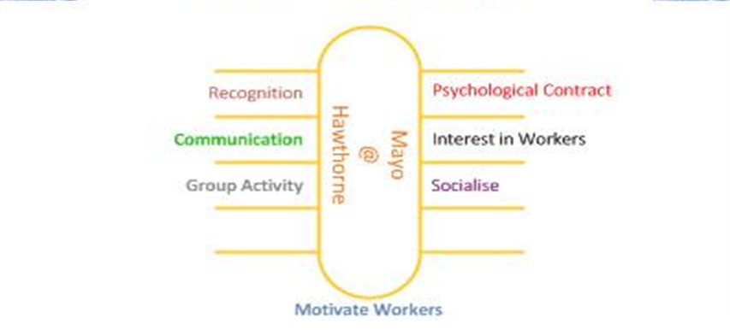

Advantages and Disadvantages of Theory

All theories will have been either criticized or agreed upon by other theorists, they will look at all aspects and then draw their own conclusions. Despite the positive impact on organizations by professor Elton mayo theory, it has been criticized about mayo’s role in the Hawthorne study, some people have rejected it as being outmoded and simplistic and some people argue that mayo simply put together and he applied existed sociological theory and then applied them to his research, the experiments was conducted under controlled environment, there more importance given to workers aspects. Also, workers cannot improve production on their own without the help of technology and production needs depend on technological and various other factors. There is more importance given to group decision making. When individuals are making decision without consulting others cannot be correct all the time and everybody has different views/opinions. These responsibilities can cause stress, anxiety and pressure on making the correct decisions. The supervisors are not given importance but workers are given all the freedom needed, this can have a negative effect such as workers will be too relaxed and will slow down production thus decreasing the output of the organization. Supervisors will have less control over the workers in the organization.

The Elton mayo theory has advantages which is used at Amazon.com. There is an understanding between the employee and the organization regarding what is required from them to do. This is called the psychological contract. Workers are given training on how to do their job and instructions as to what is needed to be part of the organizations. They will be given a contract, which will have written information for the employee such as working hours, pay (incentives), job role, health and safety procedures and also a code of conduct ( behavior).
Team leaders will need to be observing, communicating and cooperating with workers to have better bonding. This will help the workers to feel a belonging to the organization. Also, a worker would be motivated when they feel that leaders sow an interest in them. Mayo did study the workers through his experiments as showing an interest in the workers
Working as a group makes employee to have team bonding, increases social factors among them and it has an influence on their behavior in organization. Also, this can affect morals, values and respect amongst workers. According to mayo having a work group activity is advantageous to the organization because it will aid in increase productions.
Social aspect of work can be associated to work as by letting workers socialize in and out of work hours. This will give workers to speak to each other at lunchtime perhaps discussing job roles or can be learning new skills from each other. Workers need to rest or otherwise they will not be able to perform their daily job.
Recognizing workers is done by amazon through ownership and invent and simplify in their core values. This shows that amazon have put belief in their workers to be creative with ideas, they give you full access to the company and this shows that workers can make decision in finding new products for the company.
Communication is another factor used by amazon. This is done by expecting leaders/workers to earn trust. This means they must listen, treat others respectfully, cooperating with colleagues and this will improve production. Motivating workers is done by having a good relationship between workers and management. This creates opportunity to get feedback from workers.

The traditional view of how to motivate employees is that you offer monetary rewards (pay increases, bonuses etc) for work completion. However the Hawthorne experiments may suggest that motivation is more complicated than that. Advocates of the "Hawthorne Effect" will state that the Hawthorne experiment results show that motivation can be improved through improving working relationships and social interraction.

Bibliography

Barrett, R. (2014). The values-driven organization. Oxon: Routledge.
Bratton, J. (2010). Work and organizational behaviour. Basingstoke: Palgrave Macmillan.
Brooks, I. (1999). Organisational behaviour. London: Financial Times Pitman.
Cunningham, J. (2001). Researching organizational values and beliefs. Westport, Conn.: Quorum Books.
Hopkins, B. (2016). Cultural Differences and Improving Performance. London: Taylor and Francis.
Hultman, K. and Gellermann, W. (2002). Balancing individual and organizational values. San Francisco, CA: Jossey-Bass/Pfeiffer.
Mayo, E. (2010). The human problems of an industrial civilization. London: Routledge
McEwan, T. (2001). Managing values and beliefs in organisations. Harlow, England: Financial Times/Prentice Hall.
Mullins, L. and McLean, J. (1985). Organisational behaviour in the workplace. 12th ed. Harlow: Pearson Education Limited.
Paul, R. and Elder, L. (2006). The international critical thinking reading & writing test. Dillon Beach, CA: Foundation for Critical Thinking.
Rokeach, M. (1975). Beliefs, attitudes, and values. San Francisco: Jossey-Bass.
Rollinson, D. (2005). Organisational Behaviour and Analysis (3a. ed.). Essex: Pearson Education.
Schermerhorn, J., Hunt, J., Osborn, R. and Uhl-Bien, M. (2010). Organizational behavior. New York [etc.]: Wiley & Sons.
Shealy, C. (2015). Making sense of beliefs and values. 1st ed. New York: springer publishing company.
Torgler, B., García-Valinas, M. and Macintyre, A. (2010). Participation in environmental organizations. Milton Park, Abingdon, Oxon: Routledge.
Tyrer, G. (n.d.). Elton Mayo's theory of industrial management.
Usó-Doménech, J. and Nescolarde-Selva, J. (2015). What are Belief Systems? Foundations of Science, [online] 1(1), pp.147-152. Available at: https://doi.org/10.1007/s10699-015-9409-z
Williams, V. (1991). Human beliefs - personal values. Derby: CEM.

