MBA – Master of Business Administration
International Business
Dissertation – LCMB7035
Dissertation Supervisor: Nishi Ramsurrun
Boris Vladimirov – 2124687



Dissertation:
Monetary vs Non-Monetary Rewards: How Different Rewards Influence Employee Motivation in the Manufacturing Sector in the UK

Submission date: 31.01.2026
Word Count: 15008


Acknowledgements
I would like to express my sincere appreciation to my dissertation supervisor, Ms. Nishi Ramsurrun, for her guidance, constructive feedback, and ongoing support during the development of this research.
I am also grateful to the academic staff of the University of Wales Trinity Saint David for providing the knowledge and learning environment that supported my academic progress.
Finally, I would like to thank all the participants who took part in the survey, as their time and contributions were essential to the completion of this study.
Abstract
Employee motivation remains a critical factor influencing organisational performance, particularly within the highly competitive UK manufacturing sector. This study examines the influence of monetary and non-monetary rewards on employee motivation, aiming to identify which reward mechanisms are perceived as most effective. A quantitative research design was employed, with data gathered through a structured survey distributed to 50 employees working in the UK manufacturing sector. The data were analysed in Microsoft Excel and SPSS software using descriptive statistics, reliability test, Pearson correlation, and multiple regression analysis. The results show that while monetary rewards remain important in supporting baseline motivation and perceptions of fairness, non-monetary rewards such as recognition, training, and development opportunities play a stronger role in sustaining long-term motivation. Furthermore, the results reveal a clear preference among employees for balanced reward systems that incorporate both financial and non-financial incentives. This study contributes to the existing literature by empirically applying established motivational theories within an under-researched sector and provides practical insights for manufacturing organisations seeking to develop effective and sustainable reward strategies.

Table of Contents
Chapter 1 Introduction 9
1.1 Background of the Study 9
1.2 Problem Statement 11
1.3 Research Aim, Objectives, and Questions 12
1.3.1 Research Aim 12
1.3.2 Research Objectives 12
1.3.3 Research Question 12
1.4 Relevance of the Study 13
1.5 Scope of the Study 14
1.6 Research Methodology 14
1.7 Dissertation Structure 16
Chapter 2 Literature Review 17
2.1 Introduction 17
2.2 Reward Systems 17
2.3 Monetary and Non-Monetary Rewards 19
2.3.1 Monetary Rewards: Definition and Concept 19
2.3.2 Importance of Monetary Rewards 20
2.3.3 Non-Monetary Rewards: Definition and Concept 20
2.3.4 Importance of Non-Monetary Rewards 21
2.4 Definition and Importance of Employee Motivation 22
2.5 Theoretical Frameworks Related to Monetary Rewards, Non-Monetary Rewards, and Employee Motivation 23
2.5.1 Herzberg’s Two-Factor Theory 23
2.5.2 Maslow’s Hierarchy of Needs 25
2.5.3 Self-Determination Theory 26
2.5.4 Equity Theory 27
2.5.5 Expectancy Theory 28
2.6 Research Gap 29
2.7 Chapter Summary 31
Chapter 3 Research Methodology 31
3.1 Introduction 31
3.2 Research Philosophy 32
3.3 Research Approach 32
3.4 Research Method 33
3.5 Data Collection Method 33
3.6 Sampling Method 34
3.7 Data Analysis Techniques 35
3.8 Ethical Considerations 36
3.9 Chapter Summary 36
Chapter 4 Data Analysis and Discussion 37
4.1 Introduction 37
4.2 Survey Results 37
4.3 Data Analysis 50
4.3.1 Demographic Characteristics of Participants 50
4.3.2 Descriptive Statistics 51
4.3.3 Reliability Analysis 52
4.3.4 Pearson Correlation Analysis 53
4.3.5 Multiple Regression Analysis 54
4.3.6 Assumption Checks 56
4.4 Discussion of Findings 56
4.4.1 Influence of Monetary and Non-monetary Rewards on Employee Motivation 57
4.4.2 Perceived Effectiveness of Monetary and Non-Monetary Rewards 58
4.4.3 Employees’ Perceptions and Preferences Regarding Different Reward Types 59
4.5 Chapter Summary 60
Chapter 5 Conclusion, Limitations, and Recommendations 61
5.1 Introduction 61
5.2 Key Research Results 61
5.3 Research Limitations 64
5.4 Practical and Theoretical Recommendations 66
5.5 Recommendations for Future Research 67
References 69
Appendix 77
Appendix 1 - Reliability Test 77
Appendix 2 – Assumption Check 79

List of Figures:
Figure 1 - Maslow’s Hierarchy of Needs 26
Figure 2 - SDT Construct and Workplace Outcomes 27
Figure 3 - Expectancy Theory Elements 29
Figure 4 – Question 1 - Participants' Age 38
Figure 5 – Question 2 - Participants' Gender 38
Figure 6 – Question 3 - Participants' Years of Experience 39
Figure 7 - Question 4 - I feel motivated to give my best effort in my daily work tasks. 39
Figure 8 - Question 5 - I put extra effort into my job, even when tasks are demanding or repetitive. 40
Figure 9 - Question 6 - I feel committed to achieving high performance in my role. 41
Figure 10 - Question 7 - I am willing to take the initiative to improve my work processes or productivity. 41
Figure 11 - Question 8 - Salary is the main factor that motivates me to perform better at work. 42
Figure 12 - Question 9 - Regular bonuses and incentives increase my motivation and job satisfaction. 42
Figure 13 - Question 10 - The pay I receive reflects the work I do. 43
Figure 14 - Question 11 - Monetary rewards are an important factor in keeping me motivated at work. 44
Figure 15 - Question 12 - Recognition motivates me to work harder. 44
Figure 16 - Question 13 - Opportunities for training and skill development improve my motivation. 45
Figure 17 - Question 14 - Career advancement opportunities (e.g., promotions) are more motivating than financial incentives. 45
Figure 18 - Question 15 - Non-financial benefits (e.g., flexible hours, job security) matter to me more than money. 46
Figure 19 - Question 16 - I am more motivated by monetary rewards than non-monetary rewards. 47
Figure 20 - Question 17 - A balance of both financial and non-financial rewards keeps me motivated. 47
Figure 21 - Question 18 - In the long term, non-monetary rewards (training and recognition) sustain motivation better than financial incentives. 48
Figure 22 - Question 19 - I believe that strong performance will be recognised or rewarded by management. 48
Figure 23 - Question 20 - The link between effort, performance, and reward is clear in my organisation. 49
Figure 24 - Question 21 - I believe my effort at work is fairly rewarded compared to my colleagues. 49
Figure 25 - Question 22 - The balance between what I contribute and what I receive feels fair. 50
Figure 26 - Histogram 79
Figure 27 - Regression Standardized Residual 79
Figure 28 - Scatterplot 80

List of Tables:
Table 1 - Herzberg's Motivation and Hygiene Factors 24
Table 2 - Demographic Characteristics of Participants 51
Table 3 - Descriptive Statistics 51
Table 4 - Reliability Test/ Cronbach's Alpha 52
Table 5 - Pearson Correlation Analysis 53
Table 6 - Regression Analysis/ Model Summary 55
Table 7 - ANOVA Table 55
Table 8 - Regression Coefficients 55
Table 9 - Appendix 1 - Reliability Statistics - Motivation 77
Table 10 - Appendix 1 - Reliability Statistics - Monetary Rewards (4 Items) 77
Table 11 - Appendix 1 - Reliability Statistics - Monetary Rewards (3 Items) 78

Chapter 1 Introduction

1.1 Background of the Study
Employee motivation can be defined as the internal state that drives, activates, or guides human behaviour toward achieving a specific goal (Kumar et al., 2025). Employee motivation remains a fundamental driver of organisational performance, productivity, and competitiveness. Motivated employees tend to demonstrate higher engagement, commitment, and efficiency, contributing significantly to a company’s overall success (Roslinda and Andias, 2025). Within the manufacturing sector, employee motivation is crucial due to the demanding nature of work, the reliance on labour productivity, and the ongoing challenges associated with retention and skill shortages (Ahmad, 2023). As a result, organisations continue to invest in various reward mechanisms to stimulate motivation and encourage positive workplace behaviours (Mithunmita and Britto, 2021).
Rewards form an essential component of human resource management as they are designed to strengthen employee motivation by recognising contributions, enhancing job satisfaction, and encouraging high performance (Kankisingi and Dhliwayo, 2022). These rewards can be broadly categorised into monetary and non-monetary, both playing distinct motivational roles. Monetary rewards are tangible and typically include financial incentives such as salary increases, bonuses, and performance-based pay, which fulfil employees’ economic expectations and basic needs (Paul, 2024). In contrast, non-monetary rewards are intangible and include intrinsic and relational aspects such as recognition, autonomy, skill development, and supportive working conditions, which enhance employees’ internal satisfaction and emotional connection (Madhani, 2021).
Organisational reward strategies have emphasised financial incentives under the assumption that pay is the strongest motivator (Adesina and Egbuta, 2025). However, contemporary research suggests that money alone may not sustain long-term motivation, particularly when employees’ basic needs are already met (Mdhlalose, 2022). The shift towards more holistic reward strategies has amplified interest in the effectiveness of non-financial motivators, such as career progression, employee recognition, and meaningful work, which are linked to enhanced performance and long-term engagement (Chatzoglou, Diamantidis, and Karras, 2024).
The UK manufacturing industry provides a particularly relevant context for exploring this issue, as it combines a strong tradition of performance-based incentives with increasing awareness of the need to address employees’ psychological and social needs (Sarkar and Lakshmi, 2025). In small and medium-sized enterprises (SMEs), especially, the balance between financial constraints and motivational effectiveness makes reward design a complex managerial challenge (Kankisingi and Dhliwayo, 2022). The present study aims to contribute to this discussion by examining how monetary and non-monetary rewards influence employee motivation and identifying the factors that are most influential in enhancing engagement and performance in the UK manufacturing environment.
Globalisation and technological change have also transformed how rewards are perceived. Many manufacturing companies are integrating performance-based pay with non-monetary practices such as flexible scheduling, training opportunities, and participative management (Ahmad, 2023). These developments reflect the assumption that motivation is multi-dimensional and that employees respond differently depending on their personal values, career stage, and job context. Consequently, a one-size-fits-all reward approach is increasingly seen as inadequate in complex production environments (Ercegović, 2025).
Despite extensive global research, significant gaps remain in industry-specific evidence. Many studies have predominantly focused on service industries or multinational corporations. Conversely, the manufacturing sector, especially in the United Kingdom, remains underrepresented academically. Manufacturing jobs often involve repetitive tasks, strict production schedules, and physically demanding environments, which may influence how employees perceive rewards (Michail, 2024). Additionally, post-pandemic changes, the living cost crisis, and increasing automation have brought new challenges that may reshape motivational factors within the sector.
Therefore, an investigation of reward preferences and their motivational effects within UK manufacturing organisations is both relevant and timely. A deeper understanding of how employees perceive and respond to different reward approaches can help organisations design more effective reward systems, reduce turnover, and improve workforce motivation and productivity. This study consequently explores both monetary and non-monetary rewards to determine their comparative influence on employee motivation in the UK manufacturing context.

1.2 Problem Statement
Manufacturing organisations in the United Kingdom continue to face challenges relating to employee motivation, engagement, and retention. The industry has experienced rising labour shortages, high turnover rates, and an ageing workforce, negatively impacting productivity and competitiveness (Ahmad, 2023). While reward systems are commonly implemented to improve motivation, their effectiveness varies greatly depending on the nature of work, employee perceptions, and the organisational environment (Romy, 2024).
According to Chatzoglou, Diamantidis, and Karras (2024), financial and economic crises such as the cost-of-living crisis in the UK can also shift employee perception and preferences towards different types of rewards. In the current competitive business environment, organisations face the challenge of cultivating a highly motivated workforce to maximise performance and ensure long-term success and sustainability. While numerous strategies can be employed to enhance employee motivation, financial constraints, particularly those arising from recent economic challenges, highlight the importance of identifying and focusing on the most effective reward systems to motivate the workforce and yield the greatest impact on employee performance.
Most of the existing research observing reward effectiveness has been conducted within sectors such as retail, hospitality, and corporate services, leaving a lack of empirical evidence specific to manufacturing roles. This creates a knowledge gap in understanding which reward types produce the most desirable motivational outcomes in manufacturing settings. Additionally, many organisations continue to prioritise financial incentives despite evidence suggesting that non-monetary rewards may become increasingly influential, particularly for sustaining long-term motivation (Roslinda and Andias, 2025).
The lack of sector-focused research leaves HR practitioners without solid guidance when designing reward systems aligned with employee expectations. Consequently, reward investments may fail to deliver expected benefits if they do not align with motivational drivers within the industrial environment. To address this gap, there is a need to assess how monetary and non-monetary rewards influence motivation among the workforce in UK manufacturing organisations and which rewards are perceived as most beneficial.
Without such understanding, organisations risk continuing ineffective reward practices, which can potentially lead to demotivation, lower performance, and an inability to attract and retain skilled manufacturing workers. This research seeks to address this critical gap and contribute to more informed and impactful HR strategies in the UK manufacturing sector.

1.3 Research Aim, Objectives, and Questions

1.3.1 Research Aim
This research aims to examine the influence of monetary and non-monetary rewards on employee motivation in the UK manufacturing sector.

1.3.2 Research Objectives
The objectives required to achieve the study aim are as follows:
- To examine the impact of monetary rewards on employee motivation in the UK manufacturing sector.
- To assess the influence of non-monetary rewards on employee motivation in the UK manufacturing sector.
- To evaluate the relative effectiveness of monetary and non-monetary rewards in influencing employee motivation.
- To provide recommendations for the manufacturing sector on optimising reward systems to enhance employee motivation.

1.3.3 Research Question
To achieve the study objectives, the following questions must be answered:
- How do monetary and non-monetary rewards influence employee motivation in the UK manufacturing sector?
- To what extent do employees perceive monetary or non-monetary rewards as more effective in enhancing their motivation?
- What are employees’ perceptions and preferences regarding different types of rewards?

1.4 Relevance of the Study
Employee motivation remains one of the most influential factors for productivity, engagement, and overall organisational effectiveness. In the fast-changing and increasingly competitive UK manufacturing sector, keeping a motivated workforce has become a strategic priority for maintaining operational efficiency, high-quality output, and ongoing innovation (Shende and Mudgal, 2025). As the industry faces rising challenges, including automation, technological advancements, and a growing skills gap, understanding how different types of rewards influence motivation is more critical than ever (Ahmad, 2023). Examining the influences of monetary and non-monetary incentives offers valuable insights that connect academic theory with organisational practice.
From a theoretical perspective, this study contributes to the ongoing academic discourse on employee motivation by situating recognised motivational frameworks, such as Herzberg’s Two-Factor Theory, Maslow’s Hierarchy of Needs, Self-Determination Theory, Equity Theory, and Expectancy Theory, within the specific context of the UK manufacturing sector. Much of the existing research on reward effectiveness has concentrated on service-oriented sectors or multinational corporations, often overlooking the unique dynamics of manufacturing, where work tends to be structured, process-driven, and physically demanding (Michail, 2024). By applying these theories to this distinct setting, the research aims to refine existing motivational models and highlight the sector-specific interplay between financial compensation, intrinsic satisfaction, and job-related commitment.
From a practical standpoint, the study holds substantial relevance for human resource management and organisational strategy. The findings will provide evidence-based insights into how HR professionals and business leaders can design and implement balanced reward systems that not only attract and retain skilled employees but also foster long-term motivation and engagement. As manufacturing firms continue to navigate pressures related to automation, evolving workforce demographics, and increasing global competition, understanding which forms of rewards are most effective can support better decision-making in areas such as compensation, employee recognition, and career development (Ahmad, 2023). Furthermore, the study’s results may serve as a foundation for developing fair and equitable reward policies that align organisational objectives with employee aspirations.
This research contributes to both scholarly understanding and professional practice by exploring how monetary and non-monetary rewards influence employee motivation within a key economic sector in the United Kingdom. The outcomes are expected to advance theoretical knowledge on motivation while offering practical recommendations that promote a more motivated, productive, and resilient workforce capable of supporting sustainable growth in the manufacturing industry.

1.5 Scope of the Study
This study was conducted within the UK manufacturing sector, with a precise focus on small and medium-sized enterprises (SMEs) located in London, from an organisational perspective. The manufacturing industry is characterised by intense competition, rapid technological advancement, and a continuous demand for innovation (Lin et al., 2024). Within this context, the research examines how monetary and non-monetary rewards influence workforce motivation in this sector. The study also explores internal organisational factors, such as employee motivational drivers, to deliver a comprehensive understanding of the effect of different rewards within manufacturing SMEs facing increasingly uncertain market conditions.

1.6 Research Methodology
This study adopts a positive philosophical stance. By emphasising objective measurement, structured data collection, and rational analysis, positivist research enables the production of findings that are dependable, reproducible, and applicable across broader contexts. This research philosophy is suitable for the study due to its focus on measurable realities, rational interpretation, and the pursuit of an objective and unbiased understanding (Ali, 2024).
The research employs a deductive approach, starting from established theoretical perspectives and assessing their validity through empirical evidence. This approach allows for the formation of assumptions derived from existing theories, which can afterward be examined through the analysis of collected data (Fife and Gossner, 2024).
Quantitative research method is employed. This method is suitable because it allows reward-related perceptions and motivational factors to be measured objectively across a large sample (Ghanad, 2023). This approach supports hypothesis testing and aligns with the study’s positivist, deductive orientation. It also enhances the reliability and generalisability of findings within the UK manufacturing sector.
Online surveys based on a Likert scale are used to gather structured data from employees working in UK manufacturing organisations. The survey measures key constructs, such as perceived effectiveness of monetary and non-monetary rewards, motivation levels, and reward preferences. Surveys are suitable for this research because they enable the efficient collection of standardised, quantifiable data on employees’ perceptions of reward practices and motivation across a broad sample (Murphy, 2023).
A stratified random sampling technique is applied to ensure participants represent diverse roles and work environments across manufacturing companies, enhancing the validity of the findings. This method improves representativeness by reducing variation within each subgroup, which in turn strengthens the accuracy and overall reliability of the study’s results (Makwana et al., 2023).
The data is analysed statistically using Microsoft Excel and SPSS software, applying descriptive statistics, correlation analysis, and regression test to identify relationships between reward types and motivation levels, and to evaluate differences in perceptions. Ethical principles guide the research, ensuring anonymity, voluntary participation, transparency, and informed consent.
Despite the structured research design, respective methodological limitations must be addressed. The use of a survey-based strategy proposes potential response bias, as participants may give socially desirable answers or underreport negative perceptions. To minimise conflicts of interest, senior managers and HR personnel directly involved in reward allocation are excluded from the sample. However, this may limit the width of organisational perspectives captured. Additionally, the sampling approach may restrict the representativeness of the findings, as participation depends on employee availability and willingness to respond. Collectively, these limitations may influence the generalisability of the results, although the chosen methodology remains appropriate due to its efficiency, capacity for comparison, and suitability for exploring trends and relationships within the study context.

1.7 Dissertation Structure
The dissertation is organised into five chapters in total as follows:
Chapter 1 – Introduction presents the research topic, defines the study's context, and clearly states the research aim, objectives, and significance. The chapter also includes the relevance of the research and the scope of the study.
Chapter 2 – Literature Review examines existing research linked to different types of rewards, including monetary and non-monetary rewards, and their influence on employee motivation. It clarifies key concepts and highlights the importance of both reward types. Additionally, it critically reviews theoretical frameworks and prior empirical findings to reveal gaps that this research aims to address.
Chapter 3 – Research Methodology sets out the study design, including the philosophical stance, selected approach, and methodology. It further explains the techniques employed for data gathering and analysis, alongside the ethical considerations followed throughout the study.
Chapter 4 – Data Analysis and Discussion introduces the survey results and interprets the data, linking the findings to the literature and research objectives.
Chapter 5 – Conclusion, Limitations, and Recommendations reviews the key outcomes, acknowledges the study's constraints, and offers practical suggestions for future research and organisational practice.

Chapter 2 Literature Review

2.1 Introduction
This chapter reviews the relevant literature on reward systems and employee motivation in the workplace based on selected studies. The review explores both monetary and non-monetary rewards, their definitions, importance, and the role they play in motivating employees. It also examines key motivational theories that underpin the relationship between rewards and motivation, including Herzberg’s Two-Factor Theory, Maslow’s Hierarchy of Needs, Self-Determination Theory, Equity Theory, and Expectancy Theory. These frameworks provide the conceptual foundation for understanding how employees perceive rewards and how these perceptions influence their motivation and performance. Finally, the chapter identifies the research gap that this study aims to address, highlighting the limited empirical evidence on the effectiveness of different reward types in the UK manufacturing environment.

2.2 Reward Systems
Reward systems represent a fundamental element of strategic human resource management, functioning as key mechanisms for strengthening employee motivation, commitment, and a sense of belonging. Traditionally, such systems were largely transactional in nature and centred on financial remuneration, including wages, bonuses, and performance-related pay (Adesina and Egbuta, 2025).
However, in recent years, developments in talent management have encouraged a move toward more integrated and value-oriented reward models that combine extrinsic and intrinsic elements. Modern approaches place substantial emphasis on non-financial rewards, such as formal acknowledgement, opportunities for skill development, and initiatives supporting work–life balance, as integral elements of a total rewards framework. The author adds that this transition reflects a deeper understanding of employee motivation, recognising that although financial rewards address basic needs, long-term engagement depends on meeting higher-level psychological requirements related to recognition, personal development, and meaningful contribution (Shuxia, Arshad, and Jingjie, 2025).
According to Balamurugan and Princia (2019), a reward system can be defined as the structured set of practices an organisation uses to acknowledge performance and encourage individual or team motivation, which can be especially important in a manufacturing environment. Such systems may encompass various forms of rewards, including both intrinsic and extrinsic, as well as direct and indirect, or financial and non-financial incentives. Because these mechanisms influence employee behaviour, productivity, and engagement, it is essential that manufacturing organisations design reward structures that align with their specific operational needs. Over time, reward systems have evolved from narrowly focusing on financial compensation to incorporating broader motivational elements intended to enhance workplace satisfaction and performance.
An effective organisational reward system should support higher levels of productivity, commitment, and engagement, while also reinforcing strategic objectives, organisational values, and cultural expectations within the SMEs. Ensuring alignment between reward practices and organisational goals contributes to improved motivation, which in turn leads to increased organisational effectiveness, enhanced work outcomes, and increased employee retention (Manzoor, Wei, and Asif, 2021).
According to Veena and Bhavikatti (2024), in the manufacturing sector, where work processes rely heavily on employee effort, discipline, and morale, the presence of an effective compensation and reward system is essential for ensuring organisational performance. A coherent and well-designed reward structure can strengthen job satisfaction and build long-term employee loyalty. These outcomes are associated with improved productivity and reduced turnover, factors that are particularly important in maintaining operational stability within manufacturing environments. Nevertheless, preliminary insights suggest that inconsistencies in how compensation and rewards are administered may undermine employee motivation. Such discrepancies can contribute to perceptions of inequity or insufficient appreciation, which in turn may reduce engagement and diminish employees’ willingness to excel.
Understanding these issues is therefore crucial for evaluating how reward practices shape motivational outcomes in a manufacturing environment.

2.3 Monetary and Non-Monetary Rewards
Rewards play a fundamental role in human resource management, serving to motivate employees, reinforce positive performance, and help organisations retain individuals who contribute effectively to their goals. Employers can increase the level of commitment from their workforce by offering the appropriate combination of rewards. Those rewards can be divided into two groups: monetary (tangible) and non-monetary (intangible) (Reddy, 2024).

2.3.1 Monetary Rewards: Definition and Concept
According to Madhani (2021), monetary rewards are financial benefits provided to employees as acknowledgment of their work performance, effort, or contribution toward organisational objectives. These incentives are tangible and expressed in monetary form, commonly used to attract talent, retain staff, and motivate employees through direct financial compensation. Kumari et al. (2021) noted that monetary rewards refer to financial compensation, including salaries, bonuses, incentives, profit-sharing, and performance-based pay. These rewards are extrinsic in nature, as they are externally provided by the organisation to encourage desired performance. Monetary rewards serve as direct motivators by fulfilling basic financial needs and offering measurable value to employees.
Adams (2025) adds that monetary rewards encompass any type of financial compensation, such as fixed salaries, performance bonuses, or additional allowances, all of which are easily quantified and comparable within an organisation. Their primary strength lies in the immediate motivational effect they provide, which is crucial in manufacturing conditions. However, this influence often remains short-term, as employees may quickly adjust to higher financial benefits and require additional incentives to maintain the same level of motivation.
Monetary rewards are generally considered economic benefits offered by an organisation. However, research shows that in certain circumstances, these external financial incentives can diminish intrinsic motivation. When employees begin to focus more on the reward than the work itself, their inherent interest and satisfaction may decline, which can subsequently influence both their performance and their long-term motivation levels (Chi et al., 2023).

2.3.2 Importance of Monetary Rewards
The importance of monetary rewards lies in their ability to attract, retain, and motivate employees (Madhani, 2021). According to Mithunmita and Britto (2021), monetary rewards are a crucial element in encouraging employee engagement and reinforcing their sense of value within an organisation. Financial incentives are commonly used to boost employee effort and enhance productivity. When employees receive adequate monetary recognition, they are more likely to feel that their contributions are acknowledged, motivating them to maintain or improve their performance. On the other hand, the absence of financial rewards may lead employees to believe that their hard work is unappreciated, which can result in reduced motivation, lower commitment, and diminished performance factors that are particularly important in a manufacturing context.
According to Huda, Akbar, and Lina (2024), ensuring that employees are paid on time, receive compensation that meets their basic needs, and are provided with wages they consider fair contributes significantly to fostering loyalty. When workers perceive the pay system as equitable, their satisfaction and organisational commitment tend to increase. Shende and Mudgal (2025) add that monetary reward systems play a key role in improving employee satisfaction and reducing turnover, thereby minimising the expenses associated with staff replacement. Well-designed financial incentives can also lead to lower absentee rates and greater overall satisfaction. In manufacturing, when monetary rewards are aligned with organisational priorities, they become a powerful tool for motivating employees and supporting the organisation in reaching its strategic goals.

2.3.3 Non-Monetary Rewards: Definition and Concept
According to Qader (2021), non-monetary rewards encompass incentives that do not include direct financial compensation but are used to recognise employee contributions, strengthen satisfaction, and encourage intrinsic motivation. These forms of reward emphasise psychological and emotional factors, such as acknowledgment, development opportunities, and balance between work and personal life, rather than material benefits. Such rewards help nurture employees’ sense of autonomy, competence, and relatedness, all of which are fundamental to sustaining intrinsic motivation and overall job satisfaction in manufacturing SMEs.
Huda, Akbar, and Lina (2024) add that non-financial compensation encompasses the feelings of comfort, fulfilment, and personal value that employees experience while performing their roles. Often considered complementary to monetary rewards, these forms of compensation are implemented to help retain staff over time and foster a pleasant and motivating workplace atmosphere.
In a manufacturing setting, employee performance is essential to a business's success since employees' efforts directly affect the organisation's outcomes. Non-financial rewards can motivate employees in ways that monetary incentives alone cannot achieve. Such forms of recognition often have a deeper and more sustained impact, boosting motivation by enhancing employees’ confidence, sense of value, and opportunities for personal and professional growth. When workers feel genuinely appreciated by management, whether through promotions, recognition schemes, skills-development opportunities, or flexible scheduling, their overall motivation, engagement, and performance can improve significantly (Harendra, 2025).

2.3.4 Importance of Non-Monetary Rewards
As social norms evolve and workplace environments, including the manufacturing industry, undergo significant transformation, the relevance of non-monetary factors in forming employee attitudes has increased considerably. Senior management also plays a growing role in influencing these non-financial aspects of work, underscoring their strategic importance. This shift is reflected in the heightened focus on issues such as work-life balance, job satisfaction, and workforce well-being. Recently, these areas have become priorities for employees, who increasingly value benefits like flexible working arrangements, remote work opportunities, wellness initiatives, and mental health support (Alshaidhani et al., 2024).
Based on the findings of Pavithra and Princy (2024), non-monetary rewards are a key driver of employee motivation, offering value that extends past financial incentives. Practices such as recognition, flexible working options, development opportunities, and well-being support help employees feel appreciated and connected to their organisation. These rewards strengthen job satisfaction, loyalty, and overall engagement. They also contribute to several positive organisational outcomes, including higher retention, improved team morale, and greater openness to change and innovation. By reinforcing a positive workplace culture and aligning with organisational values, non-monetary rewards enhance productivity and attract talented candidates seeking supportive environments. Additionally, they encourage ongoing feedback, strengthen employee–manager relationships, and promote long-term well-being, highlighting their essential role in sustaining motivation and performance in the manufacturing sector

2.4 Definition and Importance of Employee Motivation
According to Kumar et al. (2025), motivation has long been a topic of interest for scholars across disciplines, as it represents a powerful internal force that shapes human behaviour and drives individuals to meet their needs and pursue desired outcomes. It is commonly understood as an internal condition that energises, directs, and sustains actions toward specific goals. In essence, motivation reflects the behaviours people exhibit to satisfy needs and achieve objectives. It is a complex phenomenon that encompasses biological, emotional, social, and cognitive influences, all of which help initiate and regulate behaviour while supporting an individual’s overall well-being. Ultimately, motivation functions as the underlying force that encourages consistent effort and goal-oriented activity.
Riak and Bill (2022) add that motivation plays a crucial role in the success of organisations across both the public and private sectors. In the workplace, employee motivation refers to the processes through which an organisation encourages its staff, often through mechanisms such as incentives, bonuses, and other rewards, to work toward achieving organisational objectives. It represents the internal and personal drive that compels individuals to invest effort and engage in work tasks. More broadly, motivation has been described as the psychological forces that influence the direction of an individual’s behaviour within an organisation, the intensity of their effort, and the persistence with which they continue that effort over time.
Employee motivation plays a central role in shaping job satisfaction and sustaining effective workflow, which is critical in manufacturing conditions. A motivated workforce is essential for maintaining high performance levels and ensuring operational efficiency. Although fostering motivation among all employees can be challenging for managers, it remains a fundamental component of organisational success. Motivation not only strengthens the relationship between job satisfaction and performance but also enhances the quality of employees’ work. When employees feel motivated, they are more productive, more engaged, and better equipped to contribute to the achievement of organisational goals (Zakaria and Chitsimran, 2022).
According to Akerele (2023), understanding the importance of employee motivation is essential for organisations aiming to improve productivity and overall performance. Their research shows a strong link between motivated employees and positive organisational outcomes. Intrinsic motivation, driven by personal interest, enjoyment, or a sense of purpose in the work, enhances job satisfaction, creativity, and willingness to go beyond basic responsibilities. Employees who feel their work is meaningful tend to perform better and contribute more effectively to organisational goals. On the other hand, extrinsic motivation, which comes from external rewards such as pay or other financial incentives, also plays an important role. Competitive compensation and structured reward programmes can boost morale, encourage higher performance, and support employee retention in a manufacturing environment. Together, intrinsic and extrinsic motivators help organisations strengthen commitment, improve productivity, and maintain a high-performing workforce.

2.5 Theoretical Frameworks Related to Monetary Rewards, Non-Monetary Rewards, and Employee Motivation
To understand the connection between rewards and motivation, several motivational theories provide conceptual guidance. These frameworks explain why individuals respond differently to monetary and non-monetary rewards and how these incentives influence behaviour.

2.5.1 Herzberg’s Two-Factor Theory
The Herzberg Two Factor Theory, which combines job satisfaction and motivation into a single paradigm, is a key content theory of motivation. According to Frederick Herzberg's framework, an employee's attitude towards work and job performance is determined by two aspects that characterise employee motivation: hygiene factors and motivation factors (Siruri and Cheche, 2021).
As noted by Lee et al. (2022), motivators, such as accomplishment, recognition, and personal progression, lead to satisfaction and motivation. On the other hand, hygiene factors, including pay, job security, and workplace environments, prevent dissatisfaction but do not naturally motivate. Herzberg’s theory suggests that while fair pay and safe working conditions are essential, they alone do not guarantee motivation. Employees become more motivated when their roles offer recognition, responsibility, and opportunities for advancement. This framework highlights the importance of balancing both monetary and non-monetary rewards to achieve sustainable motivation, which can be vital in manufacturing SMEs.
Table 1 - Herzberg's Motivation and Hygiene Factors
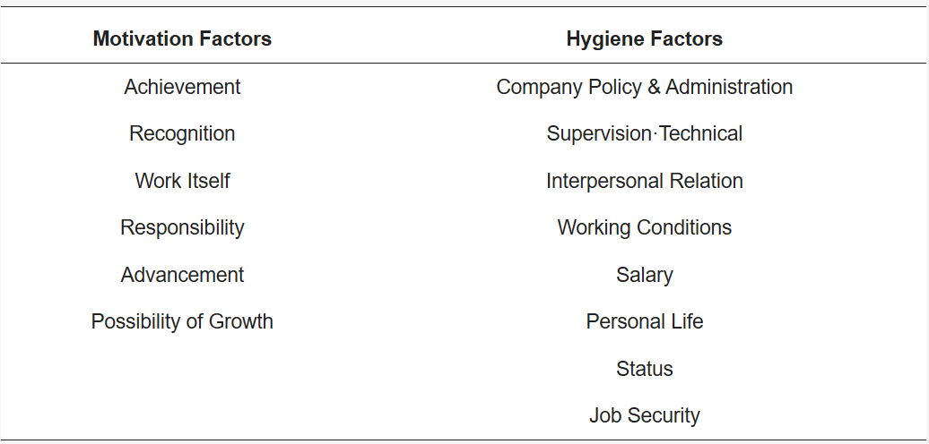
Source: Lee et al. (2022)
Despite its influence, Herzberg’s Two-Factor Theory has been subject to several criticisms. The model has been viewed as overly simplified, as it separates hygiene and motivator factors too rigidly and does not fully account for how these elements may interact in practice, particularly in manufacturing environments where working conditions, safety, and task variety are closely interconnected. Furthermore, methodological limitations have been raised, as Herzberg’s original findings were based on retrospective accounts from employees, which may have led to biased interpretations of what caused satisfaction or dissatisfaction.
Even with these limitations, the theory remains useful for manufacturing organisations by emphasising the need to address basic working conditions while also enhancing intrinsic motivation through enriched roles, acknowledgement, and opportunities for skill development (Choudhary and Agarwal, 2024).

2.5.2 Maslow’s Hierarchy of Needs
Maslow’s motivational theory is founded on the premise that all individuals share a common set of needs that influence their sense of well-being. His framework is typically described as a five-level hierarchy, beginning with physiological needs and progressing through safety, belongingness, esteem, and ultimately self-actualisation. According to Maslow, higher-order needs only become salient once lower-level needs have been sufficiently fulfilled. The theory is built on several core assumptions: that human motivation follows a hierarchical structure in which fundamental needs must be addressed before advanced needs emerge; that the sequence of this hierarchy is not absolute and may shift depending on personal or specific environmental factors like manufacturing; and that human actions are usually driven by multiple needs simultaneously rather than by a single motive (Ghaleb, 2024).
McLeod (2025) adds that Maslow’s early proposition that individuals progress through needs in a strict sequence has been challenged by more recent studies showing that people often seek to fulfil various needs concurrently. The priority given to certain needs can also differ across cultural settings; for example, collectivist cultures may value social belonging more strongly than individualistic ones. Nevertheless, the hierarchy continues to offer practical insight into understanding motivational barriers and shaping strategies to meet diverse employee needs.
Figure 1 - Maslow’s Hierarchy of Needs
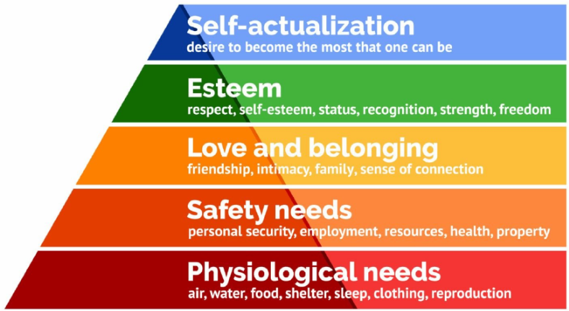
Source: McLeod (2025)
Maslow’s hierarchy has been critiqued for its rigid structure, which may not align with the realities of the manufacturing sector. Employees in manufacturing often prioritise needs differently. For example, valuing job security and stable income over higher-level needs makes the assumption of a fixed progression through the hierarchy unrealistic. Furthermore, the theory’s simplified language may fail to capture the complex motivational patterns present in physically demanding and operationally constrained manufacturing environments (Ihensekien and Joel, 2023).

2.5.3 Self-Determination Theory
According to Ryan and Vansteenkiste (2023), Self-Determination Theory (SDT) provides a comprehensive explanation of individual growth and psychological health, transforming current understanding of what drives motivation and personality development. At the heart of the theory are the basic needs for autonomy, competence, and relatedness, which must be supported by the environment for individuals to succeed. By emphasizing how these needs shape motivation, SDT has influenced the development of more effective strategies in various settings, resulting in increased engagement, well-being, and meaningful motivation.
Building on this, McAnally and Hagger (2024) highlight that individuals’ motivational experiences are directly shaped by the extent to which their behaviours satisfy these three core needs. Autonomy concerns the feeling of initiating actions willingly, and in alignment with one’s true self, competence involves the need to perceive oneself as effective and capable, and relatedness pertains to the need to feel connected, valued, and supported by others in one’s social surroundings.
Figure 2 - SDT Construct and Workplace Outcomes
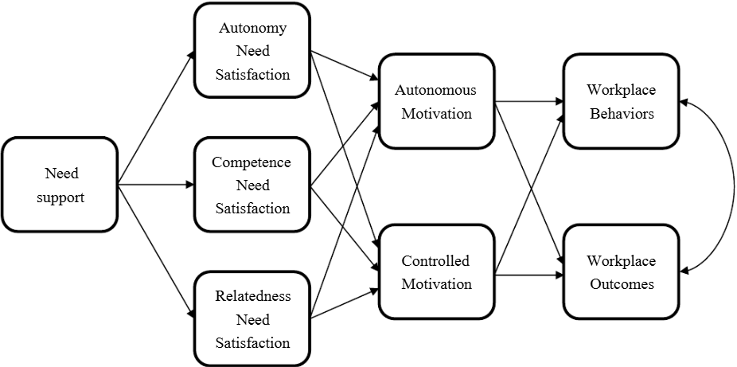
Source: McAnally and Hagger (2024)
Although Self-Determination Theory enhances understanding of motivation, applying it in manufacturing settings presents several challenges. The expression of autonomy, competence, and relatedness varies across cultures, and in production environments that rely on coordinated teamwork, employees may prioritise collective goals over individual independence. There is also the risk of reverse causality: workers who are dissatisfied with their roles may be less willing to engage in skill development or take initiative in planning their tasks. Moreover, supporting employees’ psychological needs often requires short-term investments, such as training or job redesign, which must be balanced against operational and budget constraints. As a result, manufacturing firms need to identify cost-effective ways to foster intrinsic motivation while maintaining efficient production (Guo, 2023).

2.5.4 Equity Theory
The theory suggests that individuals evaluate how fair their place of work is by comparing their inputs, such as time, effort, abilities, experience, and education, to the outputs, such as compensation, acknowledgement, benefits, and career advancement, that they receive. To ascertain whether they are receiving fair treatment, this input-to-output ratio is therefore compared to that of referent people, such as peers, coworkers, or sector standards. When employees perceive fairness, they are more prone to experience satisfaction and remain motivated. However, when they sense an imbalance, whether feeling under-rewarded or excessively rewarded, it can trigger discomfort, reduced motivation, and, over time, disengagement from their work (Shinde, 2025).
Mdhlalose (2022) adds that although intrinsic and extrinsic motivation are the fundamental forms of reward-driven behaviour, perceptions of equity can stem from both monetary and non-monetary incentives. For industries like manufacturing to achieve strong performance, it is essential that employees remain motivated, and effective reward mechanisms play a central role in sustaining that motivation. To meet the diverse preferences and expectations of the workforce, organisations must maintain an appropriate balance between financial and non-financial rewards, ensuring that both types of incentives contribute meaningfully to employee motivation.
Individuals may react to perceived unfairness in different ways, yet equity theory offers little clarity on which response is likely to occur in a given situation. Its predictive power is limited, as it can only be meaningfully applied once an exchange has taken place. In a UK manufacturing setting, judging perceived inequity becomes even more complex because several factors must be taken into account. For instance, a particular task, such as operating advanced machinery or undertaking physically demanding work, may be viewed by some employees as an input, while others may perceive it as an output. As a result, equity theory provides no clear guidance on how such differences should be interpreted when assessing employee satisfaction and motivation in manufacturing conditions (Ahmadpour-Samani et al., 2022).

2.5.5 Expectancy Theory
According to Fang (2023), the theory emphasizes outcomes rather than individual needs. Expectancy Theory proposes that the level of effort employees choose to exert is formed by their belief that such effort will lead to the desired results. In other words, employees are more prone to work persistently when they perceive a clear link between additional effort, increased performance, and meaningful rewards. This perspective indicates that organisations can strengthen overall performance by ensuring that employee contributions are appropriately recognised and rewarded. For this reason, HR practitioners should align reward mechanisms with employee values and create a supportive work environment that reinforces the effort–performance–reward connection. Failing to do so may lead to reduced motivation and, in some cases, prompt employees to leave if they feel their expectations regarding rewards will not be met.
Figure 3 - Expectancy Theory Elements
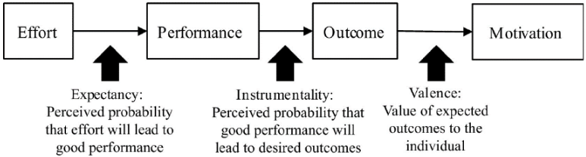
Source: Fang (2023)
A common criticism of expectancy theory is that it oversimplifies how employees are motivated, despite being refined over time through ongoing research and development. It is also criticised for assuming that individuals act solely out of rational self-interest, aiming to increase rewards and reduce discomfort, which may be true in many organisational or cultural settings but not universally. However, studies conducted across various sectors, including UK manufacturing, different job roles, and diverse labour markets, have largely supported the theory’s relevance and reliability (El-Farr, 2023).

2.6 Research Gap
Although the connection between rewards and employee motivation has been extensively studied, significant gaps remain within the existing body of literature, particularly in relation to the UK manufacturing sector. Much of the current research is concentrated in service-oriented environments, hospitality, retail, education, or large multinational corporations, where work dynamics, organisational cultures, and motivational drivers differ substantially from those found in manufacturing. As a result, insights drawn from these contexts cannot be fully generalised to manufacturing settings, specifically those concerning small and medium-sized enterprises (SMEs), which make up a large portion of the UK’s industrial landscape.
Furthermore, a considerable proportion of existing studies tends to emphasise the role of monetary rewards, including pay, bonuses, and financial incentives, as the primary mechanism for enhancing motivation (Roslinda and Andias, 2025). While financial compensation is undeniably important, the growing relevance of non-financial rewards, such as recognition, personal growth prospects, skills development, autonomy, and supportive leadership, has received comparatively less empirical attention in manufacturing contexts. This imbalance in the literature creates an incomplete understanding of how different forms of rewards simultaneously influence motivation within an industry characterised by physically demanding work, structured routines, and performance pressures linked to productivity targets (Manzoor, Wei, and Asif, 2021).
Another notable gap concerns the contextual factors that shape reward perceptions within manufacturing environments. According to Michail (2024), manufacturing roles often involve repetitive tasks, limited job flexibility, shift work, and strict performance monitoring, all of which may influence how employees evaluate both monetary and non-monetary incentives. For example, as noted by Ercegović (2025), recognition or career progression opportunities may be perceived differently by employees working on production lines compared with those in office-based roles. Yet, scholarly work exploring these nuanced perceptions remains limited, leading to an oversimplified view of motivation in the sector.
Additionally, as noted by Ahmad (2023), only a small number of recent studies have focused precisely on the UK manufacturing industry, a sector undergoing substantial transformation due to automation, digitalisation, skills shortages, and demographic changes in the workforce. These developments may alter employees’ reward preferences, making previous findings less applicable to current industry conditions.
Given these gaps, there is a clear need for research that examines how monetary and non-monetary rewards influence employee motivation within the UK manufacturing sector. By providing an updated and context-specific analysis, this study seeks to contribute to the literature by offering insights that are both theoretically meaningful and practically applicable. Such an investigation will support HR practitioners and organisational leaders in designing effective reward strategies tailored to the unique characteristics and evolving demands of the manufacturing workforce.

2.7 Chapter Summary
This chapter has provided an overview of relevant studies addressing reward systems and employee motivation. It distinguished between monetary and non-monetary rewards, discussed their definitions and significance, and examined their roles in motivating employees within the manufacturing sector. The review also explored major motivational theories, including Herzberg’s, Maslow’s, Self-Determination, Equity, and Expectancy theories, which together provide the theoretical framework for the study. Finally, the chapter identified a substantial research gap concerning the relative effectiveness of different reward types in motivating manufacturing employees in the UK, forming the basis for the empirical investigation that follows.

Chapter 3 Research Methodology

3.1 Introduction
This chapter defines the methodological framework that guided the study, ensuring that the research objectives are addressed systematically and credibly. It describes the philosophical assumptions that underpinned the investigation, the research approach adopted, and the overall methodological choices that shaped the design of the study. Since the research aimed to investigate the relationship between monetary and non-monetary rewards and employee motivation within the UK manufacturing sector, it was essential to employ a structured and rigorous methodology capable of producing reliable and generalisable findings.
The chapter, therefore, detailed the positivist philosophy that informed the research, the deductive approach used to derive hypotheses from established motivational theories, and the quantitative method selected to test these assumptions empirically. The data collection process, which relied on a structured survey instrument, is also explained, along with the sampling strategy designed to ensure representativeness across different job roles within manufacturing organisations in the UK.
Furthermore, the chapter described the statistical techniques employed to analyse the data and interpret the results in line with the study’s objectives. Ethical considerations are also discussed to demonstrate how participants' rights, confidentiality, and well-being were safeguarded throughout the research process. By presenting these elements clearly, the chapter provided a transparent explanation of how the study was conducted and justified the methodological choices that supported the generation of robust and meaningful findings.

3.2 Research Philosophy
The study employed a positivist research philosophy, as it sought to investigate the connection between financial and non-financial rewards and employee motivation within the UK manufacturing sector using objective, quantifiable evidence. Positivism aligned with the aims of the study because it emphasised observable phenomena, empirical measurement, and logical reasoning. This philosophical stance enabled the researcher to collect numerical data through a structured survey and analyse it using statistical techniques, thereby generating findings that were reliable and generalisable to a wider manufacturing workforce in the UK (Mwita, 2025).
Positivism was appropriate because the study focused on identifying patterns, testing theoretical assumptions, and drawing conclusions based on measurable variables. By adhering to objective procedures and minimising researcher bias, the positivist stance strengthened the validity of the results (Ali, 2024).
Positivism is preferred over realism, critical theory, and interpretivism because it aligns best with the study’s aim to measure and compare the effects of different rewards on employee motivation using quantitative data. Unlike interpretivism and critical theory, which are typically used in qualitative research and focus on subjective meanings or social critique, positivism provides an objective, structured framework for statistical analysis. While realism acknowledges underlying mechanisms, positivism more directly supports the empirical, data-driven approach required for this research (Keong, Husin, and Kamarudin, 2021).

3.3 Research Approach
A deductive research method was adopted. This approach began with existing theories on employee motivation and used them to formulate hypotheses about how monetary and non-monetary rewards might influence motivation in the UK manufacturing context. The deductive strategy enabled the researcher to test these theoretical assumptions through empirical data gathered from manufacturing employees in the UK (Daniel and George, 2025).
Using deduction allowed for a structured and logical progression from theory to data. The hypotheses were developed based on established literature, and the survey responses were analysed to determine whether the observed findings supported or contradicted these theoretical expectations. This approach ensured that the study remained focused, theory-driven, and aligned with the overall objective of explaining variations in employee motivation based on different reward practices.

3.4 Research Method
The study adopted a quantitative research method, which was appropriate given the need to measure relationships between variables and draw generalisable conclusions. Quantitative research enabled the gathering of standardised data from a large group of participants from UK manufacturing SMEs, allowing statistical analysis to be conducted to identify trends, correlations, and differences in motivation levels across different reward types (Taherdoost, 2022).
This method was particularly appropriate for the manufacturing context, where large workforces and structured organisational systems made numerical data collection viable and meaningful. The use of a quantitative approach also ensured objectivity, as the findings were built on numerical evidence rather than subjective interpretation. This strengthened the credibility of the results and supported the goal of producing clear and measurable insights.

3.5 Data Collection Method
Data were collected using a structured questionnaire, spread electronically to employees working within UK manufacturing organisations. The survey format allowed respondents to provide information anonymously, reducing social desirability bias and encouraging honest responses, particularly regarding perceptions of rewards and their influence on motivation (Domede and Dinkelman, 2022).
Surveys were chosen for their efficiency in gathering structured data from manufacturing employees. The questionnaire consisted of 22 Likert-scale items enabling the quantification of variables across seven sections: demographics, employee motivation, perceptions of monetary rewards, perceptions of non-monetary rewards, comparative views of both reward types, perceived fairness, and employees' rewards expectations (Tanujaya, Prahmana, and Mumu, 2022). These measures captured key constructs including reward preferences, comparative perception, motivation levels, fairness perceptions, and effort–reward expectations. Rather than adapting existing scales, the survey was designed from scratch specifically for the UK manufacturing context to ensure clarity and relevance to the study’s objectives.
A total of 50 manufacturing employees from different organisational levels participated in the study. The survey excluded senior managers and HR personnel directly responsible for reward allocation to avoid bias and ensure that responses reflected the experiences of employees rather than those shaping reward policies. This improved the objectivity and relevance of the data. The questionnaire remained open for two weeks, allowing sufficient time for participation and ensuring an adequate sample size.
The selected sample size of 50 participants is justified by both practical and methodological reasons. Limited access to employees, the exclusion of HR staff and senior management, combined with the time constraints of the study, have limited the ability to include a larger population. However, the number of participants chosen is sufficient to observe meaningful variations in responses and supports the development of reliable quantitative results.

3.6 Sampling Method
A stratified random sampling technique was utilised to obtain a representative sample of manufacturing employees. Participants were grouped into strata, and employees were randomly selected from each stratum. This method reduced sampling bias and ensured that various job levels within manufacturing were adequately represented (Jamalludin et al., 2022).
Stratified sampling was appropriate because manufacturing organisations often have hierarchical, role-specific structures. Including individuals from multiple strata improved the generalisability of findings across the wider sector. Furthermore, by reducing variability within each stratum, the sampling technique enhanced the precision and reliability of the results (Makwana et al., 2023).
The final sample size of 50 participants was considered sufficient for quantitative analysis, enabling accurate measurement of relationships between different reward practices and employee motivation.

3.7 Data Analysis Techniques
Survey data were examined through a combination of descriptive and inferential statistical techniques. Descriptive statistics, including percentages and frequencies, were utilised to summarise demographic characteristics and provide a summary of participants’ responses. These descriptive measures provided initial insight into employees’ perceptions of key variables, including monetary and non-monetary rewards, overall motivation levels, perceived fairness, and expectancy-related beliefs.
Inferential statistics, including correlation and regression analysis, were used to examine the relations between different reward types and employee motivation. These methods enabled the researcher to test the hypotheses derived from the theoretical framework and determine whether the results are statistically significant (Wang, 2024).
A simple, also known as Pearson product-moment correlation analysis, was conducted to explore the relationships between monetary rewards, non-monetary rewards, and employee motivation. This method was chosen because it provides a clear way to investigate the strength and direction of associations among variables while remaining straightforward to interpret. The correlation findings helped determine whether higher levels of specific reward types were associated with increased motivation (Zheng and Cao, 2022).
A multiple regression analysis was performed to examine the influence of monetary and non-monetary rewards on employee motivation in the UK manufacturing industry. This method was selected because it allows both predictors to be assessed simultaneously, providing a direct comparison of their relative influence on motivation while accounting for the effect of each other. This approach enabled the identification of which reward type has a stronger impact on motivation and whether both reward categories significantly predict motivational levels.
Before running the correlation and regression analyses, key statistical assumptions were checked. This included assessing linearity, normality of residuals, homoscedasticity, and the absence of multicollinearity or influential outliers. These checks confirmed that the data were suitable for the planned analyses and that the resulting findings could be interpreted with confidence.
The use of quantitative analysis tools strengthened the validity of the findings, allowing the researcher to draw conclusions based on observable patterns rather than subjective interpretations (Barella et al., 2024). Data analysis was conducted using statistical software, including Microsoft Excel and SPSS software, to ensure accuracy and consistency.
A comparison with previous research was undertaken to determine the degree to which the results align with existing theories of motivation.

3.8 Ethical Considerations
Ethical guidelines were developed to ensure that research principles were applied in a way that reflected the norms and expectations of the UK manufacturing environment. These guidelines helped translate broader ethical standards into practices suitable for this sector’s organisational culture and operational realities (Al Habsi, 2024).
The study strictly adhered to ethical guidelines to safeguard participants’ rights and ensure the integrity of the study. Participation was voluntary, and informed consent was acquired prior to respondents completing the questionnaire. Participants were guaranteed that their answers would remain anonymous and confidential, with no identifiable or personal information collected.
Employees were notified of their right to withdraw at any time without explanation. The exclusion of HR professionals and senior managers ensured that participants did not feel under pressure to take part or respond in a certain way. All data were securely saved and used only for academic purposes.

3.9 Chapter Summary
This chapter presented the methodological framework that guided the study. A positivist philosophy and deductive approach were adopted to allow the testing of theoretical assumptions through empirical investigation. A quantitative method and survey-based data collection were selected to gather data from 50 employees in the UK manufacturing sector to generate objective and generalisable findings. Stratified random sampling was used to ensure representativeness across different job roles within the UK manufacturing sector. Data were analysed using statistical techniques, and strict ethical protocols were followed to safeguard participants. Collectively, these methodological choices ensured that the study was accurate, reliable, and aligned with its research objectives.
The next chapter builds upon this methodological foundation by presenting the empirical results of the study. It will detail the survey outcomes, analyse the data using appropriate statistical techniques, and discuss how the findings relate to existing theories and literature on employee motivation and different reward types within the UK manufacturing industry. It will provide a comprehensive interpretation of the results and establish the basis for the study’s conclusions.

Chapter 4 Data Analysis and Discussion

4.1 Introduction
This chapter presents and analyses the quantitative findings of the study examining the influence of monetary and non-monetary rewards on employee motivation in the UK manufacturing sector. Using data collected from 50 manufacturing employees, the chapter reports the survey results, descriptive statistics, reliability testing, Pearson correlation analysis, and multiple regression analysis. The findings are interpreted in relation to the research questions and discussed with reference to relevant motivational theories and prior empirical research.

4.2 Survey Results
A total of 50 employees from the UK manufacturing sector participated in the survey. For the purpose of the research, participants were asked 22 questions divided into 7 sections, including demographics, employee motivation, perceptions of monetary rewards, perceptions of non-monetary rewards, comparative views of both reward types, perceived fairness, and employees' rewards expectations.
Figure 4 – Question 1 - Participants' Age
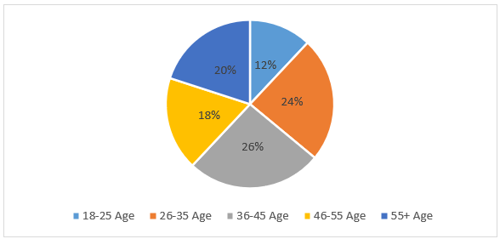
Source: created by Author
Age 18 - 25 | Age 26 - 35 | Age 36 - 45 | Age 46 - 55 | Age 55+
12% | 24% | 26% | 18% | 20%
The age distribution of respondents was relatively balanced, with the largest proportion falling within the 36–45 age group (26%), followed by those aged 26–35 (24%). Participants aged 46–55 and 55+ accounted for 18% and 20% respectively, while younger employees aged 18–25 represented 12% of the sample. This distribution indicates representation across a wide range of age groups within the manufacturing workforce.
Figure 5 – Question 2 - Participants' Gender
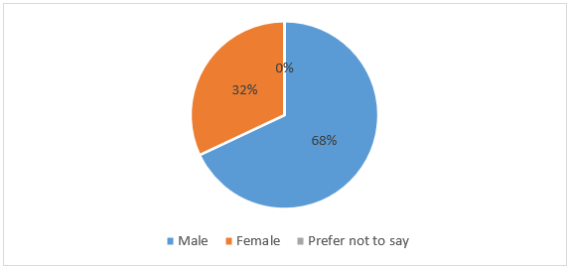
Source: created by Author
Male | Female | Prefer not to say
68% | 32% | 0%
The gender distribution of the sample indicates that most respondents were male (68%), while females accounted for 32% of the participants. No respondents selected the “prefer not to say” option. This distribution reflects the traditionally male-dominated nature of the UK manufacturing sector and suggests that the sample is broadly representative of the industry workforce.
Figure 6 – Question 3 - Participants' Years of Experience
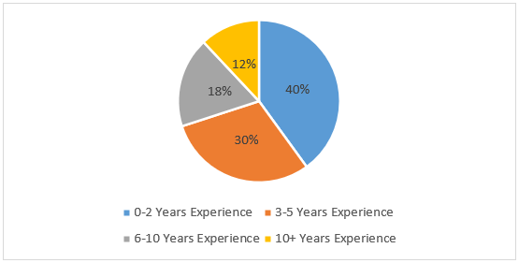
Source: created by Author
Experience 0 – 2 Years | Experience 3 – 5 Years | Experience 6 – 10 Years | Experience 10+ Years
40% | 30% | 18% | 12%
The sample was predominantly composed of employees with relatively lower levels of experience, with 40% reporting 0–2 years and 30% reporting 3–5 years of experience. More experienced employees were less represented, with 18% having 6–10 years of experience and 12% reporting over 10 years of experience. This suggests that the findings largely reflect the perceptions of early- to mid-career employees within the manufacturing sector.
Figure 7 - Question 4 - I feel motivated to give my best effort in my daily work tasks.
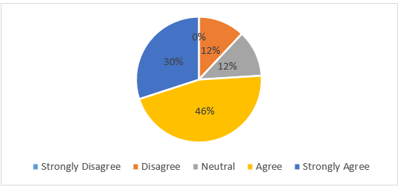
Source: created by Author
Strongly Disagree | Disagree | Neutral | Agree | Strongly Agree
0% | 12% | 12% | 46% | 30%
Responses indicate a generally high level of motivation among participants, with 76% either agreeing (46%) or strongly agreeing (30%) that they feel motivated to give their best effort in daily work tasks. Neutral responses accounted for 12%, while 12% disagreed, and no respondents strongly disagreed, suggesting an overall positive motivational outlook among employees.
Figure 8 - Question 5 - I put extra effort into my job, even when tasks are demanding or repetitive.
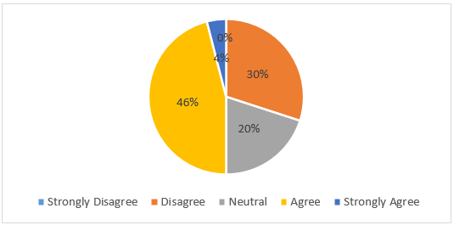
Source: created by Author
Strongly Disagree | Disagree | Neutral | Agree | Strongly Agree
0% | 30% | 20% | 46% | 4%
Responses show a mixed pattern, with 50% of participants agreeing or strongly agreeing that they put extra effort into their job when tasks are demanding or repetitive. However, a notable proportion disagreed (30%) or remained neutral (20%), suggesting variability in employees’ willingness to exert additional effort under challenging or repetitive working conditions.
Figure 9 - Question 6 - I feel committed to achieving high performance in my role.
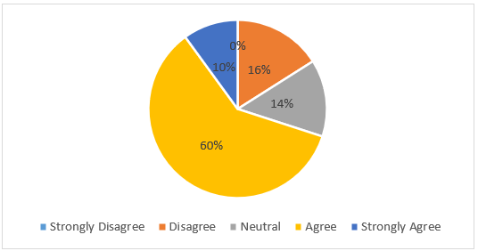
Source: created by Author
Strongly Disagree | Disagree | Neutral | Agree | Strongly Agree
0% | 16% | 14% | 60% | 10%
The majority of respondents reported a strong sense of commitment to high performance, with 70% either agreeing (60%) or strongly agreeing (10%) with the statement. Neutral responses accounted for 14%, while 16% disagreed, indicating generally positive performance commitment among participants.
Figure 10 - Question 7 - I am willing to take the initiative to improve my work processes or productivity.
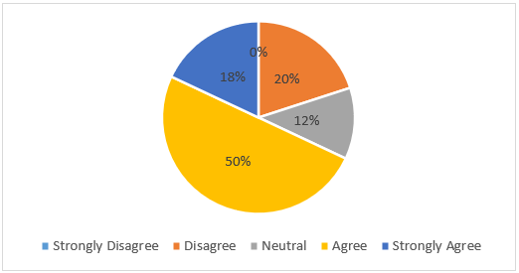
Source: created by Author
Strongly Disagree | Disagree | Neutral | Agree | Strongly Agree
0% | 20% | 12% | 50% | 18%
Responses indicate a generally proactive attitude among participants, with 68% agreeing (50%) or strongly agreeing (18%) that they are willing to take the initiative to improve work processes or productivity. However, 20% disagreed, and 12% remained neutral, suggesting that while most employees demonstrate initiative, a minority may require additional support or motivation.
Figure 11 - Question 8 - Salary is the main factor that motivates me to perform better at work.
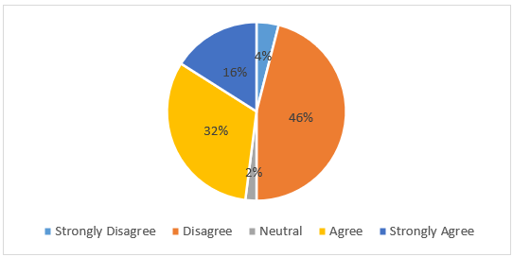
Source: created by Author
Strongly Disagree | Disagree | Neutral | Agree | Strongly Agree
4% | 46% | 2% | 32% | 16%
Responses indicate mixed views regarding the motivational role of salary. While 48% of respondents agreed or strongly agreed that salary is the main motivator for improved performance, a substantial proportion (50%) either disagreed or strongly disagreed, and 2% remained neutral. This suggests that salary alone may not be the primary motivational drive for many employees.
Figure 12 - Question 9 - Regular bonuses and incentives increase my motivation and job satisfaction.
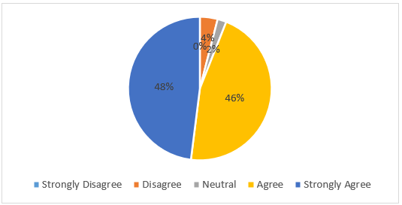
Source: created by Author

Strongly Disagree | Disagree | Neutral | Agree | Strongly Agree
0% | 4% | 2% | 46% | 48%
The findings indicate strong support for the motivational impact of bonuses and incentives, with 94% of respondents agreeing or strongly agreeing that regular bonuses enhance their motivation and job satisfaction. Only a small minority expressed disagreement (4%) or neutrality (2%), highlighting the perceived importance of performance-related financial incentives.
Figure 13 - Question 10 - The pay I receive reflects the work I do.
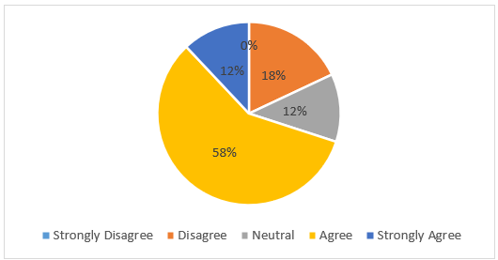
Source: created by Author
Strongly Disagree | Disagree | Neutral | Agree | Strongly Agree
0% | 18% | 12% | 58% | 12%
The majority of respondents perceived their pay as reflective of their work, with 70% agreeing or strongly agreeing with the statement. Neutral responses accounted for 12%, while 18% disagreed. This suggests a generally positive perception of pay fairness, although a notable minority expressed dissatisfaction.
Figure 14 - Question 11 - Monetary rewards are an important factor in keeping me motivated at work.
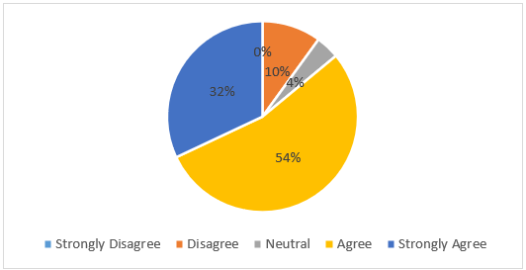
Source: created by Author
Strongly Disagree | Disagree | Neutral | Agree | Strongly Agree
0% | 10% | 4% | 54% | 32%
The results indicate that monetary rewards are widely viewed as important for maintaining motivation, with 86% of participants agreeing (54%) or strongly agreeing (32%) with the statement. Only 10% disagreed, and 4% remained neutral, suggesting that monetary rewards play a substantial role in sustaining employee motivation
Figure 15 - Question 12 - Recognition motivates me to work harder.
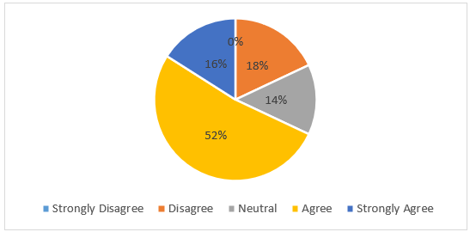
Source: created by Author
Strongly Disagree | Disagree | Neutral | Agree | Strongly Agree
0% | 18% | 14% | 52% | 16%
Responses suggest that recognition is an important motivator, with 68% of participants agreeing (52%) or strongly agreeing (16%) that recognition motivates them to work harder. Neutral responses accounted for 14%, while 18% disagreed, indicating that although most employees value recognition, its motivational impact may vary across individuals.
Figure 16 - Question 13 - Opportunities for training and skill development improve my motivation.
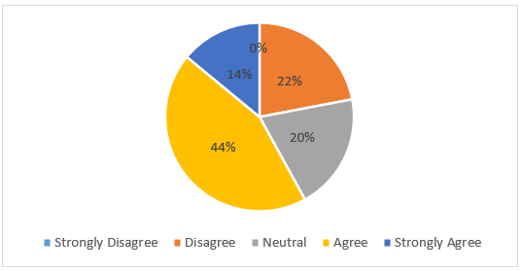
Source: created by Author
Strongly Disagree | Disagree | Neutral | Agree | Strongly Agree
0% | 22% | 20% | 44% | 14%
The findings show a generally positive view of training and skill development, with 58% of respondents agreeing (44%) or strongly agreeing (14%) that such opportunities enhance their motivation. However, 22% disagreed, and 20% remained neutral, suggesting that while development opportunities motivate many employees, their perceived value is not universal.
Figure 17 - Question 14 - Career advancement opportunities (e.g., promotions) are more motivating than financial incentives.
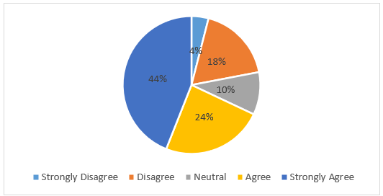
Source: created by Author
Strongly Disagree | Disagree | Neutral | Agree | Strongly Agree
4% | 18% | 10% | 24% | 44%
Responses indicate mixed but generally positive perceptions of career advancement as a motivator, with 68% of participants agreeing (24%) or strongly agreeing (44%) that promotion opportunities are more motivating than financial incentives. However, 22% disagreed or strongly disagreed, and 10% remained neutral, highlighting variation in employee reward preferences
Figure 18 - Question 15 - Non-financial benefits (e.g., flexible hours, job security) matter to me more than money.
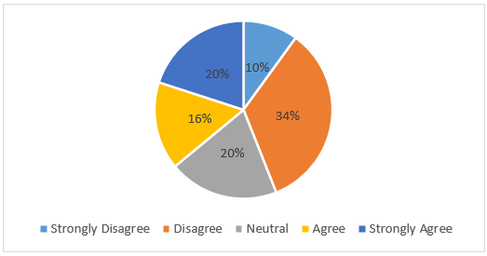
Source: created by Author
Strongly Disagree | Disagree | Neutral | Agree | Strongly Agree
10% | 34% | 20% | 16% | 20%

Responses reveal divided views on the importance of non-financial benefits compared to financial benefits. While 36% of respondents agreed (16%) or strongly agreed (20%) that non-financial benefits matter more than monetary rewards, a larger proportion (44%) disagreed or strongly disagreed, and 20% persisted neutral. This suggests that preferences for non-financial benefits vary considerably among employees.
Figure 19 - Question 16 - I am more motivated by monetary rewards than non-monetary rewards.
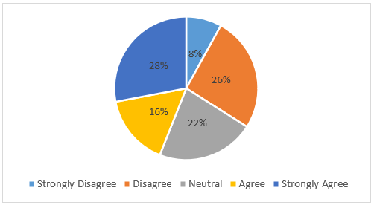
Source: created by Author
Strongly Disagree | Disagree | Neutral | Agree | Strongly Agree
8% | 26% | 22% | 16% | 28%
Responses indicate varied perceptions regarding the relative motivational impact of reward types. While 44% of respondents agreed (16%) or strongly agreed (28%) that they are more motivated by monetary rewards, 34% disagreed or strongly disagreed, and 22% remained neutral. This reflects a lack of consensus among employees and suggests diverse motivational preferences
Figure 20 - Question 17 - A balance of both financial and non-financial rewards keeps me motivated.
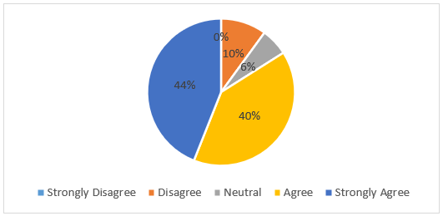
Source: created by Author
Strongly Disagree | Disagree | Neutral | Agree | Strongly Agree
0% | 10% | 6% | 40% | 44%
The majority of respondents supported a balanced reward approach, with 84% agreeing (40%) or strongly agreeing (44%) that a combination of monetary and non-monetary rewards helps maintain motivation. Only 10% disagreed, and 6% remained neutral, indicating strong endorsement of integrated reward systems.
Figure 21 - Question 18 - In the long term, non-monetary rewards (training and recognition) sustain motivation better than financial incentives.
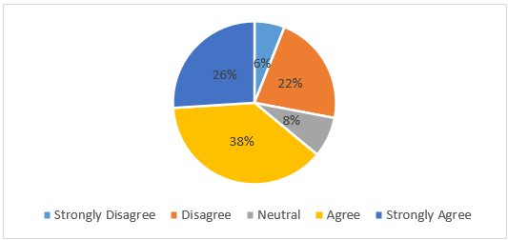
Source: created by Author
Strongly Disagree | Disagree | Neutral | Agree | Strongly Agree
6% | 22% | 8% | 38% | 26%
Responses suggest a generally positive perception of the long-term motivational value of non-monetary rewards, with 64% of participants agreeing (38%) or strongly agreeing (26%) with the statement. However, 28% disagreed or strongly disagreed, and 8% remained neutral, indicating that while non-monetary rewards are viewed as more sustainable motivators by many, opinions vary across the workforce.
Figure 22 - Question 19 - I believe that strong performance will be recognised or rewarded by management.
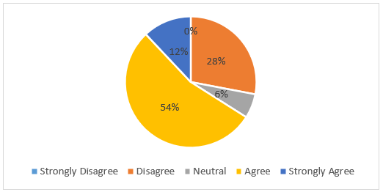
Source: created by Author
Strongly Disagree | Disagree | Neutral | Agree | Strongly Agree
0% | 28% | 6% | 54% | 12%
The findings indicate a generally positive perception of performance recognition, with 66% of respondents agreeing (54%) or strongly agreeing (12%) that strong performance will be recognised or rewarded by management. However, 28% disagreed, and 6% remained neutral, suggesting that a notable minority may question the consistency of recognition practices.
Figure 23 - Question 20 - The link between effort, performance, and reward is clear in my organisation.
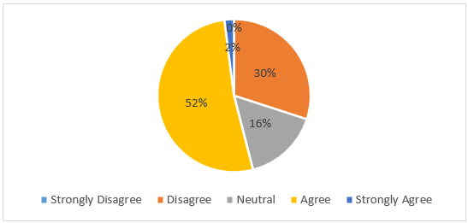
Source: created by Author
Strongly Disagree | Disagree | Neutral | Agree | Strongly Agree
0% | 30% | 16% | 52% | 2%
Responses reveal mixed perceptions regarding the clarity of the effort–performance–reward relationship. While 54% of participants agreed (52%) or strongly agreed (2%) that this link is clear within their organisation, 30% disagreed, and 16% remained neutral, indicating potential gaps in how reward systems are communicated or perceived.
Figure 24 - Question 21 - I believe my effort at work is fairly rewarded compared to my colleagues.
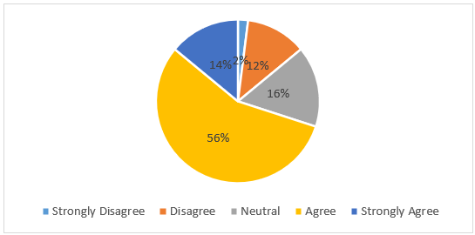
Source: created by Author
Strongly Disagree | Disagree | Neutral | Agree | Strongly Agree
2% | 12% | 16% | 56% | 14%
The majority of respondents perceived their efforts as fairly rewarded compared with colleagues, with 70% agreeing (56%) or strongly agreeing (14%) with the statement. Neutral responses accounted for 16%, while 14% disagreed or strongly disagreed, indicating generally positive perceptions of fairness with some remaining concerns.
Figure 25 - Question 22 - The balance between what I contribute and what I receive feels fair.
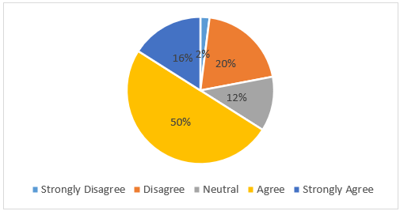
Source: created by Author
Strongly Disagree | Disagree | Neutral | Agree | Strongly Agree
2% | 20% | 12% | 50% | 16%
Responses indicate that most participants perceived a fair balance between their contributions and rewards, with 66% agreeing (50%) or strongly agreeing (16%) with the statement. Neutral responses accounted for 12%, while 22% disagreed or strongly disagreed, suggesting that although perceptions of fairness are generally positive, some employees remain dissatisfied.

4.3 Data Analysis

4.3.1 Demographic Characteristics of Participants
The following table summarises the demographic characteristics of the respondents. The sample consisted of 50 participants working in the UK manufacturing sector.

Table 2 - Demographic Characteristics of Participants
Variable | Category | Frequency | Percentage (%)
Age | 18-25 | 6 | 12.0
Age | 26-35 | 12 | 24.0
Age | 36-45 | 13 | 26.0
Age | 46-55 | 9 | 18.0
Age | 55+ | 10 | 20.0
Gender | Male | 34 | 68.0
Gender | Female | 16 | 32.0
Gender | Prefer not to say | 0 | 0.0
Experience | 0-2 years | 20 | 40.0
Experience | 3-5 years | 15 | 30.0
Experience | 6-10 years | 9 | 18.0
Experience | 10+ years | 6 | 12.0
Source: created by Author
The sample was predominantly male (68%), reflecting the gender distribution commonly observed in the manufacturing sector. A wide age range was represented, with the largest proportion of participants falling within the 36 - 45 year age range (26%). In terms of experience, 70% of respondents had five years or less of manufacturing experience, indicating an early to mid-career stage workforce.

4.3.2 Descriptive Statistics
Descriptive statistics were calculated for the composite variables: employee motivation, monetary rewards, and non-monetary rewards.
Table 3 - Descriptive Statistics
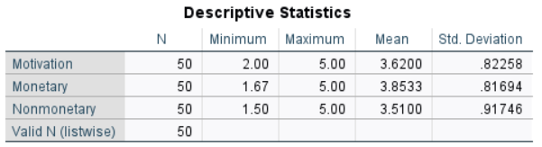
Source: created by Author
Employee motivation recorded a mean score of 3.62 (SD = 0.82) on a five-point Likert scale, indicating a moderately high level of motivation among participants. The relatively low standard deviation suggests that motivation levels were consistent among respondents, with most employees agreeing with motivational statements. This indicates a generally motivated workforce within the UK manufacturing sector.
Monetary rewards produced the highest mean score among the three constructs (M = 3.85, SD = 0.82), suggesting that financial incentives such as salary and bonuses are perceived as important motivational factors by employees. The moderate standard deviation shows some variability in how employees value monetary rewards, reflecting individual differences in financial priorities and circumstances.
Non-monetary rewards reported a mean score of 3.51 (SD = 0.92), indicating a positive overall perception, though slightly lower than monetary rewards. The higher standard deviation suggests greater variability in responses, implying that employees differ more in their valuation of recognition, training opportunities, and career advancement.
These descriptive findings provide a robust foundation for subsequent inferential analyses examining the relative influence of monetary and non-monetary rewards on employee motivation.

4.3.3 Reliability Analysis
Cronbach’s alpha was used to assess the internal consistency of the scales.
Table 4 - Reliability Test/ Cronbach's Alpha
Scale | Number of Items | Cronbach’s Alpha
Employee Motivation | 4 | .894
Monetary Rewards | 3 | .777
Non-Monetary Rewards | 4 | .811
Source: created by Author
Note: One item measuring perceived pay fairness was removed from the monetary rewards scale to improve internal consistency.
Reliability analysis was conducted to measure the internal consistency of the study constructs using Cronbach’s alpha, ensuring that the survey items consistently measured the intended concepts. The employee motivation scale showed excellent reliability (α = .894), revealing a high level of internal consistency among the items used to capture motivational behaviours and attitudes. Similarly, the non-monetary rewards scale also showed strong internal consistency (α = .811), indicating that the items measuring recognition, development opportunities, and non-financial benefits were coherent and conceptually aligned.
The monetary rewards scale initially produced a lower alpha (α = .658). Item-total statistics indicated that one item (“The pay I receive reflects the work I do”) exhibited a low corrected item–total correlation, and its exclusion increased Cronbach’s alpha to .777. As this item primarily captured perceptions of fairness rather than motivational influence, it was excluded from the final scale to enhance both reliability and conceptual alignment.
(For a detailed reliability test, please refer to Appendix 1)

4.3.4 Pearson Correlation Analysis
Pearson correlation techniques were applied to assess the associations between monetary rewards, non-monetary rewards, and employee motivation.
Table 5 - Pearson Correlation Analysis
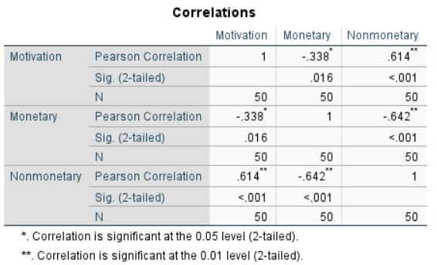
Source: created by Author
A significant negative correlation was found between monetary rewards and employee motivation (r = −.338, p = .016). This indicates that, within this sample, higher emphasis on monetary rewards is associated with lower reported motivation levels. Although counterintuitive at first glance, this finding suggests that financial incentives alone may not sustain or enhance motivation, particularly in a manufacturing context where repetitive tasks and intrinsic engagement play a crucial role. Employees who place stronger importance on monetary rewards may experience reduced intrinsic motivation, supporting theoretical arguments that excessive dependence on extrinsic rewards can undermine internal motivational drivers.
A strong positive correlation was observed between non-monetary rewards and employee motivation (r = .614, p < .001). This suggests that employees who value recognition, training opportunities, and career development tend to report significantly higher motivation levels. The strength of this relationship indicates that non-financial rewards play a central role in motivating the workforce, reinforcing the importance of intrinsic and psychological factors in the workplace. This finding aligns with motivation theories emphasizing autonomy, competence, and recognition as key drivers of sustained engagement.
A strong negative correlation was identified between monetary and non-monetary rewards (r = −.642, p < .001), indicating that employees who strongly value one type of reward tend to place less importance on the other. This inverse relationship suggests the presence of distinct motivational orientations within the workforce: some employees are more financially driven, while others are more motivated by developmental and relational rewards. This finding supports the rationale for examining both reward types simultaneously in the regression analysis.

4.3.5 Multiple Regression Analysis
Multiple regression analysis was conducted to examine the combined and relative influence of monetary and non-monetary rewards on employee motivation.
Table 6 - Regression Analysis/ Model Summary
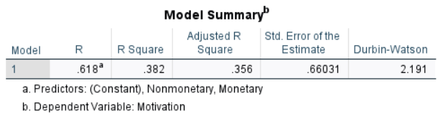
Source: created by Author
The model explained 38.2% of the variance in employee motivation, indicating a moderate to strong explanatory power. The Durbin–Watson statistic (2.191) suggested no autocorrelation issues.
Table 7 - ANOVA Table
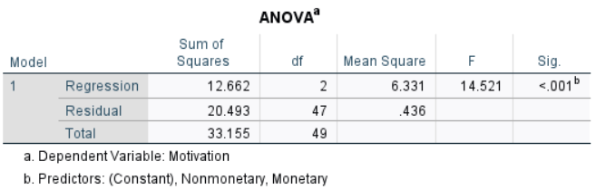
Source: created by Author
The regression model was statistically significant (F (2,47) = 14.521, p < .001), confirming that the predictors jointly contributed to explaining employee motivation.
Table 8 - Regression Coefficients
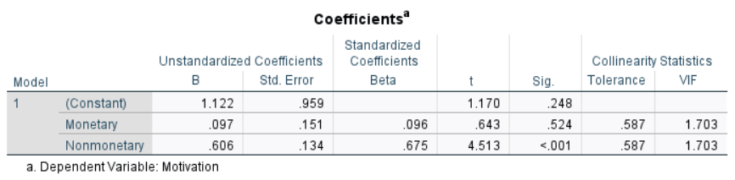
Source: created by Author
Non-monetary rewards emerged as a significant predictor of employee motivation, whereas monetary rewards did not show a statistically meaningful effect. Specifically, non-monetary rewards demonstrate a strong positive standardized effect on motivation (β = .675, t = 4.513, p < .001), indicating that increases in recognition, development opportunities, and non-financial benefits are associated with higher motivation among employees in the UK manufacturing sector. In contrast, monetary rewards had a weak, non-significant relationship with motivation (β = .096, t = .643, p = .524), suggesting that financial incentives alone do not substantially enhance motivation when non-monetary rewards are considered. Collinearity diagnostics indicated levels (VIF = 1.703), confirming that multicollinearity was not a concern and that the regression estimates were reliable. Overall, these findings reinforce the conclusion that non-monetary rewards play a more influential role in driving employee motivation than monetary rewards.

4.3.6 Assumption Checks
Regression assumptions were assessed before interpretation. Residual plots and histograms indicated that the residuals were approximately normally distributed. Scatterplots showed no evidence of heteroscedasticity. Tolerance and VIF values confirmed the absence of multicollinearity. No extreme outliers were observed, supporting the robustness of the regression results.
(For histograms, residual plots, and scatterplots, please refer to Appendix 2)

4.4 Discussion of Findings
This section presents the study's key findings in association with the research questions and the existing literature on employee motivation and different types of rewards. Drawing on the quantitative results presented in the previous section, the discussion critically examines the relative influence of monetary and non-monetary rewards on employee motivation in the UK manufacturing sector, while integrating insights from established motivational theories.

4.4.1 Influence of Monetary and Non-monetary Rewards on Employee Motivation
The first research question aims to examine how monetary and non-monetary rewards influence employee motivation in the UK manufacturing sector. The findings indicate a clear distinction between the two reward types. While both monetary and non-monetary rewards were rated positively by respondents at the descriptive level, inferential analysis revealed that only non-monetary rewards significantly predicted employee motivation when both reward types were considered simultaneously.
The multiple regression analysis demonstrated that non-monetary rewards were a strong and statistically significant predictor of motivation (β = .675, p < .001), whereas monetary rewards did not exert a significant independent effect. This suggests that although financial compensation remains an important baseline factor, it does not, on its own, substantially enhance motivational outcomes once non-financial factors are accounted for. As noted by Harendra (2025), when workers feel genuinely appreciated by management through non-financial rewards such as promotion opportunities, recognition schemes, skills development, or flexible working time, their overall motivation, engagement, and performance can improve significantly. This finding reinforces the argument that monetary rewards may function more as maintenance or hygiene factors rather than as true drivers of sustained motivation.
These results are consistent with Herzberg’s Two-Factor Theory, which posits that salary and financial incentives prevent dissatisfaction but do not essentially lead to higher motivation or job satisfaction. On the other hand, motivators such as recognition, individual progress, and responsibility are more likely to foster genuine engagement (Lee et al., 2022). In the manufacturing context, often characterised by repetitive tasks, structured workflows, and limited autonomy, non-monetary rewards such as recognition and progress opportunities are playing a crucial role in improving intrinsic motivation.
Furthermore, the findings align with contemporary research conducted by Chi et al. (2023), suggesting that overreliance on financial incentives can produce diminishing motivational returns, especially in environments where financial rewards are perceived as expected rather than exceptional. In such contexts, employees may become desensitised to monetary incentives, shifting their motivational focus toward rewards that provide psychological fulfilment and long-term value.
On the other hand, the findings contradict the research carried out by Kumari et al. (2021) and Mithunmita and Britto (2021), which state that monetary rewards serve as the main motivator to encourage employees to achieve the desired performance and productivity by reinforcing their sense of value within an organisation.

4.4.2 Perceived Effectiveness of Monetary and Non-Monetary Rewards
The second research question explored the extent to which employees perceive monetary or non-monetary rewards as more effective in enhancing motivation. The correlation analysis exposed a strong positive connection between non-monetary incentives and employee motivation (r = .614, p < .001), whereas the relationship between monetary rewards and motivation was weak and statistically insignificant.
These findings suggest that employees in the UK manufacturing sector are more strongly motivated by non-financial rewards than by financial incentives alone. This perception may reflect changing workforce expectations, where employees increasingly value recognition, career advancement, job security, and work-life balance alongside, or even above, financial compensation. These findings align with Alshaidhani et al. (2024) conclusion that social norms evolve and workplace environments undergo significant transformation, affecting employees' perceived effectiveness of monetary and non-monetary rewards.
Self-Determination Theory (SDT) provides a valuable framework for interpreting this result. According to SDT, motivation is enhanced when a person's needs for autonomy, competence, and relatedness are fulfilled (McAnally and Hagger, 2024). Non-monetary rewards such as training opportunities, recognition, and career progression directly support these psychological needs, whereas monetary rewards tend to operate externally and may not foster internal motivation. The strong predictive power of non-monetary rewards in this study suggests that employees derive greater motivational value from rewards that enhance their sense of purpose, capability, and organisational belonging.
At the same time, the findings do not imply that monetary rewards are irrelevant. Rather, they suggest that financial incentives may be more effective when combined with non-monetary rewards, supporting the notion of a balanced reward system. As highlighted by Lee et al. (2022), the balance between monetary and non-monetary rewards can lead to increased and sustainable motivation, which can be crucial in manufacturing SMEs. This interpretation is consistent with Expectancy Theory, which emphasises that motivation depends on the perceived link between effort, performance, and valued outcomes (Fang, 2023). Employees may be motivated not simply by pay increases, but by the belief that their efforts will be recognised and lead to meaningful personal and professional outcomes.

4.4.3 Employees’ Perceptions and Preferences Regarding Different Reward Types
The third research question examined employees’ perceptions and preferences regarding different types of rewards. A notable finding was the moderate negative correlation between monetary and non-monetary rewards (r = −.642, p < .001). This suggests that employees who place greater emphasis on non-monetary rewards tend to place less emphasis on monetary rewards, and vice versa.
This pattern highlights the heterogeneity of employee motivation, suggesting that a “one-size-fits-all” reward strategy may be ineffective. Employees differ in their values, career stages, and personal circumstances, which influence how they perceive and prioritise rewards (Ercegović, 2025). For instance, employees who feel financially secure may place greater value on recognition and development, while those experiencing financial pressure may prioritise pay and bonuses.
This interpretation is particularly relevant within the current UK economic context. Chatzoglou, Diamantidis, and Karras (2024) argue that periods of economic uncertainty, such as the ongoing cost-of-living crisis in the UK, can temporarily shift employee preferences towards specific rewards depending on their current personal needs. These findings reinforce the importance of understanding employee motivation as context-dependent rather than static.
The finding also indicates that regardless of participants' preferences toward specific reward types, most participants (84%) agreed or strongly agreed that a combination of financial and non-financial rewards is most effective in maintaining their motivation. This suggests that employees recognise the complementary role of different reward mechanisms, where financial incentives address economic security while non-financial rewards support intrinsic motivation and long-term engagement.
Equity Theory offers insight into these findings by emphasising the role of perceived fairness in shaping motivation. Employees assess rewards not only in absolute terms but also relative to their contributions and to the rewards received by others (Shinde, 2025). Non-monetary rewards such as recognition and career opportunities may be perceived as more equitable and transparent than monetary rewards, particularly in manufacturing settings where pay structures are often standardised or constrained by organisational policies.
Maslow’s Hierarchy of Needs further supports this interpretation. Once basic physiological and safety needs, often satisfied through wages and job security, are met, individuals are motivated by higher-order needs such as appreciation and self-actualisation (Ghaleb, 2024). The strong connection between non-monetary rewards and motivation observed in this study suggests that many employees may have progressed beyond basic needs and are seeking fulfilment through recognition, personal growth, and meaningful work.

4.5 Chapter Summary
This chapter presented and analysed the quantitative findings of the study, examining the relationships between monetary rewards, non-monetary incentives, and employee motivation within the UK manufacturing industry in relation to the research questions, theoretical frameworks, and present literature. Descriptive statistics presented a summary of participant characteristics and response patterns, while reliability testing verified that the measurement scales demonstrated strong internal consistency. Correlation and regression analyses were then applied to assess the strength and direction of relationships between the key variables and to evaluate their relative influence on employee motivation.
The results demonstrated that while monetary rewards are valued, non-monetary rewards exert a significantly stronger influence on employee motivation in the UK manufacturing sector. Through the lenses of Herzberg’s Two-Factor Theory, Maslow’s Hierarchy of Needs, Self-Determination Theory, Expectancy Theory, and Equity Theory, the findings highlight the importance of intrinsic, developmental, and relational reward mechanisms. Together, the findings provide a robust foundation for the conclusions and recommendations presented in the final chapter.

Chapter 5 Conclusion, Limitations, and Recommendations

5.1 Introduction
This chapter synthesises the key findings related to the central research question of how monetary and non-monetary rewards influence employee motivation within the UK manufacturing sector. It draws together the key empirical results to highlight the overall patterns identified in employee reward preferences and motivational responses. In addition, the chapter critically reflects on the methodological and contextual limitations of the research, ensuring a balanced interpretation of the findings. Finally, it outlines practical and theoretical implications and proposes directions for future research to support more effective and sustainable reward management practices within manufacturing organisations.

5.2 Key Research Results
This research examined the influence of monetary and non-monetary rewards on employee motivation within the UK manufacturing sector. The findings provide a comprehensive understanding of how different reward mechanisms form motivation and offer clear conclusions in connection to the study’s research questions.
Overall, the results demonstrate that both financial and non-financial rewards contribute to employee motivation, even though they do so in distinct ways. Monetary rewards, including salary and financial incentives, remain an essential component of motivation, particularly in establishing perceptions of fairness, economic security, and baseline job satisfaction. Participants consistently acknowledged the importance of adequate and equitable pay, indicating that monetary rewards play a foundational role in motivating employees, reinforcing their sense of value within the organisation, and enhancing their productivity (Mithunmita and Britto, 2021). However, financial incentives alone were not perceived as sufficient to sustain motivation over the long term.
In contrast, non-monetary rewards emerged as particularly influential in supporting sustained motivation and engagement. Rewards such as recognition, opportunities for skill development, career progression, and non-financial benefits were widely valued by employees. These forms of rewards were closely associated with employees’ willingness to exert discretionary effort, demonstrate commitment, and remain engaged in their roles. This finding suggests that intrinsic and relational aspects of work play a crucial role in motivating employees within the manufacturing context, even in traditionally task-oriented and structured environments (Qader, 2021).
A further important outcome relates to employee preferences and reward trade-offs. The findings revealed clear differences in how employees prioritise reward types, reflecting variations in personal circumstances, career stages, and financial pressures. Some employees placed greater emphasis on monetary rewards, particularly in light of economic uncertainty and cost-of-living concerns in the UK (Chatzoglou, Diamantidis, and Karras, 2024). Conversely, others prioritised non-monetary rewards that contribute to personal growth and job satisfaction (Harendra, 2025). Despite individual differences in reward preferences, the findings reveal a strong consensus that a balanced combination of financial and non-financial rewards is the most effective approach for sustaining employee motivation.
An additional key finding of the study relates to employees’ perceptions of reward clarity and organisational credibility. The results indicate that employees are more motivated when there is a clear and reliable link between effort, performance, and reward (Fang, 2023). Participants generally agreed that strong performance should be recognised and that transparent reward systems enhance motivation. This suggests that motivation is not driven solely by the type of reward offered, but also by employees’ confidence in how consistently and fairly rewards are applied. Within the UK manufacturing context, where work processes and performance expectations are often clearly defined, the credibility of reward systems appears to play an essential role in reinforcing motivation.
The findings of this study partially diverge from some existing literature that positions monetary rewards as the dominant motivational driver in operational and industrial contexts. While monetary rewards remain important, the stronger influence of non-monetary factors observed in this study may reflect broader changes within the UK manufacturing sector, including increased automation, higher skill requirements, and greater emphasis on continuous learning (Ahmad, 2023). These developments may have altered employee expectations, shifting motivation away from purely transactional reward relationships toward more developmental and recognition-based incentives. This suggests that existing theoretical models and sector-based generalisations may require contextual re-evaluation when applied to modern manufacturing environments.
At the organisational level, the results also expose a practical tension between employee expectations and operational realities. Manufacturing organisations are under increasing pressure to control labour costs while remaining competitive in volatile markets (British Chambers of Commerce, 2026). Although employees expressed a preference for balanced reward systems, implementing such approaches may be constrained by limited financial flexibility and managerial capacity. As a result, companies may rely more heavily on low-cost non-monetary strategies, such as recognition programmes or internal progression opportunities, as substitutes for financial incentives. However, this approach carries the risk of dissatisfaction if employees perceive compensation as insufficient, highlighting the importance of aligning reward design with both workforce expectations and organisational sustainability (Lee et al., 2022).
These findings highlight that employee motivation in the UK manufacturing sector is multidimensional and context-dependent. Employees do not view reward mechanisms as isolated or competing, but rather as complementary components of an effective motivational framework. Financial rewards address essential economic and security needs by ensuring financial stability and supporting employees’ basic and safety needs, as outlined by Paul (2024). On the other hand, non-monetary rewards foster intrinsic motivation, reinforce employees’ sense of recognition and value, and encourage long-term engagement within the organisation (Madhani, 2021). This integrated perspective underscores the importance of flexible reward strategies that cater to diverse motivational drivers and evolving employee expectations.
Taken together, the key research results demonstrate that reliance on a single form of reward is unlikely to maximise motivation in the manufacturing sector. Instead, the most effective motivational outcomes are achieved through well-designed, balanced reward systems that combine financial fairness with meaningful non-monetary incentives. These conclusions directly address the research questions and establish a coherent foundation for the practical and theoretical recommendations presented in the next sections.

5.3 Research Limitations
Despite the contributions of this study, respective limitations must be addressed when interpreting the findings.
The sample size of 50 participants represents a relatively small proportion of the wider workforce within the UK manufacturing sector. Although the sample was sufficient to conduct the planned quantitative analyses and identify meaningful patterns, the limited number of respondents restricts the extent to which the findings can be confidently generalised across the entire sector. As employee motivation and reward preferences can vary considerably across organisations, regions, and job roles, the results should be interpreted as indicative rather than representative of all manufacturing employees in the UK. Future studies should employ larger samples across multiple UK manufacturing companies to strengthen external validity and enable subgroup analysis.
The study’s sector-specific focus on UK manufacturing further limits generalisability. Manufacturing environments differ substantially from other sectors in terms of job design, organisational structure, and reward practices. Factors such as repetitive tasks, tight production schedules, and standardised pay systems may influence how employees perceive and respond to rewards (Michail, 2024). Consequently, the findings may not be directly transferable to service-based, creative, or knowledge-intensive industries where motivational dynamics and reward expectations may differ significantly. Additional research could extend this work by conducting comparative studies across industries to assess whether reward preferences differ by sector.
A notable limitation of the study is the scarcity of recent empirical research examining reward systems and employee motivation within the UK manufacturing sector, which reduced the availability of directly comparable empirical studies under current economic conditions. As a result, the findings should be interpreted cautiously when considering their broader applicability across the sector. To build a stronger empirical evidence base and support theory development in industrial contexts, future research should prioritise this economically significant sector by conducting sector-specific investigations
In addition, the distribution of work experience among participants may have influenced the study’s findings. A substantial proportion of respondents were at an early stage of their careers, which may have shaped their perceptions of reward effectiveness. Early-career employees are often more focused on skill development, career progression, and recognition as they seek to establish themselves professionally. As a result, this group may place greater value on non-monetary rewards (Dhanpat et al., 2025). Consequently, the dominance of early-career employees in the sample may have amplified the perceived importance of non-monetary rewards, suggesting that reward preferences could differ among more experienced employees. This reinforces the need for cautious interpretation and highlights the importance of additional research examining motivational drivers across different demographics and employees with various levels of experience.
Another important limitation concerns the use of self-reported survey data, which may be subject to potential biases, including social desirability bias, response bias, and individual interpretation of survey items (Domede and Dinkelman, 2022). Participants may have overstated positive attitudes toward motivation or rewards, particularly where organisational norms encourage favourable responses. Subsequent research could integrate mixed methods, such as interviews or organisational performance data, to triangulate findings and improve measurement accuracy.
Despite the strong reliability achieved by most constructs, the monetary rewards scale produced a Cronbach’s alpha of .658, which is slightly below the conventional threshold. Although this was improved through item refinement, the reduced number of items may limit the scale with which monetary rewards are captured. Future research could extend this work by incorporating a broader range of monetary reward indicators and larger samples to further validate the scale.
Taken together, these limitations highlight the need for cautious interpretation of the results. Acknowledging these constraints strengthens the credibility of the research and underscores the importance of further investigation using broader samples, additional sectors, and complementary research methods.

5.4 Practical and Theoretical Recommendations
From a managerial perspective, the findings strongly suggest that manufacturing organisations should move beyond a narrow focus on pay-based incentives. While competitive wages remain essential, particularly during periods of economic uncertainty, they should be embedded within a broader, balanced reward framework.
Manufacturing organisations are therefore encouraged to place a stronger focus on non-monetary rewards such as recognition initiatives, opportunities for training and skill development, and clear career progression pathways. These rewards can enhance intrinsic motivation, foster employee commitment, and support long-term engagement (Shuxia, Arshad, and Jingjie, 2025).
Additionally, reward systems should be designed with flexibility in mind, recognising that employees’ preferences and motivational drivers vary according to individual circumstances and career stages. Ensuring transparency and perceived fairness in rewards allocation is also essential, as perceptions of equity play a significant role in shaping employee motivation (Shinde, 2025). Aligning reward strategies with long-term organisational objectives, rather than focusing solely on short-term performance outcomes, can further support sustainable productivity and workforce stability. Importantly, non-monetary rewards represent a cost-effective approach for manufacturing firms operating under financial constraints, enabling organisations to enhance motivation without placing undue pressure on budgets (Pavithra and Princy, 2024).
While the proposed recommendations offer valuable guidance, their implementation may present practical challenges for manufacturing managers. Resistance to organisational change, limited managerial capability, and time constraints may hinder the effective adoption of new reward practices. For example, introducing structured recognition programmes may require additional supervisory training, while expanding development opportunities may be constrained by production schedules and operational demands.
Similarly, efforts to improve transparency and fairness in reward allocation may face difficulties in organisations with rigid pay structures or limited communication channels. Acknowledging these challenges highlights the importance of phased implementation, managerial support, and employee engagement in designing reward strategies. By addressing such practical barriers, organisations can increase the likelihood that reward system improvements lead to meaningful and sustainable motivational outcomes.
From a theoretical perspective, this research contributes to the motivation and reward literature by empirically examining established motivational frameworks within the UK manufacturing sector, an industry that remains underrepresented in existing research. The findings present empirical support for Herzberg’s Two-Factor Theory by highlighting the distinction between monetary rewards as hygiene factors and non-monetary rewards as key drivers of intrinsic motivation (Lee et al., 2022). In addition, the strong connection between non-monetary rewards and sustained motivation lends support to Self-Determination Theory, predominantly the significance of autonomy, competence, and recognition in fostering long-term engagement, even within structured industrial environments (McAnally and Hagger, 2024).
The study also reaffirms the relevance of Maslow’s Hierarchy of Needs by demonstrating that once basic financial and security needs are met, employees increasingly value higher-order needs related to esteem, personal growth, and fulfilment (Ghaleb, 2024). Furthermore, the findings align with Equity Theory by highlighting the role of perceived fairness and transparency in shaping motivational responses to reward systems (Mdhlalose, 2022). By emphasising the effectiveness of balanced reward strategies, this research advances theoretical understanding of how extrinsic and intrinsic motivators interact in practice, suggesting that they function as complementary rather than competing forces. As such, the study extends existing motivational theories by situating them within a contemporary manufacturing context characterised by economic uncertainty and evolving workforce expectations.

5.5 Recommendations for Future Research
Future research could extend the findings of this study by testing the observed relationships between reward types and employee motivation across larger and more diverse samples within the UK manufacturing sector. Replicating the study with participants from different regions, organisational sizes, and manufacturing subsectors would help determine whether the identified patterns remain consistent or vary across contexts, thereby strengthening the external validity of the results. Larger sample sizes would also enable more robust analysis to examine how factors such as age, experience, or organisational culture influence the relationship between rewards and motivation.
In addition, future studies could adopt research designs to examine how employee motivation and reward preferences evolve over time, specifically in response to changes in economic conditions, organisational strategies, or career progression. Tracking employees across different career stages or economic conditions would allow future studies to assess the long-term effectiveness and sustainability of monetary and non-monetary reward strategies, extending the cross-sectional insights provided by the present study.
Furthermore, to complement the quantitative findings, future research could employ qualitative approaches, such as interviews or focus groups, to investigate the underlying reasons behind employees’ reward preferences and motivational responses. Such methods would provide deeper contextual insight into how organisational practices, leadership behaviour, and workplace culture shape employee motivation in manufacturing environments
Finally, comparative studies across sectors could test whether the findings observed in the current study, conducted within the manufacturing industry, are sector-specific or reflect broader labour market trends. This would contribute to a more comprehensive understanding of reward management practices and support the development of industry-sensitive motivational frameworks.
This dissertation contributes to the understanding of employee motivation within the dynamic UK manufacturing sector by providing empirical evidence on the comparative effects of monetary and non-monetary rewards. By linking established motivational theories with current organisational and economic challenges, the study offers both theoretical insight and practical relevance. Ultimately, the research emphasises the importance of adopting flexible and sustainable reward strategies and invites further investigation into how motivational practices can adapt to evolving workforce expectations and industry demands.

References
- Adams, U. (2025). International Journal of Science and Management Studies (IJSMS) The Effect of Reward System on Employee Performance. International Journal of Science and Management Studies, 8(3). Available at: https://doi.org/10.51386/25815946/ijsms-v8i3p118.
- Ahmad, A. (2023). The impact of performance management systems on employee motivation and turnover: A mixed-methods study in manufacturing companies. Journal of Administrative and Business Studies, 9(2), pp.86–101. Available at: https://doi.org/10.20474/jabs-9.2.3.
- Ahmadpour-Samani, P., Arman, H., Foukerdi, A., Hadi-Vencheh, A., and Mavi, R.K. (2022). The Equity theory: a Quantitative Perspective Using Data Envelopment Analysis. RAIRO - Operations Research, 56(5), pp.3711–3732. Available at: https://doi.org/10.1051/ro/2022178.
- Adesina, I.A. and Egbuta, O.U. (2025). Strategic Reward and Recognition Systems: Driving Employee Engagement and Retention in Talent Management Practices. Journal of Economics, Finance and Management Studies, 8(5), pp.2715–2724. Available at: https://doi.org/10.47191/jefms/v8-i5-18.
- Akerele, O.O. (2023). The Link between Motivation and Organizational Performance: An Exploration of Factors Influencing Employee Motivation and Its Impact on Organizational Success. International Journal of Business Ethics and Governance, 6(1), pp.27–37. Available at: https://doi.org/10.51325/ijbeg.v6i1.118.
- Al Habsi, S.S. (2024). Ethical Considerations in Obtaining Informed Consent in Research Participation. International Journal of Educational Contemporary Explorations, 1(1), pp.22–32. Available at: https://doi.org/10.69481/divl1152.
- Ali, I.M. (2024). A Guide for Positivist Research Paradigm: from Philosophy to Methodology. Idealogy Journal, 9(2), pp.187–196. Available at: https://doi.org/10.24191/idealogy.v9i2.596.
- Alshaidhani, A.S.N., Musallami, S.A.N.A., Balushi, F.M.B.A. and Roy, D.N. (2024). The Effect Of Non-Monetary Benefits On Employee Retention. IOSR Journal of Business and Management, [online] 26(12), pp.55–59. Available at: https://doi.org/10.9790/487x-2612015559.
- Balamurugan, G. and Princia, A. (2019). Conceptual Framework on Reward Systems in Organizations for Success and Its Impacts: A Wide View. International Journal of Trend in Scientific Research and Development (IJTSRD), [online] 3(2), pp.734–740. Available at: https://www.ijtsrd.com/papers/ijtsrd21445.pdf [Accessed 14 Nov. 2025].
- Barella, Y., Fergina, A., Mustami, M.K., Rahman, U., and Alajaili, H.M.A. (2024). Quantitative Methods in Scientific Research. Jurnal Pendidikan Sosiologi dan Humaniora, 15(1), pp.281–287. Available at: https://doi.org/10.26418/j-psh.v15i1.71528.
- British Chambers of Commerce (2026). Cost Pressures Hit Jobs Market Further. [online] British Chambers of Commerce. Available at: https://www.britishchambers.org.uk/news/2026/01/cost-pressures-hit-jobs-market-further/ [Accessed 18 Jan. 2026].
- Chatzoglou, P.D., Diamantidis, A.D., and Karras, A. (2024). Unveiling employee motivating factors during economic crisis periods: A structural approach. Journal of occupational and organizational psychology, 97(3), pp.1148–1165. Available at: https://doi.org/10.1111/joop.12507.
- Chi, H., Vu, T., Nguyen, H.V., and Truong, T.H. (2023). How financial and non–financial rewards moderate the relationships between transformational leadership, job satisfaction, and job performance. Cogent Business & Management, 10(1). Available at: https://doi.org/10.1080/23311975.2023.2173850.
- Choudhary, S. and Agarwal, M. (2024). Evolution of Management Theories & Their Impact on Employee Motivation. International Journal of Research, 11(5), pp.75–91. Available at: https://doi.org/10.5281/zenodo.11124215.
- Daniel, B. and George, G. (2025). Inductive vs. Deductive Research Methods: A Comprehensive Methodological Guide for Bachelor’s and Master’s Theses. International Journal of Scientific Research in Engineering and Management, 09(09), pp.1–9. Available at: https://doi.org/10.55041/IJSREM52576.
- Dhanpat, N., Mabeso, L., Madiba, M., Malete, K., and Mashanye, L. (2025). Cultivating meaningful work for early-career professionals. SA Journal of Industrial Psychology, 51(0). Available at: https://doi.org/10.4102/sajip.v51i0.2288.
- Domede, A.B. and Dinkelman, A. (2022). Survey Forms for Data Collection. IGI Global eBooks, pp.171–188. Available at: https://doi.org/10.4018/978-1-7998-8085-1.ch010.
- El-Farr, H. (2023). Expectancy theory. Encyclopedia of Human Resource Management, pp.122–123. Available at: https://doi.org/10.4337/9781800378841.e.35.
- Ercegović, M.Đ. (2025). The Impact of Financial and Non-Financial Rewarding System on Employee Motivation and Productivity: Balancing Incentives in Modern Workplaces. Global Journal of Management and Business Research, 24(5), pp.5–11. Available at: https://doi.org/10.34257/gjmbravol24is5pg5.
- Fang, J. (2023). Application and Limitations of the Expectancy Theory in Organizations. Advances in Economics Management and Political Sciences, 54(1), pp.7–12. Available at: https://doi.org/10.54254/2754-1169/54/20230868.
- Fife, S.T. and Gossner, J.D. (2024). Deductive Qualitative Analysis: Evaluating, Expanding, and Refining Theory. International Journal of Qualitative Methods, 23(6), pp.1–12. Available at: https://doi.org/10.1177/16094069241244856.
- Ghaleb, B.D.S. (2024). Towards A Dynamic Model of Human Needs: A Critical Analysis of Maslow’s Hierarchy. International Journal of Multidisciplinary Approach Research and Science, 2(3), pp.1028–1046. Available at: https://doi.org/10.59653/ijmars.v2i03.674.
- Ghanad, A. (2023). An Overview of Quantitative Research Methods. International Journal of Multidisciplinary Research and Analysis, [online] 6(8), pp.3794–3803. Available at: https://doi.org/10.47191/ijmra/v6-i8-52.
- Guo, M. (2023). Motivation at work: An analysis from the self-determination theory perspective. SHS Web of Conferences, [online] 180(03017), pp.1–5. Available at: https://doi.org/10.1051/shsconf/202318003017.
- Harendra, K.C. (2025). The Influence of Non-Monetary Rewards on Enhancing Employees’ Performance. The Management Review, 1(1), pp.172–187. Available at: https://doi.org/10.3126/tmr.v1i1.82226.
- Huda, J.A., Akbar, M.A., and Lina, R. (2024). Financial and Non-Financial Compensation on Employee Productivity. Advances Jurnal Ekonomi & Bisnis, [online] 2(5), pp.281–293. Available at: https://doi.org/10.60079/ajeb.v2i5.383.
- Jamalludin, N.N.M., Idrus, Z., Zanariah, Z., Ahmarofi, A.A., Hamid, J.A., and Mahadzir, N.H. (2022). Data Clutter Reduction in Sampling Technique. International Journal of Advanced Computer Science and Applications, 13(12), pp.802–811. Available at: https://doi.org/10.14569/ijacsa.2022.0131294.
- Kankisingi, G.M. and Dhliwayo, S. (2022). Rewards and Innovation Performance in Manufacturing Small and Medium Enterprises (SMEs). Sustainability, 14(3). Available at: https://doi.org/10.3390/su14031737.
- Keong, Y.W., Husin, M.M., and Kamarudin, S. (2021). Understanding Research Paradigms: A Scientific Guide. Journal of Contemporary Issues in Business and Government, 27(2), pp.5857–5865. Available at: https://doi.org/10.47750/cibg.2021.27.02.588.
- Kumar, B.G., Jose, A.E., Modem, R.K., Saratkar, N., and Archana, P. (2025). Exploring Employee Motivation: Theories, Strategies, and Implications for Organizational Success. Journal of Scientific Research and Reports, 31(3), pp.33–50. Available at: https://doi.org/10.9734/jsrr/2025/v31i32875.
- Kumari, K., Ali, S.B., Khan, N. un N. and Abbas, J. (2021). Examining the Role of Motivation and Reward in Employees’ Job Performance through Mediating Effect of Job Satisfaction: An Empirical Evidence. International Journal of Organizational Leadership, [online] 10(4), pp.401–420. Available at: https://ijol.cikd.ca/article_60606_c6180c04e3edef7ffc81d5ebaf5b7dbc.pdf [Accessed 18 Nov. 2025].
- Lee, B., Lee, C., Choi, I., and Kim, J. (2022). Analyzing Determinants of Job Satisfaction Based on Two-Factor Theory. Sustainability, [online] 14(19). Available at: https://www.mdpi.com/2071-1050/14/19/12557 [Accessed 14 Nov. 2025].
- Lin, Z., Gu, H., Gillani, K.Z., and Fahlevi, M. (2024). Impact of green work–life balance and green human resource management practices on corporate sustainability performance and employee retention: Mediation of green innovation and organisational culture. Sustainability, 16(15). Available at: https://doi.org/10.3390/su16156621.
- Madhani, P.M. (2021). The Rewards Value Chain: Optimal Mix Of Tangible And Intangible Rewards For Enhancing Business Performance. [online] ResearchGate. Available at: https://www.researchgate.net/publication/352705060_The_Rewards_Value_Chain_Optimal_Mix_Of_Tangible_And_Intangible_Rewards_For_Enhancing_Business_Performance [Accessed 12 Nov. 2025].
- Makwana, D., Engineer, P., Dabhi, A., and Chudasama, H. (2023). Sampling Methods in Research: A Review. International Journal of Trend in Scientific Research and Development (IJTSRD), [online] 7(3), pp.762–768. Available at: https://www.researchgate.net/publication/371985656_Sampling_Methods_in_Research_A_Review [Accessed 23 Nov. 2025].
- Manzoor, F., Wei, L., and Asif, M. (2021). Intrinsic Rewards and employee’s Performance with the Mediating Mechanism of employee’s Motivation. Frontiers in Psychology, 12(12). Available at: https://doi.org/10.3389/fpsyg.2021.563070.
- McAnally, K. and Hagger, M.S. (2024). Self-Determination Theory and Workplace Outcomes: A Conceptual Review and Future Research Directions. Behavioral sciences, 14(6), pp.1–20. Available at: https://doi.org/10.3390/bs14060428.
- McLeod, S. (2025). Maslow’s Hierarchy of Needs. Available at: https://doi.org/10.5281/zenodo.15240897.
- Mdhlalose, D. (2022). The Innovative Employee: The Assessment of Reward Equity on the Predisposition to Make Creative Contributions through Literature Review. Journal of Human Resource and Sustainability Studies, [online] 10(03), pp.433–448. Available at: https://doi.org/10.4236/jhrss.2022.103026.
- Michail, A. (2024). Assessing Competitive Strategies in UK Manufacturing SMEs. Business management and strategy, 15(1), pp.120–139. Available at: https://doi.org/10.5296/bms.v15i1.21667.
- Mithunmita, R. and Britto, M.J. (2021). Effectiveness of Monetary Reward System on the Employee’s Performance Level. Shanlax International Journal of Management, 9(1), pp.50–53. Available at: https://doi.org/10.34293/management.v9i1.3883
- Murphy, L. (2023). The Questionnaire Surveying Research Method: Pros, Cons, and Best Practices. Available at: https://doi.org/10.14293/s2199-1006.1.sor-.pp3wys8.v1.
- Mwita, K. (2025). Understanding research philosophies and designs: A guide for early-career researchers. Eminent Journal of Social Sciences, 1(1), pp.43–52. Available at: https://doi.org/10.70582/m1ne6430.
- Paul, D. (2024). Effects of Monetary and Non-Monetary Incentives on Employee’s Performance. Management Journal for Advanced Research, 4(1), pp.68–72. Available at: https://doi.org/10.5281/zenodo.10691486.
- Qader, A.N. (2021). The Effect of Non-Monetary Incentives & Work Environment on Employee’s Job Satisfaction. Studies of Applied Economics, [online] 39(7). Available at: https://doi.org/10.25115/eea.v39i7.5223.
- Pavithra, G.S. and Princy, A.S. (2024). A Study on Effect of Non-Monetary Rewards Towards Employee Motivation. International Journal of Novel Research and Development (IJNRD), [online] 9, pp.747–754. Available at: https://www.ijnrd.org/papers/IJNRD2404591.pdf [Accessed 19 Nov. 2025].
- Reddy, S.S. (2024). A Study On Reward System Of Employees In An Organization Introduction. International Journal of Creative Research Thoughts (IJCRT) www.ijcrt.org 399 |, [online] 12(1), pp.2320–2882. Available at: https://www.ijcrt.org/papers/IJCRTZ020046.pdf [Accessed 17 Nov. 2025].
- Riak, G.A. and Bill, D.B.A. (2022). The Role Of Employee Motivation. IJRDO - Journal of Social Science and Humanities Research, 8(11), pp.40–44. Available at: https://doi.org/10.53555/sshr.v8i11.5388.
- Roslinda, J.A. and Andias, A.B. (2025). Exploring Employee Motivation: A Comprehensive Analysis of Key Motivational Factors Across Diverse Industries. International Journal of Multidisciplinary Applied Business and Education Research, 6(6), pp.2985–3005. Available at: https://doi.org/10.11594/ijmaber.06.06.28.
- Romy, E. (2024). Employee Performance: The Impact of Reward and Incentive. Jurnal Ekonomi, Bisnis dan Entrepreneurship, 18(1), pp.230–243. Available at: https://doi.org/10.55208/jebe.v18i1.554.
- Ryan, R.M. and Vansteenkiste, M. (2023). Self-Determination Theory. The Oxford Handbook of Self-Determination Theory, pp.3–30. Available at: https://doi.org/10.1093/oxfordhb/9780197600047.013.2.
- Sarkar, S. and Lakshmi, R.V. (2025). Performance Management System in Manufacturing Industries: Strategies for Enhancing Employee Productivity and Engagement: A Literature Review. European Economic Letters (EEL), 15(2), pp.4525–4552. Available at: https://doi.org/10.52783/eel.v15i2.3305.
- Shende, A. and Mudgal, T.R. (2025). Impact of reward system on employee performance in manufacturing industry. International Journal of Research in Management, 7(2), pp.442–453. Available at: https://doi.org/10.33545/26648792.2025.v7.i2e.482.
- Shinde, S. (2025). From Perceived Inequity to Retention: Leveraging Equity Theory in Contemporary Workforce Management. RESEARCH REVIEW International Journal of Multidisciplinary, 10(4), pp.292–300. Available at: https://doi.org/10.31305/rrijm.2025.v10.n4.032.
- Shuxia, C., Arshad, M.A.B., and Jingjie, L. (2025). The Impact of Rewards on Job Satisfaction: A Systematic Literature Review. International Journal Of Academic Research In Accounting, Finance & Management Sciences, 15(1). Available at: https://doi.org/10.6007/IJARAFMS/v15-i1/24142.
- Siruri, M.M. and Cheche, S. (2021). Revisiting the Hackman and Oldham Job Characteristics Model and Herzberg’s Two Factor Theory: Propositions on How to Make Job Enrichment Effective in Today’s Organizations. European Journal of Business and Management Research, 6(2), pp.162–167. Available at: https://doi.org/10.24018/ejbmr.2021.6.2.767.
- Taherdoost, H. (2022). What Are Different Research Approaches? Comprehensive Review of Qualitative, Quantitative, and Mixed Method Research, Their Applications, Types, and Limitations. Journal of Management Science & Engineering Research, 5(1), pp.53–63. Available at: https://doi.org/10.30564/jmser.v5i1.4538.
- Tanujaya, B., Prahmana, R.C.I., and Mumu, J. (2022). Likert scale in social sciences research: Problems and difficulties. FWU Journal of Social Sciences, 16(4), pp.89–101. Available at: https://doi.org/10.51709/19951272/winter2022/7.
- Veena, I., and Bhavikatti, V.I. (2024). A Study on Compensation and Reward System and Its Impact on the Motivational Level of Employees. International Journal For Multidisciplinary Research, 6(6). Available at: https://doi.org/10.36948/ijfmr.2024.v06i06.29712.
- Wang, Z. (2024). Hypothesis Testing in Modern Research Principles and Practices. Journal of Biometrics & Biostatistics, 15(5). Available at: https://doi.org/10.37421/2155-6180.2024.15.233.
- Zakaria, I.H. and Chitsimran (2022). Impact of Employee Motivation on Maintaining Firm Performance. Technoarete Transactions on Entrepreneurship and International Business, [online] 1(2). Available at: https://technoaretepublication.org/entrepreneurship-and-international-business/article/impact-employee-motivation.pdf [Accessed 18 Nov. 2025].
- Zheng, S. and Cao, Y. (2022). Pearson product-moment correlation coefficient. Biometrics & Biostatistics International Journal, 11(4), pp.127–129. Available at: https://doi.org/10.15406/bbij.2022.11.00365.

Appendix

Appendix 1 - Reliability Test
Table 9 - Appendix 1 - Reliability Statistics - Motivation
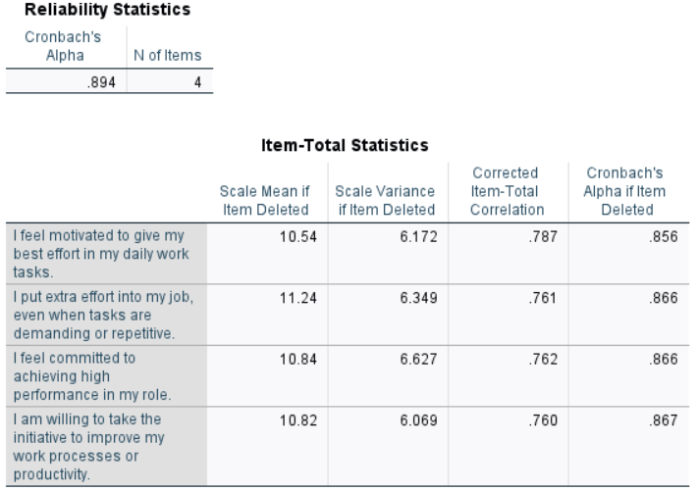
Source: created by Author
Table 10 - Appendix 1 - Reliability Statistics - Monetary Rewards (4 Items)
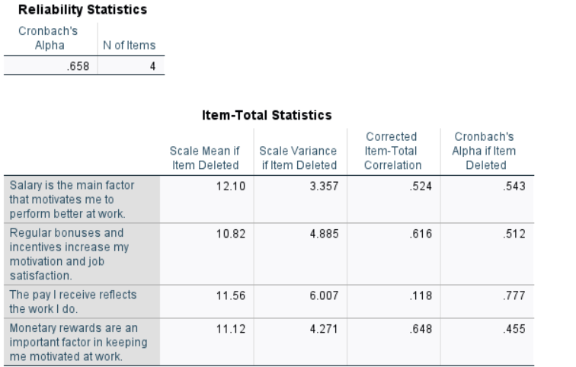
Source: created by Author
Reliability analysis indicated that one item within the monetary rewards scale (‘The pay I receive reflects the work I do’) demonstrated a low corrected item–total correlation (.118). Removal of this item increased Cronbach’s alpha from .658 to .777. As this item relates more closely to perceived fairness than motivational influence, it was excluded to improve internal consistency and conceptual alignment of the scale.
Table 11 - Appendix 1 - Reliability Statistics - Monetary Rewards (3 Items)
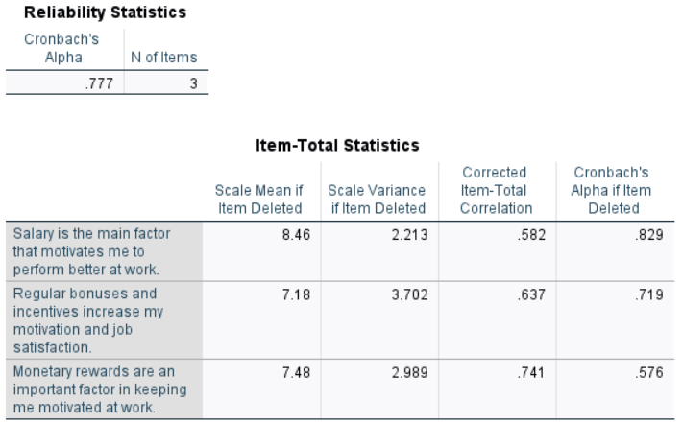
Source: created by Author

Appendix 2 – Assumption Check
Figure 26 - Histogram
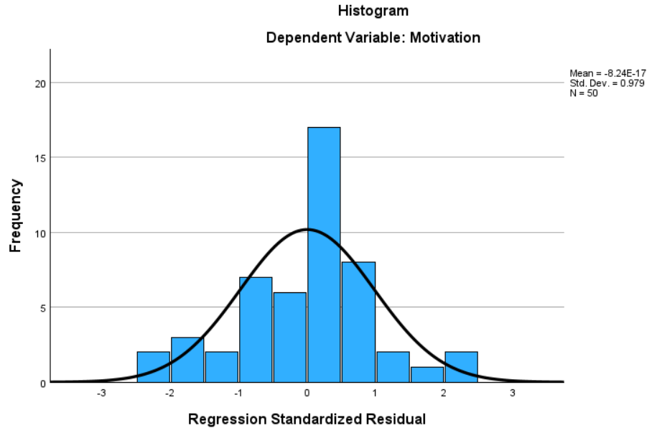
Source: created by Author
Figure 27 - Regression Standardized Residual
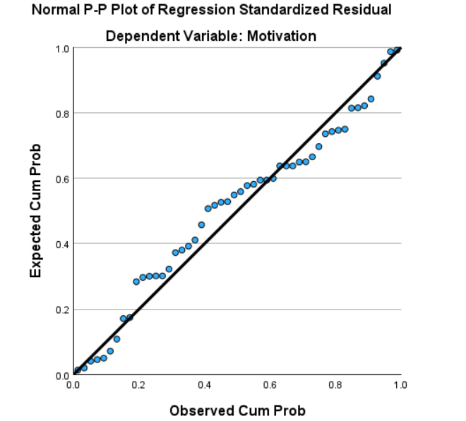
Source: created by Author
Figure 28 - Scatterplot
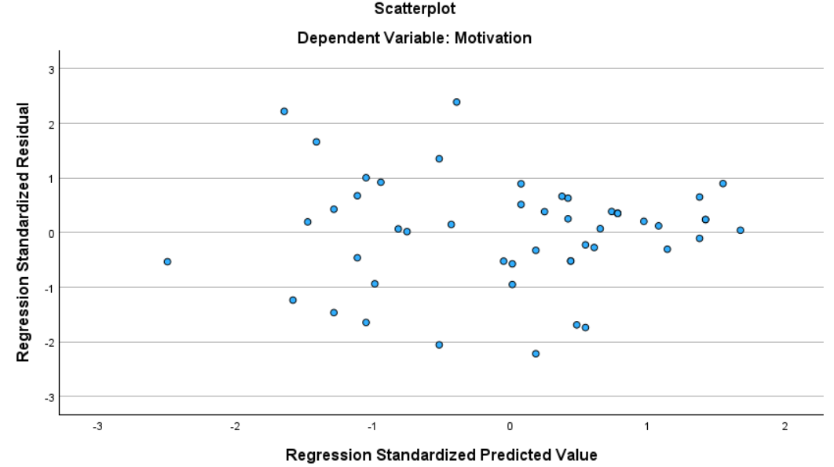
Source: created by Author

