Poster and Pitch: Virtual Mental Health Counseling Platform

Name: Aysha Hussain
Student ID:2319032
Professor: Samuel Assan

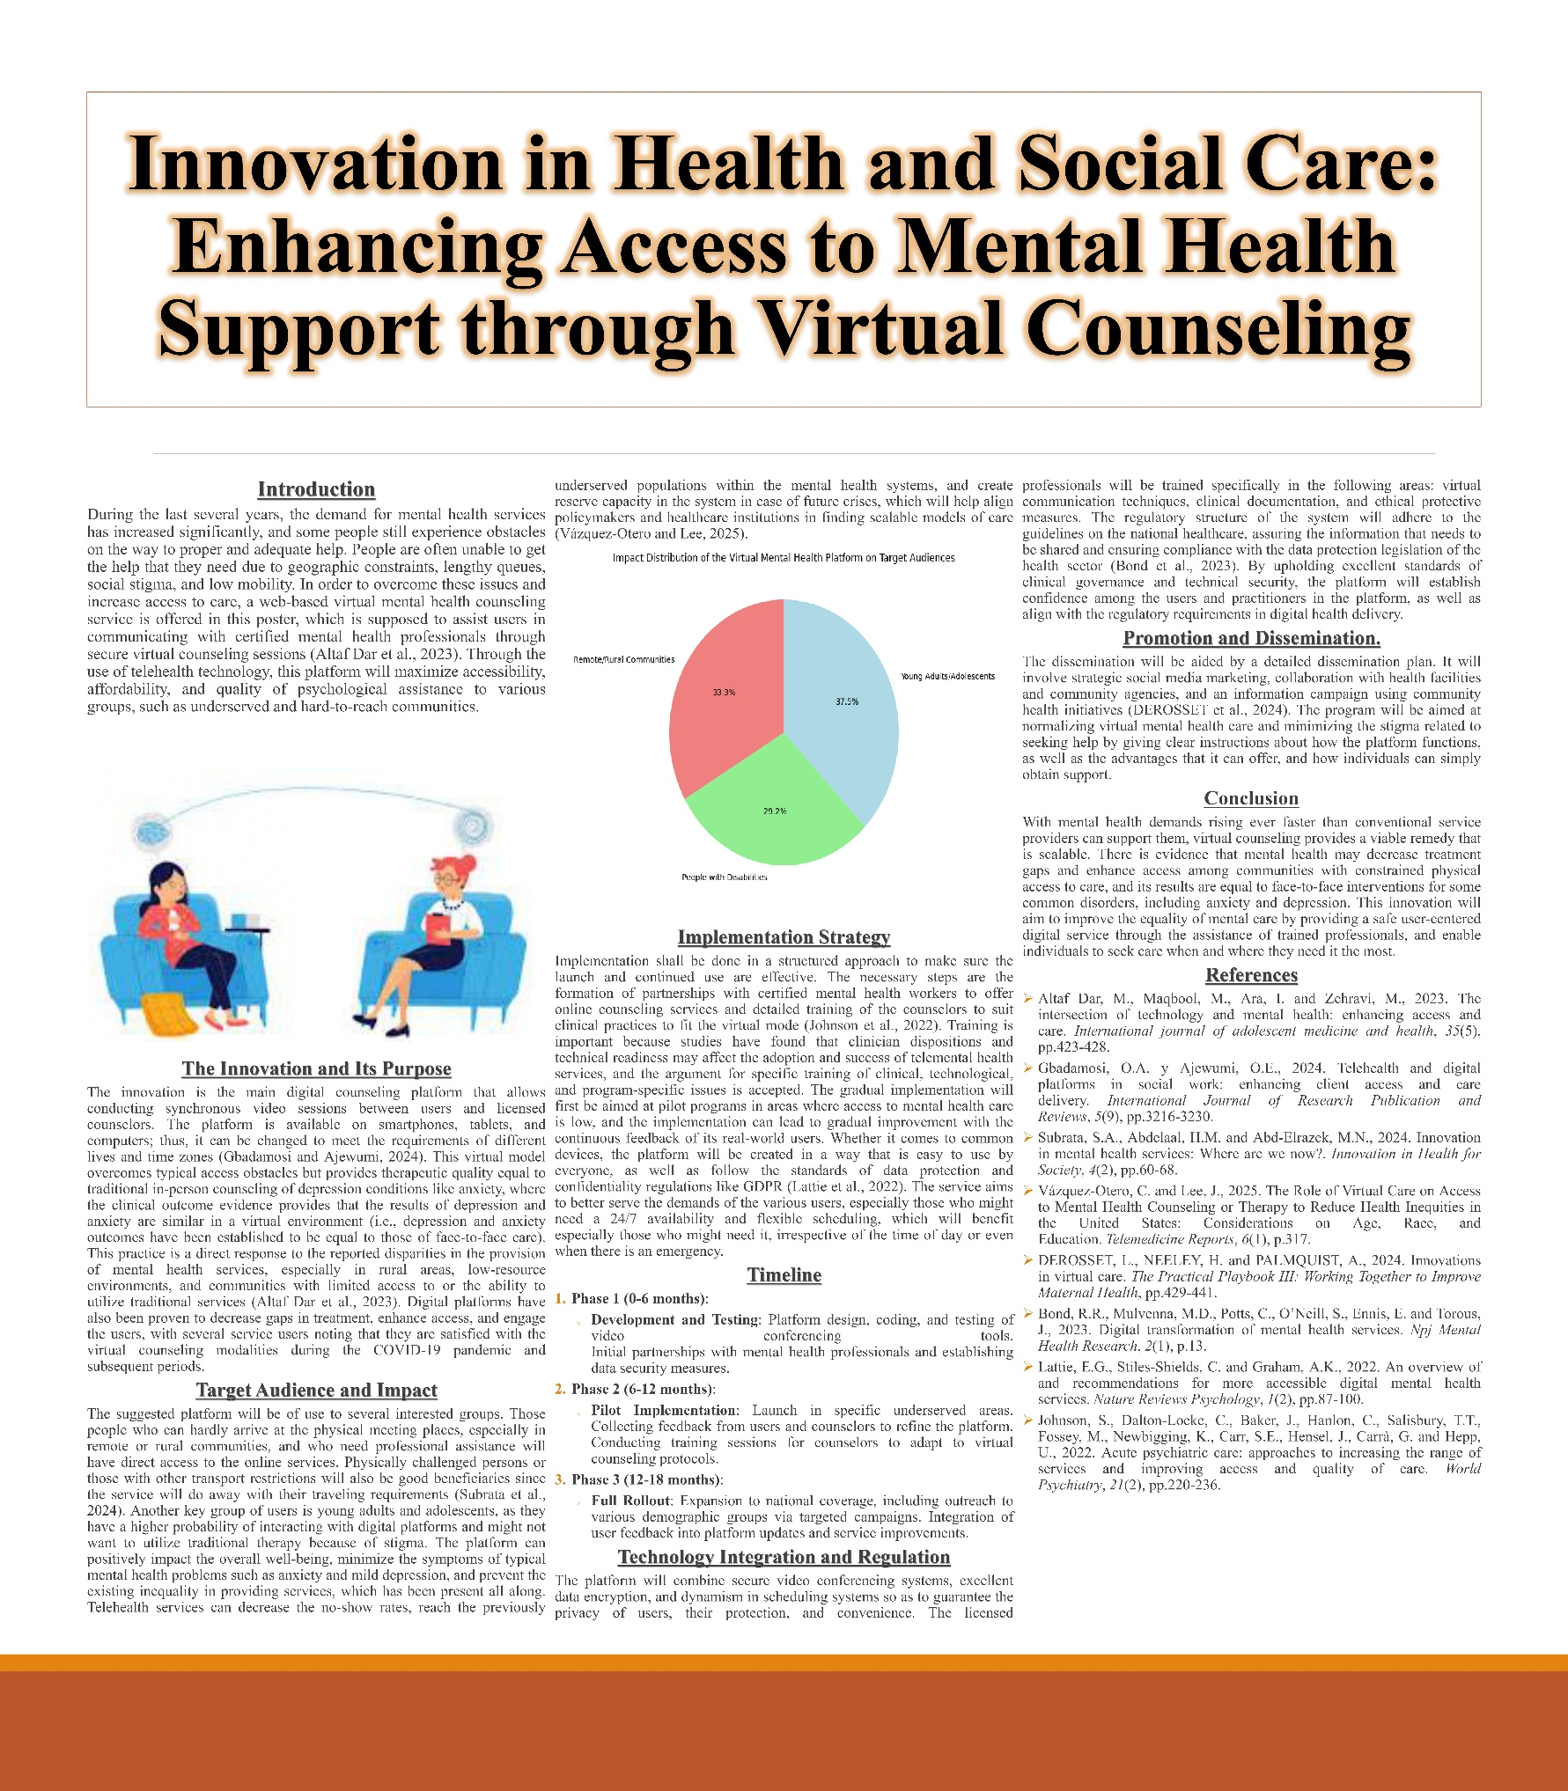
PITCH
Introduction
Mental health is a dilemma in the entire world, and it has been estimated that in the world, millions of people encounter issues of mental health problems. The growing need for psychological support has become extremely high, but opportunities for mental health services remain scarce, particularly in the rural, underserved, and marginalized populations (Subrata et al., 2024). The conventional face-to-face therapy may be punishing because of geographical boundaries, financial factors, and social stigma. Nevertheless, due to the progress in technology, especially telehealth systems, a novel method of providing mental health care is being introduced (Johnson et al., 2022). This proposal introduces a solution, which is a virtual mental health counseling platform, a proposal aimed to provide mental health assistance to people of different demographic groups available, efficiently, and at low prices.
The Need for the Platform
Mental health services are being ever demanded, and the traditional face-to-face counseling services can be a great hindrance to accessibility. Rural or remote residence can make people unlikely to access face-to-face therapy because of the distance, whereas social stigma can make other people unwilling to seek assistance. They can be overcome by using telehealth and digital platforms, according to which individuals will have a chance to obtain professional assistance from the convenience of their homes. As Altaf Dar et al. note (2023), technology has been central in the improvement of mental health care through the increased availability of services that were not accessible to the majority of people. Gbadamosi and Ajewumi (2024) also highlight the role telehealth platforms have had in changing the access of clients to care as part of the social work process by showing that digital platforms can prove helpful in improving the provision of mental health care.
Target Audience and Impact
The virtual counseling site will be of benefit to several critical populations that lack access to mental healthcare the most. These include:
- Remote and Rural Communities: A significant number of people in the rural communities are unable to get mental healthcare because they do not have access to nearby mental health providers or psychiatric clinics (DEROSSET et al., 2024). This situation will make such people have direct connections with mental health professionals through safe video calls, which do not require them to travel far distances.
- Individuals with Physical Disabilities or Transport Limitations: Physical disability and difficulties with transportation may render persons with mobility problems or those who struggle with transport difficulties unable to visit the physical therapy sessions (Altaf Dar et al., 2023). The online system will enable these people to be treated from the comfort of their homes, and hence, provide easier and more convenient therapy.
- Young Adults and Adolescents: Online platforms can reach such generations more effectively, as young people tend to use online services more (Johnson et al., 2022). Additionally, when people can obtain services more confidentially and anonymously, the stigma related to the need to undergo therapy can also be decreased.
This platform will be impactful because it will provide flexible, confidential, and affordable mental health assistance to the greatest number of people. It will lessen the obstacles surrounding the conservative face-to-face treatment and contribute to eliminating the years of disproportionate inequalities in access to mental health care. Virtual care can help decrease health disparities by promoting easier access among underserved populations, as Vazquez-Otero and Lee (2025) say.
Technology Integration and Innovation
The virtual mental health platform will be a combination of various advanced technologies to give a smooth and efficient service delivery. The technologies will make sure that people have a good experience in using the platform and receiving assistance.
- Video Conferencing Tools: Patients will be provided with the opportunity to communicate with therapists in real time using video conferencing, as their interaction will help to recreate the usual interactive conditions of traditional face-to-face therapies and make them convenient (Bond et al., 2023).
- Artificial Intelligence-based Matching System: The site will include an AI algorithm that will help find the most appropriate counselors according to the needs, preferences, and concerns of the users (DEROSSET et al., 2024). Such individual treatment will allow people to get the maximum care possible.
- Data Security and Privacy: The platform will comply with stringent data protection standards, such as GDPR (Subrata et al., 2024). Communications and information of users will be encrypted in order to ensure confidentiality and security.
Such technologies go in tandem with suggestions offered by Lattie et al. (2022), according to whom digital mental health services should be accessible and easy to use in order to ensure that users feel comfortable and safe when using the platform.
Implementation Strategy and Timeline
The proposal will be introduced in three stages, which will have particular activities and objectives:
- Phase 1 (0-6 months): This will involve the development and testing of the platform, which will involve the incorporation of video conferencing tools, AI-based matching algorithms, and security protocols. Alliances will be presented with accredited mental health practitioners to offer online counseling services, and the site will go through proper testing to ascertain that it is safe and operational.
- Phase 2 (6-12 months): Pilot implementation shall occur in underserved areas, though the focus shall be on getting user/ counselor feedback to improve the platform. It will also be trained to effectively offer virtual care, meaning that the counselors will be well-trained and will be able to offer high-quality online therapy.
- Phase 3 (12-18 months): The entire implementation of the platform will take place within this period, and national outreach activities will be conducted in the form of raising awareness and attracting involvement. Feedback from users will be constantly included in the updates in the platform, and hence, it will satisfy all users.
Challenges and Solutions
Although the virtual counseling platform has a considerable number of advantages, there are a number of challenges that must be solved to be successfully implemented. One of these obstacles is technological barriers since not all people can access trustworthy internet resources or devices, thus the platform will not reach everyone. To alleviate this, the platform will provide low-bandwidth and collaborate with the local governments to have the resources required in underserved locations (Bond et al., 2023). The other issue is the adjustment to the regulations because the platform will have to meet the healthcare and data privacy laws. Frequent audits and updates will make sure that the platform is in line with current legal regulations that secure user data and can guarantee the maximum level of protection (Gbadamosi and Ajewumi, 2024). Even with the social stigma on mental health services, the social stigma may still prevent the use of the service. To address it, the platform will initiate awareness programs whose mission should be to enable the population to understand telehealth advantages and strive to diminish the stigma, ensuring more individuals accept online therapy (DEROSSET et al., 2024).
Conclusion
The virtual mental health counseling service is a pioneer service that will change the manner of provision of mental health care. With the help of digital technologies, the platform will ensure mental health services revenue access, affordability, and confidentiality among people in remote locations, persons with disabilities, and the younger generation. The platform will fix the missing gap in mental health service delivery through a personalized care approach, data security, and flexible scheduling, which will reduce stigma and enhance outcomes among a wide variety of users. The platform can transform mental health care and make society healthier and resilience-based by implementing a strategic action plan and using feedback from the users continuously.

References
Altaf Dar, M., Maqbool, M., Ara, I. and Zehravi, M., 2023. The intersection of technology and mental health: enhancing access and care. International journal of adolescent medicine and health, 35(5), pp.423-428.
Bond, R.R., Mulvenna, M.D., Potts, C., O’Neill, S., Ennis, E. and Torous, J., 2023. Digital transformation of mental health services. Npj Mental Health Research, 2(1), p.13.
DEROSSET, L., NEELEY, H. and PALMQUIST, A., 2024. Innovations in virtual care. The Practical Playbook III: Working Together to Improve Maternal Health, pp.429-441.
Gbadamosi, O.A. y Ajewumi, O.E., 2024. Telehealth and digital platforms in social work: enhancing client access and care delivery. International Journal of Research Publication and Reviews, 5(9), pp.3216-3230.
Johnson, S., Dalton‐Locke, C., Baker, J., Hanlon, C., Salisbury, T.T., Fossey, M., Newbigging, K., Carr, S.E., Hensel, J., Carrà, G. and Hepp, U., 2022. Acute psychiatric care: approaches to increasing the range of services and improving access and quality of care. World Psychiatry, 21(2), pp.220-236.
Lattie, E.G., Stiles-Shields, C. and Graham, A.K., 2022. An overview of and recommendations for more accessible digital mental health services. Nature Reviews Psychology, 1(2), pp.87-100.
Subrata, S.A., Abdelaal, H.M. and Abd-Elrazek, M.N., 2024. Innovation in mental health services: Where are we now?. Innovation in Health for Society, 4(2), pp.60-68.
Vázquez-Otero, C. and Lee, J., 2025. The Role of Virtual Care on Access to Mental Health Counseling or Therapy to Reduce Health Inequities in the United States: Considerations on Age, Race, and Education. Telemedicine Reports, 6(1), p.317.

