
L4-quality & Business Improvements
Assignment Title: Quality tools and Root cause analysis


Gruffydd Bray
Student Number:1812705

Contents

Introduction Page 3

Data Analysis Page 3-5

Causes Page 5-6

Fishbone Diagram Page 6

5 whys Page 7

Evaluation/Action Plan Page 7-9

FMEA Page 10

Bibliography Page 11

Quality and Business Improvement
  - Quality Tools and Root Cause Analysis

Introduction
The objective of this report is to investigate the defects during a production process and provide a plan to correct the problem or problems for the best results. Through the use of quality tools and techniques to analyse the data I aim to provide an adequate corrective action plan. The assumptions I have made regarding the information provided is that the company investment is low, prioritise quantity rather than a good quality of product and workers work long hours per day.

Data Analysis

Pareto Analysis theory is an ideal tool to use in this case as it identifies opportunities for improvement, shows us what needs to be addressed first and also we can look at the 80% of problems that is important to us.
Through looking at these findings it is clear to see that surface finish is the biggest contributing defect. Surface finish is responsible for 63% of the total defects so it is worth investigating that defect further to get to the root cause of the problem. According to Pareto’s theory we should focus on the 80%, which in this case would be the surface finish and blow hole defects as they have a cumulative percentage of 84.77%. The aim is to rectify these defects at the root cause so that the number of the total defects fall significantly. This graph also highlights the “muda” or waste in the production process. Womack and Jones (2003) define waste as “specifically any human activity which absorbs resources but creates no value”.

Comparing the Processes

Through looking at these two charts it is clear that the sand casting process causes more defects to the product than the milling process. Worker A and B both cause more defects than workers C and D. During the sand casting process 121 defects occur compared to 76 in the milling process. This means sand casting is responsible for 61% of the defects.

Weekly Trend

This scatter diagram shows the trend of the defects throughout the week. It shows how the amount of defects vary from Monday to Saturday (1-6). From this graph it is clear that the variables have a nonlinear relationship. But it shows the defects increase from Monday to Wednesday where the amount of defects reach its highest. The amount of defects then slowly decline from Wednesday to Saturday.
The reason for this may be because the workers become more careless and complacent as the week goes on, and are then more focused after the increase in defects or because they’re almost at the end of their working week.
This suggests that the workers managers are not in regular contact with them to provide any motivation or solutions to a problem that may have arisen.

Causes
Through analysing the data the majority of the problems seem to come from the sandcasting part of the process. According to Custompart.net the most common causes for defects that occur when sandcasting are “Insufficient material, Low pouring temperature, Melt temperature is too high, Non-uniform cooling rate, Sand has low permeability, Non-uniform cooling rate, Erosion of sand mould interior, A crack in the sand mould, Mould halves shift”.
The most common causes for defects during the milling process are “Incorrect cutting parameters - If the cutting parameters such as the feed rate, spindle speed, or axial depth of cut are too high, the surface of the workpiece will be rougher than desired and may contain scratch marks or even burn marks. Also, a large depth of cut may result in vibration of the cutter and cause inaccuracies in the cut. Dull cutter - As a cutter is used, the teeth will wear down and become dull. A dull cutter is less capable of making precision cuts. Unsecured workpiece - If the workpiece is not securely clamped in the fixture, the friction of milling may cause it to shift and alter the desired cuts.”.
Fishbone Diagrams are a form of cause and effective diagram and help to categorize the problem and relate them to the effect. In Root Cause Analysis: A framework for tool selection M, Dogget says they are used “primarily to illustrate the possible causes of a particular problem by sorting and relating them using a classification scheme. The construction and study of the diagram is intended to stimulate knowledge acquisition and promote discussion, but it can also educate others about a process or problem”. In this case I believe the fishbone should be made with both management and the workers so a discussion can be opened, and they can both be educated about the problem and/or process to come to the best possible solutions.
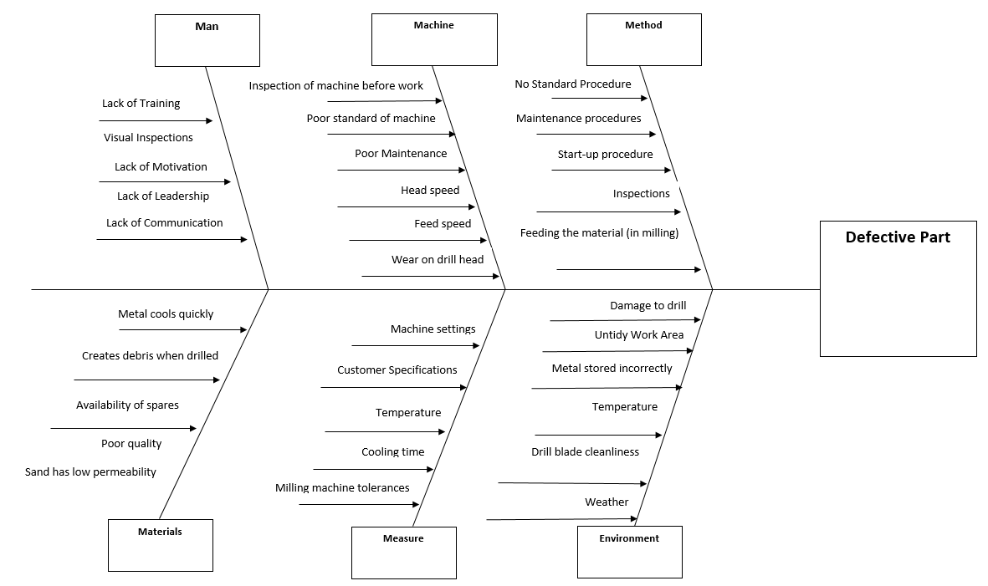

  - 5 whys

Customer receive defective part due to surface finish
Why?
The casting mould is cracking and effecting the finish of the metal
Why?
The moulds are not checked regularly or changed regular enough
Why?
Workers are not told to do so
Why?
No system in place for regular inspections or replacing
Why?
Management have not implemented a system to address the problem and monitor the situation.
  - Counter-Measure
Management should implement a PDCA cycle and have regular meeting for updates and to ensure the problem is reiterated to the workers so that it doesn’t arise again. “The (Plan-Do-Check-Act) PCDA Cycle is another excellent continuous improvement technique. Similar to the scientific method, the PCDA cycle is a way of identifying and testing hypotheses. The four steps of the PDCA Cycle are:
- Plan: Identify an opportunity and plan for change.
- Do: Implement the change on a small scale.
- Check: Use data to analyze the results of the change and determine whether it made a difference. “ – PlanView LeanKit
Gemba walks would also be very useful to keep the communication between the front line workers and management level. This allows us to catch any upcoming problems as quickly as possible. Management can then put systems in place to correct the problem as soon as possible.

Action Plan

Fundamentally there needs to be a change of outlook in the company where quality is held at a higher priority than it currently is. Using Juran’s Juran on Quality by design (1992), where quality is split into three parts “quality planning, quality control and quality improvement”. Further he breaks each part down, where quality planning includes the following steps “ Establishing goals, identify the customers -those who will be effected by the efforts to meet the goals, Determine the customer needs, develop product features that respond to customer needs, develop processes that are able to produce those product features, establish process controls and transfer the resulting plans to the operating forces”. In this case I think establishing goals is crucial to keep the workforce motivated to reach targets and no let there standards drop. We would also need to find out the customer needs and develop features that help meet those needs. Assuming the customer wants a product with a good surface finish etc then we can upgrade the milling machine, or even just the drill head itself to a better quality. If we don’t have the means for these then we can increase the maintenance and changing of the drill head to ensure clean cuts consistently. The next part is quality control which he breaks down as “ evaluate actual quality performance, compare actual performance to quality goals, act on the difference”. This is where we see if the changes that were made had an impact on the amount of defects. If we did not meet our goals then we must go back and ask the same questions again and make another plan to resolve the problem. This is a crucial step to see if the changes were effective and to see any improvement in the quality performance. The 3rd and final step is quality improvement which is categorised as “establish the infrastructure needed to secure annual quality improvement, identify the specific needs for improvement- improvement projects, for each project establish a project team with clear responsibility for bringing the project to a successful conclusion, provide the resources, motivation and training needed for the teams to: diagnose the problems, stimulate establishment of remedies, establish controls to hold the gains”. Establishing improvement projects is a good concept as it gives workers something to work towards as a team. The individual projects would be decided from the fishbone diagram and or the FMEA created, with the highest RPN taking priority. The most important part of the quality improvement section is establishing the controls necessary to hold the gains. This means that when we have implemented the changes and the quality has improved and defects decreased we have to keep it that way. The PDCA is a good way of doing this as it can provide routine check ups to ensure everyone is still working at the high standard achieved.

Using all the information gathered and the FMEA attached one would suggest a control plan to implement that addresses most if not all of the issues. Firstly it is clear that management are key to making the control plan work and to insure all are on board. The following are the actions I would suggest the company take (Prioritised where 1 is highest priority):
- Provide the workers with more training and knowledge about the process 4
- Acquire better equipment 3
- Automate more of the stages of the process like feeding during milling or pouring and cooling during the sandcasting 7
- Have a better inspection either through an automated inspection like Cognex or train the workers to know how to see the defects early 3
- Invest in more suitable equipment (more automated machinery for milling mainly) 6
- Ensure the workers are more quality driven, bonuses for better quality/ less defects 5
- Employ another worker on each process to help with workload 8
- More regular maintenance checks eg. change drill bit heads more often 2
- Implement PDCA cycles and Gemba walks so that management are in regular contact with the workers to keep motivation high and deal with problems that arise as soon as they come up 9
- Implement a standardised working procedure to ensure more consistency and reliability throughout the two shifts 1
One will also use an FMEA (next page) to tackle the problems for the defects. Carl Carlson in Effective FMEAs says “FMEAs when properly performed on the correct parts with the correct procedure during the correct time frame with the correct team, can prevent costly failures before products enter the marketplace. It is far less costly to prevent the problems through the proper use of FMEA than to pay for expensive field problems or litigation, and suffer from loss of reputation. Once lost, reputation is very difficult to earn back”. This shows the value of an FMEA. They guide you through the problem while taking into account severity, occurrence and detection. This will then provide you with an RPN number which provides you with the problems you must prioritise. They also give a corrective action and also put the responsibility on people for those actions to be carried out. This is useful as when you are checking the progress of any corrective action you can talk to the people responsible to find out why it hasn’t been completed or to find if there are any issues.
Using the FMEA attached the stand out problem are dull cutters, unsecured workpiece, non-uniform cooling rate and blowholes. These problems have the highest RPNs and also are responsible for poor surface finish and blowholes which are two of the major contributors to the defects in production. The corrective actions for these are quite similar which is to implement a standard working procedure. This would ensure that all employees will work to the same standards or as close as possible while adhering to some rules and checks also. For example the standard working procedure would include carrying out checks on the machinery before use and changing the drill bit if it is dull. It will also include clamping the work down before beginning to perform your work on it. To achieve a uniform cooling rate it would take some investment in either a cooling system or more training for employees. Also, through looking at the FMEA it becomes clear that most of the controls in place is an inspection. This control is not sufficient because of the number of defects that make their way through the production process. To remedy this would also need some investment, in either an inspection machine that flags up the defects or providing the employees with the proper knowledge on how to spot a defect and also what is acceptable standard for the customer to receive.

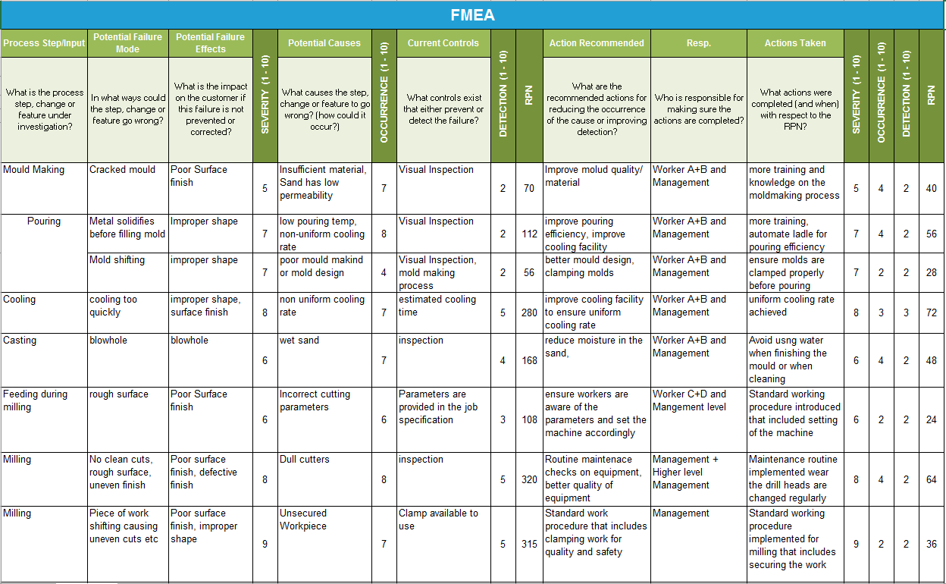

Bibliography

Carlson, Carl (2012) Effective FMEAs New Jersey: John Wiley and Sons Inc.
Dogget, Mark (2005). Root Cause Analysis: A Framework for Tool Selection. Quality Management Journal P.35-44
Juran, J M. (1992) Juran on Quality by Design, The new steps for planning quality into goods and services . New York : Free Press
Womack, J P and Jones, D T (2003) Lean Thinking Banish Waste and Create Wealth in your Corporation 2nd ed. New York: Free Press
Planview Inc. 2019 Planview LeanKit 6 Continuous Improvement Tools and Techniques. https://leankit.com/learn/kanban/6-continuous-improvement-tools-and-techniques/ 7/4/2019
CustomPartNet Sand Casting https://www.custompartnet.com/wu/SandCasting 5/4/2019
CustomPartNet Milling https://www.custompartnet.com/wu/milling 5/4/2019
iSixSigma (2019) Determine The Root Cause: 5 Whys https://www.isixsigma.com/tools-templates/cause-effect/determine-root-cause-5-whys/ 18/4/2019

