

Module: Data Handling & Business Intelligence
Code: LCBB5000
Lecturer: Xavier Matieni
Submitted by: Nikol Stoyanova
Student ID: 2130583
Uploaded on the 19/12/23

Part 1
The table below indicates the average total price from 2017 to 2022. The prices are $549304.11, $ 2984721.57, $ 18015.29, $ 20857.3, and $ 19436.8, respectively.
The results indicate 2018 as the most profitable year in hotel reservations, with a total average price of $ 2,984,721.57 recorded. The revenue dipped in 2019 to $ 18,015.29 before gaining momentum in 2020. The payment, however, remained low until 2022, when a significant margin was recorded from the revenue streams for the hotel reservations.
Year | Price
2017 | 549304.11
2018 | 2984721.57
2019 | 18015.29
2020 | 20857.3
2021 | 19436.8
2022 | 159353.81

The above line graph indicates the trend in the average price for hotel reservations from 2017 to 2022.
The graphic indicates a significant rise in the average price of hotel reservations in 2018, the peak of the sales. Nevertheless, the prices dipped in 2019 and have gradually started increasing since then.
Pivot Table
 |  | Data
Room types reserved | Booking status | Sum of Weekend Nights | Sum of Weekday nights | Sum of Average price
Room Type 1 | Canceled | 7758 | 20771 | 922669.42
 | Not Canceled | 14179 | 39009 | 1775518.89
Room Type 1 Total |  | 21937 | 59780 | 2698188.31
Room Type 2 | Canceled | 200 | 597 | 22403.56
 | Not Canceled | 443 | 1006 | 38387.64
Room Type 2 Total |  | 643 | 1603 | 60791.2
Room Type 3 | Canceled | 2 | 3 | 210.75
 | Not Canceled | 2 | 11 | 305
Room Type 3 Total |  | 4 | 14 | 515.75
Room Type 4 | Canceled | 2054 | 5690 | 274191.43
 | Not Canceled | 3600 | 9701 | 484673.85
Room Type 4 Total |  | 5654 | 15391 | 758865.28
Room Type 5 | Canceled | 68 | 188 | 9956.11
 | Not Canceled | 133 | 394 | 22833.3
Room Type 5 Total |  | 201 | 582 | 32789.41
Room Type 6 | Canceled | 427 | 1082 | 76727.73
 | Not Canceled | 426 | 1169 | 99289.87
Room Type 6 Total |  | 853 | 2251 | 176017.6
Room Type 7 | Canceled | 39 | 101 | 8202.75
 | Not Canceled | 78 | 239 | 16318.58
Room Type 7 Total |  | 117 | 340 | 24521.33
(blank) | (blank) |  |  | 708657.92
(blank) Total |  |  |  | 708657.92
Grand Total |  | 29409 | 79961 | 4460346.8

The above pivot table summarizes the dataset based on the room type reserved, booking status, sum of weekend nights, sum of weekday nights, and the sum of average price. The results indicate that room type 1 has the highest number of weekend night cancelations, whereas room type 3 has the least number of flight cancelations during the weekend night booking. Room type 1 still leads in the number of flight cancelations during the weekday nights. Room type 1 leads in the total average price of bookings by $2698188.31 recorded between 2017 and 2022. Notably, the actual revenue achieved through this period is $1775518.89.

Meal Plans and Canceled Reservations
Meal plan 1 has the highest cancelations for the reservations of the seven types of rooms. More cancelations were experienced for meal plan 1 alongside room type 1.
Meal plan 1 also has the highest average price for the hotel reservations that were not canceled.

The results coincide with several other studies on the hospitality industry. Shapoval et al. (2021) indicate that the COVID-19 crisis led to an unfavorable situation for the hotel industry to survive in 2019. The hospitality industry has continued to become important in the global economy, and COVID-19 has stripped the industry’s vulnerability. Fundamentally, the perceptions of physical and personal security play a pivotal role in influencing people’s intentions to travel to a
destination affected by security concerns. The above perceptions fueled the significant reduction of hotel reservations in 2019 as many people developed a fear of contracting the deadly virus abroad.
The medial typically covers the pandemics such as COVID-19 in a negative light. Most countries hit by the deadly viruses imposed a partial and full lockdown, which led to a major shift in the hotel reservation industry. Those who had booked and arrived at the hotel by then were forced to spend more time in the hotel rooms. Also, those who were yet to book the hotel during the onset of the COVID-19 pandemic were forced to cancel their bookings in the spirit of embracing isolation and quarantine. According to statistica (2019),
the global hotel and hospitality industry contributed to 2.9 trillion United States dollars. For that reason, the employment history in the hospitality sector was the highest in 2018. Nevertheless, the first cases of the COVID-19 pandemic began in early 2019, leading to a reduction in hotel revenues (Bartik et al., 2020).
The advent of COVID-19 shut down the world’s economy, which led to unprecedented challenges in the hospitality industry. The stay-at-home and isolation orders were prevalent in most countries affected by the pandemic. Notably, the above policies led to the temporary closure of many hospitality businesses worldwide. In some cases, restaurants were ordered to limit their operations to only take-outs. The restrictions imposed by various authorities worldwide led to a sharp decline in hotel occupancy and revenues (Gössling et al., 2020).
Gursory et al. (2020) indicated that over 50% of the customers in the hospitality industry were only willing to dine in a restaurant after a period. Despite the efforts of governments in various countries to ease the restrictions of travel in late 2019, numerous customers needed more time to immediately adjust and resume hotel bookings.

Sum of Average price
Market type | Total
Aviation | 12588
Complementary | 1228.43
Corporate | 167232.98
Offline | 964708.84
Online | 2605930.63
Grand Total | 3751688.88

The above pivot chart indicates the average price and market type sum.
In the period from 2017 to 2022, the aviation, complementary, corporate, offline, and online businesses recorded a revenue stream of $12588, $ 1228.43, $ 167232.98, $964708.84, and $2605930.63, respectively.
Online businesses account for the largest share of average prices and revenue received between 2017 and 2022. Whereas the aviation industry became the worst hit due to lockdowns and isolations, more opportunities were created in the online businesses, which saw a significant increase after the pandemic. For instance, physical meetings were replaced with online meetings, which saw the emergence and dominance of videoconferencing tools like Zoom, Teams, and Google Meet.

 | Data
Market type | Sum of Average price | Sum of Lead-time | Sum of Arrival date
Aviation | 12588 | 686 | 1920
Complementary | 1228.43 | 4706 | 5872
Corporate | 167232.98 | 44007 | 31657
Offline | 964708.84 | 1293603 | 162090
Online | 2605930.63 | 1748809 | 364242
Grand Total | 3751688.88 | 3091811 | 565781

The above chart pivot table indicates the summary of the market type, sum of the average price, lead time, and arrival time. The lead time in the aviation industry is the lowest based on the nature of business, which requires prompt planning and scheduling of activities. Online bookings account for the most significant lead time between 2017 and 2022.The lead time and arrival date play a crucial role in the aviation, complementary, corporate, offline, and online markets for hotel reservations. The results indicate that the online market produces a huge revenue but with increased lead time, which factors like the personal touch might contribute.
In a nutshell, using Excel to conduct statistical analysis was beneficial because of the application of the IF, Vlookup function, and pivot tables to generate the results. The IF function helped examine the implication of one variable to another; for instance, if the year changed, the average price was experienced. The explanation and justification of the dip in revenue in 2019 is explained and backed by numerous studies on the implication of COVID-19 in the hospitality industry. Further, the data visualization led to a better understanding of the variables and results, with attention drawn to the trend in the average prices over the years. The pre-pandemic landscape began in 2019. The hotel industry was thriving up to 2019 when the pandemic led to unprecedented fluctuation in hotel prices. Initially, global travel was high, and the hotel industry was reaping huge benefits from the consistent revenue streams. The hospitality industry was a crucial contributor to many economies, providing employment and fostering tourism. The imposition of travel restrictions worldwide led to an immediate impact on hotel prices, limiting customer movement. During the early days of the pandemic, hotels experienced a massive decline in bookings. This scenario led to a surplus of vacant rooms. The hotel industry then adjusted its pricing strategy to help it stay afloat ahead of the harsh economic reality. The hotels resolved to offer huge discounts and promotional packages to attract more customers. The above assumption backs the results of the significant adjustment of the average prices for reserving a room.
The ongoing challenges and pricing trends have played a vital role in resuming activities in the hospitality sector. As the pandemic persisted, the hotel industry faced precedented challenges, forcing them to adapt to the changing travel restrictions and consumer behavior. For that reason, hospitality saw a shift towards cancelation policies and enhanced safety measures influencing the pricing strategies. Above all, the hotel industry continues to experience significant changes in the pricing strategies to adapt to the new realities even as the normalcy resumed from 2021.

Part 2
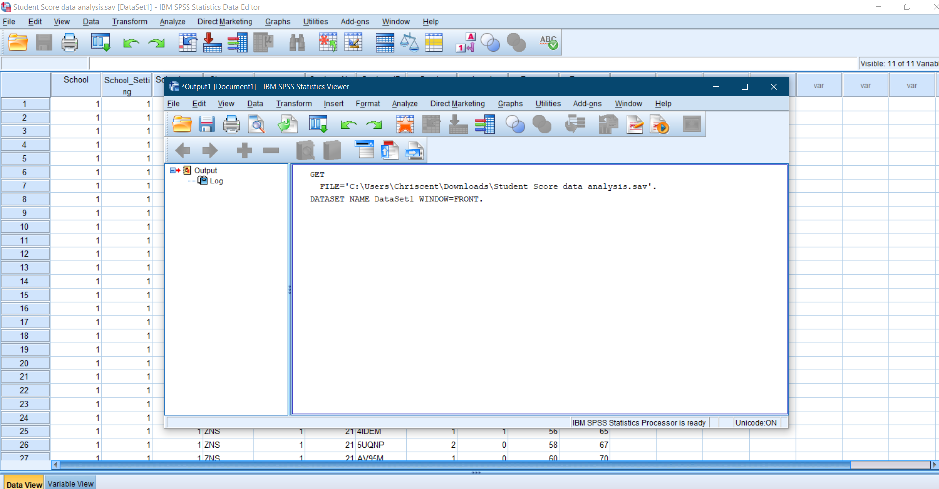

- How many students are male and female?

Gender
 |  | Frequency | Percent | Valid Percent | Cumulative Percent
Valid | Male | 1056 | 48.2 | 49.5 | 49.5
Valid | Female | 1077 | 49.2 | 50.5 | 100.0
Valid | Total | 2133 | 97.4 | 100.0
Missing | System | 56 | 2.6
Total |  | 2189 | 100.0

The SPSS output table above indicate that there are 1056 male and 1077 female students. The male population in the school accounts for 49.5% while the female population accounts t0 50.5% of the population

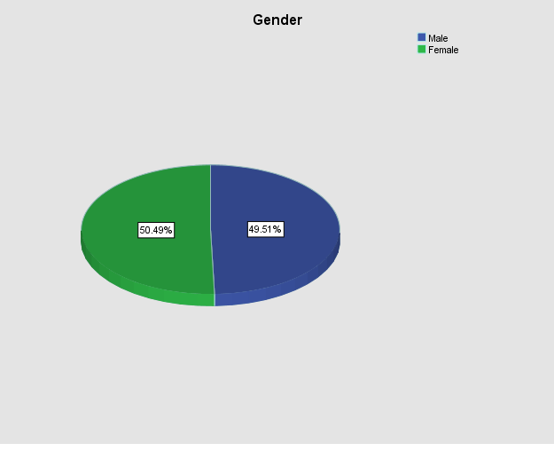
- How many students qualifies and does not qualify for reduced/free lunch?

Lunch
 |  | Frequency | Percent | Valid Percent | Cumulative Percent
Valid | Does not qualify for free/ reduced lunch | 1215 | 55.5 | 57.0 | 57.0
Valid | Qualifies for free/ reduced lunch | 918 | 41.9 | 43.0 | 100.0
Valid | Total | 2133 | 97.4 | 100.0
Missing | System | 56 | 2.6
Total |  | 2189 | 100.0

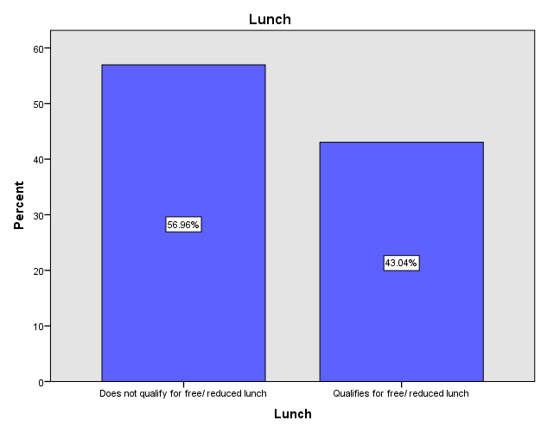

1215 students do not qualify for a free/ reduced lunch which accounts to 56.96% of the student’s population while 918 students qualify for the free/ reduced lunch

3. What are the mean and median of students who qualifies and does not qualify for reduced/free lunch?
The mean for the students who qualifies for reduced/ free lunch is 0.43 while those that do not qualify for a reduced lunch is 0.57.
Statistics
Lunch
. | N | Valid | 0
. | N | Missing | 56
Does not qualify for free/ reduced lunch | N | Valid | 1215
Does not qualify for free/ reduced lunch | N | Missing | 0
Does not qualify for free/ reduced lunch | Mean |  | .00
Does not qualify for free/ reduced lunch | Median |  | .00
Does not qualify for free/ reduced lunch | Mode |  | 0
Does not qualify for free/ reduced lunch | Std. Deviation |  | .000
Does not qualify for free/ reduced lunch | Sum |  | 0
Qualifies for free/ reduced lunch | N | Valid | 918
Qualifies for free/ reduced lunch | N | Missing | 0
Qualifies for free/ reduced lunch | Mean |  | 1.00
Qualifies for free/ reduced lunch | Median |  | 1.00
Qualifies for free/ reduced lunch | Mode |  | 1
Qualifies for free/ reduced lunch | Std. Deviation |  | .000
Qualifies for free/ reduced lunch | Sum |  | 918

- Using the dataset Student_Score.csv provided in conjunction with SPSS, give a specific example of Clustering (ex. K-Means Clustering).

The K-means cluster analysis is a method of grouping variables into K clusters.
The method involves vector quantization, where each cluster belongs to a specific cluster.
The Student Score data set has the following variables;
- School
- School setting
- School type
- Classroom
- Teaching method
- Student number
- Student ID
- Gender
- Lunch
- Pretest
- Post-test
The second step is identifying the dependent variables that will be clustered, and they include
- Pretest
- Post-test

The next step involves the standardization of the selected variables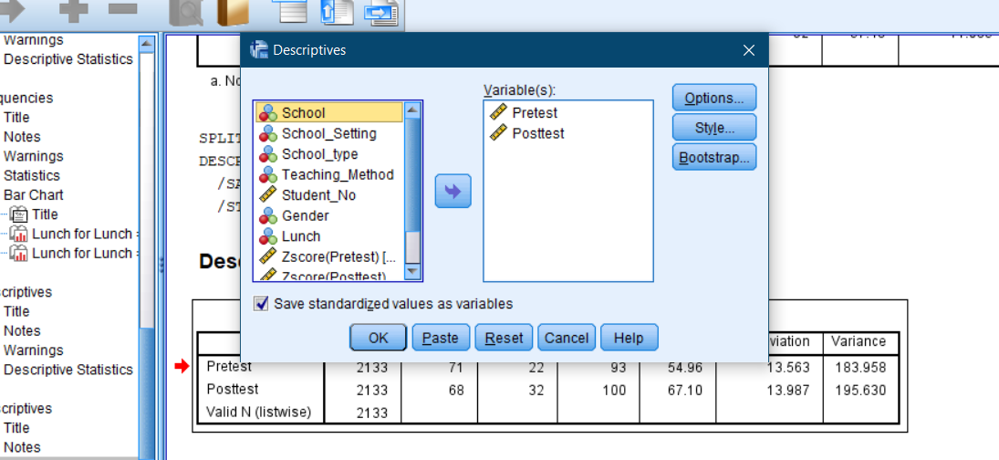
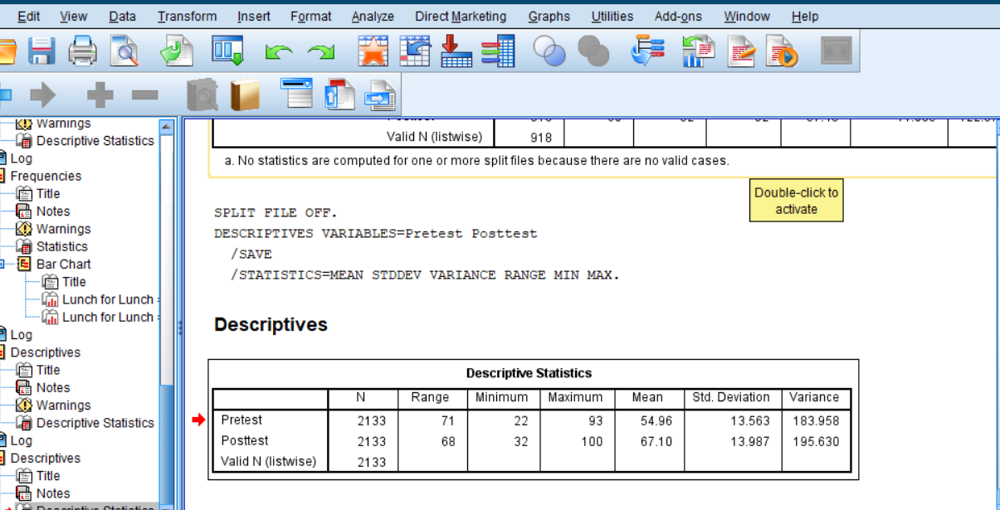

Descriptive Statistics
 | N | Range | Minimum | Maximum | Mean | Std. Deviation | Variance
Pretest | 2133 | 71 | 22 | 93 | 54.96 | 13.563 | 183.958
Posttest | 2133 | 68 | 32 | 100 | 67.10 | 13.987 | 195.630
Valid N (listwise) | 2133

The dependent variables are created with the means above and the data view indicates the z-scores of the additional variables created.
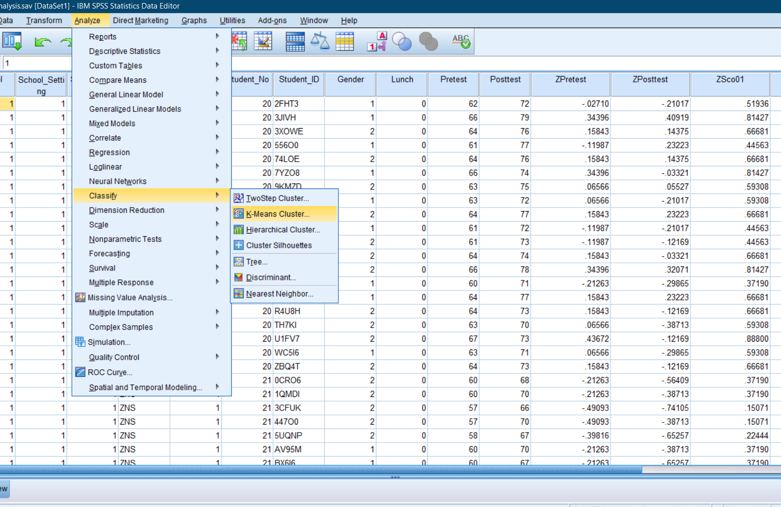

Initial Cluster Centers
 | Cluster
 | 1 | 2
Zscore(Pretest) | -2.35609 | 2.80497
Zscore(Posttest) | -2.29518 | 2.35206

Iteration Historyª
Iteration | Change in Cluster Centers
Iteration | 1 | 2
1 | 2.200 | 2.443
2 | .071 | .063
3 | .037 | .033
4 | .022 | .019
5 | .014 | .012
6 | .013 | .011
7 | .000 | .000
a. Convergence achieved due to no or small change in cluster centers. The maximum absolute coordinate change for any center is .000. The current iteration is 7. The minimum distance between initial centers is 6.945.
The above table indicates 7 iterations for the two clusters formed.

Final Cluster Centers
 | Cluster
 | 1 | 2
Zscore(Pretest) | -.87764 | .76447
Zscore(Posttest) | -.88650 | .77219
The final cluster centers after the clustering process has -0.88, -0.89 for cluster 1 for both the pretest, and 0.76, and 0.77 for cluster two respectively

ANOVA
 | Cluster |  | Error |  | F | Sig.
 | Mean Square | df | Mean Square | df | F | Sig.
Zscore (Pretest) | 1431.104 | 1 | .329 | 2131 | 4351.122 | .000
Zscore (Posttest) | 1460.133 | 1 | .315 | 2131 | 4631.188 | .000
The F tests should be used only for descriptive purposes because the clusters have been chosen to maximize the differences among cases in different clusters. The observed significance levels are not corrected for this and thus cannot be interpreted as tests of the hypothesis that the cluster means are equal.
The ANOVA table above indicates the p-value of 0.00 for both the pretest and the posttest variables. P= 0.00, P>0.05 implying that the results are statistically significant. Therefore, the pretest and the posttest variables have a significant contribution to a cluster.

Number of Cases in each Cluster
Cluster | 1 | 993.000
Cluster | 2 | 1140.000
Valid |  | 2133.000
Missing |  | .000

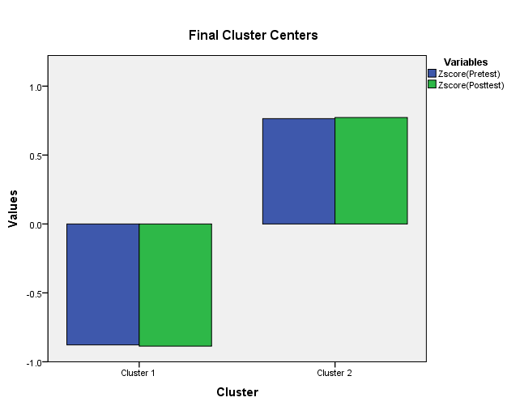

The chart below indicates the second scenario of creating 3 clusters to compare the changes
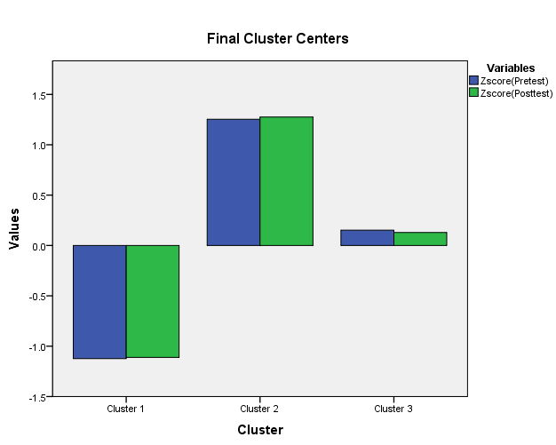

- With real world (practical) examples, explain minimum 5 most common data mining and text mining methods for each that can be used in the contemporary business.

Regression
Regression is a data mining technique that is used for prediction. Regression statistics are usually used to model the relationship between the independent and dependent variables. The already known attributes are regarded as independent variables; what the research wants to predict is termed the dependent or response variable. Notably, numerous real-world problems can take time to predict (Shrestha, 2020). Therefore, other complex techniques like logistics regression, neural nets, or decision trees are used.
An example of a regression technique is examining the relationship between sales volume and social media advertising. Social media advertising will become the independent variable, while sales volume is the dependent variable. A linear regression model helps determine the relationship between the two variables in a straight line. For instance, an increase in advertising activities could lead to an increase in the sales volume.
Classification
Classification is a data mining technique that involves assigning categories to a collection to aid the prediction and analysis. The several methods of classification are known as a decision tree. The fundamental goal of the classification rules is to answer a question and make a decision or predict behavior. A real-world example of the classification is the loan application of a bank (Jalota & Agrawal, 2019). Banks use a classification system that classifies customers into various levels of risk. For instance, there are high risky, and less difficult customers based on the customer’s data and their credit history. The data will then inform the banks on the appropriate lending strategies, which might include limiting the loan services to high-risk customers.
Clustering
Clustering is a data mining technique that involves identifying similar classes of objects. The cluster technique helps to identify dense and sparse regions and the overall distribution pattern of the dataset (Yuan & Yang,2019). Clusters are formed by utilizing attributes like the density of data points, shortest distances, graphs, and other statistical distributions. This data mining method heavily relies on unsupervised machine learning, graph analytics, data mining, statistics, and image processing. A researcher can use clustering to find groupings of related items, and the information will be drawn from various sources, including biomedical, marketing, and geographic databases (Yuan & Yang,2019). There are multiple examples of clustering data mining techniques: Agglomerative hierarchical clustering, K-means clustering, EM clustering, and hierarchical clustering. The agglomerative hierarchical clustering is also regarded as the bottom-up and top-down algorithms that consider data points as a single cluster. A dendrogram is employed with the tree root, a distinctive sample of collecting the cluster (Yuan & Yang,2019). The K-Means clustering is where the clustering algorithms discover clusters in the unlabeled dataset. K refers to the number of predefined clusters. The k-clustering is an ideal way of clustering data into different groups and a reliable way of discovering the diverse categories in the dataset.
Neural Networks
It is also referred to as an artificial neural network (ANN) and encompasses a mathematical model based on neural networks. The model consists of interconnected neurons and processes information using the connectionist approach. The feedforward neural network is a type of ANN that is arguably the most straightforward (Anitha & Vanitha, 2021). In this regard, the report moves only in one direction. On the other hand, the recurrent neural networks lack feedback connections and are models that support bi-directional data flow. A real-life example of the application of the ANN is in drone technology. Aeiou tech company, for instance, has developed a drone technology that leverages neural networks through sensors and companion computers to allow them to operate optimally in any environment. Incorporating the unmanned aerial system has made it possible to utilize the numerous benefits of artificial intelligence to enhance drone operations in oil, gas, disaster relief, and mineral exploration.
Text mining methods
Sentiment Analysis
Sentiment analysis is also referred to as opinion mining and involves a natural language processing technique that identifies the tone behind the body of a text (Mehta, & Pandya, 2020). Sentiment analysis is an ideal way for organizations to categorize the opinions regarding a particular product, service, process, or event. This technique involves using artificial intelligence, machine learning, and computational linguistics.
- Discuss the advantages and disadvantage of using SPSS and Excel using relevant practical examples and present your discussions in a table.
SPSS
Advantages | Disadvantages
SPSS has a user-friendly interface which makes it easier to use. The interface has a click and point menu which allows any user to efficiently navigate through various functionalities. | SPSS cannot analyze big data especially like that of telecommunication companies who deal with millions of customers.
SPSS is also efficient in manipulating data in different ways. For instance, users can create new variables from the existing ones. The users can also merge the data. | SPSS will always end up giving simple answers for complex problems hence not detailed and only measures specific metrics
Statistical analysis: SPSS allows for efficient statistical analysis of the huge datasets i.e descriptive statistics, regression, correlation, and ANOVA tests | Faulty and biased data collection methods in SPSS will always result to incorrect and biased results.
Textual analysis: SPSS can perform textual analysis using linguistic methods like natural language processing (NLP). NLP allows users to extract meaningful insights from big data. | SPSS can be expensive to buy for students who want to use
SPSS allows users to visualize the data through graphs, charts enabling better understanding of the results. | The graph features of SPSS are more complex compared to those in Excel

Excel

Advantages | Disadvantages
Excel is popular, easy to learn with a familiar interface and numerous functionalities for statistical analysis | The users can encounter errors and inconsistencies especially when dealing with complex formula and multiple worksheets
Excel is versatile and can handle various forms of data | Excel is slow and unstable especially to large entries. It can often freeze, or crash.
Availability: Excel is already included in the office programs and a user doesn’t have to install it separately | Limited functionalities: Excel has limitations in the functions that support advanced data analysis

References

Anitha, S., & Vanitha, M. (2021). Optimal artificial neural network-based data mining technique for stress prediction in working employees. Soft Computing, 25(17), 11523-11534.
Bartik, A. W., Bertrand, M., Cullen, Z. B., Glaeser, E. L., Luca, M., & Stanton, C. T. (2020). How are small businesses adjusting to COVID-19? Early evidence from a survey (No. w26989). National Bureau of Economic Research.
Gössling, S., Scott, D., & Hall, C. M. (2020). Pandemics, tourism and global change: A rapid assessment of COVID-19. Journal of Sustainable Tourism, 1–20. https://doi.org/10.1080/09669582.2020.1758708
Gursoy, D., Chi, C. G., & Chi, O. H. (2020). COVID-19 Study 2 Report: Restaurant and Hotel Industry: Restaurant and hotel customers’ sentiment analysis. Would they come back? If they would, WHEN? (Report No. 2), Carson College of Business, Washington State University.
Jalota, C., & Agrawal, R. (2019, February). Analysis of educational data mining using classification. In 2019 International Conference on Machine Learning, Big Data, Cloud and Parallel Computing (COMITCon) (pp. 243-247). IEEE.
Mehta, P., & Pandya, S. (2020). A review on sentiment analysis methodologies, practices and applications. International Journal of Scientific and Technology Research, 9(2), 601-609.
Shapoval, V., Hägglund, P., Pizam, A., Abraham, V., Carlbäck, M., Nygren, T., & Smith, R. M. (2021). The COVID-19 pandemic effects on the hospitality industry using social systems theory: A multi-country comparison. International Journal of Hospitality Management, 94, 102813.
Shrestha, N. (2020). Detecting multicollinearity in regression analysis. American Journal of Applied Mathematics and Statistics, 8(2), 39-42.
Yuan, C., & Yang, H. (2019). Research on K-value selection method of K-means clustering algorithm. J, 2(2), 226-235.

