

BA (Hons) Animation & VFX

Independent Project:
Project Proposal ACCA6020

Jonathan Anthony Frise

Student Number: 2404228

Supervisor: Awaiting Allocation

October 22nd, 2025.

Contents
Proposal Introduction: 3
Executive Summary 4
Aims & Objectives 5
Project Rationale & Justification 6
Project specification details 7
Project Pipeline Overview / Gannt Chart 7
Research & References 8
Ethics & AI Guidelines 9
Research Findings 10
Blade Runner 2049 Case Study 10
References for the Bunker's Architecture & Atmosphere 13
References for the Lighting & Colour Scheme 15
References for the Environmental Storytelling 16
Visual influences in undertaking the project 17
Proposal Pitch & Impact 18
Colour Scheme 18
Visual Hook 19
Scene Blackouts & Prototyping 21
Proposal - Pitch Presentation 23
Preliminary Bibliography 28

Proposal Introduction:

In this section I will discuss the following:
- Project Vision: To produce a high-quality, atmospheric sci-fi short film that serves as a proof-of-concept for the larger "Ground Zero" story world while narrowing in on the hypothesis and being a strong stand alone piece.
- Premise: Originally based on the earlier versions of "THE BUNKER" script, (Though the concept has evolved since) a lone survivor's routine is broken by a crisis, leading him to activate a dormant robot who reveals that the outside world has been habitable for over six months. Parts of this concept will remail the same, and much relevance for my other modules also.
- Aims and SMART objectives: Breaking down the creative and technically processes involved with the scope of this project. This will also involve the justification of said scope and approaches.
- Rationale: I will explain how this project is the culmination of my degree skills and will explore a long-held personal concept. It allows me to focus on world-building, character performance, and advanced real-time workflows. The short film acts as a "pilot" episode for the larger saga I have developed though will be importantly a strong stand alone short.
- Project Specification: Breaking down the shots, running time, prototyping, and pipeline plan.

Executive Summary

- My independent project, "THE BUNKER," is a photorealistic 3D animated short set in my "Ground Zero" universe, exploring an abandoned shelter after the protagonist has left. The film will be a character-less piece, relying entirely on environmental storytelling to convey the narrative.

My dissertation's core hypothesis is: "To what extent can lighting and sound design alone shape an audience's interpretation of a preceding event in a characterless 3D animated environment?" My practical work in Unreal Engine will be a direct investigation of this, using atmospheric lighting and the ironic sound of a cheerful, looped song, Harry Nilsson's "Gotta Get Up", to hopefully evoke a sense of melancholic mystery and guide the audience to piece together the story of what happened.

Below is a previously written summary of the concept. I feel it important to note the major changes of a project early on as it can influence later decisions and is important to understand the context of how it has been changed and why. After thinking about how to technically achieve it I realised I was going to be undertaking too many roles that I was worried about the time involved into such an undertaking and how it could impact the outcomes overall quality.
I wanted to narrow down the concept to areas in which I am more passionate about, not just so it is more manageable but would better represent my portfolio of my interests and technical capabilities.

- "THE BUNKER" is a 2–3-minute, photorealistic 3D animated short film produced entirely in Unreal Engine. Set within the post-apocalyptic "Ground Zero" universe I have been working on for the last few years. The story follows Jim, the clone of a brilliant scientist, whose isolated existence in a subterranean shelter is shattered when a power failure leads to the discovery of a small robot, Chips.

Together, they uncover a truth that will force Jim to confront the world he was meant to save. The project's core investigation is to test how a first-person narrative perspective can create a compelling sense of mystery and suspense for the audience.

Aims & Objectives:
The deliverable is the final animated film. The rationale for success is that this focused approach will effectively mitigates the risk of an over-ambitious project and allows for a more analytical approach and mastery that of atmosphere and lighting researched and implemented effectively.
  - To produce a 5-10 minute 2-3 minute (more accurate and achievable goal, to produce the high quality I want and expect.) To animate a short film based on previous "THE BUNKER" script adaptations to suit the new concept.
  - To develop and document a real-time production workflow from Blender to Unreal Engine 5. (e.g. Blender for asset creation and environmental design, and Unreal Engine for lighting and cinematic setup.)
  - To create a portfolio piece showcasing the non-verbal animation exploring the themes of horror and the hypothesis as stated.
The above are the major targets I want to achieve, but it is also important to understand these more thoroughly for success, as a result, here is the SMART targets:
Specific:
To produce a 2–3-minute, photorealistic 3D animated short in Unreal Engine 5.
Measurable:
The short will be judged on its ability to imply a narrative (Jim's departure) using only visual and audio cues, (Lighting and Sound design) in relation to the environmental design and narrative.
Achievable:
The scope is limited to a single environment, making high-quality asset creation and/or referencing used assets where applicable as well as accurate lighting and sound methods used, feasible by the May deadline.
Relevant:
This project directly supports my dissertation hypothesis and integrates skills from my Advanced Lighting & Rendering module.
Time-bound:
All modelling, texturing, lighting, and rendering will be completed by the final submission date in May 2026, however a more accurate Gantt chart breaking down the deliverable deadlines will be created.
Project Rationale & Justification:
For this independent project, I'm focusing on further developing the concept, "THE BUNKER," which is set within the "Ground Zero" universe I've been developing. After a lot of thought about the project's scope, I’ve made a strategic decision to actually pivot away from the complexity of character animation. And instead of showing Jim's escape, my film will be a character-less piece that explores the bunker after he has left.
This lets me focus all my energy on what I'm most passionate about: environmental storytelling and atmosphere as opposed to using much of the time balancing the already mammoth tasks related to character animation alone, even if it were a POV.
This pivot has given me a much stronger and more focused research hypothesis for my dissertation: "To what extent can lighting and sound design alone shape an audience's interpretation of a preceding event in a characterless 3D animated environment?" While specific to my concept, this hypothesis lets me also expand into other areas of environmental storytelling, lighting and sound in media and how it can create a certain notion based on the multitude of techniques used.
This hypothesis is now the creative and technical backbone of my entire project. My practical work in Unreal Engine will be a direct test of this question. My research into lighting won't just be theory; it will directly inform how I light the scene to create a sense of loneliness and imply Jim's past routine. The same goes for sound; it becomes a primary narrative tool and not just there for the sake of it which I have notice in other pieces.
The core creative hook will be using Harry Nilsson's song "Gotta Get Up" as a key diegetic element. By having this relentlessly upbeat song playing on a loop from an abandoned radio, in an otherwise silent and desolate bunker, I'm directly testing my hypothesis.
I'll be using sound in stark contrast to the depressive lighting (eerie shadows, volumetrics and the realistic lighting interactions with the scene etc all be it the use of art direction) to see if I can evoke a powerful, melancholic, and unsettling feeling in the audience, forcing them to piece together the story of what happened and allowing it to be more interpretive rather than the more popular method of a heavily directed narrative, (hand holding, which off course all depends on what you are trying to achieve).
This new focus feels much more achievable and allows me to create a far more polished and impactful final film that not just allows me to narrow in on my specialism in moving beyond in my career but lets me explore a more focused and interesting project that will be at the front of my portfolio showcasing my skills as I further expand on them beyond this.
Project specification details:
- Running time: 2-3 minutes.
- Shots: (e.g., "A series of slow, deliberate dolly shots and pans, moving through the abandoned bunker").
The shot-to-shot breakdown will be created in the storyboard and prototyping phase, to be showcased in the interim presentation. However, the above is the overarching ideology to be followed and expanded on through the research and implantation phase of production as stated in my Gannt chart.
- Pipeline Plan: Blender (Asset Creation/Sourcing) -> Unreal Engine 5 (Scene Assembly, Lighting with Lumen, Rendering) -> DaVinci Resolve (Editing, Colour Grade). This is an outline of intended software to be utilised during this project.

Project Pipeline Overview / Gannt Chart:
Below you can view my interactive Gannt chart for this project, as you can see it requires more complexity due to it spanning over several months, and I will update it as I progress.
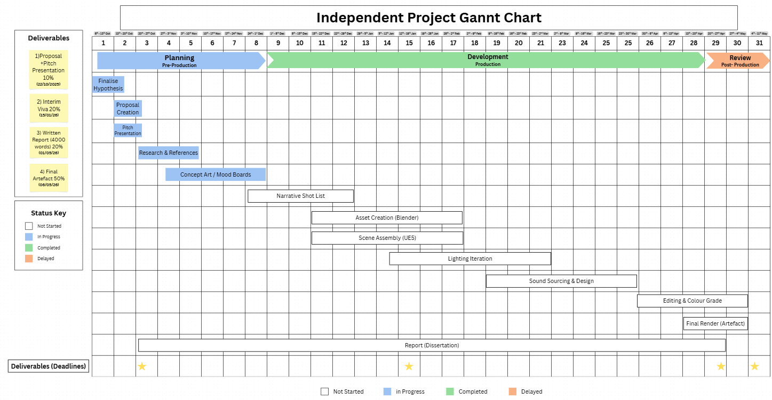
Public View Link: Independent Project Gannt Chart

Research & References
The following section will discuss the following:
- Primary Hypothesis: “To what extent can lighting and sound design alone shape an audience's interpretation of a preceding event in a characterless 3D animated environment?”
The above hypothesis is opposed to the previously thought below, however changed early on as explained in the introduction.
"This project will test the hypothesis that a first-person perspective, combined with detailed environmental storytelling, can be more effective at creating suspense and narrative intrigue in a 3D animation than a traditional third-person cinematic approach."
- Ethics & AI Guidelines: This being considered in work undertaken in the past and in this new endeavour.
- Research Findings: Including but not limited to, case studies (e.g. animators, film knowledge, VFX methods) and Research methods and information sourcing.
- Visual influences: Such as contributing factors, in undertaking the project, in covering the references, techniques and anticipated process.

Ethics & AI Guidelines:
In keeping in line with previous years I already understand the significant importance of using AI ethically and responsible, the growing role it has in the industry in every sector, as well as how I can specifically use it not as a shortcut or cheat, but an aid, a powerful tool that can expand creativeness, not as a replacement.
I believe this strongly and as such, and in conjunction with my other modules, I will only be using AI to create reflective journal structure, for example, titles and headings as per the assignment specification, and not the content itself, as it is very important I can show my creative thought process behind each decision I make and be able to evidence that here without AI is not only ethical but appropriate to learn in order be effective in any working environment to not become reliant on AI as a crutch as this is not how it should be used.
In doing so, also ensures I am keeping with university policy, whiles learning how to use AI tools responsibly and actively as it grows at a faster pace than ever in any previous years.
In writing this review I reinforce this ideology and context of use cases that AI can be applied to as per the specific areas allowed by the specification, that being, research, structure and proof reading.
Areas in which AI have been used such as specific research will be expanded on at points in this document, explaining the reasoning and context to why AI can aid research by saving countless hours, whiles still retaining an effective and ethical approach.
For example, as someone who has ADHD, it can be hard to focus for longer periods, time in which research can take. As a result, using tools such as AI audio overviews allows me to take a breather from reading and allows me to listen instead, this being a key learning method for myself. However, it is important to note, to always double check references from AI sources to make sure the information is accurate and credible for use with my IEEE referencing system/bibliography.

Research Findings:
Blade Runner 2049 Case Study:
Denis Villeneuve’s Blade Runner 2049 has stood as a monumental key example of modern visual effects and CGI, not just merely for its vast technical prowess and impressive feats, but for its masterful pro-use of large-scale CG crafted environments as a primary narrative device/s. The work put into it, particularly the nearly 300 shots delivered by the visual effects house of Framestore in collaboration with well-known VFX Supervisor John Nelson, provides a crucial case study for my project, "THE BUNKER." Particularly however it demonstrates how the art of atmosphere, lighting and its structure, and environmental detail and design can convey a story and vigorously evoke emotion in the absence of an explicit exposition within the scene as a whole.
Framestore was tasked with creating a vast, multitude of believable worlds from the ground up, two of which are actually directly relevant to my research: the "Trash Mesa" and the post-apocalyptic Las Vegas being key in terms of colour palette and lighting integration with sand and volumetrics.
The Trash Mesa was not just simply a digital backdrop; it was a world built with a larger more tangible sense of history that was created a much denser and believable world building approach and methodical-ness. The team’s approach, which involved dressing digital structures with layers of dirt, refuse, and scrap metal over underlying with wood scaffolding, created a powerful landscape that tells a story of societal collapse and desperation, this can be analysed further but what is key is how this type of narrative can inspire that similar to my project. This technique of layering substantial amounts of intriguing history and much decay onto an environment is a core principle I intend to apply to "THE BUNKER" to ensure every surface feels lived-in and contributes to the narrative of long-term isolation, weather utilising pre-built assets such as Quixel Bridge the ideology remains the same in being about to choose and apply the ‘right’ texture taking Framestore’s techniques on Blade Runner 2049 as a prime example.
Similarly, the creation of a deserted, post-apocalyptic Las Vegas is a perfect example of a character-less environment telling a story purely from an overview and approach to how this can be naturally cited in a developed world. The emptiness, grand structure/s communicate a narrative of pure abandonment and lost grandeur, forcing the audience to question what cataclysmic event took place. This directly aligns with the goal of my project, which is to have the audience piece together the story of Jim's departure through the clues left behind in the empty bunker.
Perhaps the absolute and most significant aspect of the film's pressing and abundant visual success is its use of atmospheric lighting to shape the audience's interpretation. The Las Vegas sequences were famously bathed in a vivid, burnt-orange colour. This was not just an aesthetic choice but a narrative one. The oppressiveness, the unnatural hue creates a very palpable sense of a toxic, densely irradiated, and suffocating atmosphere similarly to the world of my concept.
It tells the audience everything they need to know about the state of the world without a single line of dialogue, it is important to note how this proves the core of my hypothesis that lighting can be a primary narrative tool, however this may be a shortcomed conclusion as though it has much relevance it is not an isolated standalone short as my project will be.
Technically speaking, the team’s pursuit of capturing photorealism went beyond just sharp visuals and bold colours. They merely pioneered the use of digital lens distortion to be of a complementary nature and accomplice to the curated cinematography of Roger Deakins.
A further look into this may help influence how I use lens affects to also help a narrative and/or convey an emotion or mood. By digitally recreating the subtle, physical imperfections of a real camera lens, they grounded the synthetic digital environments in an authentic photographic reality based on their extensive photography work and concept art form the art department. This commitment to believability imperfection, rather than that of a sterile digital perfection, is a crucial takeaway for me achieving a tangible sense of realism in my shots.
In conclusion, Blade Runner 2049 is a brilliant masterclass in environmental storytelling techniques and methods. Its success proves that not only large-scale CG environments can be effective when crafted with narrative intent and lit for an emotional impact, but that in most instances can become characters in their own right and certainly have done in this example. The principles demonstrated by Framestore; building history into textures, using bold colour to create atmosphere, interaction with volumetrics, rendering techniques and grounding digital work in physical reality-based situations and story’s that will be foundational to my approach in creating the lonely, narrative-rich world of "THE BUNKER."

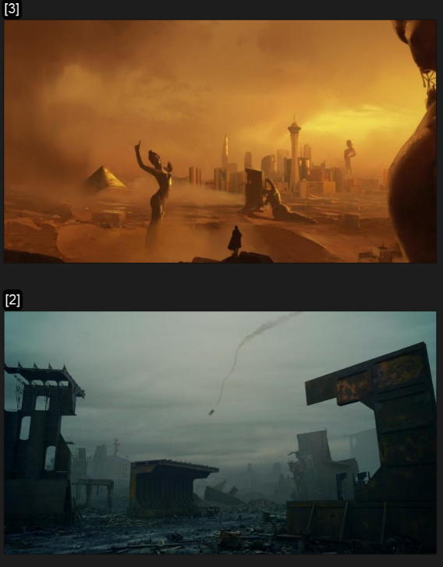

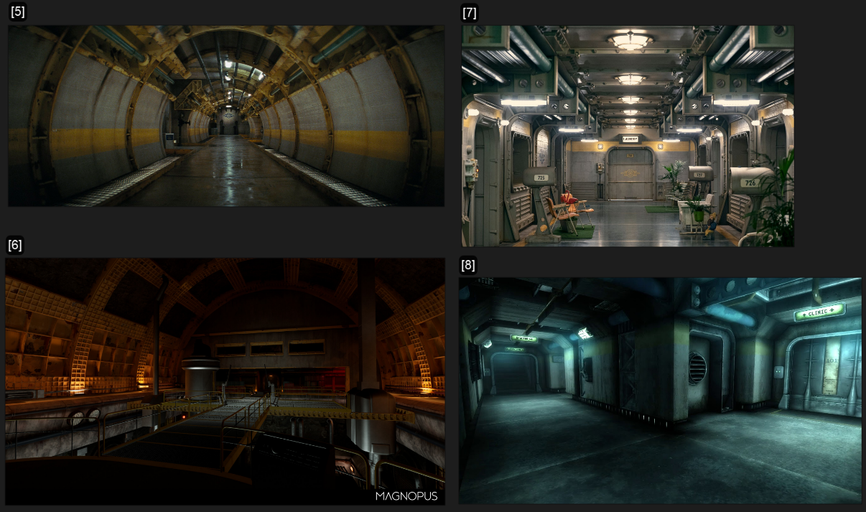
References for the Bunker's Architecture & Atmosphere: [5] – [16]

The above screenshot showcases images from the physically set of the fallout series [3], to the environmental designs of artists [4].
I then started to research closer to home, with looking into bunker sets, how the series fallout using virtual production set used digitally created CG environments as virtual photoreal set extensions for some of the bunker’s interiors. I will take inspiration from the use of lighting and rending techniques used to create such highly detailed looking environments. I will also gather more images for a mood board where I will begin to conceive a colour scheme.
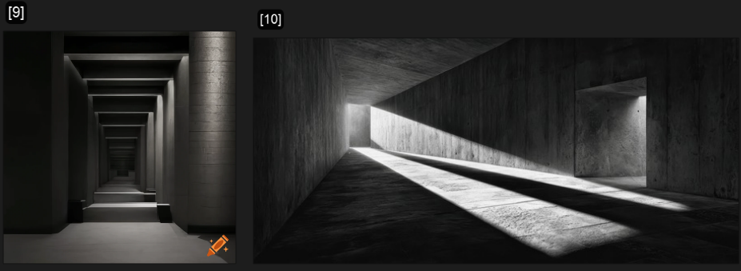
This shows the brutalist architecture, that gives a heavy, geometric, concrete feel. Important to set a cold lonely tone to the atmosphere, so is a key reference.
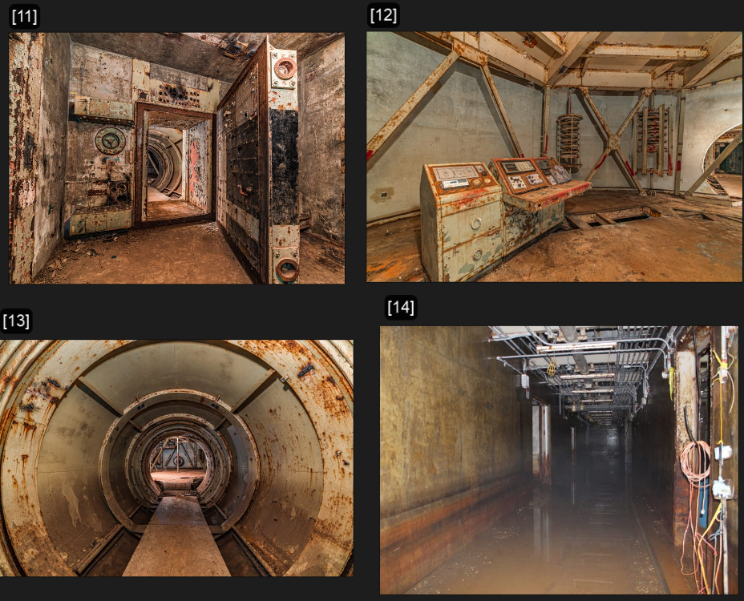
I then started to collate a real-life reference, specifically cold war bunkers, showing decay, decrepitness and purposeful spaces. I can not only mimic these structures and get a sense of scale but also understand how rust can be used to utilise tone and add to the narrative, for example, orange being associated with unease as well as darker shades of orange and brown.
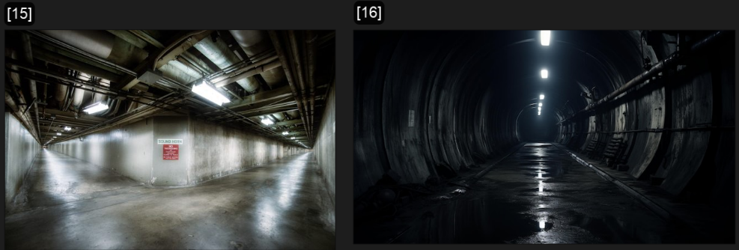

These references show the long never ending like atmospheric tunnels I want some of my scenes to capture. The sense of unease and foreboding while hearing the past echoing, dark, suspenseful and dramatic use of lighting and shadow to tell the narrative.

References for the Lighting & Colour Scheme: [17] – [19]

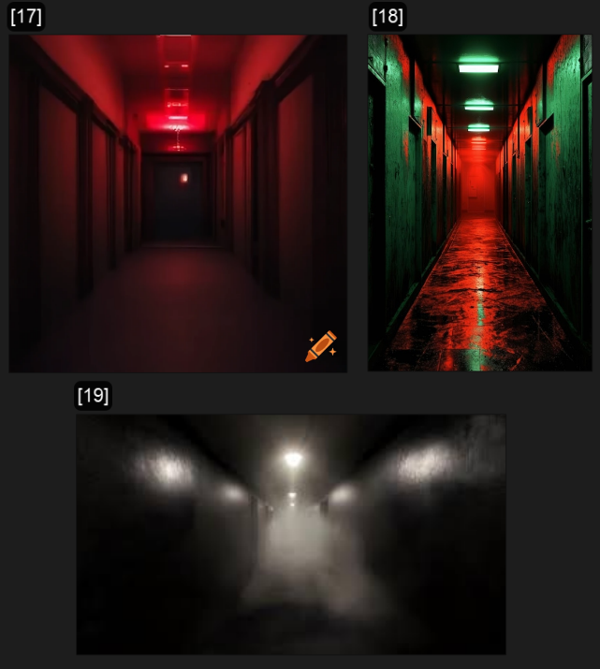
These references are a general term to find strong, moody examples in Atmospheric interior lighting and how this can be used as a powerful narrative effect. It can be cinematic, free flowing, natural, or more directed, for example the ominous fog of an eerie hospital corridor, suggesting something unnatural at foot, perhaps death itself lurking, it’s generally up for interpretation at that point but is key to analyse to understand it at foundational level.
As seen in [19] the dust and particles caught in shafts of light, which can look amazing coming from an open vault door for example, perhaps directing the viewers eyes to an object on a table, using the rule of thirds. This volumetric use and lighting are something I will be experimenting during the project to make my animation immersive and impactful as possible.
In terms of colour theory however, the use of red dark blues and green will be used as a complement to each other, but to also help contrast certain aspects of the composition to exactly show and depict what I want the viewers to get a sense of emotion happening. This of course, only being a baseline palette, of cold blue, greys and greens to build upon, that will make any of the armer red lights, pop in contrast.
References for the Environmental Storytelling: [20] – [27]
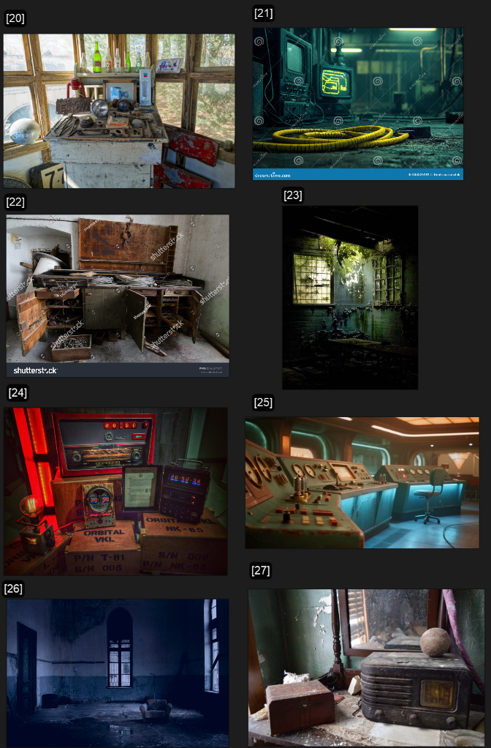
The above mod board collates images that inspire environmental storytelling, especially in the context of my short film. For example, as seen in [20] and [22] we see abandoned workbench, showing a having rushed to leave or objects adorned hinting to the characters personality for example, vintage bottles, baseball, photographs, or other personal items that you would think would have a sentimental value attached to them.
Other images, such as [23] 26] and [27] show urban decay detailing, which important to notice the peeling paint, rust textures, worn metal, and cracked concrete for potential recreation of PBR materials.
Perhaps most importantly however, in [24] and [25] we see Retro-futurism electronics that finds the right aesthetic for the bunker's technology and my key radio prop, giving influence on the similarities to a dystopian, not too different from Fallout for example, where much of the inspiration spans from in this area.

Visual influences in undertaking the project:
(In covering the references, techniques, anticipated process)
Visual references are really important to how I create things. I would begin by looking at pictures of Brutalist buildings and Cold War bunkers. I use these to model the bunker's layout in Blender, starting with a simple version. Then, I look at pictures of places that are falling apart and old metal to create the materials I'll use. This helps me show that the place has been abandoned. By adding textures like rust and dust to the surfaces, I'm putting the story of what happened there right into the environment.
I also use lighting and colour references to test out ideas from my lighting module. In Unreal Engine, I try to recreate the kind of scary red lighting I've seen in my references. I do this by using a single light source and letting its red colour spread onto the concrete walls using Lumen's Global Illumination. This makes the mood unsettling, which is what I want. Lastly, I’d use DaVinci Resolve to adjust the colours of the video. This makes sure the scene matches the colour scheme I have in mind, darkening the shadows and making the yellow radio stand out as a point of contrast. Below you can view this colour scheme, the choices I made and the creative decision behind them which I have already talked a bit about.

Proposal Pitch & Impact
The following section will discuss the following:
- Early Designs: or short series of initial designs or conceptual art
- Visual Hook: or promotional piece for this first pitch / proposal
- key moment or scene or action from the intended narrative / sequence
- Colour Scheme: As well as sense of framing and character shaping, etc

Colour Scheme:
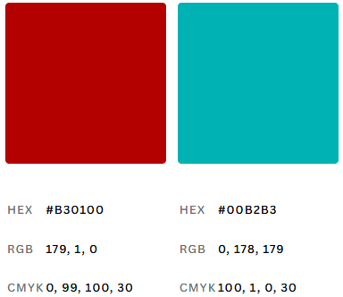


The darker red and blue hues will complement each other whiles having a strong presence amongst the scene create an eerie atmosphere, while the oranges will be used in the design of the environment to appear decayed.

Visual Hook:
(Conceptual work & Early Deigns)

Robot Prototyping/Prop Making

One of the early ideas I had for the project was to have the robot and evil entity (The Silacra) have a short scene, however after moving away from character in this piece I decided to dedicate this idea though part of the same concept to my Advanced Character Performance module instead.
However, the below shows this early design, and exercises, as well as the prototype robot I made as a prop in my spare time prior to September but can be instrumental in referencing and potential VFX use by 3D scanning.
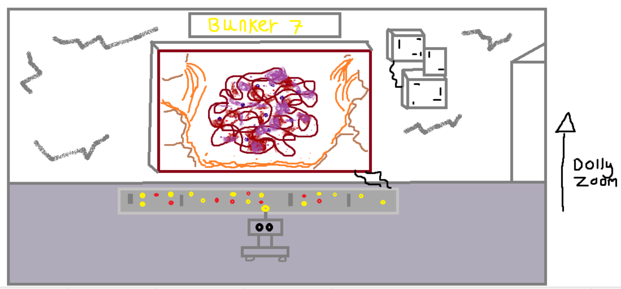

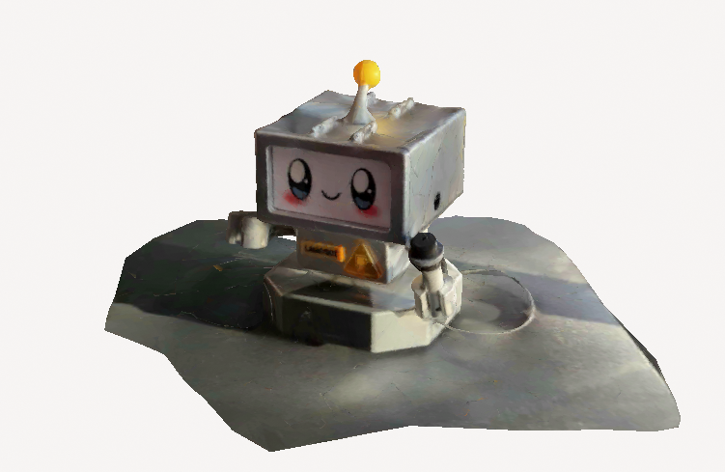
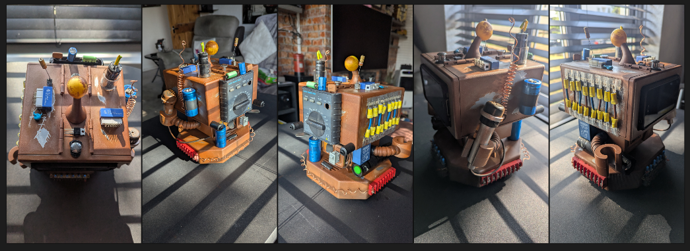

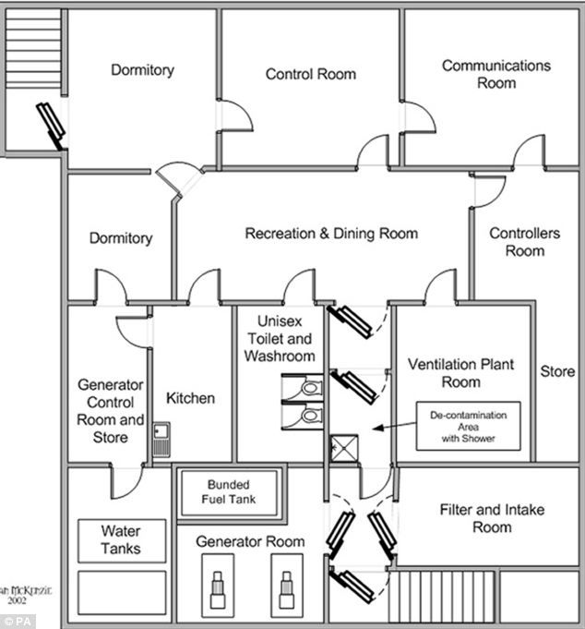
In part to designing the environment I began looking at real life examples, such as schematics of cold war bunkers to get an idea of what an accurate layout could look like.

Scene Blackouts & Prototyping:
(Including lighting tests, with characters as a focus point)
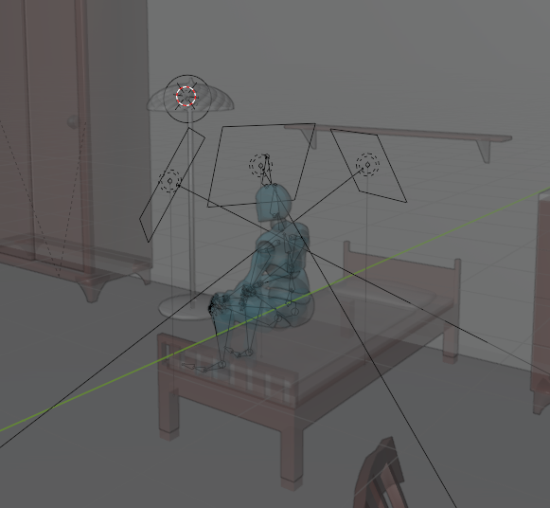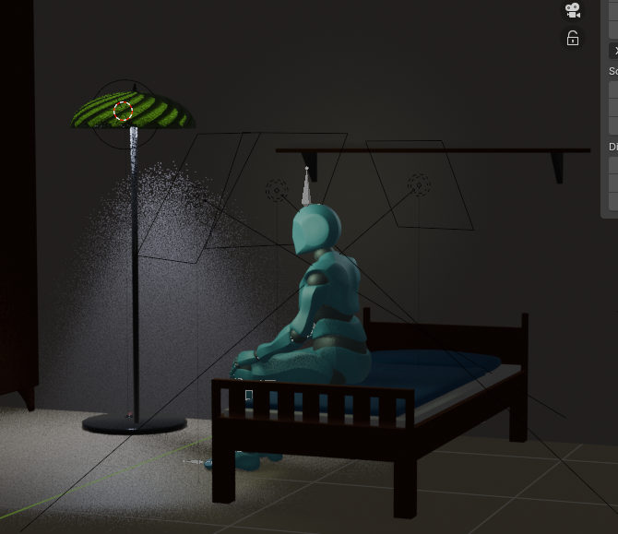
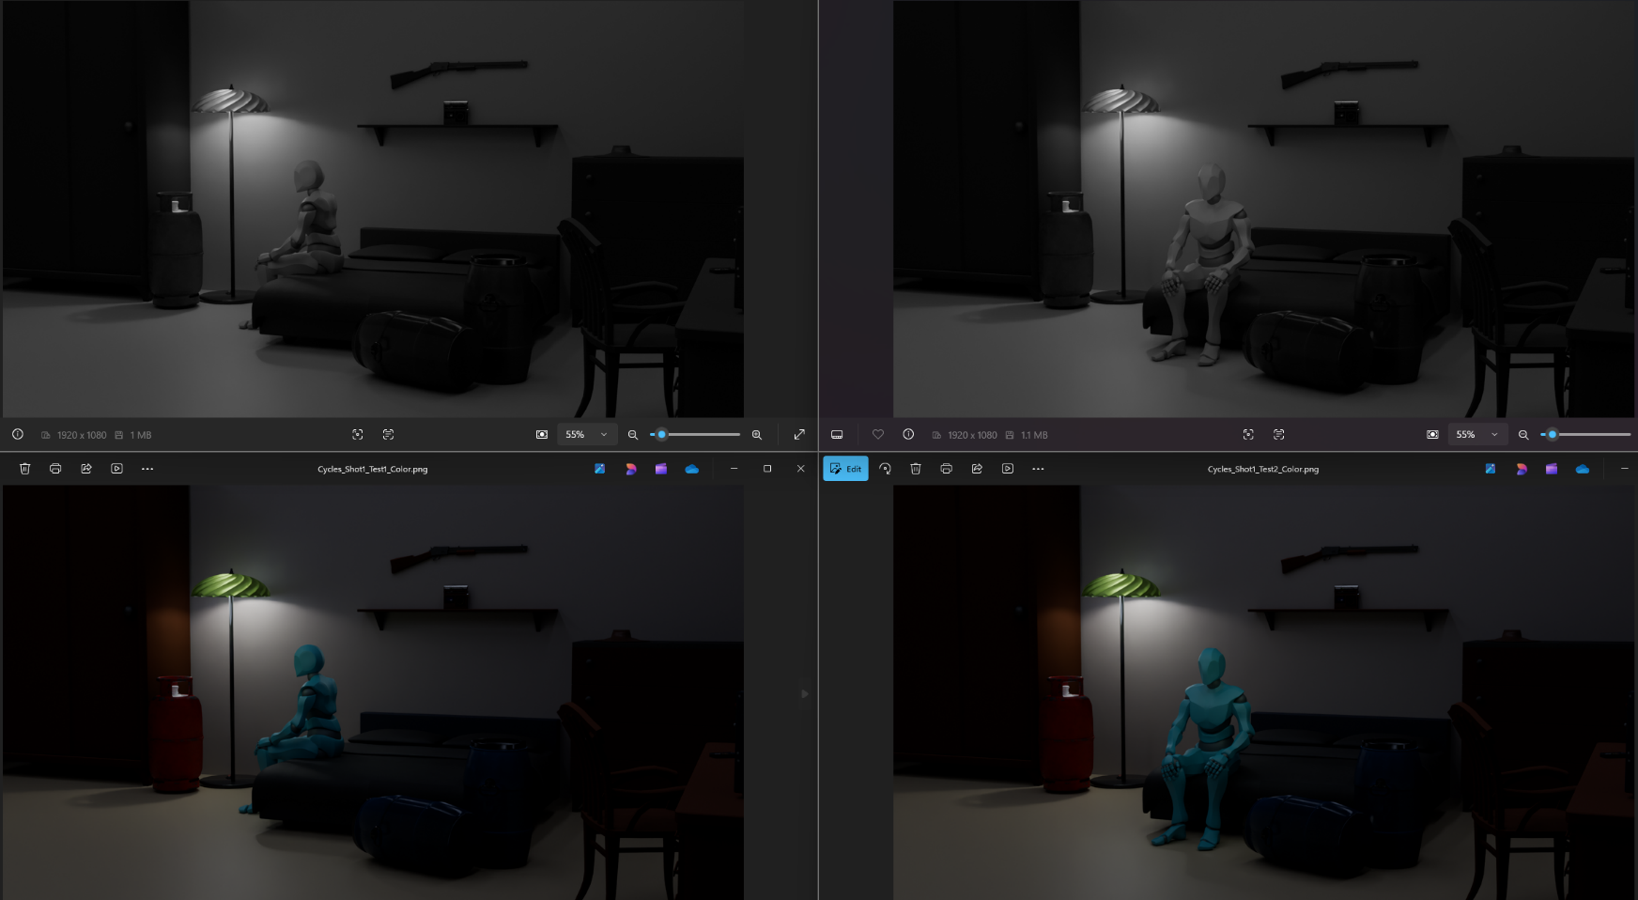
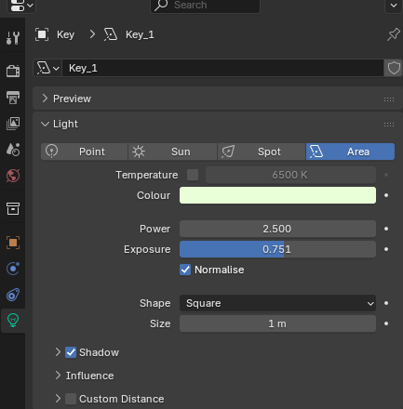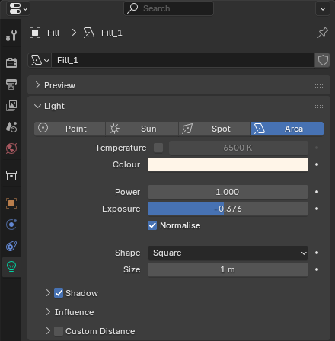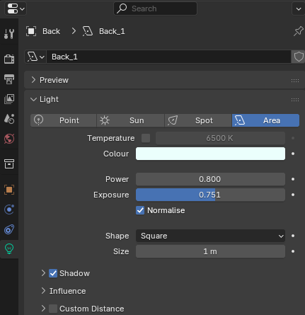
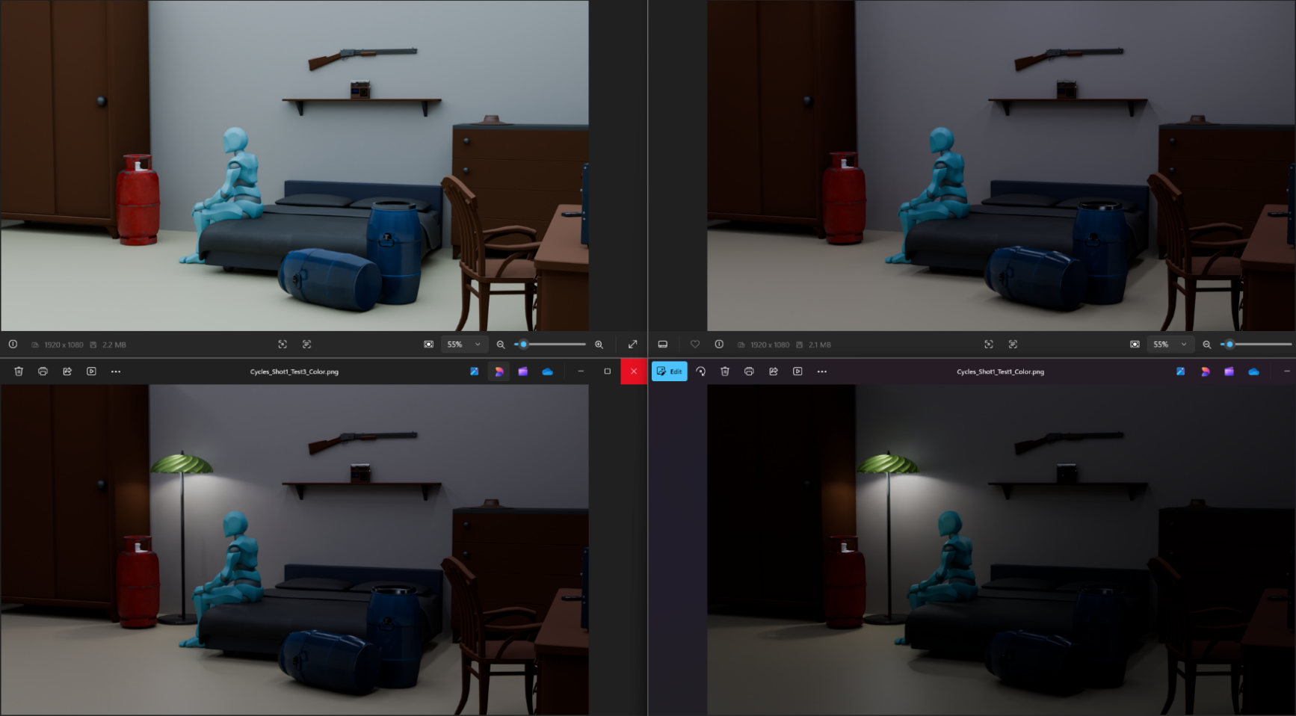
These exercises were more of a lighting test to see how I could originally portray a character precise in the scene, however the approach and learning outcomes remains the same. I learned how to use contrast, training my eye to recognise the quantity and subtlety of contrast in a composition as well as recognising depth and effective use of a 3-point lighting system.
I experimented with lighting intensity, exposure and temperature and how they interact with each other to change a mood or effect on the subject and overall scene.

Proposal - Pitch Presentation:
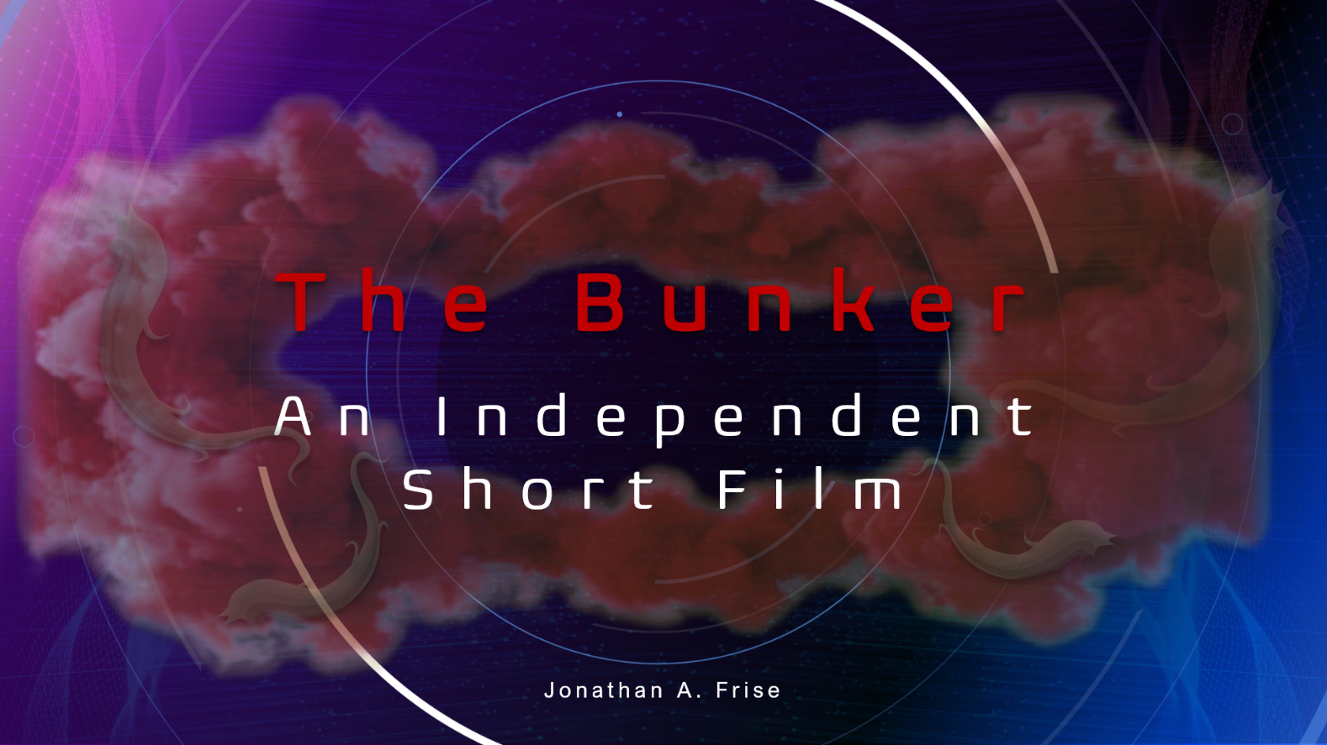
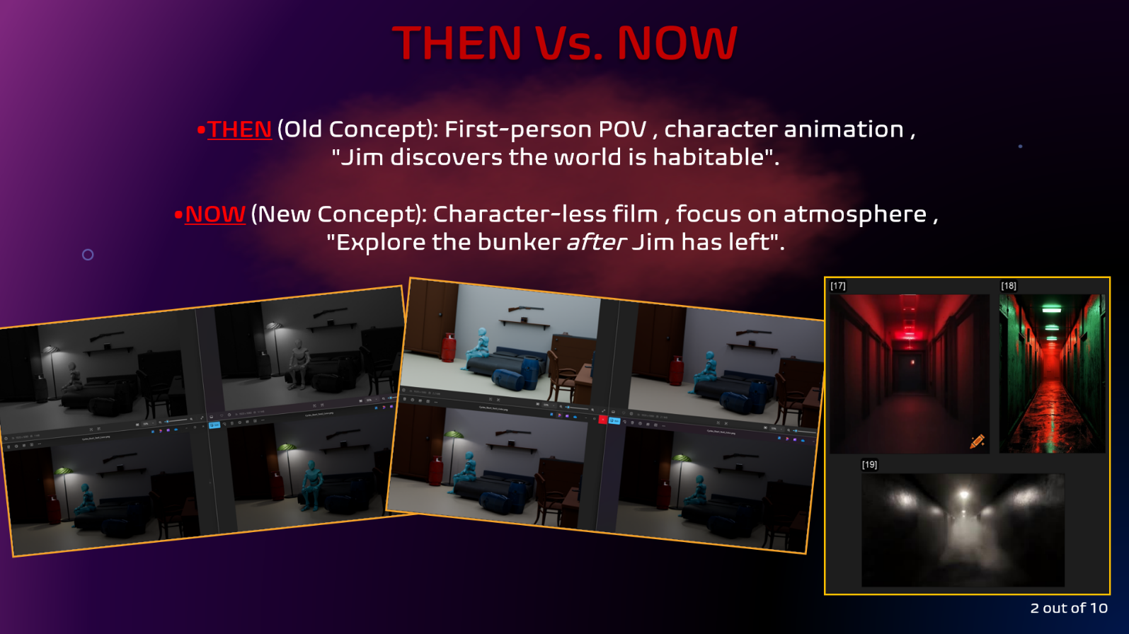
Independent Pitch Presentation.pptx

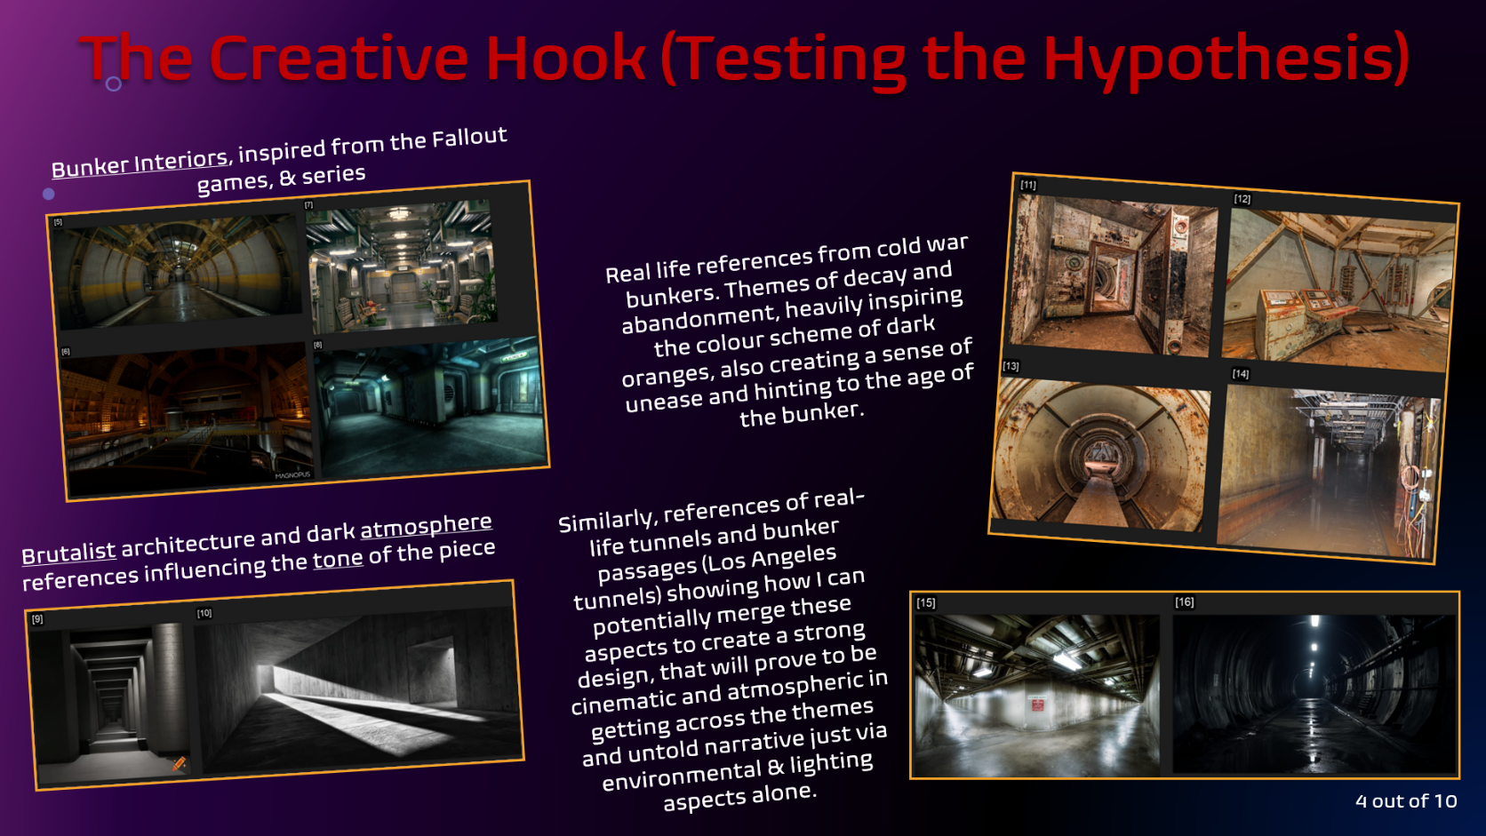
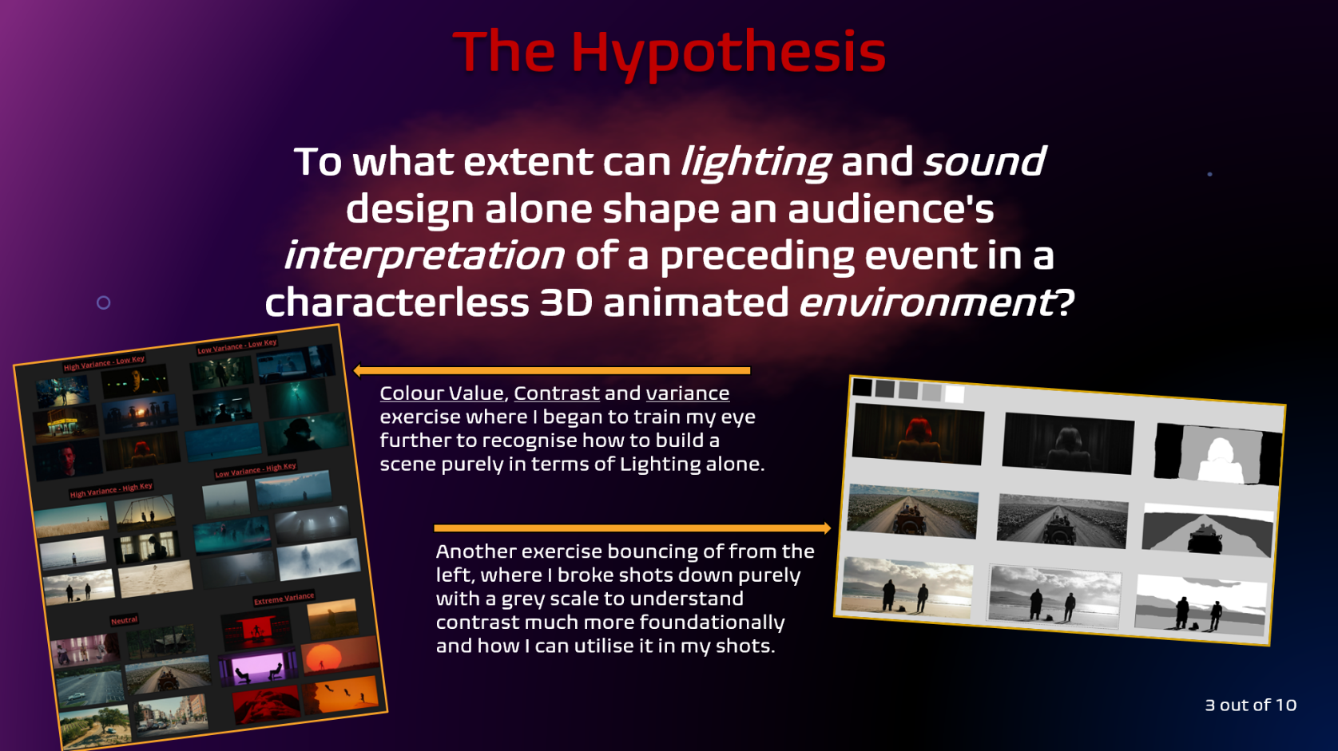

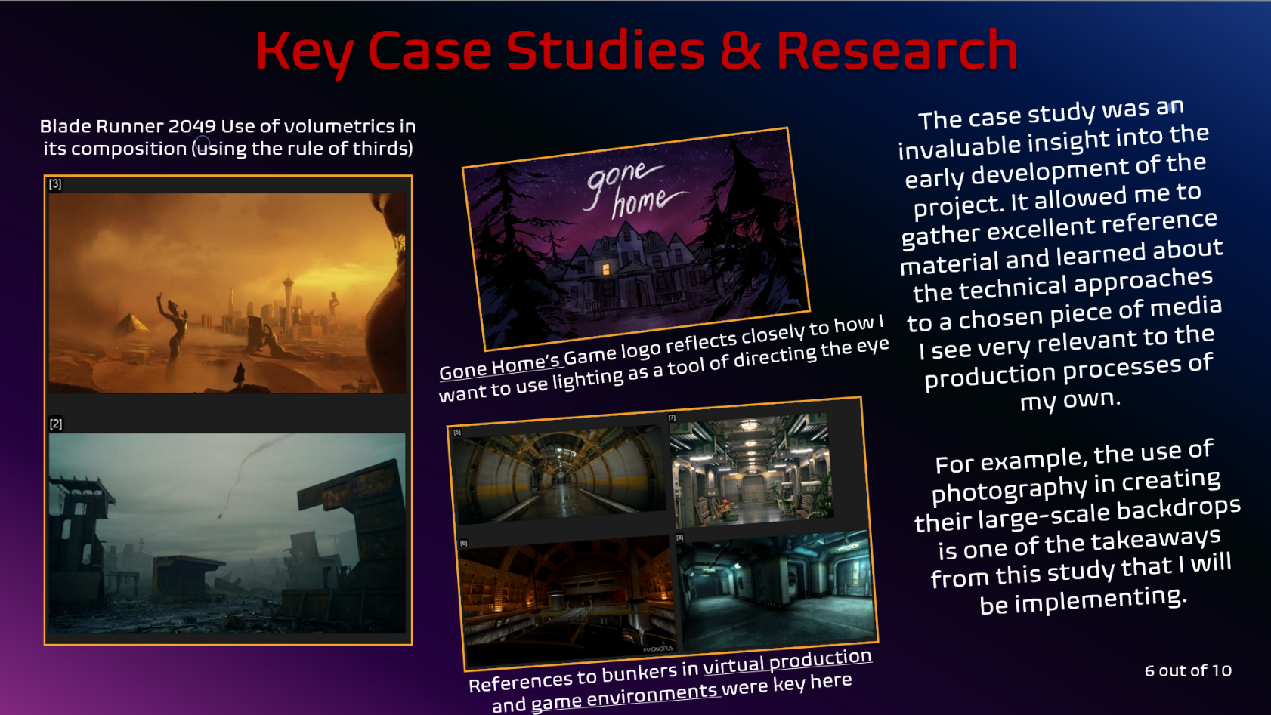
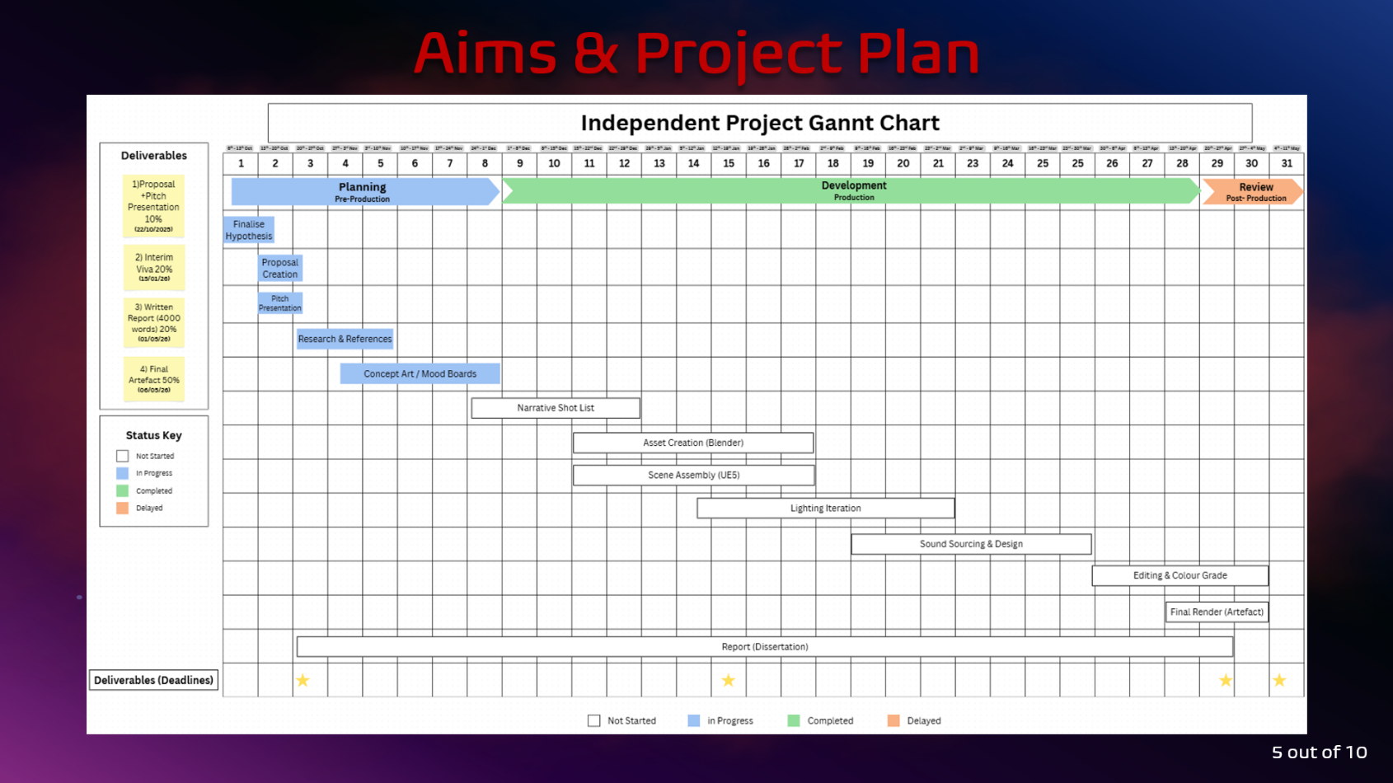
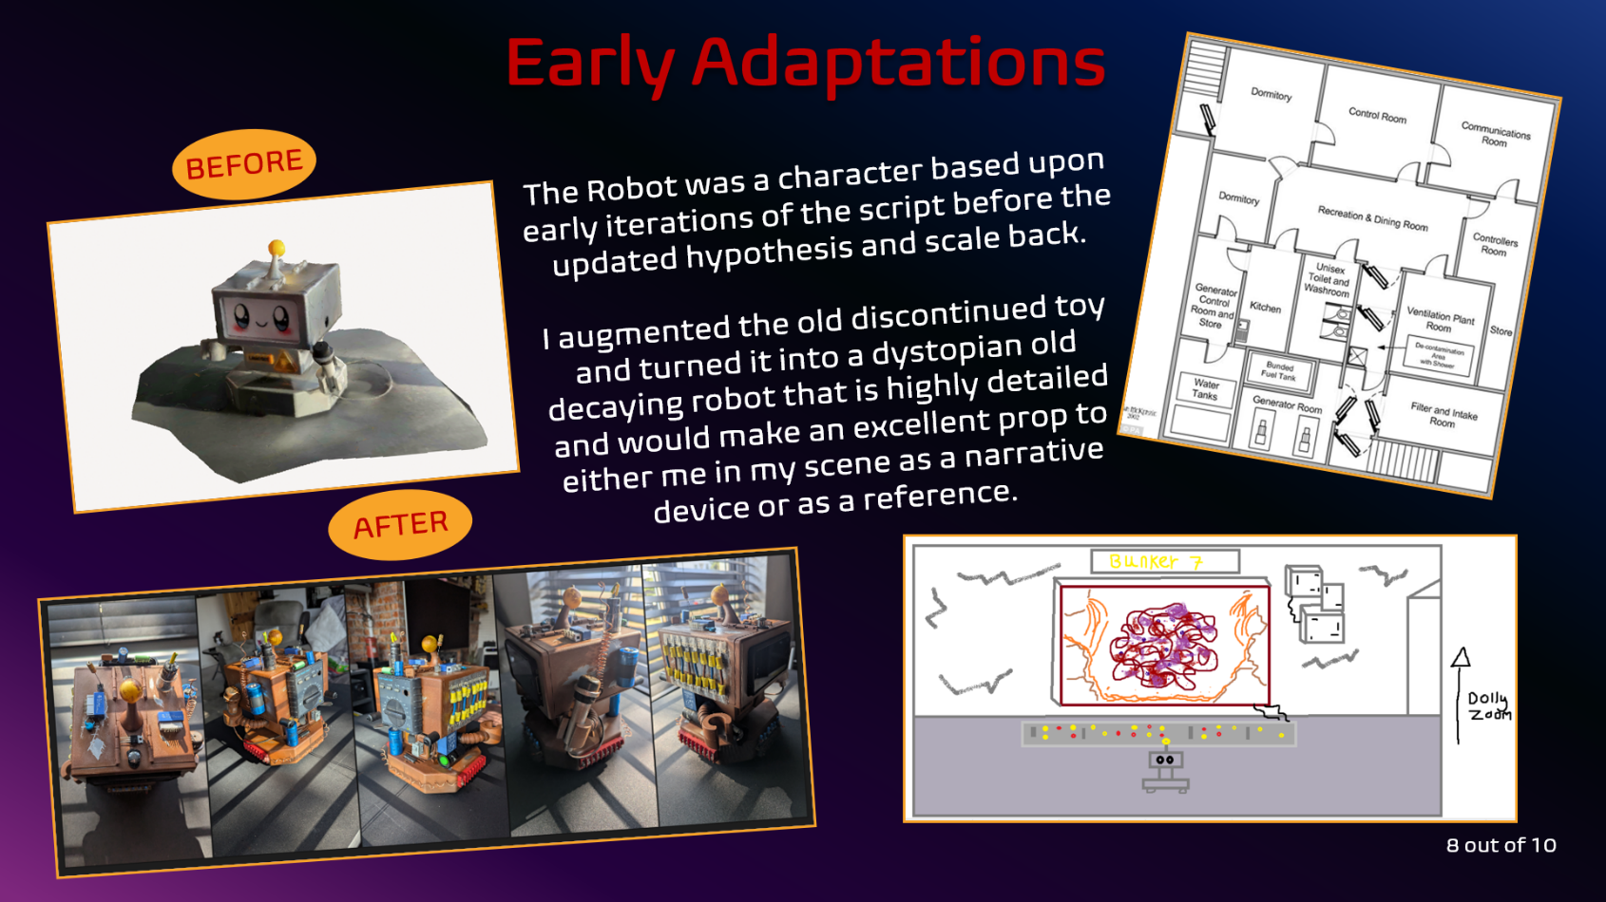
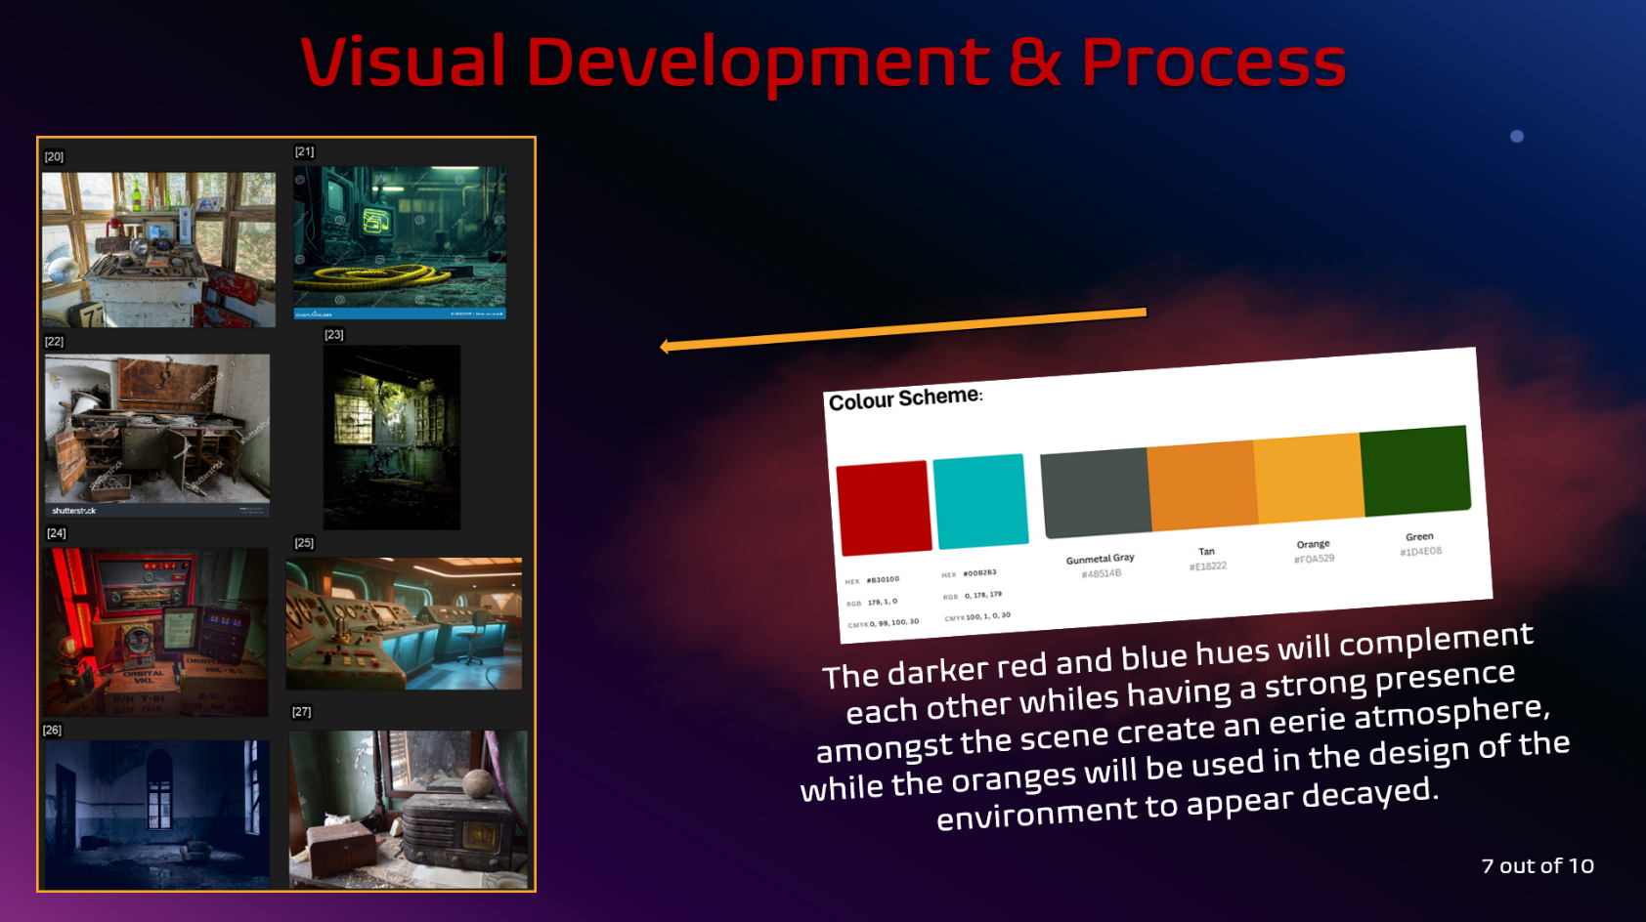

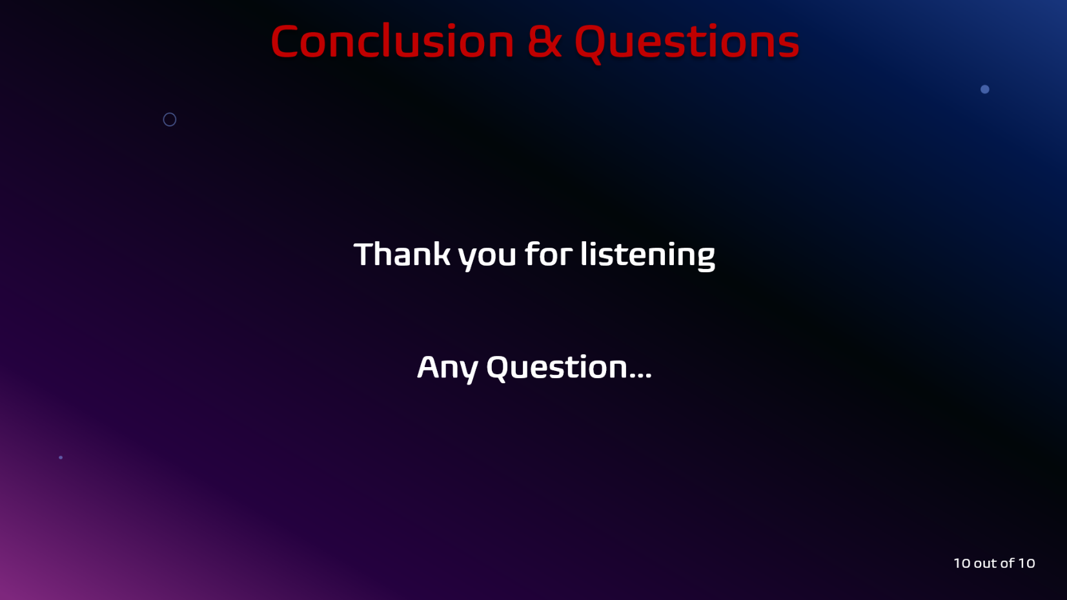
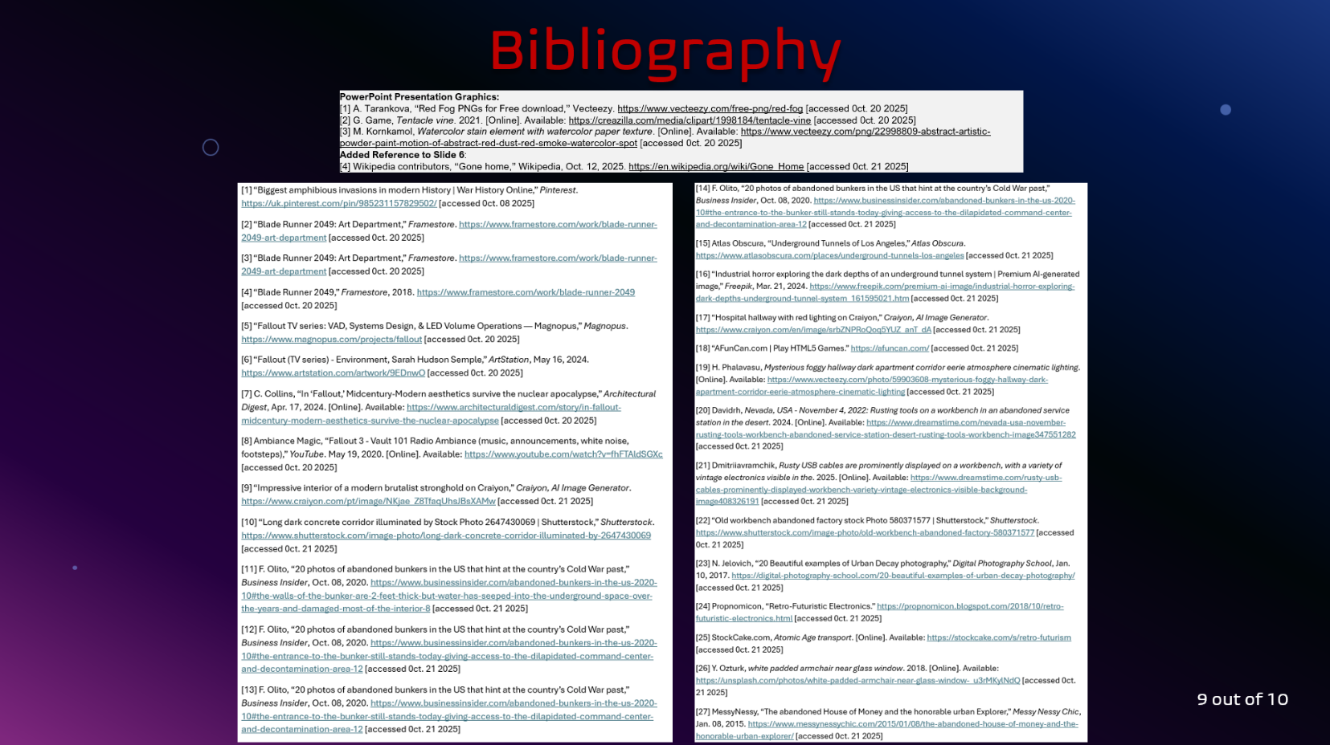

Preliminary Bibliography

[1] “Biggest amphibious invasions in modern History | War History Online,” Pinterest. https://uk.pinterest.com/pin/985231157829502/ [accessed 0ct. 08 2025]
[2] “Blade Runner 2049: Art Department,” Framestore. https://www.framestore.com/work/blade-runner-2049-art-department [accessed 0ct. 20 2025]
[3] “Blade Runner 2049: Art Department,” Framestore. https://www.framestore.com/work/blade-runner-2049-art-department [accessed 0ct. 20 2025]
[4] “Blade Runner 2049,” Framestore, 2018. https://www.framestore.com/work/blade-runner-2049 [accessed 0ct. 20 2025]
[5] “Fallout TV series: VAD, Systems Design, & LED Volume Operations — Magnopus,” Magnopus. https://www.magnopus.com/projects/fallout [accessed 0ct. 20 2025]
[6] “Fallout (TV series) - Environment, Sarah Hudson Semple,” ArtStation, May 16, 2024. https://www.artstation.com/artwork/9EDnwO [accessed 0ct. 20 2025]
[7] C. Collins, “In ‘Fallout,’ Midcentury-Modern aesthetics survive the nuclear apocalypse,” Architectural Digest, Apr. 17, 2024. [Online]. Available: https://www.architecturaldigest.com/story/in-fallout-midcentury-modern-aesthetics-survive-the-nuclear-apocalypse [accessed 0ct. 20 2025]
[8] Ambiance Magic, “Fallout 3 - Vault 101 Radio Ambiance (music, announcements, white noise, footsteps),” YouTube. May 19, 2020. [Online]. Available: https://www.youtube.com/watch?v=fhFTAldSGXc [accessed 0ct. 20 2025]
[9] “Impressive interior of a modern brutalist stronghold on Craiyon,” Craiyon, AI Image Generator. https://www.craiyon.com/pt/image/NKjae_Z8TfaqUhsJBsXAMw [accessed 0ct. 21 2025]
[10] “Long dark concrete corridor illuminated by Stock Photo 2647430069 | Shutterstock,” Shutterstock. https://www.shutterstock.com/image-photo/long-dark-concrete-corridor-illuminated-by-2647430069 [accessed 0ct. 21 2025]
[11] F. Olito, “20 photos of abandoned bunkers in the US that hint at the country’s Cold War past,” Business Insider, Oct. 08, 2020. https://www.businessinsider.com/abandoned-bunkers-in-the-us-2020-10#the-walls-of-the-bunker-are-2-feet-thick-but-water-has-seeped-into-the-underground-space-over-the-years-and-damaged-most-of-the-interior-8 [accessed 0ct. 21 2025]
[12] F. Olito, “20 photos of abandoned bunkers in the US that hint at the country’s Cold War past,” Business Insider, Oct. 08, 2020. https://www.businessinsider.com/abandoned-bunkers-in-the-us-2020-10#the-entrance-to-the-bunker-still-stands-today-giving-access-to-the-dilapidated-command-center-and-decontamination-area-12 [accessed 0ct. 21 2025]
[13] F. Olito, “20 photos of abandoned bunkers in the US that hint at the country’s Cold War past,” Business Insider, Oct. 08, 2020. https://www.businessinsider.com/abandoned-bunkers-in-the-us-2020-10#the-entrance-to-the-bunker-still-stands-today-giving-access-to-the-dilapidated-command-center-and-decontamination-area-12 [accessed 0ct. 21 2025]

[14] F. Olito, “20 photos of abandoned bunkers in the US that hint at the country’s Cold War past,” Business Insider, Oct. 08, 2020. https://www.businessinsider.com/abandoned-bunkers-in-the-us-2020-10#the-entrance-to-the-bunker-still-stands-today-giving-access-to-the-dilapidated-command-center-and-decontamination-area-12 [accessed 0ct. 21 2025]
[15] Atlas Obscura, “Underground Tunnels of Los Angeles,” Atlas Obscura. https://www.atlasobscura.com/places/underground-tunnels-los-angeles [accessed 0ct. 21 2025]
[16] “Industrial horror exploring the dark depths of an underground tunnel system | Premium AI-generated image,” Freepik, Mar. 21, 2024. https://www.freepik.com/premium-ai-image/industrial-horror-exploring-dark-depths-underground-tunnel-system_161595021.htm [accessed 0ct. 21 2025]
[17] “Hospital hallway with red lighting on Craiyon,” Craiyon, AI Image Generator. https://www.craiyon.com/en/image/srbZNPRoQoq5YUZ_anT_dA [accessed 0ct. 21 2025]
[18] “AFunCan.com | Play HTML5 Games.” https://afuncan.com/ [accessed 0ct. 21 2025]
[19] H. Phalavasu, Mysterious foggy hallway dark apartment corridor eerie atmosphere cinematic lighting. [Online]. Available: https://www.vecteezy.com/photo/59903608-mysterious-foggy-hallway-dark-apartment-corridor-eerie-atmosphere-cinematic-lighting [accessed 0ct. 21 2025]
[20] Davidrh, Nevada, USA - November 4, 2022: Rusting tools on a workbench in an abandoned service station in the desert. 2024. [Online]. Available: https://www.dreamstime.com/nevada-usa-november-rusting-tools-workbench-abandoned-service-station-desert-rusting-tools-workbench-image347551282 [accessed 0ct. 21 2025]
[21] Dmitriiavramchik, Rusty USB cables are prominently displayed on a workbench, with a variety of vintage electronics visible in the. 2025. [Online]. Available: https://www.dreamstime.com/rusty-usb-cables-prominently-displayed-workbench-variety-vintage-electronics-visible-background-image408326191 [accessed 0ct. 21 2025]
[22] “Old workbench abandoned factory stock Photo 580371577 | Shutterstock,” Shutterstock. https://www.shutterstock.com/image-photo/old-workbench-abandoned-factory-580371577 [accessed 0ct. 21 2025]
[23] N. Jelovich, “20 Beautiful examples of Urban Decay photography,” Digital Photography School, Jan. 10, 2017. https://digital-photography-school.com/20-beautiful-examples-of-urban-decay-photography/ [accessed 0ct. 21 2025]
[24] Propnomicon, “Retro-Futuristic Electronics.” https://propnomicon.blogspot.com/2018/10/retro-futuristic-electronics.html [accessed 0ct. 21 2025]
[25] StockCake.com, Atomic Age transport. [Online]. Available: https://stockcake.com/s/retro-futurism [accessed 0ct. 21 2025]
[26] Y. Ozturk, white padded armchair near glass window. 2018. [Online]. Available: https://unsplash.com/photos/white-padded-armchair-near-glass-window-_u3rMKylNdQ [accessed 0ct. 21 2025]
[27] MessyNessy, “The abandoned House of Money and the honorable urban Explorer,” Messy Nessy Chic, Jan. 08, 2015. https://www.messynessychic.com/2015/01/08/the-abandoned-house-of-money-and-the-honorable-urban-explorer/ [accessed 0ct. 21 2025]

