KNOWLEDGE AND INFORMATION MANAGEMENT SKILLS FOR THE WORKPLACE

Module code: BMSW 5106-BIRM
Lecturer Name: Yohan Mendes
Student name: Zamir Ahmed
Student I.D: 1919946

Executive Summary
TESCO is the most popular retail sector in the UK. The effective strategic planning of the knowledge and management skills of the employees of the organization helps in developing sustainability in the competitive retail sectors. However, marinating the cost effective decisions and the discounts in the products helps in attracting the middle class society. Therefore, engaging the market in the retail sectors becomes easier for TESCO. Attractive product packaging and continuous changes in the external features of the products helps in attracting the customers towards the brand. However, maintaining the sustainability of the TESCO implementation of the S/4HANA ERP system incorporates the management strategies of maintaining and analysing the information and the supply chain management of the organization. Hence, the improvement of the skills of the employees of the organization and the proper training helps in increasing the performances of the TESCO.

Table of Contents
Introduction 4
Question 1: Benefits of TESCO for using information systems 4
Question 2: Information system implemented by TESCO 6
Question 3: Competitive advantage of TESCO by using IS/IT systems 7
Porter's generic competitive strategy framework for TESCO 8
Question 4: Challenges for TESCO in implementing a new Enterprise Resource Planning (ERP) system and overcoming strategies 11
Overcoming strategies of the challenges of the ERP system of TESCO 12
Question 5: Plan for implementing a new ERP system in TESCO 14
Conclusion 16
References 18
Appendices 21
Appendix 1: graphical analysis of financial performances of TESCO 2021 21
Appendix 2: Risk management of TESCO 22

Introduction
The knowledge and management of the information skills play a significant role in the development of the organization. However, in TESCO, the whole work of the organization depends upon the effective management of the knowledge and skills of the employees of the organization. Therefore, the good knowledge and the effective communication skills of the organization help in getting success in the global market. Hence, the marketing strategies of the organization develop based on the knowledge of the market situation and managing the skills of the organization. Therefore, managing the goals and the objectives of the organization, the incorporation of the knowledge and skills positively affects on the organization.

Question 1: Benefits of TESCO for using information systems
An information system is a socio-technical, formal and organizational for collecting, processing, storing and distributing data to develop an organization. TESCO is a leading retailer company in the UK that has group sales of 49.9 billion pounds and an operating profit of 2,959 million pounds in 2020 (Tesco.com, 2020). For this huge profit and rapid development in TESCO Company, proper implementation of information Systems has a vital contribution. Previously TESCO Company was using a Linux system for Digital marketing approach (Hallikas et al. 2019). Hence, at present, TESCO has shifted to an Oracle marketing platform that is closer to customers while targeting their buying habits. Therefore, using the new information has heightened the group sales to 53.4 billion pounds that are 7.1% higher than 2020 annual sales (tescoplc.com, 2021).
In present years, TESCO has saved millions through using supply chain analytics by implementing information systems. As per the view of Hallikas et al. (2019), information systems can improve IT integration by 82% and supply chain by 77% in an organisation. At present, TESCO is implementing an Oracle warehouse management system that has strategic and systematic coordination across business functions within the supply chain. The new information system in TESCO has supported supply chain integration from suppliers to customers along with logistics and finance. An information system is important for TESCO to execute supply chain transactions and take decisions on behalf of managers. With the implementation of a prompt and effective information system, TESCO managers can be aware of retail stocks, production, customer's demand and production rate. Therefore, Information systems ensure the supply chain visibility for making impactful decisions regarding supply chain management.
Management information systems (MIS) is a computer-based system that provides important tools to TESCO managers evaluating, managing, running departments with past, present and prediction of information. As per the view of Nurwidayat et al. (2019), the present information system of TESCO is more advanced and supports web-based operations that provide solutions to shortcomings of older information systems. TESCO has one of the largest workforces in the UK, with 300,000 colleagues (Tescoplc.com, 2021). Hence, new computer-based information systems have been simplified for the TESCO HR department to maintain the database regarding employees. Through the present information system, managing employee salary, reviewing their leave application, and evaluating employee issues have become easier. On the other hand, the information system has preserved employee satisfaction with the development of TESCO production and sustainability (Brakewood and Watkins, 2019).
Present information assessment system of TESCO is important for evaluating beneficial factors and production growth in more scientific manner. Information system finds out organisational efficiency, alignment, effectiveness, strengths, capability and flexibility of TESCO (Bernadus et al. 2020). Information systems accumulate informative data about competitors by making stronger the potential factors of TESCO Company. On the other hand, the Information system provides an important database to the managers regarding production rate and customers demand, making important decisions regarding production, customers, stakeholders, and suppliers.

Question 2: Information system implemented by TESCO
TESCO Company was using a Linux system for a prompter digital marketing approach. Therefore, at present, TESCO has implemented Oracle Retail Warehouse Management System for handling management on customer approach. Oracle Retail Warehouse management system is essential with supply chain management control of orders, completes visibility and inventory throughout the distribution process.
Input: In TESCO, oracle warehouse management systems manage and optimize essential supply chain processes for a retail company through distinct visibility and inventory process. The input and primary factors of Oracle Warehouse Management depict web-based vendors to supply material on an emergency basis, inbound freight scheduling, pre-distribution of information for better guidance and inbound quality assurance, including vendor compliance (Gomes et al. 2018). In TESCO Plc, input mechanism collects raw data and information within organisation from external environment. In the context of TESCO Plc, input mechanisms are envisioned in management systems that various grocery products from different sub systems and sub-sub systems crockery utensils, foodstuff, beauty products. Oracle Warehouse System management supports optional inbound material inspection including receipt step, inspection step and put away step. In the min time, all inbound materials are separated into standard cost groups (Bajunaid and Attia, 2021). Regarding input mechanism, corrective actions and workflow notifications are built with proper justification. Oracle WMS in TESCO Plc. Supports two types of material input criteria. These are Express and Confirm Mode. In express mode, document number is needed to mention and in Confirm Mode, all information about input materials are described. This particular information system ensures compatibility with truck mount, radio frequency hardware, wrist mount and handheld.
Processing: Oracle warehouse management system starts the action of supply chain management by application data setup. In the context of the TESCO supply chain, the list of vendors, suppliers and production process are determined beforehand for clarifying the aims and objectives of TESCO. In addition, the Oracle information system set up the warehouse with Facility ID and a proper production environment (Michel, 2019). This information system sets the vendor, items list, destination, distribution and stock order for hazard-free production in the warehouse. Oracle warehouse management system also includes definite inventory management through defining out away plans, cycle count plans, replenishment method, inventory adjustment codes and transduction codes (Ying et al. 2021). In processing mechanism, Oracle Inventory management is a vital processing step. Here, besides performing material management, handling of miscellaneous issue and sub-inventory LPN (Licence Plate Number) transfer are also done. On the other hand, Lot Splitting, Lot merging, Lot Genealogy is important for processing mechanisms (Sinha, 2019). Implementation of facility management while using mobile user interface is vital step of processing mechanism in TESCO Plc. This step also includes material allocation through Task dispatch engine.
Output: Oracle Warehouse management system is solely based on gathering, collecting and evaluating information for setting up effective supply chain management. This information system processes a big database for retaining the demanding product and successful production for keeping fluency in supply chain management. Oracle warehouse management also defines the carrier codes and transportation route for maintaining low-cost transportation from warehouse to stores, customers. This information management system defines the list of products and production costs for easy delivery and a timeless investment process. Output mechanism in Oracle WHM in TESCO Plc, container management is a vital process. In this process, carton selection, container load, use of Cartonization and sales order picking are done. After that, packing, splitting, unpacking, consolidation and mobile bulk packing before starting shipping confirmation process. The last outbound mechanism is Mobile User Interface Shipping process and scheduling dock appointments.

Question 3: Competitive advantage of TESCO by using IS/IT systems
The implementation of the information technologies and the management system in the organization appropriately helps in managing the resources of the organization (VORONKOVA et al. 2017). Therefore, implementation of the development strategies of the organization and maintaining the time-consuming factors of the organization the management of the information system plays an important role. The most leading retail organization TESCO must maintain the millions of workers, customers in their store. Therefore, the effective management of the information and management technologies helps in maintaining the sustainability of the stores. TESCO uses Oracle and SAP Business Objectives Polestar application in their system and its effects on their e-commerce and financial management. However, maintaining the HR software, communications among the different stores and maintaining the supply chain of the oracle and SAP plays an important role (tescoplc.com, 2021). The significant retail sectors of TESCO, such as TESCO Express, TESCO Metro, TESCO superstore, TESCO extra, has £56.5 billion group sales and item related sales £2,959 million as per the financial report of 2020 (tescoplc.com, 2020). Therefore, maintaining the details of the retail sectors in both online and offline mode, the Information management system plays an important role.
However, maintaining the competitive analysis of the other retail sectors, Porter's generic strategies plays an important role (Islami et al. 2020). On the other hand, managing the sustainability of the organization identification of the competitive factors for the TESCO helps in maintaining the sustainability of the organization in the global market.

Porter's generic competitive strategy framework for TESCO
The TESCO is a British Private Limited organization for the retail sector. In the year 2019, the organization has substantial revenue of £ 6.760 billion and almost 4 23,000 employees are working on the organization (tescoplc.com, 2021). The sales of the TESCO as per the year 2021, show £53.4 billion in the group sales [refer to appendix 1].
However, there are three main strategies in Porter's generic strategies analysis of TESCO.

Figure1: Porter's generic competitive strategy framework
(Source: Islami et al. 2020)
Cost Leadership
The cost leadership strategies of Porter's generic competitive strategies help in analysing the competitors of the TESCO in the market based on various customers of the organization.
- The efficient management of the value chains of the TESCO using the Oracle and SAP Business Objective Polestar helps in maintaining leadership in the retail market (tescoplc.com, 2020). The Transitional Processing System (TPS) of TESCO helps in managing the business system and helps in managing the cost leadership of the company (tescoplc.com, 2019).
- The target share of the customer of TESCO focused on the middle class sectors as the population of the middle class sectors has a large number in the global market (tescoplc.com, 2021). Therefore, maintaining the cost of the products using the Transitional Processing System (TPS) of TESCO, servicers of the middle class customers, TESCO effectively controls the global market in the retail sector (tescoplc.com, 2019).
- TESCO always focuses on the affordable and highly accessible products of the world, which increases the sales growth of the TESCO at a high level of the market (tescoplc.com, 2021). On the other hand, the maintenance of the cost of the most affordable products using the Decision Support System (DSS) of TESCO helps in maintaining the competitive advantages on the global market (tescoplc.com, 2019).
- TESCO offers the discount prices of the products and lowering the production cost of the products, and maximises the supply chains of the products to attract the customers to the organization (tescoplc.com, 2021). However, the Decision Support System (DSS) helps in managing the product cost and develop productive supply chain of TESCO (tescoplc.com, 2021).
However, the cost leadership management strategy helps in maintaining the sustainability of the competitive global consumer of the market.
Differentiation
On the other hand, maintaining the competitive strategy in the global market and managing the differentiation strategies of TESCO plays an important role.
- Adoption of the Secondary Generic Strategies in the differentiation strategy TESCO implements the unique product features in the global market, and it effectively attracts the customers of the market (tescoplc.com, 2021).
- TESCO gives high importance to market analysis and the identification of the needs of the customers, and it helps in maintaining a strong and loyal bond with the customers of TESCO (tescoplc.com, 2021).
- Using the Management Information System (MIS) and Decision Support system (DSS), TESCO implements the high priority on the advertising and promotion of the products and offering alternative items to emerge in the global market (tescoplc.com, 2019). Making the celebrity endorsement on the promotion of the products of the organization helps in maintaining the competitive advantages from the other brands (tescoplc.com, 2020).
- As per the communication and marketing strategies of TESCO, the use of the combination of the old and the new brands of products creates the competitive advantages in the retail market (tescoplc.com, 2021). However, the Management Information System (MIS) of TESCO helps in managing the marketing strategies of TESCO (tescoplc.com, 2019).
- Brand logo plays an important role in the implementation of the differentiation strategies with the TESCO (tescoplc.com, 2021). The unique and distinctive logo of the brands used on every product of the TESCO helps in maintaining the differentiation strategies of the organization (tescoplc.com, 2020).
Focus Strategies
The third generic strategy includes the focus strategy, which helps in maintaining the competitive advantages of TESCO in the retail market.
- TESCO focuses on the cost of the products and the quality of the products. Therefore, in the niche market, the segment with the lowest prices and the effective, valuable products strategies of TESCO helps in maintaining the competition in the global retail market (tescoplc.com, 2021). On the other hand, Transitional Processing System (TPS) and Decision Support System (DSS) help in managing the cost leadership strategies of TESCO (tescoplc.com, 2019).
- As per maintaining focus on the attribute of the products, TESCO gives the high importance in managing the branding of the products and continuously changes the external design and packaging of the products to attract the attention of the customer (tescoplc.com, 2021). Therefore, Using the Management Information System and Decision support system (DSS) helps in managing focus strategies for developing the psychological satisfaction of the customers (tescoplc.com, 2019).

Question 4: Challenges for TESCO in implementing a new Enterprise Resource Planning (ERP) system and overcoming strategies
Implementation of the Enterprise Resource Planning in the organization system helps in maintaining the sustainability of the organization (Atrushi et al. 2020). However, in managing the staff and the activities of the organization, the ERP system plays a significant role. On the other hand, maintaining the computer-based information in the organizational supporting system increases the reliability of the services. On the other hand, several switching of the new software system creates challenges for the management of the changes in the software system (Menon, 2019). However, the implementation of the Enterprise Resources Planning (ERP) system in the organization positively affects on maintaining the performances of the products (Pham et al. 2019). TESCO used the Microsoft system in maintaining the supply chain of the organization in the year of 2001 (tescoplc.com, 2021). It cuts sustainability in the management of the supply chain. On the other hand, maintaining the sustainability and management of the integration of the sales structure of the organization, the ERP system plays an important role (Aljawarneh and Al-Omari, 2018). Therefore, maintaining the sustainability of the organization ERP system plays an important role [refer to appendix 2].
Managing the Projects
Implementation of the ERP system in the management of the projects creates big challenges for the organization. On the other hand, the data migration, designing, development, analysis and launching of the project of the big sections create challenges for the IT operational sectors (Menon, 2019).
Data integration and management
The other challenges of the ERP system are the integration and the management of the data of the organization. Developing the moving data and the multiple order system creates challenges for the organization to maintain the ERP system (Menon, 2019). TESCO has faced challenges related to management and integration of the data of the organization. Therefore, maintaining the work processes and implementation of the successful communication system of the organization implementation of the ERP system helps in maintaining the data of the organization.
Overruns of the cost
As per the study of Menon (2019), another challenge of the ERP system includes the selling of the past budget system and then implementing new business system of the organization. Therefore, the running of the cost creates a challenge for the organization in maintaining the ERP system.
Maintain Data integrity and security
A wider issue for Tesco is maintaining Data integrity and security. During the implementation of the ERP system in the TESCO process, another challenges which has been faced by TESCO is data quality issued. On the other hand, managing the retail data of TESCO is very important for evaluating the sustainability of the organization (tescoplc.com, 2019). Therefore, maintain the quality of data of TESCO during the new ERP implementation and giving the high priority of data management has a big challenge for TESCO.

Figure 2: Challenges related with implementation of ERP in TESCO
(Sources: tescoplc.com, 2021)

Overcoming strategies of the challenges of the ERP system of TESCO
TESCO has taken several strategies in overcoming the challenges related to the Enterprise Resources Planning system (ERP) of the organization and maintaining the sustainability of the organization. Now, TESCO can use the S/4HANA ERP system for mitigating the challenges related to the organization.
Managing End-to-End procurement process
TESCO has maintained the end-to-end procurement process of the organization for maintaining the phenomenon scales of the suppliers of the organization. There are 8,000 suppliers connected in maintaining the customers’ services of the organization and 1,200 factories have all emerged in the all over area. TESCO has implemented the Oracle and SAP technologies for the effective management of the challenges of the Enterprise resource planning programs (tescoplc.com, 2021).
Strategic maintaining of the cost and logistics of the organization
TESCO has chosen the S/4HANA ERP system for implementing and managing the supply chains and procurements of the products of the organization. The S/4HANA ERP system helps in maintaining the strategic database related performances and helps in maintaining the sustainability of the organization (tescoplc.com, 2021). On the other hand, managing the details of the discounts and pricing related to the products of the organization helps in maintaining the integrity and the sustainability of the organization. As per the study of Lin and Peng (2018), analysis of the problems related to the management of the organization and the implementation of the strategic planning for the development of TESCO helps in improving the performances of the organization.
Skills development and training
However, increasing the knowledge and the skills of the employees of the organization helps in maintaining the effective implementation of the software system of the organization. ERP system helps in monitoring and analysing the skills of the employees of the organization and helps in achieving the goals and objectives of the organization. However, effective management of the knowledge of the employees helps in incorporating the sustainability of the organization (Ngah, 2018). On the other hand, proper and strategic management of the knowledge and the skills of the employees of the organization help in effective management of the performances of the organization.

Figure 3: Overcoming strategies of TESCO for implementing ERP
(Source: Lin and Peng, 2018)

Question 5: Plan for implementing a new ERP system in TESCO
Steps | Expected Outcomes | Time | Cost (£)
- Planning for budget of implementation of S/4HANA ERP SYSTEM | Budget allocation and planning helps to identify the cost of the project and helps in effective implementation of the sustainability of the project. | 1 months | 120000
- Creation of the schedule of the S/4HANA ERP SYSTEM | Maintaining the schedule of the project helps in effective management of the installation of the new system in the project. | 20 days | 140000
- Infrastructural development | Installing the new devices of the organization for effective supporting of the S/4HANA ERP system in the TESCO’s organizational support. | 3 months | 100000
- Migration of the organizational data in the new system | The migration of data in the new system helps in maintaining the previous data of the organization. The data related to the employees and the supply chain of the organization can effectively be maintained in this procedure. | 6 months | 200000
- Training of the employees about the S/4HANA ERP SYSTEM | The effective and proper training to the employees of the organization helps in incorporating the new system in the TESCO’s software. However, development of the skills and their knowledge of the employees of the organization help in effective management of the new S/4HANA ERP SYSTEM. | 6 months | 340000
- Evaluation of the employees after giving the training | Evaluation of the employees of the organization after the training helps to identify the progress level of the employees. However, effective management of the new system of the employees helps in managing the S/4HANA ERP System properly. | 2 months | 170000
- Live testing of the S/4HANA ERP SYSTEM | Next step is related with the testing of the  S/4HANA ERP system of TESCO's infrastructure. In this, the identification related with the issues of implementation of the new system in organization can effectively be identified. However, this steps help in maintaining the sustainability of the organization. | 8 months | 560000
- Evaluation for the success of the project. | Last step is the evaluation and analysis of the project. This step helps to identify the effectiveness of the new S/4HANA ERP system in the retail management of the TESCO. However, the maintenance of the goals and objectives of the TESCO has been identified by this step. | 1 year | 640000
Table 1: Plan for implementing a new ERP system in TESCO

Conclusion
TESCO is now the most popular retail sector of the UK. Therefore, maintaining the competitive sectors, the TESCO takes necessary steps to maintain the sustainability chain of the organization. Incorporation of the Web Based vendor system helps in maintaining the supply chain management of the TESCO. However, implementation of the Information Technologies and the knowledge management increases the growth of the retail sectors of the TESCO. Porter's generic competitive strategic framework identifies that the discount and the low cost strategies in the retail market attracts the customers of the middle class sections. Henceforth, effective management of the product branding and the continuous changes in the packaging of the products helps in implementing the focus strategies of the TESCO. Maintaining the Secondary Generic Strategies helps in differentiating the products of TESCO from the other retail sectors. Therefore, the implementation of the S/4HANA ERP system in the organization helps in managing the information of the organization and maintaining the effective supply chain of the organization.

References
Aljawarneh, N. and Al-Omari, Z., 2018. The role of enterprise resource planning systems ERP in improving customer relationship management CRM: An empirical study of safeway company of Jordan. International Journal of Business and Management, 13(8), pp.86-100.
Atrushi, D., Salah, R.M. and Ahmed, N.S., 2020. Integrating Enterprise Resource Planning with the Organizations’ Management Structure for Decision-Making. ARO-THE SCIENTIFIC JOURNAL OF KOYA UNIVERSITY, 8(2), pp.34-39.
Bajunaid, T. and Attia, A., 2021. EFFECT OF MARKET DYNAMICS ON WAREHOUSE MANAGEMENT IN SAUDI ARABIA: A CASE OF UNIVERSAL MOTORS AGENCIES (UMA). PalArch's Journal of Archaeology of Egypt/Egyptology, 18(15), pp.85-93.
Behzad, B., Farzad, M. and Davidrajuh, R., 2020. Understanding the IKEA Warehouse Processes and Modeling using Modular Petri Nets. International Journal of Simulation--Systems, Science & Technology, 21(2).pp. 1-7
Bernadus, G.S., Sri, P.L., Alexius, U.B. and Aedah, A.R., 2020. Realization of the Benefits and Determinants of Information Systems Strategic Planning for Higher Educations in Indonesia using Systematic Literature Review. Journal of Advanced Research in Dynamical & Control Systems, 12(6), pp.2552-2563.
Brakewood, C. and Watkins, K., 2019. A literature review of the passenger benefits of real-time transit information. Transport Reviews, 39(3), pp.327-356.
Gomes, C.F.S., Ribeiro, P.C.C. and de Matos Freire, K.A., 2018. Bibliometric research in Warehouse Management System from 2006 to 2016. In WORLD MULTI-CONFERENCE ON SYSTEMICS, CYBERNETICS AND INFORMATICS (Vol. 22, pp. 200-204).
Hallikas, J., Korpela, K., Vilko, J. and Multaharju, S., 2019. Assessing Benefits of Information Process Integration in Supply Chains. Procedia Manufacturing, 39(2), pp.1530-1537.
Islami, X., Mustafa, N. and Latkovikj, M.T., 2020. Linking Porter’s generic strategies to firm performance. Future Business Journal, 6(1), pp.1-15.
Lin, C. and Peng, J., 2018. Analysis and Solution of the Problems in the Distribution of Suning Tesco. Transportation Management, 1(1).
Menon, S., 2019. Critical challenges in enterprise resource planning (ERP) implementation. International Journal of Business and Management, 14(7).
Michel, R., 2019. ERP in the Age of Omni-channel. Modern Materials Handling, 74(5), pp.34-39.
Ngah, R., 2018. Knowledge Management Practices and Generic Competitive Strategy in Knowledge-Based SMEs, pp. 212-216
Nurwidayat, A., Sudarsono, B., Pratiwi, K. and Havity, M.D., 2019. Implementation of Information System in Submitting Employees’ Annual Leave at PT. Tesco Indomaritim. Sinkron: jurnal dan penelitian teknik informatika, 3(2), pp.97-103.
Pham, Q.T., Misra, S. and Ahuja, R., 2019, July. Investigating Enterprise Resource Planning (ERP) Effect on Work Environment. In International Conference on Computational Science and Its Applications (pp. 627-644). Springer, Cham.
Sinha, R., 2019. Analytical Study of Data Warehouse. Journal Homepage: http://www. ijmra. us, 8(1), p.1.
tescoplc.com, (2021), Annual Report and Financial Statements 2021, Available at: https://www.tescoplc.com/media/757589/tesco_annual_report_2021.pdf, [accessed on: 25/10/2021]
tescoplc.com, 2019, serving shoppers a little better every day: Annual Report and Financial Statements 2019, available at: https://www.tescoplc.com/media/476423/tesco_ar_2019.pdf, [accessed on: 12/11/2021]
tescoplc.com, 2020, Annual Report and Financial Statements 2020, available at: https://www.tescoplc.com/media/755761/tes006_ar2020_web_updated_200505.pdf, [accessed on: 27/10/2021]
tescoplc.com, 2021, Core Purpose and Values, available at: https://www.tescoplc.com/about/how-we-do-business/core-purpose-and-values/, [accessed on: 25/10/2021]
tescoplc.com, 2021, Diversity & Inclusion, available at: https://www.tescoplc.com/sustainability/taking-action/diversity/diversity-inclusion/, [accessed on: 27/10/2021]
tescoplc.com, 2021, Groceries Supply Code Of Practice, available at: https://www.tescoplc.com/about/how-we-do-business/groceries-supply-code-of-practice/, [accessed on: 26/10/2021]
tescoplc.com, 2021, How we do business, available at: https://www.tescoplc.com/about/how-we-do-business/, [accessed on: 27/10/2021]
tescoplc.com, 2021, Making healthy, sustainable food affordable to all, available at: https://www.tescoplc.com/sustainability/taking-action/healthy-sustainable-products/, [accessed on: 24/10/2021]
tescoplc.com, 2021, Packaging, available at: https://www.tescoplc.com/sustainability/taking-action/environment/packaging/, [accessed on: 26/10/2021]
tescoplc.com, 2021, Serving shoppers a little better every day Annual Report and Financial Statements 2021, available at: https://www.tescoplc.com/media/757589/tesco_annual_report_2021.pdf, [accessed on: 25/10/2021]
tescoplc.com, 2021, Supporting Communities with food distribution, available at: https://www.tescoplc.com/sustainability/taking-action/community/supporting-communities-with-food-distribution/, [accessed on: 24/10/2021]
VORONKOVA, O.V., KUROCHKINA, A.A., FIROVA, I.P. and BIKEZINA, T.V., 2017. Implementation of an information management system for industrial enterprise resource planning. Revista Espacios, 38(49).
Ying, S., Sindakis, S., Aggarwal, S., Chen, C. and Su, J., 2021. Managing big data in the retail industry of Singapore: Examining the impact on customer satisfaction and organizational performance. European Management Journal, 39(3), pp.390-400.

Appendices

Appendix 1: graphical analysis of financial performances of TESCO 2021
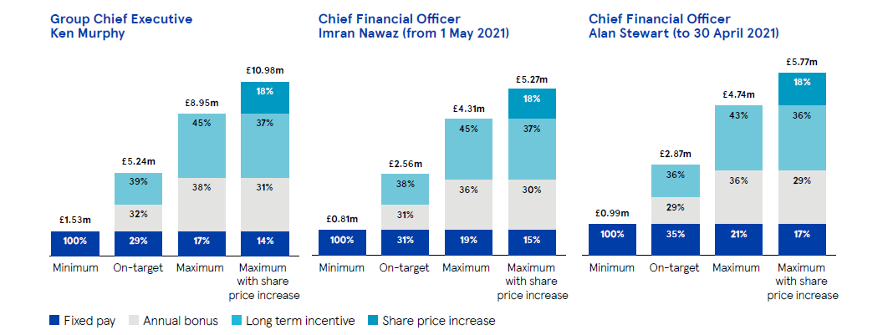
(Source: https://www.tescoplc.com/media/757589/tesco_annual_report_2021.pdf)

Appendix 2: Risk management of TESCO
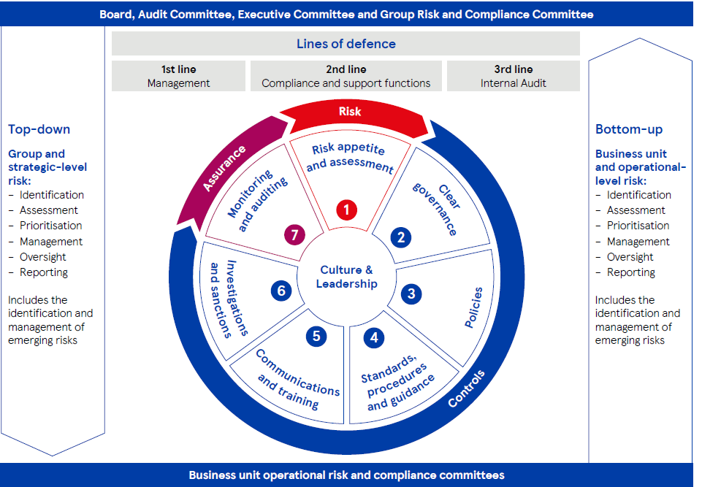
(Source: https://www.tescoplc.com/media/757589/tesco_annual_report_2021.pdf)

