Improving Outpatient Referral Triage using Decision Support
Introduction
Triaging outpatient appointment referrals is vital to establishing order for patient care (Aboelkhir et al., 2022, p. 1). Cardiff and Vale University Health Board (C&VUHB) receive patient referrals by post or electronically as a paper or digital copy, respectively. Electronic referrals (E-referrals) are the preferred method, because of the standardisation and improvement in quality (Azamar-Alonso et al., 2019, p. 325). Currently, C&VUHB use the Hospital Electronic Referral System (HERS) to receive E-referrals. The design of the HERS process involves a like for like replacement of the paper referral process (PRP). This has highlighted various deficiencies that a decision support system (DSS) could improve.
Paper referral process
The PRP in C&VUHB includes a central sorting office for referrals known as the Clinical Referral Centre (CRC). CRC, date stamp referrals on arrival before distributing the paper referrals to the relevant New Case Speciality Team (NCST) (Fig. 1). Once the NCST receives the referral, they add it to the Patient Management System (PMS). The next stage is delivering the referral by hand to either the clinician or the clinician’s secretary (Fig. 1). The NCST delivers and collects the referrals on a bi-weekly basis. Once returned, the NCST updates the referral on PMS, placing the patient on the waiting list (W/L) (Fig. 1). This method causes multiple delays in triaging patients, which impacts on care, especially urgent suspected cancer (USC) referrals (Azamar-Alonso et al., 2019, p. 325).
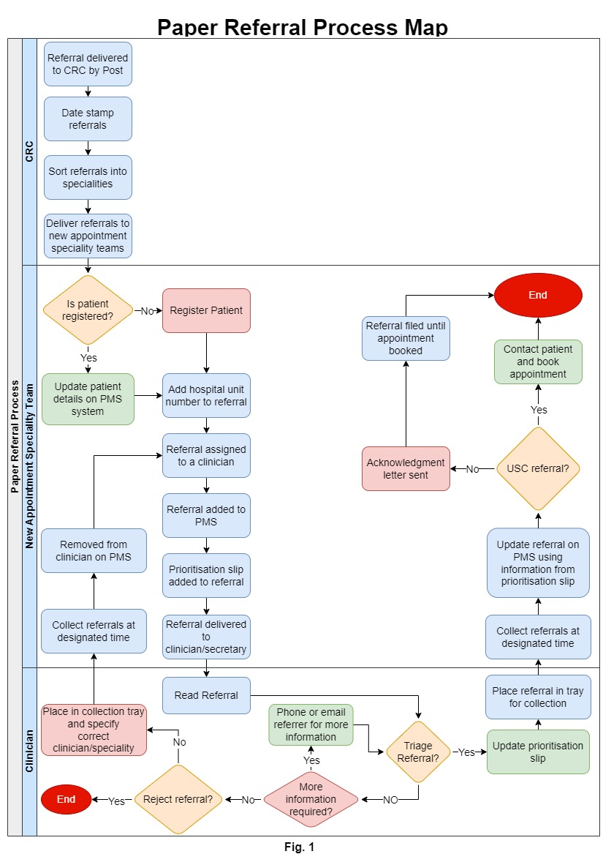

Electronic referral process
The electronic referral process (ERP) duplicates most of the PRP. Referrers send referrals to a CRC list in HERS. CRC will send the patient referrals to the specified NCST digitally (Fig. 2). The NCST will then allocate a clinician and W/L (Fig. 2). Once selected, the HERS automatically sends the referral to the clinician and adds the referral to the PMS instantly. The clinician can then read the referral digitally and triage. The clinician can send questions directly to the referrer, which helps improve the prioritisation of the referral. Lessening the time that clinicians and referrers must spend communicating during the referral process (Azamar-Alonso et al., 2019, p. 332). Once prioritised, the clinician sends the referral back to the NCST, who can update the referral on PMS (Fig. 2).

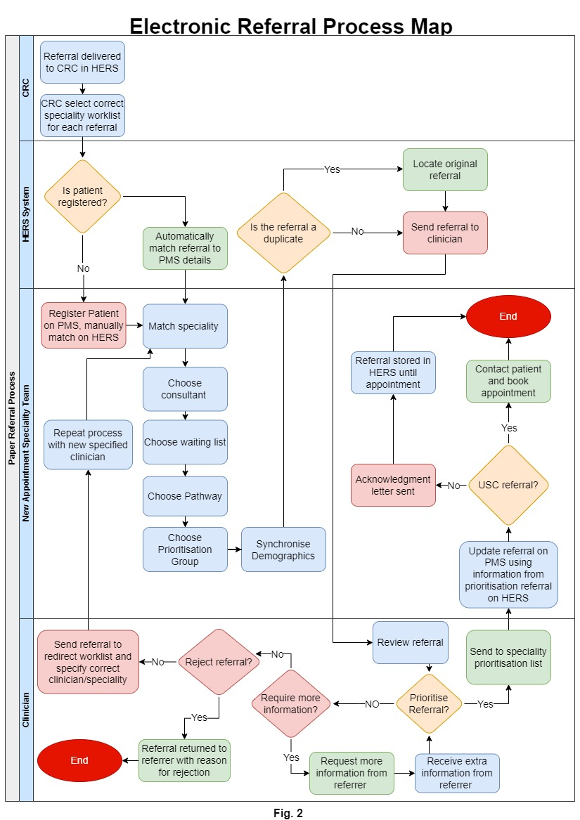

Benefits of HERS
HERS improves the referral process by reducing the referral triage time (Azamar-Alonso et al., 2019, p. 332). HERS eliminates the risk of referrals being misplaced or lost, reducing the risk of patients being negatively impacted by delays. This method also saves time with the removal of hand delivering referrals to clinicians. The digital process benefits the paperless approach set out by C&VUHB (2020, p. 6). In many circumstances, E-referrals link to a high level of clinician satisfaction and have the potential to increase referral quality (Azamar-Alonso et al., 2019, p. 332).
Drawbacks and limitations of HERS
The initial design of HERS was to replicate the PRP digitally. However, this has led to unnecessary steps within the digital process. For example, the continued need for manual sorting of referrals in the CRC. Limitations of HERS include the lack of support for clinicians with prioritisation of referrals. Clinicians within C&VUHB state that DSS could improve the ERP. For instance, DSS being used to aid ophthalmology clinicians in triaging by using eye pressures to determine the urgency of a cataract referral.
Decision Support System
DSSs within healthcare aim to enhance delivery by incorporating clinical knowledge, patient data and other relevant information in a timely manner (O’Connor and Bowles, 2017, p. 1378). The information delivered by a DSS may comprise of general clinical advice, knowledge and intelligently processed patient data (Middleton, Sittig and Wright, 2014, p. S103). A typical DSS compares patient characteristics to a computerised clinical knowledge base, before presenting the clinician with patient-specific assessments (Sim et al., 2001, p. 528). The more successful DSSs employ high-quality, actionable, current, readily available, and machine-interpretable evidence (Sim et al., 2001, p. 529).
There are two types of DSS. These are knowledge-based and non-knowledge-based (Ho et al., 2021, p. 2). Knowledge-based DSS creates rules, the system then retrieves data to evaluate the rule and produces an action or output (Sutton et al., 2020, p. 1). Knowledge-based DSSs give best practise recommendations for decision-making by simulating the cognitive processes of actual healthcare experts (Ho et al., 2021, p. 2). DSS that are non-knowledge based still need a data source, but instead of being programmed to follow expert medical knowledge, they make decisions using artificial intelligence or machine learning (ML) (Ho et al., 2021, p. 2). DSS using ML has shown it can increase the diagnostic accuracy of several disciplines within healthcare (Knitza et al., 2022, p. 2).
Benefits of Decision Support
Healthcare strategies frequently use DSS to lower errors (Sutton et al., 2020, p. 4). Enhancing the provider’s compliance with recommended medical practices (Murphy, 2014, p. 190). Regardless of the primary reason for their installation, all DSSs can attribute patient safety as an objective (Sutton et al., 2020, p. 5). Using a DSS can produce multiple benefits, not just patient safety. These include clinic management, cost containment, administration function, better documentation and workflow improvement (Sutton et al., 2020, p. 3-4).
DSS can improve patient triage (Sutton et al., 2020, p. 5). DSS has shown to enhance the E-referral process by initiating a referral to hospital if a patient with hypertension receiving treatment has uncontrolled blood pressure (Patel et al., 2020, p. 6).
DSS can be helpful in reminding clinicians to triage their outstanding referrals, using guidelines encoded into the DSS software (Sutton et al., 2020, p. 5). Therefore, enabling clinicians to be aware of USC referrals that require triaging. DSS can benefit the referral triage by producing cost savings and improved efficiency (O’Connor and Bowles, 2017, p. 1378), by enhancing documentation accuracy and reducing duplication (Sutton et al., 2020, p. 5). Allowing DSS to improve the E-referral process and remove elements of waste.
Incorporating DSS with HERS
The aid of a DSS could improve HERS on multiple levels. Including helping clinicians in triaging, reducing manual intervention for administrative staff. For this project to ensure the DSS is achievable, and for the project to remain in scope, the DSS will focus on improving the CRC process of manually sorting the referral destination. This will help safeguard clinicians receiving referrals in the appropriate timeframe (Mariotti et al., 2022, p. 912). Assisting patients to receive the correct care, under the correct clinician, the first time (Cardiff and Vale University Health Board, 2021).
Literature review
Introduction
This literature review will investigate how a DSS can help HERS achieve increased efficiency and reduce administrative staff workload. Additionally, it is important to demonstrate how the DSS will affect both clinical and non-clinical employees, as well as any potential repercussions for patient care. The following questions should be the focus of the literature review.
- What are the current DSSs that are used in conjunction with e-referrals?
- What are the benefits and drawbacks of using DSS with the e-referrals process?

Method
The ScienceDirect, PubMed, and Google Scholar databases were initially searched to find the most comprehensive body of literature. The literature review conducted literature searches between December 2022 and January 2023 using the following keywords:
- Decision support tools for outpatient referrals
- Outpatient referral decision support
- Hospital referral decision support
- E-referral decision support
To expand the body of literature, the review inserted the word “new” before the term “referral”. By including “NHS” and “Wales” in the searches, it was possible to narrow the results by learning whether solutions are already in use by NHS systems. The review has implemented additional filters to help these searches produce fewer materials. These included the use of Boolean operators.
The literature review initially examined the titles and descriptions of the articles to assess their relevance. The review recorded these findings in an excel spreadsheet that included the results’ title, author, and publication date. Once logged, the articles were further whittled down by reading abstracts of the literature. Either through free access or from the University of St Trinity’s library online resources.
After the initial procedure, the project thoroughly reviewed the literature to find any pertinent material. To develop a larger body of material, the review will also consider citations and references from relevant sources.
Quality Appraisal
To ensure the literature being reviewed is the desired quality, the review applied several factors to improve value. The review gave literature from 2015 onwards credence as the literature review is looking to provide a digital solution to HERS with DSS. Therefore, by setting a 2015 to present date range, this guaranteed the most up-to-date information on DSSs was being assessed. Text written before this time was still valid, as it might contain theories or methods that are still useful today. Especially any papers that changed the direction of the field. Consideration of the level of expertise or subject knowledge of the authors also occurred.
Results
Due to time limits, the first 400 papers only had the inclusion/exclusion criteria applied, as the results still yielded a large proportion of papers. The completion of the relevancy search reduced the number of papers to 20 for this review (Table 1).
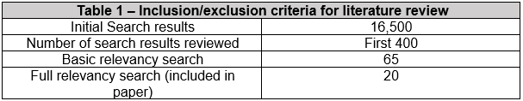
Grade of Effectiveness
The literature review graded the literature that was selected on its effectiveness. The first phase, as shown in Table 2 demonstrates the number of citations the papers received within Google scholar. Even though this metric is not a universal trait for grading effectiveness, it indicates how the literature has impacted on research in the field.
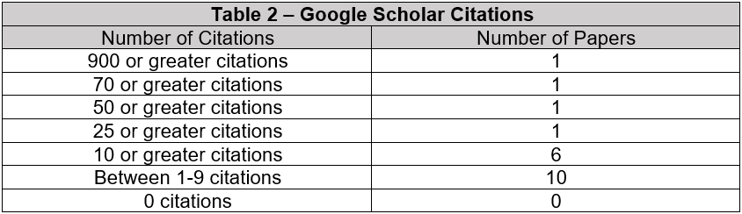
The results in Table 2 show a worryingly low average of the number of citations for the work on DSS in the E-referral process. However, the low number could be the result of the date of the literature’s publication. As Table 3 indicates, the date of publication affects the number of citations. However, the number of citations is still relatively low.
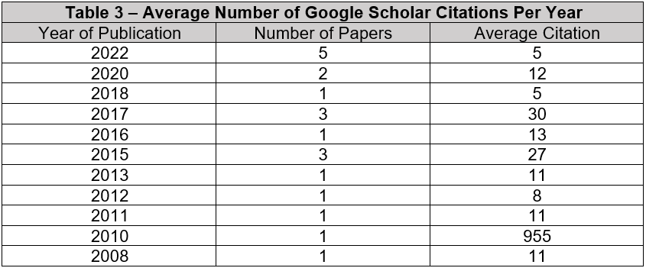

Hierarchy of evidence
The number of citations may be a good gage on the effectiveness of the literature, it is not a fool proof system. However, it is crucial to recognise that certain studies provide more accurate estimates than others when reviewing the current literature (Doleac, 2019, p. 517). It takes more than just analysing the research and determining the advantages of the results (Doleac, 2019, p. 517). Result weighting should reflect a study’s position in the hierarchy of evidence (Doleac, 2019, p. 517). Fig. 3 illustrates where the literature within this review ranks in the hierarchy.
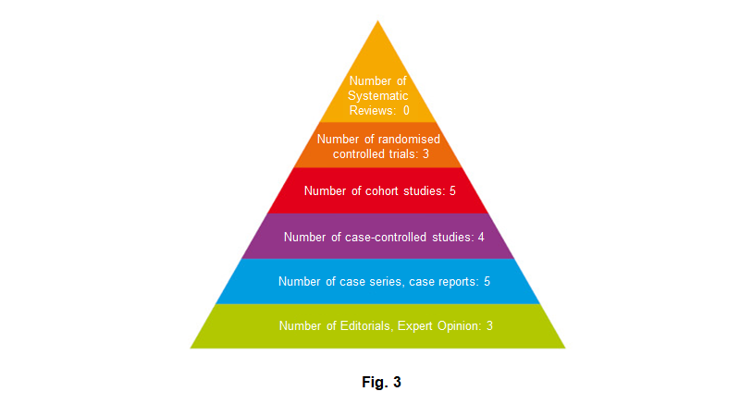
As Fig. 3 demonstrates, the review failed to find systematic reviews in the literature. The literature is spread amongst the remaining categories therefore, it is important to be critical when interpreting the results.
Discussion
Current DSSs used with E-referrals
As discovered by this literature review, individuals have used DSS in different ways to improve the referral process. Individuals have included DSS in E-referrals systems in several projects around the world. Examples include the UK-developed Early Referrals Application and the Netherlands’ Zorg Domain (Heimly and Nytro, 2011, p. 410). Multiple DSSs have aided referrers and clinicians.
Referrer DSS
The literature demonstrates numerous DSSs to help improve the process for the referrer. Mariotti, Gentilini and Dapor (2013, p.1150) state that DSS can aid referrers in choosing clinical “keywords” that are more closely related to patient features. The system enables patients to receive timely recommendations and avoid pointless referrals (Mariotti, Gentilini and Dapor, 2013, p.1150).
E-referral systems include a DSS that makes use of the prediction and optimisation based DSS algorithm, which can help decide hospital selection (Omotosho, Adegbola and Adebo, 2016, p. 38). Similar research led to the creation of the multi-agent, referral DSS for E-referrals, to identify the best hospital location (Triyono et al., 2018, p. 477). These systems will not be useful to this project as C&VUHB referral prioritisation does not consider hospital location.
Other DSSs help with choosing the correct speciality or clinicians. Based on the referral criteria that the user has given, the referrer will be guided by the DSS adopted in the application to return potential specialists (Almansoori et al., 2012, p. 574). DSS systems can also be helpful by providing objective criteria for decision making, regardless of any discrimination (Boissin, 2022, p. 10).
These DSS systems may be a helpful tool in the referral process, but most GPs will object to utilising the system if the result is a longer referral process (Heimly and Nytro, 2011, p. 410).
Clinician DSS
DSS can direct clinicians to triage patients based on standardised disease acuity metrics and risk factors. By embedding referral protocols and clinical guidelines within E-referral systems (Maghsoud-Lou, 2017, p. 2), such protocol-driven E-referral systems will speed up the referral process in accordance with institutional standards (Maghsoud-Lou, 2017, p. 2).
Tan et al. (2020, p, 170) indicated using ML can help the prioritisation of Ophthalmology referrals. ML is the process of using computer systems to conduct tasks and find patterns in data without being explicitly told how (Tan et al., 2020, p, 170).
Tan et al. (2020, p. 170) uses artificial neural networks and related structures like convolutional neural networks (CNN) which are mostly used in deep learning, a subset of ML to analyse language. Tan et al. (2020, p. 170) state that the CNN model successfully distinguishes between urgent and non-urgent Ophthalmology referrals, concluding that the model can prioritise referrals. C&VUHB could adapt this for this project’s attempt at automating the CRC process. However, this may not be suitable to mimic human triaging, as lower accuracy was obtained when trying a multi-class classification job (Tan et al., 2020, p. 170).
Another DSS by Tejal et al. (2008, p. 10) applies keywords to improve the E-referral process. For instance, calling Cardiology the coded diagnosis of “atrial fibrillation,” a new occurrence, would cause the DSS to recommend conducting specific tests before the consultation (Tejal et al., 2008, p. 10).
Pensuwan et al. (2015, p. 588) utilises DSS in the design to provide an improved E-referral system, dividing the design into two categories. A rule-based intelligent system makes up the first half, and a linked referral information system makes up the second. A collection of referral criteria with an IF-THEN structure is how the knowledge-based referral and provider selection approach is articulated (Pensuwan et al., 2015, p. 588). This system processes and analyses the information on the referral to offer a list of suitable providers (Pensuwan et al., 2015, p. 588).
Currently being used in Germany, Rheport is an online system for Rheumatology referrals that automatically schedules new rheumatic patient referrals based on the likelihood that they would develop specified Rheumatology conditions (Knitza et al., 2022, p. 2). Rheport uses a logistic regression model. The most important characteristics of the model emphasise the need to have access to earlier medical records and comprehensive patient data (Knitza et al., 2022, p. 6). Like Rheport, Patel et al.’s (2020, p. 5) referral algorithm considers a patient’s complete clinical history, current health status and treatment response (Patel et al., 2020, p. 5). DSS systems like this would be a challenge within C&VUHB with paper records widely used, with no clear vision to establish a fully digitised note system.
In the study by Swaminathan et al. (2017, p. 15), machine-learned triage strategy outperformed traditional physician triage in a variety of statistical performance measures. However, as stated in the literature by Swaminathan et al. (2017, p. 17), fictitious patient scenarios have only been used to test the algorithm. Therefore, the system still needs to be proven in an actual care setting.
Benefits of using DSS with e-referrals
The benefits of using DSS enables healthcare to enhance patient care without disrupting current workflows (Jacobsohn et al., 2022, p. 7). According to the study by Mariotti et al. (2022, p. 911), it favourably correlated agreement between general practitioners and specialists with implementing an electronic referral support system with DSS.
Even though healthcare professionals are risk-averse and desire a procedure to “cover our backs,” computerised clinical decision support has allowed them to refer twice as many patients to suitable treatment, potentially saving money (Evans et al., 2017, p. 11). Besides promoting safer, more effective, fair, and cost-effective treatment, these systems can enhance the delivery of health services and promote good medical practise, strengthening the health systems in the process (Del Rosario Perez, 2015, p. 282).
DSS is very helpful for clinicians in areas like mental health care, as it can reduce the barrier to treating patients with a lack of knowledge (Kingston et al., 2015, p. 3).
Drawbacks of using DSS with e-referrals
The drawbacks of DSS are the high cost of creating and maintaining DSS, since it calls for careful attention to the veracity of the evidence (Elwyn et al., 2010, p. 2). As building DSS into the NHS will require substantial investment and a collaboration between numerous agencies (Elwyn et al., 2010, p. 3).
DSS must be of the required standard clinical guidelines, needing to be updated frequently and doing so takes effort and involvement from the people who will use them (Heimly and Nytro, 2011, p. 410). Maintaining DSS materials and the ability to integrate with healthcare workflows presents perhaps the biggest challenge (Elwyn et al., 2010, p. 3).
One benefit of DSS with HERS could be the ability to tailor the alert criteria to the clinician or sub-speciality. However, the drawback is that it will probably impact the rates of success on the referral and subsequent utilisation (Goldstein et al., 2022, p. 8).
Conclusion
This literature review discovered that E-referral systems working with DSS provide evidence to improve referral processes (Evans et al., 2017, p. 11). However, as identified by Swaminathan et al. (2017, p. 15), given the lack of a gold standard for what makes an appropriate triage assessment, more research is required to identify if DSS works well with clinic triage. It is vital to find the ideal balance while considering the clinician, the patient and clinical guidelines when using any DSS system with HERS (Goldstein et al., 2022, p. 8).
One gap in the literature is the lack of evidence of DSS being used to help administrative staff with E-referrals. All literature that was looked at as part of this review focused on Clinical DSSs. This would either be decision support for referrers or clinicians. Administrative functions are key elements in the referral process, that can lead to delays in clinicians receiving referrals to review and triage. Improving this process requires more focus, to guarantee clinicians can triage as quickly as possible to ensure patients receive care in recommended timeframes. Therefore, identifying specific systems to be implemented without adaption to this project was difficult. In the future, more research needs to be done in this area.
Implementation Issues
Challenges of implementing DSS
Implementing DSS within HERS will undoubtedly cause issue. Therefore, it is vital to plan for such instances and try to mitigate any issues before they arise. The project is planning to add a DSS to aid in getting the referrals to clinicians quicker, enabling the patients to be triaged faster. This is essential to ensure patients’ USC diagnosis comply with the cancer pathway (Wales Cancer Network, 2023, p. 30).
The project will apply the DSS to the CRC process of referral sorting. It will use a knowledge-based system with an IF-THEN style approach (Pensuwan et al., 2015, p. 588). An example of this is the referral will automatically redirect from the CRC worklist to the Gastroenterology worklist when the referrer selects Gastroenterology as the required specialty intervention (Fig. 4). The structure would work like an email-based rule to redirect emails by keywords (Stratton, 2020).
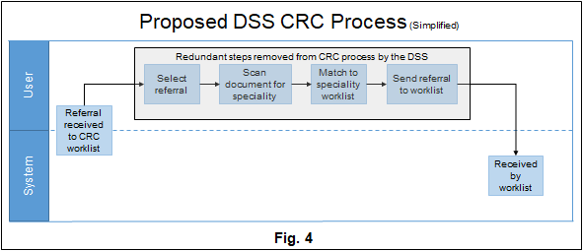
Implementation Constraints of DSS
The first iteration of the DSS will still require CRC. Currently, referrers can send referrals into the HERS using the specialty code ‘GP Other’. Referrers use this for referrals that the GP is unsure of where to send. ‘GP Other’ does not match any worklist within the HERS system (Fig. 5). This is not ideal as it is relying on non-clinical staff to choose the correct destination for these referrals. There will also be a constraint for specialities currently still paper based and need the printing of referrals to be triaged.
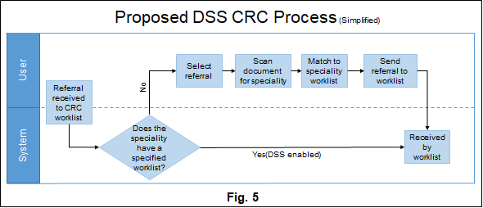
Implementation Risks of DSS
The design must be wary of implementing a system that includes inaccurate information. The DSS’ main risk is referrals being incorrectly redirected. This could cause harm by delaying triage if DSS sends referrals to the wrong worklist (Woodall et al., 2019, p. 2). This could be down to the incorrect data input at the start of the project. Other concerns that could cause issues for implementation is the incorrect worklist selection. An example of this is if the referrer selected General Medicine instead of General Surgery. This would not appear as an error to the data and will need manual intervention to correct (Woodall et al., 2019, p. 2). Another risk is the DSS holding out-of-date data, which is one of the most common data defects (Heinrich and Klier, 2015, p. 82). This risk could lead to patient care being affected and lead to delays in treatment.
An additional implementation risk is staff discover workarounds to the DSS (Cresswell et al., 2017, p. 542). Which could have an adverse effect on the success of the DSS (Cresswell et al., 2017, p. 547). However, thought needs to be given to the UX and the reason for the workaround (Cresswell et al., 2017, p. 545).
User Experience
The design must have the user experience (UX) at its core. If the design of the system aimed at easing workload is too clunky or makes the experience longer for the user, it will not be appropriate to use. As the decision support must be beneficial to be used by the operator (Greenes, 2014, p. 379).
The project must look at not just the impact on outcomes but the impact on the user when implementing DSS within HERS (Medlock et al., 2016, p. 1006). When implementing any new system, the UX is vital for the success of a new application (McNee, Riedl and Konstan, 2006, p. 6). This does not differ from implementing the DSS. When designing a DSS to be incorporated with HERS, low complexity and perceived utility for enhancing patient care are the two main factors to consider (Mariotti, Gentilini and Dapor, 2013, p.1144). Implementation of a DSS is a constant task to ensure users are conversant with system modifications (Straus et al., 2011, p. 1344).
Earlier studies have discovered that, when implementing new solutions, some users are not aware of system functionality, particularly with modifications made to address initial issues (Straus et al., 2011, p. 1344). Therefore, success will require strong strategic leadership, commissioning of high-quality content, and the provision of sustained funding to host these resources using computerised, online, or telephone supported channels (Elwyn et al., 2010, p. 3).
Managing the risks and constraints of DSS
The real challenge for any DSS is delivering value and gaining user acceptance (Greenes, 2014, p. 413). It is vital to ensure the project collects the correct information with staff concerns addressed before implementation, to reduce the chances of issues being raised (Greenes et al., 2018, p. 135). To manage the risk and constraints, the design process will need to enable a positive feedback loop where everyone can add to design changes. This will improve usability and enhance user perceptions of the DSS (Straus et al., 2011, p. 1344).
Soft interventions such as order sets with evidence-based content and ease of order entry that the user deems beneficial, or timesaving, are a good way to introduce the DSS (Greenes, 2014, p. 413). Which is why, as mentioned, the first iteration of the project will target the removal of much of the CRC process (Fig. 4). Once the user gets used to early interventions, the project will look to introduce more intrusive DSS (Greenes, 2014, p. 413). These could involve improving the duplicate referral process for expedite or follow up referrals (Fig. 6).
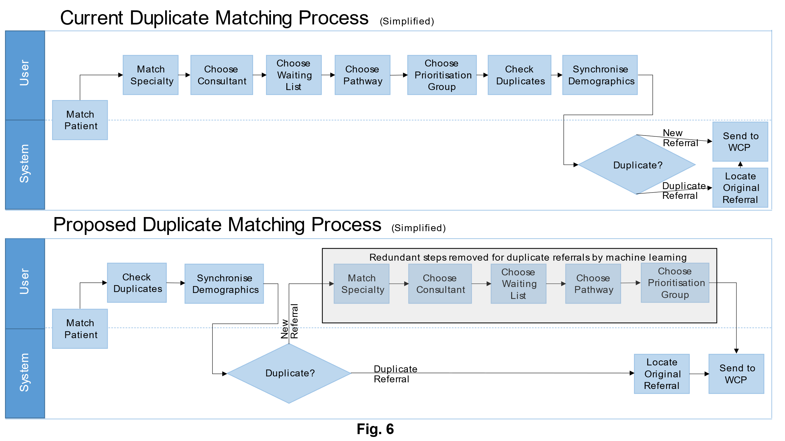

The project will need constant monitoring, of the number of referrals that are redirected. This will be a key area that will need targeting to ensure the referrals are arriving at the correct destination. Access to this data is essential, whilst tracking the effects of interventions to assure improvement (Moon and Galea, 2016, p. 215).
To ensure implementation is smooth, there will need to be continuous improvement and constant review. This will aid in system design modifications, rather than focusing solely on changing training and workflows (Straus et al., 2011, p. 1344). A DSS programme is a continuous, ongoing activity, just like all other continuous improvement projects (Greenes, 2014, p. 414). Therefore, continuous evaluation of the process will be required.
Evaluation
Despite its lengthy history, this project could describe the field as lacking in DSS acceptance within healthcare (Greenes et al., 2018, p. 135). One reason for this is the lack of sufficient evaluation of the processes and results that the DSS’s interventions should enhance (Greenes et al., 2018, p. 135). Evaluation is an important step to ensure that the DSS is clinically safe to be used (Vasey et al., 2022, p. 1). To evaluate the success of the DSS’s interventions, the project will focus on four areas:
- Effectiveness
- Safety
- Efficiency
- User Experience

The project must allow for a thorough assessment of the effects of DSS within HERS, with the assessment planned from the beginning (Brennan, Mattick and Ellis, 2011, p. 99). Providing a bedrock for success and prove that DSS aids in the improvement and acceleration of referral triage.
Effectiveness
The quality of the intervention’s substance is just as important as the delivery of the technology when determining how effective the processes are (Balestrieri et al., 2020, p. 732). To evaluate the effectiveness of the DSS on the CRC process, the project must set the parameters on the desired aims and objectives. The aim of the DSS is to improve the delivery times of referrals and reduce errors that enable the quicker prioritisation. Allowing patients to be seen in appropriate timeframes.
The project will evaluate the effectiveness of the solution reviewing the timeframe it takes the clinicians to receive the referrals. The program will analyse this by retrieving the data which is collecting in HERS to highlight changes in the delivery times from before and after intervention. To make it easier for users to understand the changes, the project will display the results in charts and graphs (Vanzant Stern, 2019, p. 75). These graphs will include a statistical process control and interrupted time series charts (Fretheim and Tomic, 2015, p. 748). Current data as shown in Table 4 indicates clinicians receive referrals on average 3 days after C&VUHB receives the referral. Therefore, when evaluating the implementation of the DSS, the project will expect this number to be reduced to 1 day.

However, this number will need to be analysed against the success rate of referral delivery. If the success rate is decreasing from the current number, then there is a safety issue as even though they may get to a clinician quicker, it will be the incorrect clinician. Needing the referral to be redirected that will lead to the patients waiting longer for treatment.
Safety
DSSs should place a heavy emphasis on performance and safety validation at the early stage (Vasey et al., 2022, p. 2). The key areas for safety in the first iteration of the project are ensuring the system sends the referrals to the correct destination and delays do not impact patient care.
The project will look to introduce a solution to the manual sorting of outpatient referrals in CRC. Safety will be a key component to this. To guarantee delays are not caused by referrals being indirectly sent to the wrong worklist, the number of redirected referrals will need to be analysed to compute the error rate.
Currently, human error attributes to referrals being sent to the wrong worklist. This is from the referrer selecting the wrong destination or the administrative staff in CRC selecting the wrong worklist. The DSS cannot eliminate human error completely from the process as the first iteration cannot cease human error from the referrer in selecting the wrong speciality. However, the redirect percentage as seen in Table 5 will need analysing as the project team expects it to decrease by 5%, removing steps in CRC that contribute.
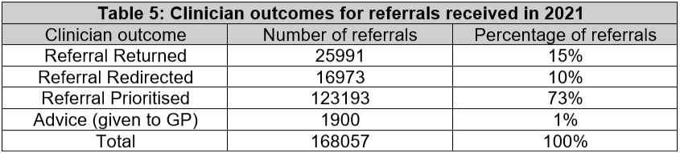
The number will need to be analysed further to look at each error to ensure it was human error that led to the incorrect worklist being selected. The referrer and specialities will also need to be monitored to discover if any patterns are emerging to discover if there are concerns regarding safety from a specific location.
Timeframes for errors to be corrected will also need to be considered. This is to safeguard the delay in the referral needing to be redirected does not affect patients’ safety.
Efficiency
Efficiency within the solution of the DSS is to ensure the clinicians receive the referrals quicker by the removal of the CRC manual decision input. One of the main areas the system is looking to improve in the current deficiencies of HERS process is the wasted administrative time. The project is seeking the administrative time in the CRC to be better served, which will improve the UX.
Table 6 demonstrates that, on average, CRC process over 3500 referrals every week. The average number of staff hours to process these referrals is 60 hours a week. With the user, required to process more than one referral a minute. This number is unsustainable and will lead to burnout for the staff (Iacobucci, 2021, p. 1). This number is likely a factor in why the redirect number in 2021 was high at 10% (Table 5).
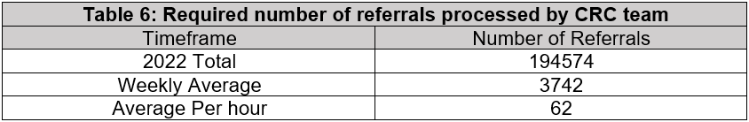
The project’s objective is to improve the efficiency and release a high proportion of the hours wasted processing referrals, despite the first iteration not including the ‘GP Other’ referrals. Table 7 indicates that the number of ‘GP Other’ referrals are relatively small compared to the number of referrals received. The project is predicting to release 80% of the hours in CRC for other duties. The project team will analyse success by looking at the CRC data in HERS on user hours along with qualitative data of the UX.
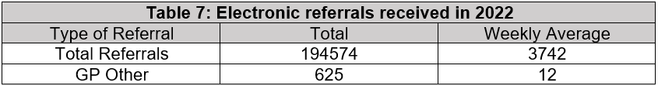
User Experience
Analysing the UX is vital to the sustained success of implementation. By utilising the knowledge of a variety of stakeholders, user-centred design is a viable technique for developing a DSS that will increase effectiveness, usability, uptake, and distribution in the future (Tucker Edmonds et al., 2019, p. 327). To evaluate UX, there will be a mixture of qualitative and quantitative methods.
The project will collect the qualitative data from questionnaires, work observations, and interviews with the staff members (Flick, 2014, p. 5). Discovering how they interact with DSS and how it has affected their day. This process will occur before and after the project has implemented the intervention to compare the changes in work patterns. Diagrams and other visual representations of crucial ideas, together with narratives that reflect participants' experiences and points of view, will portray the qualitative data (Flick, 2014, p. 305).
The quantitative data will use the system logs to analyse trends in how the DSS is being used by the staff. This can help in targeting those users not interacting with the DSS, so the project team can direct the user to training (Straus et al., 2011, p. 1344).
Conclusion
A solid, and thorough creation and reporting of evidence is required to support the inclusion of DSS in HERS (Vasey et al., 2022, p. 9). To fully realise the promise of this technology to enhance patient care, it is crucial to both guarantee the safety and effectiveness of DSS and win users’ trust (Vasey et al., 2022, p. 2).
Introducing DSS to the referral process will allow for referrals to be received quicker by clinicians, supporting patient care to not be affected by an inefficient process. Reducing human error and manual intervention in the CRC stage whilst improving the UX are the main objectives of the DSS to achieve the aim of the project.
The evaluation stage will be a key component in the project to guarantee the aims and objectives are being achieved, along with ensuring the safety of the DSS and not negatively impacting on patient care. Facilitating a greater understanding of the effectiveness and efficiency of the DSS within the referral process and permit for planning of future iterations.
Future iterations of the DSS could include ML to help administrative staff sort the ‘GP Other’ referrals. ML could also help clinicians’ priorities and triage referrals by giving suggestions from the content of the letter.

References:
Aboelkhir, H.A.B., Elomri, A., ElMekkawy, T.Y., Kerbache, L., Elakkad, M.S., Al-Ansari, A., Aboumarzouk, O.M. and El Omri, A. (2022) ‘A Bibliometric Analysis and Visualization of Decision Support Systems for Healthcare Referral Strategies’, International journal of environmental research and public health; Int J Environ Res Public Health, 19(24), pp. 16952. DOI: 10.3390/ijerph192416952
Almansoori, W., Murshid, A., Xylogiannopoulos, K.F., Alhajj, R. and Rokne, J. (2012) ‘Electronic medical referral system: Decision support and recommendation approach’, ‘Electronic medical referral system: Decision support and recommendation approach’, IEEE, pp. 572-577. DOI: 10.1109/IRI.2012.6303060
Azamar-Alonso, A., Costa, A.P., Huebner, L. and Tarride, J. (2019) ‘Electronic referral systems in health care: a scoping review’, ClinicoEconomics and outcomes research; Clinicoecon Outcomes Res,11, pp. 325-333. DOI: 10.2147/CEOR.S195597
Balestrieri, M., Sisti, D., Rocchi, M., Rucci, P., Simon, G., Araya, R. and de Girolamo, G. (2020) ‘Effectiveness of clinical decision support systems and telemedicine on outcomes of depression: a cluster randomized trial in general practice’, Family practice; Fam Pract, 37(6), pp. 731-737. DOI: 10.1093/fampra/cmaa077
Boissin, C. (2022) ‘Clinical decision-support for acute burn referral and triage at specialized centres - Contribution from routine and digital health tools’, Global health action, 15(1), pp. 2067389. DOI: 10.1093/fampra/cmaa077
Brennan, N., Mattick, K. and Ellis, T. (2011) ‘The Map of Medicine: a review of evidence for its impact on healthcare’, Health information and libraries journal, 28(2), pp. 93-100. DOI: 10.1111/j.1471-1842.2011.00940.x
Cardiff and Vale University Health Board (2020) Delivering Digital: Building a learning health and care system. A Five Year Strategy. Available at: Delivering Digital Building a learning health and care system A Five Year Strategy (nhs.wales) (Accessed on: 06 December 2022)
Cardiff and Vale University Health Board (2021) Right Bed, First Time – An overview for staff [video]. Available at: (57) Right Bed, First Time – An overview for staff - YouTube (Accessed: 31 January 2023)
Cresswell, K.M., Mozaffar, H., Lee, L., Williams, R. and Sheikh, A. (2017) ‘Workarounds to hospital electronic prescribing systems: a qualitative study in English hospitals’, BMJ quality & safety; BMJ Qual Saf, 26(7), pp. 542-551. DOI: 10.1136/bmjqs-2015-005149
del Rosario Perez, M. (2015) ‘Referral criteria and clinical decision support: radiological protection aspects for justification’, Annals of the ICRP; Ann ICRP, 44(1), pp. 276-287. DOI: 10.1177/0146645314551673
Doleac, J.L. (2019) ‘EVIDENCE‐BASED POLICY’ SHOULD REFLECT A HIERARCHY OF EVIDENCE’, Journal of policy analysis and management, 38(2), pp. 517-519. DOI: 10.1002/pam.22118
Elwyn, G., Laitner, S., Coulter, A., Walker, E., Watson, P. and Thomson, R. (2010) ‘Implementing shared decision making in the NHS’, BMJ; BMJ, 341(7780), pp. 971-973. DOI: 10.1136/bmj.c5146
Evans, B.A., Ali, K., Bulger, J., Ford, G.A., Jones, M., Moore, C., Porter, A., Pryce, A.D., Quinn, T., Seagrove, A.C., Snooks, H., Whitman, S. and Rees, N. (2017) ‘Referral pathways for patients with TIA avoiding hospital admission: a scoping review’, BMJ open; BMJ Open, 7(2), pp. e013443. DOI: 10.1136/bmjopen-2016-013443
Flick, U. (2014) The SAGE handbook of qualitative data analysis, Los Angeles: SAGE.
Fretheim, A. and Tomic, O. (2015) ‘Statistical process control and interrupted time series: a golden opportunity for impact evaluation in quality improvement’, BMJ quality & safety; BMJ Qual Saf, 24(12), pp. 748-752. DOI: 10.1136/bmjqs-2014-003756
Goldstein, J.E., Guo, X., Swenor, B.K., Boland, M.V. and Smith, K. (2022) ‘Using Electronic Clinical Decision Support to Examine Vision Rehabilitation Referrals and Practice Guidelines in Ophthalmology’, Translational vision science & technology, 11(10), pp. 8. DOI: 10.1167/tvst.11.10.8
Greenes, R.A. (2014) Clinical decision support : the road to broad adoption, 2nd edn. London, England: Academic Press.
Greenes, R.A., Bates, D.W., Kawamoto, K., Middleton, B., Osheroff, J. and Shahar, Y. (2018) ‘Clinical decision support models and frameworks: Seeking to address research issues underlying implementation successes and failures’, Journal of Biomedical Informatics; J Biomed Inform, 78, pp. 134-143. DOI: 10.1016/j.jbi.2017.12.005
Heimly, V. and Nytro, O. (2011) ‘Clinical guidelines as decision support for referrals from primary care’, ‘Clinical guidelines as decision support for referrals from primary care’, IEEE, pp. 406. DOI: 10.1109/IRI.2011.6009582
Heinrich, B. and Klier, M. (2015) ‘Metric-based data quality assessment — Developing and evaluating a probability-based currency metric’, Decision Support Systems, 72, pp. 82-96. DOI: 10.1016/j.dss.2015.02.009
Ho, K., Chou, P., Chao, J.C.-., Hsu, C. and Chung, M. (2021) ‘Design and evaluation of a knowledge-based clinical decision support system for the psychiatric nursing process’, Computer methods and programs in biomedicine; Comput Methods Programs Biomed, 207, pp. 106128. DOI: 10.1016/j.cmpb.2021.106128
Iacobucci, G. (2021) ‘Staff burnout: MPs demand ‘total overhaul’ of NHS workforce planning’, BMJ (Online), 373, pp. n1461. DOI: 10.1136/bmj.n1461
Jacobsohn, G.C., Leaf, M., Liao, F., Maru, A.P., Engstrom, C.J., Salwei, M.E., Pankratz, G.T., Eastman, A., Carayon, P., Wiegmann, D.A., Galang, J.S., Smith, M.A., Shah, M.N. and Patterson, B.W. (2022) ‘Collaborative design and implementation of a clinical decision support system for automated fall-risk identification and referrals in emergency departments’, Healthcare : the journal of delivery science and innovation; Healthc (Amst), 10(1), pp. 100598. DOI: 10.1016/j.hjdsi.2021.100598
Kingston, D., Janes-Kelley, S., Tyrrell, J., Clark, L., Hamza, D., Holmes, P., Parkes, C., Moyo, N., McDonald, S. and Austin, M. (2015) ‘An integrated web-based mental health intervention of assessment-referral-care to reduce stress, anxiety, and depression in hospitalized pregnant women with medically high-risk pregnancies: a feasibility study protocol of hospital-based implementation’, JMIR research protocols; JMIR Res Protoc, 4(1), pp. e9. DOI: 10.2196/resprot.4037
Knitza, J., Janousek, L., Kluge, F., von der Decken, C.B., Kleinert, S., Vorbrüggen, W., Kleyer, A., Simon, D., Hueber, A.J., Muehlensiepen, F., Vuillerme, N., Schett, G., Eskofier, B.M., Welcker, M. and Bartz-Bazzanella, P. (2022) ‘Machine learning-based improvement of an online rheumatology referral and triage system’, Frontiers in medicine, 9, pp. 954056. DOI: 10.3389/fmed.2022.954056
Maghsoud-Lou, E., Christie, S., Abidi, S.R. and Abidi, S.S.R. (2017) ‘Protocol-Driven Decision Support within e-Referral Systems to Streamline Patient Consultation, Triaging and Referrals from Primary Care to Specialist Clinics’, Journal of medical systems; J Med Syst, 41(9), pp. 139. DOI: 10.1007/s10916-017-0791-7
Mariotti, G., Gentilini, M. and Dapor, V. (2013) ‘Improving referral activity on primary–secondary care interface using an electronic decision support system’, International journal of medical informatics (Shannon, Ireland); Int J Med Inform, 82(12), pp. 1144-1151. DOI: 10.1016/j.ijmedinf.2013.08.003
Mariotti, G., Siciliani, L., Rebba, V., Coretti, S. and Gentilini, M. (2022) ‘Consensus among clinicians on referrals’ priority and use of digital decision-making support systems’, Health policy (Amsterdam), 126(9), pp. 906-914. DOI: 10.1016/j.healthpol.2022.07.003
McNee, S., Riedl, J. and Konstan, J. (2006) ‘Making recommendations better’, ‘Making recommendations better’, ACM, pp. 1103. DOI: 10.1145/1125451.1125660
Medlock, S., Wyatt, J.C., Patel, V.L., Shortliffe, E.H. and Abu-Hanna, A. (2016) ‘Modeling information flows in clinical decision support: key insights for enhancing system effectiveness’, Journal of the American Medical Informatics Association : JAMIA; J Am Med Inform Assoc, 23(5), pp. 1001-1006. DOI: 10.1093/jamia/ocv177
Middleton, B., Sittig, D.F. and Wright, A. (2016) ‘Clinical Decision Support: a 25 Year Retrospective and a 25 Year Vision’, Yearbook of medical informatics; Yearb Med Inform, 25, pp. S103-S116. DOI: 10.15265/IYS-2016-s034
Moon, J.D. and Galea, M.P. (2016) Improving health management through clinical decision support systems, Hershey, Pennsylvania: Medical Information Science Reference
Murphy, E.V. (2014) ‘Clinical decision support: effectiveness in improving quality processes and clinical outcomes and factors that may influence success’, The Yale journal of biology & medicine; Yale J Biol Med, 87(2), pp. 187-197. Available at: Clinical Decision Support: Effectiveness in Improving Quality Processes and Clinical Outcomes and Factors That May Influence Success - ProQuest (Accessed on: 14 January 2023).
O’Connor, M. and Bowles, K.H. (2017), ‘CLINICAL DECISION SUPPORT: IMPROVING CARE, IMPROVING OUTCOMES’, Innovation in aging, 1, pp. 1378. DOI: 10.1093/geroni/igx004.5071
Omotosho, A., Adegbola, O. and Adebo, A. (2016) ‘A Patient-based Hospital Referral Decision Support System’, International journal of computer applications, 155(10), pp. 38-43. DOI: 10.5120/ijca2016912459
Patel, S.A., Sharma, H., Mohan, S., Weber, M.B., Jindal, D., Jarhyan, P., Gupta, P., Sharma, R., Ali, M., Ali, M.K., Narayan, K.M.V., Prabhakaran, D., Gupta, Y., Roy, A. and Tandon, N. (2020) ‘The Integrated Tracking, Referral, and Electronic Decision Support, and Care Coordination (I-TREC) program: scalable strategies for the management of hypertension and diabetes within the government healthcare system of India’, BMC health services research; BMC Health Serv Res, 20(1), pp. 1022. DOI: 10.1186/s12913-020-05851-w
Pensuwan, W., Satitvipawee, P., Viwatwongkasam, C. and Soontornpipit, P. (2015) ‘E-Referral System by Means of Decision Support System’, Applied Mechanics and Materials, 781, pp. 587-590. DOI: 10.4028/www.scientific.net/AMM.781.587
Sim, I., Gorman, P., Greenes, R.A., Haynes, R.B., Kaplan, B., Lehmann, H. and Tang, P.C. (2001) ‘Clinical decision support systems for the practice of evidence-based medicine’, Journal of the American Medical Informatics Association : JAMIA; J Am Med Inform Assoc, 8(6), pp. 527-534. DOI: 10.1136/jamia.2001.0080527
Stratton, J. (2020) Outlook: Automating Your Email with Mail Rules, Carpenteria, CA: linkedin.com [video]. Available at: Boost your productivity with email rules (linkedin.com) (Accessed on: 26 January 2023)
Straus, S.G., Chen, A.H., Yee, H., Kushel, M.B. and Bell, D.S. (2011) ‘Implementation of an electronic referral system for outpatient specialty care’, pp. 1-10. Available at: Implementation of an Electronic Referral System for Outpatient Specialty Care (nih.gov) (Accessed on 06 January 2023)
Sutton, R.T., Pincock, D., Baumgart, D.C., Sadowski, D.C., Fedorak, R.N. and Kroeker, K.I. (2020) ‘An overview of clinical decision support systems: benefits, risks, and strategies for success’, NPJ digital medicine; NPJ Digit Med, 3(1), pp. 17. DOI: 10.1038/s41746-020-0221-y
Swaminathan, S., Qirko, K., Smith, T., Corcoran, E., Wysham, N.G., Bazaz, G., Kappel, G. and Gerber, A.N. (2017) ‘A machine learning approach to triaging patients with chronic obstructive pulmonary disease’, PloS one; PLoS One, 12(11), pp. e0188532. DOI: 10.1371/journal.pone.0188532
Tan, Y., Bacchi, S., Casson, R.J., Selva, D. and Chan, W. (2020) ‘Triaging ophthalmology outpatient referrals with machine learning: A pilot study’, Clinical & experimental ophthalmology; Clin Exp Ophthalmol, 48(2), pp. 169-173. DOI: 10.1111/ceo.13666
Tejal K. Gandhi, M., MPH, Nancy L. Keating, M., MPH, Matthew Ditmore, David Kiernan, Robin Johnson, Elisabeth Burdick, M.S. and Claus Hamann, M., MS (2008) ‘Improving Referral Communication Using a Referral Tool Within an Electronic Medical Record’, pp. 1-12. Available at: https://www.ahrq.gov/sites/default/files/wysiwyg/professionals/quality-patient-safety/patient-safety-resources/resources/advances-in-patient-safety-2/vol3/Advances-Gandhi_22.pdf#:~:text=We%20hypothesized%20that%20electronic%20communication%20via%20a%20referrals,specialists%2C%20PCPs%2C%20and%20patients%20about%20their%20referral%20experiences. (Accessed on: 13 January 2023)
Triyono, G., Hartati, S., Pulungan, R. and Lazuardi, L. (2018) ‘E-Referral System Modeling Using Fuzzy Multiple-Criteria Decision Making’, Indonesian Journal of Electrical Engineering and Computer Science, 11(2), pp. 475. DOI: 10.11591/ijeecs.v11.i2.pp475-486
Tucker Edmonds, B., Hoffman, S.M., Lynch, D., Jeffries, E., Jenkins, K., Wiehe, S., Bauer, N. and Kuppermann, M. (2019) ‘Creation of a Decision Support Tool for Expectant Parents Facing Threatened Periviable Delivery: Application of a User-Centered Design Approach’, The patient : patient-centered outcomes research; Patient, 12(3), pp. 327-337. DOI: 10.1007/s40271-018-0348-y
Vanzant Stern, T. (2019) Leaner Six Sigma : making Lean Six Sigma easier and adaptable to current workplaces, United States: Productivity Press.
Vasey, B., Nagendran, M., Campbell, B., Clifton, D.A., Denaxas, S., Denniston, A.K., Faes, L., Geerts, B., Mateen, B.A., McCradden, M.D., Morgan, L., Ting, D.S.W., Weber, W., Wheatstone, P., Lee, A.Y., Fraser, A.G., Connell, A., Vira, A., Esteva, A., Beam, A.L., de Hond, A., Bradlow, A., Ercole, A., Paez, A., Tsanas, A., Kirby, B., Glocker, B., Velardo, C., Park, C.M., Paton, C., Johner, C., McGenity, C., Faivre-Finn, C., Simon, C., Bzdok, D., Treanor, D., Steiner, D.F., Higgins, D., Benson, D., O’Regan, D.,P., Neri, E., Magrabi, F., Rademakers, F.E., Hogg, H.D.J., Chan, H., McIntyre, H.F., Harvey, H., Habli, I., Fackler, J.C., Shaw, J., Higham, J., Wohlgemut, J.M., Chong, J., Cohen, J.F., Kers, J., Morley, J., Krois, J., Monteiro, J., Moons, K.G.M., Karpathakis, K., Catchpole, K., Hood, K., Balaskas, K., Kamnitsas, K., Militello, L., Oakden-Rayner, L., Lovat, L.B., Smits, L.J.M., Hinske, L.C., van Smeden, M., Giavina-Bianchi, M., Daley, M., Sendak, M.P., Sujan, M., Rovers, M., DeCamp, M., Woodward, M., Komorowski, M., Marsden, M., Mackintosh, M., Abramoff, M.D., Armengol de la Hoz, Miguel Ángel, Hambidge, N., Peek, N., Ahmad, O.F., Keane, P.A., Ferreira, P.N.P., Mascagni, P., Guan, P., Chopra, R., Finlayson, S.G., Vollmer, S.J., Tan, T., Stocker, T.J.W., Giannini, V., Madai, V.I., Newcombe, V., Ng, W.Y., Park, Y. and Perkins, Z.B. (2022) ‘Reporting guideline for the early stage clinical evaluation of decision support systems driven by artificial intelligence: DECIDE-AI’, BMJ (Online); BMJ, 377, pp. e070904. DOI: 10.1136/bmj-2022-070904
Wales Cancer Network (2023) A Cancer Improvement Plan for NHS Wales 2023-2026 Available at: https://collaborative.nhs.wales/networks/wales-cancer-network/full-plan/ (Accessed on: 01 February 2023)
Woodall, P., Giannikas, V., Lu, W. and McFarlane, D. (2019) ‘Potential Problem Data Tagging: Augmenting information systems with the capability to deal with inaccuracies’, Decision Support Systems, 121, pp. 72-83. DOI: 10.1016/j.dss.2019.04.007

