

Title of the Essay | Individual business model Canvas with entrepreneurial reflection using appropriate academic models
Student Name | Laura Lupoae
Student ID | 2128001
Module Title | Entrepreneurship
Module Code | BMIH5001
Lecturer's name | Christopher Wilkin
Word Count | 2172
Date of Submission | 1st March 2024

Part 1- Hospitality Business Concept

Introduction
The UK hospitality sector is growing, indicating a constant growth in the demand for hospitality services. The current size of the industry is $24.11 billion, which grow at 2.53% annually till 2029 (Mordor Intelligence, 2023). However, the UK's hospitality industry is very broad, and the business idea needs to be more niche. Therefore, the restaurant market can be analysed. According to (Chee, 2021), the restaurant industry has experienced a 20% surge in demand for products. It shows the rise in demand for food. Hence, this report will develop a business plan based on the restaurant industry, and the business plan will be based on a business model canvas.

The Business Idea-A Pop Up Restaurant
The idea is to build a pop-up restaurant. A pop-up restaurant is a temporary restaurant that can be set up for a short period. Pop-up restaurants are established in unconventional and unused spaces. The name of the restaurant will be 'Popper’s Eatery'. The restaurant will be located in London, UK. As it is a restaurant business, it belongs to the hospitality industry. According to Jones (2023), the annual size of the pop-up restaurant industry in the UK is £2.3 billion. Besides, (Booth, 2021) found that 172,217 empty buildings in the UK can be utilised for building pop-up restaurants. The number of pop-up restaurants in the UK is increasing rapidly, and the demand for on-the-go foods is also rising. For example, demand for on-the-go food has increased by 31.7% in 2022 (Foodnavigator.com, 2023). The following picture demonstrates the proposed concept for the pop-up restaurant.
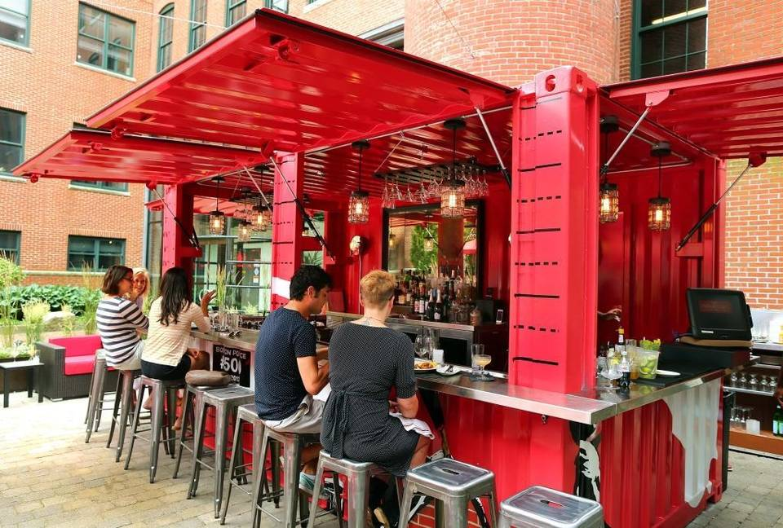
Figure 1: Pop-up restaurant Concept in the UK (Source: Cake, 2018)

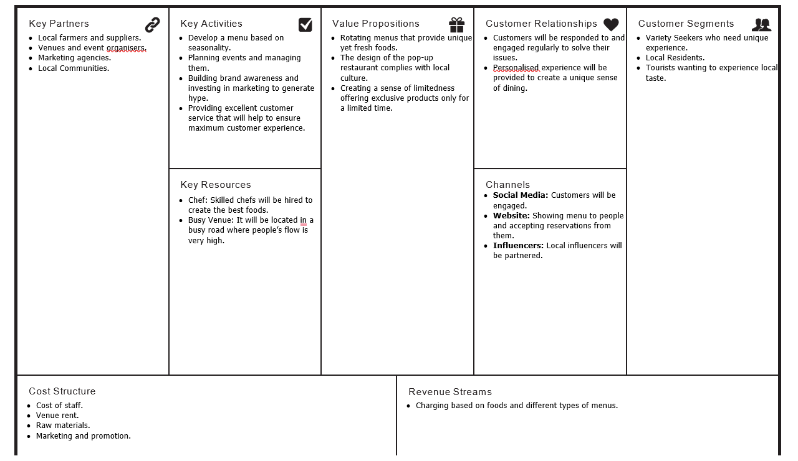
Business Model For the Proposed Pop-Up Restaurant

Figure 2: Business Model of the Proposed Pop-Up Restaurant (Source: Self-Made)
The above business model shows how the overall pop-up restaurant will be operated. It demonstrates important resources required, important activities, value propositions, customer segments, channels, and so on.

Key Partners
According to McLoughlin (2018), to run a business successfully, it needs to be dependent on some people or other businesses, and they largely impact the success of a business. Partners help businesses to access resources that will be needed to operate a business. To start the pop-up restaurant, partners will be required. Firstly, the partners will be farmers and suppliers. Farmers will provide raw materials such as vegetables and spices to produce meals. Besides, venues and event organisers will be required to set up the place for operating the business. A good relationship will be built with marketing agencies and communities to build a positive brand image. Kotler and Armstrong (2020) suggested that marketing is very important for a business as it facilitates sales.

Key Activities
Key activities consist of those activities that are required to perform the operations of a business successfully every day. Firstly, a seasonality-based menu will be developed. Because food offered to customers depending on the season can help to attract them. Besides, HGEM (2015) argued that offering a seasonal menu is cost-effective because raw materials are found in abundance during the season, which reduces raw materials' cost. Secondly, events will be managed for customers if they order food for events. Thirdly, brand awareness will be built among consumers because strong brand awareness can help people to find the restaurant and enjoy meals. Finally, it will be ensured that customers are getting proper service. It will assist in ensuring maximum customer satisfaction.

Key Resources
Key resources are those resources that will assist the pop-up restaurant to operate efficiently. Firstly, chefs will be required to cook meals. However, to prepare delicious foods, a skilled chef will be required as the chef will understand customers' tastes and will prepare various types of foods for consumers. The, venue where the restaurant will be located will be the second important resource. According to Wang and Yan (2017), busy and highly populated locations are the most desirable venues for restaurants. Because populated locations increase the chance of restaurant sales, when customers come back from their work, they will think of a place where they can eat. So, when they will find the restaurant, they will choose the restaurant. Hence, London is chosen as the city where the pop-up restaurant will be located.

Value Propositions
Value propositions are major values that are offered to customers. Value propositions are directly linked with customer satisfaction. The first value proposition of the business will be varied menus. Customers will be given a wide range of foods on a menu. A large number of options will allow them to choose a food, and it will increase sales. For example, Snyder (2020) states that Starbucks offers the same coffee in four different sizes to convince customers to buy the product rather than offering only one size. Secondly, the design of the pop-up restaurant will be done in such a way that will match the local culture because it will create a feeling of belonging among the consumers. Finally, a sense of scarcity will be created among the customers. For this, a limited-time discount will be provided. Also, a few meals will be developed that will be available only on certain days of the week.

Customer Relationships
A positive customer relationship is very important for a business's sales. According to Nassar (2020), a business can generate repetitive sales from loyal customers and build a base of loyal customers; positive customer relationships are a must. Moreover, to provide a unique experience to customers, personalised meals will be offered. Customers will be able to customise their meals according to their needs. For example, UIBLE (2023) found that 80% of consumers are more likely to return to a restaurant to have meals as they get a customised experience from the restaurant. A personalised experience is a unique message, offer, and recommendation that is tailored for a certain customer (Sheth et al., 2022). It will cater to the specific needs of customers.

Customer Segments
The pop-up restaurant will target a large base of customers. However, the area of the restaurant can limit the number of customers served. Nevertheless, three specific customer segments are chosen. Firstly, the customers who seek variety will be targeted. Variety seekers prefer to have unique experiences. The pop-up restaurant will provide unique meals and foods to customers which will provide a unique experience. The second customer segment will be residents. It means people living near the pop-up restaurant. Offering products based on the needs of residents will help the restaurant to gather popularity among them. According to Jalilvand et al. (2017), target customers should be those people who will enjoy a business's products regularly and businesses should focus on acquiring those customers mainly. Therefore, residents have been chosen as one of the segments because residents have a higher probability of becoming regular customers of the restaurant.

Channels
According to Matsushima (2016), channels refer to the ways in which a business can reach its customers. Therefore, the choice of channels should be made in such a way that will ensure maximum reach to customers. Firstly, social media will be used to reach customers. According to Zivkovic (2021), 77.9% of the UK population uses social media. Therefore, social media has been chosen as the first channel as it will increase the restaurant's reach to a large audience. Besides, the website has been chosen as the second channel because the number of people using the internet in the UK is very high. For example, as of 2023, 97.8% of the population uses the Internet (Kemp, 2023). Higher internet users mean they have access to websites, and they browse websites for their needs. Therefore, targeting the websites will increase the visibility of the business.

Cost-Structure
Cost structure includes all the costs that are necessary to be incurred to operate a business. Costs mainly will be staff, marketing, rent, and raw materials. According to Kulchania (2016), the cost structure of a business can be both cost-driven and value-driven. The cost structure of the pop-up restaurant will be cost-driven, which means the business will focus on identifying areas that will reduce operational costs, and various measures will be taken to achieve efficiency in reducing costs. However, it will be made sure that every GBP spent on cost has to bring greater value than the money. The following table shows a budget for operating the business based on the cost structure.
Costs | Amount (£)
Staff Salaries | £2000
Raw Materials Cost | £5000
Rent | £500
Marketing Expense | £2000

The costs will ensure that the business generates enough sales and, most importantly, can produce high-quality foods for its customers. Also, the achievement of efficiency will reduce both the cost and waste of food.

Revenue Streams
There will be only a single revenue stream, which is selling food. The pop-up restaurant will earn revenue by selling food only to customers. However, in the future, new revenue streams will be created, such as selling merchandise and introducing loyalty programs. But they are contingent on the early success of the restaurant.

Conclusion
The business idea is to build a pop-up restaurant whose name is 'Popper’s Eatery'. The pop-up restaurant will position itself in the market as a unique dining experience provider. Besides, the restaurant will incorporate various steps that will ensure maximum efficiency and will result in lower food waste. Finally, it can be said that the pop-up restaurant trend is rising, and the demand is also growing, showing a lucrative business opportunity.

Part 2 – Reflective Evaluation

Introduction
This essay will reflect on my experience and will demonstrate what I have learnt from my experiences. The discussion will focus on what I learned from this module and how it relates to entrepreneurship. Also, it will analyse my traits in the light of various leadership and personality traits.

Gibbs Reflective Cycle
Gibbs's reflective cycle consists of six stages, which are demonstrated in the following picture.
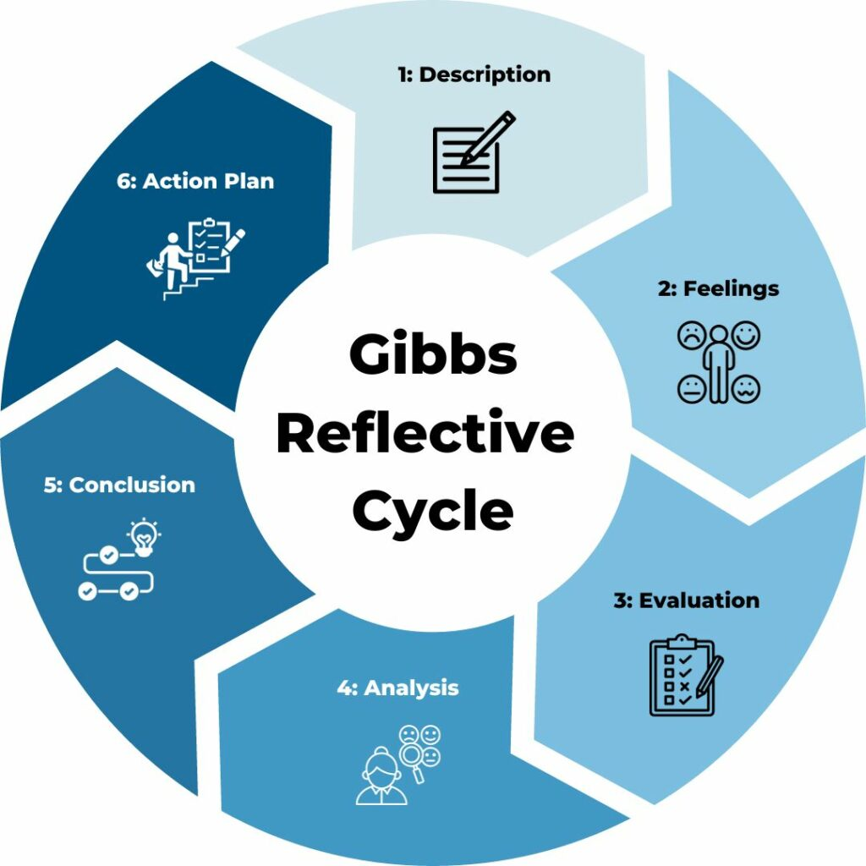

Figure 3: Gibbs Reflective Cycle (Source: Self-Developed)

Description
I have evaluated my personality traits by participating in a personality trait questionnaire. For this test, I was able to identify areas for improvement and my strengths. I identified that I am a creative person who prefers novelty. Besides, I have risk-taking behaviour, which is a very important trait for an entrepreneur. However, I understood that I lacked leadership skills, which required improvement. Besides, I also understood how leadership skills can help me in being an entrepreneur.

Feelings
I felt motivated and discontent after learning about my traits. When I learnt that I had strong creativity skills, I was motivated. Because I thought I could bring new ideas that can solve numerous problems. Besides, I also learned that I have strong willpower, which I can use for my future career advancement. However, I also identified that I lack effective leadership. It caused a feeling of discontent in me.

Evaluation
The evaluation helped me to understand that I am predisposed to creativity and risk. However, I need to improve my leadership skills. I have implemented the Big Five traits theory to evaluate my traits.
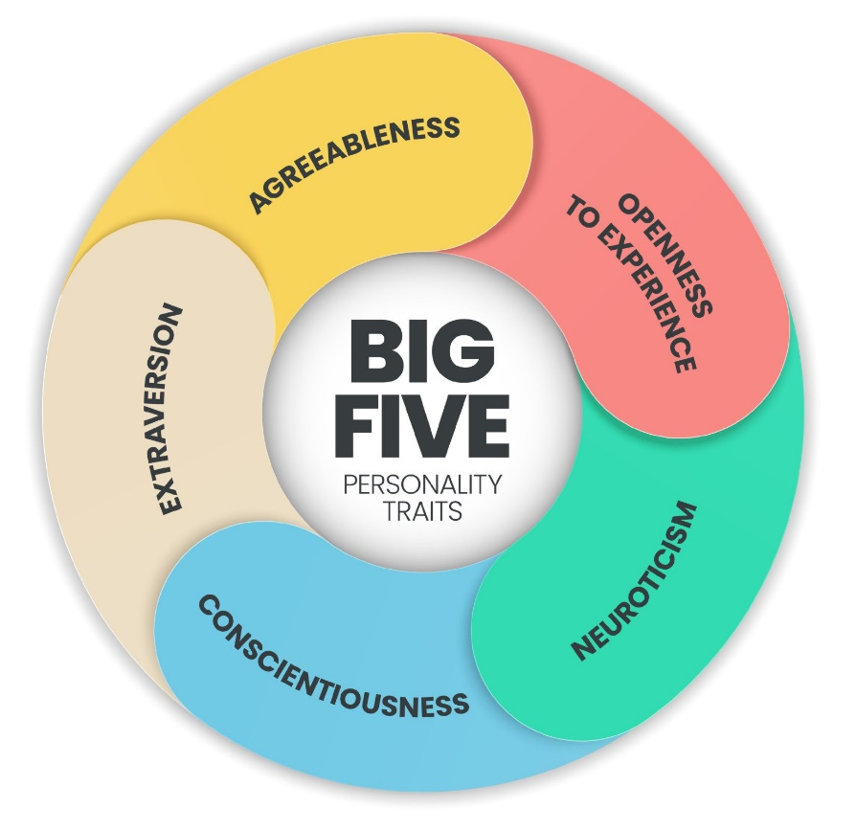
Figure 4: Big Five Personality Traits (Source: Lim, 2023)
According to the theory, I am an extrovert person. Also, I am more open to experience and high level of conscientiousness. It means I like to meet people and work with them. Besides, I have a higher level of attention to detail that allows me to gather important insights. Also, my ability to strike a balance between flexibility and challenges will allow me to be responsible and focused.
According to Gnambs (2017), important leadership traits are effective communication, the ability to influence others, and solving problems. Therefore, based on the personality trait assessment, I knew that I could communicate my extroversion trait. Also, I can influence others with this same trait. Finally, my creativity can help in solving problems.

Analysis
According to Garrett and Camper (2019), effective leadership traits are collaboration and adaptability. These two traits can help an entrepreneur navigate through challenges. Besides, as an entrepreneur, my goal will be to increase growth and build a collaborative culture that will foster innovation.

Conclusion
The analysis shows that I possess some traits and skills that can help me to be a successful entrepreneur. Besides, I also identified areas where I need to improve. I learnt that I have creativity skills and a risk-taking attitude. However, I lack effective leadership. Thus, I need to improve them.

Action Plan
The following table shows the skills I will work on to improve my leadership skills.
Skills I Want to Improve | Required Resources | Actions/Strategies | Timeline
Communication | Books, internet, and laptop | - I will join free online courses on communication.  - I will read the book How to Win Friends and Influence. | - 3 months
Teamwork | Internet and laptop | - I will watch videos on YouTube to improve my teamwork skills.  - I will frequently engage in teamwork to sharpen myself. | - 4 months

Conclusion
The essay demonstrates my strengths, such as creativity, risk-taking attitude, and willpower. Also, it demonstrates my weakness, which is in leadership skills. The findings of the reflective evaluation have helped me to be self-aware. It also helped me to identify areas for improvement.

Reference list
Booth, K. (2021). Why pop-up restaurants are here to stay. [online] BDC Magazine. Available at: https://bdcmagazine.com/2021/03/why-pop-up-restaurants-are-here-to-stay/#:~:text=Covid%2D19%20forced%20nearly%20every.
Cake, V. and (2018). Pop-Up Café: Hire Event Staff, Temporary Buildings & Other Things to Consider. [online] Vintage and cake. Available at: https://www.vintageandcake.co.uk/pop-up-cafe-hire-event-staff-temporary-buildings-other-things-to-consider/.
Chee, C. (2021). Restaurant Industry Statistics in the UK - Must-Know Numbers for 2021. [online] Truly Experiences Blog. Available at: https://trulyexperiences.com/blog/restaurant-industry-statistics-uk/.
Foodnavigator.com (2023). High inflation and footfall recovery driving UK food-to-go market growth. [online] foodnavigator.com. Available at: https://www.foodnavigator.com/Article/2023/03/10/high-inflation-and-footfall-recovery-driving-uk-food-to-go-market-growth#:~:text=Processing%20and%20Packaging-.
Garrett, J.M. and Camper, JM (2019). Formative Assessment as an Effective Leadership Learning Tool. New Directions for Student Leadership, 2015(145), pp.97–106.
Gnambs, T. (2017). Opinion leadership types or continuous opinion leadership traits? International Journal of Psychology. doi:https://doi.org/10.1002/ijop.12442.
HGEM (2015). The Benefits of Seasonal Menus. [online] HGEM. Available at: https://www.hgem.com/opinion/the-benefits-of-seasonal-menus#:~:text=Seasonal%20produce%20grows%20in%20abundance.
Jalilvand, M.R., Salimipour, S., Elyasi, M. and Mohammadi, M. (2017). Factors influencing word of mouth behaviour in the restaurant industry. Marketing Intelligence & Planning, 35(1), pp.81–110. doi:https://doi.org/10.1108/mip-02-2016-0024.
Jones, L. (2023). Pop-Up Restaurants Why are their Popularity Growing in 2024. [online] PDQ Funding. Available at: https://pdq-funding.co.uk/pop-up-restaurants/#:~:text=Business%20Leader%20states%2C%20%E2%80%9CThe%20UK.
Kemp, S. (2023). Digital 2023: The United Kingdom. [online] DataReportal – Global Digital Insights. Available at: https://datareportal.com/reports/digital-2023-united-kingdom#:~:text=Kingdom%20in%202023-.
Kotler, P. and Armstrong, G. (2020). Principles of Marketing. 18th ed. Harlow: Pearson Education Limited.
Kulchania, M. (2016). Cost Structure and Payout Policy. Financial Management, 45(4), pp.981–1009. doi:https://doi.org/10.1111/fima.12133.
Lim, A.G.Y. (2023). Big Five Personality Traits: The 5-Factor Model Of Personality. Simply Psychology. [online] Available at: https://www.simplypsychology.org/big-five-personality.html.
Matsushima, N. (2016). Expanding Distribution Channels. SSRN Electronic Journal. doi:https://doi.org/10.2139/ssrn.2736005.
McLoughlin, D. (2018). Commentary on 'Business-to-Business Marketing Textbooks: A Comparative Review'. Journal of Business-to-Business Marketing, 14(4), pp.85–91. doi:https://doi.org/10.1300/j033v14n04_06.
Mordor Intelligence (2023). Uk Hospitality Industry Market Size. [online] www.mordorintelligence.com. Available at: https://www.mordorintelligence.com/industry-reports/hospitality-industry-in-the-united-kingdom/market-size#:~:text=UK%20Hospitality%20Market%20Analysis.
Nassar, B.A.Y.A. (2020). The customer trust and customer commitment of e-customer relationship management. International Journal of Electronic Customer Relationship Management, 9(1), p.33. doi:https://doi.org/10.1504/ijecrm.2015.070697.
Sheth, J.N., Jain, V., Roy, G. and Chakraborty, A. (2022). AI-driven banking services: the next frontier for a personalised experience in the emerging market. International Journal of Bank Marketing, 40(6), pp.1248–1271. doi:https://doi.org/10.1108/ijbm-09-2021-0449.
Snyder, M. (2020). State of the Profession: The Starbucks Effect. Academe, 92(1), p.70. doi:https://doi.org/10.2307/40252902.
UIBLE, M. (2023). Unleashing the Power of Customisation: How to Sell More and Elevate your eCommerce Customer Experience. [online] www.threekit.com. Available at: https://www.threekit.com/blog/unleashing-the-power-of-customization-how-sell-more-and-elevate-you-ecommerce-customer-experience#:~:text=Personalization%20is%20becoming%20an%20increasingly.
Wang, J. and Yan, X. (2017). How Location Matters in Restaurant Success? [online] Available at: https://core.ac.uk/download/pdf/301373001.pdf.
Zivkovic, J. (2021). UK Social Media Statistics and Facts [2022]. [online] Cybercrew. Available at: https://cybercrew.uk/blog/social-media-statistics-uk/#:~:text=Top%2010%20Social%20Media%20Statistics.

