Reflective essay
This essay will discuss how, as a group, we decided to together a performance. With the options being a performance, website or leaflet it was decided to go with the performance; this was not a unanimous decision however no one fought the suggestion. In regard to self-promotion, a performance is the most effective tool available for us; it gives each person a chance to show off their work, be that in person, a recording or someone reading for them. A performance is the only way to have a human element to it, a website and leaflet can of course have personality in but it comes nowhere close to a performance. So, with the decision landing on performance, there was little else to do in the beginning. However, a classmate was enthusiastic about the night and began working immediately. The produced a piece of work that would be the opener and suggested a meeting in a weeks time to see how people’s works were coming along.
A week past and the class reconvened. Many people had a semblance of what their work could be but nothing concrete. This was because there was no set theme or themes. In this meeting, we discussed the themes and with the pieces Infront of us the themes of grief, love and death were potent. This was not a bad thing, strong and difficult emotions can make brilliant pieces of work. There was the concern that the performance may be too dark for the viewers liking but that was quickly remedied as two classmates wished to have more light-hearted pieces, Following the sound advice that ‘He who is through art is a tragic poet is a comic poet also’. In this meeting we also found a name for our performance as well as finding a date. The performance was titled ‘Confessions of creative minds’ and would take place between 5 and 7pm on May 1st. This was a problem for I had a previously set meeting in that time. However, there were ways around this. Not being able to perform, I volunteered to take care of the promotion side of things.
To achieve this, we decided that posters would be best to get the word out. With the help of the article make a good poster by Stafford undergrad I was able to make an effective poster, those being:
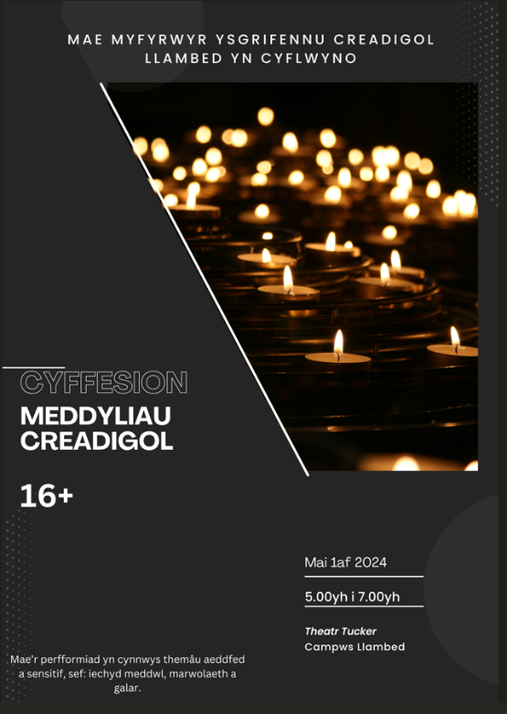
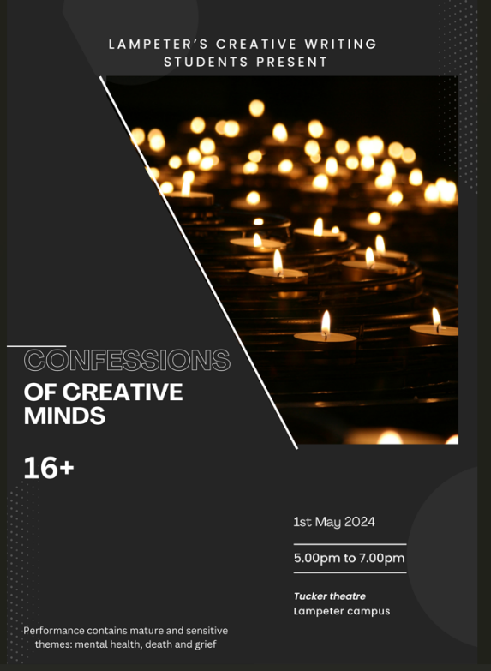

As was the intention, all relevant and important information is displayed. I.e. the time, date, sensitivity warning etc. The black background and bold white font create an eye-catching contrast and the image of the candles convey the theme of the performance. After the poster was sent around and approved by those preforming, I asked it to b translated and then printed them at the earliest convenience. Having 30 Posters (15 in English and 15 in Welsh) I then placed them around campus, areas with high traffic like the café and accommodation doors. This was successful not just because of the posters but the act of placing them, whilst doing so I was asked about the performance, so I encouraged all to visit.
With my task complete, I had little to do in regard to the performance. However, this was a mistake. With the benefit of foresight, I realise that if I engaged with the workshopping element of the module, I would have been in a position to offer valuable and constructive feedback. Not only that, but fair few performers were also quite nervous so I could have offered reassurance. All the same, I still went to the meetings which were now rehearsals. Whilst I had no part, it was still beneficial to get a feel for how the night may be so I can attract more attendees.
The performance went well, better than well. The turnout was greater than I expected. Having free drinks and a host of the night brought an organised air to the performance. In regard to the intended outcome, I believe we far exceeded what was expected of the performance and as mentioned before, the performance was a wonderful tool for self-promotion. I believe an important factor of that is following up after someone else. For example, person A puts an immense amount of effort into their piece and it comes off spectacularly and then Person B must follow up, they haven’t put much effort in and it’s noticeable which would leave them in an embarrassing state. I believe this worry pushed those to produce something to the best of their ability.

Bibliography
- Rudd Fleming, The journal of philosophy, Vol. 36, pp. 543
- Stafford undergrad, undergraduate research and independent projects
- Why you should fuel your difficult emotions into writing, Sownmya Stridhar, November 2020

Why you should fuel your difficult emotions into writing, Sownmya Stridhar, November 2020
Rudd Fleming, The journal of philosophy, Vol. 36, pp. 543
Stafford undergrad, undergraduate research and independent projects

