University of Wales Trinity Saint David 24.07.2023
Birmingham

MANAGING PROJECTS IN THE ORGANISATION
BMSW 5104

Project Management Plan
Vita-sport Pro Vitamin

Student name & ID: Tutor name:
Cristina Anton- 2110293 Dr. Abel Agoba
Andreea Rotariu- 2107119
Andreea Vlasceanu- 2108084
Natalia Rupet- 2109475

Table of Contents
Introduction 1
Project description 2
Project Aim 3
Project Objectives 3
Scope 3
Work breakdown structure 4
Figure 1: Work Breakdown Schedule for the project 4
Quad Chart 5
Table 1: A Quad Chart for the project 6
Gantt Chart 6
Figure 2: The Gantt Chart 7
Stakeholder Involvement 7
Table 2: Stakeholder classification 8
Table 3: Responsibility Allocation Matrix 10
Allocation of resources 11
Table 4: Alocation of resources 11
Risk Analysis 11
Table 5: Risk level 12
Conclusion 13
References 14
Appendix A 16

Introduction
The project plan is for the introduction of a new item (Vita-sport Pro Vitamin) into a highly competitive market. Pharma refers to the sector that includes pharmaceutical companies, regulatory agencies, healthcare professionals, and scientific researchers all working together in the research, development, production, and distribution of drugs and medications. They have a significant impact on the introduction of innovative therapies to the market, enhancing healthcare outcomes, and contributing to advancements in medical science (Britannica, 2023). Pharma company created the product, which seeks to provide athletic nourishment to jocks and active people. This plan defines the venture planning, scope, stakeholders, and resources required for the product's successful launch. It also investigates how risks are detected and managed. Previous attempts at original product releases failed to meet the desired sales targets. As a result, upper management has selected a team to oversee the market launch of this new brand of multivitamins in order to establish momentum with new customers, infirmaries, and stores. If the introduction is successful, the therapy establishment may achieve supremacy in the extremely competitive market, increasing earnings. The goal of this precise schematic is to provide an exhaustive study of all the essential pieces that must inevitably be scrutinised in order to certify the triumphant debut of the unique offering. This includes establishing market studies, product packaging, price plans, promotional methods, distribution, and logistics. Risk analysis and resource allocation will also be investigated in order to reduce potential problems and expenses. Despite the fact that all necessary components have been assembled, the team will strategize and carry out the task in a systematic manner.

Project description
Vita-sport Pro Vitamin is pharma company's sports nutrition supplement. This product is intended to allow athletes and individuals leading active lifestyles to improve their performance and recover faster. The solution contains an assortment of vital vitamins and minerals in appropriate levels to help optimal functionality and recovery (Smith et al., 2014). The word "pro" refers for "professional," meaning that this product is intended for those who are serious about their nutrition and performance. The usefulness and safety of this supplement have been decisively proved through thorough scientific testing. It retains an unadulterated essence due to the absence of extra saccharides, synthetic chromatics, and chemical conservers. Furthermore, the supplement contains a precisely calculated combination of important vitamins and minerals tailored to those who engage in regular physical exercise (Amazon, n.d). It is also accessible to customers in a portable capsule form, conveniently packed for ease of use. Vita-sport Pro Vitamin is intended to be used as a nutritional supplement, not as a replacement for existing nutrition programmes. This product will assist athletes and active people in improving their performance and recovery. It would undoubtedly be an excellent supplement for any dedicated athlete looking to maximise performance. Several actions must be done to enable the successful launch of Vita-sport Pro Vitamin into the market. Market study, product packaging, price strategies, promotional methods, distribution, and logistics are examples of these jobs (Shaw, 2012). To reduce potential difficulties and expenses, risk analysis and resource allocation will be explored.

Project Aim
The aim of this project is to collect data, evaluate pricing, and promote the Vita-sport Pro Vitamin product in order to successfully put it into the market.

Project Objectives
- Conduct market research on Vita-sport Pro Vitamin to better understand the target audience.
- To create a unique and alluring product package that would appeal to the target market.
- Develop a pricing strategy that will keep the product competitive in the market while being profitable for the organisation.
- Create advertising and distribution plans to reach the target market and assure product availability.

Scope
This project's goal is to introduce people to the Vita-sport Pro Vitamin product. The project's primary focus areas are the various aspects related to marketing, communicating, and promoting the product, even though increasing revenue and earnings remains the end goal. This calls for duties such carefully examining the market, product packaging, cost-saving strategies, publicity tactics, and disseminating and coordinating. Finding relevant client groups and the demographic divisions within them requires a thorough analysis of the commercial landscape. This includes performing surveys and studies to determine the size of the market and potential clientele (Shah et al., 2019). Product packaging entails creating packaging and labelling that represent the product's market positioning. Pricing methods that maximise product sales must be created. To ensure customer awareness and engagement with the product, promotional techniques must also be established. It is critical to use sophisticated distribution strategies and ensure optimal logistics to ensure client delivery (Sharma et al., 2019). The intricate coordination of several diverse units and their various assets will be required for the endeavour to succeed. This team undertaking the endeavour will ensure its success by bringing together a diverse mix of specialists with complementary skill sets ranging from project management and market research to design, finance, marketing, and logistics. Although promotional materials, packaging materials, and a sizable advertising budget will surely be required, these resources, both material and financial, will be critical to the project's ultimate success (Mooradian et al., 2019). To appropriately minimise the risks inherent in the business, prudent safeguards customised to this specific venture must be consistently executed in order to identify and neutralise potential dangers associated with the initiative.

Work breakdown structure
A thorough examination of the many components of a market enables the identification of specific groups of prospective consumers and the locations they occupy that are the most promising to pursue. The marketing research team must undertake extensive studies and polls in order to understand their target demographic and potential clients (M Altaf Khan, 2011). The assignment will last four weeks and will conclude with a market analysis report. The packaging and labelling of a product must correspond to its market position. To stand out in a crowded market, the design team must create eye-catching designs. The task will last two weeks and will culminate in the design of product packaging. Price strategy maximises sales (Prasad, 2019). To provide the company with a competitive edge in the current market, the finance staff must thoroughly examine the competitive environment and market trends. The task will last two weeks and will result in a pricing plan document. A promotional plan is created in order to improve customer involvement and product recognition (Lane, 2020). This necessitates the marketing team figuring out the best strategies to reach customers and increase sales. The work will take two weeks to complete and will result in a promotional strategy plan. Careful planning and coordination are used to organise and distribute products to eager purchasers. Logistics and distribution personnel must organise and supervise the process. The assignment will last four weeks and will conclude with a distribution plan.
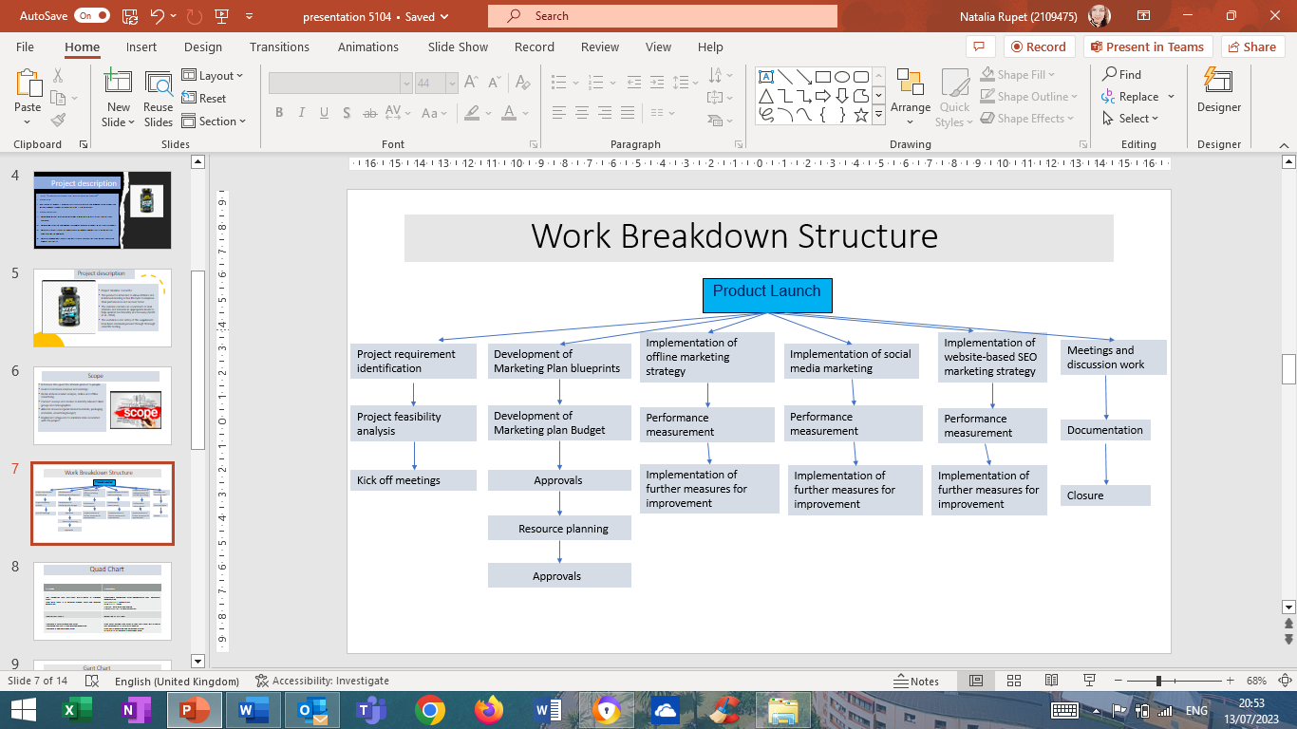

Figure 1: Work Breakdown Schedule for the project

Quad Chart
The aforementioned study had showcased a Quad chart showcasing the entire project details in a crisp and coincident manner. The first quadrant showcases the need for the project management, along with providing a brief overview. Based on the information represented in the table, it can be inferred that the project is mainly regarding promotions of NPL Nutritional Multivitamins to intended consumers. Precisely, the sales of the products and services had been comparatively low, hence, the company management had decided to undertake an initiative for organizing a promotions campaign. The second quadrant showcases detailed information regarding the intended users of the project. Precisely, the marketing project management team had segmented consumers based on demographics and behavioural segmentation. As a part of demographic segmentation strategy, NPL Nutritional Multivitamins would be utilizing income, age and gender.
On the contrary, it can be stated that inclination towards fitness has been extensively utilized by NPL Nutritional Multivitamins. Ultimately, the desired consumer profile includes, consumers belonging to; Middle class income group, age group 25-45, both male as well as Female and are Fitness enthusiast. Evidence by Civera et al. (2019), have been suggestive that, majority of the organizations across the globe, have been suggestive of the fact that, majority of the consumers across the globe. The third quadrant, on the other hand showcases, information regarding the intended results from the project. Specifically, the project team intends to enhance the; sales volume and value, profitability and revenue generation and increase consumer base. Lastly, the fourth quadrant showcases the metrics that would be essential for measuring the success of the project. The project management team of NPL Nutritional Multivitamins can consider project success; only if sales volume and value is enhanced by 12 %, profits increase by 24% and 12 % increase in consumer base.

Table 1: A Quad Chart for the project
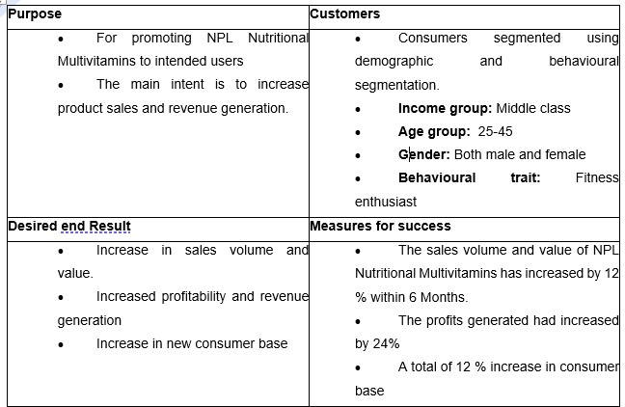

Gantt Chart
A Gantt chart is a project management tool that shows the relationship between work that has been accomplished over time and the time that was scheduled for it. In this instance, it is divided into two sections: on the left is a list of tasks, and on the right is a timeline with schedule bars to show how much time is being spent on each activity. (Ramachandran and Karthick, 2019)
The figure provided below, represents, the entire schedule for the project management process. In fact, as per the schedule, it becomes evident that, the project would be accomplished within 66 days from the date of commencement of the project.
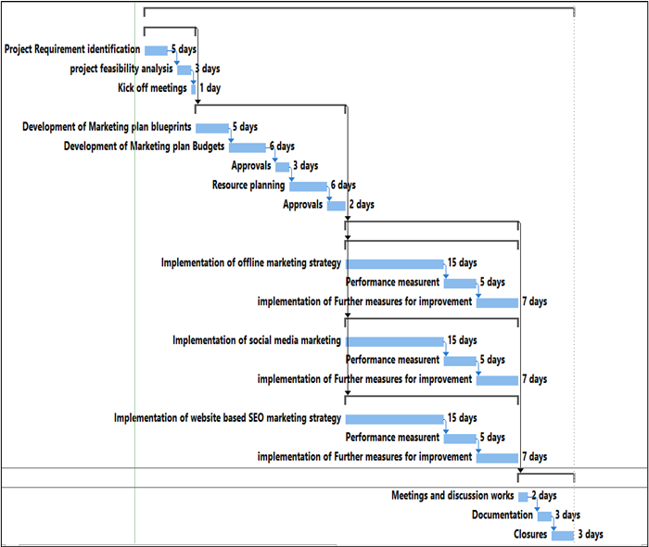

Figure 2: The Gantt Chart
Reviewing the project schedule, presented above, it can be stated that, the slack value of tasks, associated is Zero. Hence, it is imperative that all tasks associated with the project is critical and delays within anyone of the tasks, would imply delay in final project delivery.

Stakeholder Involvement
Stakeholders in projects are individuals, or group of individuals that have direct or indirect influence on project development process. In fact, it can be stated that their influence can both positively or negatively influence project development process. One of the most frequent reasons of unmanaged change causes and uncontrolled change consequences in a project is inadequate communication, followed by a lack of integration of stakeholders. (Zhao et al., 2010). The following segment would be listing the potentials stakeholders associated with the project, their areas of interests and ways of communication. Additionally, frequency of communication would also be elucidated in the table below. Moreover, responsibility of each stakeholders associated with the project would also be explained in detail in the following segments.

Table 2: Stakeholder classification
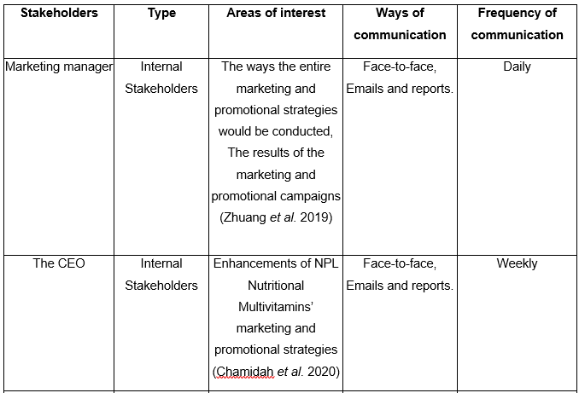
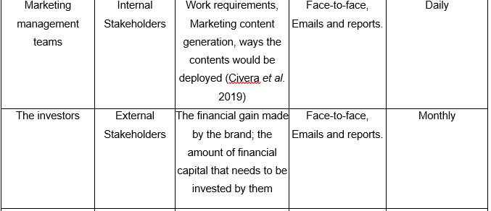
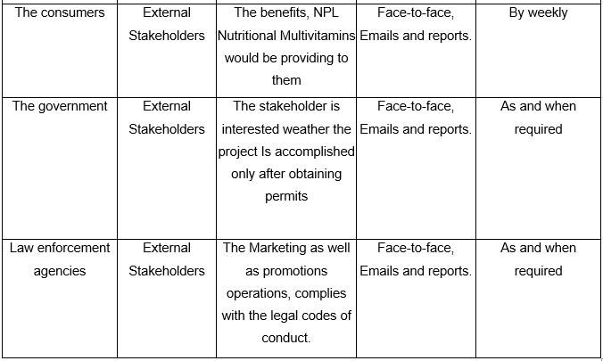
Depending on the RACI matrix, it can be inferred that, the marketing managers and marketing management teams would be responsible for all tasks associated with the marketing project. On the other hand, the CEO, the Government and law enforcement agencies are consulted and informed associated with the project. Whilst the investors and consumers associated with the project would just be informed regarding project.

Table 3: Responsibility Allocation Matrix
(Source: Influenced from Suhanda, and Pratami, 2021)
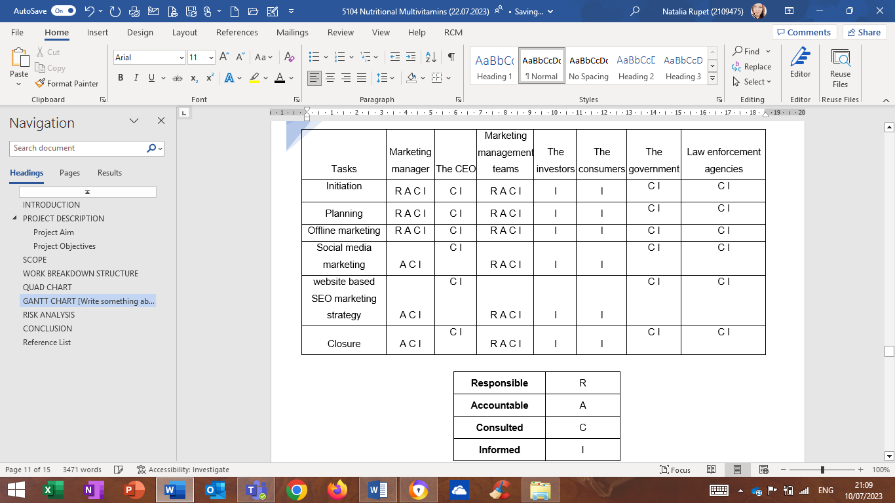

Allocation of resources
Cristina Anton – Project Manager
Andreea Rotariu- Marketing Manager
Natalia Rupet- Marketing leader
Andreea Vlesceanu- Marketing leader

Table 4: Allocation of resources
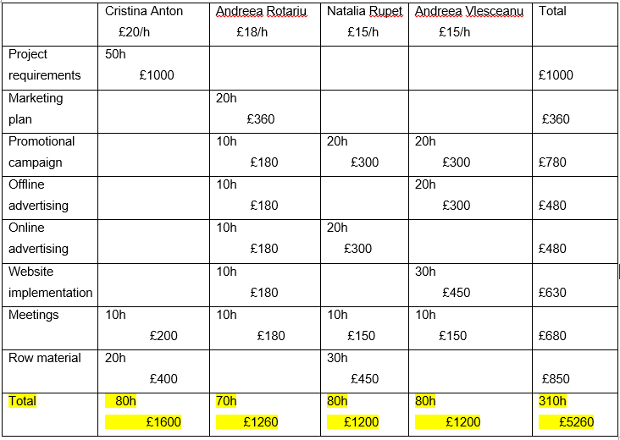

Risk Analysis
Any endeavour has some risk, but those risks need to be recognised and managed. Despite the temptation of creating a new product, doing so is risky and, if ignored or unforeseen, could rapidly turn the promise of success into the perdition of failure. The precarious nature of its means of production and the inherent vulnerabilities that come with this specific offering present significant side effects. Customer feedback and unexpected side effects may arise, so it is essential to establish effective procedures for handling complaints, addressing concerns promptly, and ensuring the safety and effectiveness of the product. To genuinely please customers, it seems essential to ask for their feedback to make sure that the offers match their needs. A significant project risk is the project's inability to establish traction with clients (Brebbia, 2013). The product's potential for success through significant sales generating will remain unmet despite the absence of customer knowledge and engagement. A variety of carefully designed promotional strategies that fully connect potential customers with the offering must be strategically applied to ensure continuous market success (Spanjol et al., 2011). Non-compliance with applicable laws and regulations during the product launch poses a significant risk in the highly regulated pharmaceutical industry. The competitive landscape carries a certain level of risk as competitors may introduce similar products or employ aggressive marketing strategies, which can impact the market share and profitability of Vita-Sport Pro. The inability to successfully launch our offering into the market represents a serious risk that necessitates immediate correction. This risk can be reduced by carefully allocating resources and adhering to deadlines and financial restrictions. To successfully launch a product in the market, it is essential to use sophisticated risk management techniques, such as identifying impending threats and developing risk reduction strategies (Lontzek and Narita, 2011). Careful risk appraisal and regulation strategies should be used to get around the project's inherent dangers. Sales and market penetration could be affected if the target market does not fully embrace or adopt the new product due to competition, lack of awareness, or customer preferences for existing alternatives (Brebbia, 2013). Identification and severity evaluation of prospective threats are part of the risk analysis process. The successful launch of the product into the market can be ensured by giving the project team the tools they need to design plans to reduce risks and take required safeguards.

Table 5: Risk level
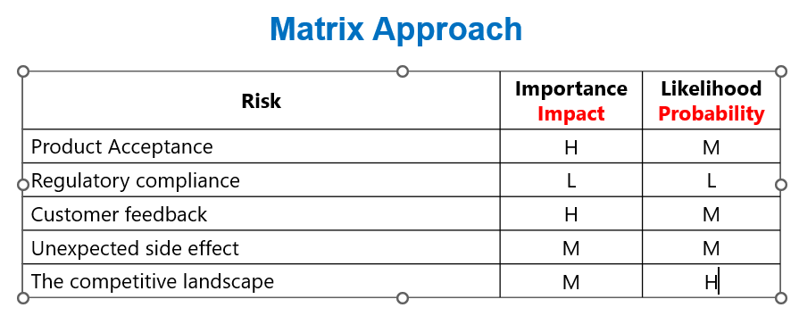
After careful analysis the product acceptance is highly important for the company and the probability to be accepted by the customers is medium. Regulatory compliance is low important because the company ensure to be up to date with all taxes that mean also probability to happen is low. Customer feedback have a high importance because negative feedbacks can lead to project failure but probability to happen is medium because the product will be tasted before launching but this depends also on each person. Unexpected side effects are medium as importance because Pharma does not expect it, but probability also is medium, it can happen and can affect brand image. The competitive landscape is medium as importance because the company believe in its product, and people trust more product medically tested but probability to happen is high because customers are loyal to old branded used.

Conclusion
For a successful product launch, the Project Management Plan is important. Systematically planning and executing the project by outlining its multifaceted parameters, including the breadth of its scope, the specificity of essential tasks, the availability of resources to accomplish said scope and tasks, and potential risks, allows the team to approach the project in an organised manner. Product launches can be successful with a good Project Management Plan. During the formulation of any project management strategy, a thorough assessment of a plan's vulnerabilities and potential threats to its success must be done to foresee and limit the chance of undesired events. Risk analysis involves finding and assessing risks. Allowing the project team to design risk mitigation strategies and apply necessary safeguards ensures the product's commercial success. The team must plan and manage resources efficiently for resource allocation, an essential aspect of the project. Human capital, raw supplies, and cash must be wisely allocated through management and control for the project to succeed. A successful market debut can be achieved by using proven project management methods and risk mitigation strategies. The project group will be able to plan and complete the project while defining its scope, requirements, methods, and risks. For a successful product launch, the project management plan is crucial.

References
Amazon.com : VitaSport Pro7ein Synthesis ([no date]). Available at: https://www.amazon.com/VitaSport-Pro7ein-Synthesis-Health-Household/s?k=VitaSport+Pro7ein+Synthesis&rh=n%3A3760901&page=4 (Accessed: 29 June 2023).
Brebbia, C.A. (2013) Risk analysis VIII. Southampton: Wit Press.
Chamidah, N., Guntoro, B. And Sulastri, E., (2020). Marketing communication and synergy of pentahelix strategy on satisfaction and sustainable tourism. The Journal of Asian Finance, Economics and Business, 7(3), pp.177-190.
Civera, C., De Colle, S. and Casalegno, C., (2019). Stakeholder engagement through empowerment: The case of coffee farmers. Business Ethics: A European Review, 28(2), pp.156-174.
Lane, N. (2020) ‘Special issue: strategic sales and strategic marketing’. Journal of Strategic Marketing 17(3-4), pp. 189–190. doi: https://doi.org/10.1080/09652540903064621.
Lontzek, T.S. and Narita, D. (2011) ‘Risk-Averse Mitigation Decisions in an Unpredictable Climate System*’. The Scandinavian Journal of Economics 113(4), pp. 937–958. doi: https://doi.org/10.1111/j.1467-9442.2011.01679.x.
M Altaf Khan (2011) Strategic marketing. New Delhi: Enkay Pub. House.
Marabelli, M., Rajola, F., Frigerio, C. and Newell, S. (2013) ‘Managing Knowledge in Large-Scale Virtual Projects: A Community-Based Approach’. SSRN Electronic Journal . doi: https://doi.org/10.2139/ssrn.2644516.
Mooradian, T.A., Matzler, K. and Ring, L.J. (2019) Strategic marketing. Harlow Pearson Education Limited.
Prasad, B. (2019) ‘Analysis of pricing strategies for new product introduction’. Pricing Strategy and Practice 5(4), pp. 132–141.
Ramachandran, K.K. and Karthick, K.K., 2019. Gantt chart: An important tool of management. Int. J. Innov. Technol. Explor. Eng, 8(7).
Shah, D., Isah, H. and Zulkernine, F. (2019) ‘Stock Market Analysis: A Review and Taxonomy of Prediction Techniques’. International Journal of Financial Studies 7(2), p. 26. doi: https://doi.org/10.3390/ijfs7020026.
Sharma, A., Kumar, V. and Cosguner, K. (2019) ‘Modeling Emerging-Market Firms’ Competitive Retail Distribution Strategies’. Journal of Marketing Research 56(3), pp. 439–458. doi: https://doi.org/10.1177/0022243718823711.
Shaw, E.H., (2012). Marketing strategy: From the origin of the concept to the development of a conceptual framework. Journal of Historical Research in Marketing.
Smith, M., Jenkin, G., Signal, L. and McLean, R., (2014). Consuming calories and creating cavities: beverages NZ children associate with sport. Appetite, 81, pp.209-217.
Spanjol, J., Qualls, W.J. and Rosa, J.A. (2011) ‘How Many and What Kind? The Role of Strategic Orientation in New Product Ideation*’. Journal of Product Innovation Management 28(2), pp. 236–250. doi: https://doi.org/10.1111/j.1540-5885.2010.00794.x.
Suhanda, R.D.P. and Pratami, D., (2021). RACI matrix design for managing stakeholders in project case study of PT. XYZ. International Journal of Innovation in Enterprise System, 5(02), pp.122-133.
Zhuang, T., Qian, Q.K., Visscher, H.J., Elsinga, M.G. and Wu, W., (2019). The role of stakeholders and their participation network in decision-making of urban renewal in China: The case of Chongqing. Cities, 92, pp.47-58.

Appendix A


