Critically appraise the procurement and resource planning used within an organisation, such as the UK MOD, to meet the organisation’s strategic objectives such as Army 2020.

Introduction
Procurement and resource planning in an organisation is integral to managing resources, goods, and expected time lines, availability of stocks, feasibility and so forth (Dominick & Lunney, 2012). Procurement and resource planning involves a lot of preparation as this department usually develops strategies in line with company performance and can recommend realistic and planned activities for the organisation to meet their consumer demands (Frigenti & Comninos, 2002). Accordingly, McDonald’s is recognised as one of the world’s notable fast food restaurants with procurement and resource planning being central to their supply chain management and success (Ruddick, 2014). With their specialisation in burgers, fries, drinks and salads, they have a need to continue meeting and changing their strategies to suit consumer demand on a consistent basis. As they predominantly deal with food, their procurement and resource planning department is essential for their longevity and survival (Arpita, 2013). As a result, an insight into the procurement and resource planning process of McDonald’s will be identified in order to demonstrate how they are meeting the organisation’s strategic objectives.
Procurement and Resource Planning used within McDonalds to meet the Organisation's Strategic Objectives
For us to better understand the procurement and resource planning within McDonald’s, it is important to identify their market orientation. Simply put, market orientation has been identified as a combination of several tactics which look to focus on meeting the needs and demands of a particular target market (Morgan & Strong, 1998). This is often done by monitoring customers shopping habits for instance, to allow us to discover their preferences and what they would like to see more of (Keskin, 2006). In the case of McDonald’s, their target market is quite broad and has developed over the years to also suit the needs of vegetarian consumers and children. Gheysari, et al., (2012) stipulate that the product mix of an organisation is important to its market orientation because the more products and services a business is able to provide, the more diverse their target market will be and the chances of meeting consumer expectations is higher. To further provide an insight into the market orientation of McDonald’s in order to indicate its importance to their procurement process, the 4P’s, also known as the marketing mix, can be employed as seen in figure 1 (McCarthy, 1964).

Figure 1: McDonald’s Marketing Mix
Marketing Mix of McDonald’s
PRODUCT | McDonald’s provides a variety of products in the form of burgers, wraps, nuggets, a range of drinks, salads and fruit. Popular choices include the McChicken Sandwich, Cheeseburgers, Fillet O Fish, McFlurry and milkshakes amongst many more. They take pride in sourcing and providing meat from their long term supplier, Keystone.
PRICE | Conveniently priced, mainly target consumers on a low budget, short of time or on the go. McDonald’s provides the choice of meals, individuals or their selection from the ‘Savers Menu’.
PLACE | Currently operates over 1,300 restaurants across the UK and Ireland. A number of their restaurants can be found spread across cities, including their drive throughs. Usually located in places which are convenient and are easily accessible.
PROMOTION | McDonald’s can noticeably be found as sponsors for high profile games and events such as the Olympics and FIFA for instance. Their popular slogan ‘I’m lovin’ it’ is advertised on billboards, television advertisements and magazine. They have previously included celebrities such as Justin Timberlake to promote the fast food restaurant as well.

Adapted from: McCarthy (1964); McDonald’s (2018)
Figure 1 suggests some of the elements from the marketing mix that are important to the procurement process of McDonald’s. For example, McDonald’s ‘product’ indicates that they have a wide selection to choose from and there is no obligation for consumers to buy food as they also have the choice of drinks and desserts. The more critical aspect of this element is that McDonald’s have been using the same supplier to source their meat since the 1960’s which is Keystone Foods (McDonald’s, 2018). Relationships with suppliers are important because it reflects effective procurement management which Christopher & Towill (2002) state is essential to the marketing mix as it helps to meet consumer demand more closely. The significance of strong procurement management is reflected in McDonald’s partnership with Keystone when they both jointly developed the line of Chicken McNuggets, which became popular amongst consumers (McDonald’s, 2018). Therefore, it can also be argued that strong supplier relationships are important in order to drive innovation within an organisation forward as well, Mitrega, et al., (2017).
This leads into the importance of recognising resource planning in McDonald’s and how this is used to meet the strategic objectives of the organisation, including its stakeholders. In order to allow us to understand this, it becomes key to firstly identify what McDonald’s strategic objectives are. One strategy is apparent from the example above of Keystone, which is the organisations desire to want to develop positive working relationships with suppliers, workers and franchisees, whilst also providing quality food for customers (McDonald’s, 2018). The management of franchisees and workers in the resource planning of McDonald’s is important, as without the correct resources and knowledge of the procurement process, employees will fail to meet the demands of their consumers effectively, risking the level of quality and service which they offer (Turner, 2011). As a result, one way in which McDonald’s aimed to meet this strategy is by introducing the Restaurant Supply Planning Department in 2004 as a way to support and assist restaurant managers by helping them to improve procurement management (McDonald’s Restaurants, 2018). Initially, the management of procurement was left with restaurant managers, but since this development, McDonald’s has witnessed a positive change to their supply chain success. The process which McDonald’s have undertaken for better procurement management also conforms to the five essential tasks of strategic management which can be seen in figure 2 (Tapera, 2014). This includes the development of a strategic vision, setting objectives, devising or planning techniques to meet those objectives, followed by implementation and finishing with evaluating their performance (Haines, 2000).

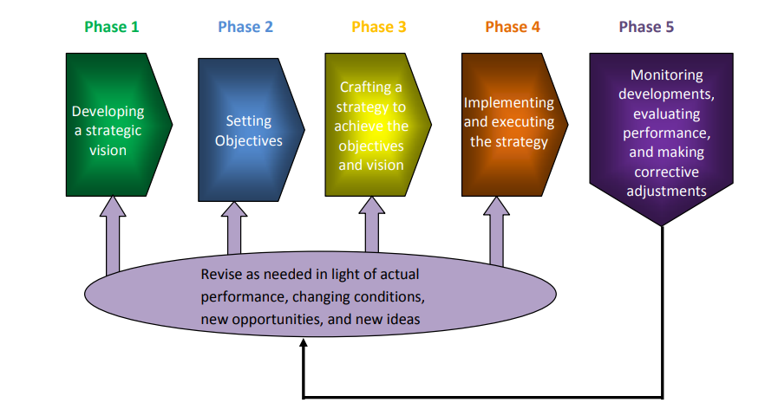
Figure 2: The Five Phases of Strategic Management

Source: Tapera (2014, p. 124)
Procurement management and resource planning is also central to meeting McDonald’s competitive strategic objectives. Porter’s (1980) five forces for instance (see figure 3), can help evaluate the competitive scope of McDonald’s by identifying its competitors. This is supported by Campbell, et al., (2002) who stipulate that recognising competitors helps in effective communication to take place between the organisation and its target market, assists in differentiating products, improves processes and ensures a plan is in place to tackle potential challenges arising from competition. McDonald’s (2018) growth strategy includes five main pillars, with regaining customers by improving the quality and taste of their food; converting casual diners into customers who are more committed to drinks and snacks and becoming more digitally savvy in their restaurants through interactive experiences for customers, are potential indicators in their strategy of how they are competing with others in the industry. Their competitors can be seen in the form of KFC and Burger King for example and according to Porter’s model, threat of substitute products would be a challenge for them due to having similar price points and service. However, in terms of suppliers, McDonald’s can be considered as having a strong position due to their long term provider, Keystone and Martin Brower (Martin Brower, 2018). This works in their advantage because it ensures that they are providing a consistent level of service with good quality taste and ingredients and also reflects that their procurement management and resource planning is also robust (Kannan & Tan, 2006). Additionally, it helps them to combat competition and work closer to meeting their strategy of regaining customers.

Figure 3: Porter’s (1980) Five Forces
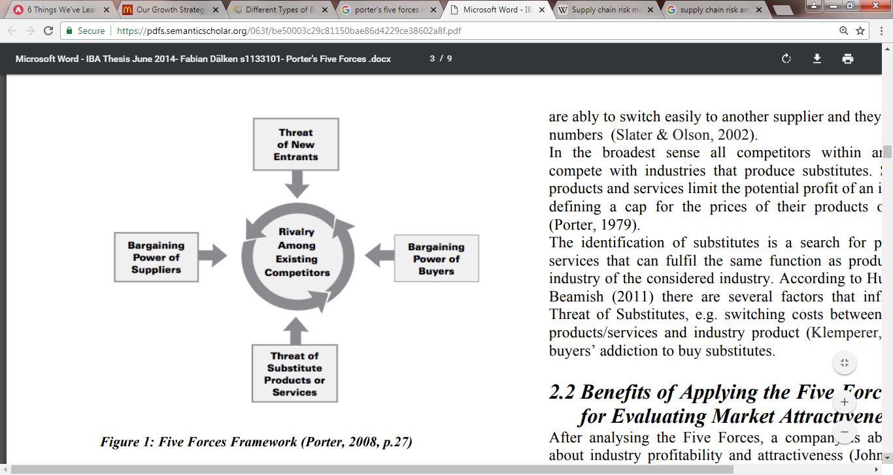

Source: Porter (2008, p.27)
In regards to McDonald’s competitive strategy of retaining their customers by increasing their commitment to snacks and drinks, this is a strategy which has already been implemented in their restaurants and has further been diversified by introducing popular and different flavours of the McFlurry ice-cream for instance and smoothies (McDonald’s, 2018). The benefits of this strategy are that they can increase their appeal to their target market and allow for suppliers in their procurement process to innovate and find new ways of preparing and sourcing products. Figure 4 illustrates how closely aligned corporations, customers and competitors are and the need to diversify services and products in business strategy (Ohmae, 1982). The aim of providing differentiating products indicates to customers that McDonald’s are aiming to meet their expectations as well as demonstrate that they are unique in comparison to the other competitors in the industry (Prajogo, 2007). However, the differentiation in products could also cause for further substitute products to develop by their competitors which can put organisations in a challenging position. For example, Burger King also provides similar additional snacks to McDonald’s such as their Mozzarella Dippers which come in the form of Chilli Cheese Bites with jalapenos (Burger King, 2018). This extra ingredient in Burger Kings Cheese Bites could prove to be disadvantageous for McDonald’s as it is a similar product with a different taste. Furthermore, the diversification and innovation of new products in McDonald’s could potentially create new challenges in procurement and resource planning because this would be additional products which they would have to source and manage. Therefore, although the diversification of McDonald’s food helps to maintain and increase consumer choice, it can also generate new competition from dessert places or smoothie bars for example, who are already established in their line of work (Magretta, 2012).

Figure 4: The Three Strategic C’s
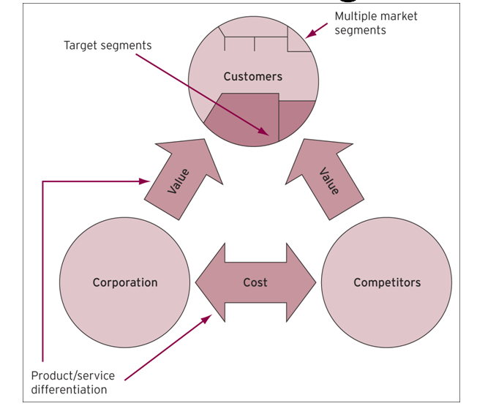

Source: Ohame, (1982)
McDonald’s procurement management and resource planning also contributes to combating different types of performance failures which can occur, something that they have recognised and put strategic measures in place to improve (Dias & Teixeira, 2017). For example, when McDonald’s noticed that their restaurant owners around the world were finding it challenging to undertake resource management themselves, they introduced the Restaurant Supply Planning Department in 2004 as stated above (McDonald’s Restaurants, 2018). By doing this, there were fewer chances of human error or mistakes of occurring as McDonald’s managers had the correct support from a department which had specialised knowledge in the field of procurement. To further improve or avoid performance failures from occurring in McDonald’s so that they can meet another growth strategy which is delivery, in an effort to bring McDonald’s experiences to their customers at home or the workplace, they assess delivery drivers on the amount of time which it takes them to get to the recipient (McDonald’s, 2018). Similarly, in order to ensure that McDonald’s procurement management abilities are not affected due to performance failure, they ensure that the timing of deliveries to their restaurants and shipment is conducted between off-peak hours such as early morning, using forecasting tools so that their customer experience is not interrupted (McDonald’s, 2018). Therefore, it may also be argued that McDonald’s have also incorporated a certain level of interpretive strategy within their goals, as this type of strategy focuses on improving organisational culture by concentrating on internal and external relationships (Faulkner, 2002). Internal relationships would include McDonald’s stakeholders such as their suppliers and external relationships would be concerned with their customers. Due to their efforts in developing their interaction with their customers, it suggests that McDonald’s have a desire to want to also improve their image and the way they are perceived. As a result, reducing performance failure through better coordination with suppliers and ensuring that the customer experience stays intact, they can remain at the forefront of customer service.
Similarly, managing supply risk management in the procurement and resource process is also integral to ensuring McDonald’s know how to deal with risks that can affect their logistics and resources, which in turn can impact the customer experience and meeting their strategic objectives negatively (Ritchie & Brindley, 2007). In 2014, McDonald’s developed a Global Sustainability Framework ‘Scale for Good’ as part of their growth plan (McDonald’s, 2018). In this, McDonald’s have embraced sustainability as a way to continue providing great tasting food based on their own sustainable initiatives which include climate action, beef sustainability, packaging and recycling, commitment to families and investment in their people (McDonald’s, 2018). The sustainability framework is also highly relevant to their procurement process as it also enables their suppliers to become sustainable as a result of sourcing produce which is more environmentally friendly. For example, McDonald’s have stated that by 2020, they want to reach their strategic vision of sustainable beef in 10 countries, including the UK, by pioneering new practices such as progressive farm partnerships for instance (McDonald’s, 2018). Therefore, strategic goals such as this can help to identify the steps that need to be taken to reach the aim, as well as assess the strengths and weaknesses of the plan which is critical to managing supply risk in the procurement process (Joseph & Janssen, 2001). These goals also prove to be a threat to their competitors as a more sustainable supply chain will improve procurement and resource planning by allowing them to engage in ‘green purchasing’, ensuring and securing the survival of their business in the long run (Dabhilkar, et al., 2016).

Conclusion
This essay has articulated the procurement and resource planning process of McDonald’s and how this department contributes to making their strategic objectives a success. In order to critically appraise the procurement and resource planning, McDonald’s market orientation played a key role in the identification of their target market so that their customer needs and demands could be met more effectively. The 4P’s helped identify what McDonald’s position was on each element and what they were doing as an organisation, including how their products were an important factor in the procurement and resource planning process due to their diverse choice of foods and their long term supplier, Keystone. This was reflected in McDonald’s strategy of wanting to develop strong relationships with their suppliers, whilst also providing great tasting food for their customers. Hence, McDonald’s developed their Restaurant Supply Planning Department to help their employees understand and engage with the procurement process better, seeing them conform to the five tasks of strategic management, from the initial idea stage to the implementation and evaluation of performance. Porter’s five forces demonstrated McDonald’s competitive scope, whilst identifying who their competitors were in the form of Burger King and KFC. Their competitive stance was not only integral to the profitability of their organisation, but also to their strategies of trying to regain and retain customers. The three C’s further supported this and emphasised the need to be competitive with the diversification of foods and procurement and resource planning being a contributor in helping McDonald’s innovate. Performance failure and managing risk in the supply chain was also discussed by highlighting how deliveries and time management was important to avoiding performance failure and improving external and internal relationships within the organisation. Furthermore, their strategy of ‘Sale for Good’ was implemented via their Global Sustainability Framework, with emphasis on how they could make procurement and resource planning more sustainable through sourcing beef that had minimal impacts.

References
Arpita, A., (2013). How much is strategic fit important? Business Strategy Series. 14 (4). pp. 99-105
Burger King, (2018). Sides. (Online). Available at: http://www.burgerking.co.uk/menu/sides. (Accessed 17th June 2018)
Campbell, D., Stonehouse, G and Houston, B., (2002). Business Strategy. Oxon: Routledge.
Christopher, M and Towill, D.R., (2002). Developing market supply chain strategies. The International Journal of Logistics Management. 13 (1). pp. 1-14
Dabhilkar, M., Bengtsson, L., and Lakemond, N., (2016). Sustainable supply management as a purchasing capability: A power and dependence perspective. International Journal of Operations & Production Management. 36 (1). pp. 2-22
Dias, A and Teixeira, A., (2017). The anatomy of business failure: A qualitative account of its implications for future business success. European Journal of Management and Business Economics. 26 (1). pp. 2-20
Dominick, C and Lunney, S., (2012). The procurement game plan: Winning strategies and techniques for supply management professionals. USA: J. Ross Publishing
Faulkner, D., (2002). Strategy: Critical perspectives on business and management, volume 1. London: Routledge
Frigenti, E and Comninos, D., (2002). Practice of project management. UK: Kogan Page.
Gheysari, H., Rasli, A., Roghanian, P and Norhalim, N., (2012). A review on the market orientation evolution. Procedia Social and Behavioural Sciences. 40 (1). pp. 542-549
Haines, S., (2000). The systems thinking approach to strategic planning and management. London: CRC Press
Joseph, A.D.F and Janssen, A., (2001). Implementing strategy successfully. Measuring Business Excellence. 5 (4). pp. 406
Kannan, V and Tan, K.C., (2006). Buyer-supplier relationships: The impact of supplier selection and buyer-supplier engagement on relationship and firm performance. International Journal of Physical Distribution & Logistics Management. 36 (10). pp. 755-775
Keskin, H., (2006). Market orientation. learning orientation, and innovation capabilities in SMEs: An extended model. European Journal of Innovation Management. 9 (4). pp. 396-417
Magretta, J., (2012). Understanding Michael Porter: The Essential Guide to Competition and Strategy. Boston: Harvard Business Review Press.
Martin Brower, (2018). Martin Brower UK Services. (Online). Available at: http://martinbrower.co.uk/services.html. (Accessed 17th June 2018)
McCarthy, E.J., (1964). Basic Marketing. Illinois: Richard D. Irwin.
McDonald’s (2018). “Our Growth Strategy”. (Online). Available at: https://corporate.mcdonalds.com/corpmcd/about-us/our-growth-strategy.html. (Accessed 17th June 2018)
McDonald’s (2018). “What are the business aims and objectives for McDonald’s in the U.K.?”. (Online). Available at: https://www.mcdonalds.com/gb/en-gb/help/faq/18507-what-are-the-business-aims-and-objectives-for-mcdonalds-in-the-uk.html. (Accessed 16th June 2018)
McDonald’s (2018). Beef Sustainability Report. (Online). Available at: https://corporate.mcdonalds.com/content/dam/gwscorp/scale-for-good/McDonald%27s-Beef-Sustainability-Report.pdf. (Accessed 17th June 2018)
McDonald’s (2018). Revolutionizing the quick service food industry: Keystone Foods. (Online). Available at: https://www.mcdonalds.com/us/en-us/about-our-food/meet-our-suppliers/keystone-foods.html. (Accessed 16th June 2018)
McDonald’s Restaurants, (2018). “Managing stock to meet customer needs: A McDonald’s Restaurants case study. (Online). Available at: https://businesscasestudies.co.uk/mcdonalds-restaurants/managing-stock-to-meet-customer-needs/introduction.html#axzz319ui7Hlu. (Accessed 17th June 2018)
Mitrega, M., Forkmann, S., Zaefarian, G and Henneberg, S., (2017). Networking capability in supplier relationships and its impact on product innovation and form performance. International Journal of Operations & Production Management. 37 (5). pp. 577-606
Morgan, R and Strong, C., (1998). Market orientation and dimensions of strategic orientation. European Journal of Marketing. 32 (11-12). pp. 1051-1073
Ohame, K., (1982). The Mind of the Strategist: The Art of Japanese Business. USA: McGraw-Hill
Porter, M., (1980). How competitive forces shape strategy. Harvard Business Review.
Porter, M.E., (2008). The Five Competitive Forces that Shape Strategy. Harvard Business Review.
Ritchie, B and Brindley, C., (2007). Supply chain risk management and performance: A guiding framework for future development. International Journal of Operations & Production Management. 27 (3). pp. 303-322
Ruddick, G., (2014). “How McDonald’s was turned around in the UK”. 16th November 2014. The Telegraph. (Online). Available at: https://www.telegraph.co.uk/finance/newsbysector/retailandconsumer/11234229/How-McDonalds-was-turned-around-in-the-UK.html. (Accessed 17th June 2018)
Tapera, J., (2014). The importance of strategic management to business organizations. Research Journal of Social Science & Management. 3 (11). pp. 122-130
Turner, R., (2011). Supply management and procurement: From the basics to best-in-class. Florida: J. Ross Publishing

