
Lucky Task Work C 1

Student name:Lucky Osagiede Osagiede
Student ID:2312706

Module name: Changemakers : Building Your Personal Brand for Sustainable Employment
Module code : BMHP5015
Lecturer : Caroline Salami

Table of Contents
Introduction 2
Definition of ambition 2
Self – awareness 3
Definition of net – working 4
Unit 1 :Brand Me 4
Unit 2 : IT’s a small Word 5
Unit 3 : Opportunity Knocks 5
Unit 4 : The Pursuit of Happiness 6
Conclusion 7
References 7

Introduction
This reflective portfolio presents the learning journey undertaken as part of the module `Changemakers :Building Your Personal Brand for Sustainable Employment ‘ . The portfolio explores how four key units – Brand me , it’s small world , opportunity knocks , and the pursuit of happiness – have supported my professional and personal growth towards achieving my long – term goal of becoming a Care Home Manager .
The reflections draw upon key theories and models , including Gibbs’ Reflective Cycle (1988), Johari’s Window ( Luft and Ingham ,1955 ) , and the PERMA Model of Wellbeing (Seligman, 2018) . These frameworks have provided the foundation for understanding self – awareness , leadership , communication ,and resilience within the health and social care context . The module has encouraged a proactive approach to professional development , helping me align my personal values and skills with the expectations of leadership within the care sector . I will be writing about ambition , self – awareness , and net – working .

Definition of ambition
Ambition is the internal motivation that drives individuals to set challenging goals and persevere toward achieving personal or professional success . It reflects a desire for growth , improvement , and long- term achievement ( Roberts , 2020 ) .

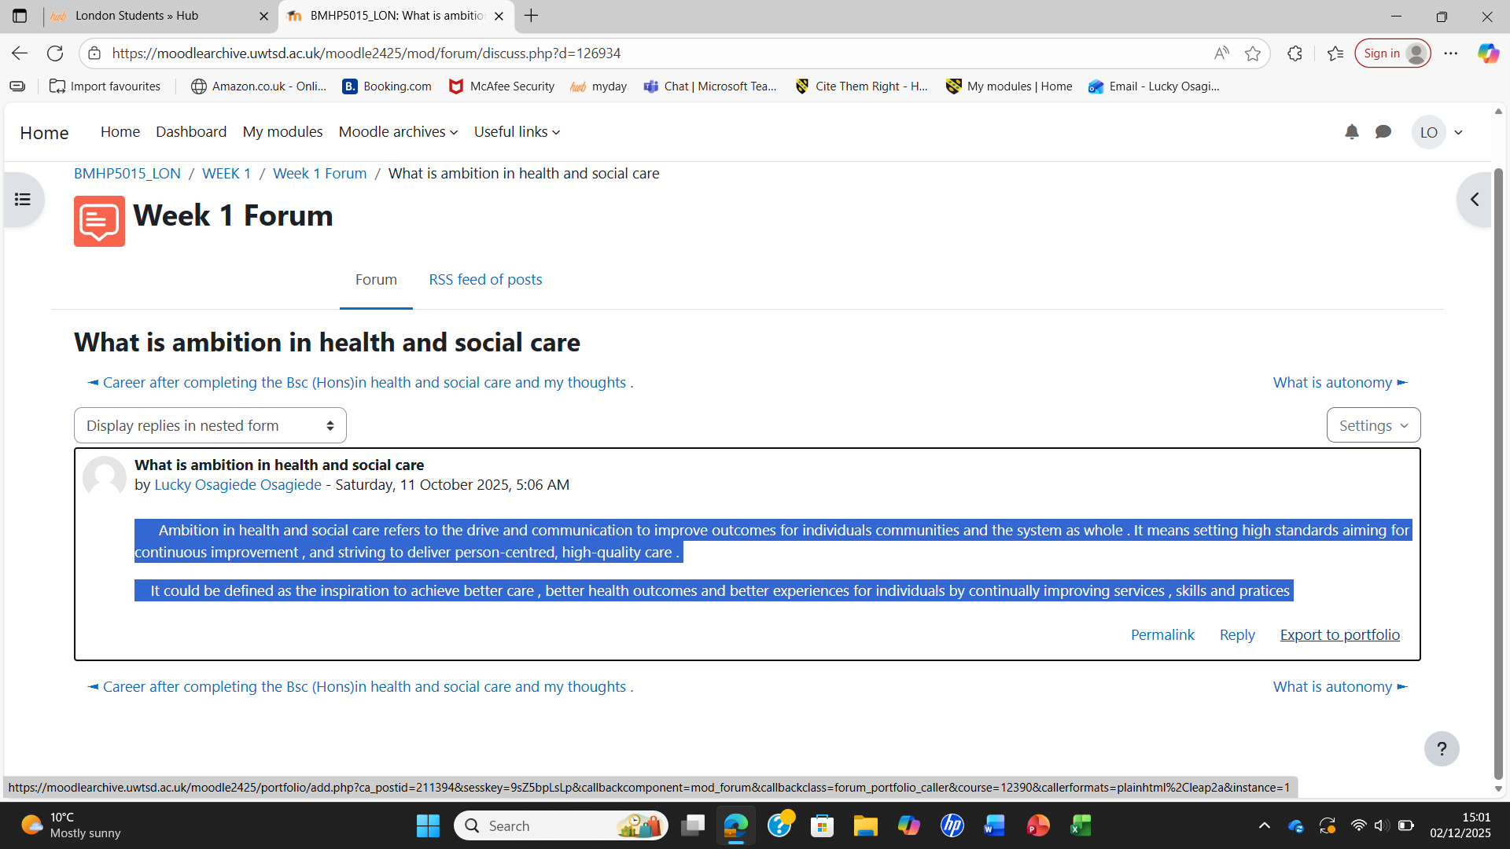

Self – awareness
Is the ability to recognise and understand one’s own emotions , behaviours , strengths and limitations , and how these influence interactions with others . It is a core component of emotional intelligence and essential for reflective professional practice .( Goleman , 1995 ) .
Self – awareness in the UK health and social care involves
. Understanding your values and beliefs
. Knowing emotional responses
. recognising your strengths and limitations
. Reflecting on your practice ( Gibbs’ Reflective cycle or Kolb’s experiential Learning) commonly used in UK.
. Understanding how one’s behaviour affects others .
Self – awareness is important according to UK standards . It links to several UK frameworks and policies .

Definition of net – working
Net – working is the process of creating, developing and maintaining relationships with individuals and organisations to exchange knowledge , gain support , and enhance professional opportunities . It is considered a key strategy for career development and employability ( Hodkinson and Sparkes ,2019 ) .
Networking in health and social care means professionals and organisations working together , sharing information , and coordinating support so that people receive joined – up person- centred care . It assists different services- such as health , social care , and community organisations- communicate effectively and avoid gaps in support .
Example is a GP , social worker , and mental health nurse regularly share updates and plan together for an elderly patient who has diabetes , mobility issues , and depression . By networking , they coordinate medical treatment , home- care support , and mental health services so the patient receives consistent and well organised care .

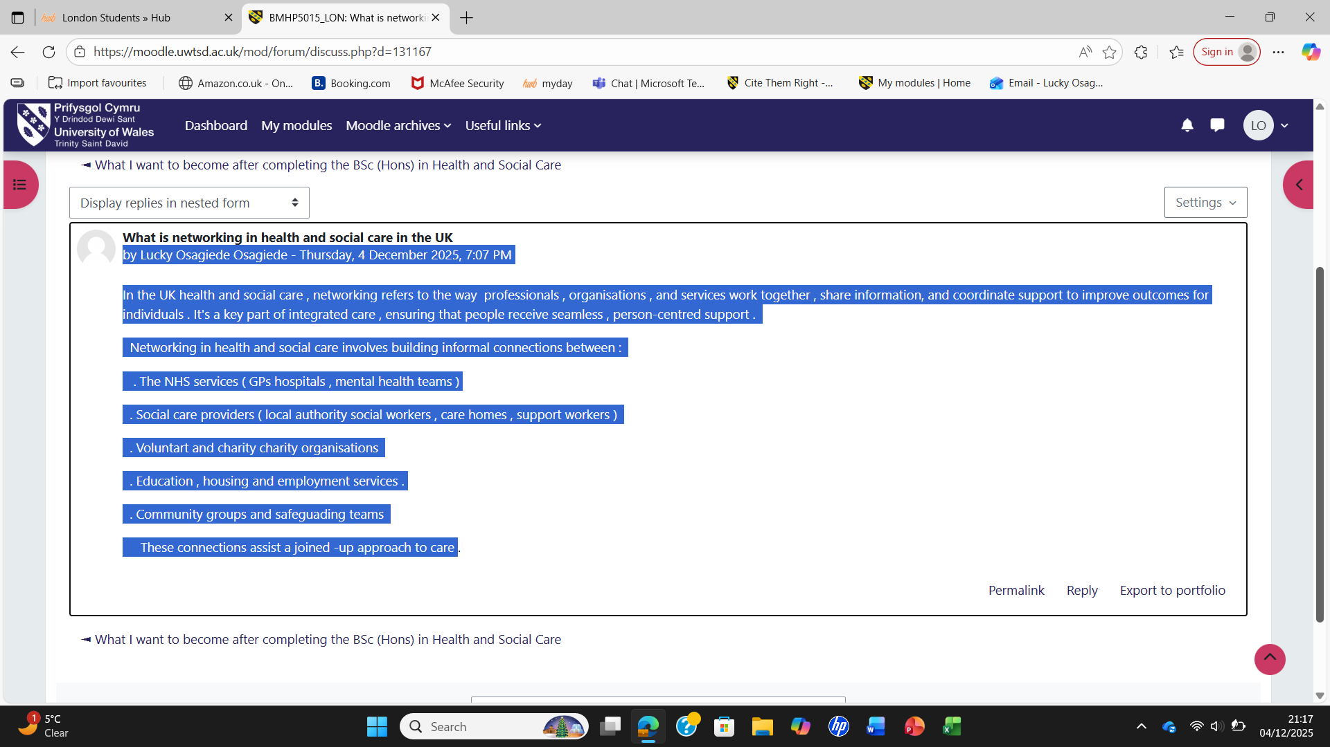

Unit 1 :Brand Me
The first unit `Brand Me ‘ , focused on self – awareness and personal
Branding . Through reflective activities , I was able to identify my strengths , values , and professional attributes that align with leadership in health and social care . Using Johari’s Window ( Luft and Ingham, 1955 ). I explored how feedback from others helps to uncover blind spots and develop self – knowledge . This reflection was particularly valuable in improving my communication style and confidence , which are critical for managing staff and ensuring person- centred care in a residential setting .
Applying Gibbs’ Reflective Cycle ( 1988 ) enabled me to think critically about my experiences working as a support worker .For instance , I recognised that I sometimes hesitated to delegate tasks due to fear of mistakes .Through reflection , I realised that effective leadership involves trust and empowerment rather than control . I have since started to practise active listening and positive reinforcement to motivate team members , improving collaboration and morale . These skills are directly transferable to the Care Home Manager role .
I also developed my professional identity by creating a personal brand statement that highlights compassion , accountability , and integrity -values that underpin the Care Act ( 2014 ) and the CQC’s key lines of enquiry for care leadership . My online presence on LinkedIn now reflects this brand , enhancing my employability and visibility in the care sector .

Unit 2 : IT’s a small Word
This unit explored the importance of cultural awareness global interconnectedness , and inclusivity within the workplace . As a professional in health and social care , understanding diversity essential to promoting equality and dignity for service users and staff . Through discussion activities , I learned to apply Hofstede’s Cultural Dimensions Theory ( 2011 ) to recognise how cultural values influence communication , teamwork , and decision – making .
I reflected on a situation where communication barriers affected understanding between colleagues from different cultural backgrounds . By applying cultural competence principles ( Cross et al, 1989 ), I was able to promote clearer dialogue and mutual respect . This experience reinforced the significant of empathy and adaptability in leadership – skills that contribute to an inclusive and supportive care environment .
This unit strengthened my commitment to anti- discriminatory practice , as outlined in the Equality Act ( 2010 ) . I also learned how to model inclusive behaviour that encourages diversity of thought , which is vital for innovation and high-quality care delivery within a care home setting , and care about the holistic person- centred care . This enables the service users put their trust and confidence on the workers

Unit 3 : Opportunity Knocks
In this unit , I developed strategies for identifying and pursuing career opportunities . Using this SMART goal framework (Doran , 1981 ) , I set clear objectives for my professional progression .One key goal is to complete the level 5 Diploma in leadership and Management for Adult Care which is a qualification required for Care Home Managers in the UK . I also plan to engage in regular continuing professional development ( CPD ) activities , such as leadership workshops and dementia care training .
Through this module , I realised the importance of networking and self – promotion in career advancement . According to Granovetter’s ( 1973 ) theory of weak ties , connections beyond immediate circles can provide unexpected career opportunities .I began engaging with professional networks such as Skills for Care and LinkedIn groups for health and social care leaders . These platforms offer valuable insights into policy changes and management practices .
This unit encouraged me to build a personal development plan ( PDP ) that aligns with my career vision . My PDP outlines short- term goals ( gaining supervisory experience ) , medium – term goals ( completing the Level 5 Diploma) , and long -term goals (applying for a Care Home Manager Position ) . Each stage includes strategies for overcoming challenges such as time management and self – doubt , supported by reflection using Gibbs’ model .

Unit 4 : The Pursuit of Happiness
The final unit explored wellbeing ,resilience , and emotional intelligence – key qualities for sustainable leadership . Using Seligman’s PERMA model ( 2018 ), I learned that wellbeing encompasses Positive emotions , Engagement , Relationships , Meaning , and Accomplishment . As a future Care Home Manager, I will need to maintain personal wellbeing to support others effectively .
I reflected on my stress management strategies during challenging shifts . Through applying mindfulness techniques and work-life balance principles , I recognised that resilience grows through self- compassion and realistic goal setting . Bandura’s ( 1997 ) concept of self- efficacy further helped me understand how belief in one’s ability impacts performance and motivation . I have since implemented daily routines that include brief reflective journaling and gratitude exercises to maintain motivation and clarity .
This unit also emphasised the role of supportive supervision and staff wellbeing initiatives . I plan to promote a positive organisational culture where employees feel valued and motivated , consistent with the NHS Leadership Framework (2013 ) . Promoting psychological safety and open communication will be central to my management approach . It assists in facilitating facilities , nursing homes , residential care settings , face a unique combination of healthcare , hospitality ,and regulatory changes . it enables me to know the staffing and workforce challenges , regulatory compliance demands ,quality of care and resident well- being , communication and family expectations , financial and operational pressures , leadership and culture , crisis and risk management , technology and record – keeping .

Conclusion
This portfolio has demonstrated how the Changemakers module has enhanced my self-awareness , confidence , and employability in health and social care . By engaging in reflective practice and applying theories such as Gibbs’ Reflective Cycle , Johari’s Window and the PERMA model , I have developed the key competencies required for effective leadership .
The module has encouraged me to take ownership of my personal brand , embrace diversity, identify career opportunities , and prioritise wellbeing . These insights have prepared me to progress towards my goal of becoming a Care Home Manager who leads with empathy , professionalism , and resilience .

References
• Bandura, A. (1997) Self-efficacy: The exercise of control. New York: Freeman.
• Care Act (2014) c.23. London: The Stationery Office.
• Cross, T., Bazron, B., Dennis, K. and Isaacs, M. (1989) Towards a culturally competent
system of care. Washington, DC: Georgetown University.
• Doran, G. (1981) ‘There’s a S.M.A.R.T. way to write management’s goals and objectives’,
Management Review, 70(11), pp. 35–36.
• Equality Act (2010) c.15. London: The Stationery Office.
• Gibbs, G. (1988) Learning by doing: A guide to teaching and learning methods. Oxford:
Oxford Polytechnic.
• Granovetter, M. (1973) ‘The Strength of Weak Ties’, American Journal of Sociology,
78(6), pp. 1360–1380 .
- Goleman , D. ( 1995) Emotional intelligence :Why It Can Matter More Than IQ New York : Bantam Books
• Hofstede, G. (2011) Culture’s Consequences: Comparing Values, Behaviours, Institutions
and Organizations Across Nations. 2nd ed. Thousand Oaks: SAGE.
• Luft, J. and Ingham, H. (1955) ‘The Johari Window: A graphic model of awareness in
interpersonal relations’, Human Relations Training News, 5(1), pp. 6–7.
• NHS Leadership Academy (2013) Healthcare Leadership Model: The nine dimensions of
leadership behaviour. London: NHS.
• Seligman, M. (2018) PERMA and the Science of Well-being. New York: Harper

