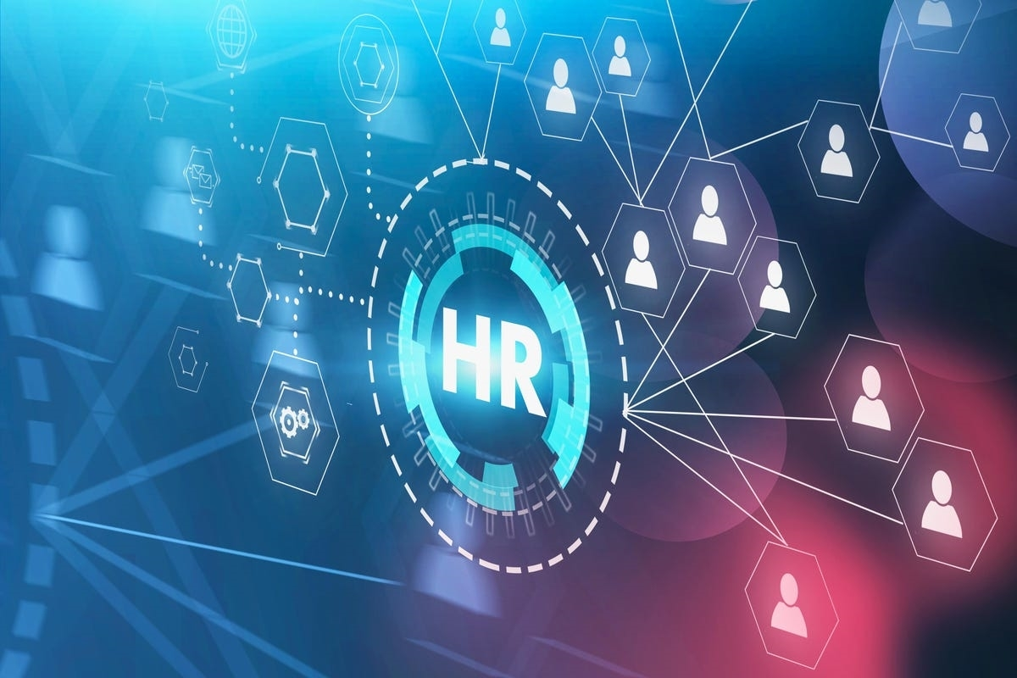
Name: MUHAMMAD FAHEEM DANISHMAL Student Number: 1922156:
Lecturer Name: GREGORY COWAN Name of the : HR MANAGENT Programme:


Introduction

◆ Need for training and development for HR

◆ Knowledge, skills, and behaviours

◆ Personal skills audit

◆ Needs for training and development

◆ Potential benefits of HR officers

Knowledge, skills and behaviours required by HR professionals across departments

Develop the culture of the organisation by finding suitable fits for several roles in the organisation (Tanwar and Kumar, 2019).

HR professionals to have an understanding of several HR practices that are beneficial for the organisation (Saeed et al., 2019)

Understanding of HR functions is only a factor that helps HR professionals to develop the organization

Need the knowledge and the skills that are beneficial for shaping the culture of the organisation and lead towards successful achievement of the organisational goals.

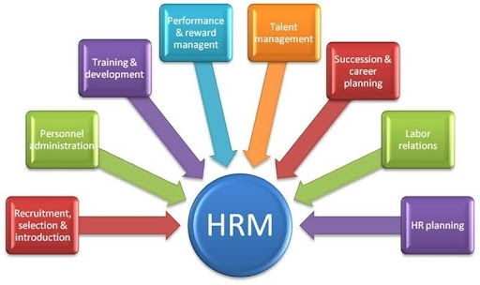
Cont…

Communication skills Empathy Confidence Collaboration Equality and diversity Recruitment skills

Cont…

Knowledge regarding formulation of policies on working conditions management, performance management, equal opportunities, disciplinary processes and absences

Knowledge regarding staff handbooks, payroll and other payroll issues (including promotions and benefits), conducting regular pay surveys.

Demonstrate behaviour that is acceptable across the departments’

Non-discriminatory behaviour towards the human resources (Alfes et al., 2019).

Maintaining transparency and trustworthiness, purpose-oriented, accountability

Courage to challenge the change.

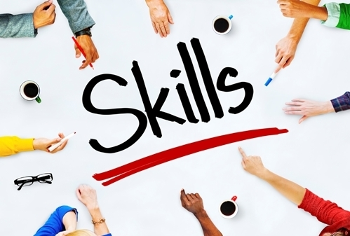
Personal skills audit

MS Word

Excel spreadsheets

Using internet, emails, and PowerPoint Communication skills
Contract drafting PowerPoint presentations Report writing Conducting training sessions Problem solving

Need for training and development

Time management creates self-discipline Creates productivity
Communication skills increase job efficiency Improves listening
Team work increases collaboration

Potential benefits of HR officer through effective training and development

Fresh mind

Effective resource utilisation Future leader
Future managers Workplace engagement Increased collaboration

Cont…

Stay up to date on changes in the industry, such as in quality standards, safety, ethics etc.

◆ Inform employees about changes in this area, such as ethical, safety or quality standards

Show UN staff new ways of thinking and working

Master the latest technology and processes and educate staff on cyber security threats.

Applying new tools in my daily work can give me better results as an employee and UN as an employer.

Conclusion

◆ HR is an important function

◆ HR develops the organisational environment

◆ Finds best fit for the job

◆ Arranges training and development for themselves and team

References

◆ Al Mamun, C.A. and Hasan, M.N., 2017. Factors affecting employee turnover and sound retention strategies in business organization: A conceptual view. Problems and Perspectives in Management, (15, Iss. 1), pp.63-71.

◆ Alfes, K., Shantz, A.D., Bailey, C., Conway, E., Monks, K. and Fu, N., 2019. Perceived human resource system strength and employee reactions toward change: Revisiting human resource's remit as change agent. Human Resource Management, 58(3), pp.239 -252.

◆ Brewster, C. and Söderström, M., 2017. Human resources and line management 1. In Policy and practice in European human resource management (pp. 51-67). Routledge.

◆ Jabbour, C.J.C., Sarkis, J., de Sousa Jabbour, A.B.L., Renwick, D.W.S., Singh, S.K., Grebinevych, O., Kruglianskas, I. and Godinho Filho, M., 2019. Who is in charge? A review and a research agenda on the ‘human side’of the circular economy. Journal of cleaner production, 222, pp.793-801.

◆ Saeed, B.B., Afsar, B., Hafeez, S., Khan, I., Tahir, M. and Afridi, M.A., 2019. Promoting employee's proenvironmental behavior through green human resource management practices. Corporate Social Responsibility and Environmental Management, 26(2), pp.424-438.

◆ Tanwar, K. and Kumar, A., 2019. Employer brand, person-organisation fit and employer of choice: Investigating the moderating effect of social media. Personnel Review.

