University of Wales Trinity Saint David
Effective Team Working and Communication
Student name: Vasilka Nikolova
Lecturer’s name: Timothy Hopkins

Introduction
- What is communication?
- Why is communication important?
- Types of communication
- Effective teamwork and communication in work
- Models of communication
- Conclusion
- References
- Appendix

- What is communication?
Communication is the act of passing on information from one person, group to another through using commonly caught on signs, images and semiotic rules. Communication is the act of passing on information from one person, group to another through using commonly caught on signs, images and semiotic rules. The method of sending and accepting messages through speech or verbal communication: writing and graphical representations such as infographics, maps and charts, signs, signals and behaviour. More basically, communication is said to be “the creation and trade of meaning.” All creatures on our word have a way to communicate and impress their feelings to one another. People use words and dialect to exchange implications that sets us from animals. Another thing that we use to communicate with others is writing, which has been a portion of the human experience for more than 5.000 a long time. In any communication there’s a sender and a receiver, a message and translations of meaning on both closes. The receiver gives feedback to the sender of the message, both amid the message’s movement and a short time later. Feedback signals can be verbal or nonverbal, such as gesturing in ascension or looking away and murmuring or other signals.

- Why is communication important?
Being able to communicate well is imperative. Having good communication skills helps in all perspectives of life from professional life to personal life and everything that falls in between. From trade point of view, all exchanges result from communication. Great communication skills are basic to permit others to get information more precisely and quickly. There are a lot of people to communicate with. This may be our family. At home with our friends and relatives who we communicate daily, there is no need for worry or anxiety. We are free to show all our feelings, worries and desires. To the doctor we went to, for our health problem, when we are ill there are many things to discuss. We must explain what exactly our problem is and help our doctor understand what we want from him. This may be difficult when we must explain this detail in foreign language. At work, we must get along well our colleagues, and above all with our boss. Communication is important because without it, we get unwanted problems that harm us and our workplace. I work at a McDonald’s in central London. I interact with many and different people every day at work. Some of them do not speak English at all and it is difficult to communicate with them, but with different facial expressions we find a way to understand each other. It is important to have an understanding and communication outside as well. Every day we travel to school or work, take our child for a walk, or just shop at a nearby supermarket. We need to understand what the person we are contacting wants from us and be able to respond.

- Types of communication
There are some types of communication we use every day: verbal, nonverbal, written and visual. There are a few different ways we share information with one another. It can be face to face or talking on the telephone. There is formal verbal communication as meeting in the office and informal as chatting with our friend or family. In any case of the sort, it isn’t around the words, it is additionally around the calibre and complexity of those words, how we string those words together to make a message, as well as the sound for example our tone or pitch. We use verbal communication when sharing presentations with our team in workplace, speak with someone and discuss different things. Particularly when presenting information to some or a group of people, we must use strong voice so everybody can effectively listen us. We must be confident when talking so that our thoughts are clear and simple for others to get it. Another way of using verbal communication is listening and hearing others. Active listening skills are key in presentations, meetings or even taking part in a one on one discussion. Doing that we develop our self as a communicator. Active listening in any case, is maybe one of the most critical types of communication because if we cannot listen and understand the person we are talking with, we cannot give effective feedback. Nonverbal communication is the using of body language, motions and facial expressions to communicate with another person. Nonverbal communication helps us understand the real thoughts and feelings of others. What we do when we talk usually says more than the real words. Nonverbal communication includes facial expressions, pose, eye contact, hand movements, touch, smile. For example, if someone is showing “closed” body language such as crossed arms or legs, they could be feeling anxious, angry or nervous. In case he is showing “open” body language with both feet on the floor and arms by their side or on the table, they are likely feeling positive and open for information. We can use our nonverbal communication to support our verbal communication, that way we can be very confident in what we say. We might use written communication when we are applying for a work or sending e-mail or just write our assessment. Writing communication is the act of writing or printing symbols like letters and numbers to give information. It gives us a record of information for reference. Writing is using in books, blogs, letters and more. In visual communication we use photos, graphs for giving information. Visuals are usually used for presentations to support our written and verbal communication. We have different learning styles visual communication may be more supportive for a few to expend thoughts and information. People use visual communication by television, videos, images, Promoters uses visual communication by imagery to offer items and ideas.

- Effective teamwork and communication in work
Good and successful communication is a basic instrument in achieving efficiency and keeping up strong, enduring working connections at all levels of an association. Managers who invest time and vitality into getting clear lines of communication with quickly construct believe among employees, driving to increments in efficiency and resolve in common. Poor communication within the work environment, due to personal reasons or a need of adequate innovation, will lead to unmotivated, ill-informed staff which will start to address confidence in their capacities. Nowadays using technology is important for effective communication in businesses. Through e-mail we hold things below control about ours projects. Organize meetings and input changes for which everyone is informed. Video communication gives the opportunity to have face to face discussions with groups from other workplaces and even other countries. Video discussions gives successful collaboration allow our staff to induce to know each other way better, instead just a voice on the phone. Effective communication within the workplace is a necessarily part of business development and collaboration between professionals. If we want our group or team to develop, we must get in touch with an expert who can find online and he can give us a shortlist of candidates that fit well in our business.

5, Models of communication
Sannon and Weaver Models of communication are models clarify the process of communication. The first example was created in 1948 by Claude Elwood Shannon and distributed with a presentation by Warren Weaver. Taking after the basic concept communication is the method of sending and accepting messages or exchanging information from one(sender) to another(receiver). Shannon and Weaver model demonstrate contains five elements: information, source, transmitter, channel, receiver and destination. The information source is where the information is put away. The message is encoded into signals, so it can travel to its goal. After the message is encoded, it goes through the channel which the signals are adapted for the transmission, goes to the receiver and finally to the destination. If the channel carries any noise or obstruction, that might give to the receiver different information.

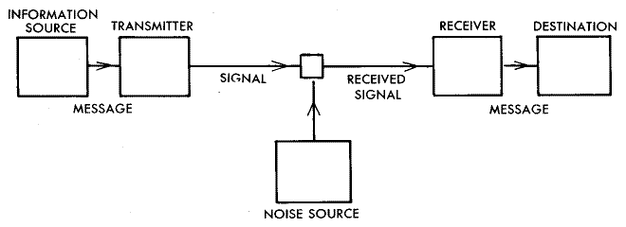

I can give an example for Shannon and Weaver in my life. I work in a fast food store, there are many different people with different desires every day. One day we had new promotions and one of my colleagues I worked with had to explain them to me. He showed me a brochure that had all the information I needed. A client came to me. He wanted exactly this promotion, I told him exactly what it included, but he did not hear and did not understand the price of the menu he had chosen because of the many noise and people around us. Upon payment we found that there was a misunderstanding and I had to repeat the whole order. He understood and agreed to the price and took his order. My boss came to me and recommended to speak loud and clear to the customers and before payment repeat the entire order to make sure I was understood. In this situation the information is the promotion we had, I was the transmitter, the noise was the people around us, the receiver was the costumer and finally the misunderstanding as a destination.

Schramm Model
Within the Osgood Schramm demonstrate, messages travel back and forward between the sender and the receiver. In this way, the sender can deliver one message and after that become the receiver, getting a message. The Osgood Schramm model has benefits and disadvantages. Within the advantage category, it gives a clear approach to communicating, with sender and receiver exchanging parts back and forward in a circular design. This permit both parties to contribute similarly and share their feedback, which acts as confirmation that the message has been gotten and decoder. As a negative this communication model is in some cases impaired by semantic noise and misunderstanding that cause a message to be translated differently than it was planning. This explain why we will say the same thing to two people, and they can understand what we said totally in an unexpected way. One of the greatest points of this model is the translation perspective of the communication. It relies on one to one communication instead of different members.

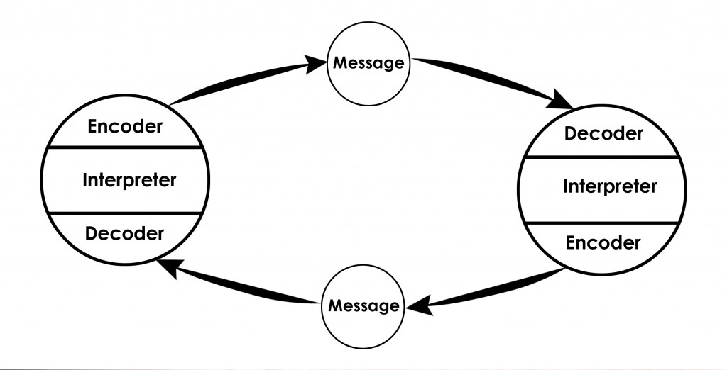

Berlo’s model
In 1960 David Berlo shows factors affecting the person components within the communication making the communication more efficient. The model also centres on encoding and decoding which happens before send the message and before receiver gets the message respectively. Berlo’s Model has basically, four components to explain the communication process. They are sender, message, channel and receiver. Each of the component is affected by a lot of factors. There is no concept of feedback, so the impact isn’t considered. There is no concept of communication process, it may be a straight model of communication, there’s no two-way communication. Both sights must be comparative to all the factors said over.



6. Conclusion
Nowadays we depend on sharing information and having good communication skills is important. Good verbal, nonverbal and written communication skills are basic in order to provide and get information quickly and precisely. Being able to communicate effectively may be an imperative life skill and should not be overlooked. Good communication progresses groups, motivates and upgrades the working environment culture. Communication may be a two-way process, so we must be careful on other people’s verbal and nonverbal signals as well as our owns. By instructing our self how to communicate more effectively, we will be connected in a more useful and productive way, making the workplace a positive environment.

7. References
By Nordquist R. online 2019 What is communication? The Art of Communicating and How to Use it Effectively
Available at https://www.thoughtco.com/what-is-communication-1689877
Accessed 05/01/20
N.K. online Available at https://www.caresearch.com.au/caresearch/tabid/1095/Default.aspx
Accessed at 05/01/20
N.K. 2019 online Career Guide
Available at https://www.indeed.com/career-advice/career-development/types-of-communication
Accessed 06/01/20
By N.K. 2018 Berlo’s SMCR Model of communication online
Available at Connectivitycheck.platform.hicloud.com
Accessed at 07/01/20
By Page M. The importance of good communication online
Available at https://www.michaelpage.co.uk/advice/management-advice/development-and-retention/importance-good-communication
Accessed 05/01/20
By Willkomm A. 2018 Five types of communication online
Available at https://drexel.edu/goodwin/professional-studies-blog/overview/2018/July/Five-types-of-communication/
Accessed at 06/01/20

- Appendix



