Red Riding Hood; Contemporary visual artist and how they subvert our normal understanding of the story
Word count: 2,505
Harlow Harper-2404710
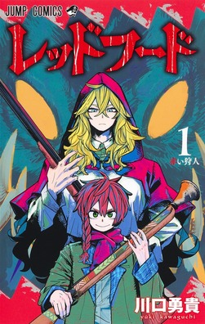
Fig. 1, Kawaguchi 2022

The story of little red riding hood a familiar tale to all it’s been around for centuries, starting as oral telling’s that date back over 3000 years ago. The story has evolved over the years with hundreds of different versions, translations and adaptations, but the moral staying the same is a warning to the dangers and deception of strangers. Ultimately the story must change to suit today’s audience with their more complex palettes for media wanting more representation and relatability (Gracey, 2017) . The focus of this essay is on the comparison of this classic story to a recent reinterpretation and how each character has changed, with little red changing from being the damsel who needs saving to a strong independent woman capable of keeping herself safe and protecting those around her, as well as the similarities within these characters and their origins. In particular, how the art forms emphasize the role of women in the narrative through character design.

The Hunters Guild Red Hood by Yuki Kawaguchi first published in 2022 and follows Velou, a young boy who wants to do everything he can to protect his village from werewolves. Already this starts off different from the classic tales as it doesn’t follow from red riding hoods perspective. The leader of Velou’s village, the mayor, hires a Hunter to get rid of the wolves, and we are then introduced to this version of Red a hunter named Grimm. Her first appearance is the regular child with the giant red cape confirming this is our red riding hood as well as giving her a name which isn’t said in any of the old tales, already giving her character depths. Later we see her as a very mature grown woman. From this point the story follows the same key points as the classic stories, going through the woods to granny’s house and being eaten, but each step has a twist. Going through the woods we don’t meet the wolf head on but instead things leading the path to the old ladies house, such as a scream, claw marks on the trees and blood leading to the home, putting Grimm’s character in a setting where they are hunting the wolf rather than being hunted. Entering they find a pile of blood and bones suspected to be the mayors. The grandmother shows herself as the wolf, mocking Grimm and Velou. The classic lines are then brought up but not from Grimm, instead the old lady asks and answers mocking them both in an eerie and terrifying scene “Why is my mouth so big you ask?... all the better to eat you up my dears!”(Kawaguchi, 2022) as she picks up Grimm and eats her. The structure of the classic stories is noticeable with Velou following after splitting the wolf’s belly with the axe, the narrative shifts with it’s own story revealing that Grimm intentionally allowed herself to be swallowed in order to plant explosives hidden within her basket. This action by Grimm reframes the readers viewpoint of the helpless Red Riding Hood, as a strategic and capable hunter. Following the wolf’s defeat, the story diverges from its classic origins and establishes its own narrative, with Grimm inviting Velou to join the Hunters Guild.
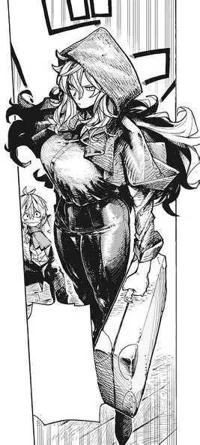
Fig.2 , Kawaguchi 2022

In this retelling Grimm is vastly different. She is given a name, compared to the originals where she is just called little red based on her cape, as she is called Grimm already, this gives more character and allows the reader to relate to her making her more human as she is given unique individual details rather than being general stereotype of a woman(Tater, 2002). She isn’t as naive or childish, instead she comes across quite cold and speaks with a responsible yet wise tone, not really acting like a child at all. At the end of the book it is revealed that she is actually an adult but cursed to be stuck in a child’s body, but does have a device that allows her to temporarily be her normal age from time to time. Her Younger appearance looks very friendly and inviting, her cape fully covering her with only her feet and face showing. When the hunter shows up she’s perceived as childlike and inexperienced for the job, she doesn’t look strong enough to deal with the wolves troubling the villagers, puzzling everyone in the scene and vastly underestimating what Grimm is capable of (Kasaix, 2022). However later when we see her older appearance she has a cold and calculated demeanour, matching better with her personality. Compared to the older tales this version of red riding hood is independent and capable of quick thinking and protecting herself and others, the kind of traits discussed by Zipes (1993). Our little red in Charles Perrault's story is described as" pretty creature" within the first sentence which feels off as it makes her character a thing or object from the start. Through his story we don't get much depth or personality just a girl with a red cloak, this almost feels deliberate on his part so the reader doesn't feel much empathy for Little Reds end. Charles Perrault’s story follows the key points of the classic story, however changing the story with misogynistic viewpoints and making Red out be at fault for her demise the original story have red be stupid enough to trust the wolf (Evans, 2011)…. The moral of his story is that “girls who allow strange men into there homes are responsible for their fate (Gracey, 2017) blaming girls for consequences out of there control and suggesting they should not lean into their own sexual desires, being young and naive yet asking for it as horrible actions follow after. His work was critiqued as being misogynistic and not true to the moral and stories of little red riding hood. Grimm is depicted not naive and isn’t reliant on the male characters in the story and isn’t blamed for any of the problems that emerge in the story. She offers to help those who can’t protect themselves without judging. Fighting against Charles Perrault’s morals Kawaguchi gives depths and layers to Grimm and his other female characters which is something Charles Perrault desperately lacks.
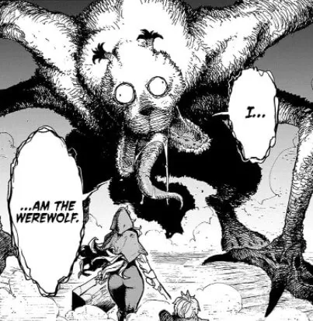
Fig. 3, Kawaguchi 2022

However with the wolf there's much more to his character, described as “cunning and have a very great mind” . This gives the wolf more depth showing him as superior since he gets away with his actions with no consequence. Another thing to point out is what the wolf is symbolizing. The obvious is that of stranger danger, with both Perrault’s story and the Grimm brothers using the wolf, a sex craved beast, as a metaphor for sexually dangerous men and preying on young girls who are seen as the exact opposite such as weak and helpless (Spahr, 2014). When we’re first introduced to the wolf in Red Hood the wolf is revealed as a shape shifter, the old lady of the village. Her true form is first seen with her human face in the jaws of her wolf body looking as if she is being eaten, similar to the original story of the grandmother being eaten. The wolves in this dont look like regular wolves having a gaping mouth that splits into three parts. As reviewers note, Kawaguchi’s visual style in Red Hood is heavily surreal and exaggerated giving the creatures and monsters an abstract, wolf‑like appearance (Kasaix, 2022), seeing the other wolves that attack the village the shapes are unique to there own characters. Naraoia, being one of the wolves, is very round and a lot fluffier reflecting that she is just a child. Her brother Dodou appears taller and more triangular. They stand the same height as trees making Grimm tiny in comparison. Overall it is a terrifying amalgamation that uses body horror to scare the viewer instead of being a plain normal wolf. This version of the story does not need to include any sexual undertones about the wolves, in this version the wolves are there to intimidate or scare the reader, in modern retellings, the wolf no longer as any sexual undertones and is simply an intimidating beast, a figure of violence rather than lust (Zipes, J, 1993). Looking like a normal wolf wouldn’t work as well since this story is taking classic fairytales to the extreme, that has to reflect with the creatures they are fighting. In the original story the grandmother is shown weak and helpless since she needs help from both Red and the Huntsman just like Reds character, she needs help from the male figure and also falls victim to the wolf. However in Red Hood it challenges this making her the wolf and causing the havoc around her. She is much more independent and intelligent fooling the village into thinking she is this sweet old lady when in fact she is a bloody thirsty animal hiding behind this innocent façade . In this new telling this takes the original roles of men and completely flips it giving their power to the women.

Red riding hoods cape in classic tales is used as their main form of identification, naming her after the cape. Her cape usually represents womanhood or the innocence of women’s purity and sin, similar to what is discussed by Pass (2025). This is possibly shown, as in her child form the cape engulfs her entirely only showing her face, hidden in her cape is this façade of innocence and purity. When she is in her adult form the cape becomes smaller in comparison to her as her body is fully shown so her cape isn’t hiding her anymore as we see her true form that is far from innocent or pure as she kills the wolves. The cape seems massively relevant at the start of the story of Red Hood as the reader can immediately recognize her as little red riding hood. Though later in the story her cape has very little significance to her identity it’s not the main reason for her character but a piece that adds up to who she is. It represents her connection to the red hood guild as the founder who is called Red Hood wore a red cape. Two possible reasons could be Grimm isn’t the red riding hood of this story but filling in her spot, while Red Hood was the original Red riding hood, Grimm’s character is an admirer of Red Hood and continues on their legacy through their work for the guild. Or alternatively, Red Hood is a relative of Grimm’s, so is carrying on the name Red Hood for the hunters guild. It is unclear who exactly Red Hood is but these do seem like two very possible scenarios for the story. Grimm’s character isn’t solely reliant in this cape to be who she is, most likely she has it as a warning to those who know of the guild so has it as a statement of her work.
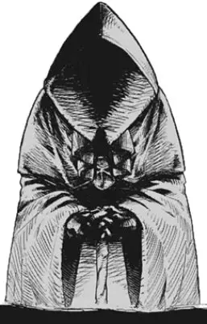
Fig. 4, Kawaguchi 2022

Looking at Grimm’s design, despite her character being quite big chested and a very feminine figure, she doesn’t seem sexualized. There isn’t at any point comments on her body or jokes made and she is wearing very demure clothing , not making her personality about her appearance. The story stays focused on driving the narrative forward. In the original story symbolism of sex and vulnerability of the body are found everywhere(Martin, 2023) with the red cape representing innocence and virginity, the wolfs intentions and decisions. Every detail had something relating back to sexuality in a away. With Yuki Kawaguchi’s story, he has these underlying messages shown very little keeping the story focused on action and horror with the touch of comedy. With sexuality, the female characters are more focused on their role in the story having high ranking jobs and independence not relying on sexist humour or fan-service to keep the viewers interested.

Velou is quite interesting, he seems to be filling the boots of the huntsman in this story but instead of being the only saviour he has help from Grimm. Visually Velou is the youngest of the cast. the style is more softer compared to the older story books. His story tells us that he wants to be a hunter to keep his village safe, and after he has done so Grimm takes him under her wing to become a Hunter at the guild. The Huntsman in the Grimm brothers tale saves both the Grandmother and Red “ A huntsman was just passing by he thought it strange that the old woman was snoring so loudly so he decided to take a look” (Grimm, 2015). The huntsman did not know of the danger in the grandmother’s house but still he shows concern for the old lady. When Velou enters the Grandmother’s house he is aware that he is entering dangerous territory not sure of the old ladies state but her husband suspected dead. He finds the Grandmother hidden in the wardrobe but is cautious as the situation in front of him seems to not add up. Velou is portrayed as observant and determined as he provides quite a bit of help to Grimm. So far the men in this book aren’t superior or beneath the woman, both genders are treated equally in terms of power and position, as we grow in a society literature shows how gender stereotypes can be challenged and offers new inspiring ways to see gender roles ( Hiremath, 2025)
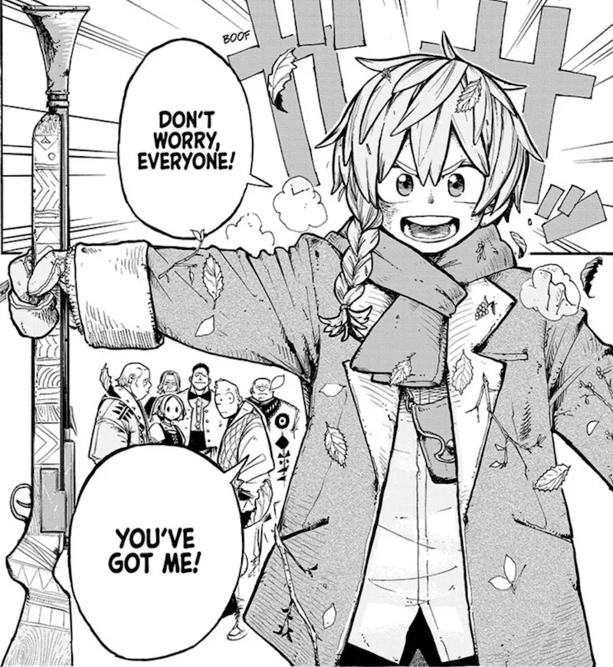
Fig. 5, Kawaguchi 2022

Within this essay it has analysed the social struggles of woman in a world dominated by wolves. Showing that in a fictional world it can display the hardships we go through in the non-fictional world, but books also have the potential to mold, change, or challenge the habits, thoughts and behaviours of the real world (Smeets, 2022). Red has been filled with personality and depth giving her a name and independence. An important role which isn’t making her the target of monsters but having her own strength to fight them. Little Red Riding hoods classic tale has served as great story telling with a cautionary tale to human beings actions and consequences. Even though the moral of stranger danger and sexuality aren't present in this story, Yuki Kawaguchi still keeps the reader's attention with deep connection between his characters and thrilling action keeping the reader on edge with their twist on the classic fairy tale's narratives. This book has made woman's roles have the same level of importance and power as the men, giving both genders equality. He has perfectly executed his point with our struggles today of equality and feminism bringing these issues to light in his work to show how as a society we can work on and diminish these problems together.
“The femenist characters recognition of her agency and her voice invariably leads to some sort of transcendants, usually taking the form of a triumph over whatever system or structure was repressing her.”
(Trites, 1997, P. 07)

Bibliography
Campbell, S. and Behan, E. (2025). Interpreting the Story and Symbols of ‘Little Red Riding Hood’. [online] Owlcation. Available at: https://owlcation.com/humanities/symbols-of-little-red-riding-hood.
Eng, M. (2025). Issue 2 www. IJRAR25B3826 International Journal of Research and Analytical Reviews, [online] 12. Available at: https://ijrar.org/papers/IJRAR25B3826.pdf?utm_source=copilot.com. .
Evans, L. (2011). Little Red Riding Hood Bites Back: A Feminist Reinterpretation. Visual Arts Research, 37(2), p.128. doi:https://doi.org/10.5406/visuartsrese.37.2.0128.
Fivush, R. and Grysman, A. (2021). Narrative and gender as mutually constituted meaning-making systems. Memory, Mind & Media, 1. doi:https://doi.org/10.1017/mem.2021.4.
Gracey, J. (2017). 50 Shades of Red: Sexuality and Loss of Innocence in Little Red Riding Hood. [online] #FolkloreThursday. Available at: https://folklorethursday.com/folktales/50-shades-red-sexuality-loss-innocence-little-red-riding-hood/.
Grimm, J. and Grimm, W. (2015). Grimm 26: Little Red Cap. [online] sites.pitt.edu. Available at: https://sites.pitt.edu/~dash/grimm026.html.
Kasaix (2022). Review: The Hunters Guild: Red Hood - Fun But Short Ride - Anime Corner. [online] Anime Corner. Available at: https://animecorner.me/review-the-hunters-guild-red-hood-fun-but-short-ride/?utm_source=copilot.com#google_vignette.
Kawaguchi, Y. (2023). The Hunters Guild: Red Hood, Vol. 2. VIZ Media LLC.Martins, J. (2023). Little Red Riding Hood and the Invisibility of Older Women. [online] juliamartins.co.uk. Available at: https://juliamartins.co.uk/little-red-riding-hood-the-menopause-and-the-invisibility-of-older-women.
Pass, J. (2025). Simply Put Psych. [online] Simply Put Psych. Available at: https://simplyputpsych.co.uk/mind-over-media/into-the-woods-a-psychological-journey-through-red-riding-hood?utm_source=copilot.com.
Perrault, C. (2003). Little Red Riding Hood. [online] sites.pitt.edu. Available at: https://sites.pitt.edu/~dash/perrault02.html.
Roberta Seelinger Trites (1997). Waking Sleeping Beauty Feminist Voices in Children’s Novels. University Of Iowa Press.Smeets, R. (2022). Actual Fictions. Cambridge University Press.Spahr, A. (2014). The Monster Within: When Red Riding Hood Becomes the Wolf. [online] Academia.edu. Available at: https://www.academia.edu/7791040/The_Monster_Within_When_Red_Riding_Hood_Becomes_the_Wolf.
Tatar, M. (2002). The annotated classic fairy tales. New York: Norton.Wegman, M. (n.d.). TRACING DESIRE: FEMALE EMPOWERMENT IN LITTLE RED RIDING HOOD. [online] Available at: https://www.wtamu.edu/_files/docs/academics/college-fine-arts-humanities/epml/Tracks%202%20Papers/4%20Wegman.pdf.
Writing Through Media. (2013). The Mischievous Wolf Theme. [online] Available at: https://share.google/rjrhTl1W2rLdJv9lc [Accessed 22 Nov. 2025].
www.royalacademy.org.uk. (n.d.). ‘And she met a great Wolf in the wood ...’ | Works of Art | RA Collection | Royal Academy of Arts. [online] Available at: https://www.royalacademy.org.uk/art-artists/work-of-art/and-she-met-a-great-wolf-in-the-wood.
Yuki Kawagichi (2022). The Hunters Guild: Red Hood, Vol. 1. VIZ Media LLC.Zipes, J. (1993). The trials and tribulations of Little Red Riding Hood: versions of the tale in a socio-cultural context. London: Routledge.

