

Name: Rajveer Rana
Student ID: 2526006
Module no: LCHS7009
Module Name: Practice Based Research
Lecturer: Dr. Zeno Leung
Programme Name: MSc in Public Health and Social care in Practice

Dental Caries and the Risk of Dental Abscess among British Asian Children Living in High-Deprivation Areas (IMD 1- 3) in England: A Systematic Literature Review Proposal

Table of Contents
1. Prevalence of the Problem 3
2. Introduction and Literature-Based Background 6
2.1 Childhood Dental Caries as a Public Health Issue 6
2.2 Oral Health Inequalities and Socioeconomic Deprivation 7
2.3 Ethnic Inequalities among British Asian Children 7
2.4 Dental Caries Progression to Dental Abscess 8
2.5 Literature Gap 8
3. Rationale 9
4. Research Question, Aim and Objectives 10
Research Question 10
Research Objective 11
01 Prevalence of Dental Caries 11
02 Dental Abscess Occurrence 11
03 Deprivation & Access Factors 12
5. Research Methodology 12
Research Design 12
PEO framework 13
Data Collection Method 14
Identification 14
Screening 14
Eligibility 14
Inclusion 15
Data Sources 17
Search Strategy 17
Exclusion Criteria 19
Data Extraction 20
Quality Appraisal 21
Data Analysis 22
7. Implications of the Research 24
8. Plan of Work and Time Schedule (Gantt Chart) 26
Conclusion 27
References 28

1. Prevalence of the Problem

Dental caries is one of the most common chronic diseases affecting children worldwide and remains a major public health challenge despite being largely preventable. According to the World Health Organization (WHO, 2025), oral diseases affect approximately 3.5 billion people globally, with untreated dental caries in primary teeth affecting over 530 million children. If untreated, dental caries can progress to pain, infection and dental abscesses, often requiring emergency treatment, hospital admission or tooth extraction under general anaesthesia (Peres et al., 2023).

In England, childhood dental caries continues to be a significant cause of preventable morbidity. The Department of Health and Social Care (DHSC, 2025) reported that 22.4% of five-year-old children had obvious dental decay in the 2024 oral health survey. Dental caries also remains one of the leading causes of hospital admissions among young children, with many requiring extractions under general anaesthesia each year (OHID, 2025).

The burden of disease is unequally distributed across the population. National data show that 37.7% of British Asian five-year-old children experience dental decay compared with 20.5% of White British children (Ethnicity Facts and Figures, 2024). Socioeconomic deprivation further increases this inequality, with children living in the most deprived areas (IMD quintiles 1-3) more than twice as likely to experience untreated dental caries than those in the least deprived communities (Marmot et al., 2020; DHSC, 2025). Consequently, British Asian children living in deprived areas represent a high-risk population for poor oral health outcomes. Addressing these persistent inequalities is essential to improve child oral health and reduce preventable complications through targeted public health interventions and equitable access to preventive dental services.

Source (Ethnicity and Figures, 2024)

2. Introduction and Literature-Based Background

Oral health is an essential component of overall health, wellbeing and quality of life. Good oral health enables children to eat, speak and socialise without pain, while poor oral health negatively affects nutrition, sleep, education and psychosocial wellbeing (WHO, 2025). Childhood oral diseases can also have lifelong consequences.
Dental caries is a multifactorial, biofilm-mediated disease caused by repeated acid attacks following frequent consumption of fermentable carbohydrates. It is recognised as a non-communicable disease sharing common risk factors with obesity, cardiovascular disease and type 2 diabetes, including excessive sugar intake, unhealthy lifestyles and socioeconomic disadvantage (Pitts et al., 2021). Prevention therefore requires both clinical and public health approaches.

2.1 Childhood Dental Caries as a Public Health Issue

Despite improvements in preventive dentistry, childhood dental caries remains one of the most common chronic diseases worldwide (Peres et al., 2023). In England, it continues to be a leading cause of preventable hospital admissions for tooth extractions under general anaesthesia (OHID, 2025). Untreated caries causes pain, infection, disturbed sleep, eating difficulties, poor school attendance and reduced quality of life, making prevention a national public health priority (Pitts et al., 2021).

2.2 Oral Health Inequalities and Socioeconomic Deprivation

Childhood dental caries follows a clear social gradient. Health outcomes are strongly influenced by social determinants such as income, education, housing and healthcare access (Marmot, 2020). Children living in IMD quintiles 1-3 experience poorer oral hygiene, higher sugar consumption, irregular dental attendance and reduced access to preventive services (DHSC, 2025). Limited oral health literacy, transport barriers and difficulty accessing NHS dental care further contribute to persistent inequalities (Watt, 2023).

2.3 Ethnic Inequalities among British Asian Children

British Asian children experience higher levels of untreated dental caries than many other ethnic groups in England (Ethnicity Facts and Figures, 2024). However, these disparities are primarily associated with wider social and structural determinants rather than ethnicity itself. Socioeconomic disadvantage, language barriers, limited oral health literacy, reduced access to culturally appropriate services and dietary practices all influence oral health outcomes (Goodwin et al., 2023; Moynihan and Kelly, 2021). Current evidence therefore supports culturally tailored interventions while avoiding cultural stereotyping.

2.4 Dental Caries Progression to Dental Abscess

Untreated dental caries progresses from enamel demineralisation to dentine and pulp infection, potentially resulting in irreversible pulpitis, periapical infection and dental abscess (Pitts et al., 2021). Dental abscesses can cause severe pain, facial swelling, fever and eating difficulties, often requiring emergency treatment or extraction under general anaesthesia, increasing emotional distress and NHS costs (OHID, 2025).

2.5 Literature Gap

Although extensive research has examined childhood dental caries, socioeconomic deprivation and ethnic inequalities separately, few studies explore how British Asian ethnicity and deprivation (IMD quintiles 1-3) interact to influence progression from dental caries to dental abscess. Evidence on culturally appropriate preventive strategies for this population also remains limited. Therefore, a systematic literature review is needed to synthesise existing evidence, identify knowledge gaps and inform future research, public health policy and targeted interventions to reduce oral health inequalities in England.

3. Rationale

Childhood dental caries remains one of the most common preventable diseases in England, disproportionately affecting British Asian children living in deprived communities (DHSC, 2025). Untreated caries can progress to dental abscesses, causing pain, infection, poor nutrition, reduced school attendance and hospital admissions, increasing pressure on NHS services (OHID, 2025). Although studies have linked deprivation and ethnicity with poor oral health (Marmot et al., 2020; Watt, 2023), limited evidence examines how these factors interact to influence progression from dental caries to dental abscess. A systematic literature review is needed to identify evidence gaps and inform targeted public health interventions and preventive strategies.

4. Research Question, Aim and Objectives

Research Question

What evidence exists regarding the relationship between dental caries and the risk of dental abscess among British Asian children living in high-deprivation areas (IMD 1- 3) in England?

Research Aim

To systematically review and critically evaluate the published evidence regarding the relationship between dental caries and the risk of dental abscess among British Asian children living in high-deprivation areas (IMD 1-3) in England.

Research Objective

01 Prevalence of Dental Caries
To determine the prevalence of dental caries among British Asian children living in deprived areas of England (IMD 1-3).

- Identify caries rates by age group
- Compare across ethnic sub-groups
- Map geographic distribution

02 Dental Abscess Occurrence
To examine the occurrence of dental abscesses associated with untreated dental caries in British Asian children.
- Track progression from caries to abscess
- Identify emergency treatment rates
- Asses hospital admission patterns

03 Deprivation & Access Factors
To explore relationship between deprivation (IMD), oral behaviours and access to NHS dental services.

- Analyse NHS registration rates
- Examine dietary and hygiene behaviours
- Explore socioeconomics barrries

5. Research Methodology

Research Design

This study will adopt a systematic literature review (SLR) to identify, evaluate and synthesise evidence addressing the research question (Page et al., 2021). Unlike narrative reviews, an SLR follows a structured, transparent and reproducible methodology, reducing selection bias and improving methodological rigour. As the study aims to synthesise existing evidence rather than collect primary data, this approach is appropriate for examining childhood dental caries, dental abscess risk, ethnicity and socioeconomic deprivation. The review will follow PRISMA 2020 guidelines to ensure transparent and comprehensive reporting (Page et al., 2021).

PEO framework
Because this research investigates associations rather than interventions, the PEO (Population, Exposure, Outcome) framework is considered more appropriate than PICO.

Population (P) | British Asian Children (0-16) living in England
Exposure (E) | Living in high-deprivation areas (IMD 1-3), poor oral hygiene, high sugar intake, limited access to NHS dental services
Outcome (O) | Dental caries and progression to dental abscess

Data Collection Method

The literature search will follow the PRISMA 2020 protocol.

The review process will include four sequential stages:

Identification

Relevant studies will be identified through comprehensive searches of selected electronic databases using predefined search terms.

Screening

Duplicate records will be removed before titles and abstracts are screened against predefined eligibility criteria.

Eligibility

Potentially relevant full-text articles will be critically assessed to determine whether they satisfy the inclusion criteria.

Inclusion

Studies meeting all eligibility requirements will be included within the final review and subjected to detailed critical appraisal and data extraction.

The PRISMA flow diagram will be used to document the number of studies identified, excluded and included throughout each stage of the review process, thereby enhancing methodological transparency (Page et al., 2021).

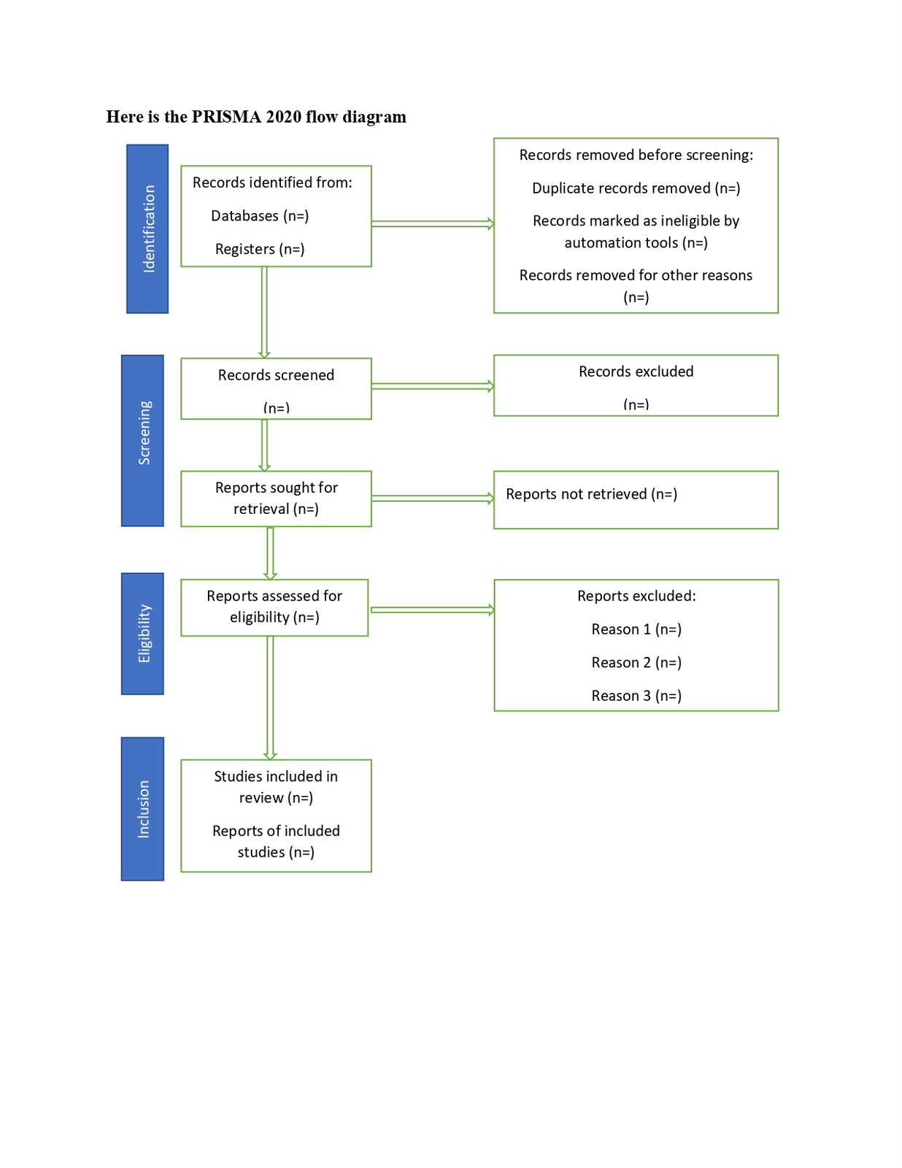

Data Sources

Electronic databases will include:

- PubMed/MEDLINE
- Scopus
- CINAHL Ultimate
- Web of Science
- Cochrane Library
- Google Scholar (for supplementary searches)
- NHS Evidence
- Office for Health Improvement and Disparities (OHID)
- World Health Organization (WHO)

Search Strategy

The search strategy will combine Medical Subject Headings (MeSH) and free-text keywords using Boolean operators (AND, OR).

Example search terms include:

Dental caries
Tooth decay
Dental abscess
British Asian
South Asian
Children
Paediatric
Oral health inequalities
Ethnicity
Socioeconomic deprivation
Index of Multiple Deprivation
England
NHS dental services

An example search string may be:

(“Dental caries” OR “tooth decay”) AND (“Dental abscess”) AND (“British Asian” OR “South Asian”) AND (“Children”) AND (“England”) AND (“Socioeconomic deprivation” OR “Index of Multiple Deprivation”).
Inclusion Criteria

Studies will be included if they:

- are published in English;
- were published between 2015 and 2026;
- involve children aged 0–16 years;
- examine dental caries or dental abscess;
- investigate British Asian or South Asian children, or include ethnicity-specific findings relevant to England;
- investigate socioeconomic deprivation or IMD;
- are peer-reviewed quantitative, qualitative or mixed-methods studies, systematic reviews or national reports.

Exclusion Criteria

Studies will be excluded if they:

- focus exclusively on adults;
- are conducted outside contexts that are not transferable to England;
- investigate unrelated oral diseases;
- are editorials, conference abstracts, opinion articles or unpublished theses;
- lack sufficient methodological quality.

Data Extraction

A standardised data extraction form will be developed to ensure consistency.

The following information will be extracted:

- Author(s)
- Year of publication
- Country
- Study design
- Population characteristics
- Sample size
- Oral health outcomes
- Risk factors identified
- Main findings
- Strengths and limitations
- Overall quality assessment

Using a structured extraction form will reduce reviewer bias and facilitate comparison across studies.

Quality Appraisal

The methodological quality of included studies will be assessed using recognised critical appraisal tools.

Depending on study design, appropriate instruments from the Joanna Briggs Institute (JBI) or the Critical Appraisal Skills Programme (CASP) will be used. These tools evaluate methodological quality, risk of bias, sampling, validity, reliability and applicability of study findings.

Quality assessment will strengthen the credibility of the systematic review by ensuring conclusions are based upon robust evidence.

Data Analysis

A thematic analysis approach will be used to synthesise findings because the included studies are expected to vary considerably in design, populations and outcome measures.

Following Braun and Clarke’s six-phase framework, data will be coded before being organised into broader analytical themes. Potential themes may include:

- prevalence of dental caries;
- progression from caries to dental abscess;
- socioeconomic deprivation;
- ethnicity and cultural influences;
- oral health behaviours;
- access to NHS dental services; and
- preventive interventions.

Thematic synthesis will enable comparison of findings across quantitative and qualitative studies while identifying consistent patterns, contradictions and gaps within the current evidence base.

6. Ethical Considerations

Although this study will not involve direct interaction with human participants, ethical considerations remain essential to ensure research integrity. As this is a systematic literature review, no primary data or identifiable personal information will be collected; therefore, NHS Research Ethics Committee approval is unlikely to be required. Where necessary, approval will be obtained from the university’s research ethics committee.

The review will include only publicly available evidence from peer-reviewed journals and reputable organisations, including the WHO, OHID, DHSC and NHS England. Academic integrity will be maintained through accurate Harvard referencing to avoid plagiarism (BERA, 2024). To minimise bias and ensure transparency, the review will follow PRISMA 2020 guidelines with predefined search strategies, eligibility criteria and data extraction methods (Page et al., 2021). Included studies will be critically appraised using the CASP checklist, and findings will be reported objectively while recognising the influence of socioeconomic, behavioural and healthcare factors on oral health inequalities (Watt, 2023).

7. Implications of the Research

This systematic literature review has the potential to contribute to public health practice, oral health policy, clinical practice and future research. By examining the relationship between childhood dental caries, dental abscess, British Asian ethnicity and socioeconomic deprivation, the findings may help explain persistent oral health inequalities in England.

From a public health perspective, the review may support the development of culturally appropriate oral health promotion programmes tailored to British Asian communities. Such interventions could address language barriers, health literacy, dietary practices and access to preventive services through schools, community organisations and primary healthcare settings (Goodwin et al., 2023).

The findings may also inform NHS service planning by identifying barriers to preventive dental attendance among children living in deprived areas. This evidence could support improved resource allocation, expansion of community dental services and greater access to routine preventive care. Earlier identification of high-risk children may reduce progression from dental caries to dental abscess, lowering hospital admissions, treatment under general anaesthesia and healthcare costs.

From a policy perspective, the review may strengthen national oral health strategies and guide initiatives led by OHID, NHS England and local authorities. It will also identify gaps in the current evidence, particularly regarding the combined effects of ethnicity, deprivation and disease progression, providing recommendations for future research and evidence-based decision-making to reduce oral health inequalities.

8. Plan of Work and Time Schedule (Gantt Chart)

Activities | Month 1 | Month 2 | Month 3 | Month 4
Research Proposal approval | 
Develop Review Article
Develop search strategy
Database searching
Title and abstract screeing
Full text screening
Quality appraisal
Data Extraction
Data analysis
Writing Findings
Editing and Proof reading
Final Submission

Conclusion
Childhood dental caries remains a major public health challenge in England, particularly among British Asian children living in socioeconomically deprived communities, where the risk of dental abscess and other complications is substantially higher. This systematic literature review will synthesise existing evidence on the relationship between dental caries and dental abscess using a rigorous PRISMA 2020 methodology to identify current knowledge and evidence gaps. The findings are expected to support public health policy, inform culturally appropriate preventive strategies and improve equitable access to NHS dental services. By providing a stronger evidence base, the review may contribute to the development of targeted interventions that reduce oral health inequalities and improve oral health outcomes for vulnerable British Asian children in England.

References

1. BERA (2024) Ethical Guidelines for Educational Research. 5th edn. London: British Educational Research Association. Available at: https://www.bera.ac.uk/publication/ethical-guidelines-for-educational-research-2024 (Accessed: 19 July 2026).
2. Braun, V. and Clarke, V. (2006) ‘Using thematic analysis in psychology’, Qualitative Research in Psychology, 3(2), pp. 77–101. Available at: https://doi.org/10.1191/1478088706qp063oa (Accessed: 19 July 2026).
3. Department of Health and Social Care (DHSC) (2025) National Dental Epidemiology Programme for England: Oral Health Survey of 5-Year-Old Children 2024. London: DHSC. Available at: https://www.gov.uk/government/collections/national-dental-epidemiology-programme (Accessed: 19 July 2026).
4. Ethnicity Facts and Figures (2024) Oral health and dental decay among children by ethnicity in England. Available at: https://www.ethnicity-facts-figures.service.gov.uk (Accessed: 19 July 2026).
5. Goodwin, M., Pretty, I.A., Tickle, M. and Watt, R.G. (2023) ‘Reducing oral health inequalities among children: culturally appropriate approaches to prevention’, British Dental Journal, 235(4), pp. 285–291.
6. Marmot, M., Allen, J., Boyce, T., Goldblatt, P. and Morrison, J. (2020) Health Equity in England: The Marmot Review 10 Years On. London: Institute of Health Equity. Available at: https://www.instituteofhealthequity.org/resources-reports/marmot-review-10-years-on (Accessed: 19 July 2026).
7. Moynihan, P. and Kelly, S. (2021) ‘Effect on caries of restricting sugars intake: systematic review’, Journal of Dental Research, 100(6), pp. 561–568. Available at: https://doi.org/10.1177/00220345211006216 (Accessed: 19 July 2026).
8. Office for Health Improvement and Disparities (OHID) (2025) Oral Health Profile for England. Available at: https://fingertips.phe.org.uk/profile/oral-health (Accessed: 19 July 2026).
9. Page, M.J., McKenzie, J.E., Bossuyt, P.M., et al. (2021) ‘The PRISMA 2020 statement: an updated guideline for reporting systematic reviews’, The BMJ, 372, n71. Available at: https://www.bmj.com/content/372/bmj.n71 (Accessed: 19 July 2026).
10. Peres, M.A., Macpherson, L.M.D., Weyant, R.J., et al. (2023) ‘Oral diseases: a global public health challenge’, The Lancet, 402(10398), pp. 249–260. Available at: https://doi.org/10.1016/S0140-6736(23)01296-0 (Accessed: 19 July 2026).
11. Pitts, N.B., Twetman, S., Fisher, J. and Marsh, P.D. (2021) ‘Understanding dental caries as a non-communicable disease’, British Dental Journal, 231(12), pp. 749–753. Available at: https://www.nature.com/articles/s41415-021-3775-4 (Accessed: 19 July 2026).
12. Watt, R.G. (2023) ‘Addressing oral health inequalities: implications for public health policy and practice’, Community Dentistry and Oral Epidemiology, 51(5), pp. 657–664.
13. World Health Organization (WHO) (2025) Oral Health. Available at: https://www.who.int/health-topics/oral-health (Accessed: 19 July 2026).

