Chef
- Prezzo
- Baulmsholme, Northampton (NN1), NN1 2DA
- Published: 9 hours ago
- £12.88 - £13.39 / hour



ChefPrezzo
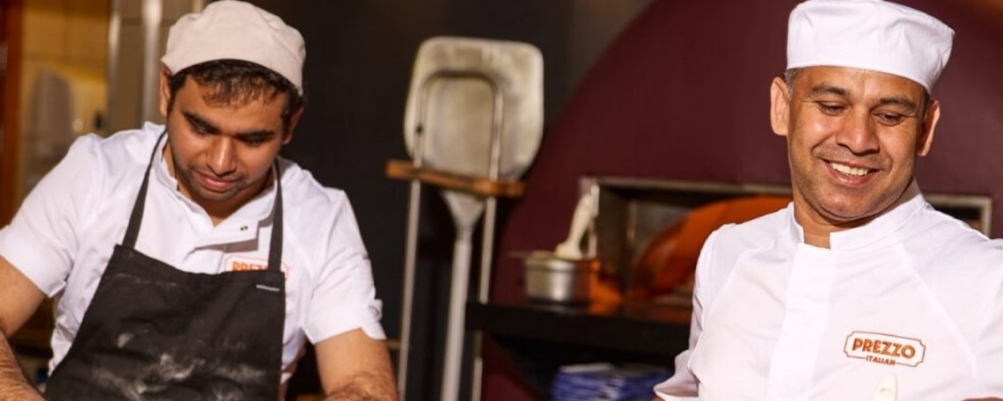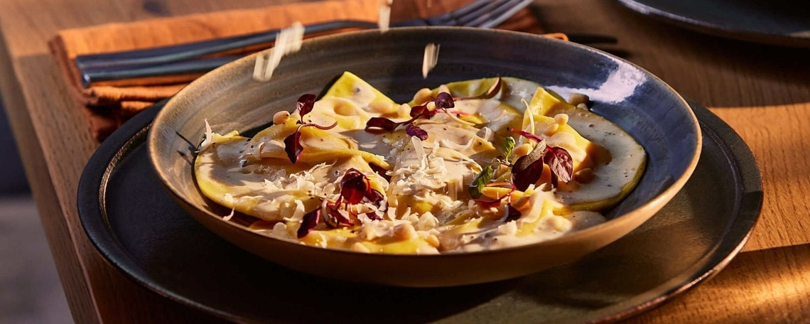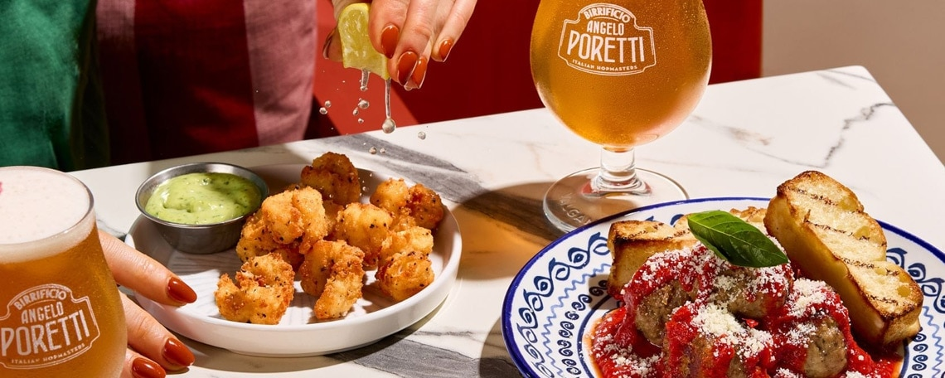
Love Food? Bring the Heat to Prezzo!
Line Chef | Up to £13.39 per hour + Tronc & Perks
At Prezzo, we don’t just cook—we create "Hospitality Magic." We’re looking for high-energy, food-obsessed Chefs to join our incredible, like-minded kitchen team. If you want to bring your personality to every shift, have fun, and work with a team that truly has your back, you belong here.
Why Prezzo Italian?
- Perks that Matter: Free meals on shift, your birthday off, and wellbeing support.
- Big Discounts: 50% off food for you and your favourite people.
- Get Paid Your Way: Access your earned wages early via Wagestream.
- Level Up: Clear paths Chef Accreditation Programme — earn bronze, silver or gold status (and extra pay + prizes)
- The Extras: Pension, life assurance, and exclusive retail rewards.
The Role
You’re the heartbeat of the kitchen. You’ll work with a passionate team to send out plates filled with pride. Whether you're mastering a new section or smashing a busy service, you’ll do it with energy, speed, and a supportive team cheering you on.
What You’ll Bring:
- Pure Energy: You thrive when the kitchen is buzzing and the tickets are flying.
- Team Spirit: You’re a positive, like-minded pro who loves working with others.
- Heart & Soul: You take pride in every dish and love making guests smile.
- The Basics: Experience in a fast-paced kitchen and a "can-do" attitude.
Ready to bring your passion to a team that celebrates you? Apply now.

COVER LETTER:

Dear Hiring Manager,

I am writing to express my interest in the position available within your company. With over eight years of experience in the hospitality and food service industry, I have developed strong leadership, operational, and customer service skills that allow me to thrive in fast-paced environments.

I am currently working as a Kitchen Supervisor at Tortilla in Bluewater, where I oversee daily kitchen operations, ensure compliance with food safety and hygiene standards, manage stock levels, delegate tasks, and support the development of team members. Prior to this, I held supervisory roles at Wingstop and gained valuable culinary experience as a Commis Chef at Amazon's LCY3 canteen and as a Kitchen Team Member at KFC.

Throughout my career, I have consistently demonstrated reliability, adaptability, and a strong work ethic. I enjoy leading by example, motivating teams to achieve high standards, and ensuring customers receive excellent quality food and service. My experience in staff training, inventory management, health and safety compliance, and operational efficiency has prepared me to make a positive contribution to any hospitality team.

I am particularly attracted to your organisation because of its reputation for quality and commitment to excellent customer service. I am confident that my experience, positive attitude, and willingness to learn would make me a valuable addition to your team.

Thank you for taking the time to consider my application. I would welcome the opportunity to discuss how my skills and experience can contribute to your business. I look forward to hearing from you.

Yours faithfully,

Sorin Petcu

 | SORIN PETCU
Contact  Address: 62 Lunedale Road, Dartford, DA26LN  Phone: 07491737697  E-mail: keenzzo93@yahoo.com |  | About  Hardworking kitchen team member always ready to assist with diverse needs. Helps keep kitchen clean, stocked and organized for fast-paced demands.  Trained in health, safety and best practices for kitchen support. Organized and dependable candidate successful at managing multiple priorities with a positive attitude. Willingness to take on added responsibilities to meet team goals.
Key skills  Food safety and rotation  High-volume meal preparation  Head Cook deputizing  Ingredient stock control  Care staff collaboration  Chef support  Food storage safety  Stock management  Kitchen staff coordination  Inventory monitoring |  | Experience  December 2023 – Present  KITCHEN SUPERVISOR  TORTILLA – BLUEWATER (GREENHITHE)  - Met kitchen hygiene standards by preparing, implementing and monitoring routine cleaning schedules.  - Evaluated kitchen staff performance and implemented monthly targets based on results.  - Delegated daily tasks and held team accountable for task completion.  - Enforced health and safety regulations and restaurant standards by supervising food preparation.  - Conducted weekly inventories to maintain optimal stock levels for kitchen.  June 2023 – December 2023  COMMIS CHEF - CANTEEN  AMAZON – LCY3 Rennie Drive (Dartford)  - Prepared and presented innovative dishes of exceptional quality and uniformity.  - Supported senior chefs in preparing original daily menus, showcasing culinary abilities with seasonal produce.  - Supported food service in canteen environment  - Followed precise recipe cards and food preparation procedures.  March 2022 – June 2023  SHIFT SUPERVISOR  WINGSTOP – BLUEWATER (GREENHITHE)  - Gauged food preparation and portions to maintain consistency.  - Scheduled employee shifts and assigned designated tasks and duties.  - Reconciled cash drawers and prepared bank deposits.  - Monitored waste control to protect quality measures.  - Managed conflict resolutions between employees to promote a respectful workplace.  - Directed team to practice proper handling of food procedures to maintain excellent standards.  - Inspected food supplies, dishware, and flatware to verify quality.  - Assisted staff with meal service to provide customer satisfaction.  - Answered questions and resolved customer and employee complaints.  - Supervised and trained new staff to perform best practices and adhere to company policies.  Jan 2022 – March 2022  HOSPITALITY TEAM MEMBER  SHAWA – BLUEWATER (GREENHITHE)  - Created warm, friendly atmosphere through positive guest interactions.  - Prepared food while upholding strict brand standards.  - Completed housekeeping duties to maintain clean and orderly Front Of House (FOH) spaces.  - Maintained organised work spaces to keep track of inventory and offer professional first impression.  - Remained flexible to change shift patterns and cover absences with minimal notice.  - Served food and beverages, going the extra mile to deliver personalised customer service.  - Prepared food in line with recipe instructions and portioning standards.  - Guaranteed exceptional level of customer care in line with company procedures and regulations.  Dec 2017 – Jan 2022  KITCHEN TEAM MEMBER – COOK  KFC - DARTFORD  - Maintained strict food health, hygiene and safety standards for ongoing kitchen compliance.  - Cleaned and organised kitchen workstations to maintain smooth operations and minimise delays.  - Thoroughly cleaned and sanitised knives and cutting boards, storing correctly to maximise kitchen efficiency.  - Trained junior kitchen staff in food preparation and hygiene practices.  - Delivered food to highest hygiene, quality and safety standards by strictly following regulations.  - Prepared ingredients prior to service, rotating stock and storing in temperature-controlled environments to meet health requirements.  - Washed cutlery and crockery using industrial dishwashers and manual methods for pristine finish.  - Carried out regular rubbish removal, mopping and sweeping, maintaining clean kitchen environments throughout service shifts.  - Used kitchen equipment as instructed and to safety protocols.  - Trained junior staff on kitchen processes to meet food preparation standards.  - Thoroughly cleaned kitchen utensils, cookware, glassware and serving dishes, maintaining faultless hygiene and presentation standards.

Education

Economic Highschool

Craiova – Romania

- Level

Summary

Multi tasking person able to take on any required task and adapt to changing conditions with resourceful and hardworking mindset. Dedicated to business success and ready to learn more..

References

Available on request

