Effective Team Working and Communication

Executive summary
The ability to operate well in a team is critical to the success of any organisation. As a result of bad team management inside the organisation, Trinity Social Care Home employees are struggling in their jobs, placing an increasing of conflict on the organization's working environment and hampering the quality of service in this organisation. The focus of this report will be on team communication in general, as well as the many components that make it effective. This report will outline a team development model like the Bruce Tuckman team-performing model that Trinity Social Care Home may adopt to improve their team effectively. This report will also cover the benefits of having a productive team as well as the repercussions of having a dysfunctional one.

Contents
Executive summary 2
Introduction 4
How management at Trinity Social Care Home can develop an effective team 5
The impact effective team working can have in a health and social care setting 6
Barriers to effective teamwork 7
The types of roles that are needed to create a cohesive and effective team 8
Conclusion and recommendation 11
References 12

Introduction
The ability to operate well in a team is vital to the development of any organisation. A well-functioning organization's team contributes to increasing employee motivation. A successful team in health and social care settings may be developed by the HR department of Trinity Social Care Home, according to the discussion and analysis of this report. Because of the poor teamwork inside the organisation, Trinity Social Care Home's employees are having internal conflicts resulting in reduced productivity. This puts an increased amount of pressure on the organisation's personnel to replace them. The focus of this report will be on effective team coordination and communication in general, as well as the benefits and barriers relevant to this issue. This report will outline a team development model like the Bruce Tuckman team-performing model that Trinity Social Care Home may adopt to improve their team effectively (West, 2012). This report will cover the sorts of roles required to build a cohesive and productive team, as well as the necessity of taking team roles into account when hiring new employees. This report will also discuss the benefits of having a productive team as well as the drawbacks of having an ineffective one. Some suggestions will be made on how to enhance teamwork and the significance of teamwork in this report.

How management at Trinity Social Care Home can develop an effective team
A team is a collective noun referring to a group of people who have agreed to cooperate in pursuit of a shared objective. Teams can be made up of a small or big number of individuals, and they can be assigned different sorts of tasks. Participants work together on several connected activities or tasks that are critical to accomplishing certain goals. Being a member of a team necessitates contributions from all members, but the team's overall success is dependent on the group as a whole (Wilson and Edmondson, 2011). A team is made up of individuals who work together and depend on one another to achieve a common objective. The next discussion will cover the four most critical factors that are required for successful teamwork at Trinity Social Care Home.

Figure 1: Critical factors of effective teamwork (Whitcomb, 2013).
Communication
A team's ability to communicate effectively is critical to the team's success because it keeps everyone on the same page regarding the group's goals and objectives. An effective communicator is also an excellent listener, demonstrating the importance of paying attention to what the other team members have to say.
Efficiency
To build methods that allow them to work together successfully to complete a task in the time allotted, a cohesive and strong team is needed (O’rourke, 2015). Working with co-workers allows people to better understand and appreciate each other's strengths as well as the strengths of the team as a whole.
Ideas
Working in a team fosters the exchange of ideas and opinions among team members. Because it fosters trust and respect among team members, more constructive and collaborative brainstorming sessions may be achieved.
Delegation
Working as part of a team allows people to better identify the strengths and shortcomings of their co-workers (Mackin, 2014). With the support of a strong group effort, the members and the team leaders can more easily identify and distribute the many aspects of a project.

The impact effective team working can have in a health and social care setting
Trinity Social Care Home' management and organisational operation will benefit from improved teamwork in a variety of ways.

Figure 2: Impacts of effective teamwork (Kehoe, 2012).
Teamwork helps to generate fresh ideas and creativity since each team member brings a unique perspective to bear on the problem. By combining these different ideas, they can come up with a new, better solution to the situation at hand. As members of successful teamwork hard to attain better results and outcomes, effective team functioning will assist Trinity Social Care Home in enhancing their productivity (Herbert, 2012). Members of the team who work well together motivate one another, which increase productivity. Working in a team also reduces stress by distributing the task among the members. Employees that perform a lot of heavy lifting on their own often burn out. So, the teamwork of the employees of Trinity Social Care Home will help them to reduce the pressure of their workload. To motivate and raise the morale of the staff, effective teamwork is necessary. It aids in the sharing of success, which improves team motivation, as well as the sharing of failures, which encourages the development of new strategies to minimise them. When a team works well, it gives its members more influence over the project and a higher sense of pride and ownership in it (Crick, 2014). Moreover, taking a risk is easier when people are working in a team because they feel confident taking a risk. They may imagine bigger and take on more dangerous decisions because of the support and comfort they receive from the other members of the group. As a result, more creative and novel solutions are generated.

Barriers to effective teamwork
Trinity Social Care Home' unproductive and underprepared workforce has had a variety of negative consequences for the organisation due to their incapability of effective communication. Some of the barriers to effective teamwork in this organisation have been discussed below.
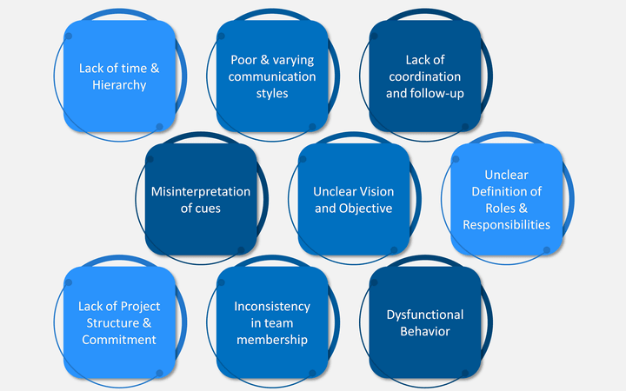
Figure 3: Barriers to effective teamwork (Abdin, 2018).
Due to the inefficiency of the Trinity Social Care Home team members, the organisation has had to deal with an increasing workload. As a result of the team members' inability to finish the assignment by the deadline, the health and social care setting suffered. Team members that do not function well together are unsure of their responsibilities and the value they provide to Trinity Social Care Home as a whole (Wilson and Edmondson, 2011). Because of this ambiguity, team members lose out on critical information, such as the altered team objectives, because the team leader fails to keep them updated. Continual conflict occurs when team members disagree on how to solve a problem, which leads to inefficient and ineffective teamwork. It has the effect of preventing them from completing their job and achieving their goals. Constant disagreement in Trinity Social Care Home has raised the team inefficiency and reduced the organisational productivity. Due to a lack of shared vision and responsibility among the team members, the service of this organisation has suffered (West, 2012). Productivity declines as a result of inefficient and ineffective teamwork in healthcare organisations. In Trinity Social Care Home, the quality of health and social care services declined, resulting in fewer people visiting the care facility as a result of ineffective and poor teamwork.

The types of roles that are needed to create a cohesive and effective team
Strength and degree of interpersonal connection between team or group members are referred to as "team cohesiveness." Members that have strong interpersonal ties are more engaged and motivated in achieving the team's goals and objectives (Whitcomb, 2013). The roles required to build a team that works well together at Trinity Social Care Home are as follows.
Developing a strategic plan
It is the responsibility of Trinity Social Care Home's management to develop a team mission and a strategic plan before assembling the various teams. Having a clear mission empowers team members to do their best work toward achieving the goal.
Diversity management
The team leader's job is to put together a diverse group of people. The members of the varied team have a wide range of backgrounds and abilities. Diversity management will help to maintain team cohesion in the working environment of Trinity Social Care Home (O’rourke, 2015).
Efficient communication
A cohesive and productive team is built on the foundation of good communication. Using a variety of efficient communication strategies is essential for the team leaders and HR managers in Trinity Social Care Home to ensure the new team is cohesive.
Proper use of individual strengths
It is the leader's responsibility to assess the strengths of the team and then give each member the work that is most closely aligned with those strengths (Mackin, 2014).
Model of team development
Bruce Tuckman's team-performing model is the approach Trinity Social Care Home may use to grow its new team. These models can be considered by this organisation since they help recognise that teams or groups have not been fully constituted and operating since they started. Tuckman's approach states that a team’s progress from being a collection of individuals to task-focused groups that work well together is vital for the productivity of an organisation (Kehoe, 2012). To conclude, Tuckman's model of team development is critical in the health and social care sector, since it facilitates group discussion on a particular issue. When it comes to creating teams to perform better, educational psychologist Bruce Tuckman has found a five-stage strategy to be quite beneficial. Trinity Social Care Home may employ these five steps to build a strong team: forming, norming, storming, performing, and adjourning.
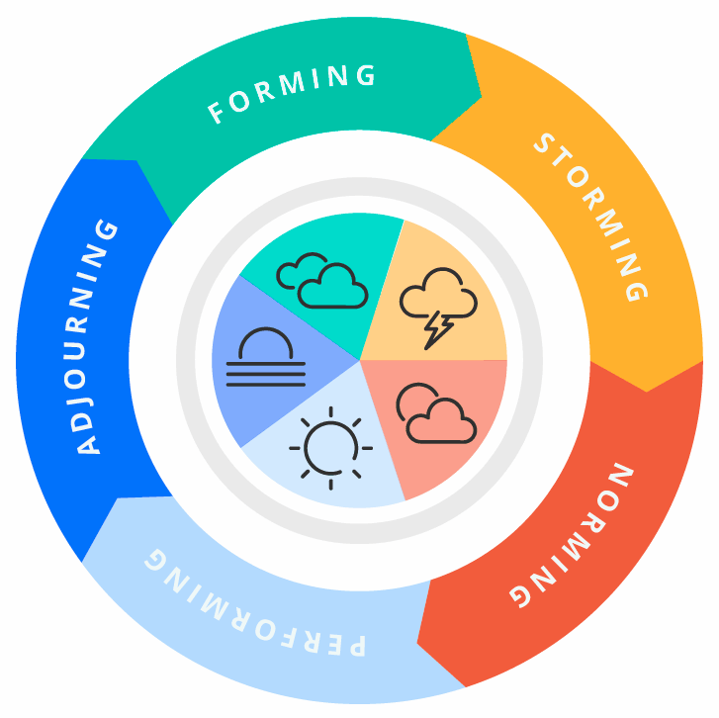
Figure 4: Bruce Tuckman team-developing model (Wilson and Edmondson, 2011)
Forming
The senior leadership team of Trinity Social Care Home can become acquainted with the new team's members during this time. The team members follow the leader's instructions and directives. At this point, they are trying to keep a professional distance from the rest of the group (West, 2012). A new team's leader is forthcoming with information and responsive to the members' inquiries.
Storming
It is the most crucial and toughest stage since each team member is trying to establish a personal image inside the group. During this stage, team performance suffers as energy is diverted to pointless endeavours (Abdin, 2018). To go beyond this stage, Trinity Social Care Home's leader must embrace the differences among all members and work through divergent opinions on the project.
Norming
It is difficult to get to the stage of norming, but once people do, they will observe a sense of togetherness among the team members. It is at this point that Trinity Social Care Home's leader or managers, as well as the responsibilities of individual members, can come to a consensus (Herbert, 2012). It is clear that as team members become more cooperative and laser-focused on the team's objectives, their level of performance rises.
Performing
If Trinity Social Care Home’s teams reach this point, the team member will agree and work with the team. A well-established, organised, mature, and well-functioning team will be part of the group. Conflicts and issues will be addressed proactively.
Adjourning
At this point, the team has effectively achieved their objectives. Wrapping up the last work and demonstrating the effort and outcomes are both important. It is clear that throughout the team's first phases of negotiation, relationships are formed and a feeling of loss is felt when those bonds are broken (Crick, 2014). At this point, the progress made by the team members is shown concerning the entire journey.

Conclusion and recommendation
So it can be concluded that effective cooperation, collaboration, communication and teamwork is critical in Trinity Social Care Home since it aids in generating new ideas, resolving issues via collaboration, raising employee morale, as well as alleviating unproductive attitude caused by the growing conflicts among the employees. This report discusses the sorts of responsibilities needed to build a cohesive and productive team, as well as the need of taking team roles into account when hiring new employees. Trinity Social Care Home’s teamwork and workplace productivity may be improved by using effective communication patterns, raising team morale, inspiring and supporting team members, and recognising their contributions.

References
Abdin, J. (2018). The Barriers of Communication & Guidance of Effective Communication. SSRN Electronic Journal.
Crick, J. (2014). Effective team communication. In Practice, 36(2), pp.96–98.
Herbert, V. (2012). Effective teamwork resulted in the best outcome for everyone. Nursing Standard, 26(44), pp.26–26.
Kehoe, D. (2012). Effective communication. North Ryde, N.S.W.: Mcgraw-Hill.
Mackin, D. (2014). The team-building tool kit: tips and tactics for effective workplace teams. New York Etc: Amacom American Management Association International, Cop.
O’rourke, J. (2015). Effective communication. London] Dorling Kindersley Limited.
West, M.A. (2012). Effective teamwork: practical lessons from organizational research. Chichester, West Sussex: Pbs Blackwell.
Whitcomb, C.A. (2013). Effective interpersonal and team communication skills for engineers. Hoboken, New Jersey: Ieee Press; Hoboken, New Jersey.
Wilson, J.W. and Edmondson, J. (2011). Effective communication. London: The Pensions Management Institute.

