University of Wales Trinity Saint David
(London Campus)

BA (Hons) Business Management

Module: Management Economics

Assessment 1

Module Code: LCBB5003
Student name: Stefania Prohnitchi
Student ID: 1917713
Submitted date: 07.09.2022

Executive Summary
Tesco is large multinational grocery company which headquarter is in Welwyn Garden City in England. The report has analysed the market demand of fresh vegetable and fruits of Tesco in the UK on the aspect of discussing market equilibrium. The report has based on the Management economics in the aspects of market demand and equilibrium. However, context has highlighted the different factors which influence the demand of products of Tesco. Price Elasticity of Demand of the products of Tesco have been described along with the factors that impacts the price elasticity.

Table of Contents
Introduction 4
Discussion about the chosen products 5
Justification for choosing products 7
Analysing the aspects that influence the Demand for the product 7
Defining Demand and Market Equilibrium 7
Price of substitutes 7
Price of complements 8
Consumer Income 8
Tastes and Preferences of the Consumer 9
Expectations of Price 9
Demographics 10
Factors influencing the Price Elasticity of Demand 11
Price Elasticity of Demand 11
Substitution Effect 12
Luxury and Necessity Products 12
Income Effect 13
Pricing Policy 13
Conclusion 15
References 16

Introduction
Management economics referred to the main aspects of applying microeconomic analysis of the business. This aspect defines all the methods which help the business to take organisational decisions. The report will analyse the business of Tesco and its products which is fresh vegetables and fruits. Along with this, the report will describe the Demand for these products in terms of analysis of and Market Equilibrium in the current days. However, different types of factors such as Consumer Income, Consumer expectations of the product prices, and Demographical aspects will be evaluated in terms of influence on the Demand for fresh vegetables and fruits. The aspects of the Price Elasticity of Demand for the products will be discussed in the report.

Discussion about the chosen products
The business is Tesco which is one of the largest general merchandise retailers and multinational grocery company in the UK. The company sells various types of products such as clothing, electronics, furniture, financial services, toys, petrol, software, vegetables, fruits and other packaged foods. The company generated around 5,788.7 crores GBP in 2021 (Tesco, 2022). The company has operated by around 367,321 employees across the world. The company is famous for retailing these products to the customers as per the market demand. However, the company sells the most of healthy foods to its customers. The USP of the company is to value the customer service efforts, offer a large range of products and turn the business operations or selling toward customer-centric. The company sells 1,600 product lines across the country. The chosen product of Tesco is fresh vegetables and fruits. However, the sales of these fresh foods are increasing day to day as people across the UK become concerned about their daily consumption (Aigner-Walder, 2015). The most sold products by Tesco are Chopped Garlic, Mixed Herbs, Adult Multi-Vitamin Raspberry, Cooked Prawns, Schwartz Turmeric and others. Apart from this, the company sells fresh vegetables and fruits to the customers.
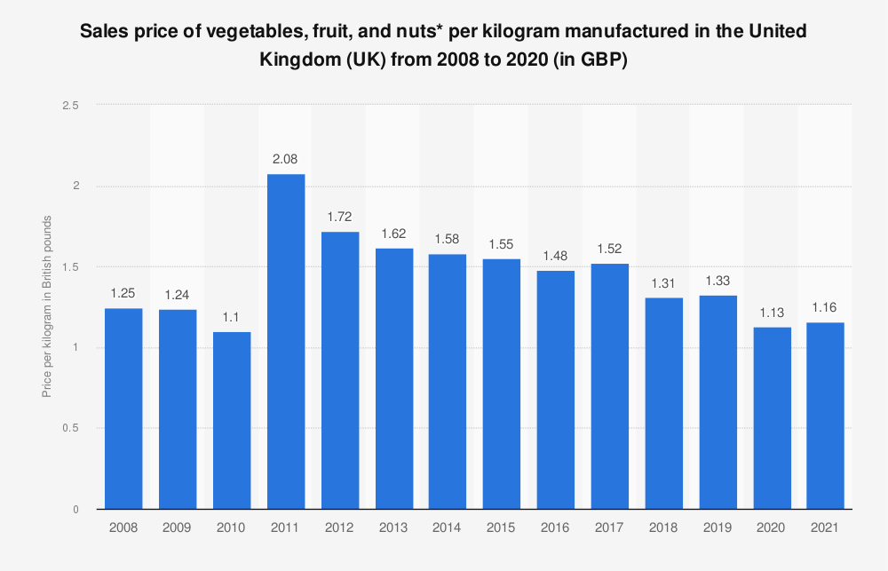
Source: (Statista, 2021)
The graph has shown that the sales price of manufacturing vegetables, and fruits were 2.08 GBP per kilogram. Whereases, the sales price of manufacturing vegetables, and fruits become 1.31 GBP per kilogram in 2018. The above graph has interpreted that the sales of fresh vegetables decreased in 2018 as of 2011 (Statista, 2021). This has happened because people cannot prepare foods with fresh vegetables due to a lack of time in their busy life. However, the sales price manufacturing of vegetables per kilogram is 1.13 GBP in 2020 and 1.16 GBP in 2021 (Statista, 2021). Because people become concerned about consuming fresh vegetables and fruits after the pandemic. People become more health concerned and maintain hygiene to protect themselves from different types of health issues. Thus, this chosen product is appropriate for analysing the market demand for food purchasing and consumption habits of UK people.

Justification for choosing products
The chosen products are fresh vegetables and fruits which will be based on analysing of Demand and Market Equilibrium. However, these fresh foods are increased day to day as people across the UK become concerned about their daily consumption. This fresh food consumption has increased after the pandemic scenario in the UK (Andreyeva et al., 2010). Along with this, this product is suitable to explore the factors that influence the demand for purchasing and consuming habits of fresh foods by the people of the UK. The influence of the Price of substitutes, tastes and preferences of customers along with their income in the present days on the demand for fresh vegetables and fruits in the market in terms of analysing market equilibrium.

Analysing the aspects that influence the Demand for the product

Defining Demand and Market Equilibrium
The demand is defining the quantity of a good that the people or customers are willing to purchase at affordable prices from the market. However, the relation between the price and demand of the number of products is highlighted in the definition of demand (Bagwell, 2005). The market equilibrium has referred the aspect of demand and supply of the products in the market. This equilibrium highlights that one business supplies the products according to the market demand to meet the requirements of consumers.

Price of substitutes
The substitute of prices defines that people in the country prefer other products in substituting the products. However, some of the customers who purchase fresh and raw vegetables and fruits cannot prepare foods with fresh vegetables due to a lack of time in their busy life. Thus, the company is preferring to set the price of this product at a reasonable cost. For this reason, people with low or moderate incomes can purchase fresh vegetables from Tesco according to their daily needs. Along with this, the low pricing strategies of the products of Tesco impact the demand of consumers in the market (Baker, 2003). After this implementation of the strategy, people are preferring to purchase fresh fruits and vegetables to maintain health consciousness.

Price of complements
The strategy of giving compliments means that the company give offers products to the customers with the main products. However, the complements with products define that company influence the customers to purchase a large quantity of products in terms of getting other complementary products (Baker, 2003). With this strategy, the company can sell large-quality products to customers to generate more profits. Thus, the complementary products strategy influences the demand of customers to purchase more products. Some of the customers spend more money to buy products unnecessarily.

Consumer Income
Consumer Income is an important factor that affects the demand for a product. The British multinational company Tesco sells fresh vegetables as well as fruits to customers which are considered necessary items that fulfil the basic needs of customers. As a result, a change in income level may not affect the demand for the product. However, the price of vegetables and fruits sold by the respective company is comparatively higher than the normal market price. Therefore, a decrease in the income of the consumer will lead to a fall in the demand for the fresh vegetables sold by the company (bbc, 2022). There was an economic slowdown during the covid pandemic when a lot of people experienced a cut down in their wages as well as lost jobs that compelled them to spend only on essential commodities. As vegetables and fruits are considered essential products, a decrease in the income level of the consumer will not affect the demand for the product as consumers cannot skip consuming these necessary items which are essential for living.

Tastes and Preferences of the Consumer
Consumer tastes and preferences are also crucial factors that reflect the consumption of vegetables and fruits sold by the renowned company Tesco. The greater the preferences for fresh vegetables and fruits of the company, the more will be demand as well as revenue. In recent years, people are more health conscious and are prone to eating fresh fruits and vegetables rather than fast food or instant food. This shift in consumer preference has raised the demand for fruits and vegetables. Healthy-minded Brits are in greatest demand in this century shown by the latest data which truly helped in generating more revenue for the company (tescoplc, 2021). During the lockdown, working from home was the new normal, and spent more time on home-cooking which greatly enhanced the business of the company. Thus, consumer tastes and preferences are important in affecting the business of a company.

Expectations of Price
Expectations of the price of a product by the consumer effect making the final purchasing decision. Customers always expect the price that they have in their mind before entering a store to purchase something. The purchasing power of the consumer generally depends on the consumer’s income and expenditure. According to the disposable income, the consumers set their expectations of price for different products such as basic needs to be fulfilled first and after that other needs to be fulfilled gradually (Mead and Hardesty, 2018 pp.102-112). It also depends on the brand value as well such as consumers will spend on the fresh fruits and vegetables of the popular company Tesco rather than the normal fruits and vegetables sold in the open market. In the graph below we can see that the equilibrium market price is reached at point P1 where consumer demand and supply become balanced and customers will be willing to buy the product at this particular market price.

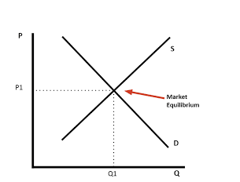
Source: (Penkovskii et al., 2018)

Demographics
The demographics of the population influence the market or the economy to a great extent. The valuable customers of the fruits and vegetable sector of Tesco comprise a wide range of customers. The company never compromises the quality of the product that attracts a diverse range of populations around the country as well. The ageing, as well as the increasing number of working female population, has led to a decline in home meal preparation. As a result, UK retailers have focused more on serving cooked food at home with maintaining hygiene also increased the demand for the fresh vegetables of Tesco. The customer of Tesco includes the new generation of youths who are more focused on healthy habits which include consuming fresh fruits, vegetables, and salads which also enhanced the business of the company to a great extent (highspeedtraining, 2020). In addition to this, old-age people are combating many diseases that compelled them to eat fresh fruits and vegetables to keep their health well. This also enhanced the demand for the fresh products delivered by the company.

Factors influencing the Price Elasticity of Demand

Price Elasticity of Demand
Percentage change in the demand of the quantity of a product or service subject to the percentage change in the price of that particular product is referred to as the price elasticity of demand (ionos.co, 2021). It is the ratio of the change in percentage of the quantity of the product to the change in percentage in price. A minimal change in the prices of fruits and vegetables would not lead to a change in demand for the product, so the good is not perfectly elastic as a change in prices has not affected the demand for the good. As shown in the figure below, the increase in the price of a product from P1 to P2 will lead to a fall in the demand for the product from Q1 to Q2. On the other hand, the decrease in the price from P1 to P3 has increased the demand for the product from Q1 to Q3. Thus, a change in the prices of a product greatly influences the demand for the product.
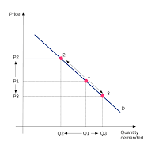
Source: (economicsonline, 2020)

Substitution Effect
The substitution effect refers to the shift to cheaper alternatives when the price of a particular product rises by decreasing the sales of the product. Suppose, the price of a product increases but the income of the consumer does not increase simultaneously, then the consumer will look for the same type of product at a cheaper rate. In case, the price of fruits and vegetables in Tesco increases but the income of the consumers of those products does not increase, then the customers will prefer to buy those items from another store at a lower cost.

Luxury and Necessity Products
Luxury and necessity goods should be described in this context which will help in explaining the concept of price elasticity of demand. In case, an increase in the income of the consumer increases the demand for a particular good then it will be considered a luxury good (Dean, 2020). These goods are highly elastic as an increase or decrease in income greatly affects the demand for the product. On the other hand, the necessary products include food, water, and electricity. The demand for these products does not depend on the consumer income as without these products living cannot be possible. However, whether the item is luxury or necessary is considered from the point of view of the consumer. For instance, laptops, tablets, and mobile phones are necessary items for business persons or persons working in the IT sector. In contrast, these electronic gadgets are luxury items for daily wage earners. Wealthy people spend a large portion of their income on buying these luxury items whereas the daily wage earners spend a greater portion on buying necessary goods. Therefore, the change in the prices of the necessary goods will not affect the demand for these items. On the other hand, the change in the prices of electronic gadgets will compel the middle-income group to cut down the purchasing of luxury goods but the business or IT persons will keep buying these products as they are necessary items for those persons.

Income Effect
The income effect refers to the change in the demand for a product due to a change in purchasing power of the consumer or a change in the real income. The income of a person and the demand for a good is deeply linked to each other regardless of the demand and price equation which is known as the income elasticity of demand. The income elasticity of demand can be positive, negative, or zero. The income effect is positive for normal goods will rise with the rise in consumer income (studysmarter, 2021). The rise or fall in income does not affect the demand for essential goods. In this case, the income elasticity is zero for the product as the rise or fall in income does affect the demand for the good. Negative income elasticity can be seen for inferior goods. In this case, a rise in income reflects a fall in demand and vice-versa.
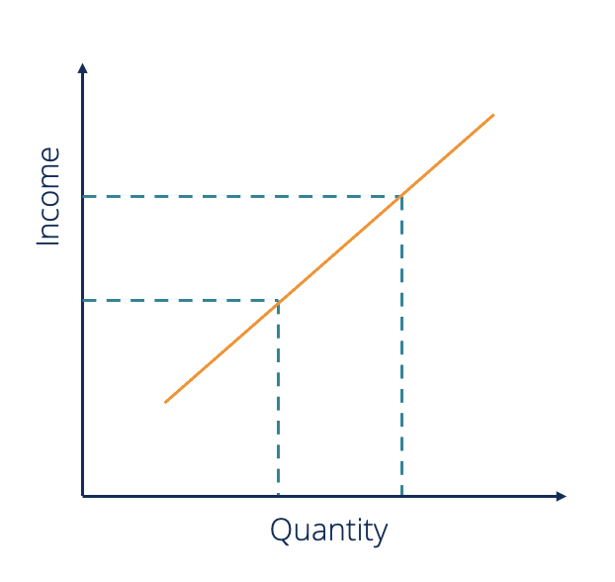
Source: (CFI, 2022)

Pricing Policy
Pricing policies play a crucial role in attracting customers. Therefore, different companies adopt suitable pricing strategies to enhance the growth of their business. The low-cost pricing strategy is a popular method that helps to attract more customers from a wide range of income bases of people. Bundle pricing is another method that helps in making a broader customer base. The company also provides combo offers with main products which is a good pricing policy that pushes the customers to purchase more items from the company as well.

Conclusion
Thus, the report has evaluated different concepts of economics that influence the demand for a product. The multinational company Tesco has been chosen as the company and its product, fresh fruits and vegetables have been used to explain those concepts precisely. The demand and market equilibrium are identified which depends on the price of the product, the price of substitutes as well as the price of complements. The demand for the chosen product depends on the consumer income, tastes and preferences, and demographics that have been elaborated on in the report as well. The concept of price elasticity of demand has also been illustrated in the report. The luxury and necessary goods and income effects are some of the components that impact the demand for a product which have been discussed as well. Apart from these, the ideal pricing policy that the company should employ to expand as well as enhance its business has been recommended in the report as well.

References
Aigner-Walder, B. (2015) Effects of the Demographic Changes on Private Consumption: An Almost Ideal Demand System Analysis for Austria. Journal of Economic and Social Studies, 5, 1, 33-57
Andreyeva, T., Long, M. and Brownell, K. (2010) The Impact of Food Prices on Consumption: A Systematic Review of Research on the Price Elasticity of Demand for Food. American Journal of Public Health, 100, 2, 216-222.
Bagwell, K. (2005) The Economic Analysis of Advertising. Columbia University Discussion Papers No. :0506-01
Baker, J. (2003) Competitive Price Discrimination: The Exercise of Market Power Without Anticompetitive Effects (Comment on Klein and Wiley). Articles in Law Reviews & Other Academic Journals. Paper 278.
bbc, (2022). The economy and business. [Online] Available at: https://www.bbc.co.uk/bitesize/guides/zrwtmfr/revision/3
CFI, (2022). Income Elasticity of Demand. [Online] Available at: https://corporatefinanceinstitute.com/resources/knowledge/economics/income-elasticity-of-demand/
Dean, E., Elardo, J., Green, M., Wilson, B. and Berger, S., (2020). Polar Cases of Elasticity and Constant Elasticity. Principles of Economics: Scarcity and Social Provisioning (2nd Ed.).
economicsonline, (2020). Price elasticity of demand. [Online] Available at: https://www.economicsonline.co.uk/competitive_markets/price_elasticity_of_demand.html/
highspeedtraining, (2020). Changes in Eating Habits Over the Years: Comparing Diets Now & Then. [Online] Available at: https://www.highspeedtraining.co.uk/hub/changes-in-eating-habits/
ionos.co, (2021). Price Elasticity of Demand – An Important Indicator for Companies. [Online]Available at: https://www.ionos.co.uk/startupguide/grow-your-business/price-elasticity-of-demand/
Mead, J.A. and Hardesty, D.M., (2018). Price font disfluency: Anchoring effects on future price expectations. Journal of Retailing, 94(1), pp.102-112.
Penkovskii, A., Stennikov, V., Mednikova, E. and Postnikov, I., (2018). Search for a market equilibrium of Cournot-Nash in the competitive heat market. Energy, 161, pp.193-201.
statista, (2021). Frequency of vegetable or salad consumption in the UK as of 2021. [Online]Available at: https://www.statista.com/statistics/1280510/vegetable-consumption-frequency-uk/
studysmarter, (2021). Income Elasticity of Demand. [Online] Available at: https://www.studysmarter.co.uk/explanations/microeconomics/supply-and-demand/income-elasticity-of-demand/
tesco, (2022). about us. [Online] Available at: https://www.tesco.com/
tescoplc, (2021). Brits are creating the highest demand for fruit and vegetables this century. [Online]Available at: https://www.tescoplc.com/news/2021/fruit-and-veg-demand-at-its-highest-in-20-years/

