MARKETING PLAN
STUDENT NAME: Iuliana-Daniela Giurea
STUDENT ID: 2226406
Tutor: Luciana Suardi

Table of Contents
Component A: Marketing Plan 4
Introduction 4
Situational analysis 4
5 C’s analysis 4
Objectives 8
Strategy 9
Tactics 9
Marketing mix 9
Action 11
Control 12
Conclusion 12
Component B: Presentation 12
Slide 1: Component B: Presentation 12
Slide 2: Introduction 12
Slide 3: Situational analysis 13
Slide 4: Continue 13
Slide 5: Objectives 14
Slide 6: Strategy 14
Slide 7: Tactics 15
Slide 8: Action 15
Slide 9: Control and conclusion 16
Reference list 17
Appendices 20
Slide 2 : Introduction 20
Slide 3: Situational analysis 20
Slide 4: Continue 21
Slide 5: Objectives 21
Slide 6: Strategy 22
Slide 7: Tactics 22
Slide 8: Action 23
Slide 9: Control and conclusion 23
Slide 10: Reference list 24

Component A: Marketing Plan

Introduction
A marketing plan is basically the advertising strategy that businesses implement in order to sell the service or product of the company. In order to conduct the current study, Hilton Hotel has been selected. The purpose of the marketing plan of Hilton Hotel is to identify the marketing opportunity of the business in the current marketplace. The marketing plan would be delivered to the management of Hilton Hotel which would help the company in taking advantage of the available opportunities. SWOT analysis, targeting ad segmentation, Bowman's strategy clock, 4Ps or marketing mix, a SMART objective would be delivered in this study.

Situational analysis

5 C’s analysis
Company (SWOT analysis)
Strengths  - Effective schemes of retaining consumers (queviv, 2016).  - Experience in the field of operating in the hotel industry for a long time.  - Use of innovative technologies. | Weakness  - Overdependence on the market of the USA.  - Lack of flexibility.
Opportunities  - Investing in technologies.  - Developing alliances. | Threats  - Political instability.  - Competition.
Table 1: SWOT analysis of Hilton Hotel
(Source: Self-developed)
Customers- Segmentation and targeting

Segmentation type | Criteria | Target segment of Hilton Hotel
Demographic | Age | 25-40
Demographic | Income | Middle
Demographic | Occupation | No occupational boundary is required to visit the Hilton Hotel. From Doctors, Engineers to students, anyone can visit the hotel.
Psychographic | Social status | Middle-class and upper-middle-class.
Psychographic | Hobby | People who prefer to spend time in luxury.
Psychographic | Lifestyle | People who prefer the use of technology in their regular life.
Behavioural | Personality | Compassionate.
Behavioural | Benefits sought | Individuals who are very keen to enjoy their holidays in a lavishing way.
Geographic | Region | Nigeria.
Table 2: Targeting and segmentation of Hilton Hotel
(Source: Self-developed)
Competitors- Bowman’s strategy clock
Low-price and low-valued
Hilton Hotel does not use this position as it does not offer services at a lower value.
Low-price
Hilton hotel follows a premium pricing strategy (Oliver, 2020). In this context, after the integration of technologies including self-checkouts, AI and others, the Hotel cannot follow a low-price strategy.
Hybrid
This strategy cannot be followed by Hilton Hotels as the hotel does not offer lower-cost services.
Differentiation
By offering self-checkout facilities through the Hilton Hotel app, the company is undertaking differentiation strategies (Hilton Hotel, 2022).
Focus-differentiation
The unique attributes of the services of Hilton Hotel is making the firm competitive.
Increased price / standard product
This is a short-term strategy which Hilton Hotel can follow after integrating the use of technologies.
Low volume/ high price
This is an absolutely inappropriate strategy for Hilton Hotels as the company has many competitors.
Standard price/low-value
Following this strategy might result in losing the market share for Hilton Hotel.
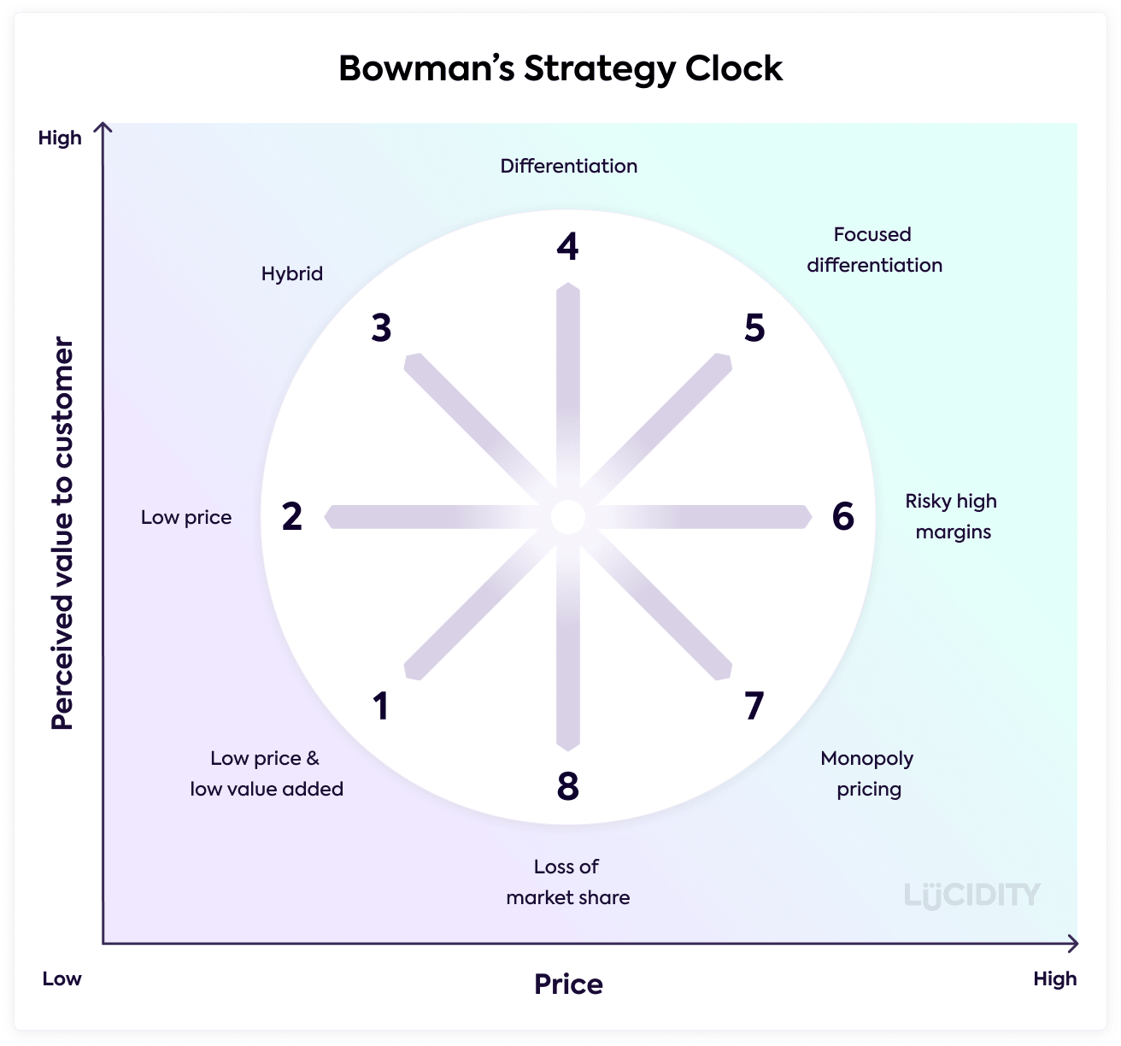
Figure 2: Bowman’s strategy clock
(Source: Echchakoui, 2018)
Collaborators-Franchise
According to Bui, Jambulingam and Amin, (2022), franchising would allow a bigger business-like Hilton Hotel to brand out and expand its operations across the globe.
Climate-PESTLE
Political factor | - The USA is the second largest democracy.  - The democratic party of the USA is more liberal.  - Stable political climate.
Economic factor | - The GDP of the USA in 2022 was $25,464,500 million (Countryeconomy, 2023).  - Employment figure in the USA in 2022 was over 158 million (O’Neill, 2023).
Social factor | - As of February 2023, the population of the USA was 336,147,397 (Worldometers, 2023).  - The culture of the nation is extremely diverse.
Technological factor | - The people of the USA prefer to adopt the use of advanced technologies.  - Home to over 302 million social media users (Statista, 2022).
Legal factor | - The USA demands equal treatment for its citizens and foreigners (van Waas and Jaghai, 2018).  - Each state of the country has a different government structure.
Environmental factor | - Diversified climate, geography and wildlife.  - International tourist visits every year.
Table 3: PESTLE analysis
(Source: Self-developed)

Objectives
To integrate the use of augmented and virtual reality along with self-checkouts.
Specific | This objective is specific as it helps in enhancing the fertility of the hotel.
Measurable | The effectiveness of the objectives can be measured after 1 to 2 months.
Achievable | By investing in R&D, the objective can be achieved.
Relevant | Makes the experience of consumers immersive and interactive.
Time-bound | Within the next 8 months
Table 4: SMART objectives
(Source: Self-developed)

Strategy
The strategy of Hilton Hotels is to integrate the use of AR and VR into their operations. This would help the company in making its consumer aware of the norms and culture of the hotel. According to Orús, Ibáñez-Sánchez and Flavián, (2021), AR can transform the rooms of a hotel through the combination of virtual objectives with a real environment. This can provide a chance for the target consumers to experience the real environment by sitting in their homes. In this way, the consumers can make the decision of enjoying their holidays at the Hilton Hotel.

Tactics

Marketing mix
According to Dadzie et al., (2017), marketing mix is one of the major strategies of the marketing plan. The marketing mix of the Hilton Hotel is given below.
Product
The new services of AR and VR by Hilton hotel would be offered in Nigeria. The company currently offers its services of AR and VR in the USA, UK and others developed countries. Hence, in developed countries like Nigeria, it has the opportunity to offer its services.
Place
The distribution channels which would be used in the new marketing planning include the official websites of the Hilton Hotel, online travel agencies, and the international distribution system. According to Majeed et al., (2020), online travel agencies offer a convenient way for travellers to arrange their stay. These are one-stop solutions which can satisfy the travelling need of people.
Price
The hotel follows a premium pricing strategy. It is suggested to the hotel use a competitive pricing strategy. This would help the hotel in making its middle-class consumers able to experience the facilities offered by the hotel. According to Kweon and Kweon, (2021), a competitive pricing strategy can help the business prevent losing its share in the market.
Promotion
Social media promotional strategy can be followed by Hilton Hotel. In this context, the use of Instagram and Facebook can be beneficial for Hilton Hotels considering the popularity of these mediums among people across the entire globe. By 2027, the number of social media users would become 5.85 billion (Dixon, 2022). Hence, selecting the strategy of social media promotions can definitely be beneficial for Hilton Hotels.
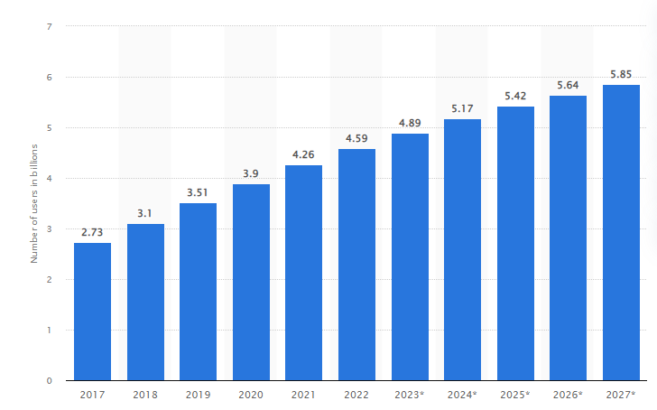
Figure 3: Number of social media users across the globe
(Source: Dixon, 2022)

Action
Goals | Week 1-2 | Week 3-4 | Week 5-6 | Week 7-8 | Week 9-10
Developing marketing goals
Conducting marketing audit and research
Target audience identification
Developing budget
Identifying marketing strategies
Table 5: Gantt Chart of the marketing plan
(Source: Self-developed)

Control
In order to measure success, consumers of the Hilton Hotel can be surveyed or asked about their experiences with the new services. Another vital way of measuring the success of any marketing plan can be by measuring its increasing or decreasing revenues over time. The survey can help Hilton Hotel in locating the positive attitude of consumers toward the new service and in this way the success of the new marketing plan can be measured.

Conclusion
After conducting the entire study, it can be understood that budget management can be a critical challenge for Hilton Hotel. Furthermore, the implementation of AR and VR can be challenging if Hilton Hotel fails to hire appropriate employees who can maintain all the goals and responsibilities effectively. In this aspect, providing proper training to employees and investing in R and D to locate the trends in the market can help Hilton Hotel to overcome its challenges and successfully implement its new marketing plan.

Component B: Presentation

Slide 1: Component B: Presentation

Slide 2: Introduction
- This presentation focuses on developing a new marketing plan for the Hilton Hotel.
- The presentation delivers the integration of VR and AR by Hilton Hotel.
In this presentation, all the components are focused on the delivery of a marketing plan for the Hilton Hotel.

Slide 3: Situational analysis
- 5 Cs of situational analysis have been delivered.
- In company analysis, it can be seen that Hilton Hotel uses advanced technologies which is a major strength of the Hotel.
- In customer analysis, it can be seen that Hilton Hotel targets the 25 to 40 age group to offer its new services in Nigeria.
- By analysing competitors by Bowman’s clock, it can be seen that the Hilton Hotel uses a differentiation strategy (Hilton Hotel, 2022).
- The company has the opportunity to collaborate by making franchises.
This slide delivers the situation analysis of the Hilton Hotel. In this aspect, the slide delivers consumer, company and competitor, collaborative analysis.

Slide 4: Continue
Political factor | - Stable political climate.
Economic factor | - Employment figure was over 158 million in the USA in 2022 (O’Neill, 2023).
Social factor | - The culture of the nation is extremely diverse.
Technological factor | - 302 million social media users (Statista, 2022).
Legal factor | - Equal treatment for everyone (van Waas and Jaghai, 2018).
Environmental factor | - Global tourist visits every year in the USA.
Table 1: PESTLE analysis
(Source: Self-developed)
In this slide, the PESTLE analysis of the USA has been delivered where the headquarter of the Hilton Hotel is situated.

Slide 5: Objectives
To Use AR and VR.
Specific | Enhanced consumer experiences
Measurable | Can be measured in 1 month.
Achievable | Invest in Research and development
Relevant | Immersed consumer experience.
Time-bound | 8 months
Table 2: SMART objectives
(Source: Self-developed)
The slide delivers the SMART objectives of the Hilton Hotel.

Slide 6: Strategy
- To use innovative technologies like AR and VR.
- Offer virtual experiences to customers with AR (Orús, Ibáñez-Sánchez and Flavián, 2021).
Basically, the company has made the strategy to integrate AR and VR and offer services in Nigeria.

Slide 7: Tactics
Product: Innovative services through AR and VR.
Place: Nigeria.
Price: Competitive pricing.
Promotion: Social media channels.

Slide 8: Action
Goals | Week 1-2 | Week 3-4 | Week 5-6 | Week 7-8 | Week 9-10
Developing marketing goals
Conducting marketing audit and research
Target audience identification
Developing budget
Identifying marketing strategies
Table 3: Gantt Chart of the marketing plan
(Source: Self-developed)

Slide 9: Control and conclusion
- Success of the plan can be measured by surveying, and accessing revenues.
- The company can provide training to employees.
- Investing in R and D is a great option to locate the market trends (Rahko, 2021).
The success of the plan can be measured by accessing its revenues. Providing training to employees and investing in R and D are some recommendations to the firm.

Reference list
Bui, T.T.H., Jambulingam, M. and Amin, M. (2022). A literature review of franchisee performance: Insights for further research. Cogent Business & Management, [online] 9(1). doi:https://doi.org/10.1080/23311975.2022.2044573.
Countryeconomy (2023). United States (USA) GDP - Gross Domestic Product 2022 | countryeconomy.com. [online] countryeconomy.com. Available at: https://countryeconomy.com/gdp/usa#:~:text=The%20GDP%20figure%20in%202022.
Dadzie, K.Q., Amponsah, D.K., Dadzie, C.A. and Winston, E.M. (2017). How Firms Implement Marketing Strategies in Emerging Markets: An Empirical Assessment of The 4A Marketing Mix Framework. Journal of Marketing Theory and Practice, 25(3), pp.234–256. doi:https://doi.org/10.1080/10696679.2017.1311220.
Dixon, S. (2022). Number of Social Media Users Worldwide 2010-2021. [online] Statista. Available at: https://www.statista.com/statistics/278414/number-of-worldwide-social-network-users/.
Echchakoui, S. (2018). An analytical model that links customer-perceived value and competitive strategies. Journal of Marketing Analytics, [online] 6(4), pp.138–149. Available at: https://link.springer.com/article/10.1057/s41270-018-0043-9.
Hilton Hotel (2022). Customer Support. [online] Hilton.com. Available at: https://help.hilton.com/s/article/How-do-I-check-out.
Kweon, H. and Kweon, S. (2021). Pricing Strategy within the U.S. Streaming Services Market: A Focus on Netflix’s Price Plans. International Journal of Contents, [online] 17(2). doi:https://doi.org/10.5392/IJoC.2021.17.2.001.
Majeed, S., Zhou, Z., Lu, C. and Ramkissoon, H. (2020). Online Tourism Information and Tourist Behavior: A Structural Equation Modeling Analysis Based on a Self-Administered Survey. Frontiers in Psychology, 11. doi:https://doi.org/10.3389/fpsyg.2020.00599.
O’Neill, A. (2023). U.S. total employment and unemployment rate 1980-2027. [online] Statista. Available at: https://www.statista.com/statistics/269959/employment-in-the-united-states/#:~:text=In%202022%2C%20it%20was%20estimated.
Oliver, D. (2020). ‘A new normal’: Hilton follows Marriott, Airbnb with cleanliness initiative amid coronavirus pandemic. [online] USA TODAY. Available at: https://www.usatoday.com/story/travel/hotels/2020/04/27/coronavirus-hilton-announces-new-cleanliness-measures/3032384001/.
Orús, C., Ibáñez-Sánchez, S. and Flavián, C. (2021). Enhancing the customer experience with virtual and augmented reality: The impact of content and device type. International Journal of Hospitality Management, [online] 98, p.103019. doi:https://doi.org/10.1016/j.ijhm.2021.103019.
queviv (2016). These are the brands the biggest hotel chains are building to attract millennials. [online] USA TODAY. Available at: https://www.usatoday.com/story/travel/roadwarriorvoices/2016/01/26/these-are-the-brands-the-biggest-hotel-chains-are-building-to-attract-millennials/83277358/ [Accessed 28 Feb. 2023].
Rahko, J. (2021). R&D internationalization and firm productivity. Does the host country matter? Applied Economics, 53(16), pp.1807–1825. doi:https://doi.org/10.1080/00036846.2020.1853668.
Statista (2022). Topic: Social media usage in the United States. [online] Statista. Available at: https://www.statista.com/topics/3196/social-media-usage-in-the-united-states/#topicOverview.
van Waas, L. and Jaghai, S. (2018). All Citizens are Created Equal, but Some are More Equal Than Others. Netherlands International Law Review, 65(3), pp.413–430. doi:https://doi.org/10.1007/s40802-018-0123-8.
Worldometers (2023). U.S. Population (2019) - Worldometers. [online] Worldometers.info. Available at: https://www.worldometers.info/world-population/us-population/.

Appendices

Slide 2 : Introduction
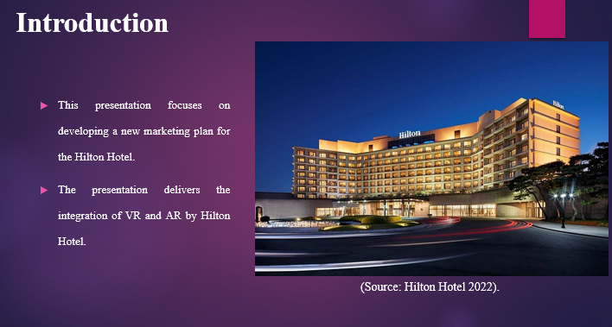

Slide 3: Situational analysis
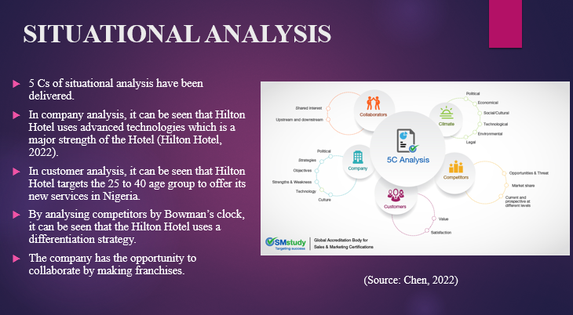

Slide 4: Continue
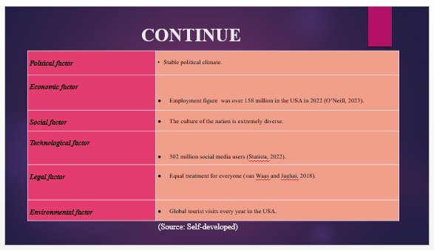

Slide 5: Objectives
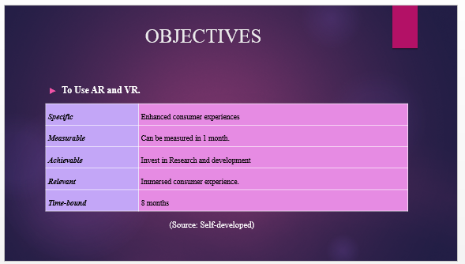

Slide 6: Strategy
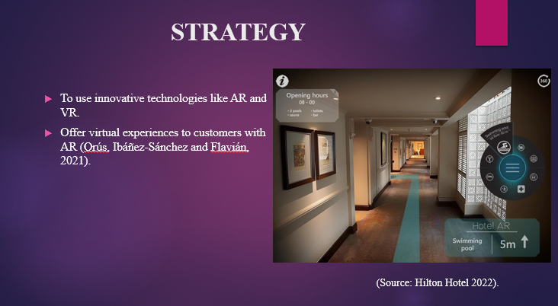

Slide 7: Tactics
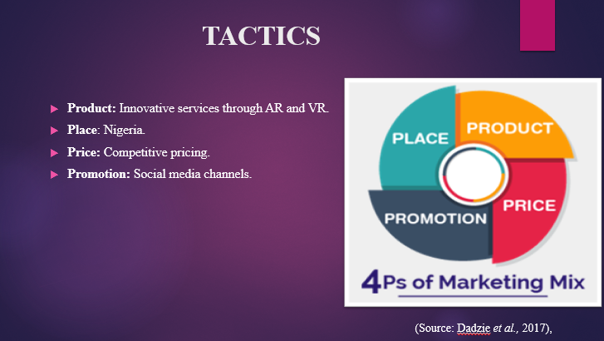

Slide 8: Action
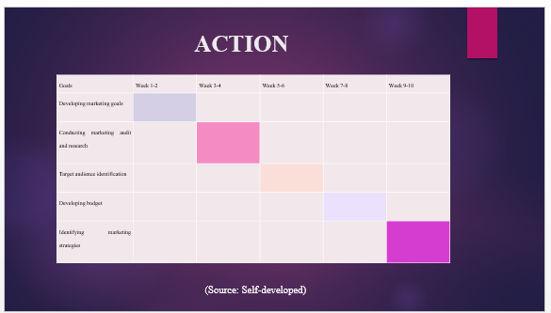

Slide 9: Control and conclusion
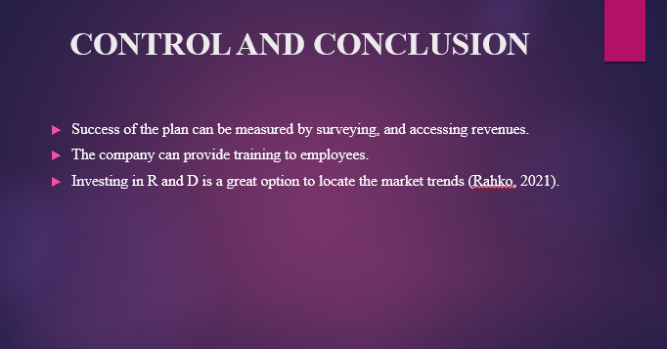

Slide 10: Reference list


