Improvement of customer satisfaction within fsg tool and die limited
Harveer Singh (1912321)

University of Wales Trinity Saint David (Swansea)
BEng (Hons) Advanced Manufacturing Operations

Abstract

This report examines the state of customer satisfaction within FSG Tool and Die Limited. A graph made showed the number of customer complaints per six months had spiked towards the end of the period of the three years. Five recent complaints were chosen in order to determine how this could be the case. This was done through retrieving customer return/complaint logs, along with incorporating continuous improvement techniques. This study demonstrated that it was potentially down to either human error or systematic error. Further research, as well as an interview allowed for the consideration of solutions, where a flow chart checklist was made in order to organise the current procedure within the planning section. From here, it was made apparent that the machinists could have more involvement with the change. This was done by implementing checks for a correct sequence of operations, also that all the appropriate operations are on the route pack for the extra layer of security. Finally, recommendations have been given as the project is currently ongoing. This consists of where the project could potentially go, as well as conclude how successful the project has been.

List of figures and tables

Figure 1 – Types of FMEA ………………………………………………………………………….7
Figure 2 – FMEA example ………………………………………………………………………….8
Figure 3 – Ishikawa example ………………………………………………………………………9
Figure 4 – Image showing mistake proofing scenario …………………………………………11
Figure 5 – First Gannt chart ………………………………………………………………………11
Figure 6 – Second Gannt chart …………………………………………………………………..12
Figure 7 – 2019 customer complaint log…………………………………………………………14
Figure 8 – 2020 customer complaint log…………………………………………………………15
Figure 9 – 2021 customer complaint log…………………………………………………………15
Figure 10 – 2022 customer complaint log……………………………………………………….16
Figure 11 – Route pack page one………………………………………………………………..17
Figure 12 – Route pack page two………………………………………………………………..18
Figure 13 – Improvement action report………………………………………………………….20
Figure 14 – FSG Tool and Die Limited customer survey…………………………………..22,23
Figure 15 – Graph of customer complaints.………………………………………………….....24
Figure 16 – First complaint Ishikawa…………………………………………………………….25
Figure 17 – First complaint FMEA……………………………………………………………….25
Figure 18 – Second complaint Ishikawa………………………………………………………...27
Figure 19 – Second complaint FMEA…………………………………………………………...28
Figure 20 – Third complaint Ishikawa…………………………………………………………...29
Figure 21 – Third complaint FMEA……………………………………………………………...29
Figure 22 – Fourth complaint Ishikawa………………………………………………………….31
Figure 23 – Fourth complaint FMEA…………………………………………………………….31
Figure 24 – Fifth complaint Ishikawa……………………………………………………………32
Figure 25 – Fifth complaint FMEA………………………………………………………………33
Figure 26 – Flow chart (solution)………………………………………………………………..35
Table 1 – Total types of customer complaints………………………………………………….16
Table 2 – Survey results………………………………………………………………………….23

Table of Contents

Abstract 1

List of figures and tables 2

Introduction 4
Aims and objectives 4

Literature review 4
1.1 Customer satisfaction 5
1.2 Continuous improvement 5
1.3 FMEA 6
1.4 Ishikawa 8
1.5 Five whys 9
1.6 Stakeholder analysis 9
1.7 Mistake proofing 10

Timekeeping 11
2.1 Gantt charts 11

FSG Tool and Die Limited quality procedures 12
3.1 Voice of customer 12
3.2 Customer complaint logs 13
3.3 Route packs 17
3.4 Improvement Action Report 19

Work carried out 21
4.1 Questionnaire 21
4.2 Graph of complaints 24
4.3 Axium valve seat 24
4.4 Axium valve 26
4.5 Coppice punch (A) 28
4.6 Coppice punch (B) 30
4.7 Oerlikon engagement rings 32
4.8 Potential solution for systematic errors 33
4.9 Implementation of systematic solution 37

Conclusion 38
Recommendations 39

References 40

Introduction

Founded in 1961, FSG Tool and Die Limited are the largest, privately-owned design and build toolmaking company in Europe. It began based around the manufacturing of various press tools for the food and drink industry, with an example being foil tools for packaging. As investments into new technology was made, FSG Tool and Die Limited was able to expand out into more industries such as automotive, industrial, and also medical. From here it was possible to provide precision machined products, as well as prototype manufacturing. This led to a larger variety in terms of the customer base and types of components manufactured. This project will be based around the improvement of customer satisfaction within FSG Tool and Die Limited. Various types of research will be carried out, leading into how the areas for improvement are found. An example of this being looking into documents within the company, moreover types of complaints. The voice of the customer will be used when finding root causes. From here, potential solutions will be made in an attempt to try and improve customer satisfaction. Quality will be considered throughout.

Aims and objectives

When choosing the project aims and objectives, areas within FSG Tool and Die Limited which are not shown often to apprentices were considered as this gives a more outside perspective on how things such as procedures are carried out. It is also a good opportunity to learn more about other sections such as planning or quality assurance, which may be able to be applied to other roles within the company. What has been found is over the past three years is that the number of complaints has totalled to 100. Out of this number 64 are for rework, which accounts for 64% of the complaints. One result of this is additional time and cost to components. A further cost to consider is the reputational cost this will have on FSG Tool and Die Limited, which may be more damaging as this has an impact on the future on the company in terms of upcoming customers. The aim for this project is to try and reduce the number of reworks by 30%, which in turn will improve the customer satisfaction by reducing the number of complaints. An additional benefit towards this change could be a reduce in cost for manufacturing components by reducing the time taken. The results found from the questionnaire handed out to the customers confirms this is an underlying issue due to finding that overall quality was rated the lowest.

Literature review

1.1 Customer satisfaction

Some background research has been conducted in order to help determine which project to carry out. This has been done in a number of forms in order to ensure that there is not only an understanding around the topic, but also to see if there is enough information to start with.
“Customers are the key factor of the existence and company development on the market.”, Biesok & Wyród-Wróbel (2011) (A). This gives the obvious point that in order to keep a business going, customers are required for the receiving end of a product. “There is a concept of needs and their fulfilling.”, Biesok & Wyród-Wróbel (2011) (B). This implies that the needs are the product(s) requested, furthermore the fulfilling being the company being able to provide the product. The combination of the two could be what contributes towards customer satisfaction within a company.
The blog states “The three major factors that affect modern customer satisfaction are customer understanding, service, and technology.”, CommenceCRM (2018) (A). This suggests that customer satisfaction is has a relatively extensive number of factors which can contribute towards it as all are constantly taken into consideration within all types of organisations.
“Loyal customers want to be assured that they are buying from an organization that truly cares about their best interests.”, CommenceCRM (2018) (B). This may be an important point to consider when discussing customer satisfaction as creating loyal customers have the potential to bring in more work, therefore the possibility for more future profit.

1.2 Continuous improvement

Within an engineering environment, improvement can be achieved through a variety of approaches. The blog states “Kaizen is a Japanese word that translates to improvement (continuous) or changes for the better in English.”, Sharma (2022). This implies that there is a Japanese concept for continuously improving within the workplace. “It means gradual and continuous progress, increase of value, intensification, and improvement.”, Singh & Singh (2013). This methodology can be used within an organisation through employee engagement to employ incremental change.
“The most significant effects of kaizen application are productivity, quality, and efficiency improvement, lower costs, waste elimination, workplace safety etc.”, Vesna Janjić et al (2019). This suggests that kaizen is a very versatile model in the fact that it can be applied to achieve a number of different facets within an organisation.

1.3 FMEA

As mentioned earlier within the report, continuous improvement is a versatile model, therefore there are a lot of ways to carry it out. The article states “Failure mode and effects analysis (FMEA) is an engineering and management technique, which is widely used to define, identify, and eliminate known or potential failures, problems, errors, and risk.”, Du et al (2014). This infers that FMEA is a useful tool within this project in terms of helping eliminate errors.
“Potential failure mode is defined as the manner in which a component, subsystem, or system could potentially fail to meet or deliver the intended function.”, Xu et al (2001). FMEA can be used to increase quality within an organisation. This will be able to be used to create preventative actions to reduce the chance of failure.

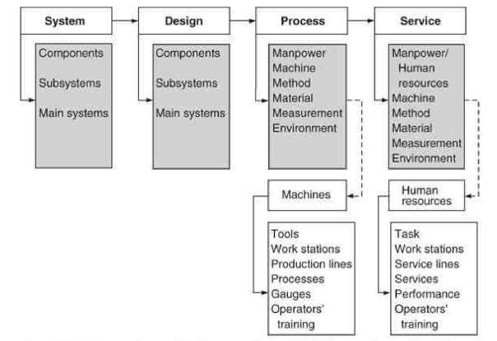
The above diagram has been taken from a book showing the four different types of FMEA. “A process FMEA focuses on failure modes caused by process or assembly deficiencies.”, Stamatis (2003) (A). Looking into this will allow for a better perspective of how they might have happened as it focuses on factors such as reliability, maintainability, productivity, etc. Cost is a separate factor taken into consideration here.
“Service FMEA- Used to analyze services before they reach the customer.”, Stamatis (2003) (B). Similar to the process FMEA, the service FMEA is where the customer satisfaction comes into it. The focus of this is to maximise customer satisfaction through the means of quality and service. This may be more beneficial as the voice of the customer is included within the investigation.
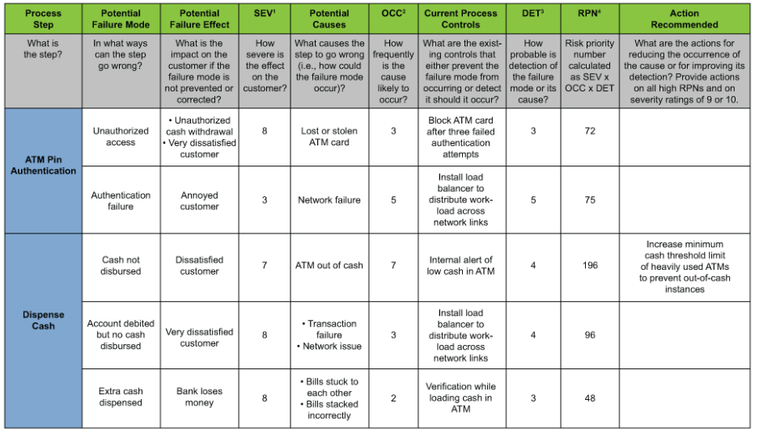
The above example shows a template of an FMEA being carried out in regard to a cash machine. Once the process step is recorded, anything that could go wrong is placed under ‘potential failure mode’. The result of this action is known as ‘potential failure effect’. The severity of this mode is then given a rating from one to ten, depending on how severe the effect is on the customer.
The next section looks into the potential causes of the failure, moreover how things could have gone wrong. Another rating is then given based on how often this could go wrong. The current process controls are considered to give a good overview as to what is already in place to try and prevent the failure. This is also given a rating based on how probable the detection of the failure mode is.
A risk priority number is made by multiplying the three mentioned ratings together, furthermore the higher the number, the more severe the failure mode is. From here the failure modes can be ordered from lowest to highest risk priority number to show which needs action the most.
Finally, any recommended actions can be considered in an attempt to try and reduce the risk priority number of any of the failure modes. It may be recommended to start with the most severe to be able to try and get the most change. Implementing mentioned changes and carrying out another FMEA will show the results of the actions taken.

1.4 Ishikawa

Another technique used within continuous improvement is known as Ishikawa. The text states “Fishbone diagram (also known as Ishikawa diagram) was created with the goal of identifying and grouping the causes which generate a quality problem.”, Ilie (2010). This implies that Ishikawa is another technique used to try and determine the root cause of a problem based around quality.
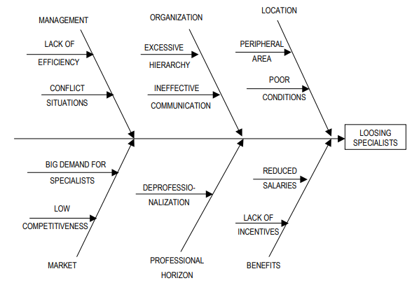

In the above diagram, it can be seen that the root cause trying to be identified is for why an organization is losing specialists. The main causes taken into consideration are on the outside of what would be the fishbones, showing where things within the organization could be going wrong. For this scenario the facets taken into account are the location, benefits, the organization itself, professional horizon, market and management.
From here, the secondary causes are considered. This is done by thinking about what is affecting the primary causes. An example here being that the reduced salaries and lack of incentives are having a negative impact on the overall benefits, which could be a viable root cause as to why the organisation is losing specialists.

1.5 Five whys

The five whys is another technique which could be used for continuous improvement. The article states “The five whys is a technique which can be used for troubleshooting, quality improvement and problem solving across the board.”, Channell (2021). This implies that the five whys is another method used to determine the root cause.
“Clearly, the Five Whys technique will suffer if it is applied through deduction only.”, Serrat (2009)(a). This infers that the five whys is a very basic technique to use, furthermore it could be criticized for this reason. The result being a number of issues, some being the following, “The tendency of investigators to stop at symptoms, and not proceed to lower-level root causes.”, Serrat (2009)(b), “The inability of investigators to cast their minds beyond current information and knowledge.”, Serrat (2009)(c). Despite it being an easy method to use, its simplicity may result in lack of information for a project with such a broad influence.

1.6 Stakeholder analysis

“Stakeholders have an interest in the success of the project and can be within or outside of the organization that’s sponsoring the project.”, Landau (2022) (A). This suggests that stakeholders may have an influence on the project in terms of decisions. “There are also critical or key stakeholders, whose support is needed for the project to exist.”, Landau (2022) (B). Key stakeholders also possess interest within the project being carried out, furthermore supporting the project. It may also be important to update them throughout the different phases of the project as it could have a direct impact on them, depending on their role within the organisation.

1.7 Mistake proofing

Within manufacturing, there is a number of ways in which tasks can be carried out. With this comes the fact that errors can be made easily. There are approaches in which components can be set up in order to try and eliminate this. The dictionary states “So simple and easy to understand that it is unable to go wrong or be used wrongly.”, Cambridge Dictionary (2023). This implies that this is a methodology used to allow for the implementation of a tool or mechanism to prevent someone from completing a task in an incorrect manner.
The research paper states “Poke-yoke translates to ‘‘mistake-proofing” in Japanese.”, Karthick et al (2021). This infers that there is another Japanese technique which can be used in order to aid the project. Despite this being used as a technique for the manufacturing stage of a component, the concept may be able to be applied to find a solution to the underlying issue. The article states “Motion-step in poka-yoke determines whether prescribed steps are completed in order.”, Bland (2022). This suggests that this type of approach tends to errors stemming from an incorrect sequence of events.
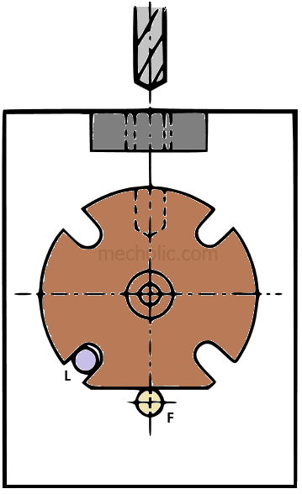
The above image shows an example of mistake proofing. Here the component is located through pin ‘L’ and pin ‘F’ is used to mistake proof the setup as it makes it impossible to load the component in any other orientation. “This concept ensures that the component will fit into work holder only in its correct position.”, Mecholic (2023). For this scenario, the concept of mistake proofing has been applied in order to generate a simple and more effective way of carrying out a task.

Timekeeping

2.1 Gantt charts
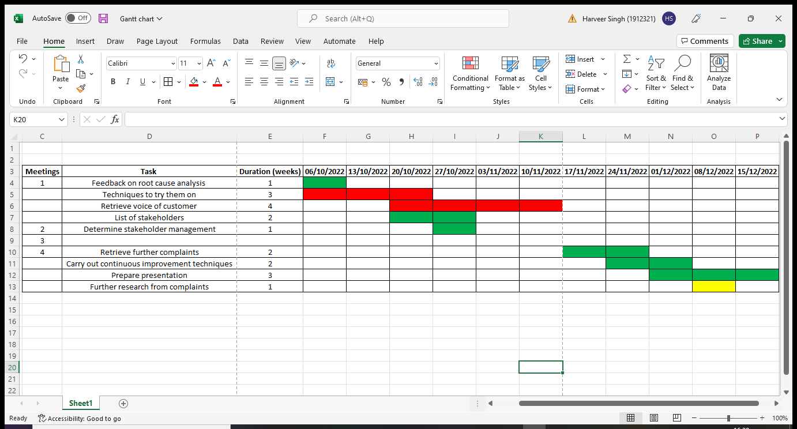

To keep track of the current tasks completed, a Gantt chart has been made tailored towards the project. The aim was to complete each set of tasks within the two week increments I had meetings with the project supervisor.
The green boxes are where tasks were started and completed in the predicted time. The red is where the tasks took longer than expected. An example of this is the voice of the customer taking 4 weeks to be completed as there was slight difficulty finding the sales engineer. Any of the boxes in yellow represent the ongoing tasks. This is the first Gantt chart made to aid the planning of the project up to the stage of the first presentation. The following Gantt chart will be keeping track of everything beyond that point.
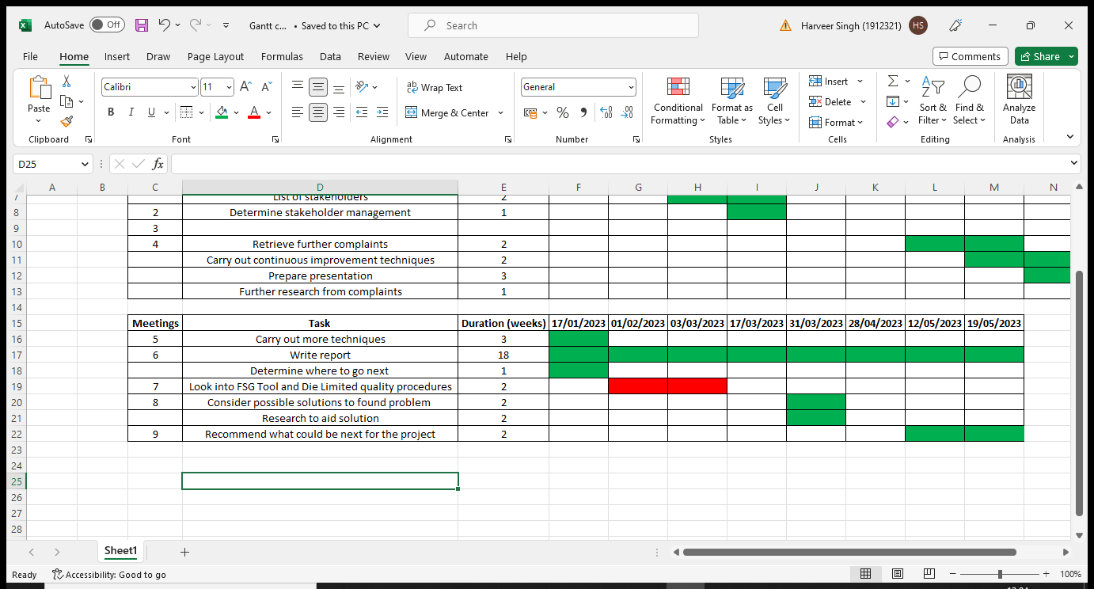This Gantt chart has been used since the start of the new semester. It is structured the same as the first, with the only difference being the gaps in the dates. There is a period at the beginning where there was a lack of meetings due to an increasing work from other modules taking the focus away from the project. There was also the period of where annual leave took place, disallowing for meetings. The red phase at the beginning of the chart is again from having difficulty finding an individual within FSG Tool and Die Limited to try and interview to find information.

FSG Tool and Die Limited quality procedures

3.1 Voice of customer

Within this current state of the project there was a small number of stakeholders, being myself, the project supervisor, and the sales engineer. There may need to be more to be able to make this project successful as the higher interest of the project may allow for more access to a variety of more information.
After taking into consideration the research mentioned above, the new list of stakeholders turned into the following:
- Myself
- Project supervisor
- Sales engineer
- Apprentice co-ordinator
- Quality manager

Some interviews have been conducted within FSG Tool and Die Limited to determine any quality procedures in place. “It is part of Sales role to deal with customer complaints at a front-end perspective. The customer will usually contact the sales engineer who dealt with their enquiry and relay the issues that have occurred.”, (Railton, L. Interview 20th Jul 2022) (A). The sales engineer was interviewed for information regarding customer satisfaction as they are constantly working closely with the customers. The process of sales enquiry was discussed, as well as the complaint protocol. It was found that if a service issue has occurred, then it is down to the Sales Engineer and quality manager to determine where the failing occurred and best course of action to prevent this from happening in future. A visit to the customer’s site will take place as a face-to-face dealing can often shine inter-personal relations onto the matter which can defuse situations.
“If there is a conformity issue with the order, this is passed onto QA Team Leader who will compile a Customer Complaint Report. This will review said issue and determine an engineering solution.”, (Railton, L. Interview 20th Jul 2022) (B). The collection of complaints is stored electronically in a log to keep track of any underlying issues found with products. This further suggests that QA (quality control) also contributes towards customer satisfaction within FSG Tool and Die Limited as the section helps suggest solutions.
Further interviews were conducted with the quality manager asking about the chosen customer complaints. This was carried out to provide more detail as to what could have gone wrong. “Communication with the customer found that the Axium valve seats were returned due to the etching not being requested by the customer.”, (Dauncy, R. Interview 10th Oct 2022) (A). The customer was asked through the means of emailing for more information in relation to their complaints. “The valve was also returned but due to an incorrect surface finish caused by out of centre machining.”, (Dauncy, R. Interview 10th Oct 2022) (B). Despite both of these complaints being for the same customer, they are vastly different with potentially different root causes. “Coppice found that there was an M10 hole out of position.”, (Dauncy R. Interview 10th Oct 2022) (C). The voice of the customer has been effective here to provide more detail as to why the complaints were made.
A further interview had to be conducted for the next pair of complaints looked into, again for the further detail. “Another complaint has been made from Coppice in relation to a punch made. This time it was because a dowel hole was not finish size.”, (Dauncey R. Interview 10th Nov 2022) (A). This infers that something has there has been an error in planning. “Oerlikon engagement rings were also sent back to us as there had been rust present on the components on arrival.”, (Dauncey R. Interview 10th Nov 2022) (B). This is a much more unique complaint to the rest mentioned as this may have occurred during transportation. Further work into the root causes will determine this.

3.2 Customer complaint logs

Documents were obtained which show a log of the returns and complaints for each customer, giving details such as the date of the complaint, which component it was, and brief detail of what action was taken to resolve this. Upon further inspection, it can be seen why each complaint was made. Research was conducted to the ending of 2021 as it provides a full year worth of information to look into.
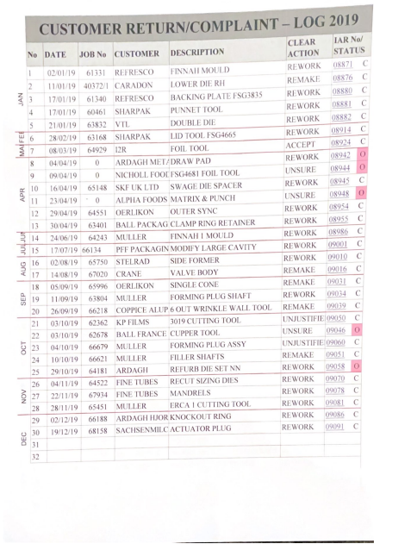
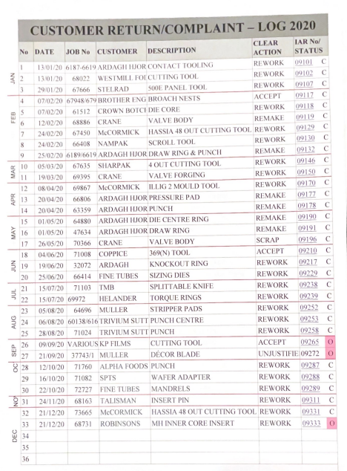
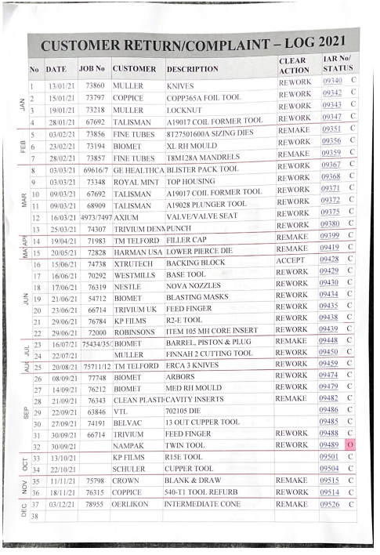
The different actions from the complaints were tallied up to see where could be improved. This was done from a cumulative number of 100.
Year | Remake | Rework | Scrap | Other
2019 | 5 | 18 | 0 | 6
2020 | 6 | 22 | 1 | 3
2021 | 8 | 24 | 0 | 1
Total | 19 | 64 | 1 | 10

The past three years of customer complaints show that the highest number of complaints is for reworks. The most recent complaint log was also retrieved to aid in further progression of the project.
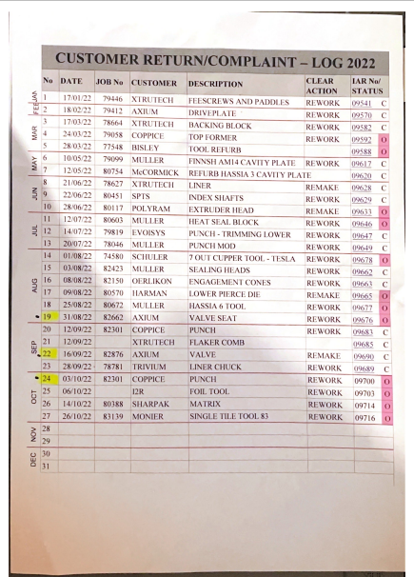

From this log, recent complaints can be looked into to determine the root causes. At the time of this stage three complaints were chosen to carry out the continuous improvement techniques studied. The voice of the customer was used here through the means of an interview with the quality manager.

3.3 Route packs

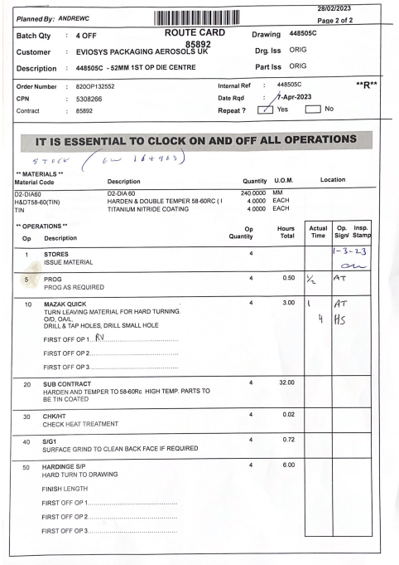
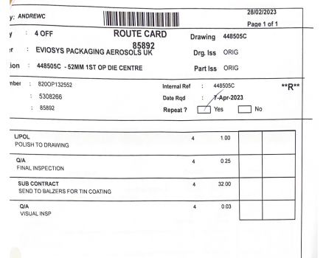

Within FSG Tool and Die Limited, there is a way to keep track of the components produced known as a route pack. This piece of documentation is used to also show which processes a component need to undertake in order to achieve the final product. It shows information about the stock material, such as what type of steel is used and what size it is cut to. Also, the amount of stock material given. There is an ‘hours total’ section where the estimated time to complete each task is shown. This is additionally determined by the planning team in regards to seeing what is comprised of in the drawing. Next to it the employee can write the time they have taken on the specific operation and sign to show who has carried it out.
A procedure is used in order to determine how the parts are made. This all begins with the drawing, furthermore the planning team will look at the information provided to see how the component will be made. The first thing taken into consideration is if any jigs, fixtures or electrodes (for wiring) will be needed. This can be determined from the form and/or features of the component being manufactured. From here a separate route pack can be made to manufacture them if any are needed.
There are a number of factors which can influence the way a component is made. One being what type is being made. In the document shown above, there is a route pack for a die centre. For its purpose, it will need to be tin coated. This is not a regular occurrence within components made by FSG Tool and Die Limited, therefore it is sub-contracted to a third party to conduct. Another potential influence could be in relation to tolerancing, where more accurate features will need to have material left before finishing if processes such as heat treatment is involved.
For each operation, there is instruction as to what to do to the material. An example here could be on operation ‘10’, where it specifies to leave material for hard turning. From looking at it initially, it seems very vague as it does not specify the amount of material to leave on the surfaces specified. This can vary due to parts having different features, thicknesses, forms, etc. An interview with the head of design confirmed this information. “The route packs are vague, however this is to give the machinist the opportunity to manufacture components as they please.”, (Jones. M. Interview 28th Mar 2023). With that being said, it should be more specific about how much material to leave on the detailed forms.
This ties into the systematic errors found because it is their role to give instructions to the machinists. Unclear instructions may allow for more opportunity for error. In this scenario, leaving too little material could lead to the component collapsing or too much distortion during heat treatment. This would result in the part having to be remade. On the contrary, too much material would take a lot more time than expected to hard machine away, resulting in more unnecessary time being put into the component(s). The outcome is increased cost.
On the route packs there are areas where it mentions ‘first off’. This is a quality procedure put in place to ensure that components are made to the specified tolerances. This has the same issue with the instructions as it does not specify any ways to check components in particular. An example of this could be using precision pins to check a dowel hole as opposed to a vernier calliper. The ‘QA’ checks share this underlying issue.
During the same interview where information about the route packs was found, there was also one method the planning team used in order to save time. “If features share similarities with a previous component, the route pack will be copied over.”, (Jones. M. Interview 28th Mar 2023). This seems unideal as this allows missing/unnecessary steps within route packs much more easily. An example of this could be that another die centre could be made for the same company as the one mentioned in the above document, however it does not require the tin coating. If this was copied and sent through without being checked over, it could lead to further customer complaints due to it not being required.

3.4 Improvement Action Report

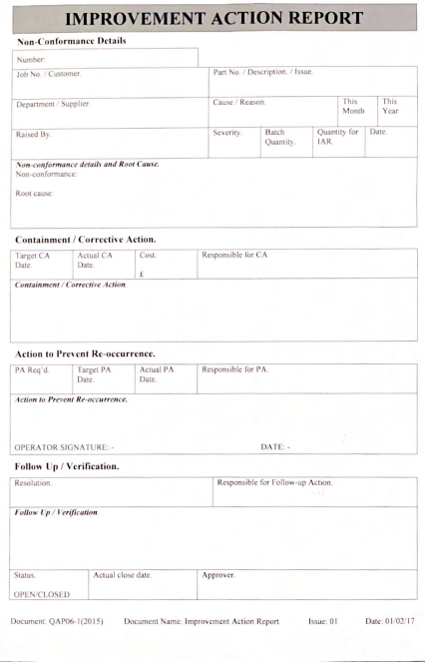
This piece of documentation is an improvement action report, or more commonly called IAR within FSG Tool and Die Limited. It is used when something goes wrong in an attempt to stop it from happening again. The first section is around the problem itself. Details such as which component has been made incorrectly, the date of the occurrence, and the root cause are considered here. The department and who was involved with the action causing the error are also mentioned within this section, where it also states who it was raised by.
The second section is around the corrective actions to take place in order to prevent the mistake from happening again. This is determined from the root cause found in the first section. This section states who is responsible for the corrective action, as well as dates for when it is expected to take place and the actual date. An example of this could be that a surface finish was not made to drawing. The root cause may be that the cutting conditions were not ideal for what was being machined. A corrective action for this could be conducted by the team leader of the section, where they provide training on cutting conditions in order to achieve the desired surface finish in the future.
Next, there is the action to prevent re-occurrence, where something is put in place to prevent this from happening again. An example for this scenario could be having the machinist who made the error take notes during the training provided to ensure that even if they forget, the cutting conditions will be recorded somewhere. This will allow for something to reference back to if need be.
The final section of the Improvement Action Report is in regard to verification. This section denotes if the action taken has been successful or if further action is needed. The Improvement Action Report is used throughout FSG Tool and Die Limited in order to try and prevent errors from occurring in the same way in the future. They are handed out to every section on and off the shop floor in regards to the root cause identified from the customer complaint. Despite the fact that something is in place for when things go wrong, it is also important to have procedures in place to prevent getting towards this stage. This will be taken into consideration when applying the solution for the project.

Work carried out

4.1 Questionnaire

From my research I found customer satisfaction is a broad topic in the fact that there is a number of factors that can affect it. A questionnaire was made using the research and information gathered from the interview to give to six random customers in order to determine if there are any underlying issues with quality, transport, communication, etc.
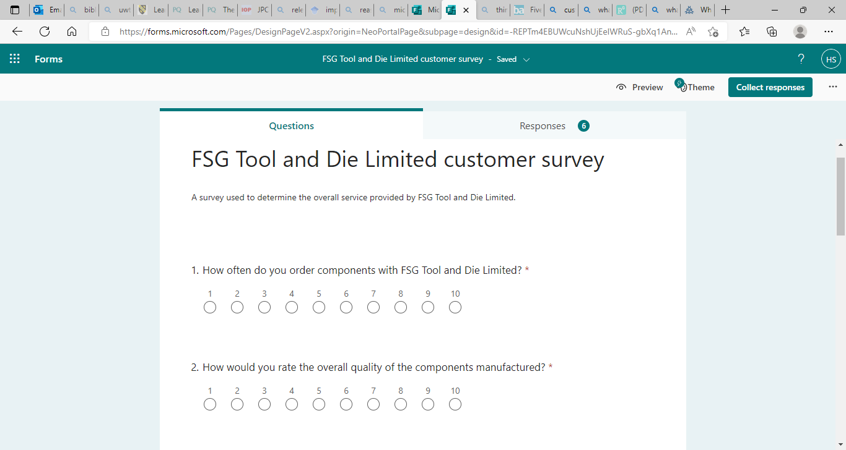
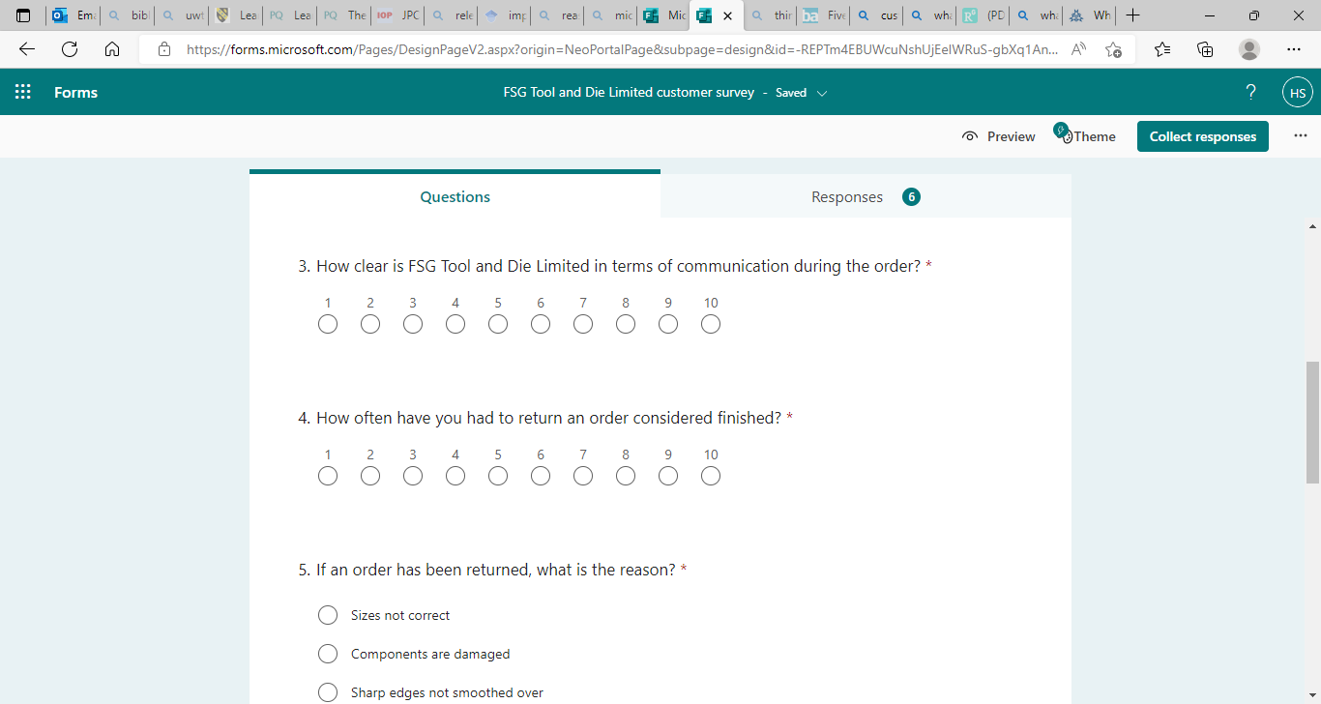

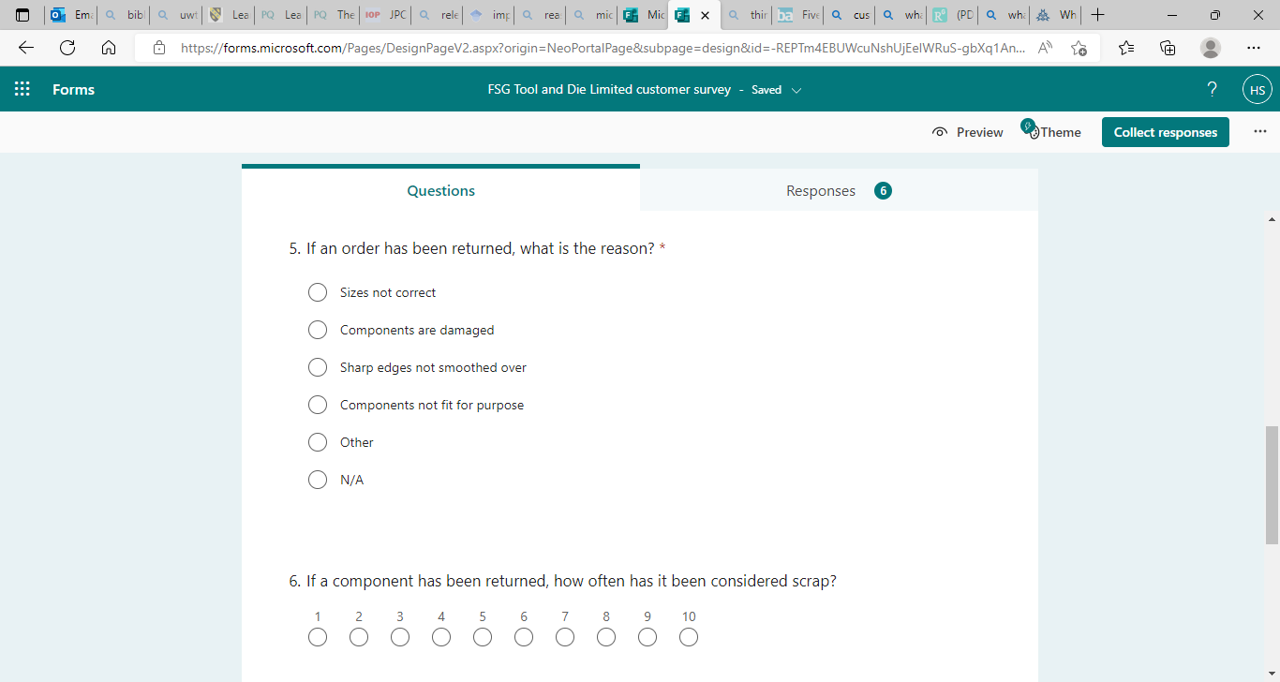
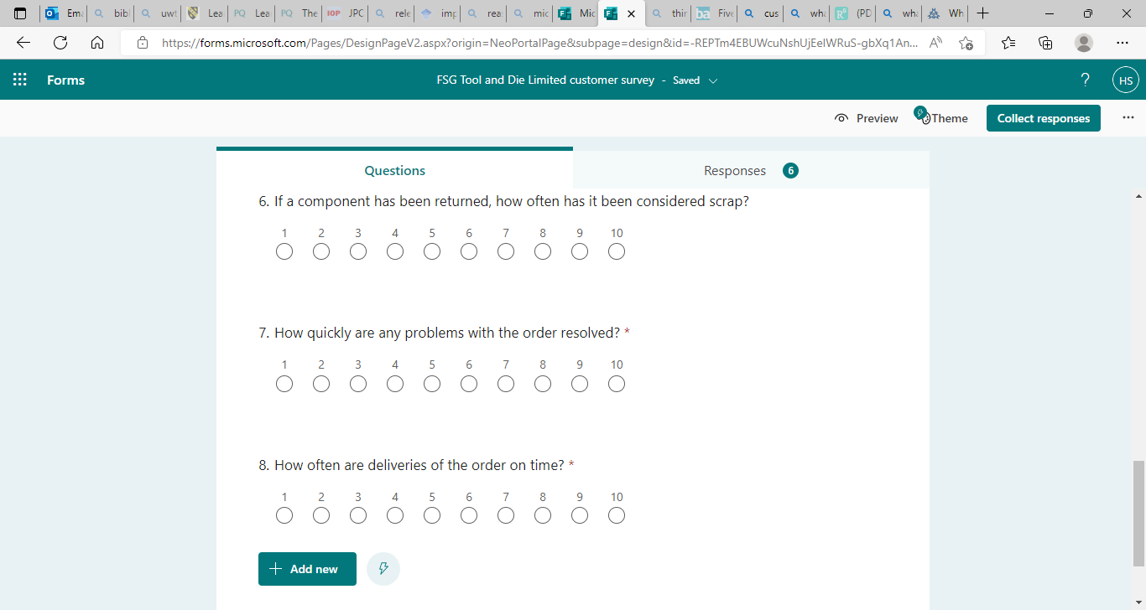

The results are as follows:
Name | Question 1 | Question 2 | Question 3 | Question 4 | Question 5 | Question 6 | Question 7 | Question 8
Customer 'A' | 10 | 7 | 5 | 2 | N/A | 1 | 8 | 10
Customer 'B' | 2 | 3 | 5 | 8 | Sizes not correct | 0 | 5 | 8
Customer 'C' | 10 | 6 | 7 | 6 | Sizes not correct | 4 | 3 | 7
Customer 'D' | 1 | 2 | 4 | 8 | Sizes not correct | 8 | 2 | 8
Customer 'E' | 8 | 4 | 4 | 4 | Sharp edges not smoothed over | 2 | 10 | 8
Customer 'F' | 8 | 4 | 7 | 6 | Components are damaged | 4 | 4 | 7

At the time of making the questionnaire no customer names were mentioned due to confidentiality reasons. This is why it was decided to name them customers ‘A’ to ‘F’. From looking at the results, it can be seen that most customers have returned an order often. This goes hand in hand with the overall quality. From conducting this questionnaire, it has been found that there is space for improvement from a quality perspective. Improving quality has the potential to improve overall customer satisfaction by providing better components more consistently.

4.2 Graph of complaints

The number of customer complaints was considered before starting this project. The graph has a steady trend, until the last six months of 2021 where it spikes. Further details of these complaints were found through the means of documents showing the complaints, as well as retrieving the voice of the customer through the means of the sales engineer and quality manager.

4.3 Axium valve seat

The first complaint looked into was the ‘Axium valve seat’. This was returned due to the components having details etched onto them despite this not being requested by the customer.

Five whys

Why? – Because it was specified on the part ticket.
Why? – Planning team implemented this.
Why? – To be able to determine which parts they are.
Why? – To avoid any confusion with the various number of components being produced.
Why? – Because a variety of components are made for this customer.

It was concluded that the components were etched because a variety of components are made for the customer, therefore it was thought to be necessary to keep track of them.

Ishikawa

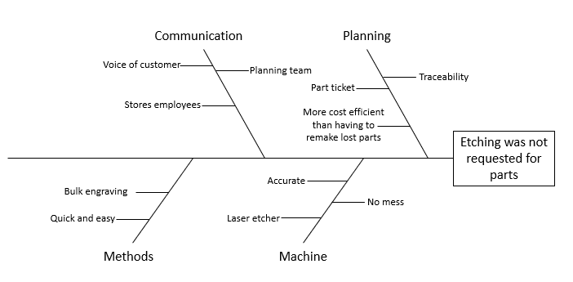

The same conclusion was found after conducting an Ishikawa diagram.

FMEA

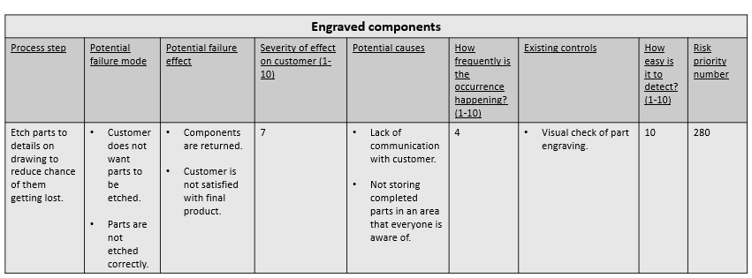

The FMEA also came to the same conclusion as the Ishikawa diagram, where it was done to keep track of the components. Despite this, the customers did not want them to be engraved. This could come down to a lack of communication, which would give the inference that it was a systematic error as it specifies on the route packs to do so.

4.4 Axium valve

The second complaint looked into was for the same customer, however the complaint was much different. In this scenario out of centre machining caused an incorrect surface finish (runout) on the components.

Five whys

Why? – The workholding used was inadequate.
Why? – The workholding was not made concentric to the part required.
Why? – The workholding was not machined prior to holding the part.
Why? – Because they were already the size of the component.
Why? – They were used previously.

For the five whys it was found that the workholding was already to size from being used previously, which is why they were not re-machined to suit the components going onto the machine.

Ishikawa

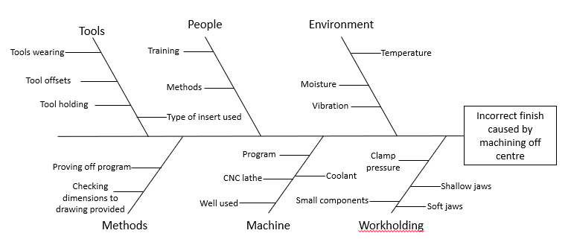

For Ishikawa, it is possible that this could have been caused by either lack of training or a method which went wrong. This is referring back to the conclusion made on the five whys with the workholding.

FMEA

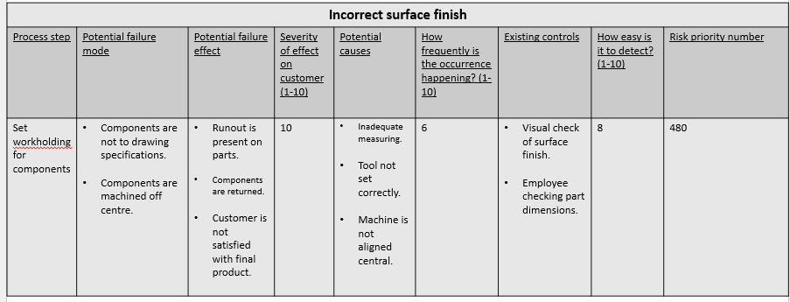
For the FMEA, it was reflected how the machine could have affected how the components came out the way they did. One of the ways this may have influenced the components was by the tools not being set correctly. This could have made it machine off centre, creating the runout found on the components. Regardless of this, there are still ways to check this before conducting the machining. The conclusion came down to human error during the set-up phase.

4.5 Coppice punch (A)

The third complaint was for a different customer. It was filed because the customer found that a tapped hole (M10) was out of position.

Five whys

Why? – The component was programmed incorrectly.
Why? – The employee misread the dimensions on the drawing.
Why? – Not much care taken when entering data into the machine.
Why? – The employee did not look over the drawing carefully.

A conclusion was drawn that there was not much care taken when programming the component from the five whys.

Ishikawa

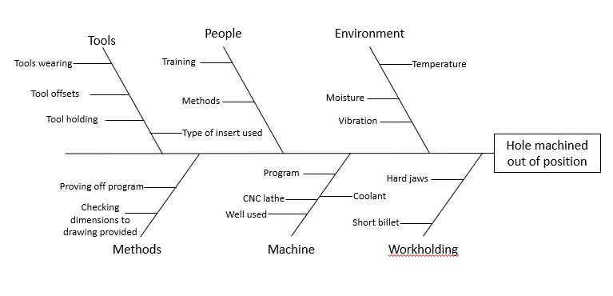
The Ishikawa had similarities to the previous complaint where it was potentially caused by either lack of training or the set up was ineffective.

FMEA

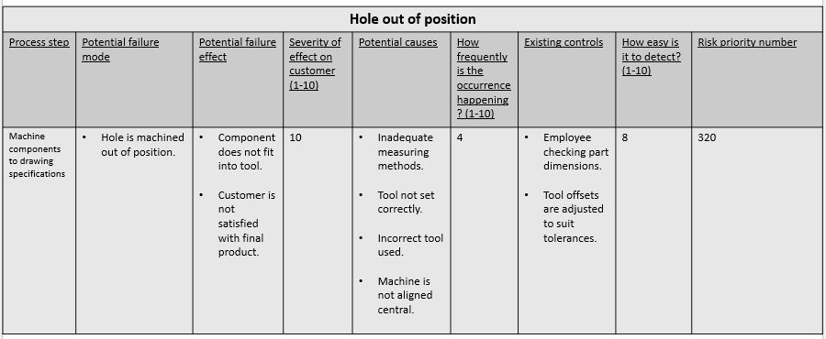

The FMEA was also very similar as the set up is the same. The only difference being the tools used and maybe different diameter workholding. This is due to the Axium components being much smaller than the punch mentioned here.
Looking at the results there was not much clear direction for the project to go in because despite finding that there were two complaints caused by human error and one caused by a systematic error, they were all completely different issues. From here the most recent complaint log was referred back to in order to find more complaints to use to try and get a clearer direction. From here two more complaints were picked to carry out the continuous improvement techniques on.

4.6 Coppice punch (B)

The next complaint looks into another component manufactured for Coppice, moreover another hole. For this scenario the dowel holes are not finish size.

Five whys

Why? – They were not machined to finish size intentionally.
Why? – Material needs to be kept in diameter to be finished later on.
Why? – The diameter would become distorted, taking the hole out of tolerance.
Why? – They went to get heat treated.
Why? – To alter the component properties to suit its purpose.

From conducting five whys it was found that the holes were machined undersize intentionally.

Ishikawa

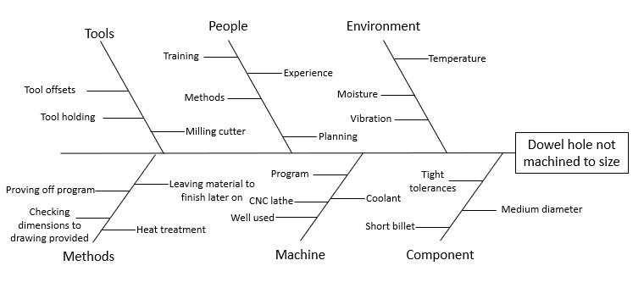
The same can be said for the Ishikawa diagram, moreover to allow for finishing of the size after the component has been through all of the necessary processes in order to achieve the tight tolerance.

FMEA

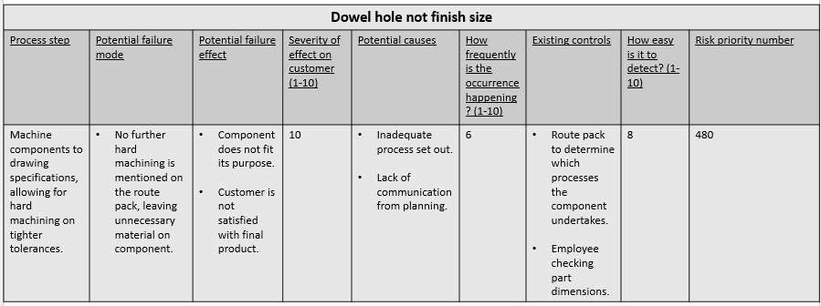

This complaint was interesting as the employee followed procedure for heat treated components. This being that material needs to be left on the more important dimensions to be finished later as the heat causes distortion. Despite the procedure being followed, the component was still technically wrong. This would be a systematic error as the hole was not given a step in the route pack to be finished later on. This was found on all three of the techniques carried out.

4.7 Oerlikon engagement rings

The fifth and final complaint was from Oerlikon, who are a long-term customer to FSG Tool and Die Limited. This brings another original complaint, being rust forming on the components during transportation.

Five whys

Why? – Because they were exposed to moisture.
Why? – Packaging may have been damaged during transportation.
Why? – Components were not protected appropriately for the transport being undertaken.
Why? – Components were not packaged correctly.

For the five whys the conclusion was that the components were not packaged correctly for the transportation they were going through.

Ishikawa

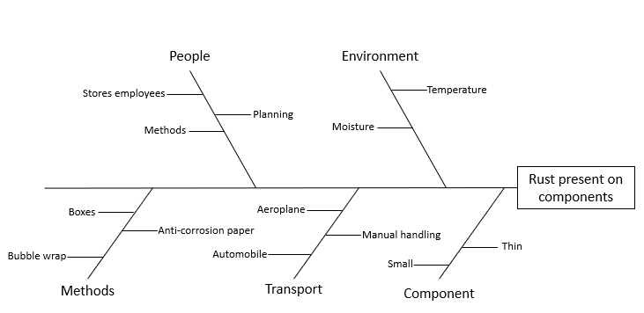
From the Ishikawa, it was found that they may have been exposed to moisture whilst being in the aeroplane. Here the methods of packaging were also considered.

FMEA

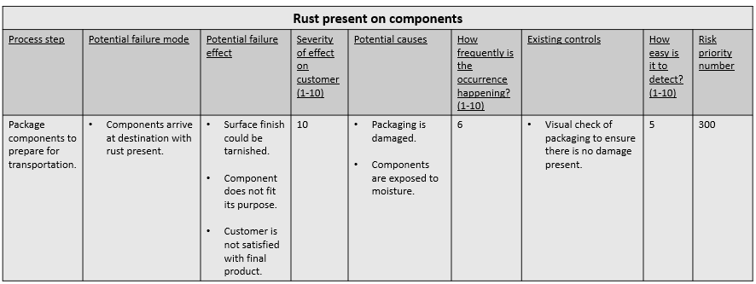

Finally, for the FMEA the same conclusions were drawn as the other techniques. This gives an outcome of human error.
Overall, Ishikawa has been the best technique to use for this part of the project as it allows for digging deep into every aspect involved around the error. The five whys have also been viable for this project, but it was also confirmed that due to its simplicity, it was very easy to consider a number of things without focusing much into them.
As there has now been five complaints where the continuous improvement techniques have been carried out, the directions in which the project will be able to go are much clearer. Three conclusions have come to potential human error, and two have been potential systematic errors. It may be easier to find information about the latter error due to the fact that there is a larger opportunity within FSG Tool and Die Limited to possibly interview employees and managers to find out about information such as any further procedures in place. This will allow for solutions to be drawn in the attempt of increasing customer satisfaction.

4.8 Potential solution for systematic errors

Using the fact that systematic errors have been found, along with the research around mistake proofing, potential solutions can be made in order to try and reduce the number of errors made. Upon finding out that the route packs are copied over on some occasions, the initial thought behind the solution would be to put something in place to prevent reaching a point where an improvement action report needs to be handed out. This brings the idea of creating a ‘standard’ route pack where it would act as a template for the planning team to consider when creating new route packs. With that being said, the problem with this is that there are so many different types of components to consider. Examples of this being parts of a tool which can consist of punches, dies, bolsters, pillars, etc. Due to them all being manufactured with different processes, this may not be the best solution, moreover a template would have to be made for each category of component produced. The next idea is to create a flow chart checklist to help guide the planning team to produce a route pack which takes all the details of the component into consideration. This would act as a guideline in order to prevent faulty route packs from being produced. The aim of this is to try and reduce the number of systematic errors occurring, which in turn could reduce the number of reworks, bringing down the number of customer complaints.
Yes
Are the components going to be heat treated?
Machine component(s) to drawing
Drawing is retrieved
(Start)
Stores issues material
Determine which machine is appropriate based off drawing and stock provided
Are there any tied up features?
No
Move to QA for final inspection
Yes
Specify that there needs to be material left on tied up features to be finished later
Yes
Move to stores for dispatch or to tool build for assembly
(End)

Are the features achievable in the operation?
No
No
Sub contract components to be heat treated
Determine which processes are appropriate for achieving tied up features
Machine component(s) to drawing
Are additional processes required?
Move to QA for final inspection
Sub con/ work to drawing to achieve requirements
Move to stores for dispatch or to tool build for assembly
(End)

Yes
No
The above flow chart has been made based around the prevention of an incorrect sequence of events by taking each phase of the component into consideration. It begins by a member of the planning team retrieving the drawing provided. From here, ‘stores’ is always first on the route packs because it is where the stock material is kept. Next, it is important to state which machine would be ideal to manufacture the component. Factors such as forms, features and shape can influence this decision.
A number of questions need to be asked once this has been decided. The first question is if there are any important features on the drawing as this will determine if there needs to be material left on the features to be finished later. If there are no features which need to be accurate, the component can be finish machined, where it can be taken to Quality Assurance for a final inspection. Finally, it can be moved to either stores for dispatch or tool build to be assembled.
If there are important features present, the next question which needs to be considered is if the component is going to be heat treated because this is a common procedure the components undertake. This process can distort the component in its current state. The result of this is an impact on sizes, therefore leaving material on the more accurate forms and features is important. The route pack will need to specify that the component is going to be heat treated, therefore this is the next step from this point of the flow chart.
If the component is not going to be heat treated, it needs to be determined if the dimensions can be achieved within the current operation. An example of this could be achieving a tapping fit within a dowel hole. If this is the case, it can be machined to drawing to not waste time involving an extra operation to finish this later. From here it can be checked by Quality Assurance, then taken to either stores for dispatch or tool build to be assembled. In the scenario that the tolerances are not achievable, it needs to be specified on the route pack that material needs to be left on the important features in order to be finished later.
Once the component has been machined with the material left for finishing sizes, or it has come back from heat treatment, the appropriate process is decided in order to achieve the more accurate tolerances. The type of tolerance is going to have an influence on which process the component is going to undertake. An example of this could be if a feature is related to flatness and parallelism, the component may be moved to grinding to achieve this. On the contrary, if the form is important but the flatness and parallelism is not as essential, the component may be hard turned.
Next, the component may specify on the drawing that it may need to go through an additional process such as polishing or tin coating. Polishing is much more common because the main product produced within FSG Tool and Die Limited are tools, the result of this is more commonly seeing a face or diameter having to be made to a specific surface finish. This is put into the flow chart as a question to consider as this is a general flow chart for all components, hence this is not always required. Coatings such as tin coating are not carried out within FSG Tool and Die Limited, therefore it is important to sub-contract such processes for third parties to carry out.
Finally, the components will have a final check from Quality Assurance to ensure all sizes are correct. They will then be moved to either stores for dispatch or to tool build for assembly.
In comparison to the flow chart created, there are a number of similarities with the current procedure. An example of this is to determine if the component needs to be heat treated in order for the final product to be achieved. This has been made something important to consider within the flow chart as it is a very common sub-contract process for components to undertake. It also ties in with the prevention of missing steps, which was one of the root causes observed when looking into customer complaints. The overall aim for creating the flow chart was to look into the current procedure, and furthermore create a more organized approach to making route packs. This will be more effective as it makes the current procedure clearer to follow. The expected result of this is reducing the number of ineffective route packs, moreover reducing the number of route packs being copied and printed incorrectly.
This approach can be improved further through the means of involving the machinists. Checks for a correct sequence of operations, also that all the appropriate operations are on the route pack can be things to consider. This allows for the use of the individual’s experience and common sense. The purpose of this is to add another layer of security in order to ensure that there will be no operations missing, or the potential of an incorrect sequence of operations. This is seen in the first complaint discussed where the components had their details etched onto them, despite this not being requested by the customer.

4.9 Implementation of systematic solution

In order for the found solution to be implemented, there needs to be clear communication throughout the whole planning team on the changes being made. It is also important to inform why this is happening as this gives reason to follow the applications in the first place.
As the above flow chart was going to be used to help create route packs, the idea will be proposed to the head of the team. If approved, a meeting could be held to communicate the changes. An electronic copy of the flow chart could also be made available so there is always access to the new process in case of confusion or misunderstanding. The significance of an electric copy is that if a physical copy was handed out, there is a chance of it being misplaced among other paperwork in use. Also the computers are always in use, furthermore this allows for easy access. As this is not a significant change to the current process, it is predicted that this will be easy for the planning team to adapt to.
As for the machinists, this will have slightly more impact on how they work. Despite the fact that the approach towards communicating the implementations can be the same, it involves adding another task to consider. This may bring the problem of simply forgetting to carry out the newly implemented task. After the operation specifying that stores issues material, another operation can be added to ensure that the machinist has checked the route pack to ensure that it has been done correctly. This will allow for the route pack to be checked prior to taking on a component. To confirm that it has been checked they can sign a box stating the individual has carried out the checks, similarly to how they can sign onto operations and the duration of time it has taken.

Conclusion

To conclude, the problem was identified through the means of a questionnaire handed in order to determine where they are any underlying issues in a number of categories. The results showed that customers of FSG Tool and Die Limited had returned an order often. The different types of complaints were tallied to find that out of the 100, 64% of the complaints were reworks.
From here the most recent complaint log was obtained, where five recent complaints were chosen. Three human errors and two systematic errors were identified. The systematic errors occurred off of the shop floor, which was the focus for a solution for this problem. With the found information, a flowchart checklist was comprised as a solution to guide the planning team to help generate successful route packs. As FSG Tool and Die Limited is a toolmaking company, the flowchart checklist was made with the manufacturing of tool components in mind. This allows for a larger range of components to have more consistent route packs.
The concept was improved further with the machinists in mind, giving them the chance to check over the route pack and use their experience to determine if the component can be made successfully. This also adds another layer of security if anything was to be incorrect.
Finally, as mentioned earlier in the report, this will be easy to implement for the planning team because it shares similarities with the current procedure. Another operation can be added to ensure that the machinist has checked the route pack to ensure that it has been done correctly. This will be applied to help the machinists adapt to the change in procedure.

Recommendations

As the project is ongoing, it is not yet fully complete. This gives the opportunity to give further recommendations as to where it could potentially go next.

- The current state of the project can be moved forwards by reviewing how well the implementations have been after a set amount of time. This could be a time period of six months to a year in order to determine if it has had an impact on the number of customer complaints. Between the complaints, the numbers can be compared. Different types can once again be observed in order to see if the number of reworks, or other types of complaint have reduced as a result of the changes.

- Another part of the project, adding onto the first point made could be to carry out a cost analysis based off of the assumption that something has changed. This could be done by analysing the additional cost per hour of manufacturing the components for the reworks, as well as any extra material purchased for any components that have to be remade. This can be compared with the new figures found, as well as the company turnover to determine if there is any cost savings.

- The project could also be backtracked to look into an additional solution to help reduce the number of human errors occurring. From here further research could be conducted in order to allow for more types of solutions to be considered. This will be more focused towards the machinists on the shop floor as the human errors all occur here. An example of this could be implementing the ‘first off check’ to the program. This involves another machinist checking over the program in order to determine if it is correct, which ties in with one of the complaints where a hole was out of position.

References

- Biesok & Wyród-Wróbel (2011). Customer satisfaction – Meaning and methods of measuring. Chapter 2. Page 23. Retrieved 10/09/2022.

- CommenceCRM (2018). What Factors Influence Customer Satisfaction?. Retrieved 10/09/2022 from Commence.
What Factors Influence Customer Satisfaction? (commence.com)

- Railton L. (2022). Procedures for dealing with unsatisfied customers. Interviewed by Harveer Singh on 20/07/2022.

- Sharma (2022). What is Kaizen? Kaizen process, strategy and examples. Retrieved 10/09/2022 from TechJockey.
What is Kaizen? | Kaizen Process, Strategy and Examples (techjockey.com)

- Vesna Janjić et al (2019). Key success factors and benefits of Kaizen implementation. Vol. 32. Page 98. Retrieved 10/09/2022.

- Du et al (2014). New failure mode and effect analysis: An evidential downscaling method. Page 737. Retrieved 10/09/2022.

- Stamatis (2003). Failure mode and effect analysis: FMEA from theory to execution. Second edition. Pages 45,46. Retrieved 10/09/2022.

- Xu et al (2002). Fuzzy assessment of FMEA for engine systems. Issue 1, Volume 75. Page 19. Retrieved 10/09/2022.

- Ilie & Ciocooiu (2010). Application of fishbone diagram to determine the risk of an event with multiple causes. Vol. 2. Issue 1. Page 1. Retrieved 17/09/2022.

- Landau (2022). What is a stakeholder? Definitions, types & examples. Retrieved 17/09/2022 from ProjectManager.
What Is a Stakeholder? Definitions, Types & Examples - ProjectManager

- Channell (2021). The five whys: Getting to the root of a problem quickly. Retrieved 17/09/2022 from TSW Training.
The Five Whys: Getting to the Root of a Problem Quickly | TSW Training

- Serrat (2009). The five whys technique. Page 3. Retrieved 17/09/2022.

- Dauncey R. (2022). Customer complaint details (A). Interviewed by Harveer Singh on 10/10/2022.

- Dauncey R. (2022). Customer complaint details (B). Interviewed by Harveer Singh on 10/11/2022.

- Jones M. (2023). Route packs. Interviewed by Harveer Singh on 28/03/2023.

- Singh & Singh (2013). Continuous improvement philosophy – Literature review and directions. Page 75. Retrieved 10/03/2023.

- Karthick et al (2021). Numerical analysis of modified tooth in spur gear for increasing the performance using fool proof technology. Page 5863. Retrieved 17/03/2023.

- Cambridge Dictionary (2023). Foolproof. Retrieved 17/03/2023 from Cambridge Dictionary.
FOOLPROOF | English meaning - Cambridge Dictionary

- Bland (2022). Poka-yoke in manufacturing: Methods, pros, cons & examples. Retrieved 17/03/2023 from Unleashed.
Poka-yoke in Manufacturing: Methods, Pros, Cons & Examples - Unleashed Software

- Mecholic (2023). Fool proofing of location devices. Retrieved 17/03/2023 from Mecholic.
Fool Proofing of Location Devices | Mecholic

