ASSIGNMENT

University of Wales Trinity Saint David
Powertrain & Sustainability
M6X01206
Combustion and Emission Study:
Modelling Fuels and NOx
XILONG SONG
1904076

Introduction
In this study, the combustion and emissions characteristics were investigated numerically. Author has demonstrated his knowledge and understanding on how to calculate the mass percentage, determine the AFR and analyse enthalpy in task 1. For the task 2, author use EXCEL compute the $NO_{x}$ PPM stochometric with many assumptions and plot a graph for it as fuel equivalence ratio increasing from 0.6 to 1 as different degreases. Before working out the PPM, author had count different enthalpy and used the Zeldovich model.

Contents
Introduction 2
TASK 1 4
Calculate the mass percentages 4
Calculate the air fuel mass ratio 4
calculate the lower heating value of the blend 5
explanation of enthalpy of formation 6
Explain the difference 7
Calculate the mass of CO2 7
Describe the properties of an “Ideal” fuel 7
TASK 2 8
plot a graph of NOx PPM as a function of equivalence ratio on the lean side 8
calculate the effect of adding E. G. R 16
Conclusion 20
Reference 21

TASK 1

- Calculate the mass percentages
According to the task description, assuming methanol and isooctane are both 0.5 molar. Then the mass percentages as follow:
$C_{8}H_{18}$ $12×8+18×1=114$
$CH_{3}OH$ $12×1+16×1+4×1=57$
$C_{8}H_{18}$ $\frac{114×0.5}{114×0.5+57×0.5}=78.08\%$
$CH_{3}OH$ $\frac{57×0.5}{114×0.5+57×0.5}=21.92\%$
- Calculate the air fuel mass ratio
$$0.5C_{8}H_{8}+0.5CH_{3}OH+X\left(O_{2}+3.76N_{2}\right)→n_{1}CO_{2}+n_{2}H_{2}O+n_{3}N_{2}$$
$$n_{1}=0.5×8+0.5×1=4.5$$
$$n_{2}=\frac{0.5×18+0.5×4}{2}=5.5$$
$$X=\frac{4.5×2+5.5×1-0.5}{2}=7$$
$$n_{3}=7×3.76=26.32$$
Then
$$0.5C_{8}H_{8}+0.5CH_{3}OH+7\left(O_{2}+3.76N_{2}\right)→4.5CO_{2}+5.5H_{2}O+26.32N_{2}$$
$$AFR by mass=\frac{Air Mass}{Fuel Mass}$$
$$AFR br mass=\frac{7×\left(2×16+3.76×2×14\right)}{114×0.5+57×0.5}=\frac{960.96}{73}=13.16$$
- calculate the lower heating value of the blend
According to the table
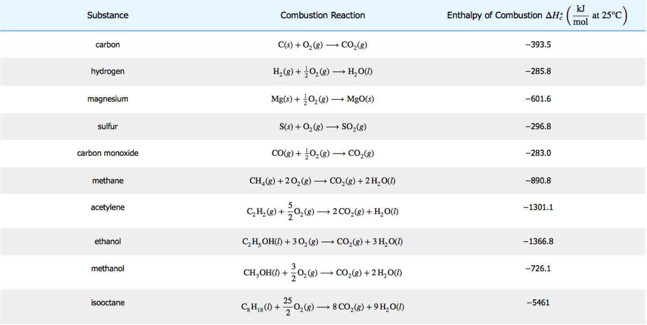
We should be able to do more complex fuels by using standard tables and fuel data,
$$0.5C_{8}H_{8}+0.5CH_{3}OH+7\left(O_{2}+3.76N_{2}\right)→4.5CO_{2}+5.5H_{2}O+26.32N_{2}$$
$$∆H_{c}^{o}=-726.1×0.5+\left(-5461×0.5\right)=-3093.55KJ/mol$$
$$\frac{-3093.55×1}{114×0.5+32×0.5}=42.38 MJ/kg$$
- explanation of enthalpy of formation
According to the table, it shows a detailed list of fuel characteristics for a range of fuels. 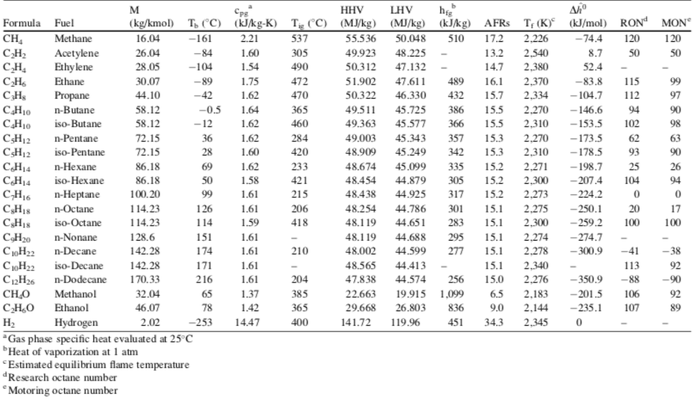
We can see $∆H_{f}^{o}$ for iso-octane is -259.2KJ/mol, $∆H_{f}^{o}$ for $CH_{4}O$ is -201.5KJ/mol, and we need $∆H_{f}^{o}$ for ${CO}_{2}$ is -393.5KJ/mol, $∆H_{f}^{o}$ for water (l) is 285.8KJ/mol and $∆H_{f}^{o}$for water (g) is -241.8KJ/mol
$$0.5C_{8}H_{8}+0.5CH_{3}OH+7\left(O_{2}+3.76N_{2}\right)→4.5CO_{2}+5.5H_{2}O+26.32N_{2}$$
Enthalpy need for product =$259.2×0.5-285.8×0.5=-13.3MJ$
Enthalpy released from reaction=$4.5×393.5+5.5×241.8=3100.65MJ$
Then the net enthalpy is $3100.65-13.3=3087.3MJ$
$$LHV : \frac{3087.3}{114×0.5+32×0.5}=42.29MJ/mol$$
So burning 1k mol of C8H18 at constant pressure releases 3087.3 MJ of heat energy (enthalpy)
- Explain the difference
The ‘Lower Heating Value’ is the term used when H2O is a gas (LHV) and the ‘Higher Heating Value’ is the term used when H2O is a gas (HHV). Therefore, we can determine isooctane and compared with the above table:

$$HHV:\frac{3100.65-(259.2×0.5+241.8×0.5)}{114×0.5+32×0.5}=39.04MJ/mol$$
$$LHV : \frac{3087.3}{114×0.5+32×0.5}=42.29MJ/mol$$
f)Calculate the mass of CO2$$0.5C_{8}H_{8}+0.5CH_{3}OH+7\left(O_{2}+3.76N_{2}\right)→4.5CO_{2}+5.5H_{2}O+26.32N_{2}$$
We can see: $1mol fuel→4.5molCO_{2}$
Then $1kg fuel→\frac{1000}{114×0.5+32×0.5}×4.5molCO_{2}=61.64molCO_{2}$
$$61.64molCO_{2}=61.64×\left(12+16×2\right)=2712.33kgCO_{2}$$

g) Describe the properties of an “Ideal” fuel.
The ideal fuel is a kind of fuel that does not emit harmful gases during combustion, with low cost, high heat output and low ignition temperature, more heat per unit weight. An ideal fuel is readily available. an ideal fuel is cheap. An ideal fuel burns easily in the air at a moderate rate. It releases a large amount of energy and should not leave behind any undesirable substances which can be harmful to us. It should not affect the environment adversely.
(Roger, n.d.)When the fuel totally burned, each 1kg fuel needs consume 13.16kg air and release 42.38MJ energy. It also produces 2713.33kg carbon dioxide.

TASK2
- plot a graph of NOx PPM as a function of equivalence ratio on the lean side
According to Flame temp is when 8Фx Poly CO2 + 9Ф x Poly H20 + x(1-Ф) Poly O2 + 47 N2, $φC_{8}H_{18}+12.5\left(O_{2}+3.76N_{2}\right)→n_{1}CO_{2}+n_{2}H_{2}O+n_{3}O_{2}+n_{4}N_{2}$
and from Ф = 0.6 to Ф = 1.0Ф in 0.5 steps from Ф of 0.6 to 0.95 and 0.01 steps from Ф of 0.95 to 1.0, we can calculate every n1, n2, n3, n4 as B E F G H follow:
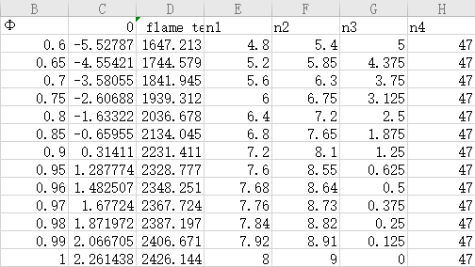
After it we can also calculate the enthalpy
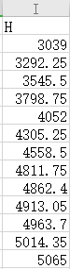
When Ф = 0.6, the enthalpy is -3039MJ/mol, we need calculate the temperature with the fuel database for $CO_{2}$, $H_{2}O$, $O_{2}$ and $N_{2}$,
At 1700K
$$4.8CO_{2}+5.4H_{2}O+5O_{2}+47N_{2}$$
$$4.8×73.44+5.4×57.78+5×47.94+47×45.42=3038.964MJ$$
As can be seen, the combustion temperature is lower running lean, but it burns more slowly. This is because burning 40% lean creates 10% less net heat released and uses 40% less fuel. When it is up to 1700K, which needs 3038.964MJ
At 1800K
$$4.8×79.4+5.4×62.71+5×51.66+47×48.97=3279.64MJ$$
We have determined the temperature is correct.
$$\frac{T-1700}{1800-1700}=\frac{3039-3038.964}{3279.644-3038.964}$$
T=1700.015
When Ф = 0.9, the enthalpy is -4558.5MJ/mol
At 2200K,
$$7.2CO_{2}+8.1H_{2}O+1.25O_{2}+47N_{2}$$
$$7.2×79.4+8.1×62.71+1.25×51.66+47×63.3=4476.8MJ$$
This is because burning 10% lean creates 10% less net heat released and uses 10% less fuel.
At 2300K
$$7.2CO_{2}+8.1H_{2}O+1.25O_{2}+47N_{2}$$
$$7.2×109.6+8.1×88.4+1.25×70.6+47×66.9=4737.7MJ$$
$$\frac{T-2200}{2300-2200}=\frac{4590-4476.8}{4737.7-4476.8}$$
T=2243.38K
Then we can calculate every flame temperature with different Ф, 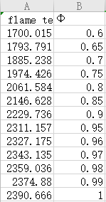
The flame temperature is not equal to the combustion zone temperature. flame temperature.Represents the initial temperature at the start of combustion, while the combustion zone. The temperature increases with the increase of cylinder pressure, which can be calculated with ideal value Gas law, except the ratio of specific heats. We know the burn zone temperature increases as the cylinder pressure rise, and we have n=1.17 which can be substitute calculation as the equation:
$$n=\frac{C_{p}}{C_{v}}$$
Molar specific heat is the amount of heat which Temperature rise 1 ° K required to increase a substance per 1 KMOL. Two types of specific heat at constant pressure and constant. The ratio of volume to specific heat is the ratio between these two values, also known as Variable index:
$$PV^{n}=constant$$
$$\frac{T_{2}^{n}}{T_{1}^{n}}=\frac{P_{2}^{n-1}}{P_{1}^{n-1}}$$
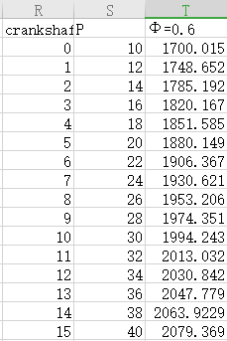
We also have the rise in pressure after start of combustion is linear and of a value 2 bar per degree from a cylinder pressure of 10 bar start of combustion, to a peak value of 40 bar. (Willim) , the crankshaft increases by 1 degree from 0 degrees.
$$1800×\frac{360}{60}=°/sec$$
Using the Zeldovich model
$$\frac{4.7×{10}^{13}×\left[N_{2}\right][O_{2}]^{\frac{1}{2}}∙exp⁡(\frac{-E_{A}}{RT})}{1800×6}=\frac{\frac{kmols}{m^{3}}}{°}$$
The volume of chamber is 40ccs and depending on the measurement and assumption of the "rate constant", the values to be used vary. For our work, we will use the version described by Günterp. Merker in "Simulated Combustion". Then $-E_{A}$ is-67837, then we have

$\frac{4.7×{10}^{13}×\left[N_{2}\right][O_{2}]^{\frac{1}{2}}∙exp⁡(\frac{-67837}{T})}{1800×6}×40×{10}^{-6}=\frac{kmols}{°}$

However, the equation can only be regarded as a rough estimate, because the reverse reaction will slow down the actual no production, so it predicts that the NO concentration is too high. Before using Zeldovich model to calculate NOx production rate, the concentration of nitrogen and oxygen in combustion must be determined first. This requires the introduction of a new variable alpha, which represents the actual amount of KMOL in the mixture. By multiplying the previous equilibrium chemical equation by alpha, the correct number of KMOL for a combustion cycle can be obtained.
$$φC_{8}H_{18}+12.5\left(O_{2}+3.76N_{2}\right)→α(n_{1}CO_{2}+n_{2}H_{2}O+n_{3}O_{2}+n_{4}N_{2})$$
We assume that the pressure into the cylinder is 1 bar atmospheric pressure and the temperature is 20 ° C. Therefore, the number of KMOL of the mixture absorbed per cycle:
PV=n RT
$$n=\frac{{10}^{5}×(400×0.5)∙{10}^{-6}}{8314×293}$$
$$n=8.21×{10}^{-6}kmols$$
Then $α\left(φ+12.5\left(1+3.76\right)\right)=6.16×{10}^{-6}kmols$
$$∂=\frac{8.21×{10}^{-6}}{φ+12.5×(1+3.76)}$$
When Ф = 0.6 $∂=13.7×{10}^{-6}kmols$
α changes with the change of fuel equivalence ratio, because at a lower ratio, there is less fuel in the mixture, thus changing the concentration of oxygen and nitrogen.And now we can calculate the nitrogen and oxygen concentration as their respective coefficients.
$$\left[O_{2}\right]=\frac{5×α}{40×{10}^{-6}}=0.01708$$
$$\left[N_{2}\right]=\frac{47×α}{40×{10}^{-6}}=0.16052$$
We have got $\frac{4.7×{10}^{13}×\left[N_{2}\right][O_{2}]^{\frac{1}{2}}∙exp⁡(\frac{-67837}{T})}{1800×6}×40×{10}^{-6}=\frac{kmols}{°}$
Then we can calculate the $NO_{x}kmols/cycle$
$$\sum_{x_{soc}}^{x_{eoc}}{(\frac{4.7×{10}^{13}×\left[N_{2}\right]\left[O_{2}]^{\frac{1}{2}}∙\exp\left(\frac{-67837}{T}\right)\right)}{1800×6}×40×{10}^{-6})}=\frac{kmols}{cycle}$$
In the combustion process, the increase of pressure leads to the increase of temperature, so the dissociation of nitrogen and oxygen is more likely to lead to the increase of nitrogen oxide.
$$PPM=\frac{NO_{x}kmols/cycle}{total exhaust kmols}×{10}^{6}$$
$$Total exhaust kmols=α(8φ+9φ+n_{3}+47)$$
When Ф = 0.6, finally PPM=11.4709
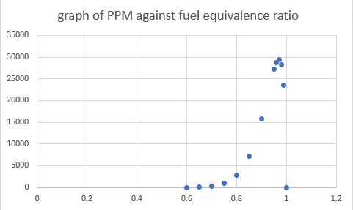

- calculate the effect of adding E.G.R
In internal combustion engines, exhaust gas recirculation (EGR) is a nitrogen oxide emissions reduction technique used in petrol/gasoline and diesel engines. EGR works by recirculating a portion of an engine's exhaust gas back to the engine cylinders. (JSTOR, 2009)
Adding EGR requires a recalculation of the balanced isooctane chemical equation, assuming adding 10% of the exhaust gases back into the combustion gives the following equation:
$$\left(φC_{8}H_{18}+12.5\left(O_{2}+3.76N_{2}\right)\right)+0.1(n_{1}CO_{2}+n_{2}H_{2}+n_{3}O_{2}+n_{4}N_{2}→1.1×(n_{1}CO_{2}+n_{2}H_{2}O+n_{3}O_{2}+n_{4}N_{2})$$
When Ф = 0.97, the volumetric efficiency is 40% and assuming EGR levels up to 20% of the air + fuel contents. And assume universal gas constant is 8314 J/ (KOML*K), polytropic index for burned zone up to peak pressure is 1.17
$$(8×0.97×1.1)CO_{2}+(9×0.97×1.1)H_{2}O+(12.5×(1-φ)×1.1)O_{2}+(47×1.1)N_{2}$$
$$1.1\left(0.97×C_{8}H_{18}+12.5\left(O_{2}+3.76N_{2}\right)\right)→8.536CO_{2}+9.603H_{2}O+0.413O_{2}+51.7N_{2})$$
the $\left[O_{2}\right] and \left[N_{2}\right]$ is constant, calculate different EGR of 0%, 5%, 10%, 15%, 20% and we have
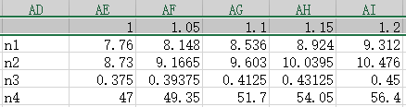
When EGR=0%, $PV=nRt$, n=$6.56816×{10}^{-6}$. With the EGR increasing from 0% to 20%, the KMOLS of mixture drawn is from $n×(1+0\%)$ to $n×(1+20\%)$. And then alpha can be carried out to $1.08618×{10}^{-6}$.
$$\left[O_{2}\right]=\frac{n_{3}×α}{40×{10}^{-6}}$$
$$\left[N_{2}\right]=\frac{n_{4}×α}{40×{10}^{-6}}$$
As the EGR increasing from 0% to 20%, $O_{2}$ is determined with 0.00102, 0.00107, 0.00112, 0.00117, 0.00122. $N_{2}$ is calculated with 0.12763, 0.13401,0.140390.14677,0.15315.$NO_{x} per cycle$ can be calculated as the same step with a) and $PPM=\frac{NO_{x}kmols/cycle}{total exhaust kmols}×{10}^{6}$ and with the graph above we can determine the total exhaust which is increasing.
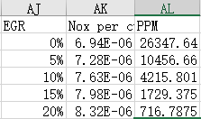
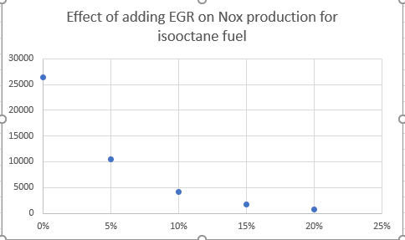
so we can see EGR can reduce the production of $NO_{x}$.

Conclusion

This report is divided to two parts-task 1 and task 2. Task 1 has done many calculations which includes mass percentages of methanol and isooctane in this blend, air fuel mass ratio for stochiometric combustion in air etc. Author also demonstrated the steps on how to work out them. Besides that, author has known the properties of ideal fuel and it is a kind of fuel that does not emit harmful gases during combustion, with low cost, high heat output and low ignition temperature, more heat per unit weight. In task 2, author work out the flame temperature and burn zone temperature, then using Excel to plot a graph of NOx PPM as a function of equivalence ratio on the lean side of stochometric. After that author has determine EGR can affect the production of $NO_{x}$ and higher EGR means lower $NO_{x}$ production which contribute to the formation of smog and acid rain and affect tropospheric ozone.

Reference
JSTOR. (2009). Wikipedia. Retrieved from https://en.wikipedia.org/wiki/Exhaust_gas_recirculation
Roger. (n.d.). https://byjus.com/chemistry/fuel-types/. Retrieved from BYJUS.
Willim. (n.d.).
Williams, O. (n.d.). combustion.
Williams, O. (n.d.). Enthalpy and Fuel.
Williams, O. (n.d.). Flame Temperatures.
Williams, O. (n.d.). Zeldovich Williams.

