A Report Focusing On:

Construction Materials – Steel Frame

Prepared For:

Alan Nantel

Created By:

J. Hughes

Date Completed:

4th December 2022

Table of Contents
Page Number
1.0 Summary 3
2.0 Steel Frame Durability 3
3.0 Stainless Steel Production 5
4.0 Environmental Affect 6
5.0 Ease of Assembly 6
6.0 Steel Comparison to Concrete 7
7.0 Conclusion 7
8.0 References 8
9.0 Appendices 9

1.0 Summary

1.1 The Burj Khalifa
Steel can be transformed into almost any shape imaginable, using steel in construction allows for the most innovative buildings known to man to be built. One of the most spectacular steel frame buildings to be built is the Burj Khalifa, Dubai, known for being the tallest building in the World. It is a multipurpose building designed to host a variety of commercial and residential occupants, as well as being able a large hospitality and entertainment events space. This Building was created very specifically, with various elements coming into discussion on how it was to be built. I will be researching these various elements and discussing why it was built the way it was.

1.2 Environmental and Social Sustainability
Full construction of The Burj Khalifa took six years. The occupants, both commercial and domestic, in the surrounding area, would have had to deal with the noise and constant delivery of materials during this time. According to Commercial Interior Design “The overall construction process will have used 330,000 m³ of concrete and 39,000 tonnes (43,000 ST; 38,000 LT) of steel rebar” Commercial Interior Design (2021). These extremely high figures only represent two of the materials used. Transport of these materials would have been regular and very often so would have caused high levels of pollution in the area. Due to the large stature of the building, many materials would be delivered on a daily basis, resulting in lots of new jobs being created. Various sources claim that there were as many as 12,000 workers that contributed to the production of the worlds tallest building. These jobs came at a cost for many workers though, according to Amanda Kloer “researchers say migrant workers in Dubai average only $175 a month — less than $0.60 an hour.” (Amanda Kloer, 2010). This figure showing that workers are brought in to the country and receive much less pay than what is deserved. Many of the workers protested against the poor salary but would be met with threats of deportation, due to the power being out of their hands, they had to settle for what they already had.

2.0 Steel Frame Durability

2.1 Earthquake Proof
Dubai isn’t commonly known for earthquakes, but when a building is being considered for construction it must consider the chance that it could occur. In 2013, there was an earthquake in Pakistan with a 7.8 magnitude, this had an impact on the UAE as it was one of the biggest earthquakes Dubai has ever felt. According to Siobhan Downes “Following that 2013 quake, Dubai Municipality revised its seismic code, ruling that any new towers with more than 10 floors would have to be built to withstand a 5.9-magnitude quake” (Siobhan Downes, 2022). Luckily the Burj Khalifa, built in 2010, was already designed to withstand a 7.0 magnitude earthquake. To achieve this ability of being able to withstand this level of earthquake, the building is equipped with a mass dampener/harmonic absorber within it to absorb strong vibrations. The Burj Khalifa is built using stainless steel. Stainless steel provides a high tensile strength. In the event of an earthquake the steel will be able withstand high vibrations.

2.2 Heat Resistance
In Dubai there are extreme heats all year round and the Burj Khalifa had to be built to able to withstand this. Temperatures in Dubai can reach as high as 55 degrees Celsius making heat resistant materials a necessity. The stainless-steel frame of the Burj Khalifa provides a high heat resistance due to its high melting point. Stainless steel has its high heat resistance due to its oxidation resistance. SRS Group say that “This enables it to retain its strength under harsh and extreme temperature conditions very effectively” (SRS Group, 2022). This was the reason stainless steel was used, it is as effective to this this day as it was when the Burj Khalifa was first built due to this. The Burj Khalifa also uses a thermal ice-storage facility to ensure that the building can withstand the extreme temperatures. This helps to provide a much safer and comfortable experience for those visiting and staying at the building. Alfa Laval state that “Using Alfa Laval plate heat exchangers, the ice slurry, built up in a tank, store the cooling energy that is later released, through the pipelines, to the entire indoor air conditioning and tap water systems” (Alfa Laval, 2022). This system helps to provide the inside spaces within Burj Khalifa with a much cooler temperature than what it would be if this was not in use.

2.3 Wind Protection
The wind levels at the top of the tower are very high due to the extraordinary height of the structure. The shape of the Burj Khalifa changes as the height increases to minimise the wind load acting upon it. Each section of the structure has a unique shape, this is to ensure that the building responds appropriately to various wind types and speeds that can vary at different heights. These unique structural designs prevent the wind from being able to organise and act as one large force upon the tower. Like many other tall structures, the Burj Khalifa utilises a Y-shaped method. According to Nicolas Tran, “The unique Y-shape mainly serves to redirect wind flow, save material, and improve aesthetics” (Nicolas Tran, 2020). This wind flow redirection doesn’t entirely eliminate vortices but leaves them with much smaller pockets to exist within. This helps to reduce the chances of the wind forming a regular rhythm and acting as one large force against the building.

3.0 Stainless steel production

3.1 The Melting of Steel
The first step in stainless-steel production is the melting of raw materials. Raw materials are placed in a furnace and are heated up to their melting point. According to Marlin Steel “This process can take anywhere between 8 and 12 hours” (Marlin Steel, 2020). This process does take a lengthy period of time but is much better for the environment than using a blast furnace. Green Car Congress states that “Steel produced by electric arc furnace (EAF) steelmakers in the US has a carbon intensity that is approximately 75% lower than traditional blast furnace steelmakers. This is the finding of an independent study of steelmakers worldwide conducted by CRU Group” (Green Car Congress, 2022). This is good evidence that the technology is improving, but will still have a negative impact on the environment due to the carbon dioxide output in the manufacturing process.

3.2 Removal of carbon
Once the raw materials are melted, they are then put through a further process to remove the excess carbon. This process is carefully completed as the carbon content is the dominant factor in the steel’s tensile strength. A high tensile strength steel generally contains 0.5-0.9% carbon so precision is vital. The product remaining is then stirred in order to distribute the elements neutrally so that each area of the steel is of the same nature. Generally, the steel will be hot rolled when used to form beams or columns, so this would have been the method used to form the Burj Khalifa.

3.3 Shaping of the Steel
After the stages listed above are complete, the steel is ready to undertake cutting and shaping. The steel will either be cut using a machine saw or a cutting torch. If the steel is thin, it may be cut using a laser operated machine instead. The steel is then ready to have the finishing applications. As an example, the metal would need to be grinded to remove sharp edges where applicable and could often need surface grinding to make it smoother.

3.4 Testing of Finished Product
Once all finishing applications are made, the material is ready to undergo testing. For steel that is used structurally, there are many detailed visual and manual tests required. A common test on steel structure is a magnetic particle test for welding, this test is non-destructive. The magnetic particle test helps to detect defects and any irregularities on the surface of the steel. Visual Testing on welding is another form of testing. Noel Mades says that “it is inexpensive and quick to perform.” (Noel Mades, 2018). This makes this form of testing very common due to its ease of accessibility. The weld inspection does not require any specialist equipment and can be done before, during and after a weld process.

4.0 Environmental Effect

4.1 Mining of Steels Elements
“Stainless steel is an iron alloy with added elements such as chromium, nickel, silicon, manganese, nitrogen and carbon. The properties of the final alloy can be fine-tuned by altering the amounts of the various elements.” (Metal Supermarkets, 2016). This shows that stainless steel is a non-renewable product but can be re-used when melted back down. To produce steel, iron is required to be mined from the ground and this can lead to various forms of pollution to its surrounding area. The machinery used to mine for iron is very loud and can cause inhabitants of the area to leave. Long exposure to noise pollution at this level can cause many health issues, hearing loss is the most common issue, but high blood pressure and stress are also factors that can cause a person to want to leave an area. When mining for iron, the carbon emissions from the machinery used is at a very high level. McKinsey Sustainability say that “the mining sector, responsible for 4 to 7 percent of greenhouse gas (GHG) emissions globally” (McKinsey Sustainability, 2020). This is a high percentage considering how many cars and power plants are in use daily. The surrounding area of the mining would experience the harmful produce of the site more than anywhere else.

4.2 Production Emissions
Steel production requires coke to be produced. The coke first helps to provide heat to melt the ore, then when it has burnt it removes the oxygen. This process results in various dangerous emissions being released. These emissions are mixtures of gases, dusts and vapours and can contain carcinogens, this causing EPA to classify coke as a Group A. This is an example of another element of the production of steel being potentially dangerous to health.

5.0 Ease of Assembly
Steel is a very popular material in construction due to its ease of assembly. Steels lightweight nature helps to provide an easy assembly and results in a straightforward erection. All columns that are used will go through necessary steps to ensure that it is ready for use when on site. During the manufacture stage, the steels are predrilled for holes where bolts will go or where pipes would pass through it. The steel will then either be bolted together or welded into the shape that is required.

6.0 Steel Comparison to Concrete
When building with a steel frame there are many advantages in comparison to a concrete frame structure. Steel will provide you with quality and speed when constructing, Metinvest say that “Most steel structures are manufactured at plants using prefabrication methods. This ensures the quality of such structures and allows for a high speed of further installation.” (Metinvest, 2020). Concrete structures do not have the same benefits as they must be created at the exact location of where they are to be used. Concrete also relies on drying time when it is being used to establish a building. Steel also has a higher strength to size ratio than concrete, this meaning that less steel is required to withstand a workload of a building when in comparison to concrete. The assembly of a steel structure is a clear understanding and is more controllable than concrete. Steel provides higher economic efficiency than concrete does when in construction, steel results in 70% less working hours than concrete does. A steel structure is much lighter than a concrete one resulting in loads on foundations being lower when using steel. Steel provides the ability to work with flexibility, whereas concrete can only be poured into its shape. Steels versatility allows creative shapes to be brought from idea into creation.

7.0 Conclusion
The steel frame used to build the Burj Khalifa was produced very specifically, and had to be built to withstand various elements of the surrounding environment. The size of the building shows how well constructed it was, as it has remained intact with little to no issues in terms of health and safety. Steel is a hugely important material in construction and will continue to be the most common material used in the construction of large structures. Steel is a very reliable material and can be used in all forms of construction due to its workability.

8.0 References
Alfa Laval (2022). World's tallest building stays cool with innovative ice-storage system. Available from: https://www.alfalaval.com/media/stories/industries/worlds-tallest-building-stays-cool-with-innovative-ice-storage-system/ [Accessed on 04/12/2022]

Amanda Kloer (2010). World’s Tallest Building Unveiled in Dubai; Built By Slaves? Available from: https://mgjack.wordpress.com/2010/01/06/worlds-tallest-building-unveiled-in-dubai-built-by-slaves/ [Accessed on 04/12/2022]

Commercial Interior Design (2021). How the Burj Khalifa was built (including design, foundations, cladding and urban myths). Available from: https://www.commercialinteriordesign.com/insight/updated-how-the-burj-khalifa-was-built-including-design-foundations-cladding-and-urban-myths [Accessed on 02/12/2022]

Green Car Congress (2022). Study finds steelmaking by electric are furnace in US produces up to 75% less carbon emissions. Available from: https://www.greencarcongress.com/2022/07/20220726-sma.html [Accessed on 22/11/2022]

Marlin Steel (2020). How is Stainless Steel Made? Available from: https://www.marlinwire.com/blog/how-is-stainless-steel-made [Accessed on 22/11/2022]

McKinsey Sustainability (2020). Here’s how the mining industry can respond to climate change. Available from: https://www.mckinsey.com/capabilities/sustainability/our-insights/sustainability-blog/here-is-how-the-mining-industry-can-respond-to-climate-change [Accessed on 22/11/2022]

Metal Supermarkets (2016). How is Stainless Steel made? Available from: https://www.metalsupermarkets.co.uk/how-is-stainless-steel-made/#:~:text=Raw%20materials,amounts%20of%20the%20various%20elements. [Accessed on 18/11/2022]

Metinvest (2020). Metal versus concrete: advantages of steel in construction. Available from: https://metinvestholding.com/en/media/article/metall-protiv-betona-preimuschestva-stali-v-stroiteljstve#:~:text=A%20steel%20structure%20is%2030,it%20were%20made%20of%20concrete. [Accessed on 28/11/2022]
Nicolas Tran (2020). Why are Tall Structures Y-Shaped? Available from: https://www.linkedin.com/pulse/why-tall-structures-y-shaped-nicolas-tran [Accessed on 23/11/2022]

Noel Mades, Quality Engineers Guide (2018). 7 Tests That You Need On The Steel Structure. Available from: https://www.qualityengineersguide.com/tests-on-steel-structure [Accessed on 28/11/2022]

Siobhan Downes, What’s On (2022). Does Dubai ever get earthquakes? Available from: https://whatson.ae/2022/07/earthquakes-in-dubai/ [Accessed on 18/11/2022]

SRS Group (2022). 7 Benefits of Stainless Steel. Available from: https://www.srsgroup.co.nz/blog/7-benefits-of-stainless-steel/ [Accessed on 28/11/2022]

9.0 Appendices
The picture below shows the Y-shape of the Burj Khalifa
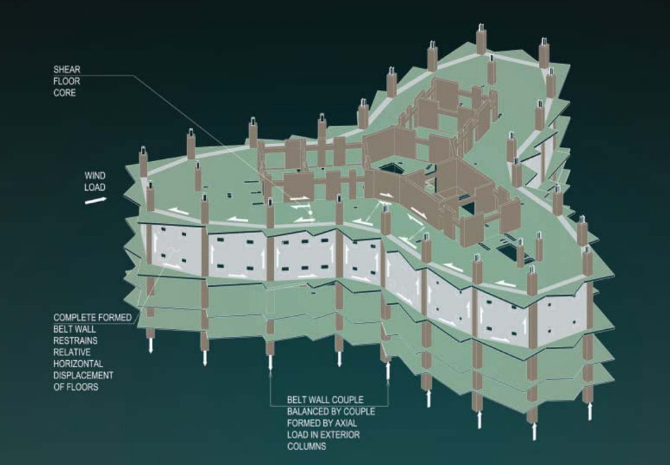
Source: Baker, Pawlikowski, (2012)
Available from: https://www.mkrgeo-blog.com/burj-khalifa-experience/ [Accessed on 2/12/2022]

