

MBA Final Dissertation Proposal

Gamification in Recruitment: Enhancing Candidate Engagement and Assessment

Student ID: 2309023
Student Name: Toushe Adil Kathawala

Abstract.
This aims to examine how the concept of gamification could apply to recruitment to increase the candidate’s participation level and add value to the accuracy of the assessments conducted. The elements like points, badges, and tasks make the traditional, boring methods of recruitment into games, which would increase the interest of the players. Employing a quantitative survey and a qualitative survey in the form of interviews with the candidates and with the experts on the issue of recruitment, the paper brings new empirical evidence to the discussion about the effectiveness and the problems of gamified recruitment.

Table of Contents
Abstract. 1
Chapter 1: Introduction. 4
1.1 Background. 4
1.2 Rationale of the Study. 4
1.3 Aims, Objectives, and Research Questions. 4
1.4 Dissertation Outline. 5
Chapter 2: Literature Review. 6
2.1 Gamification in Recruitment: Enhancing Candidate Engagement and Perceptions. 6
2.2 Gamification in Recruitment: Enhancing Candidate Engagement and Efficiency. 6
Chapter 3: Research Methodology. 7
3.1 Research Philosophy. 7
3.2 Research Approach. 7
3.3 Research Strategy. 8
3.4 Types of Investigation. 8
3.5 Research Choices. 8
3.6 Time Horizon. 8
3.7 Data Collection and Analysis. 9
Chapter 4: Analysis of Data. 10
4.1 Survey Questions: 10
4.2 Data Presentation: 10
4.3 Resources and Planning and Timescale. 11
Chapter 5: Conclusion and Recommendations and Future Research. 13
5.1 Conclusion. 13
5.2 Recommendations. 13
5.3 Future Work. 13
Chapter 6: References. 14
Survey Questions: 15

Chapter 1: Introduction.
Recruitment is a key factor of human resource management since it helps in finding the right talent to boost organizational performance. The conventional practices of HRM recruitment come with some challenges when it comes to attracting the candidate and to a greater extent when it comes to ascertaining the qualification of the candidate or the compatibility with the organization. Skills training is one of the areas that has suffered from these factors, and gamification and, the use of game design in everyday activities has been proposed as the solution to the challenges.

1.1 Background.
Gamification entails the use of point systems, badges, leaderboards, and interactivities in different processes or activities to encourage people. In recruitment, through gamification, one can turn unbearably ordinary boring tasks into something that makes its carriers as active as they can and show as much talent as they can in a fun and competitive field.

1.2 Rationale of the Study.
The purpose of this study is to fill the gaps in the conventional tactics of recruitment with new methods that can improve the interest as well as the efficiency of the assessment of candidates. This study therefore seeks to give practical findings and recommendations for organisations seeking to implement gamification within recruitment while trying to establish the effects it’ll have on turnover.

1.3 Aims, Objectives, and Research Questions.

Aims:
To evaluate the effectiveness of gamification in enhancing candidate engagement during the recruitment process.
To assess the impact of gamification on the accuracy of candidate assessments.

Objectives:
Crucial to define which specific gamification elements can be incorporated into recruitment processes.
To evaluate the level of candidates’ engagement in response to the use of gamification.
To measure the effectiveness of implementing gamification processes to enhance the consistency and validity of the given candidates’ evaluations.
To offer suggestions to organizations in the context of applying gamification in recruitment.

Research Questions:
What are the key gamification elements that can enhance candidate engagement in recruitment?
How does gamification influence candidate engagement during the recruitment process?
In what ways does gamification affect the accuracy of candidate assessments?
What are the best practices for implementing gamification in recruitment?

1.4 Dissertation Outline.
- Introduction.
  - Overview of gamification and its relevance to recruitment.
  - Purpose and significance of the study.
  - Structure of the dissertation.
- Literature Review.
  - Review of existing literature on gamification in recruitment.
  - Theoretical frameworks and models related to gamification and candidate engagement.
  - Critical analysis of key studies and findings.
- Research Methodology.
  - Explanation of the research onion model.
  - Description of the mono method positivist approach.
  - Data collection methods: surveys and interviews.
  - Sampling strategy and sample size.
  - Data analysis techniques.
- Analysis of Data.
  - Presentation of survey and interview questions.
  - Visual display of results using tables, graphs, and charts.
  - Detailed analysis and interpretation of findings.
  - Resources and Planning and Timescale
- Conclusion and Recommendations and Future Research.
  - Summary of key findings.
  - Recommendations for integrating gamification into recruitment processes.
  - Implications for future research and practice.
  - Suggestions for further research based on the study’s limitations and findings.
- References.
  - Comprehensive list of sources cited in the dissertation.
- Appendix.
  - Supplementary materials such as survey and interview questions and additional data.

Chapter 2: Literature Review.

2.1 Gamification in Recruitment: Enhancing Candidate Engagement and Perceptions.
According to Georgiou and Nikolaou, (2020), Recruitment is one of the fields in which the process of gamification, which entails the integration of features customary for games into spheres unrelated to gaming, has evolved into widespread practice due to its positive impact on candidates’ interest and satisfaction. Research shows that there is an increase in candidate experience when gamified assessment methods such as gamified SJTs are employed over conventional ones. The concept of gamification also intends to make the assessment process engaging thus possibly enhancing the perception of fairness and increased attractiveness to the organization (Gkorezis et al., 2021). Although there is preliminary empirical support for the gamified assessment construct and external validity, the nature of the game features that may have a positive effect on the applicant’s reactions has not been investigated adequately. Recruitment gamification can also be a crucial driver in improving the recruitment process's effectiveness (Miciuła and Miluniec, 2019). It is necessary to perform more research on how particular game elements can affect the candidates’ attitudes and the outcomes of the gamified assessment models.

2.2 Gamification in Recruitment: Enhancing Candidate Engagement and Efficiency.
According to Kirovska, Josimovski, and Kiselicki (2020), Recruitment can also be defined as the use of games in the hiring procedures to enhance its effectiveness and fun. They showed that through gamification, recruitment time is improved enhanced candidate engagement and experience (Obaid et al., 2020). when aspects such as points, badges, and client transactions are integrated into e-recruitment systems, organizations build an engaging environment for candidates. The pilot experiments indicate that introductions of other forms of assessments, for example, Situational Judgement Tests (SJTs), improve applicants’ perspectives towards fairness and organizational attractiveness and therefore increase the effectiveness of the assessments. Thus, further experiential analysis is needed to identify the specific game features that contribute to increasing the number of responses from applicants and overall recruitment performance indicators. These are along with understanding the continuous development and positive impacts of gamification approaches in modern running recruitment systems (Kumar et al., 2021).

Chapter 3: Research Methodology.
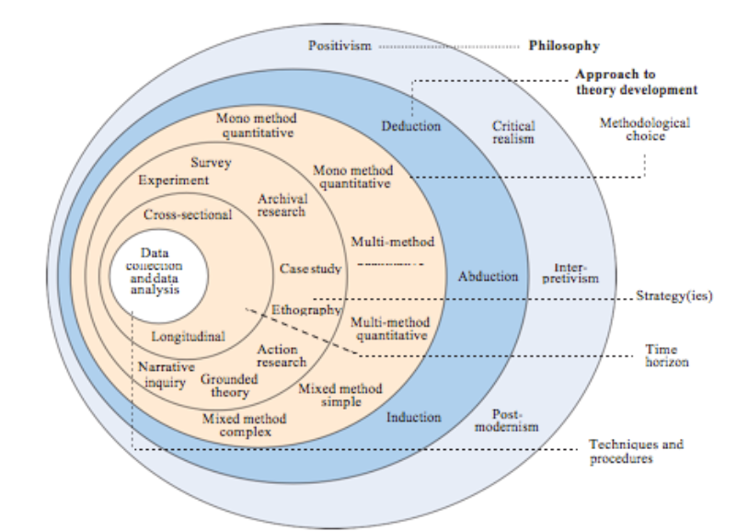
Figure 1: Research Onion Diagram
(Source: jfsdigital, 2019)

3.1 Research Philosophy.
In terms of research philosophies, this study aligns with the positivist research philosophy because this philosophy encompasses a quantitative research approach. Based on the declaration that knowledge is obtained through facts, positivism uses variables that are observable and measurable. This is suitable for the study as it aims to assess the effectiveness of the use of gamification elements in recruitment based on existing data.

3.2 Research Approach.
The work uses the deductive research approach because the different hypotheses are developed from the different theories that are available in the literature. The hypotheses will then be examined with the help of data collected and analyzed in the subsequent steps. This perspective is consistent with positivism because it involves endeavors to offer empirical support for theoretical postulations with the help of exact and methodical procedures.

3.3 Research Strategy.
The main data collection technique adopted in this study is the survey research technique. Since the quantitative data is used in positivist research surveys are commonly used to collect the data from a large number of people. This strategy is selected because it allows to receive rather general information about the attitudes and experiences of a large number of candidates and recruitment specialists concerning gamification in the context of recruitment.

3.4 Types of Investigation.
It consists of primary research that is conducted to gather primary data and information from the concerned participants. The major sources of data directly relevant to the research questions must be gathered through primary research. It facilitates the collection of both the quantitative and the qualitative data to ensure that one has an overall idea regarding the research problem (Posillico,2023).

3.5 Research Choices.
The method used in this research is qualitative mixed with quantitative, which involves the use of questionnaires as well as interviews. All the reasons point to the fact that the more mixed method is employed, the better and clearer the understanding of the study area is. Survey questionnaires will be used for Quantitative data and Interviews to be used for the collection of Qualitative data.

3.6 Time Horizon.
The research design selected in the study applies a cross-sectional time horizon in which the data is gathered at a specific period. This study calls for a cross-sectional study design to ascertain the current status of gamification in recruitment and elicit the workload participants’ first impressions and experiences.

3.7 Data Collection and Analysis.

Data Collection:

Surveys:
Quantitative data will be collected using structured questionnaires administered to a large population of candidates and recruitment professionals. These questions will be formulated to reflect the interest level, perceived attributes of the gamified aspects, and the percent accuracy of the assessments, respectively.
Sample Size: The target is 30 survey respondents.
Sampling Method: To increase the generality, the sampling technique to be employed is stratified random sampling to increase the frequency of participants from different industries and organizational statuses.

Interviews:
Quantitative data will be collected through questionnaires issued to participants who have gone through a recruitment process that incorporated a game. From the interviews, they will be able to learn more in detail about the strengths and the frailties of gamification in the aspect of recruitment.
Sample Size: The target number of interview participants are 20.
Sample Type: In this study, goal-directed sampling will be used to identify participants with credible experiences and opinions about the study’s subject matter.

Data Analysis:

Quantitative Data:
To conduct the analysis, the survey data will be entered into Statistical using SPSS. Qualitative data will be analyzed by use of descriptive statistics and quantitative data by use of inferential statistics to establish the degree of association between variables. The assessment will be aimed at identifying the influence of gamification on engagement and the result of the candidates’ tests.

Qualitative Data:
The interviews will be transported and analyzed by what can be termed as thematic analysis. This is a technique that entails the process of coding, analyzing, and describing consensus. Analyzing data in themes will ensure that the researchers get past skin deep perception of participants’ experiences and attitudes toward gamified recruitment processes.

Questionnaires.
The questions to be used in the survey and interview will be prepared about the research aims and objectives. Closed questions will be used for survey purposes to measure intensity and perception of engagement whereas the interviews shall employ more abstract, open questions to obtain a deeper understanding of participants’ experience and knowledge.
This research method entails the research onion model with relevant structured quantitative surveys and qualitative interviews for a broader evaluation of gamification in recruitment. The combination of qualitative and quantitative research provides complementary information on the statistical trends as well as about participants’ individual experiences, which is important to consider while implementing the strategies of the gamification of recruitment.

Chapter 4: Analysis of Data.
The data analysis will follow the development of survey and interview questions based on the title of the dissertation, aims, and objectives. Every question that will be asked will be constructed in such a manner that gives accurate responses on the aspect being investigated.

4.1 Survey Questions:
- How engaging did you find the gamified recruitment process compared to traditional methods?
- Which gamification elements (e.g., points, badges, leaderboards) were most effective in enhancing your engagement?
- How accurately do you think the gamified tasks assessed your skills and fit for the role?

4.2 Data Presentation:
Tables and Graphs: The survey results are presented in the form of frequency distributions and pie charts.
Written Analysis: Paragraph explaining how the outcome can be expounded to emphasize some of the discoveries made on how they relate to the study area.

4.3 Resources and Planning and Timescale.
Resources Required.
Category | Resource | Description
Human Resources | Dissertation Advisor | Provides guidance and feedback throughout the dissertation.
 | Peer reviewers | Offer additional perspectives and critique drafts.
 | Subject matter experts for interviews | Provide expert insights and data for qualitative analysis.
 | Data collection team (if applicable) | Assist with survey distribution and data gathering.
Materials and Tools | Research articles, books, journals | Essential for literature review and theoretical framework.
 | Survey tools (e.g., SurveyMonkey, Google Forms) | Used to create and distribute surveys.
 | Data analysis software (e.g., SPSS) | For analyzing quantitative and qualitative data.
 | Writing tools (e.g., Microsoft Word, Grammarly) | For drafting and proofreading the dissertation.
 | Presentation tools (e.g., PowerPoint) | For preparing the final presentation.
Technical Resources | Computer/Laptop | Primary tool for research and writing.
 | Internet access | Necessary for online research and communication.
 | Data storage (cloud services like Google Drive, Dropbox) | For storing and backing up dissertation files.
Other Resources | Access to libraries and online databases | Provides additional research materials.
 | Printing and binding services (for the final submission) | For the final physical submission of the dissertation.

Time scale (Gantt chart).
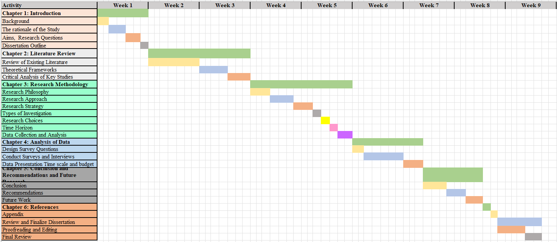

Chapter 5: Conclusion and Recommendations and Future Research.

5.1 Conclusion.
The subject research highlights how the application of gamification might revolutionize the field of recruiting by raising candidate interest and increasing the validity of evaluating candidates. The alarming statistics show that points, badges as well as other interacting tasks not only make the recruitment process more enjoyable for the candidates but provide the recruiters with better data to measure the candidate’s potential. This approach can manage with disadvantages of the mere employment of standard recruitment techniques as it tends to be more interesting for candidates.

5.2 Recommendations.
It is also recommended that organizations should adopt game elements in their recruitment processes to obtain talented employees. Some practical factors such as points, badges tasks, and scores can encourage candidates. The most key factor is how to create game-like tasks that would match the work description in terms of the essential skills and competencies to prevent misconceptions and inequity. These processes must therefore be evaluated and improved continuously, in the light of the students’ feedback and the performance of the processes themselves.

5.3 Future Work.
Future work should examine the durability of the gamification methods on recruitment results concerning workforce productivity and turnover. Comparing the impact of individual gamification components as well as the aspects of the company and job level can also offer further illumination. More research could also propose the analysis of the positive and negative impact of gamified recruitment and its limitations if any, in terms of its ethical implications.

Chapter 6: References.
- Georgiou, K. and Nikolaou, I. (2020) ‘Are applicants in favor of traditional or gamified assessment methods? Exploring applicant reactions towards a gamified selection method,’ Computers in Human Behavior, 109, pp.1-10. https://owiwi.co.uk/wp-content/uploads/2020/05/CHB-Paper-Owiwi.pdf
- Gkorezis, P., Georgiou, K., Nikolaou, I. and Kyriazati, A. (2021) ‘Gamified or traditional situational judgement test? A moderated mediation model of recommendation intentions via organizational attractiveness,’ European Journal of Work and Organizational Psychology, 30(2), pp.240-250. https://www.tandfonline.com/doi/abs/10.1080/1359432X.2020.1746827
- jfsdigital. (2019). Towards an Explicit Research Methodology: Adapting Research Onion Model for Futures Studies * Journal of Futures Studies. [online] Available at: https://jfsdigital.org/articles-and-essays/2018-2/towards-an-explicit-research-methodology-adapting-research-onion-model-for-futures-studies/ [Accessed 20 Jul. 2024].
- Kirovska, Z., Josimovski, S. and Kiselicki, M. (2020) ‘Modern trends of recruitment-introducing the concept of gamification,’ Journal of Sustainable Development, 10(24), pp.55-65. https://fbe.edu.mk/wp-content/uploads/2023/07/JSDv241.pdf#page=56
- Kumar, A., Sowdamini, T., Manocha, S. and Pujari, P. (2021) ‘Gamification as a Sustainable Tool for HR Managers,’ Acta Universitatis Bohemiae Meridionales, 24(2). https://pdfs.semanticscholar.org/8fee/dec50136c9131679e428be097c8a6fe0693f.pdf
- Miciuła, I. and Miluniec, A. (2019) ‘Gamification 3.0 for employees involvement in the company,’ In ICERI2019 Proceedings (pp. 10878-10884). IATED. https://library.iated.org/view/MICIULA2019GAM
- Obaid, I., Farooq, M.S. and Abid, A. (2020) ‘Gamification for recruitment and job training: model, taxonomy, and challenges,’ IEEE Access, 8, pp.65164-65178. https://ieeexplore.ieee.org/stamp/stamp.jsp?arnumber=9050550
- Posillico, J.J. (2023) Development of an interpersonally grounded construction management curriculum foundation model (Doctoral dissertation, Birmingham City University). https://www.open-access.bcu.ac.uk/id/eprint/14277

Appendix.
Survey and interview transcript.

Survey Questions:
- How engaging did you find the gamified recruitment process compared to traditional methods?
- Which gamification elements (e.g., points, badges, leaderboards) were most effective in enhancing your engagement?
- How accurately do you think the gamified tasks assessed your skills and fit for the role?

