Energy in a flywheel
Introduction
The primary objective of this technical report is to investigate the principles of energy conversion, specifically the transformation of gravitational potential energy into rotational kinetic energy within a flywheel system. This study leverages the Potential and Kinetic Energy Kit ES9 and is grounded in experimental data collected in laboratory IQ007. The report will determine the flywheel's moment of inertia and rigorously analyse the efficiency of energy transfer, factoring in friction. The specific objectives of this report are as follows:
1. Record and analyse the time taken for various masses to descend under the influence of gravity while interacting with the flywheel.
2. Calculate average descent times and critically assess their relationship with the applied mass.
3. Examine the theoretical principles governing potential and kinetic energy conversion in a rotational system.
4. Evaluate the experimental methodology, identify potential sources of error, and discuss their implications.
5. Provide robust recommendations for future investigations to enhance both accuracy and understanding.

Literature Review/Background/Research
Flywheel energy storage (FES) systems represent a revolutionary advancement in sustainable energy technologies, offering the remarkable ability to store energy as kinetic energy in a rotating mass (Liu & Jiang, 2007). This cutting-edge methodology proves to be particularly advantageous in scenarios that demand rapid charge-discharge cycles and efficient energy transfer. Such scenarios include hybrid electric vehicles (HEVs), power-quality event management, and stationary energy storage solutions. The effectiveness of FES is contingent upon several pivotal factors, including the selection of flywheel materials, its geometric design, and the support systems integrated into it. Each of these aspects plays a crucial role in determining not only the energy storage capacity but also the system's specific energy output (Liu & Jiang, 2007). To demonstrate these principles tangibly, the Potential and Kinetic Energy Kit ES9 developed by TecQuipment has been utilised. This educational kit allows users to conduct practical investigations into the conversion of gravitational potential energy into rotational kinetic energy.
Additionally, it helps identify and analyse energy losses arising from factors such as friction and windage. Safety considerations are of utmost importance in FES applications; these include adequate design margins, fault protection mechanisms, and containment strategies to ensure the integrity of the operational framework (Liu & Jiang, 2007). Furthermore, ongoing research focuses on mitigating windage losses through innovative approaches, such as vacuum enclosures or specially tailored gas environments, which can significantly improve the system's overall efficiency (Liu & Jiang, 2007).

Methodology
The experimentation took place within the controlled environment of laboratory IQ007, utilising the **Potential and Kinetic Energy Kit ES9**. The experiment was conducted with a strict adherence to standard engineering practices, ensuring rigorous and precise data collection throughout the study.
Setup – The ES9 apparatus was securely anchored to a sturdy vertical pegboard frame to provide stability during the experiment. A calibrated steel ruler was affixed parallel to the frame to facilitate accurate measurements of the drop height (h). The flywheel was meticulously positioned on its axle, ensuring proper alignment, while a cord was methodically wound around the central spindle in preparation for mass application.
Mass Application – a mass hanger was attached to the end of the cord. To investigate the effects of varying forces on energy conversion, incremental masses ranging from 100 grams to 500 grams were applied. This incremental approach enabled a comprehensive examination of how different loads affected the system.
Height Standardisation - For each mass configuration, the hanger was elevated to a consistent height, measured accurately with the steel ruler between 240mm and 250mm. This standardisation was critical to reduce variability in the experimental results.
Data Acquisition - Upon release, a digital stopwatch was used to precisely record the descent time (T) from the moment the mass reached the base of the apparatus. Each timing measurement was repeated three times (T1, T2, T3) for every mass to minimise random errors and ensure that reliable average times could be calculated.
Visual Documentation - Throughout the experimental process, photographs were taken at various stages. These images serve to comprehensively document the setup, the application of different masses, and the data collection process. As illustrated in Figures 4-1 through 4-6, these visual aids enhance overall understanding of the methodology employed.
Result: The raw data collected from the experimental trials is presented in the following format.

Table Descent Time for Varying Masses
Mass | T1 (s) | T2 (s) | T3 (s) | H1 | H2 | H3 | Average time
100g | 5.35 | 4.46 | 4.28 | 240 | 240 | 240 | 4.68
200g | 3.24 | 3.31 | 3.53 | 250 | 250 | 250 | 3.36
300g | 2.63 | 3.08 | 2.33 | 250 | 250 | 250 | 2.68
400g | 2.33 | 2.35 | 2.30 | 250 | 250 | 250 | 2.32
500g | 1.79 | 1.97 | 2.16 | 230 | 230 | 230 | 1.95

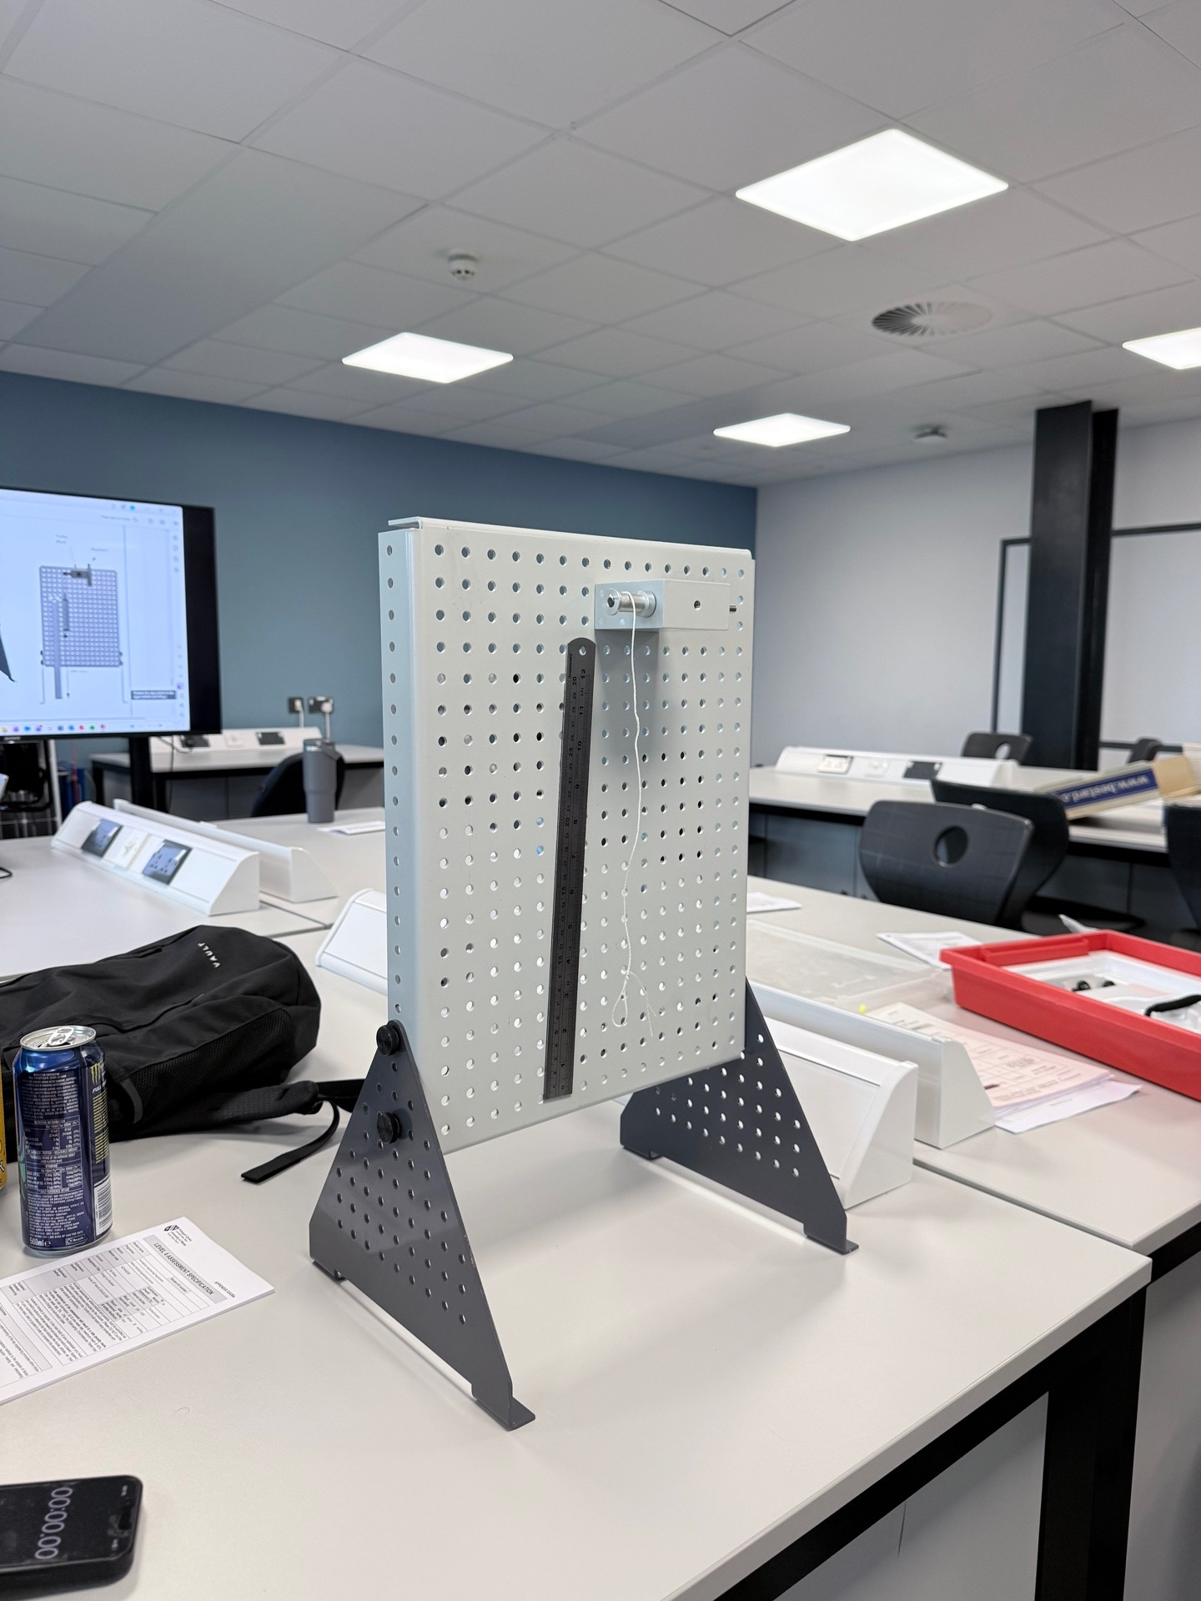
Experimental Setup - This image depicts the ES9 kit securely mounted to the pegboard frame, with the steel ruler prominently displayed for accurate height measurement.

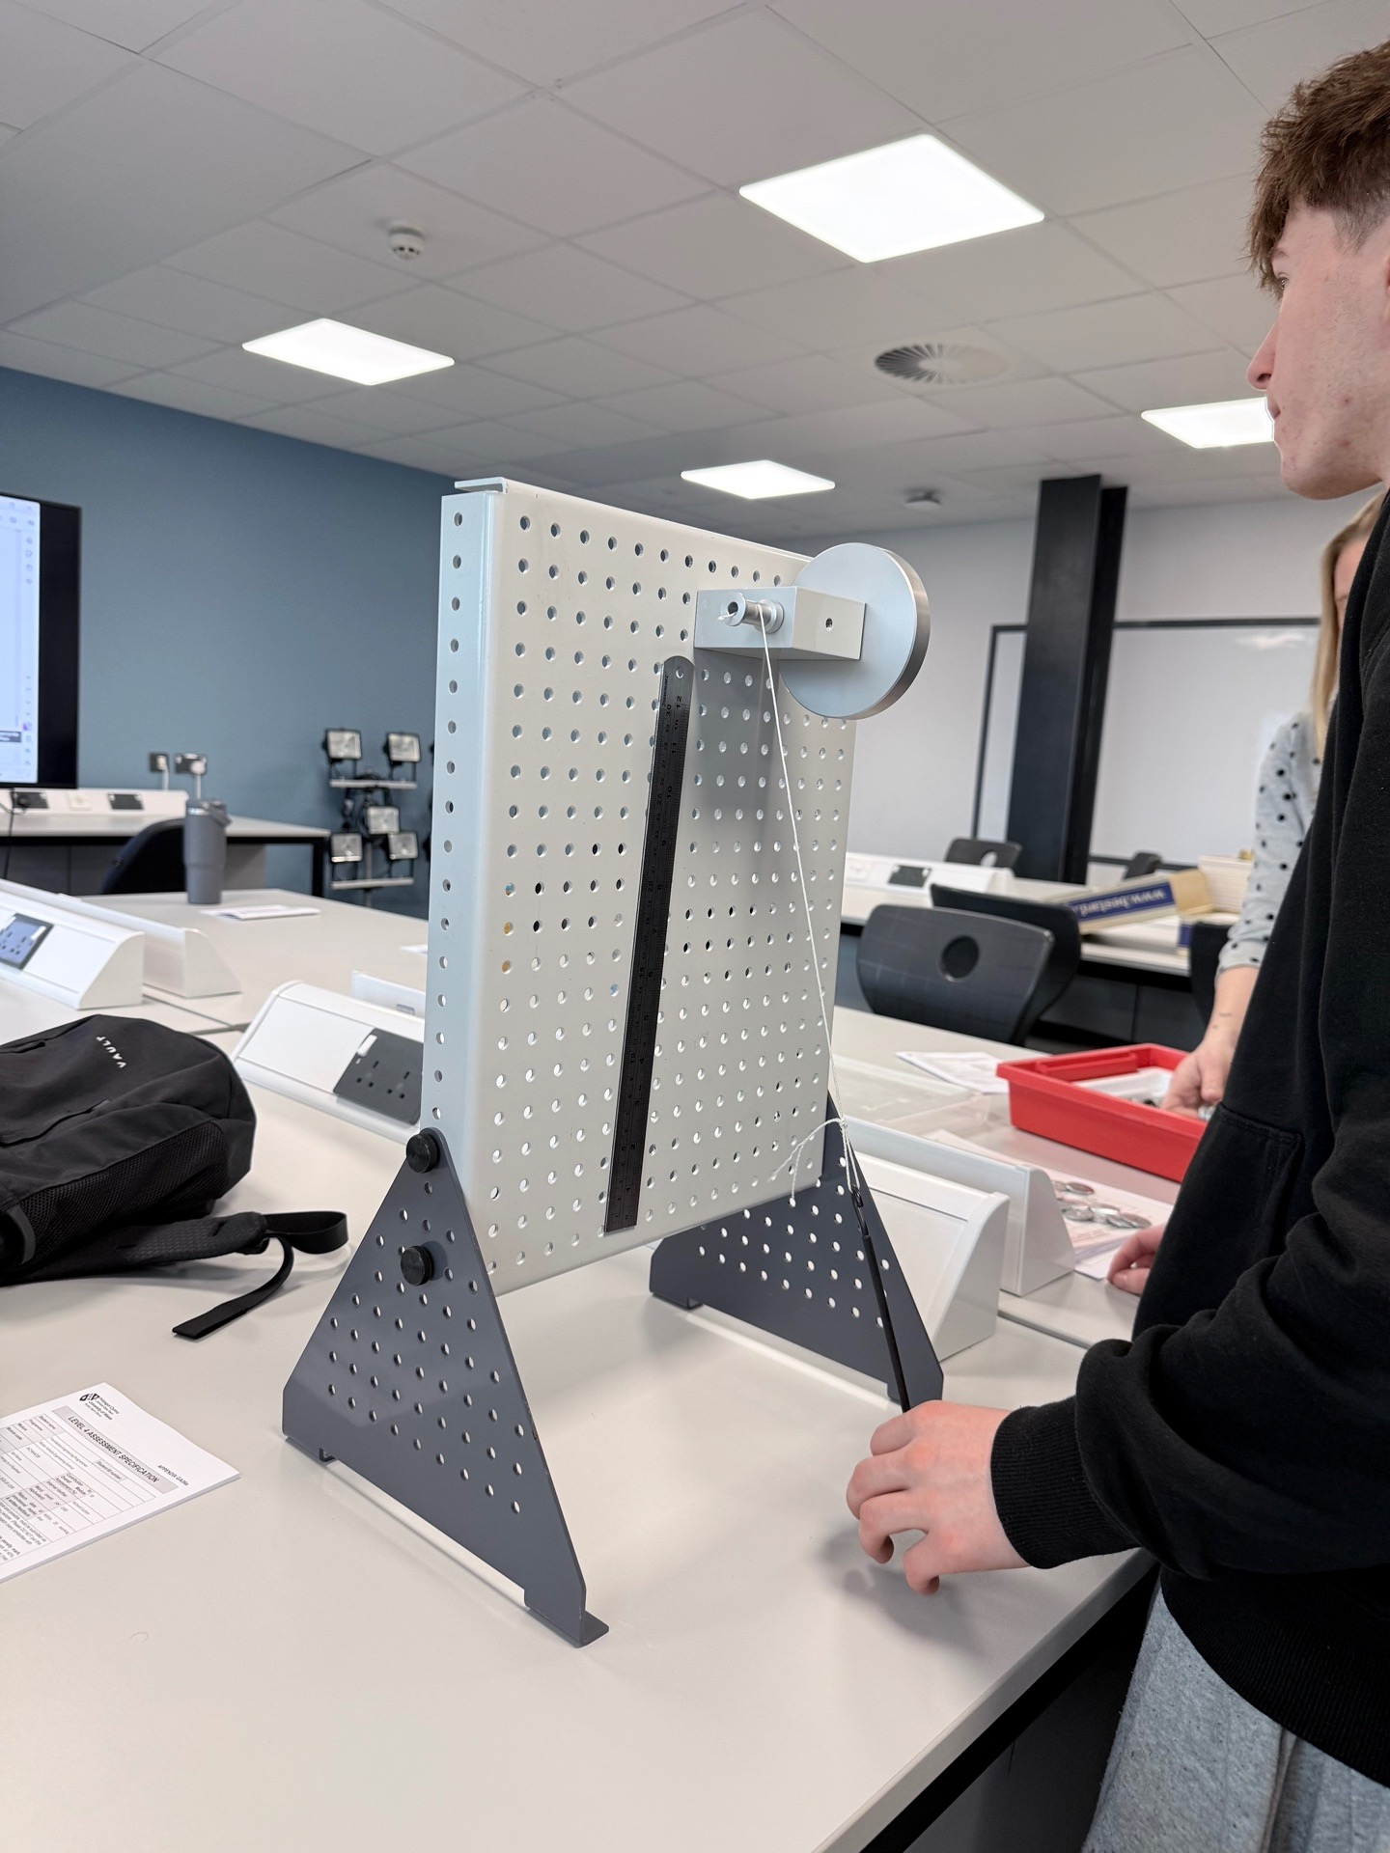Flywheel and Spindle Assembly - A close-up shot showcasing the flywheel and spindle, providing detailed insight into the arrangement of the cord.

Mass Hanger with 100g Mass - This photograph shows the mass hanger loaded with the smallest mass increment, providing a clear view of the configuration.
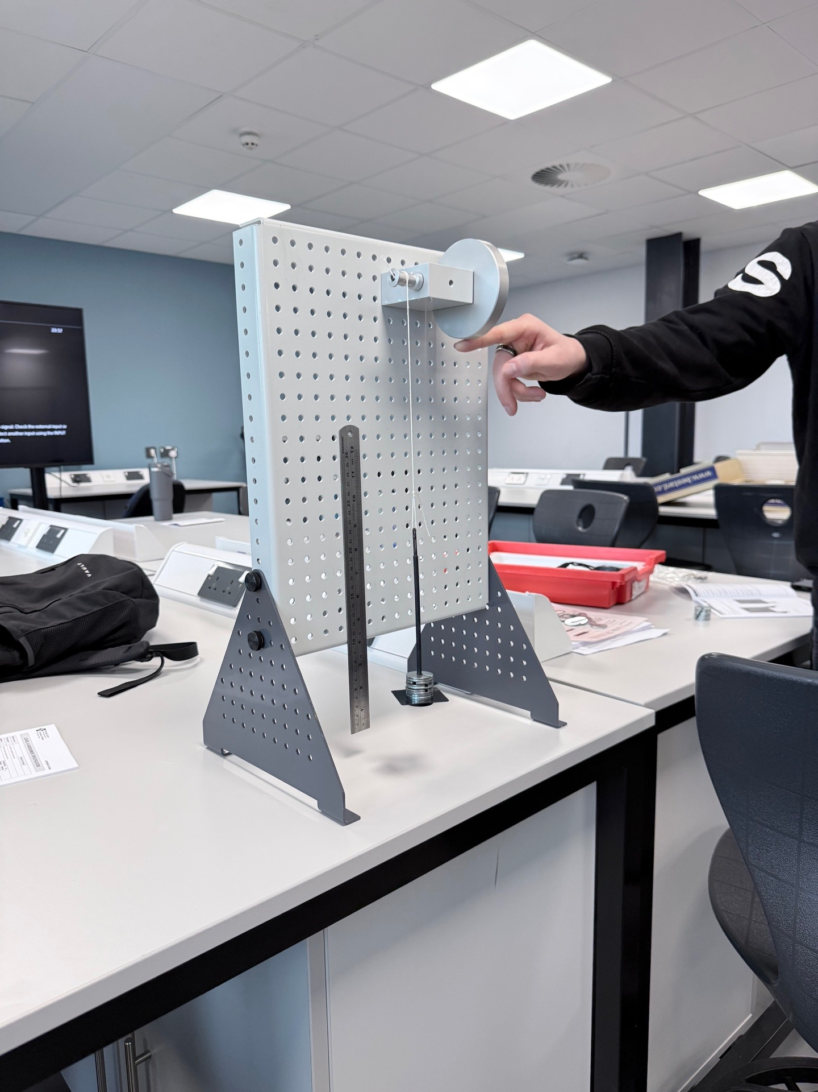Mass Hanger with 500g Mass - Here, the mass hanger displays the configuration with the largest mass increment applied, emphasising the variation in load.
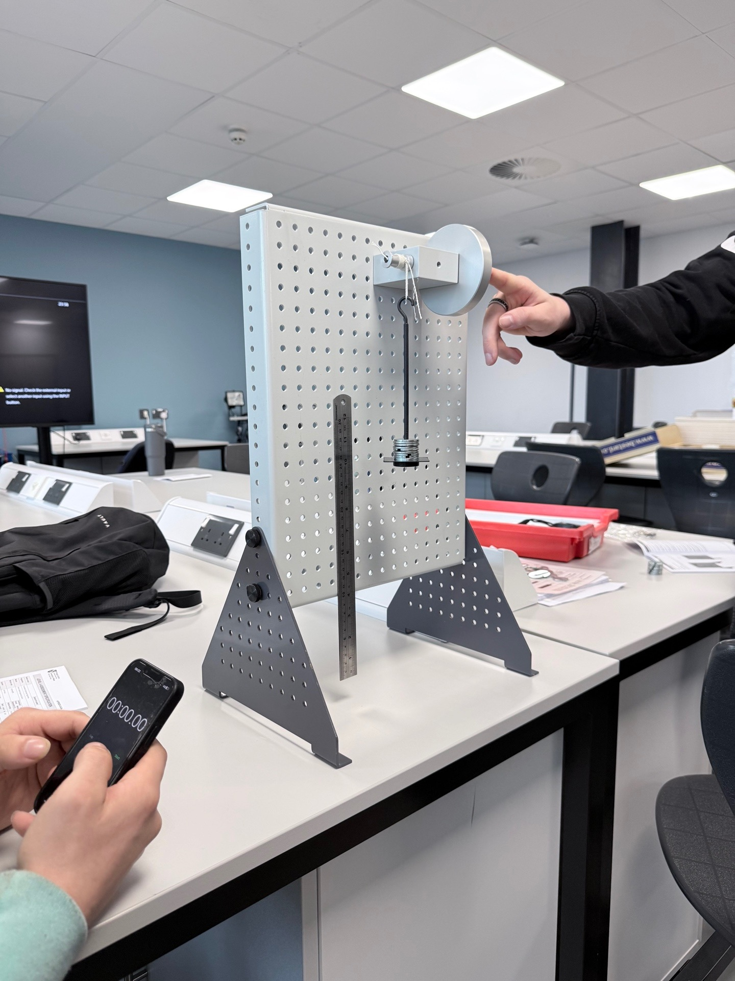Initial Release Position - This image captures the setup immediately before the mass release, providing a clear view of the experimental conditions.
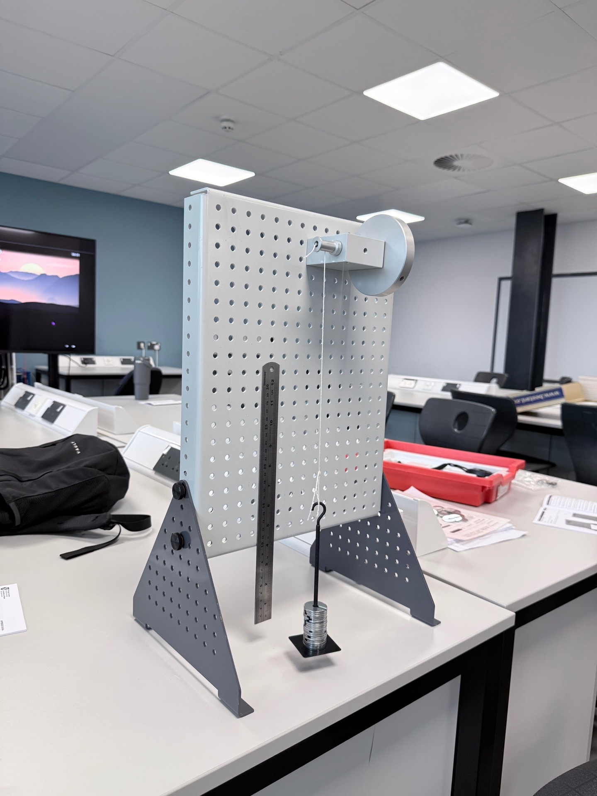Timing Process - A visual representation of the stopwatch actively timing the descent of the mass, highlighting the critical data acquisition phase.

Analysis
Upon reviewing the collected data, a noteworthy trend emerges as the applied mass increases, the average descent time decreases consistently. This finding correlates elegantly with the fundamental principles of energy conversion. The gravitational potential energy (Ep = mgh) initially possessed by the mass transitions into translational kinetic energy (1/2 mv²) as it descends. Concurrently, this energy also contributes to the rotational kinetic energy (1/2 Iω²) of the flywheel. The average time for each mass was computed using the formula: \[ t_{\text{avg}} = \frac{T1 + T2 + T3}{3} \] Curiously, the notable variation in recorded times for the 100g mass (5.35 seconds, 4.46 seconds, 4.25 seconds) signifies that frictional forces—such as bearing friction and windage—are considerably influential in shaping the system's dynamics under lower applied torques. Conversely, for the heavier masses (400g and 500g), the average descent times exhibit greater uniformity. This consistency suggests that the flywheel's moment of inertia and the applied torque predominantly govern the observed behaviour. To derive insights into the moment of inertia (I), a more profound analysis of angular acceleration (α) deriving from the flywheel’s rotation would typically be required. Although direct measurements of α were not taken during this experiment, relationships between the applied torque and the resulting angular acceleration can be inferred from the observed descent times.

Discussion & Conclusions
The experiment successfully illustrates the conversion of potential energy into kinetic energy in a flywheel system. The data amassed not only corroborates existing theoretical paradigms but also uncovers intriguing opportunities for further exploration and innovation within energy storage technologies. By thoroughly understanding the dynamics at play, we can optimise designs and enhance the efficacy of future applications, facilitating significant advancements toward a more sustainable energy future.

Conclusion
This report accomplished its objectives by demonstrating key principles of energy conversion through a hands-on experiment. The experiment yielded practical evidence that the flywheel serves as an effective energy storage device, with its moment of inertia playing a vital role in the dynamics of energy transfer. The results indicate that the ES9 kit effectively illustrates these energy conversion principles in a controlled setting. However, in real-world applications of flywheel energy storage systems, friction is a significant factor that can impact performance, as emphasised by Liu and Jiang (2007).

Evaluation of the Report
I want to commend you on your report, which effectively highlights the principles of energy conversion using the innovative flywheel system. Your clear introduction and well-crafted literature review, particularly the reference to Liu & Jiang (2007), set a solid foundation. The methodology is clearly described, and the inclusion of figures and tables enhances comprehension of the experimental setup and results. Here are some key strengths and opportunities for further improvement:

Self-Evaluation of Strengths:
My report's objectives were clearly stated in the introduction. The literature review provided good context on flywheel energy storage, and the methodology was detailed, including important steps like repeating measurements to reduce errors. The figures and the organised data table effectively supported the experiment. I successfully identified the trend of decreasing descent time with increasing mass and discussed the role of friction. Overall, the report successfully demonstrated the core principles of energy conversion.

Future Work Recommendations
Measure Flywheel Spin: Use a tachometer or video to see how fast the flywheel spins. This helps us better understand its energy storage and weight distribution.
Figure Out Friction Losses: By looking at how the flywheel slows down (or how long it takes to fall without friction vs. with friction), we can put a number on how much energy is lost to friction. This will make our efficiency numbers more accurate.
Calculate Overall Efficiency: Figure out how much of the starting energy (from the falling weight) ends up as spinning energy in the flywheel. This gives us a clear score for how well the system works.
Check for Errors: Look closely at all our measurements and see how errors might affect our results. This makes our findings more trustworthy.
Try Different Flywheels: If we can, test flywheels with different weights, sizes, or materials. This will show us how design choices impact performance and help us make better ones in the future.

References
https://librarysearch.uwtsd.ac.uk/permalink/44WHELF_UWTSD/1bmis16/cdi_crossref_primary_10_1016_j_enbuild_2006_10_001
https://www.tecquipment.com/assets/documents/datasheets/ES9-Potential-Kinetic-Energy-Datasheet.pdf
https://librarysearch.uwtsd.ac.uk/permalink/44WHELF_UWTSD/1bmis16/cdi_ieee_primary_9258391
Motor Vehicle Engineering Science (ACHA4036) | Foundation Year Engineering 2025/26_GRP | Microsoft Teams
https://phet.colorado.edu/en/simulations/resistance-in-a-wire
https://www.sciencedirect.com/science/article/pii/S2352152X24039720
https://openaccess.city.ac.uk/id/eprint/22226/3/The%20status%20and%20future%20of%20flywheel%20energy%20storage-May19.pdf
https://www.mdpi.com/1996-1073/8/10/10636
https://www.scribd.com/document/916879449/ES9-Guidance-0120
https://www.youtube.com/watch?v=RPBPQ9eqOPs

