

This essay details my experiences recorded in a field journal during an archaeological excavation at Llanllyr, Talsarn, Ceredigion, between April 15 and May 2, 2024. This was part of the Portalis project investigating the first human journeys between Ireland and Wales during the Mesolithic period (UWTSD, 2023). Llanllyr was first excavated in 2019 as part of the excavation and field experience of the University of Wales Trinity Saint David (Bates et al., 2023). The site of Llanllyr is in the Aeron Valley (See Figures 1, 2 and 3). The area was significantly modified 30,000 years ago due to major ice flow during the last glacial maximum (Glasser et al., 2018).

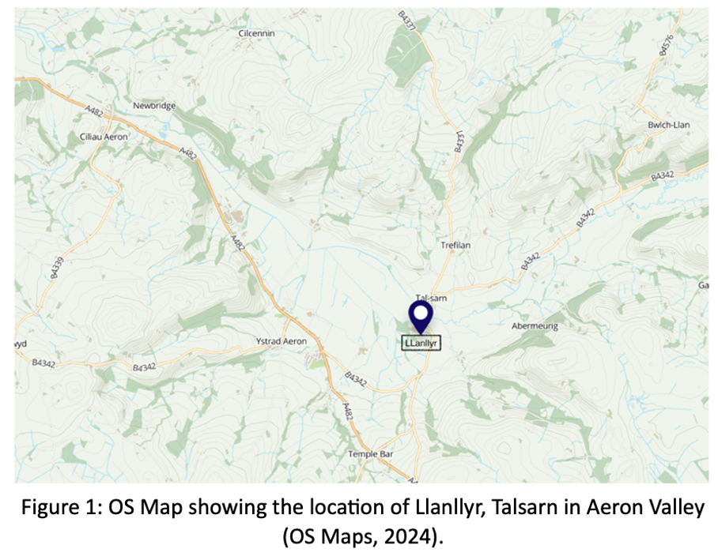

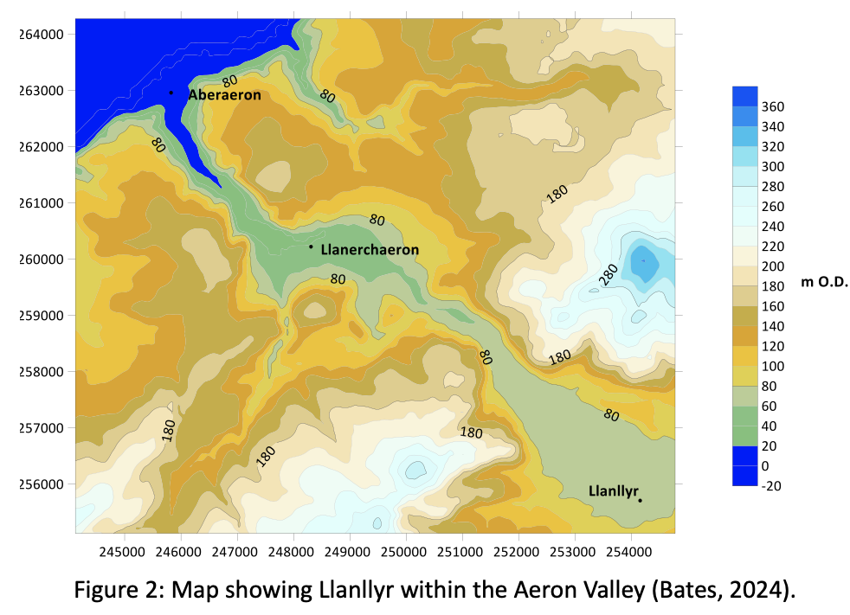

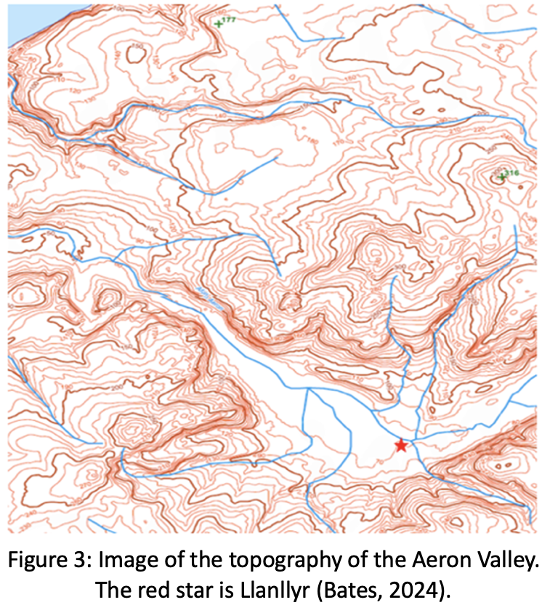

Low mounds initially considered burnt features of the late prehistoric age were found to be geological. From excavations, flintwork and a polished stone axe (See Figure 4) confirmed prehistoric activity (Bates et al., 2023).

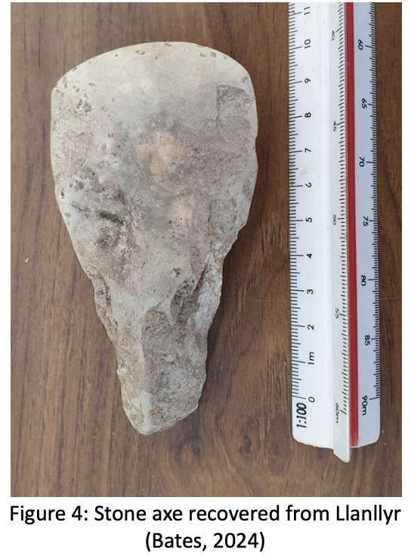

As a first-time participant in an excavation, I was excited to learn and gain experience during the three-week module. In the prep week, Professor Martin Bates, site director, explained how glacial action formed the Llanllyr site. As the ice melted, sediments from other areas were deposited, creating a resource-rich wetland attractive to hunter-gatherers (Schafer-Elliott, 2016, pp. 15-19). He stressed the significance of gathering all data to plan excavation areas effectively based on funding, resources, and time (McIntosh, 1999, pp. 64-64; Carver, 2010, pp. 63-109; Renfrew and Bahn, 2008, pp. 73-120). This excavation was conducted for research purposes, and the excavation methods used were determined by the focus of the study (Shafer-Elliott, 2016, pp. 23-25). Following a question regarding our knowledge of the Star Carr site (Star Carr, 2024), I researched and found Figure 5 helpful in visualising Llanllyr.

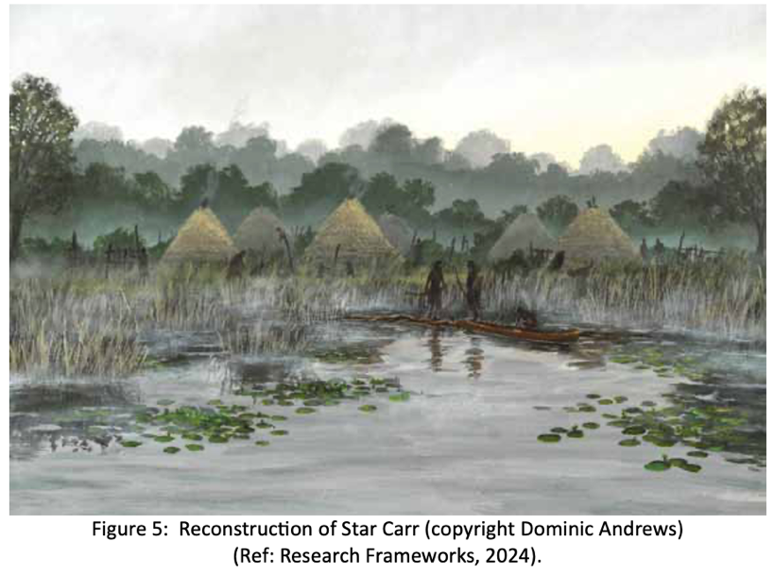

Week 1
On day one, we had a safety briefing about site conditions and equipment usage to ensure safe working practices and prevent injuries (UWTSD, 2024). Professor Bates guided us around the site (See Figure 6), explaining the position and boundaries of the lake in the prehistoric period. The fields are wetlands with expansive reed beds and some raised dryer areas or islands. Mesolithic people preferred to inhabit the edges of lakes. Thus, we focused on islands with suitable elevation and location for better archaeological prospects.
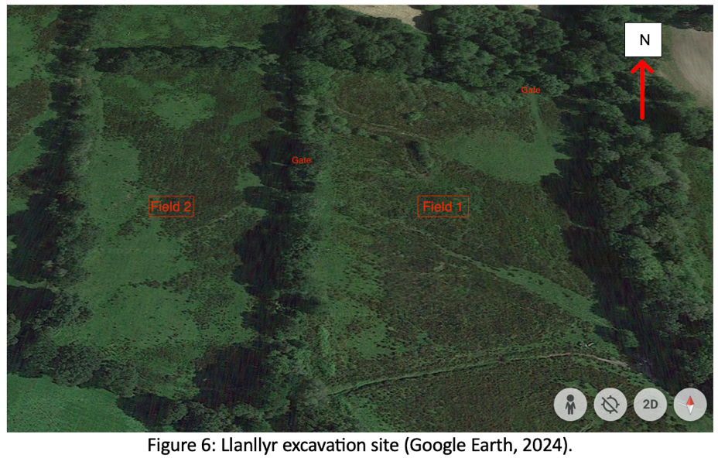
Figure 7 shows the position of previous trenches, with flints, a mid-late Mesolithic microlith and a burnt area dated to the early Neolithic (3760-3640 and 3695-3530 cal BC) discovered in Trench 10 on Mound 2 (Bates et al., 2023).
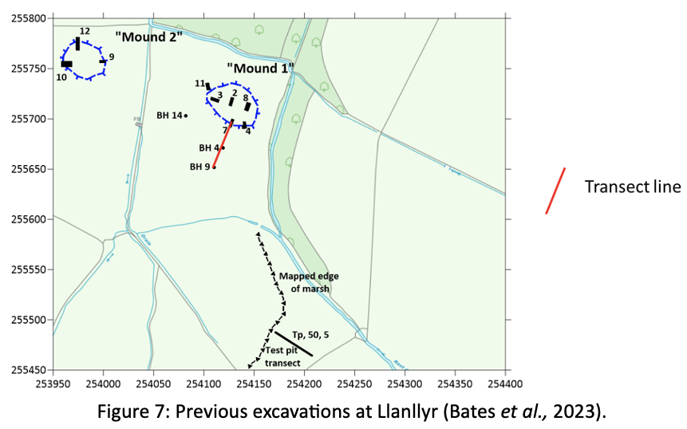
Flints found on site were not naturally occurring and were brought from possibly Aberaeron beach, sourced from the Irish Sea through glacial action (Bates et al., 2023).

We were shown how to use Pythagoras’s theorem to mark out a trench accurately (BAJR, 2025). Geometry is not my forte, so some homework was required. We were then allocated trenches, mine being an extension of Trench 10 (south) (See Figures 8 and 9). An extension of 2 metres would be placed on either side (to the north and south), running a length of 8.3 metres. The extensions were to see if the spread of flint continued and to locate the full extent of the burnt area (Schafer-Elliott, 2016, pp. 26-27).

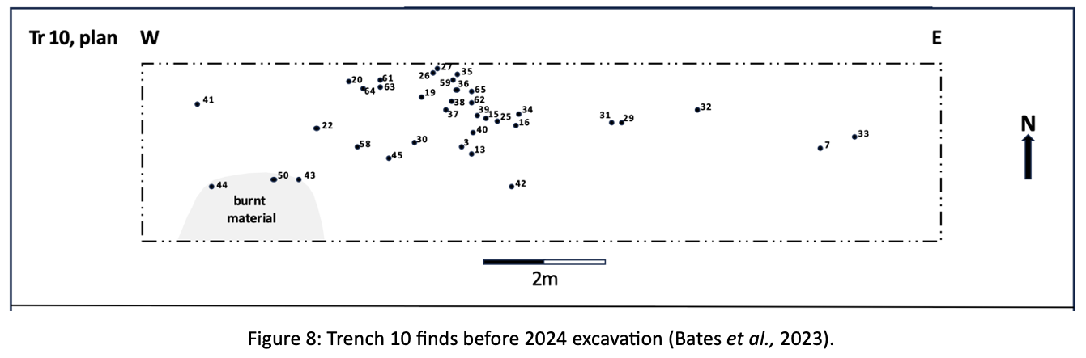

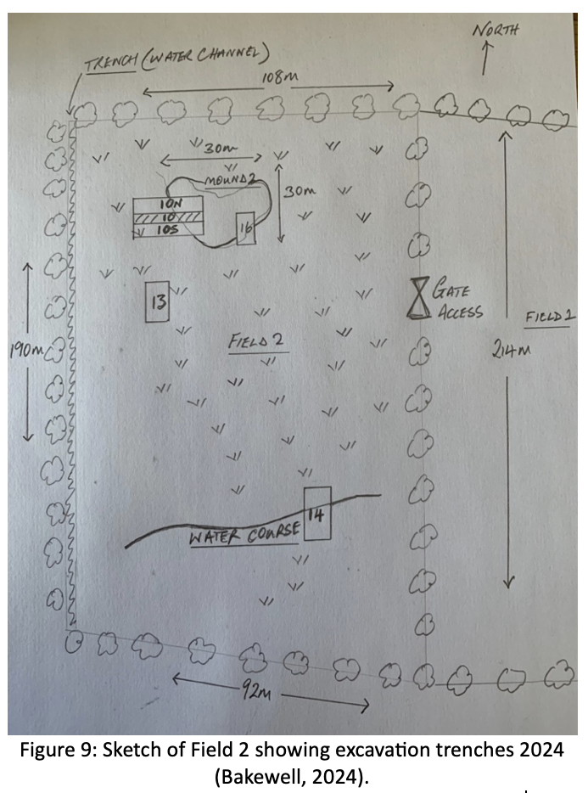

Using measuring tape, nails, and string, we marked out our trench by following Trench 10's visible outline (See Figures 10 and 11). The position was recorded with the Dumpy. Accurate records are essential in archaeology as it is a destructive science, and we only have one chance (McIntosh, 1999, pp. 51-71).

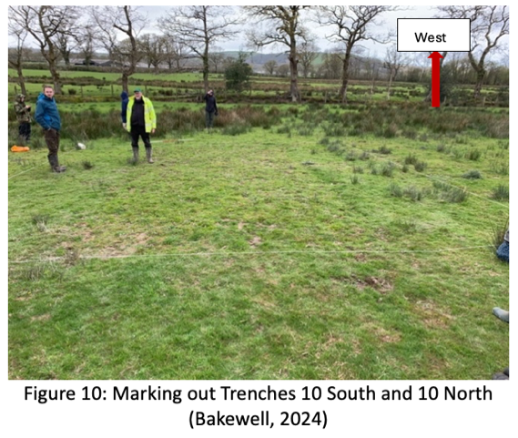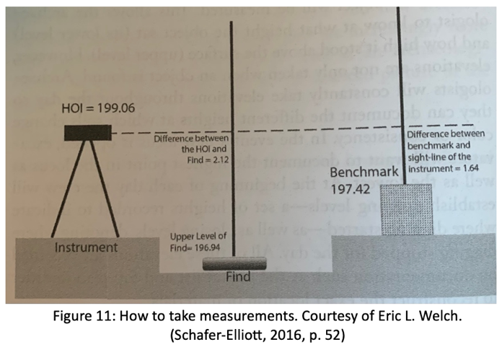

We placed a tarp beside the trench and removed the turf in small sections, forming a retaining wall for the excavated material (See Figure 12). We then removed the top layer of the earth with the Mattock. Keeping the working area tidy shows respect for the landowner and is more efficient for filling the trench at the end of the excavation.

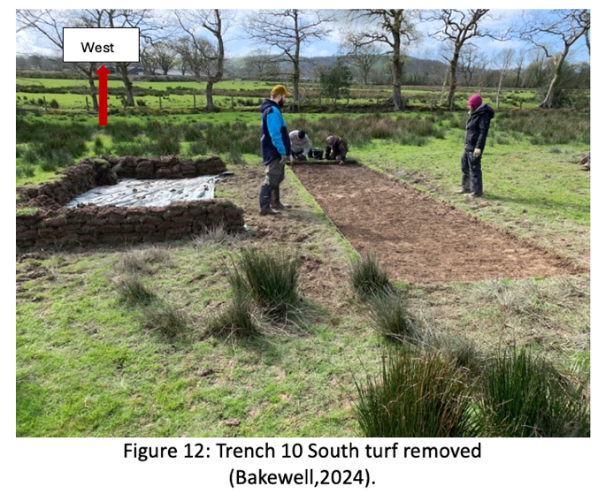

We removed shallow soil layers by trowelling, creating a flat horizon (Carver, 2010, p. 117), and earth sifted to ensure we had not missed anything (See Figure 13). This is vital in Prehistoric excavations, as finds are often small (McIntosh, 1999, pp. 55-57). We expected to find flints as Trench 10 had proved plentiful on the last dig.

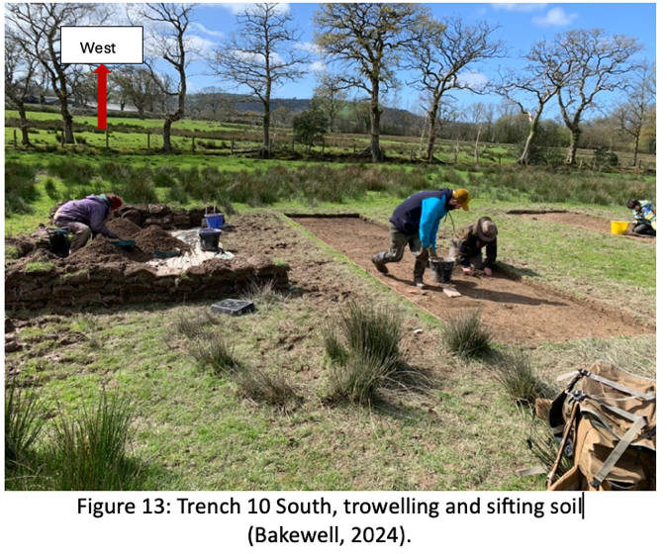

An input on identifying flint was invaluable. We were allowed to take a flint sample, which proved helpful while trowelling since flint makes a distinct noise when struck, like glass. Heavy rain made the soil sticky. Roots of reeds bound soil together, making it harder to remove (See Figure 14).
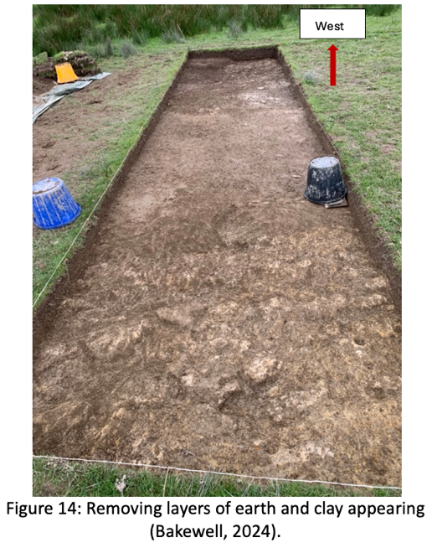

By the end of the first week, we were at a depth of 7 inches to the clay or glacial layer, and the edge of what was thought to be the original burnt area was uncovered. Small fragments of charcoal had been found across the entire trench. Another feature next to the burnt area was revealed, containing charcoal fragments, possibly a fire pit or hearth (See Figure 15).
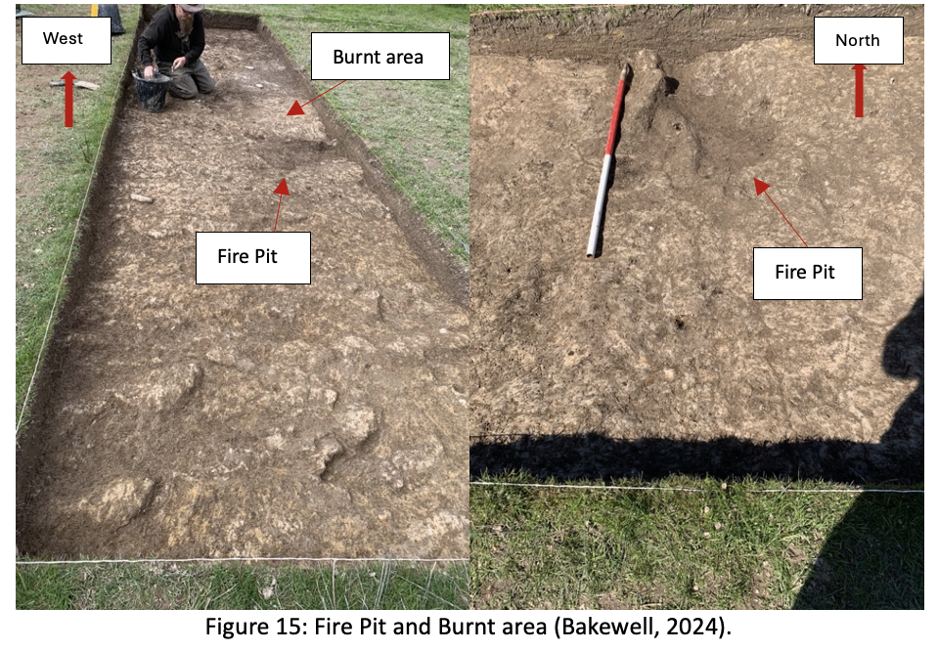

Only one flint was found in our trench by sifting and not in context, while Trench 10 North had numerous flint finds. I observed how these findings were recorded but did not participate.
Week 2

Further flint finds continued in 10 North, especially in the upper trench (East). In 10 South, we removed the remaining soil above the clay layer, avoiding the burnt area and fire pit, where samples could be recovered for radiocarbon dating. Possible plough marks were evident in the upper or east section of the trench, which may have resulted from ploughing during World War 2 (See Figure 16).
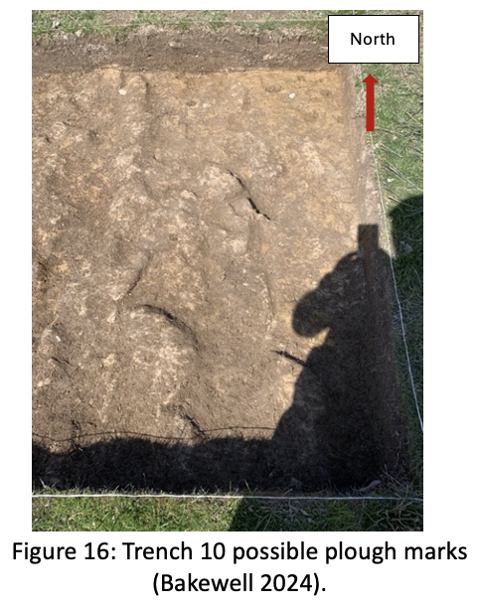

Rain showers continued during the week, necessitating us to ‘sweep’ the trench with trowels so Professor Bates could photograph it for records, including for 3D modelling, which can aid in the interpretation and visualisation of the archaeological data (Schafer-Elliott, 2016, pp. 94-97). It is advisable to record and photograph immediately after the area is cleaned, and as the ground was damp, it would show any contrasts (Carver, 2010, pp. 140-141). I was then tasked with drawing a plan for the trench on a scale of 1cm square grid to 20cm. I drew any features I could see, such as the plough marks, burnt area and fire pit, by utilising ‘hachures’, which are short parallel lines with a thicker ‘head’ and thinner ‘tail’ used to show the direction and steepness of a slope. This was done using a 1-metre grid (See Figure 17). Following this, the elevation of specific points was recorded on the plan. This plan is crucial for defining the contextual relationship of excavated materials. The photography and the plan complement each other in that what one may not show the other will (Schafer-Elliott, 2016, pp. 58-62).

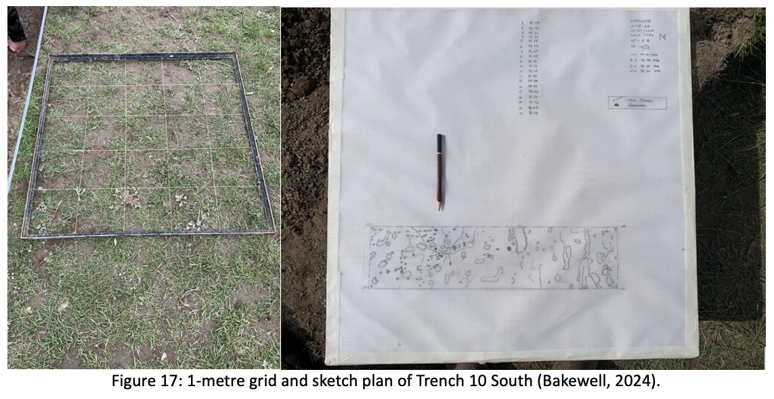

Three charcoal samples were taken from three trench sections and labelled (See Figure 18). Identifying their location is crucial for the continuity of evidence (Renfrew and Bahn, 2008).

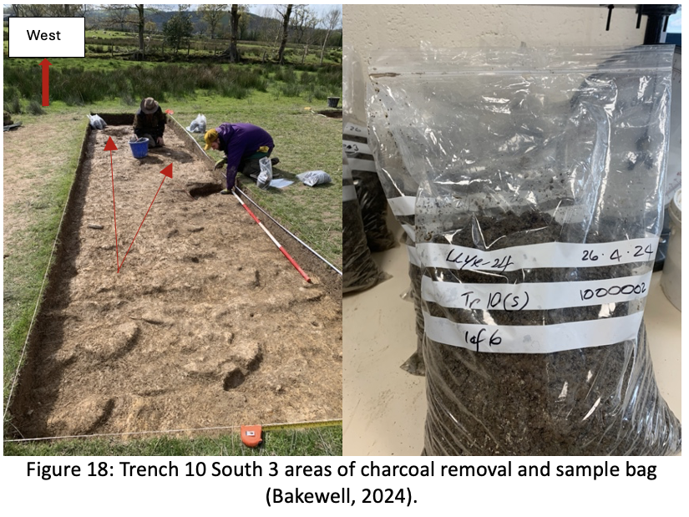

Week 3
Heavy rain had filled the trench with water, so the first job was to remove this with buckets. Sponges were also used to negate any chance of damaging the base layer. We conducted another sweep, and photographs were taken of the areas where charcoal had been removed. The fire pit discovered during this year's excavation, in a style typical of the late Mesolithic, was of primary interest and further charcoal samples were obtained (Mithen, 2019).

Bad weather cancelled the excavation for one day. Professor Bates delivered a presentation on soil, sediments, stratigraphy, and context records. Correctly filling out records eases post-excavation reviews and must be as accurate as possible (Carver, 2010, pp. 138- 147). I used Figure 19 to assist me with the context records conducted on our trench (See Figure 20).

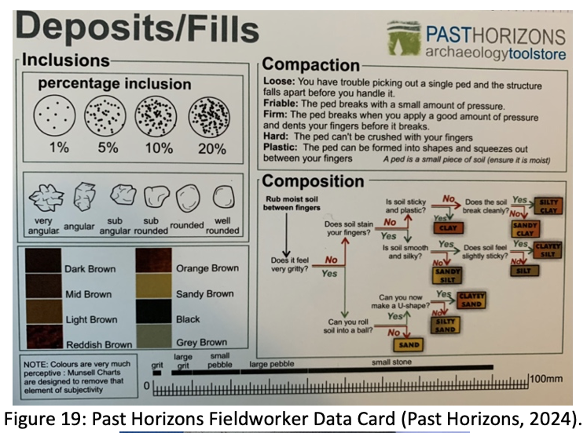
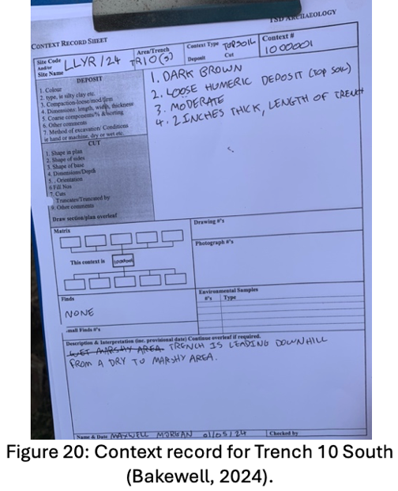

In the afternoon, I learned how to process the soil samples from our trench. The aim was to extract charcoal for radiocarbon dating. The process involved adding hydrogen peroxide to break down the soil and dilute the clay. Then, the mixture was drained and sieved to obtain the material for analysis. The material was heated in an oven for 24 hours, and the process repeated (See Figure 21).

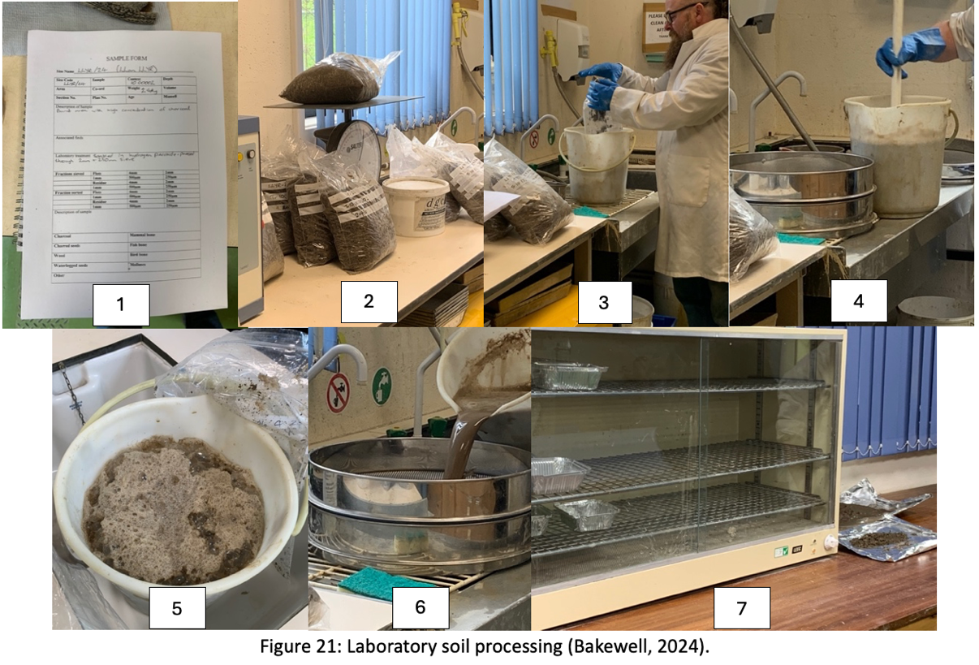

The trench was filled in as weather conditions deteriorated over the last few days. First, black membrane sheets were placed, allowing future excavators to know the depth we had reached and save time (See Figure 22).
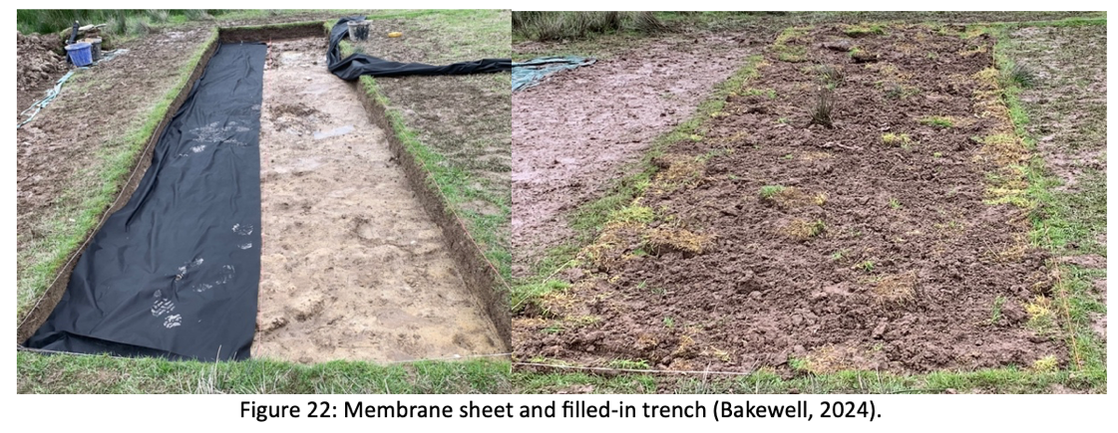

Although aware of the work on other trenches and test pits, this essay reflects my experiences of Trench 10 South and the connection with 10 North. In conclusion, Trench 10 South has revealed a fire pit. By analysing the charcoal found in this pit using radiocarbon dating, we hope to obtain an accurate date of its origin, hopefully, Mesolithic. On May 20th, I will go to the University laboratory to help process the remaining samples. Some of the samples already processed show the presence of tiny flint shards. 10 South had interesting mud cracks in a polygonal pattern, suggesting the cracks were caused by drying before the soil had formed, which is very unusual in a wetland area.

Trench 10 North had many flint finds, most found in the upper section of the trench, showing a diagonal pattern across Trench 10 towards the fire pit in our trench from Northeast to Southwest (See Figure 23). This distribution may be from a person with their back towards the fire pit flint, and an analysis of the pattern and flint sizes could suggest their position (Newcomer and Sieveking, 1980). Two flint colours were found, brown and white, which were sharp and clean and had no signs of rolling, indicating they were dropped in situ (See Figures 24 and 25). An attempt to piece them together could be made to see if they came from one nodule (Vandendriessche and Crombé, 2020).

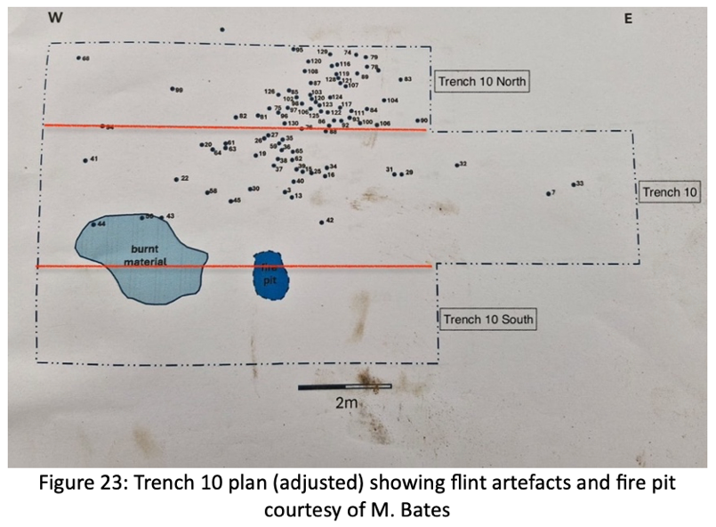

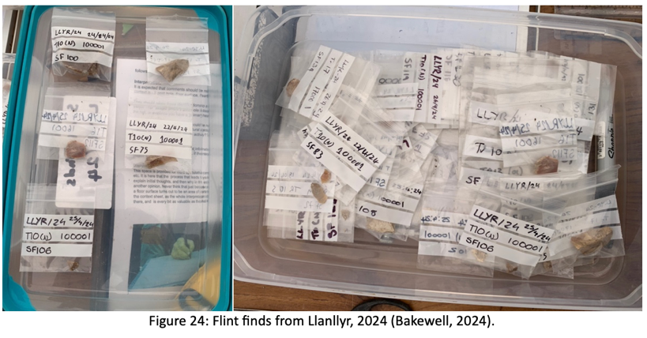

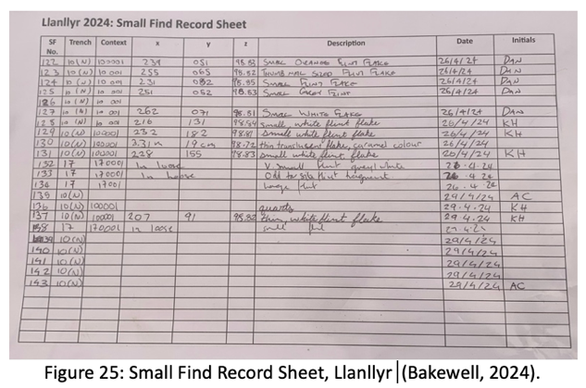

I thoroughly enjoyed the excavation, attending every day despite the rain, mud, and three-hour drive. Working in the same trench and seeing the process, from the discovery of the fire pit to processing the soil in the laboratory, was a great learning experience.
REFERENCES

BAJR (2025) Survey Basics: Laying out Trenches and Levelling. Available at: http://www.bajr.org/BAJRGuides/10.%20Basic%20Survey%20-%20Setting%20Out%20and%20Levelling/BasicSurvey.pdf (Accessed: 5 May 2024).

Bates (2024) PowerPoint from Introduction to the Field Week. Available at: https://moodle.uwtsd.ac.uk/course/view.php?id=6038 (Accessed: 4 May 2024).

Bates, M. et al. (2023) ‘Mesolithic-Neolithic landscapes in Ceredigion: a new site at Llanllyr.’ Unpublished.

Carver, M.O.H. (2010) Archaeological investigation. 2nd edn. London: Routledge.

Glasser, N.F. et al. (2018) ‘Late Devensian deglaciation of south‐west Wales from luminescence and cosmogenic isotope dating’, Journal of Quaternary Science, 33(7), pp. 804–818. Available at: https://doi.org/10.1002/jqs.3061

Google Earth (2024) Llanllyr Excavation Site. Available at: https://earth.google.com/web/@52.18020964,-4.13645882,68.96747371a,387.90060419d,35y,-0h,48.74972287t,0r/data=OgMKATA (Accessed: 28 April 2024).

McIntosh, Jane. (1999) The Practical Archaeologist : how we know what we know about the past. 1st edn. London: Thames & Hudson.

Mithen, S. (2019) ‘Mesolithic Fireplaces and the Enculturation of Early Holocene Landscapes in Britain, with a Case Study from Western Scotland’, Proceedings of the Prehistoric Society, 85, pp. 131–159. Available at: https://doi.org/10.1017/ppr.2019.6.

Newcomer, M.H. and Sieveking, G. de G. (1980) ‘Experimental Flake Scatter-Patterns: a New Interpretative Technique,’ Journal of Field Archaeology, 7(3), pp. 345–352. Available at: https://doi.org/10.1179/009346980791505392.

OS Maps (2024) Location of Llanllyr in the Aeron Valley. Available at: https://explore.osmaps.com/location?lat=52.182353&lon=-4.131019&zoom=12.0000&style=Standard&type=2d&locationName=U2FsdGVkX19mxkNMi2IBuPj4hjBygvawoXxKqSfTG5rXBAQus6gDx8k9m%2FCj5tR7&locationCoordinates=-4.131018820679482%2C52.18235264042084 (Accessed: 21 April 2024).

Past Horizons (2024) Fieldworker Data Cards. Available at: https://pasthorizons.com/collections/drafting-film-notebooks-record-sheets/products/fieldworker-data-cards (Accessed: 5 May 2024).

Renfrew and Bahn (2008) Archaeology: Theories, Methods and Practice. 5th edn. London: Thames & Hudson.

Research Frameworks (2024) Research Case Studies. Available at: https://researchframeworks.org/meso/conclusion/ (Accessed: 5 May 2024).

Shafer-Elliott, C. (ed.) (2016) The five-minute archaeologist in the southern Levant. 1st edn. Sheffield, UK: Equinox Publishing Ltd.

Star Carr (2024) About Star Carr. Available at: http://www.starcarr.com/history.html (Accessed: 5 May 2024).

UWTSD (2023) Help Discover Ceredigion’s Prehistory! Available at: https://www.uwtsd.ac.uk/news/help-discover-ceredigions-prehistory (Accessed: 4 May 2024).

UWTSD (2024) Moodle: MRB PP Presentation from Intro Week 2024. Available at: https://moodle.uwtsd.ac.uk/course/view.php?id=6038 (Accessed: 5 May 2024).

UWTSD (2024) Safety in the Field Regulations 2024. Available at: https://moodle.uwtsd.ac.uk/course/view.php?id=6038 (Accessed: 5 May 2024).

Vandendriessche, H. and Crombé, P. (2020) ‘Formalized Reduction Sequences from the Site of Kerkhove, Belgium - New Perspectives on Early Mesolithic Flint Knapping’, Lithic Technology, 45(2), pp. 110–124. Available at: https://doi.org/10.1080/01977261.2020.1721162

