System Specification
Ben Archer

Project
Tutors: Ian and Sarah

Contents
Amendment Index 1
System Description 2
Data Flow Diagrams 2
System Benefits 4
System Implications 4
Hardware and Equipment 4
Costs 5
Benefits 6
Output Specification 6
Input Specification 7
Page Mock-up 11
File Specification 12
Implementation Plan 14
References 14

Amendment Index
- Page Change No. 8 – Section No. 16
  - Change – Users can no longer choose a category of news they wish to see. Instead they are given a list of news sources with their subsequent category contained within the source information. Date of change is 25/03/2018.

System Description

Data Flow Diagrams – no data store on a level 0
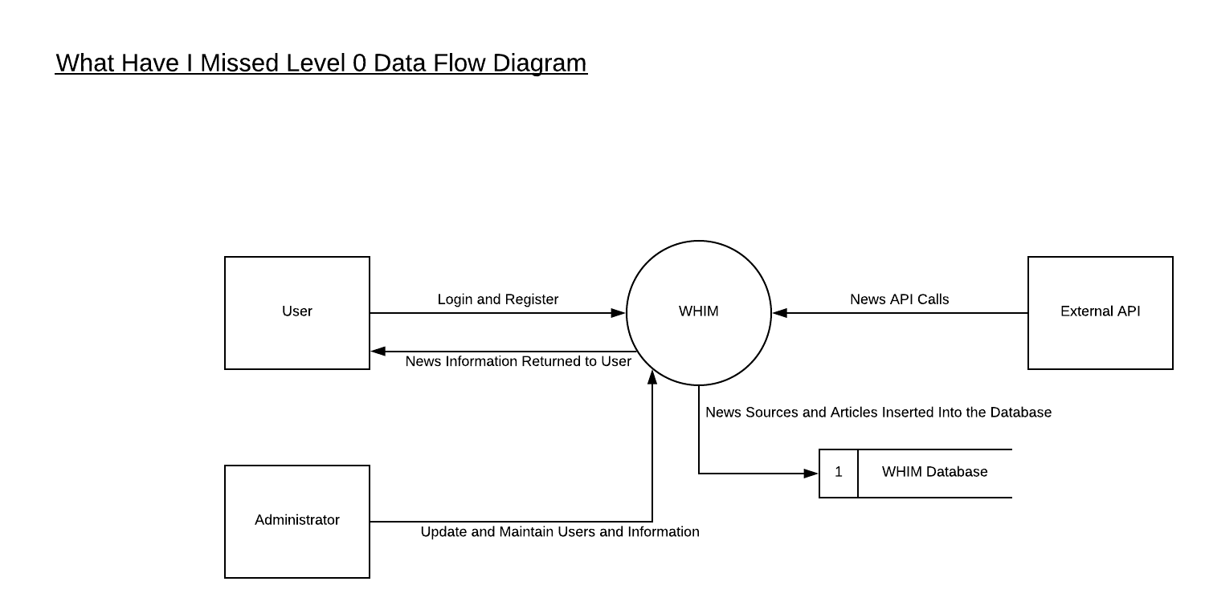

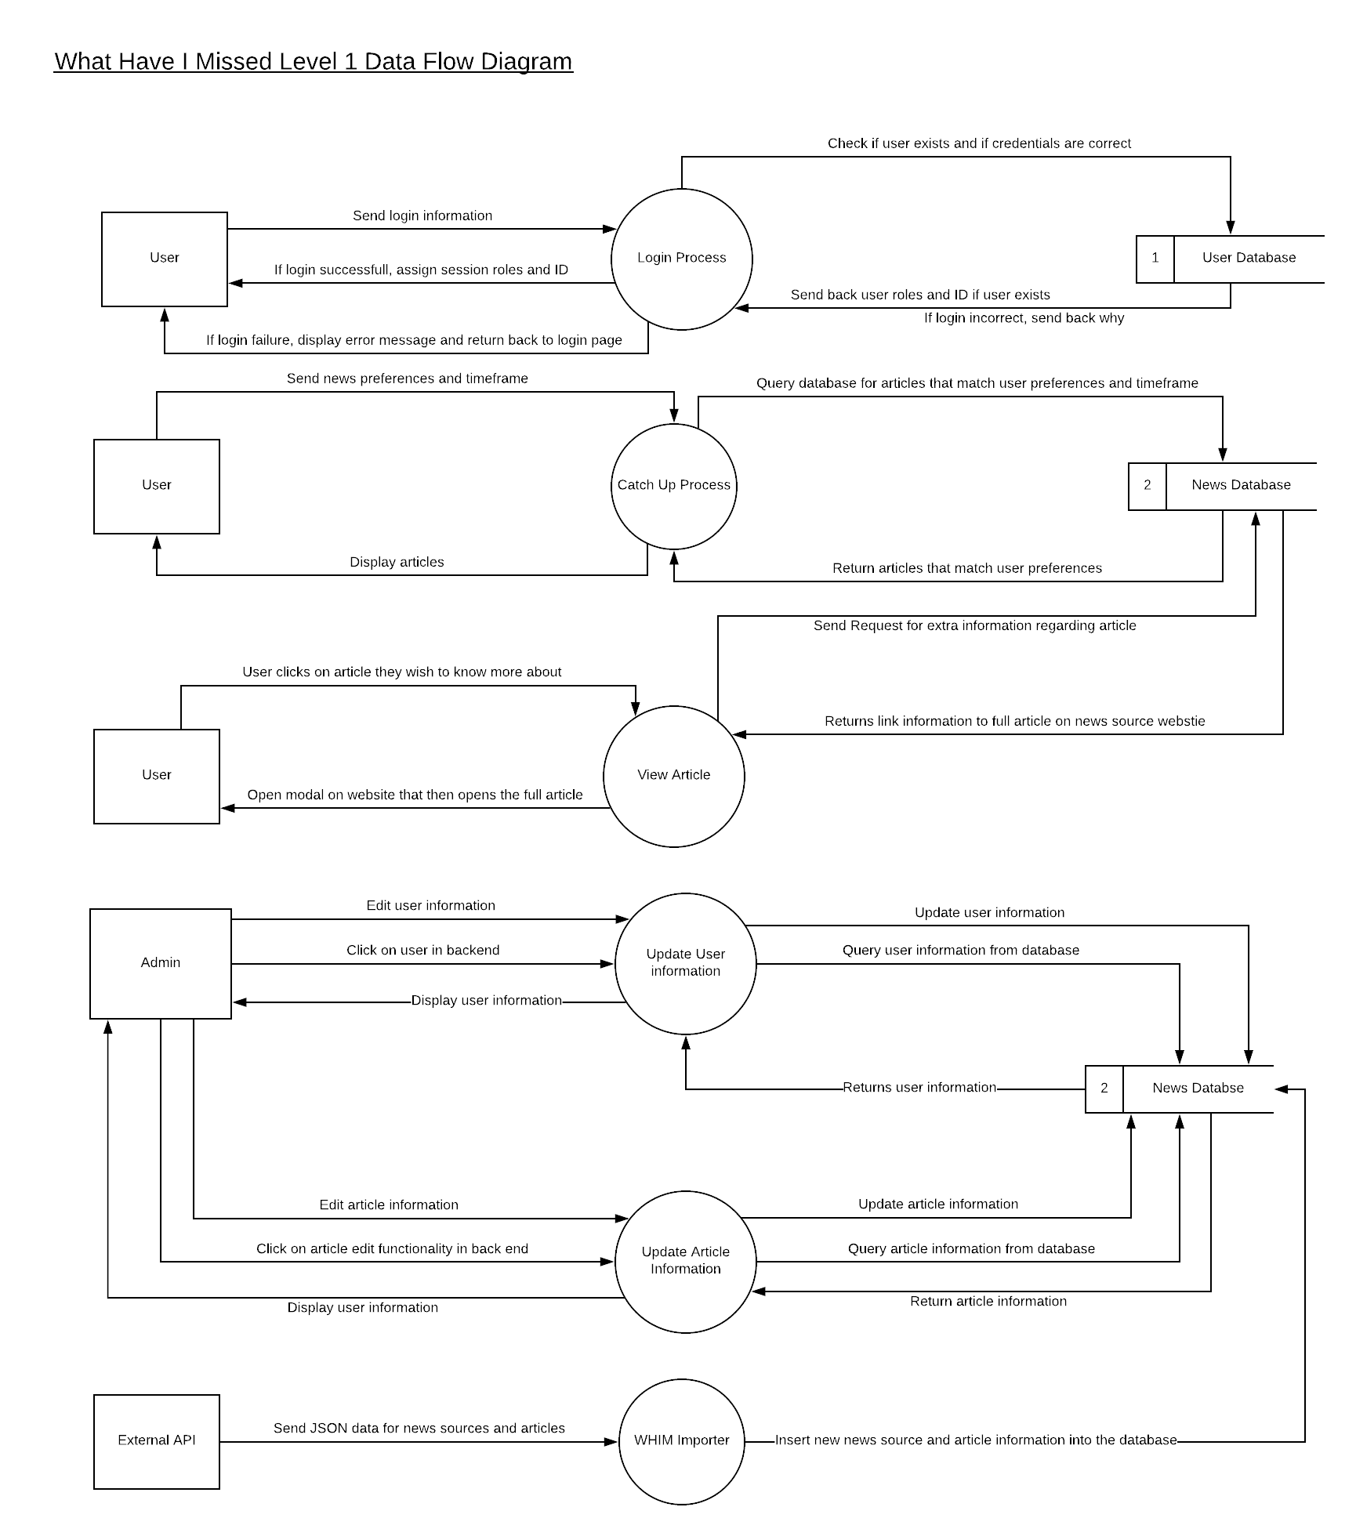
The main entities interacting with the system’s functionality are regular users, administrators and the external news API used to populate the database. The user can register and login and may be able to change their information in later phases of the system. Administrators are basically normal users but with higher level privileges compared to regular users; who can update user information as well as article information that is present within the system. The external API entity is the API service used by the system to populate the database that the system gets its information from. Every hour a program will run on the servers hosting server that collects information from the External API and subsequently update the News Database afterwards.✓

System Benefits
The benefits of the system, as outlined in the Requirements Specification, is the ability for people to stay informed of news that is of relevance to them. Moreover, the system can be tailored to fit the needs and interests of the user, increasing the feeling of comfort the user experiences when using the system.
As the system is a web-based solution, it can be accessed via a broad range of devices – allowing users to interact with the system in an increased number of scenarios and situations. Moreover, due to the implementation of a bootstrap template when designing the system, the responsiveness of the system will allow users to have the same experience regardless of what device they are using to access it.✓

System Implications
Due to the nature of the system being developed, there is no existing system in which the new systems implementation would implicate. However, there would be some implications regarding the security previsions and user support within the new system. Firstly, the security provisions that must be considered when implementing the system mainly revolves around the protection of sensitive user data – more specifically, the protection of user’s emails that are used within their registration process.
User support within the system would centre around the creation of easy to read documentation accompanying the system. Moreover, when designing the system, design considerations should be considered that ease the flow around the system, as well as the user comprehension of the systems input and output processes.

Hardware and Equipment
The system will be web-based. This eliminates most of the hardware requirements on the users end bar having an internet connection and the ability to interact with the system itself. On the other hand, due to the nature of the system; i.e. the reporting of vast amounts of news articles from many sources, there are several server and database requirements that will need to be considered when implementing the system.
For example: as the database will contain a large amount of data, and this data will be routinely accessed by many users several times a day, the hardware requirements on the server’s end will be geared towards CPU speed and RAM size. This is due to the need for an efficient user experience within the web-based system; UX would be impacted if queries or pages took any longer than the usual amount of time to load, reducing the overall user satisfaction with the system.
In addition to this, the disk space on the hosting server should be sufficient enough to support multiple backups of both the system database, as well as the system’s source code due to the need for development of the system in later versions.✓

Costs
The costs of the system will mainly occur during the implementation stage. The costs will primarily be associated with hosting the system and database on hosting servers. There may also be additional costs in the form of developer time spent after implementation in fixing bugs within the system that may not have been found during the QA phase of implementation.
The costs associated with software within the project are minimal due to the use of both Visual Studio Community and Microsoft’s SQL Server Management Studio. However, as per Visual Studio’s License Agreement [1], costs may be incurred after implementation of the system if the choice is made to monetise the system or prevent the source code from being open source.
Personnel costs will not be associated with the system due to the systems self-maintaining nature. To be more specific, unless changes must be made to the database structure, features are added to the system, or bug needed to be fixed within the system, human input in the form of personnel maintaining the system will not be required.
Training costs related to the system will not be required as the system is to be built with the user’s experience and comprehension in mind.
Support costs are likely to be minimal within the system due to, as mentioned above, the system’s self-maintaining nature. Support, if any, would be in the form of a developer fixing bugs that user’s have uncovered or administrators maintaining system output if the data stream has become out of sync or out of date.
Web hosting costs would occur in the form of the leasing of a domain name and the purchasing of an SSL certificate for the domain. Web hosting, depending on the website could cost anywhere from £7.07 per year to hundreds of thousands [2], however it is likely that due to the niche nature of the system, the costs associated with hosting would be on the lower end. After researching the cost of an SSL certificate for a single domain, an SSL certificate for the domain used for the system would cost £43.99 [3]. The certificate used within the system’s domain would follow the industry standard specifications for SSL certificates, such as 256-bit encryption as well as free verification seals. This could do with defining

Benefits
Due to the nature of the system and the fact that there are currently no existing systems that provide that same functionality within the scope that the writer has specified, the cost benefits that the system would provide are highly speculative. However, there are some areas wherein benefits could be seen.
For example, when comparing the proposed system to existing systems which only provide a small scope of information that relates solely to the organisation that is providing the system, a benefit of the proposed system would be the increased quality of information due to information being received from a wide variety of sources.
In addition, the control of information within the system could be argued to be of a greater significance compared to existing systems. Due to the data being received from an independent third-party API, data flow into the system can be controlled by simply changing the API calls that are made within the backend of the system.

Output Specification
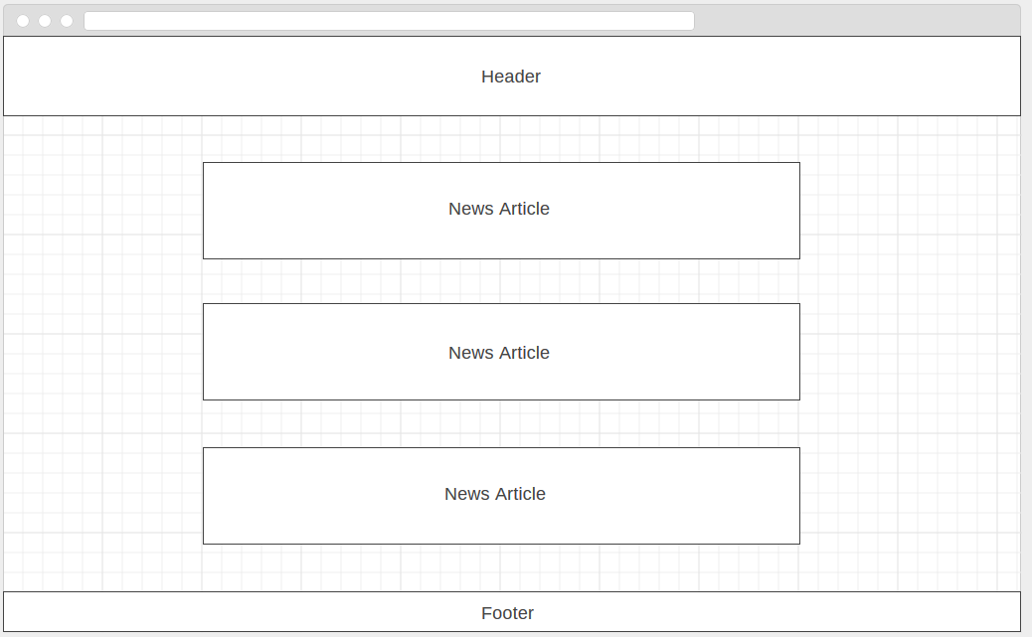
This is the screen the user will be presented with after they log into the system and have picked their preferences and news timeframe.

Input Specification
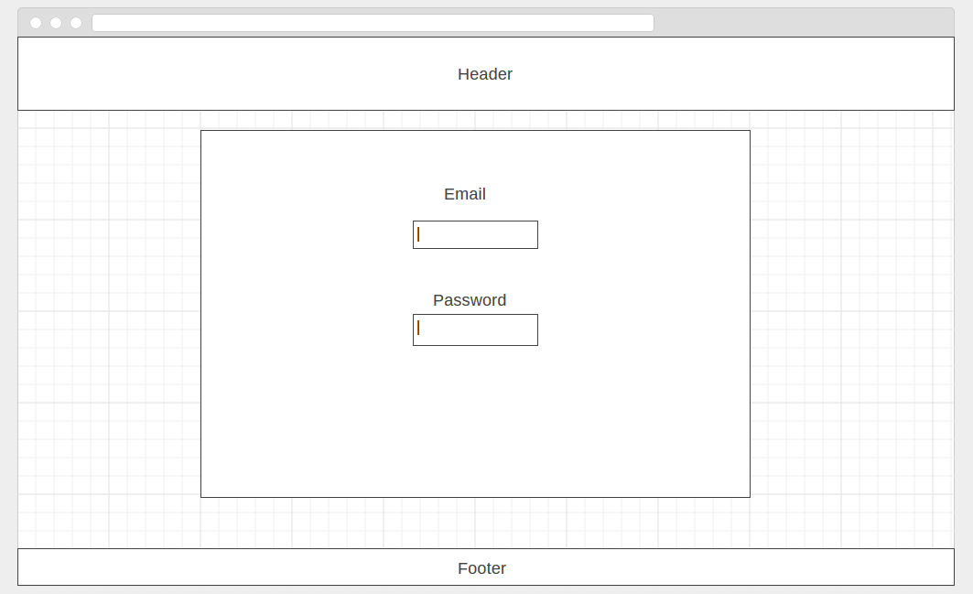
Above: The login screen the user will be presented with on landing. The user will enter their login information and, if successful, be redirected to the main page. If the login is not successful, a general validation message will display detailing that the user has entered the wrong information into the login form.

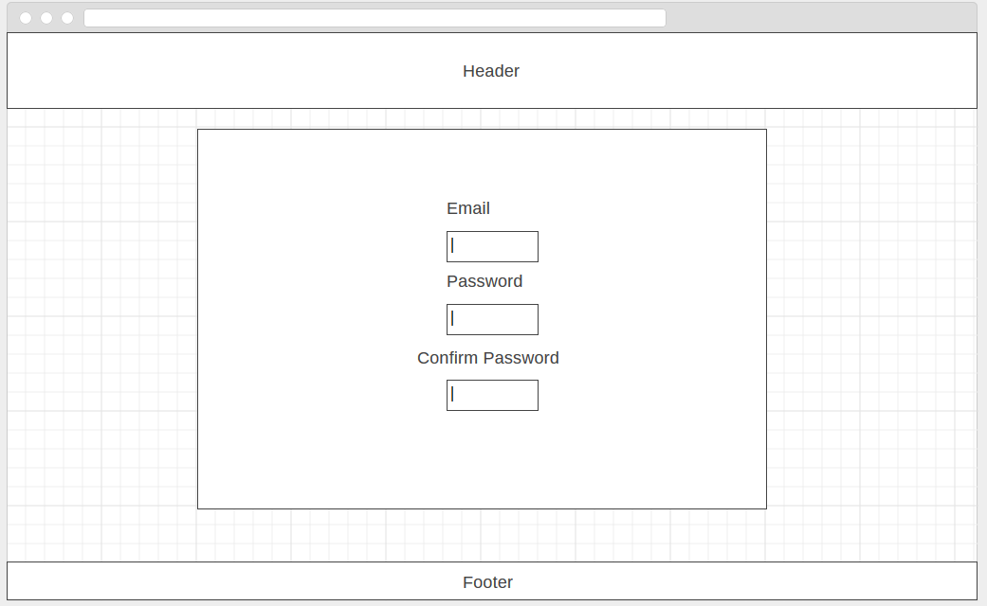
Above: The registration screen the user is presented with when registering for the first time. Email validation will be conducted using Regular Expressions. The password the user created will have to be over a certain amount of characters long.

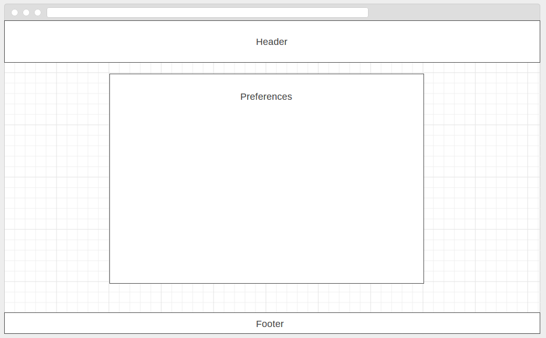
Above: After the user has entered their information, the are taken to the preference selection screen wherein they choose the news sources that they wish to get news from.

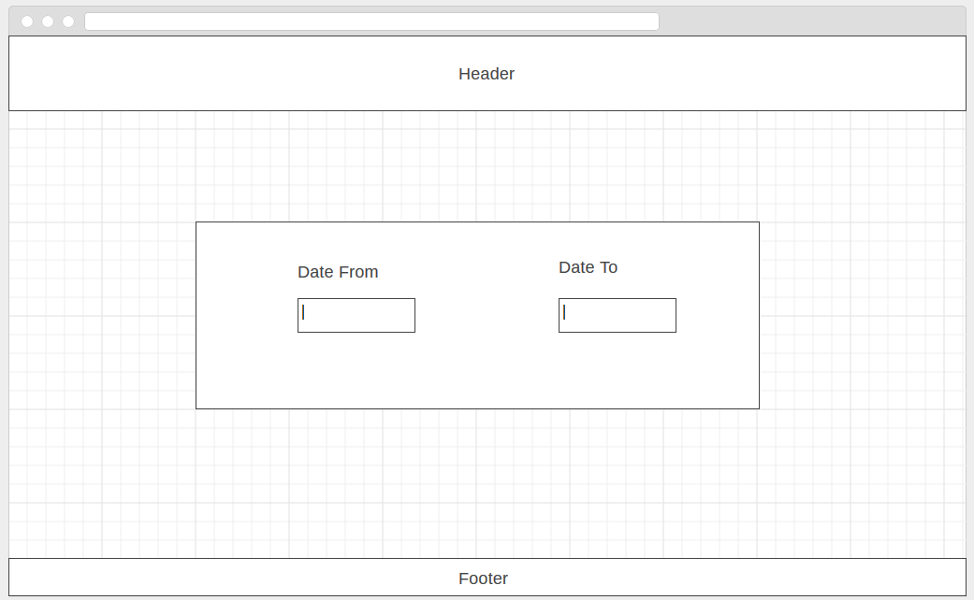
Above: This is the screen the user will be presented with after logging into the system and specifying their preferences. The user should enter the time frame in which they want to get news from their sources. After inputting the values into these fields, users are taken to the news output screen.

Page Mock-up
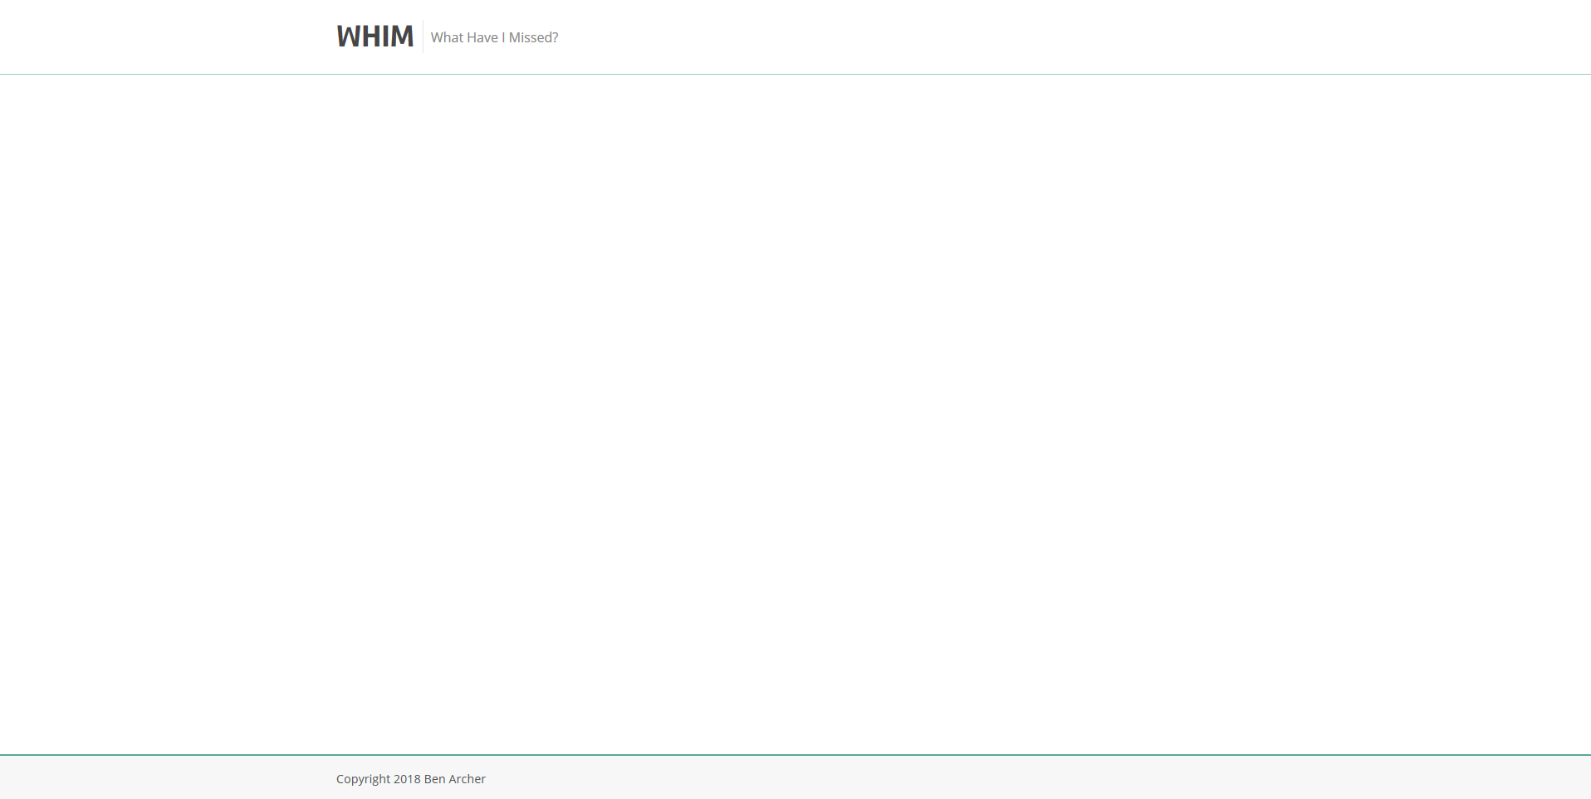
Above: The layout that will exist on all pages within the web application.

File Specification
Due to the nature of the system (MVC Web Application) there are many files associated with the system. A screenshot of the system files follows:
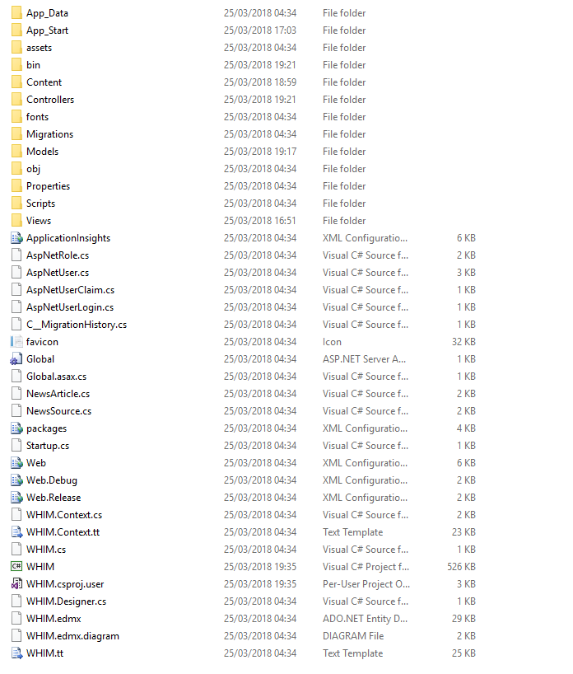
Above: All the files and folders that are used within the main web application.
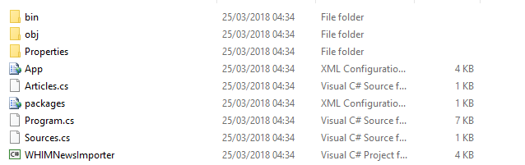
Above: All the files used within the news importer.

Implementation Plan
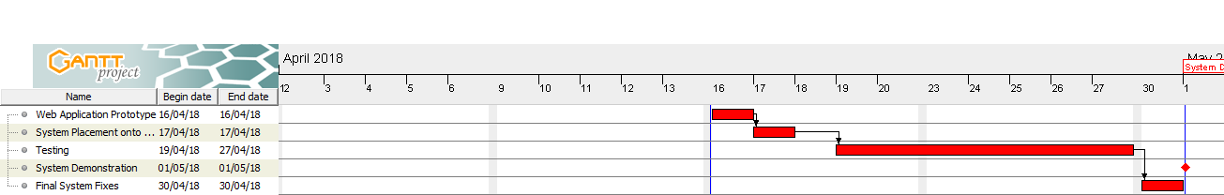
The first notable date within the implementation plan is the Web Application Prototype date. On this date it is expected that the system is in a state in which a small number of users are able to use the system in a limited capacity. The second notable date within the implementation plan is the System Placement onto Hosting Server date. This date is the scheduled date in which the physical system files, as well as the database files, are placed onto the hosting server. After this date select users will be able to access the system via their internet browsers. The following section in the implementation plan is the testing phase. Since the way in which the system was developed involves constant testing, there, theoretically, should only be a small amount of time dedicated to testing. The penultimate stage of the implementation plan is the system demonstration. During this stage the system will be demonstrated and evaluated by peers.

References
- Microsoft (2016) Understanding Visual Studio Community Edition license, Available at: https://www.visualstudio.com/vs/community/ (Accessed: 23/03/2018).
- Christopher Heng () How Much Does It Cost to Set Up a Website?, Available at: https://www.thesitewizard.com/gettingstarted/cost-setting-up-website.shtml (Accessed: 23/03/2018).
- GoDaddy (2018) SSL Certificates, Available at: https://uk.godaddy.com/web-security/ssl-certificate (Accessed: 23/03/2018).

