Types of play and how these can be supported in practice
What is play?
Play has crucial and many benefits to children. Piaget (1962) and Vygotsky (1978) has derived most of our understanding of the morals of play. Children were saw as active explorers of their world. Play is therefore dominant part of establish knowledge. This allows children to control what happens and utilize what they already know to further their understanding and development. DC. MS (2004) states that “play is define as what children and young people do when they follow their own ideas, in their own way and for their own reasons’. Additionally, NPFA (2000) states that play is freely chosen, personally directed, intrinsically motivated, behavior that actively engages the child. Therefore, by age 4 children must developed a fully formed activity of play or it will lead to low psychological preparedness for learning in the school setting.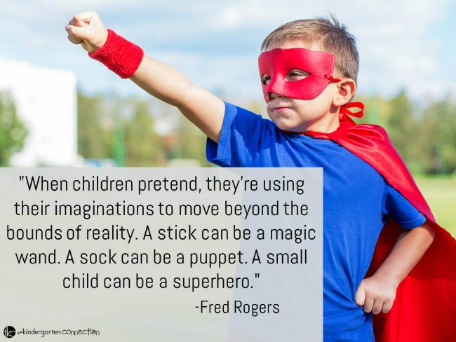Source: The Kindergarten Connection
Two types of play that are essential in children life are Dramatic and Socio- Dramatic play. Dramatic play is when children play dress up. As Nixon and Gould (1999) points out “In dramatic play children imitate the world around them through their role play”. This leads to cooperative dramatic play around agreed upon themes. Children idolize the roles of mom, dad, big brother or their favorite cartoon characters from television or books. According to Roskos and Christie (2001) “young children need to experience the concept of a story before they can begin to talk about it”. This statement is so true. Reflecting on my childhood days, Dramatic played a role. Children use kitchen set toys and pour tea from a toy teacup before he / she can perform these tasks in real world. Playing with tea sets or pretending to be a doctor or teacher helps children to understand their culture and the different roles people have in society. Dramatic play helps children transfer their enthusiasm to learn new skills. Davidson (1996) states that this type of play helps children acquire social emotional, cognitive, language and physical developmental skills. This type of play support children holistic development as they learn to see life from a different viewpoint. Through dramatic play, children learn to assert themselves in a way to build their competence in adult roles in the future (Elkind, 1981). Children will be able to adapt skills, understanding of the world, their culture and the different roles people have in society. This is a major way in which a range of literacy and numeracy skills are developed as well as creativity and confidence.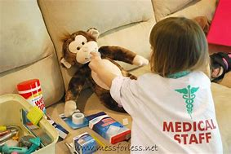

On the other hand, According to Smilansky and Shefatya (1990) “Socio-dramatic play is concerned with the nature of the role and of social interaction”. This is very different to the other types of plays which includes more body actions. They further stated that socio-dramatic play requires interaction, communication, cooperation and is characterized by the following elements:
Children have time, space and evocative objects.
It is a cooperative enterprise.
It is an expressive world of make believe yet it is reality bound.
Players must be understood by other players in order to achieve continuity.
Additionally, Smilansky (1968) points out that “Children developed language skills by creating imaginary worlds, characters, and scenarios which relate to real world”. Children use play to recreate the world and model the social behavior they see in it. In this way they can experience the world without risking the consequences. In Socio-dramatic play, interactions last longer, it shows more involvement, draw larger numbers of children into the activity and are more cooperative. The play becomes socio-dramatic if the theme is developed in cooperation with at least one other person or the members of the play collaborate with each other in both action and speech. This can support children holistic development by illustrating a growing awareness of their social surroundings. Freud (1961) saw socio-dramatic play to gain access to their inner spirit. Children instinct can be developed. This helps them by weakening the effect of the emotional pressure. Furthermore, Socio dramatic play helps them to understand others and develop feelings of empathy. Playing with others would nurture lifelong friendship, companionship, laughing and sharing. Apart from that, you could also learn about tolerance, give and take, compromise and social values. As a final point Bolton (1979) argues that all socio-dramatic play and drama is a metaphor for the children’s lives. However dramatic play has therapeutic, diagnostic and cognitive developmental functions. These two plays impacts child motivation in that a child learns to set short term and long-term goals in play. All of this points to the conclusion that both dramatic and socio-dramatic play is very essential to children holistic development. As they instill some important values and lifelong skills

The importance for children to choose their own play and the importance of the role of adults in children play
“Many years of research has shown that play is crucial to physical, intellectual and social – emotional development at all ages. This is especially true of the purest form of play: the unstructured, self-motivated, imaginative, independent kind, where children initiate their own games and even invent their own rules”. Dr. David Elkind
Self-directed play is vital for and supports the cognitive development of a child. Hughes (2010) Juster (2015, Vygotsky (1980) define self-directed play as “a type of autonomous play that progress when children choose their own play and make their own rules for how to play based on their own self led, intrinsically motivated interests without adult interference”. It is freely chosen, personally directed and intrinsically motivated that is playing in their own way for their own reasons (PPSG 2005). In other words, if your child is using simple toys in creative ways with no adult directed outcome. When children play this way, they figure out things for themselves and practice necessary skills such as overcoming obstacles, creativity, problem solving and self-discovery. In reflecting, Children are devoid freedom of play. For example, when at home they might not be allowed to go out and play. Montessori (1900) stated that play is the child’s work. Children would be best served spending their playtime learning or imagining. Frobel, Montessori and Steiner agreed that children are self-motivating. “We must give children an environment that he or she can utilize by himself: and a little washstand of his own, some small chairs, a bureau with drawers he can open, objects of common use that he can operate, a small bed in which he can sleep at night under an attractive blanket he can fold and spread by himself”. This view is supported by (Montessori 1975). Therefore, child led activities are fundamental to children development. Children cognitive, social, emotional and physical skills contributes to school success and is an important part of every child life. Child led activities builds self-confidence, it inspires independence, revive imagination, teaches problem-solving and flex their creative muscles. Additionally, some materials that children can use for self-directed play are balls, play dough, block etc. What is the role of adults in child play? According to Bruce (2004) It is important to remember that “both adults and children can initiate play, but adults must allow the children to take play in their own direction”. Is it true to say that any activity conducted by an adult is no longer play? I do believe so and will now consider the different roles adults can take during children play.
- An adult can provide everyday materials that children can change as they please such as cardboard boxes, paper towels tubes, crayons, glue etc.
- Make sure children have a safe and open space to play.
- Observe and assess the children and not to break their concentration.
- Simply watch and listen. If the children ask for help for example, cutting a window in a cardboard box, you can lend a hand. This will show that you support the play without taking over.
- Adults can support resolution of conflict through questioning to develop children negotiating skills rather than making decisions for them.
“It is essential that the child discovers himself as much as possible. If we help him to solve every problem, we deprive him of exactly what his mental development is most important.” Dr Emmi Pikler. It is part of our jobs as practitioners and parents to renown this time of play for our children. Selleck (2001) argues that “young children are the creators of the curriculum, and the adult role is to observe and support the creativity”. On the other hand, Vygotsky (1978) points out that interaction with adults or peers at a higher stage of development than the child is central to children learning development”. Vygotsky and Bruner emphasize both children and adult initiated activities, with the adult taking a supportive role. Therefore, adult’s role in play is crucial as they support and respond to children needs and potential.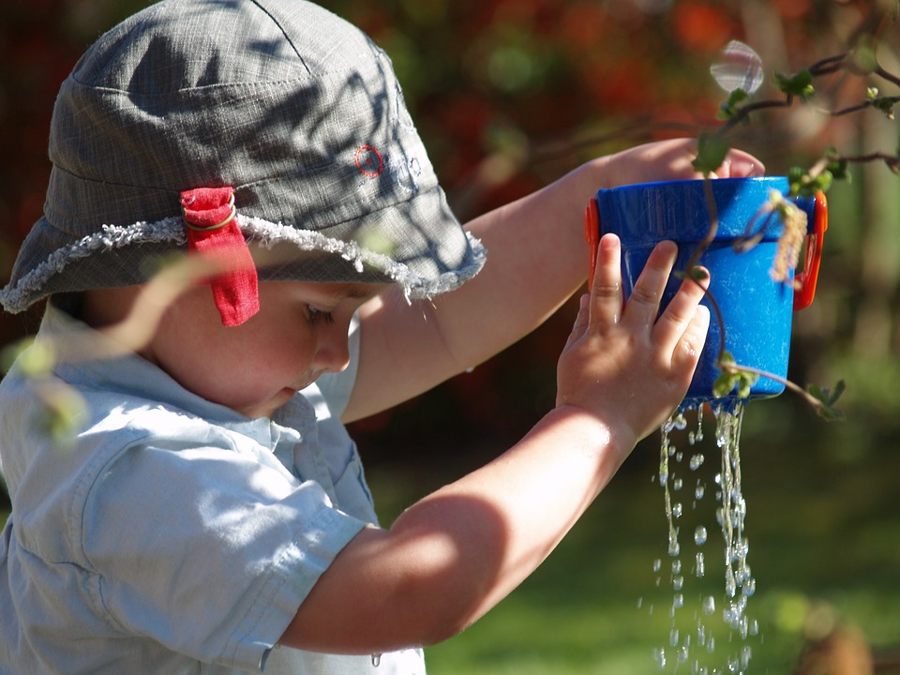
Source: Kimberly EYC, 2016
Running records for young children
Observation is a vital part of an early year’s practitioner role. Through observation we learn about children likes, dislikes, attitudes, knowledge, personalities and abilities to relate to others. Observation helps to plan accordingly on providing for children needs individually. “Careful assessment and record keeping underpin all good educational practice. They are essential elements in securing effective continuity and progression”. (Department of Education and Science 1990)
In order to truly understand a child’s unique attributes, preferences, personality and strengths you must observe them consistently using several documentation tools and techniques. One of the oldest methods of observation that is used for assessing young children is the running record. It was developed by Marie Clay, the originator of Reading Recovery. Running methods are considered as an informal method of observation. Clay (2003) defines running record as “an assessment tool which provides an insight into a student’s reading as it is happening. Practitioners can assign a day, time and setting and select a group of children or a specific child and decide on the purpose of observation. Bentzen (2009) argued that “this type of method is essential where observing young children as it provides rich detailed evidence and written accounts of everything you see and hear a child doing during a specific time frame.” He further stated the primary goal of the running record method is to “obtain a detailed objective account of behavior without inference, interpretation or evaluation. Time, paper and a pen is needed to gather observation evidence when using this method. It is a useful method and provides a holistic approach to observing a child. Therefore, when using this method, the goal is to write down everything you see and hear exactly as it occurs without adding any comment or opinions. Reflecting on my career as a teacher, I had an opportunity to use this method to assess students in my class through oral reading and spelling. This was done on a specific day where I assess each child individually as they read a passage. I Prepared a copy of the text which had space for analysis. I Followed on my script and marked the text anytime the reader made an error such as wrong pronunciation of words, hesitation. If the reader substitutes a different word for the word in the text, their substitutions are also recorded. After the student completes the reading task, they were ask questions based on the text to help determine their comprehension level. I pointed out errors and miscues that each child would have made and highlighted all their weaknesses. For example, if a child read between 90%-95% of words independently, the child is considered to be reading at the instructional level. I remembered being descriptive and concise when observing a child using this method. Clay (2005) states that “one of the primary uses of the running record is to determine if the child is reading a text at the appropriate level of difficulty”. Children can sometimes move quickly, so you must write quickly. You will know you have gathered good evidence when you can close your eyes and you can see the images in your mind as they are described in your running record (Bentzen 2009). This method helps to recognize patterns of development and seeing each child unique characteristics, personalities and abilities as they move on. Additionally, this method plays a vital role in child development as you will be able to review all the evidence you have collected and to monitor children’s progress. Practitioners can then plan an intervention on how to help each child going forward. It is written in present tense and recorded as the action is happening. However, this method can be time consuming, may be difficult to keep up and follow along as children move quickly from one activity to another. In concluding, Sharon Taberski (2000) a classroom teacher writes “Running records provide the information I need to make wise teaching decisions. They help me: decide whether the book a child is reading is matched to her stage of reading development, analyze a child miscue to see which cueing systems and strategies he or she uses and the ones she might learn to use more effectively”. Running record is an extremely valuable method of observation. Through this window you can observe much more about what your students were doing. With the information gathered using this method intervention plans can then be put in place to benefit all students and help teachers decide what children need to learn.

The role of play when undertaking observations and assessments of children and consider how this affects the child’s engagement and the accuracy of the observation.

By observing children as they play practitioners can ensure that a child development is at the expected stage, whether the environment and resources are stimulating their development and what future support the child will need. EYFS(DFE,2012A) Stressed that “there is a need to observe children in order for early years practitioners to be able to identify their needs and interests”. Also, practitioners will gain firsthand knowledge of what children can do and how they may respond to certain situations (Early Education,2012). During an observation the main role is to look and watch the child being observed, you should pay close attention to what the child is doing, their interactions with other children and what they are saying. Observations may also identify the delayed areas of children development which would signal that additional support may be required, for example, children can be formatively assessed on a weekly basis during play and building blocks. The summative assessment will be that they have improved and can now advance showing their development. To get a better understanding of the strengths and weaknesses of each individual child, educators and parents should observe children at play. As an educator, I need to observe a child in order to plan my lessons accordingly. Practitioners use observation while playing to support and enhance children development. Therefore, this does not affect the child’s engagement and the accuracy of the observation. Through careful observation we are able to learn how each child communicates, where they are and what they like to do, how they engage with others. This would then help practitioners to know where children are and what strategies need to be put in place. Observing brings individuality and better opportunities to know about the authentic traits of a child. Children learn from observations by knowing what is expected of them and how the teachers respond to them. Observation is essential to the process of supporting a child way of learning effectively as well as acknowledging how they learn. (Koshy(2010)

References
Beckley, P., 2012. Learning in early childhood. London: SAGE
Bruce, T., 1997. Early Childhood Education. 2nd ed. Scotland: Hodder&stoughton
Drake, J., 2009. Planning for children's play and learning. 3rd ed. New York: Routledge.
Hobart, C. and Frankel, J., 2009. A practical guide to child observation and assessment. 4th ed. cheltenham United Kingdom: Oxford University Press.
Johnston, J., Nahmad-Williams, L., Oates, R. and Wood, V., 2009. Early childhood studies. Pearson education limited.
Macintyre, C., 2001. Enhancing learning through play. 1st ed. Great Britain: David Fulton Publisher
MacLeod-Brudenell, I. and Kay, J., 2008. Advanced early years care and education. 2nd ed. Oxford: Heinemann Educational.
.Ukessays.com. 2022. Children’s Play Theories and Contemporary Issues. [online] Available at: <https://www.ukessays.com/essays/young-people/childrens-play-theories-and-contemporary-issues-young-people-essay.php> [Accessed 20 February 2022].

