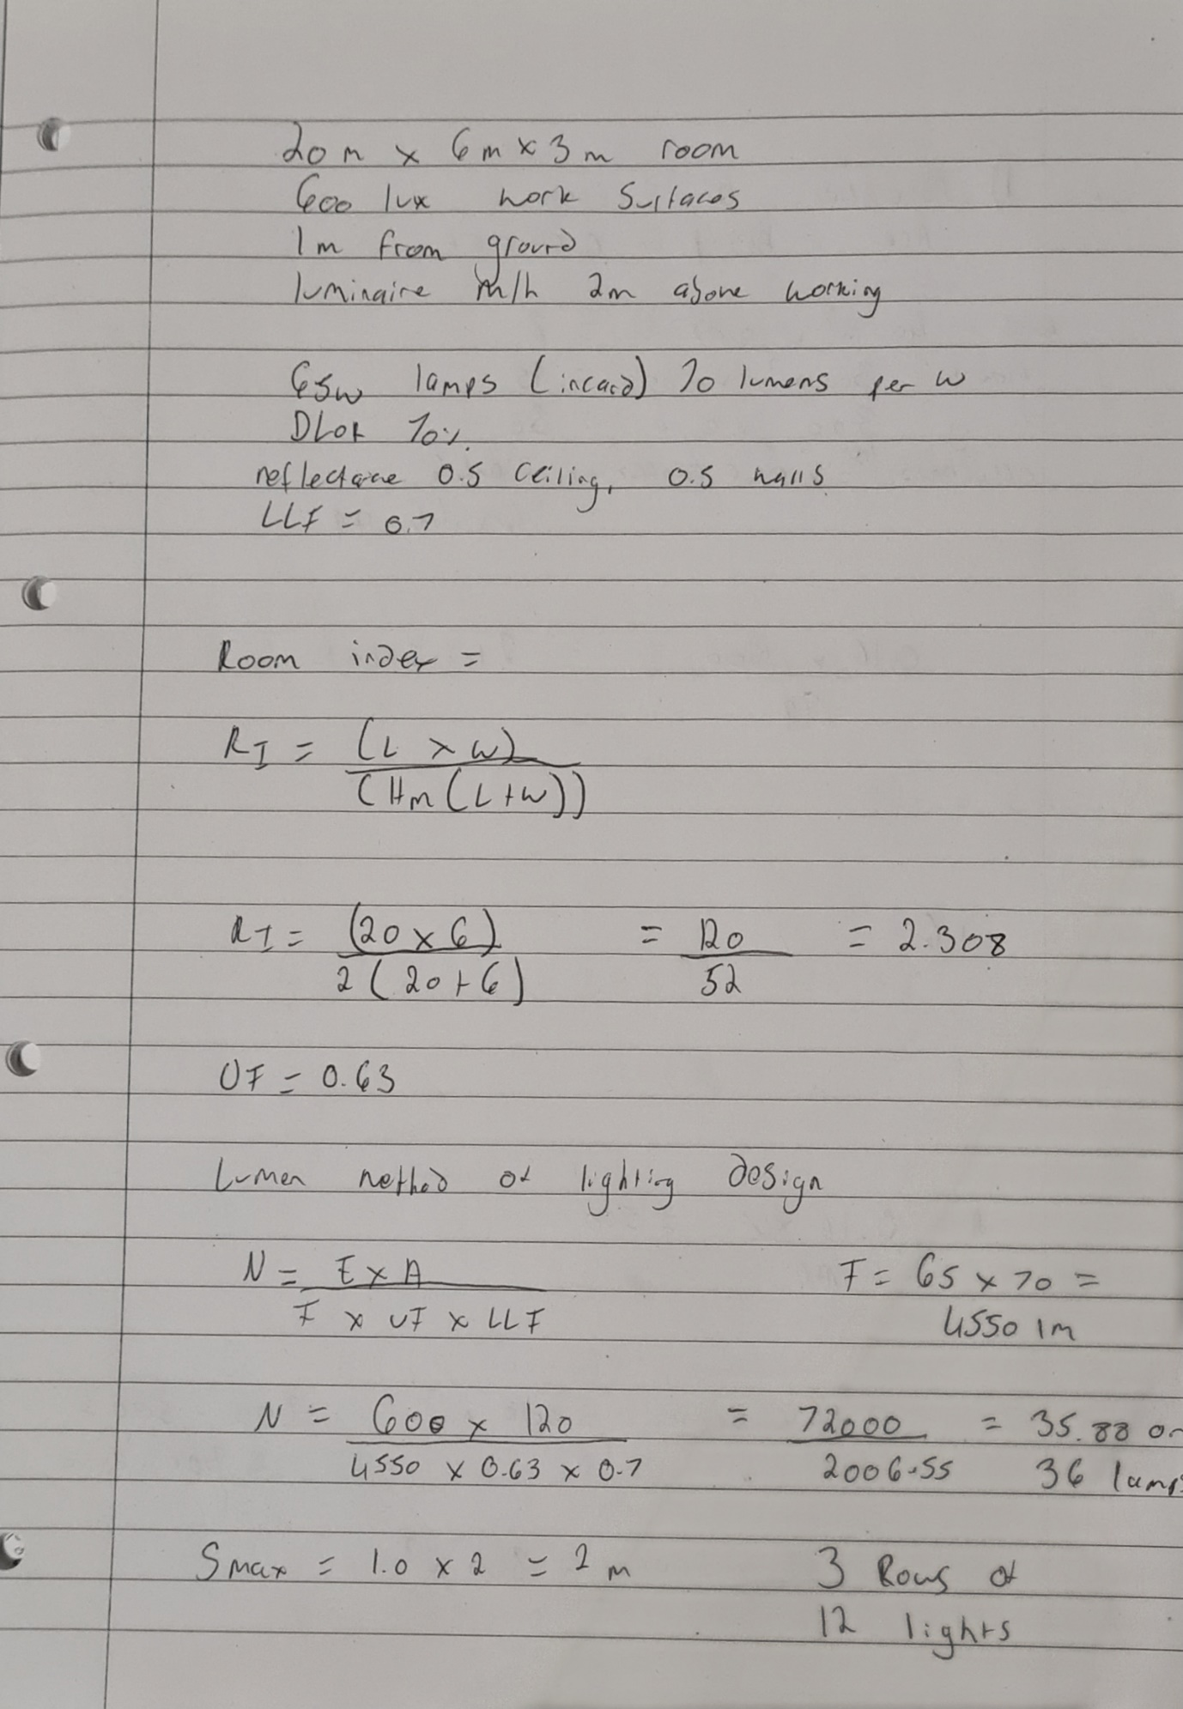

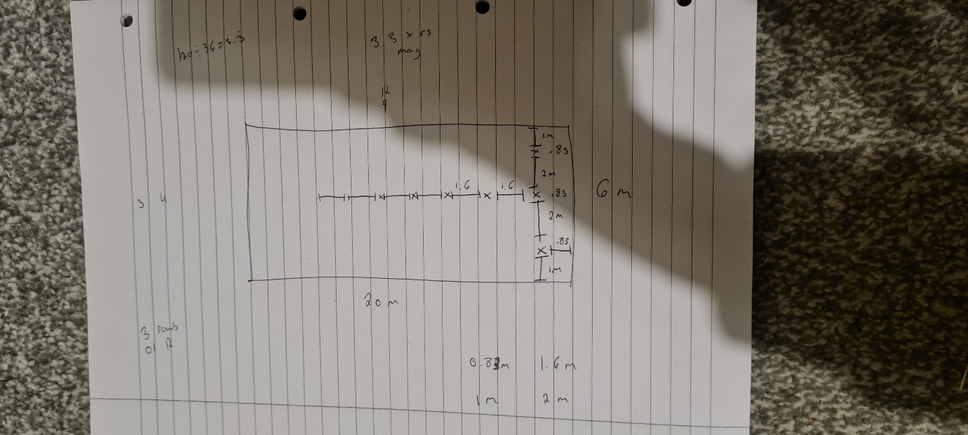

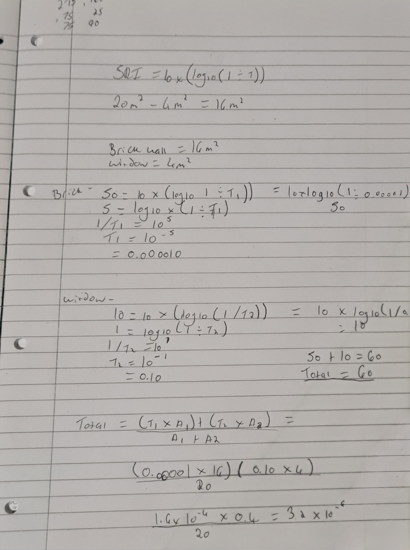
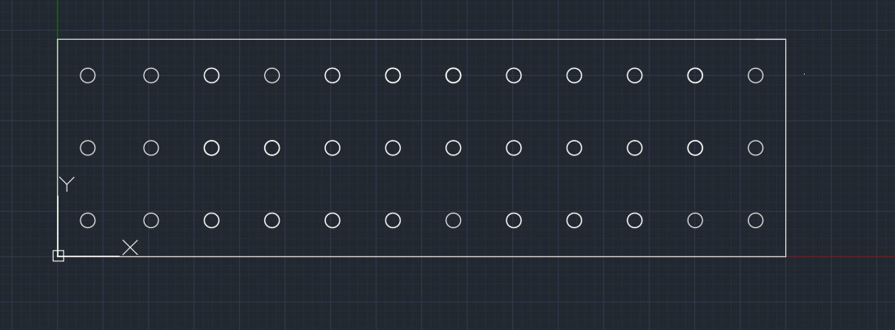
Lighting layout below for a factory measuring 20m by 6m.
1.66 Meters
2 Meters
0.83 Meters
1 Meter

Frequency is the number of times per second that a sound pressure wave repeats itself, measured in hertz (Hz). A frequency of one hertz refers to one cycle per second. The human ear can hear from 20 Hz to 20,000 Hz, although this is dependent on each individual.
Wavelength is simply the size of a wave, measured from one peak to another, or from one identical point to another.
A building’s internal design can be adapted to reduce sounds which can be disturbing to the occupants. Higher frequency sounds are easier to absorb compared to lower frequency sounds. Sound insulation is a common method of dampening sounds in buildings. Sound absorbers are also another choice. There are three main categories including porous absorbents (for high frequencies), panel absorbers (for low frequency) and cavity absorbers (for specific frequencies).
When deciding which insulation to use in a property for sound insulation there are two factors to consider; the Noise reduction coefficient (NRC) and the amount of sound the insulation blocks (STC). Mineral wool is a good contender with an NRC of 0.95 to 1.05 and an average STC rating of 45. Cotton insulation has an NRC of 1.15 and an STC of 51. Mineral wool is designed to a specific density for maximum absorption. Rockwool is designed in a similar way with the added benefit of it reflecting sound back towards the source (Brown, 2022).
This then links into constructing a partition wall with frequency and soundproofing in mind. Implementing acoustic insulation into the stud wall to aid with reducing vibrations and dampening unwanted sounds from each room. Many stud walls are constructed from a timber frame with plasterboard fixed each side. The void space within the wall allows sound to echo, resonate, and amplify making any noise louder. For many, this unwanted sound will be quite irritating, especially for multiple occupancy properties. By adding in the acoustic insulation, it makes the space much more comfortable (and quiet!) for people. Additionally, the use of thicker plasterboard with acoustic qualities will further aid the reduction in noise. This is due to the higher mass of the plasterboard which helps with noise transference and absorbing vibrations.

Brown, R. (2022). Your Guide to Different Types of Soundproof Insulation. [online] Homedit. Available at: https://www.homedit.com/soundproof-insulation/.
‌

