

ENTREPRENUERSHIP

Written Report on Favourite Entrepreneur

Created by: Vladimir Stoyanov (2219021)

Module code: LCBB5001
Lecturer’s name: Dr Said Usman

INTRODUCTION

Elon Musk: A visionary Entrepreneur

Elon Musk, one of the most influential figures of the 21st century, is known for his groundbreaking ventures in technology, transportation, and space exploration. His journey from a curious child in South Africa to becoming a globally recognized entrepreneur is nothing short of extraordinary. This report delves into Musk's background, achievements, motivations, and entrepreneurial traits, offering insights into the qualities that have propelled him to unparalleled success.

Early life and background

Maye Musk, a Canadian, and Errol Musk, a South African, welcomed Elon Reeve Musk into the world on June 28, 1971, in Pretoria, South Africa. Musk showed a keen interest in and talent for technology at a young age. He became interested in computers when he was ten years old and taught himself to program. By the age of twelve, he had developed and marketed his first piece of software, a game named Blastar.

Musk experienced difficulties as a child, such as bullying at school and the divorce of his parents. Nonetheless, these encounters strengthened his ability to bounce back and solve problems. Beyond computers, Musk was a voracious reader who consumed both non-fiction and science fiction literature, which shaped his outlook on the future.

Prior to going to the University of Pennsylvania, where he obtained degrees in economics and physics, Musk studied at Queen's University in Canada. Musk had entrepreneurial impulses while attending college by renting out a residence and converting it into a nightclub in order to earn additional cash. After two days, he left Stanford University to focus on the rapidly growing tech sector, where he had temporarily pursued a PhD.

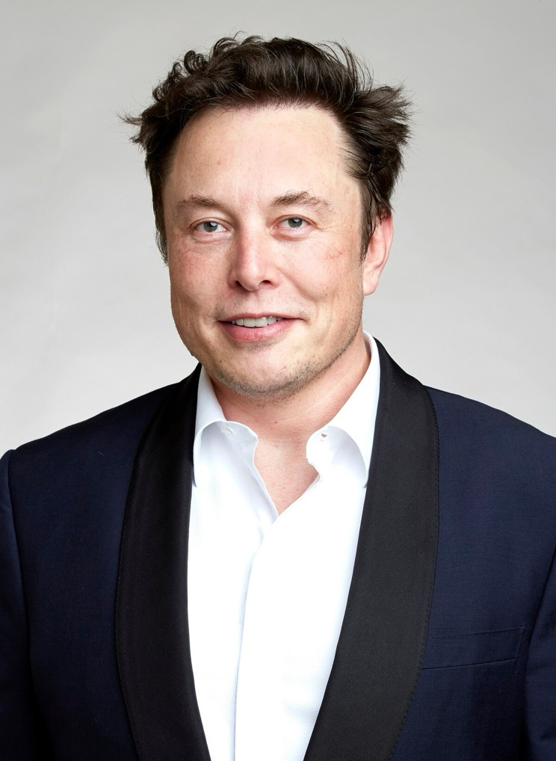

ELON’S ACHIEVMENTS

PayPal and the Dot-com Boom

Musk’s entrepreneurial journey began with Zip2, a city guide software company. After its acquisition by Compaq for nearly $300 million, he co-founded X.com, an online payment company. This venture later became PayPal, which was sold to eBay for $1.5 billion in 2002. PayPal’s success demonstrated Musk’s ability to identify and capitalize on emerging trends in digital finance.

Space Exploration: SpaceX
In 2002, Musk founded Space Exploration Technologies Corp. (SpaceX) with the goal of making space travel more affordable and accessible. SpaceX achieved several milestones:
- First privately funded company to send a spacecraft to the International Space Station (2012).
- Development of reusable rocket technology, drastically reducing costs.
- Successful launch of Falcon Heavy, the most powerful operational rocket, in 2018.
- Starship program aiming for Mars colonization, with test flights demonstrating advancements in space travel.

Electric Cars: Tesla

Musk became a chairman and investor in Tesla Motors (now Tesla, Inc.) in 2004. Under his direction, Tesla produced classic models like the Roadster, Model S, Model 3, and Cybertruck, which helped the company become synonymous with electric vehicles (EVs). The automotive industry has undergone a transformation thanks to Tesla's breakthroughs in battery technology and sustainable energy solutions.

Beyond automobiles, Tesla has developed energy products like Powerwall and Megapack that are intended to establish a sustainable energy environment. Musk's dedication to increasing production and cutting expenses is exemplified by the company's Gigafactories, which are spread across the globe.

Renewable Energy: Beyond SolarCity

Musk focused on clean energy solutions when he co-founded SolarCity in 2006. Later, Tesla purchased the business to become Tesla Energy, which prioritised energy storage and solar power. Musk's plan to switch the globe to renewable energy includes solar roof tiles and massive solar systems.

Both The Boring Company and Neuralink

Musk's other businesses include The Boring Company, which specialises in tunnelling and infrastructure solutions for urban transit, and Neuralink, which seeks to combine human intelligence with artificial intelligence through brain-machine interfaces. While The Boring Company's tunnel initiatives are intended to reduce traffic congestion in major cities, Neuralink's developments in brain-computer interfaces have the potential to transform medical treatments for neurological diseases.
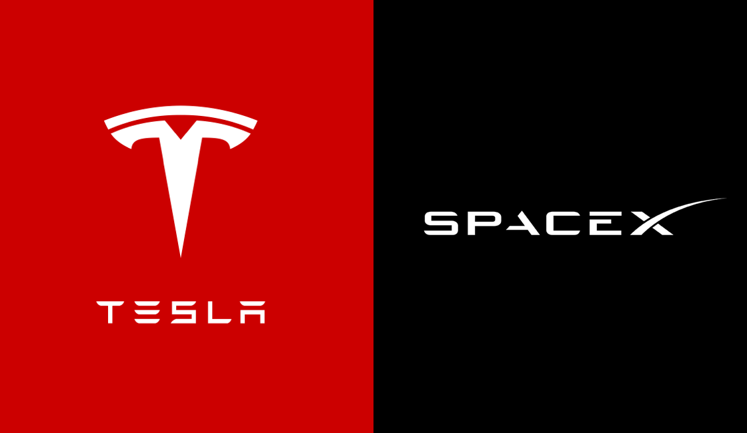
MOTIVATIONS

Musk is driven by more than just monetary gain. He is motivated by a desire to improve humanity and find solutions to existential problems:

Sustainability: Musk's initiatives in electric cars and renewable energy demonstrate his dedication to halting climate change and lowering the world's reliance on fossil fuels.

Space Exploration: In order to protect humanity from possible worldwide calamities like nuclear war or asteroid impacts, Musk imagines a multiplanetary future.

Innovation: He believes in creating a better, more technologically advanced future, which drives his unrelenting pursuit of cutting-edge technologies. Musk frequently discusses how crucial it is for mankind to develop into a "spacefaring civilisation" in order to protect the species.

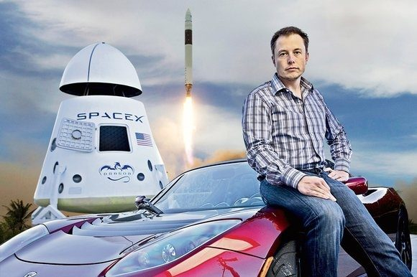
Characteristics of an Entrepreneur

Elon Musk embodies several entrepreneurial traits that have contributed to his success:

Imaginative Thought

Musk is unmatched in his ability to predict the direction of sectors like energy, transportation, and space exploration. His lofty objectives frequently test the limits of what is deemed feasible. His confidence in long-term survival and exploration, for example, is the foundation of his vision of establishing a colony on Mars.

Adaptability

Musk has continuously shown tenacity in the face of multiple setbacks, including as monetary difficulties and public censure. Examples of his resolve include SpaceX's early rocket malfunctions and Tesla's production hold-ups. He stands out for his capacity to bounce back and grow from mistakes.

Taking Chances

There are substantial financial and technological risks associated with Musk's endeavours. His risk tolerance is demonstrated by his readiness to put his own cash into SpaceX and Tesla. Musk refused to compromise on his vision, even in the face of bankruptcy.

Innovation and Solving Issues

Musk's business endeavours tackle some of the most important issues facing humanity. His focus on innovation, which includes scalable EV production and reusable rockets, demonstrates his aptitude for problem-solving. As demonstrated by Tesla's developments in battery technology, Musk's hands-on approach frequently results in breakthroughs.

Leadership and work ethic

Musk is well known for his hands-on leadership style and unrelenting work ethic. He often works long hours and gets lost in technical details. His approach inspires his teams to pursue greatness and take on difficult tasks.

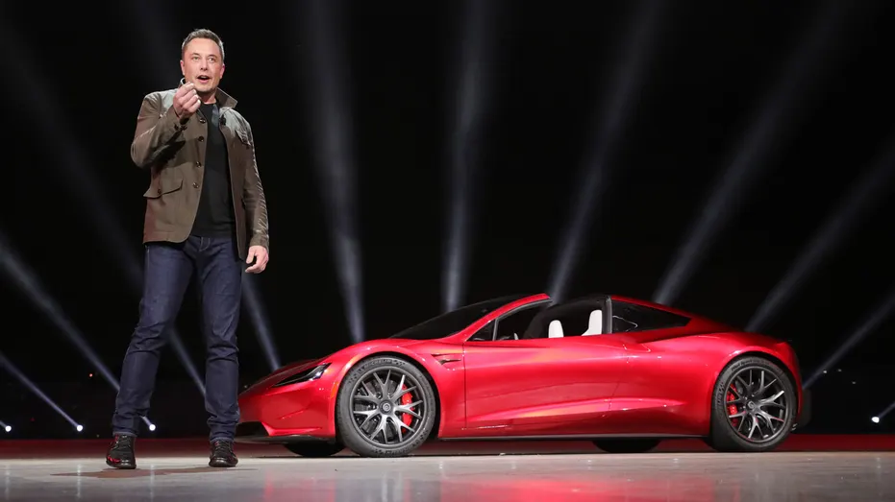
TRAITS FOR DEVELOPMENT

Imaginative Thought

Long-term success depends on cultivating the capacity to predict future trends and match them with achievable objectives. This calls for encouraging creativity and keeping up with new technological developments.

Adaptability

Developing the mental fortitude to overcome obstacles and failures is crucial for both professional and personal development. Overcoming challenges can be facilitated by learning to see setbacks as chances for improvement.

Risk Management

Groundbreaking accomplishments might result from striking a balance between measured risks and possible benefits. Gaining a solid grasp of strategic planning and risk analysis is essential.

Leadership and Team Building

Musk's success is largely attributed to his capacity to recruit and inspire high-achieving teams. Organisational effectiveness can be increased by developing leadership abilities and encouraging teamwork.

CONCLUSION

The tale of Elon Musk is proof of the strength of foresight, tenacity, and creativity. His accomplishments in tackling global issues and changing sectors highlight the value of entrepreneurial leadership. In addition to inspiring millions, Musk has changed our perception of technology and its place in the future by utilising his special qualities.

Musk's story offers budding business owners priceless lessons on how to set ambitious objectives, learn from mistakes, and persevere in the face of significant change. He is a shining example of contemporary entrepreneurship because of his capacity to see beyond the here and now and come up with answers for long-term problems. His work's lasting impact serves as a reminder that creativity, when combined with bravery and tenacity, has the power to completely reshape the future for future generations to come.

Innovating the Future of Gaming: My Journey as an Entrepreneur

I've always had a strong interest in using technology to produce captivating and immersive experiences as an entrepreneur. My goal is to create a cutting-edge gaming console that pushes the limits of engagement and fun. I came up with the concept because I think that games have the ability to unite people, create gripping tales, and further technical advancement.

My ideal console places a high value on affordability, customisation, and state-of-the-art technology. It incorporates cloud-based gaming, smooth cross-platform interoperability, and AI-driven gameplay improvements. In keeping with the increased desire for eco-friendly products, the console's design incorporates recyclable materials and energy-efficient components.

Getting started on this project requires gathering a group of talented developers and designers, obtaining funds to realise the idea, and conducting in-depth market research to find gaps and possibilities. Resilience and a growth attitude are the cornerstones of my entrepreneurial path; these qualities are crucial for overcoming obstacles like established brand competitors and technology barriers.

The goal of this project is to provide a platform that encourages diversity, innovation, and community in gaming rather than only releasing a product. By remaining creative, flexible, and value-driven, I hope to establish a niche in the cutthroat gaming market and encourage others to pursue their dreams.

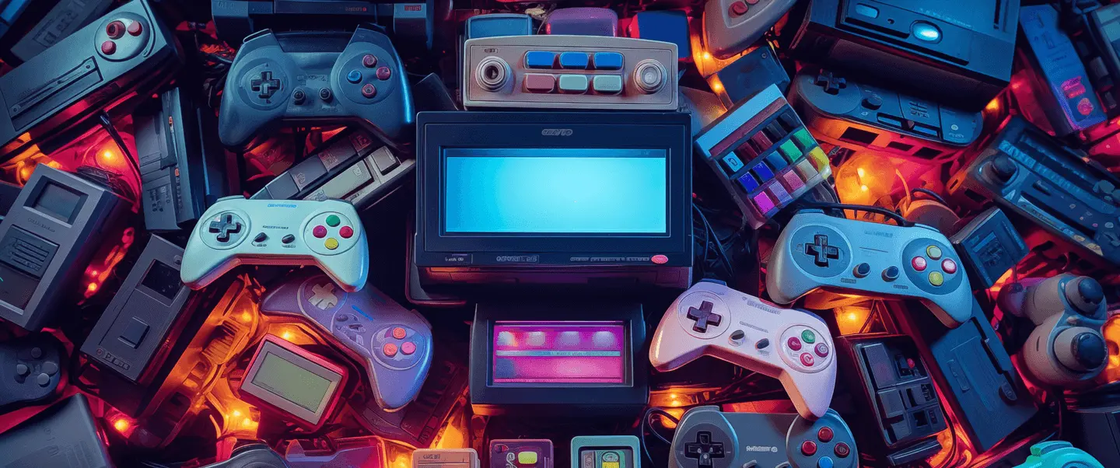

REFERENCES

- Vance, A. (2015). Elon Musk: Tesla, SpaceX, and the Quest for a Fantastic Future. HarperCollins.
- Tesla, Inc. (n.d.). Retrieved from www.tesla.com
- SpaceX. (n.d.). Retrieved from www.spacex.com
- Neuralink. (n.d.). Retrieved from www.neuralink.com

