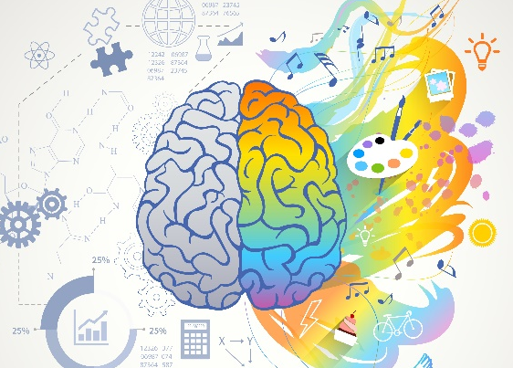
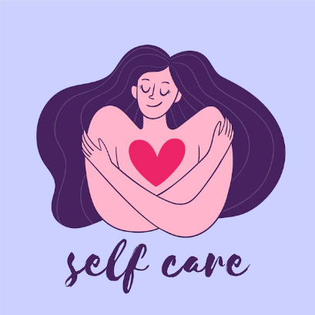
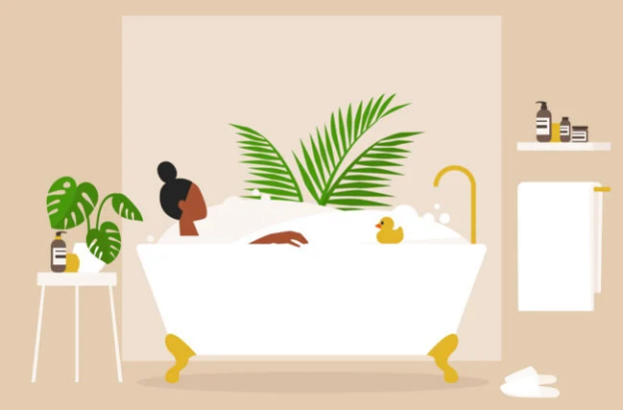
Sleep/Relaxation
Drink Water
Eat healthy
Mini Meditation session
Hobbies
Creativity
Be Selfish
Journal
Set boundaries/needs/goals
Acceptance/Pleasure
Laugh/have fun
Movie/Cuddle
Pets/Friends
Unplug for an hour
Get out of your comfort zone
Yoga/Pilates
Express feelings
Let go of negativity
Warm water
Watch a cloudy Sky
Kindness/Awareness

Delete negativity and hate
Bath/Massage
Turn off Tech
Nice Smells
Forgiveness of self & others
Mindfulness
Ask for help
Create a good habit
Soft materials
Kind people
Bake
Listen to the rain
Craft soaps or candles
Look up at starry night
Meditation
Dance/Read
Declutter
Say no/Stay home
Say yes/Stay out
Support group/Event
Poems/Paint

Positive News
https://www.positive.news/
Reading positive news enhances mood, reduces stress, and cultivates optimism. It contributes to improved mental health, fostering resilience by showcasing triumphs over adversity. The intentional focus on uplifting stories helps create a more optimistic mindset and counters the often-negative tone of mainstream news. Positive news encourages gratitude, social connection, and a balanced perspective on global events. By choosing positive news, individuals prioritise their well-being, creating a mental environment that promotes positivity and a sense of hope in the world.
Michael Sealey
https://www.youtube.com/results?search_query=michael+sealey
Michael Sealey's YouTube channel offers a valuable resource for well-being through guided meditations and hypnosis. With a focus on stress reduction, improved sleep, and anxiety relief, his content provides a calming escape. The guided sessions promote mindfulness, encouraging listeners to be present and centred. Tailored for relaxation, his videos incorporate techniques like progressive muscle relaxation and visualization. Themes of self-discovery and personal growth are explored, fostering self-reflection and positivity. Positive affirmations within the content contribute to changing negative thought patterns. Michael Sealey's channel serves as a soothing space for those seeking relaxation, mindfulness, and emotional balance.
Positive Psychology
https://positivepsychology.com/self-care-worksheets/
A solid starting point for embarking on a self-care journey is to take an inventory of how good we are at it already. This Self-Care Checkup breaks self-care down into physical, psychological, social, spiritual, and professional self-care. Checking how we score in each domain provides a good first indication for what we should prioritize. An even better first calling point is PositivePsychology.com’s Self-Care Check-in, which invites us to see where more attention is needed to ensure we are addressing our self-care needs. It reminds us of the importance of taking active steps to maintain our mental wellness, and helps us identify where we should focus our attention to satisfy our unmet needs.

