
OPERATING SYSTEM ASSIGNMENT

Name: Samir Zaky Ibrahim Morsy
ID: 2518295
Group: 3
Course: CertHE Computing Skills for Workplace
Module: Computer Architecture and Operating Systems

Table of Contents
Introduction 4
Key Functions of Operating Systems 4
Process Management 4
Memory Management 5
File System Management 6
Device Management 6
Security and Access Control 7
Windows CLI Commands 8
tasklist 8
taskkill 8
dir 9
cd 10
ipconfig 10
ping 11
net user 11
shutdown 12
schtasks 12
copy 13
Linux CLI Commands 13
ps 13
kill 13
ls 14
cd 14
ip 15
ping 15
adduser 16
passwd 16
Crontab 17
cp 17
Windows Batch Scripts 18
Script 1: Multiplication Script 18
Script 2: Backup Script 19
Linux Bash Scripts 20
Script 1: Multiplication Script 20
Script 2: System Monitoring Script 21
Conclusion 22
References 22

Introduction
Operating Systems (OS) are the most crucial components of software which manage how users and computer hardware interact. They also ensure sure that applications and resources run smoothly. Windows and Linux are two types of modern operating systems that offer robust environments for doing many things, such as handling multiple tasks, managing memory, keeping the systems safe, and differentiating hardware from software. OS makes sure that multiple programs can run at the same time, which keeps the system stable and responsive. This report will talk about the most important jobs that operating systems do, show how to use commands in Windows and Linux CLI tools, and look at scripts that are used to automate some system tasks. [1], [2].

Key Functions of Operating Systems

Process Management
One of the most essential tasks that the operating system does is manage processes, which means scheduling processes that are running at identical time. The operating system uses algorithms for scheduling like First-Come-First-Serve (FCFS) and Round Robin to make the best use of the CPU. It also takes care of starting, stopping, and synchronizing processes so that they don't conflict with each other. You can see the processes that are running on modern operating systems like Windows and Linux by using tools like the Windows Task Manager or top/htop. The process monitor utility [1, 2] can tell you how much memory and CPU a process is using and what its priority is.
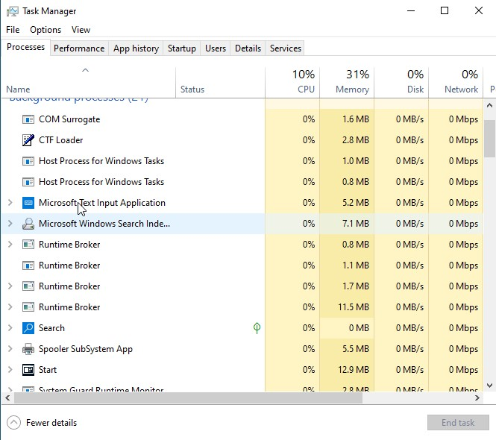
Figure 1: Windows Task Manager showing running processes and CPU usage.

Memory Management
The memory manager manages the allocation and release of memory to execute processes. The operating system uses various memory management schemes including paging and segmentation so that each process will have adequate memory for proper execution. This is achieved through the use of virtual memory that allows memory to be extended to include disk space. Memory management increases multitasking abilities as well as enables numerous processes to run concurrently on the computer. Furthermore, the OS protects memory by providing isolation among different processes. The status of memory and system performance can be checked using resource managers like the Resource Monitor on Windows OS or the free command on Linux. Memory management plays a significant role in enhancing performance and system stability [1], [2].
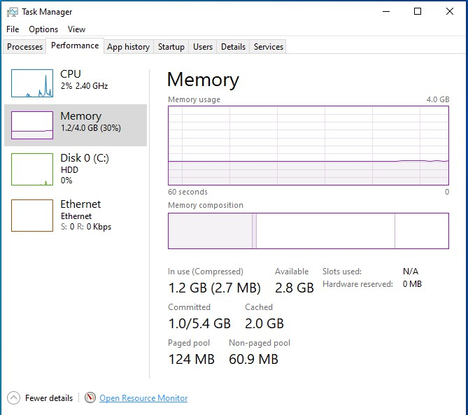
Figure 2: Displaying memory allocation and usage.

File System Management
File system management involves organizing, storing, and accessing data on the storage device. File system management includes the ability by the operating system to provide a hierarchical organization of files and folders in order to manage the data efficiently. Besides, it manages the file permissions in order to ensure data security and data integrity. Examples of common file systems are NTFS in Windows and ext4 in Linux operating systems. The operating system provides several tools for managing files and folders, such as the creation of new files and folders as well as their deletion and modification. In this way, successful file system management guarantees that data can be accessed easily by all users and applications [1], [2].
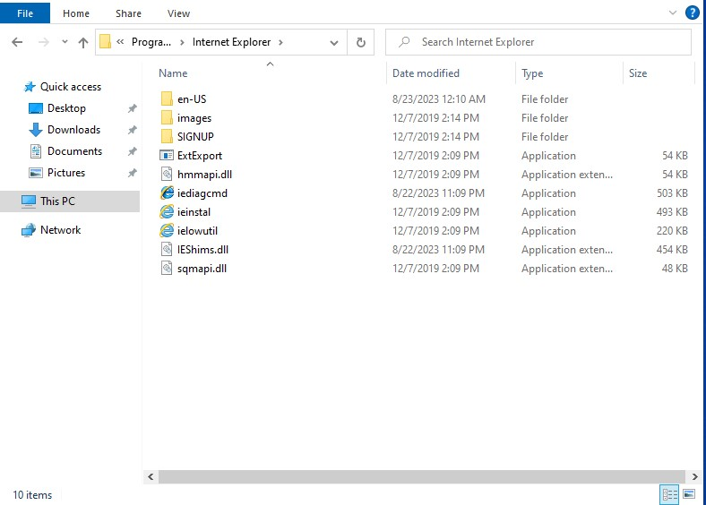
Figure 3: File Explorer showing directory structure in Windows OS.

Device Management
Hardware device management is the key factor that enables the connection between the hardware component and the operating system via device drivers. The OS is responsible for controlling and managing input and output functions in order to ensure that external peripheral components like printers, keyboard, and storages work properly within the computer. Also, buffer, cache, and spooling are other aspects which increase the performance of the system. Programs like Device
Manager in Windows or programs like lsusb and lspci in Linux allow users to examine their connected devices. Effective device management results in proper integration between hardware components and the applications installed on it [1], [2].
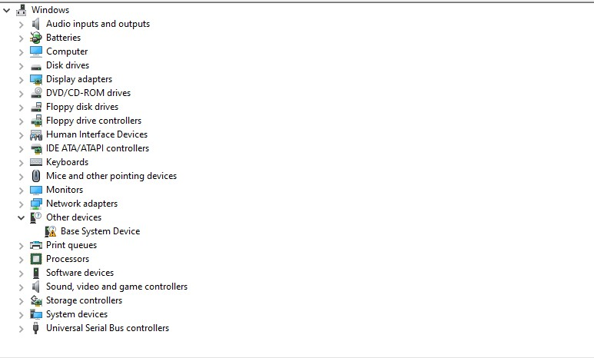
Figure 4: Windows Device Manager showing installed hardware devices.

Security and Access Control
One of the critical roles that operating systems perform is to provide security for all types of data from any kind of threats. Authentication can be achieved in different ways like the use of passwords and other biometric methods. Operating systems ensure security in the system by implementing access controls through permission controls such as Access Control List. Encryption and firewalls are some more services that help in providing additional security to the system. Windows and Linux are both operating systems that offer good security features like user account management and permission control [1], [2].
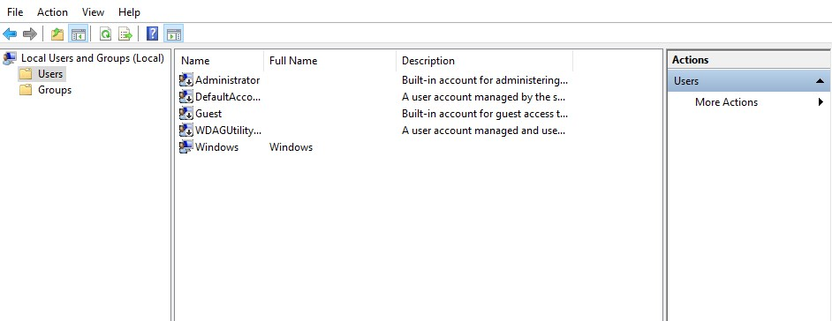
Figure 5: User account settings and permissions in Windows.

Windows CLI Commands

tasklist
Displays all currently running processes on the system along with details such as Process ID (PID), memory usage, and session name. It is useful for monitoring system activity and identifying resource-heavy applications [3].
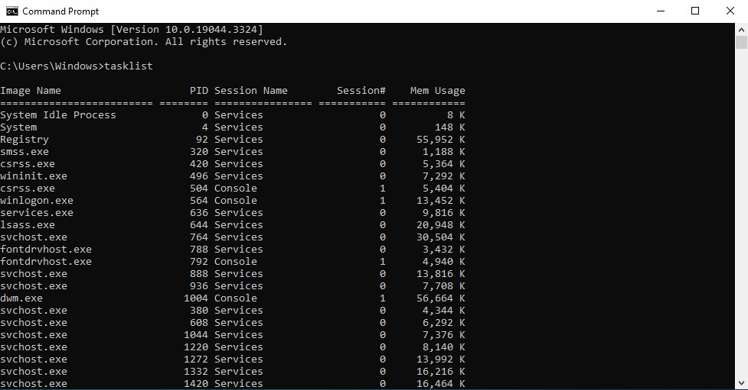
Figure 6: tasklist command output showing active processes.

taskkill
Terminates a running process using its Process ID (PID) or image name. It is especially helpful for closing unresponsive or frozen applications that cannot be ended normally. Advanced options allow forcefully stopping processes or terminating multiple tasks at once.
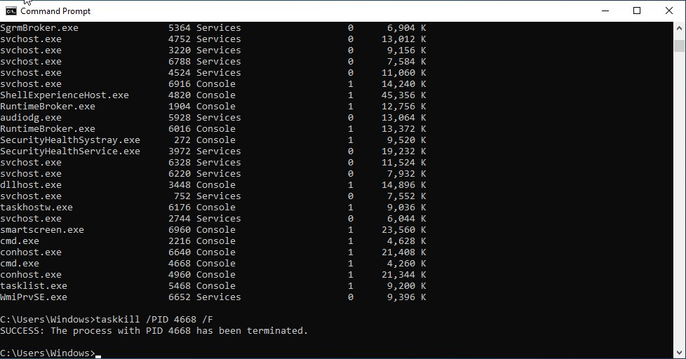
Figure 7: taskkill command terminating a process.

dir
Lists all files and directories in the current working folder, including details like file size, date, and attributes. It helps users quickly view and manage directory contents. Additional switches can filter results or display hidden/system files.
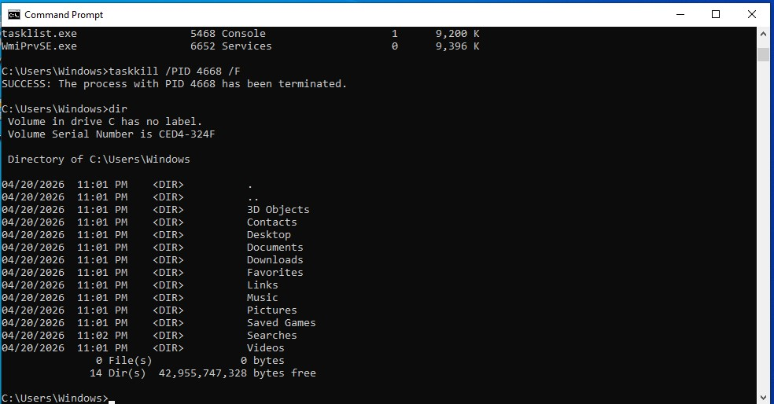
Figure 8: dir command showing directory contents.

cd
Changes the current working directory, allowing users to move between folders in the file system. It is a fundamental navigation command in the command line interface. Users can also use it to move up one level or switch drives.
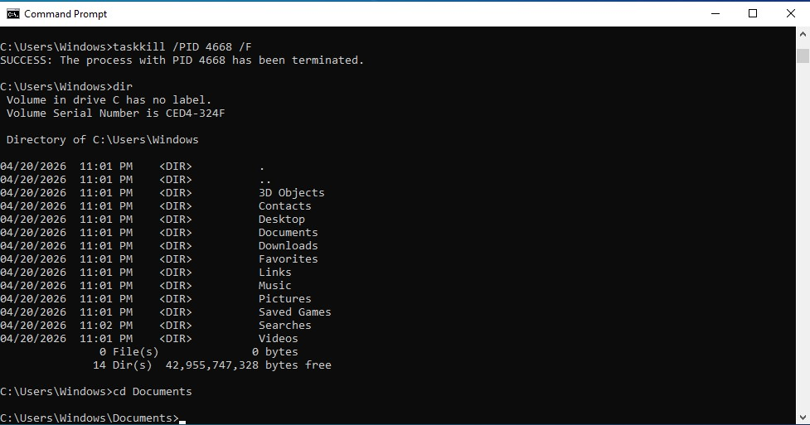
Figure 9: cd command changing directory.

ipconfig
Displays detailed network configuration information such as IP address, subnet mask, and default gateway. It is commonly used to diagnose network connectivity issues. Advanced options like /all provide more comprehensive system network details.
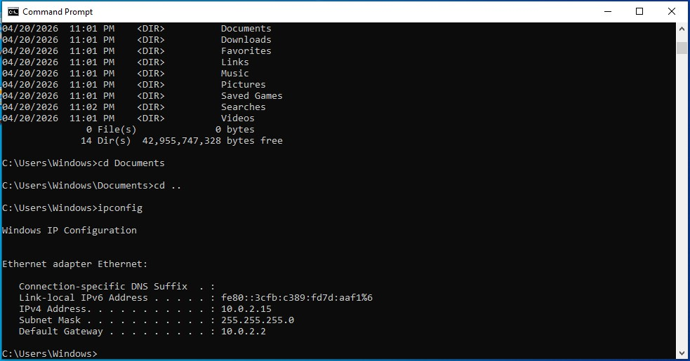
Figure 10: ipconfig output showing network details.

ping
Tests connectivity between your computer and another device on a network by sending data packets. It measures response time and detects packet loss, helping diagnose network problems. It is widely used to check if a server or website is reachable.
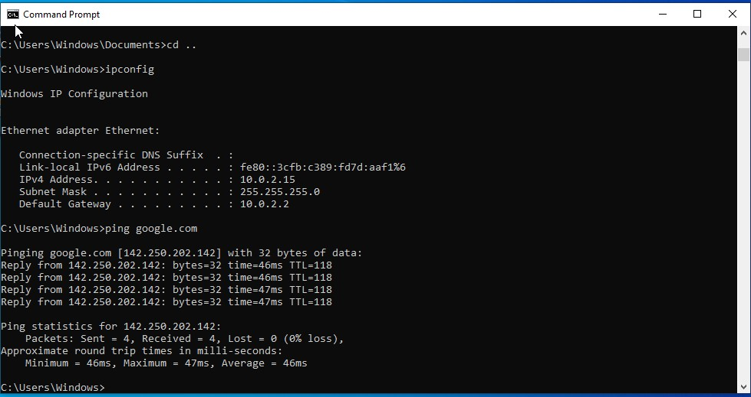
Figure 11: ping command testing connectivity.

net user
Manages user accounts on a system, including creating, deleting, and modifying users. It can also display account details such as group membership and password settings. This command is commonly used by system administrators for account management.
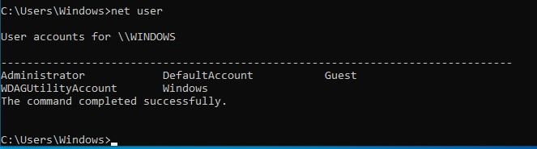
Figure 12: net user command output.

shutdown
Shuts down, restarts, or logs off the computer using command-line options. It allows scheduling shutdowns or forcing applications to close. This is useful for remote system management and automation tasks.
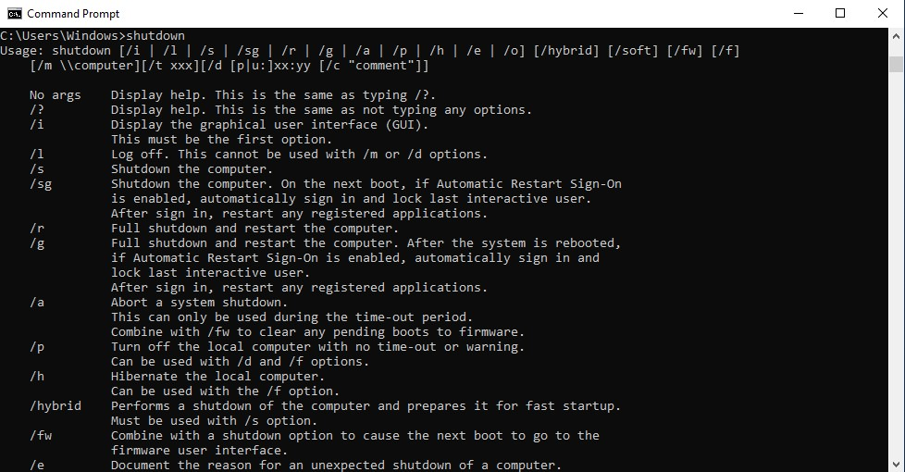
Figure 13: shutdown command execution.

schtasks
Creates, deletes, or manages scheduled tasks that run automatically at specified times or events. It is helpful for automating system maintenance, backups, or scripts. Advanced options allow detailed control over task triggers and conditions.
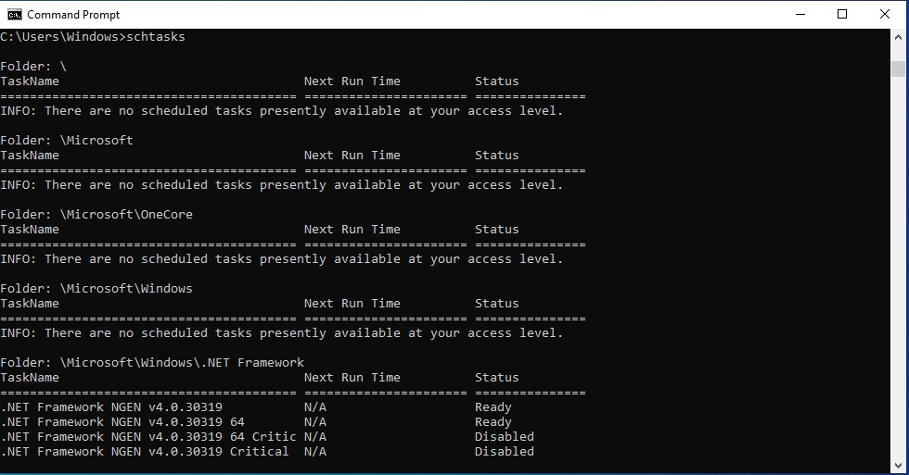
Figure 14: schtasks creating scheduled task.

copy
Copies one or more files from one location to another within the system. It supports copying multiple files and combining files into one. This command is essential for file management and backup operations.
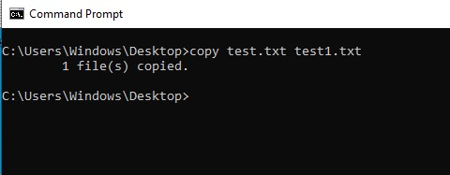
Figure 15: copy command usage.

Linux CLI Commands

ps
Displays information about currently running processes in the system, including their PID, CPU usage, and status. It is useful for monitoring system performance and identifying active tasks. Various options (like ps aux) provide more detailed process information [4].
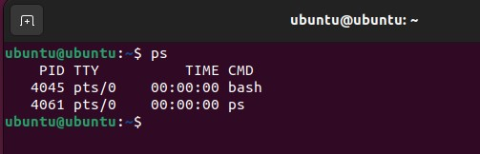
Figure 16: ps command showing processes.

kill
Terminates processes using their Process ID (PID), allowing users to stop unwanted or unresponsive programs. It supports different signals, such as forcefully killing a process. This command is essential for process management and troubleshooting.
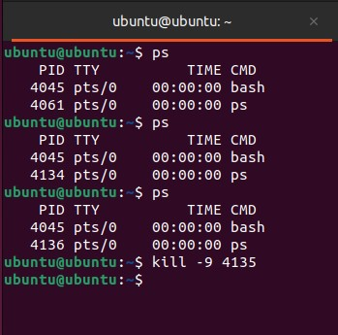
Figure 17: kill command stopping process.

ls
Lists files and directories in the current directory, showing details such as permissions, size, and timestamps. It is commonly used for navigating and exploring the file system. Options like -l and -a provide detailed and hidden file listings.
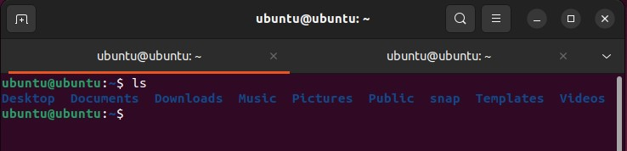
Figure 18: ls command output.

cd
Changes the current working directory, enabling users to move between folders in the file system. It is a basic navigation command used frequently in terminal operations. Users can also move to parent or root directories with simple arguments.
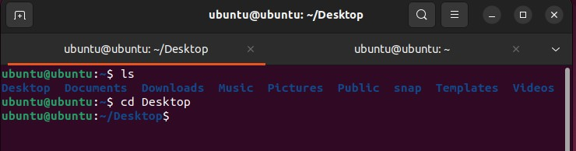
Figure 19: cd command navigation.

ip
Displays and manages network configuration details such as IP addresses and network interfaces. The ip command is the modern replacement for ifconfig in many systems. Both are widely used for network setup and troubleshooting.
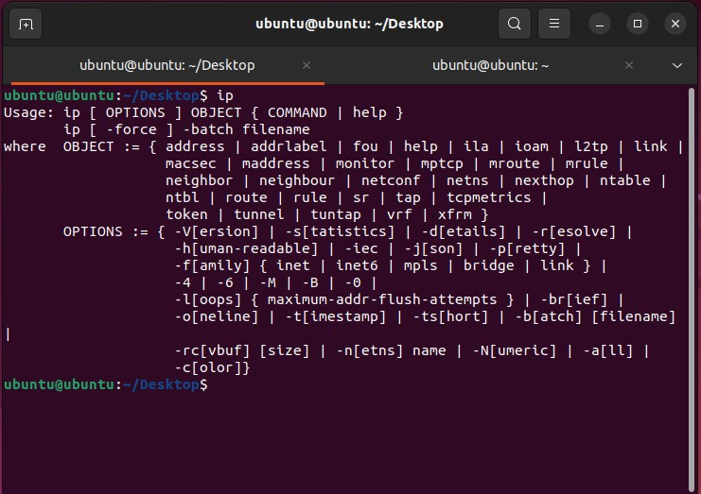
Figure 20: ip command output.

ping
Tests connectivity between the local system and another host by sending packets and measuring response time. It helps diagnose network issues like delays or packet loss. This command is commonly used to check server or internet availability.
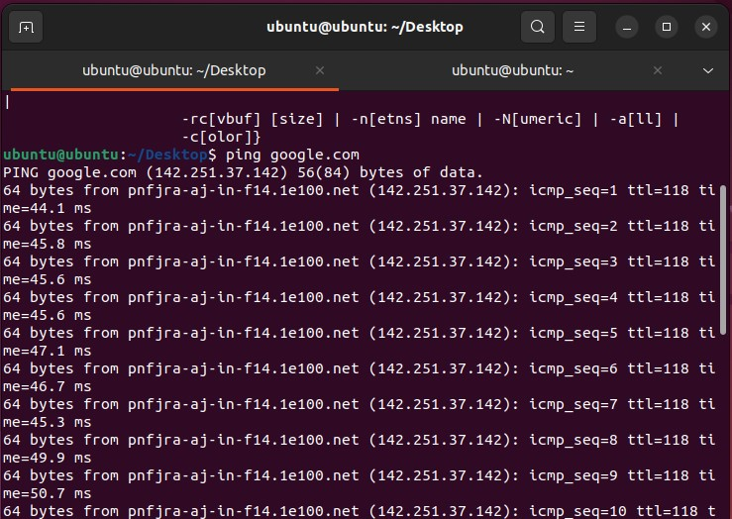
Figure 21: ping command.

adduser
Creates a new user account on the system with appropriate home directory and settings. It simplifies user management by guiding through password and configuration steps. Typically requires administrative (root) privileges.
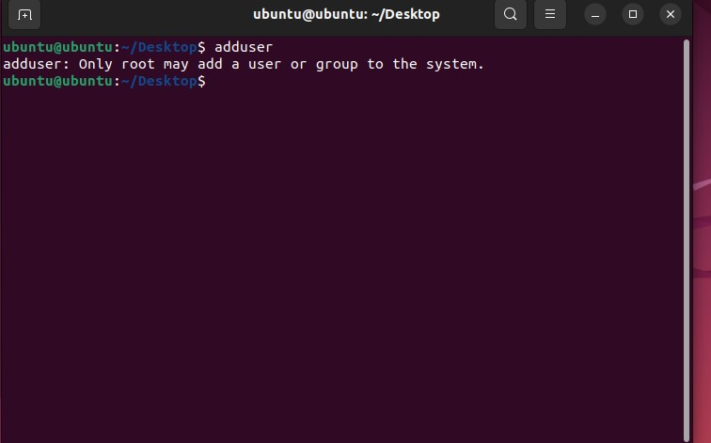
Figure 22: adduser command.

passwd
Changes or sets a user’s password to maintain account security. It can be used by both regular users (for their own password) and administrators (for others). Strong password policies can also be enforced through this command.
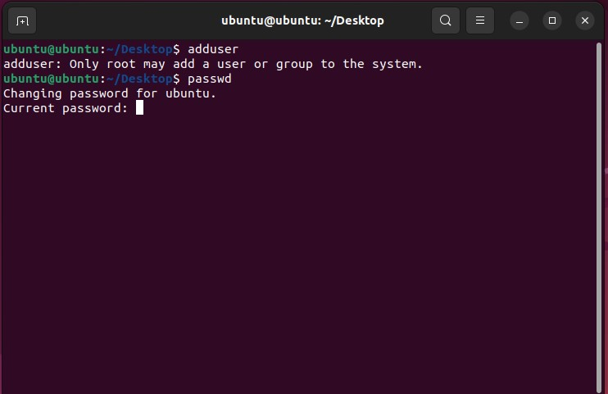
Figure 23: passwd command.

Crontab
Schedules tasks to run automatically at specified times or intervals. It is widely used for automating backups, updates, and scripts. Users can edit their scheduled tasks using the crontab -e command.
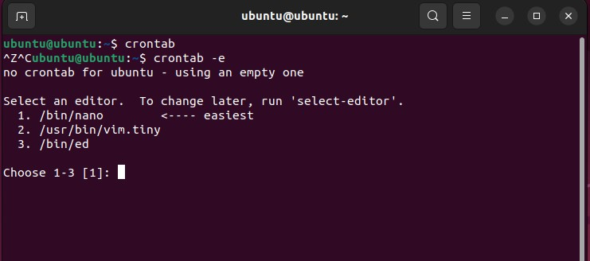
Figure 24: crontab scheduling jobs

cp
Schedules Copies files and directories from one location to another within the system. It supports copying multiple files and recursive directory copying. This command is essential for file management and backup tasks.
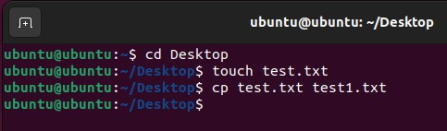
Figure 25: cp command usage.

Windows Batch Scripts

Script 1: Multiplication Script
This script takes user input and multiplies two numbers. It demonstrates variables and arithmetic operations in batch scripting. It is useful for basic automation tasks and learning scripting fundamentals.

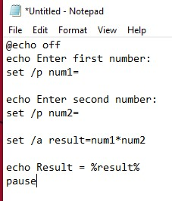
Figure 26: Batch script for multiplication code.
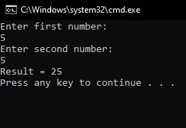
Figure 27: Batch script for multiplication with output.

Script 2: Backup Script
This script copies files from one directory to another automatically. It uses loops and file commands to perform backup operations efficiently. It helps automate repetitive file management tasks.
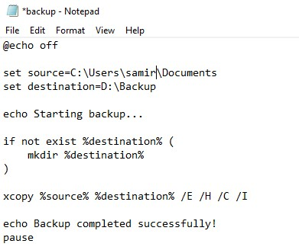
Figure 28: Batch backup script code.
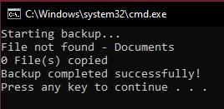
Figure 29: Batch backup script execution.

Linux Bash Scripts

Script 1: Multiplication Script
This script accepts user input and calculates multiplication using shell variables. It demonstrates basic scripting concepts like input handling and arithmetic operations.
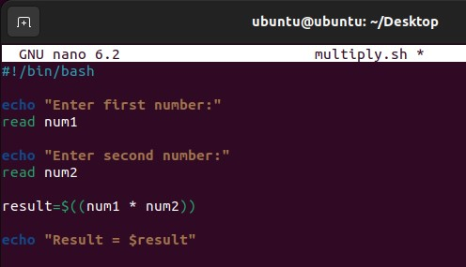
Figure 30: Bash script multiplication code.
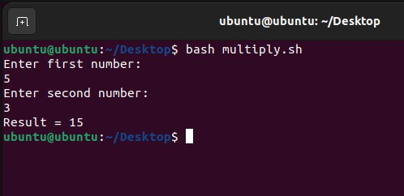
Figure 31: Bash script multiplication output.

Script 2: System Monitoring Script
This script displays system information such as memory usage and CPU load. It uses commands like top and free to monitor system performance.
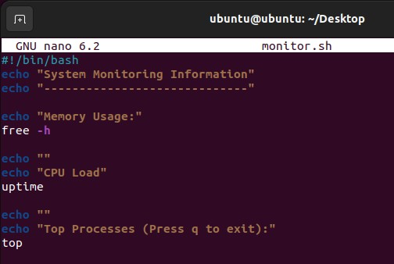
Figure 32: Bash script deploy system stats code.
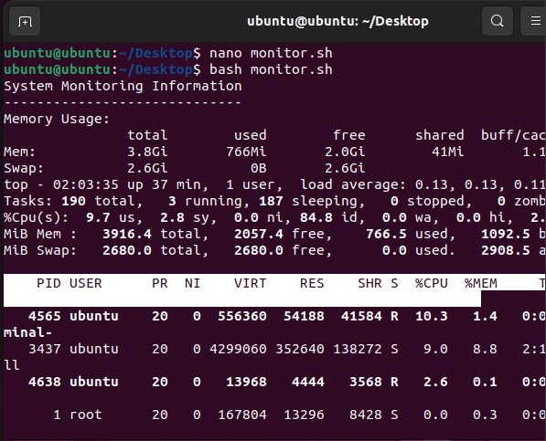
Figure 33: Bash script displaying system stats.

Conclusion
Operating systems play a crucial role in the management of computer resources and the creation of a reliable link between users and hardware components. The current paper provided an overview of such fundamental processes as process management, memory management, file systems structure, devices management, and security. Moreover, examples of command-line utilities on Windows and Linux platforms were reviewed, thus demonstrating the need to use such software in order to achieve system efficiency and solve technical issues. Also, scripting in Windows and Linux operating systems was considered, as it shows the usefulness of using such techniques in order to save time by automating tasks. It should be stated that being able to work effectively with CLI commands and scripts is an indispensable skill set for IT specialists today.

References
- A. Silberschatz, P. B. Galvin, and G. Gagne, Operating System Concepts, 10th ed. Hoboken, NJ: John Wiley \& Sons, 2018.
- W. Stallings, Operating Systems: Internals and Design Principles, 9th ed. Pearson, 2018.
- W. R. Stanek, Microsoft Windows Command-line Administrator’s Pocket Consultant. in Admin Pocket Consult Series. Microsoft Press, 2004. [Online]. Available: https://books.google.com.pk/books?id=WdDLOgAACAAJ
- W. E. Shotts, The Linux Command Line, 2nd ediTion., vol. 91, no. 5. 2019.

