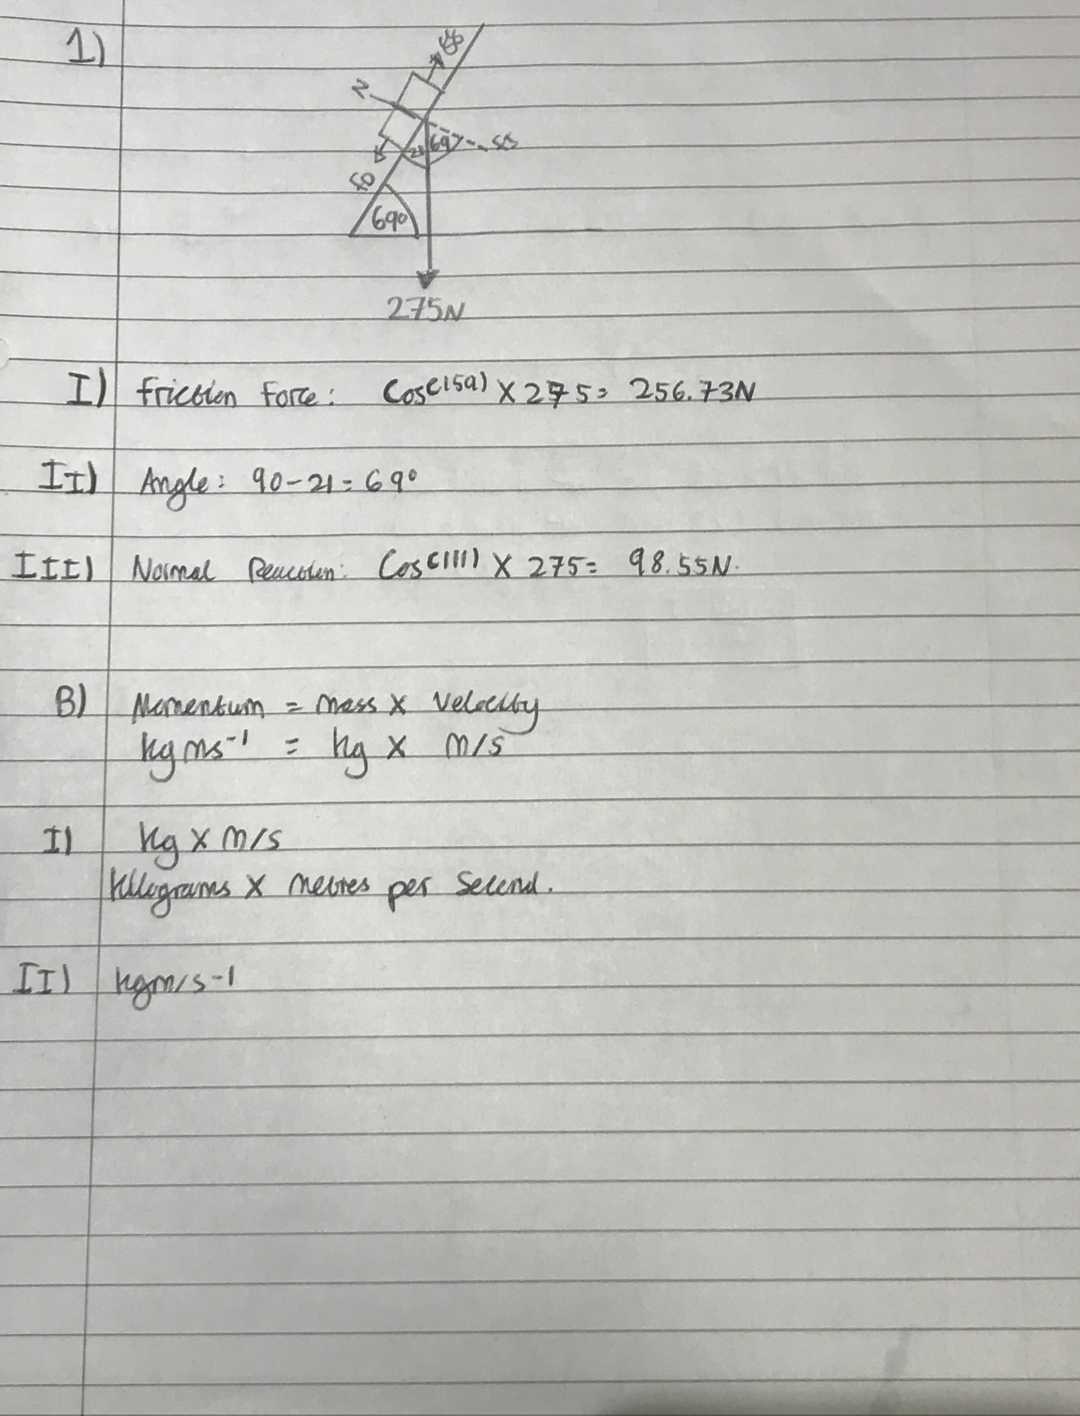
- Friction Force: 256.73N
ii) Angle: 69 Degrees Celsius
iii) Normal Reaction: 98.55 N

Bi) Kg X M/s = Kgm/s-1
ii) kgm/s-1

C) 70.075 N
I) 262.53 N
ii) 210.23 Kgm/s-1
iii) 19.55 n

2ai) 10.9091 Ohms
ii) 0.0011 Amps
iii) 0.0132 Watts
E-A: 3.6 X 10 to the power -3
F-B: 9.6 X 10 to the power -3
C-A: 1.8 X 10 to the power -3
F-D: 9.6 X 10 Power -3 / 3 = 3.2 X 10 power -3
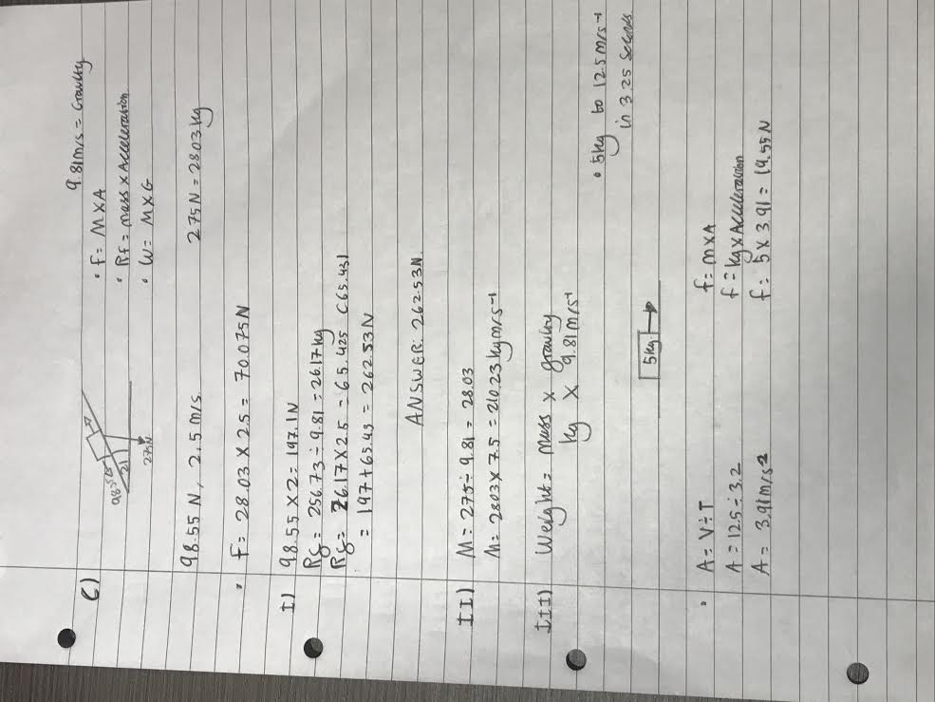
D-B: 3.2 X 10 power -3 X 2 = 6.4 X 10 Power -3

2bi) A-C: 6 Volts
ii) D-F: 4 Volts
iii) C-D: 2 Volts

3a) A moment is equic to a force X the distance it’s being applied.

Bi) Force X Perpendicular distance to the point of rotation

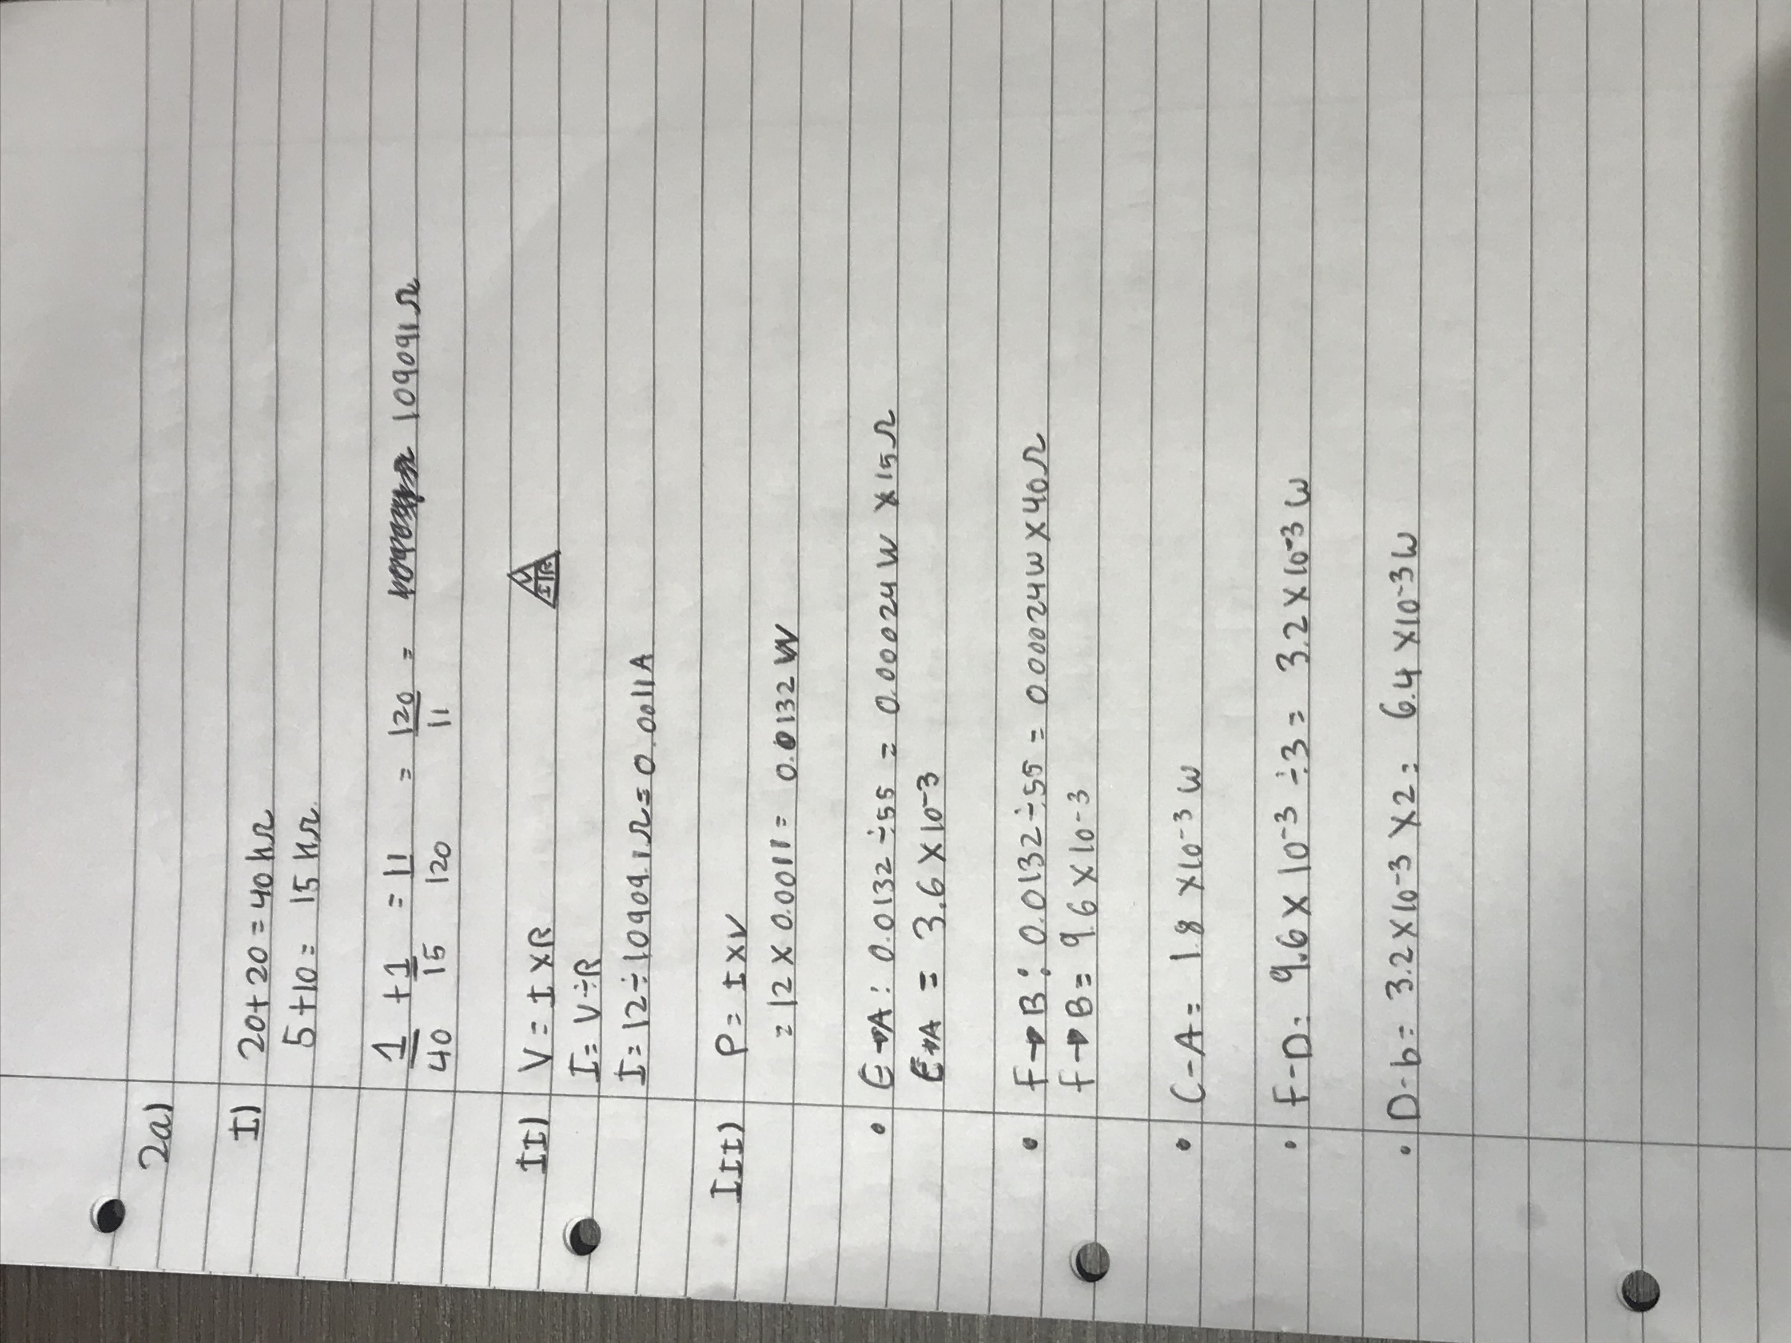
ii) 444.4 N
iii) F = K x X
Iv) N = Nm x M
N= Force Applied
Nm= Spring Constant
M= Distance



