LUXURY BRANDING AND AUDIENCE IDENTITY: BUSINESS DEVELOPMENT STRATEGIES FOR GUCCI HANDBAGS IN THE INDIAN PREMIUM FASHION MARKET

Student name: Manupati Priyanka
Student ID: 2431447
Word Count: 3440
Table of Contents
1.0 Background of the study 3
2.0 Research problem 3
3.0 Rationale of the study 4
4.0 Research aim, objectives and question 4
5.0 Preliminary literature search 5
5.1 Luxury branding strategies 5
5.2 Customer identify in premium fashion 6
5.3 Strategic alignment of branding and identify 8
5.4 Business development outcomes 9
5.5 Research Gap 10
6.0 Research methodology 11
6.1 Research design and strategy 11
6.2 Research approach and philosophical stance 11
6.3 Data collection process 12
6.4 Data sources 12
6.6 Data analysis 13
6.7 Ethical consideration 14
7.0 Potential risks to the study 14
8.0 Gantt Chart 15
REFERENCES 16

1.0 Background of the study
The Indian premium fashion market experiences rapid expansion in recent years which are drive by aspirational consumption, disposable incomes and exposure to global luxury brands (Dudia and Mathur, 2022). In this context, Gucci has been recognised among a reputable brand due to its symbolic capital and heritage of exclusivity. The brand has positioned its handbags as both cultural artefacts and functional commodities (Gucci.com, 2026). In the Indian luxury fashion market, the consumers’ behaviours are shaped by identifying constructs (Cultural symbolism, lifestyle orientation, aspiration values) which makes audience identity central towards branding strategies. In this study use of luxury branding frameworks such as Keller’s branding equity model and Kapferer’s identity prism highlights how exclusivity, heritage and storytelling reinforces consumer perceptions (Junaedi, 2025). In Indian landscape such constructs intersect with cultural capital and conspicuous consumption whereas handbags serve as self-expression and makers of status. Initiatives practiced by Gucci (experiential retail, celebrity endorsements and digital storytelling) reflects attempts to align global brand narratives to local identity-driven expectations.
However, tension among localised identity and global heritage remains as a strategic challenge which need further attention. The on-going research would enable the researcher in understanding how branding and identity interplays in shaping business development outcomes is crucial in the context of Indian luxury market. These are due to the forecasted growth of Indian market which will emerge as a primary source of revenue for Gucci in the upcoming decade. The research study is focused on Gucci’s handbags by examining how consumer identity and branding strategies coalesce to influence loyalty, market penetration and profitability.

2.0 Research problem
Despite showing gradual growth in the Indian luxury market brands such as Gucci experiences challenges during establishing alignment among global branding strategies to localised identity expectations. As per Dave and Gupta (2025) heritage and exclusivity remains as core component of luxury positioning whereas Indian consumers increases their demands on aspirational symbolism, cultural resonance and lifestyle alignment. Regarding this existing research of Foy and Gruber (2022) and Wei and Lin, (2024) isolates identity constructs and banding as priority whereas neglecting strategic interplay and its role over shaping business development outcomes. It leads to a research gap which is focused on understanding how branding initiatives of Gucci integrated with identity-driven expectations in premium fashion sector across India. The problem associated with the research topic lies on critically examining the misalignment and its implications for consumer loyalty, suitable business development and market penetration.

3.0 Rationale of the study
In this context, rationale behind considering the research topic lies on rapid growth of India’s premium fashion market with relevance to identity driven consumption. These have a massive influence towards shaping luxury brands and their success over the past decades. Gucci handbags reflects a strategic case where global heritage needs to be adopted to localise aspirations, lifestyle orientation and cultural symbolism. Scholars such as Islami et al., (2024) and Wheeler & Meyerson (2024) treats identity and branding separately which creates a gap over understanding the integrated impact of identity and branding to regulate business development outcomes. In this context, application of resource-based view and principles of institutional theory would ensure originality of the study through examining how consumer identity and banding strategies interplays. These are primarily to influence sustainable competitive advantage, loyalty and profitability in India’s luxury sector.

4.0 Research aim, objectives and question
Aim
The study aims to examine how audience identity and luxury branding shapes business development strategies for Gucci’s handbags in the India’s premium fashion market.
Question
RQ1. How does the strategic interplay among audience identity and luxury branding influence Gucci’s business development strategies for handbags in the premium fashion sector of India?
RQ2. How do Gucci’s brand strategies position its handbags within India’s premium fashion market?
RQ3. In what way do culture symbolism. Aspirational values and lifestyle orientation shapes Indian consumer’s perceptions of Gucci handbags?
RQ4. How does the integration of luxury branding with audience identity influence business outcomes in India’s premium fashion sector?
Objectives
The research objectives of the study are as follows
- To analyse Gucci’s branding strategies in positioning handbags within India’s premium fashion market
- To investigate strategic alignment among Gucci’s branding initiatives and the identity-driven expectations of India’s premium fashion consumers
- To identity factors (Cultural symbolism, lifestyles, and aspiration) in shaping consumer’s perceptions of Gucci’s handbags
- To Assess business outcomes (Profitability, market penetration and loyalty) resulting from the integration of luxury branding and audience identify

5.0 Preliminary literature search

5.1 Luxury branding strategies
Throughout the research consideration of Kapferer’s brand identity prism would enable the researcher in framing Gucci’s positioning of India through facets of exclusivity, heritage and symbolic capital. Based on evaluating the case study of Gucci it seems that the brand considers iconic motifs (Horsebit and GG monogram) and Italian craftsmanship which plays a significant role in reinforcing cultural heritage whereas celebrity collaboration sustains reflection and personality (Gucci.com, 2026). On the other hand, consideration of Keller’s customer-based brand equity model enables the researcher in focusing on resonance (Marmara, 2025). Here, Gucci’s handbags transcend utility for embodiment of aspirational narratives (Gucci.com, 2026). In the case of India’s premium luxury market exclusivity could be maintained by distribution, control and premium pricing which are aligned to Kapferer’s anti-law of luxury (Nasiri et al., 2025). However, it seems that there are some challenges or concerning events experienced by luxury brands which can be addressed when global heritage adopts local cultural symbolism. In this context, Gucci’s reliance on storytelling and scarcity which sustains brand equity Tuikka (2025) whereas if anyhow risk dilution gets exposure in India’s premium market it could lead to serious issues.
While, Kapferer’s Prism emphasises heritage and exclusivity, Keller’s CBBE emphasises on consumer connectivity and resonance. On an Indian context, use of such frameworks could conflict exclusivity risk alienating aspirational buyers, resonance plays a subsequent part in fostering inclusivity (Leppälä, 2025). In this context, Gucci’s challenges lie on maintaining balance among accessibility and scarcity which enhances symbolic capital and eventually endures without diluting brand prestige in a rapidly expanding market. Therefore, monitoring Gucci’s branding strategies in India unravel its strategic fragility and strengths. It enables the brand to practice exclusivity which sustain its symbolic capital whereas cultural adaptation determines long-term resonance. Ultimately, the brand’s ability to integrate global heritage with local identity needs to define its competitive advantage in the premium fashion sector.

5.2 Customer identify in premium fashion
Luxury fashion products purchasing behaviour are mostly shaped by consumer identity, especially in emerging economics for instance India. Because premium fashion products in India are mostly associated with social mobility and aspiration. The conspicuous consumption, a theory coined by Thorsten Veblen's manifests that the luxury products act as a symbol of prestige and wealth each enables customers to showcase their social and economic status publicly.
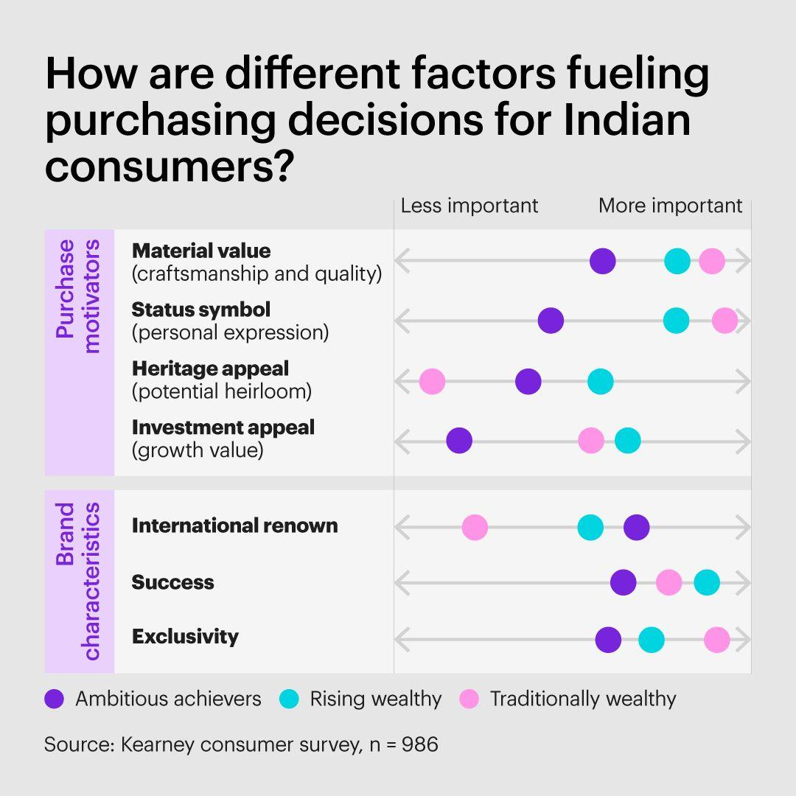
Figure 2.1: Factors influencing luxury fashion purchasing decision
(Source: Pastore, 2018)
In India, the consumers of Gucci handbags are mostly associated with a showcase of the customer’s Cosmopolitan identity public status social status achievement and most importantly exclusivity. According to the study of Pastore (2018), luxury fashion products often act as an extension of the consumers’ identity in society and economy particularly among urban consumers. As per the cultural capital theory of Pierre Bourdieu, luxury products consumption reflects social distinction, taste and sophistication. Among the high-end fashion industry in India, Gucci bags embody international culture awareness as well as modernity and at the same time satisfy customers' yearning for symbolic validation. Since millennial and generation Z consumers are very tech-savvy and seek out companies that may express their identity status and goals, the lifestyle approach to marketing has a significant impact on consumer behaviour.
While Bourdieu’s cultural capital highlights upon sophistication, Veblen’s conspicuous consumption explains traditional status signalling (Prieur et al., 2023; Sahin and Nasir, 2022). Yet, digital identity-driven purchasing of Gen-Z complicate such narratives. Regarding this, urban millennials pursue prestige through visible luxury, younger consumers or non-urban buyers emphasises online self-expression (Chopra, 2026). Thus, Gucci needs to reconcile these divergent identity logics in maintaining relevance across fragmented premium fashion market of India.

5.3 Strategic alignment of branding and identify
As per the views of George and George (2023), Gucci uses digital storytelling, interactive shopping, and celebrity endorsements to deliberately match its branding objectives with the identity-driven expectations of Indian luxury fashion buyers. Particularly among status-conscious customers in developing luxury markets, celebrity partnerships with prominent figures boost aspirational value and social validity (Cowan and Kostyk, 2024). According to the Resource-Based View (RBV), these branding skills are important and hard to replicate intangible resources that support long-term competitive advantage. Strong brand equity arises when branding methods effectively link with consumer identity and emotional values, according to Cowan and Kostyk, (2024). Gucci can therefore increase customer loyalty, set itself apart from rivals, and stay relevant in India's changing premium fashion industry thanks to its strategic alignment of branding and identity.
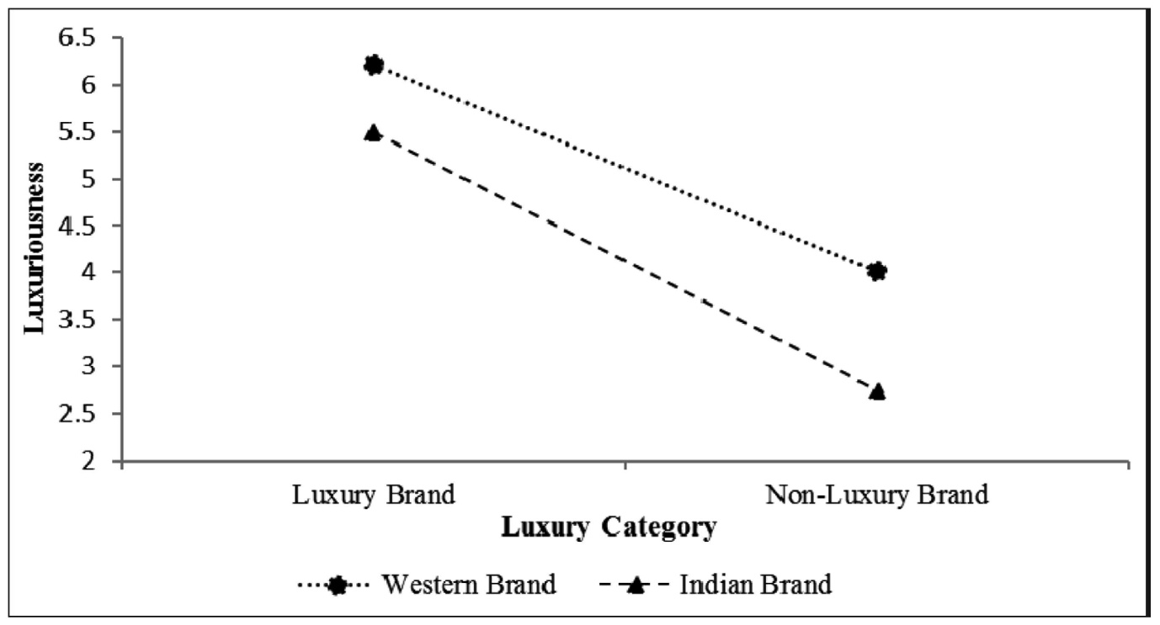
Figure 2.2: Comparison of Indian and Western Luxury Brands
(Source: Devanathan, 2020)
According to institutional theory, companies acquire credibility by conforming to societal and cultural norms in certain contexts. Gucci balances localization and exclusivity in India by using culturally relevant communication techniques while upholding its global luxury legacy. Gucci is able to build symbolic narratives and emotional engagement through digital storytelling through influencer relationships and social media campaigns, which appeal to younger consumers looking for identity validation. Additionally, impressions of exclusivity and prestige are strengthened by experiential retail initiatives, such as personalized services and the atmosphere of luxury stores. Gucci’s reliance on celebrity endorsements could improve aspirational values whereas it also bears risk of overexposure especially compared to Western markets whereas authenticity outweighs status. As per Li et al., (2026) localisation strengthen cultural resonance whereas excessive adaption could result in diluting global heritage. Therefore, the challenges lie on Gucci in maintaining balance among universal exclusivity with culturally tailored engagement to retain long-term brand equity.

5.4 Business development outcomes
In the case of Gucci operations in India, identification and brand in a luxury way can be viewed as a crucial motive for better organisation outcome. This type of approaches will allow the organisations to successfully penetrate the contemporary market of luxury fashion items and therefore it is highly important to attract the right consumers with the help of adequate marketing and branding strategies.
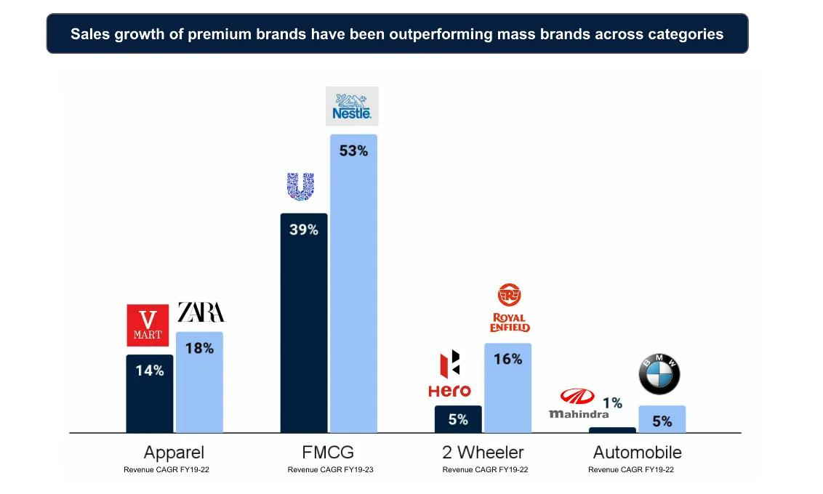
Figure 2.3: Sales growth of different brands and different categories of products
(Source: Wright Research, 2024)
According a study of Wright Research (2024), the demand of luxury fashion items is projected to increasing the upcoming years as there is a growth in the urbanization trends, increase in income and increased consumer interest towards global luxury fashion culture. Therefore, most of the studies indicated that branding focused on identity and building emotional connection with the consumers can significantly help Gucci in terms of improving consumer loyalty and at the same time attaching symbolic meaning to their brand instead of focusing on its functional organisation attribute. Ine Sach cases research is also indicated the importance of positive word of mouth communication which are crucial kingdoms of increasing repeated purchase and long-term profitability in the Indian Luxury fashion item market. Although identity-driven branding enhances loyalty measures, profitability is not guaranteed all the time. Here, counterfeit products, market saturation and exclusivity alienating aspirational buyers can undermine the growth factors. Regarding this, studies such as Park et al., (2025) and Lima (2025) shows the contribution of emotional connection in fostering repeat purchases whereas overextension risks diluting symbolic values. Therefore, Gucci needs to balance expansion with exclusivity to ensure long-term profitability in luxury fashion market of India.

5.5 Research Gap
The existing studies on luxury branding consistently emphasises over the importance of exclusivity and heritage as central to sustaining symbolic capital. However, there is a disagreement on whether such factors have the competence on securing business outcomes in the emerging markets such as India. In this context, scholars such as Acar et al., (2024) and Putra et al., (2025) highlights identity-based consumption (Cultural symbolism, aspirations, and lifestyles) as crucial driver to profitability and loyalty whereas Shahid et al., (2022) treats identity and branding as separate constructs. It leaves an explored area related to strategic interplay. Moreover, there are limited empirical evidences which explores how identity factors mediates long-term profitability and market penetrations. Therefore, the on-going research is focused on integrating branding frameworks with identity theories which examines how Gucci’s strategies aligned to Indian consumer’s identity expectations. It would have played a significant role towards exploring how branding-identity interplay shapes sustainable competitive edge in evolving luxury fashion market of India.

6.0 Research methodology

6.1 Research design and strategy
In this study to address the research purpose exploratory design and archival research strategy will be considered among methodological tools into practices (Olawale et al., 2023; Velte, 2022). In this context, the rationale behind considering exploratory design involves its competence on unravelling how luxury branding and audience identity interact in shaping business development strategies embraced by Gucci for India. These are due to the presence of limited prior empirical research to supports claims with real-world evidences. Here, the use of exploratory design will guide the researcher to practice flexibility and generating insights instead of testing predefined hypothesis (Sharma et al., 2023). On the other hand, consideration of archival strategy will guide the researcher in drawing on secondary qualitative sources involves Gucci’s annual publications, industrial reports and peer-reviewed studies. In this context, use of archival strategy would enable the researcher to record richer and contextually valid information without having any constraints of dealing with primary researchable data (Hanlon et al., 2022). It often restricted in luxury markets due to confidentiality.
Collectively, use of archival strategy and exploratory design will enable the researcher to ensure methodological rigour due to the potential of generating inductive themes and ensuring credibility through triangulation process. It would be subsequent towards critically examining branding identity interplay in a dynamic market context.

6.2 Research approach and philosophical stance
In this study to address the study purposes the researcher is going to embrace inductive reasoning and interpretivist philosophical stance as preferable methodological choices. Here, consideration of inductive approach is justified as the study is not begins with an actual theoretical model rather builds understandings through observing patterns from secondary data sources (Kumar and Ujire, 2024). It enables the researcher to emerge themes organically which reflects the complexity of branding strategies and consumer identity. On the other hand, consideration of interpretivist philosophical stance would enable the researcher in focusing on subjective meaning (Junjie and Yingxin, 2022). These are by observing how Indian consumers perceive Gucci’s handbags as a symbol of lifestyle, aspiration and cultural capital. Consideration of interpretivism also enable the researcher to understand that reality is socially constructed which makes it suitable for examining identity led consumption (Pervin and Mokhtar, 2022). Nevertheless, such philosophical stance also aligned to Braun and Clarke’s thematic analytical framework which plays a subsequent role in emphasising interpretation of meaning instead of qualification. Collectively, these methodological tools would enable the researcher in ensuring methodological coherence whereas the insights will be grounded in lived experiences of participants as well as cultural contexts instead of imposed by deductive frameworks.

6.3 Data collection process
In this context, the researcher is going to employ secondary qualitative data collection process. These are due to its competence on drawing out researchable data from industrial reports, Gucci’s corporate publications, peer-reviewed journals and market analyses (Ajayi, 2023). This method is going to be useful to improve the relevance and accessibility of the research study. Regarding this, use of secondary data from existing sources would enable the researcher in providing comprehensive insights into consumer identity and branding strategies without the limitations of primary fieldwork in restricted luxury contexts (Cheong et al., 2023). Lastly, use of qualitative data also enable the researcher in exploring symbolic meaning along with cultural constructs. It will be central to identity-driven branding which can ensure methodological efficiency while maintaining analytical depth as well.

6.4 Data sources
Throughout the course of data collection process the researchable data will be sourced from industrial reports, peer-reviewed journals, official websites and annual reports of Gucci. Consideration of such triangulation process would enable the researcher in ensuring validity and credibility throughout the process. Use of peer-reviewed literatures will ensure involvement of critical frameworks such as RBV, Institutional theory, Keller’s model and Kapferer framework. On the other hand, use of industrial and annual reports would enable the researcher in contextualising the growth of Indian luxury market. Lastly, consideration of Gucci’s publication will offer insightful knowledge relevant to branding strategies along with ensuring authenticity of corporate messaging. Collectively, these sources will ensure the researcher to reflect academic rigour along with maintaining practical relevance towards strengthening the reliability of research findings.
Throughout the dissertation to ensure clarity during evaluating business development strategies the researcher will operationalise key outcomes through the help of secondary data indicators. Here profitability will be assessed through the help of Gucci’s published industrial financial analyses, published annual reports and market research data. These aspects going to reflect revenue margins, revenue growth and brand valuation trends in India’s premium fashion sector. On the other hand, market penetration will be examined through secondary sources like distribution expansion records, consumer adoption rates, sales growth statistics and comparative market share data from industry reports. These operational definitions enable the researcher to translate broader strategic concepts into measurable outcomes. It will ensure maintenance of methodological transparency and analytical rigour while relying on publicly available textual or contextual data.

6.6 Data analysis
As for analysing the secondary qualitative researchable data Braun & Clarke’s six stepped thematic analytical framework will be considered. These are due to its transparency and flexibility which ensures identification of recurring patterns from the existing data (Braun and Clarke, 2023). Furthermore, it also enables the researcher to practice inductive coding and formulate themes on cultural symbolism, aspiration, exclusivity and business outcomes. The framework also accommodates to interpretivism philosophy which ensures the research findings remain grounded to participant perspective instead of researcher’s biases. Moreover, its systematic process such as coding, familiarization, reviewing, theme development, defining and reporting also enhances replicability and credibility of the research study (Braun and Clarke, 2006). Therefore, thematic analysis is suitable for this study which is going to ensure synthesis across diverse sources while maintaining methodological rigour.
The use of thematic analysis is going to enable the researcher to ensure synthesis among diverse sources while maintaining methodological rigour. These are to ensure clarity throughout evaluating business development strategies. The on-going research would operationalise key outcomes though secondary data indicators. Throughout the research the profitability will be assessed through the use of Gucci’s published industrial financial analyses, annual reports and market research data which reflects revenue growth, brand valuation trends and margins across the Indian premium fashion sector. The market penetration will be examined through the use of secondary qualitative sources such as distribution expansion records, sales growth statistics, consumer adoption rates and comparative market share data from industrial reports. Use of such comparative definitions would enable the researcher to translate broader strategic concepts into measurable outcomes. These are primarily to ensure analytical rigour and methodological transparency while relying exclusively on publicly available data from secondary sources.

6.7 Ethical consideration
Throughout the research to practice ethical integrity it needs to be ensure that principles of credibility, transparency and respect of intellectual property are adhered properly. During collecting researchable data, it needs to be ensured that the secondary data will be sourced from publicly available sources, peer-reviewed journals and corporate authorised materials (Nii Laryeafio and Ogbewe, 2023). It will enable the researcher to avoid threats of plagiarism and avoiding misrepresentations whereas use of proper citation and acknowledgement of previous authors will enable the researcher in safeguarding academic integrity. In addition to this, measures also needs to be taken to ensure reflectivity which is going to assist the researcher in minimising potential threat of bas during the interpretation phase (Muli, 2024). In secondary research ethical approval is implicit whereas practicing methodological transparency would enable the researcher in ensuring compliance with academic standards. It ensures the research findings remains both ethically sound, explicit and credible in nature.

7.0 Potential risks to the study
The potential risks with this research study involves with lack of depth of secondary data on consumer identity which nuances specific to Indian context. Furthermore, bias over corporate publications are also considered to be limitation of the study approach due to selective presentation of branding strategies. Furthermore, market reports could vary in reliability which could create challenges during triangulation. Besides, the risks also lie on interpretive subjectivity where research biases could influence thematic coding processes. Lastly, the dynamic nature of India’s premium luxury market means findings could experience temporal relevance risks due to potential shift of consumer trends.

8.0 Gantt Chart
Activity | Month 1 | Month 2 | Month 3 | Month 4 | Month 5 | Month 6 | Duration
Selection of topic |  |  |  |  |  |  | 10 days
Introduction |  |  |  |  |  |  | 30 days
Literature review |  |  |  |  |  |  | 60 days
Methodology |  |  |  |  |  |  | 90 days
Data collection and analysis |  |  |  |  |  |  | 60 days
Results and findings |  |  |  |  |  |  | 40 days
Discussion |  |  |  |  |  |  | 25 days
Conclusion |  |  |  |  |  |  | 20 days
(Source: Created by the learner)

REFERENCES
Acar, A., Büyükdağ, N., Türten, B., Diker, E., and Çalışır, G. (2024). The role of brand identity, brand lifestyle congruence, and brand satisfaction on repurchase intention: a multi-group structural equation model. Humanities and Social Sciences Communications, 11(1), 1-13. https://www.nature.com/articles/s41599-024-03618-w
Ajayi, V. O. (2023). A review on primary sources of data and secondary sources of data. Available at SSRN 5378785. https://papers.ssrn.com/sol3/papers.cfm?abstract_id=5378785
Braun, V. and Clarke, V. (2006) Using Thematic Analysis in Psychology. Qualitative Research in Psychology, 3, 77-101. http://dx.doi.org/10.1191/1478088706qp063oa
Braun, V., and Clarke, V. (2023). Is Thematic Analysis Used Well in Health Psychology? A Critical Review of Published Research, with Recommendations for Quality Practice and Reporting. Health Psychology Review, 17, 695-718. https://doi.org/10.1080/17437199.2022.2161594
Cheong, H. I., Lyons, A., Houghton, R., and Majumdar, A. (2023). Secondary qualitative research methodology using online data within the context of social sciences. International Journal of Qualitative Methods, 22, 16094069231180160. https://journals.sagepub.com/doi/abs/10.1177/16094069231180160
Chopra, K. (2026). Impact of Sustainability‐Themed Weddings on Consumer Shopping Behavior: Examining the Role of Social Influence, Purchase Intentions, and Long‐Term Adoption of Eco‐Friendly Fashion. Journal of Consumer Behaviour, 25(3), 1623-1643. https://onlinelibrary.wiley.com/doi/abs/10.1002/cb.70139
Cowan, K. and Kostyk, A., 2024. The influence of luxury brand personality on digital interaction evaluations: a focus on European and North American markets. International Marketing Review, 41(2), pp.386-410.
Dave, M., and Gupta, P. (2025). Elegance in Promotion: A Comparative Study of Advertising Techniques for Luxury Watches, Jewellery and Fashion. https://www.researchgate.net/profile/Meet-Dave-3/publication/391154181_Elegance_in_Promotion_A_Comparative_Study_of_Advertising_Techniques_for_Luxury_Watches_Jewellery_and_Fashion/links/687029aaae516743559bb948/Elegance-in-Promotion-A-Comparative-Study-of-Advertising-Techniques-for-Luxury-Watches-Jewellery-and-Fashion.pdf
Devanathan, S., 2020. Indian Consumers’ Assessment of ‘Luxuriousness’: A comparison of indian and western luxury brands. IIM Kozhikode Society & Management Review, 9(1), pp.84-95.
Dudia, A., and Mathur, A. (2022). A study of luxury goods market for experiential marketing. BUSINESS ADMINISTRATION, 91. http://busadmjnvu.org/AMRITA%20DUDIA%20&%20DR.%20ASHISH%20MATHUR.pdf
Foy, S., and Gruber, M. (2022). Identity–society (mis) alignment and the instrumentalization of firm creation: Creative destruction and creative reconstruction. Academy of Management Journal, 65(2), 479-515. https://journals.aom.org/doi/abs/10.5465/amj.2019.0754
George, A.S. and George, A.H., 2023. Leveraging the ego: An examination of brand strategies that appeal to consumer vanity. Partners Universal International Research Journal, 2(3), pp.94-108.
Gucci.com, (2026) About Gucci [Online] Available at: https://www.gucci.com/us/en/nst/about-gucci [Accessed on: 14th May, 2026]
Hanlon, M., Yeung, K., and Zuo, L. (2022). Behavioral economics of accounting: A review of archival research on individual decision makers. Contemporary Accounting Research, 39(2), 1150-1214. https://onlinelibrary.wiley.com/doi/abs/10.1111/1911-3846.12739
Islami, M. M., Rahyuni, S., and Rukayyah, A. (2024). Strategic branding: Building market positioning and business growth through integrated management practices. Advances in Business & Industrial Marketing Research, 2(2), 110-122. http://advancesinresearch.id/index.php/ABIM/article/view/293
Junaedi, R. A. (2025). Analysis of Telkom School's Brand Identity Using Kapferer’s Prism Model. Journal of Computer Science and Visual Communication Design, 10(2), 215-233. https://journal.unusida.ac.id/index.php/jik/article/view/1769
Junjie, M., and Yingxin, M. (2022). The Discussions of Positivism and Interpretivism. Online Submission, 4(1), 10-14. https://eric.ed.gov/?id=ED619359
Kumar, S., and Ujire, D. K. (2024). Inductive and deductive approaches to qualitative research. International Journal of Multidisciplinary Educational Research, 13(1), 58-63. http://ijmer.s3.amazonaws.com/pdf/volume13/volume13-issue1(4)/9.pdf
Leppälä, J. (2025). Building brand authority and exclusivity in the digital era: a strategic study for emerging luxury brands in a hyper-connected market. https://lutpub.lut.fi/handle/10024/170417
Li, J., Liu, D., Chung, H. F., and Fan, Q. (2026). Cultural heritage branding in a deglobalized world: global brand resonance through local cultural events. International Marketing Review, 43(2), 397-418. https://www.emerald.com/imr/article/doi/10.1108/IMR-12-2024-0535/1268099
Lima, A. B. N. (2025). Examining value creation and loyalty in luxury brands from a costumer´ s perspective: The influence of exclusivity and experience. https://repositorio.ulisboa.pt/entities/publication/94fa8dce-f5ac-4a0e-bcdf-4b6181ab2534
Marmara, Z. (2025). From Brand Equity to Self-Equity: Applying Keller’s CBBE Model to Personal Growth. https://www.researchgate.net/profile/Zoi-Marmara/publication/395706791_From_Brand_Equity_to_Self-Equity_Applying_Keller's_CBBE_Model_to_Personal_Growth/links/68d03e30a8689b51bd615c67/From-Brand-Equity-to-Self-Equity-Applying-Kellers-CBBE-Model-to-Personal-Growth.pdf
Muli, M. (2024). Legal and ethical implications of data privacy in artificial intelligence: A review of data privacy among learners in Kenyan secondary schools. Journal of the Kenya National Commission for UNESCO, 5(1). https://journals.unesco.go.ke/index.php/jknatcom/article/view/170
Nasiri, A., Richards Carpenter, N., and Ghasemi, M. (2025, June). Applicability of Kapferer’s brand identity prism to SMEs. In 3rd National Conference on Modern Management and Startups. https://repository.londonmet.ac.uk/10820/
Nii Laryeafio, M., and Ogbewe, O. C. (2023). Ethical consideration dilemma: systematic review of ethics in qualitative data collection through interviews. Journal of Ethics in Entrepreneurship and Technology, 3(2), 94-110. https://www.emerald.com/jeet/article/3/2/94/195210
Olawale, S. R., Chinagozi, O. G., and Joe, O. N. (2023). Exploratory research design in management science: A review of literature on conduct and application. International Journal of Research and Innovation in Social Science, 7(4), 1384-1395. https://www.researchgate.net/profile/Rahmon-Saka/publication/370960798_Exploratory_Research_Design_in_Management_Science_A_Review_of_Literature_on_Conduct_and_Application/links/663bc00708aa54017aee05c9/Exploratory-Research-Design-in-Management-Science-A-Review-of-Literature-on-Conduct-and-Application.pdf
Park, J., Ahn, S., and Lee, S. (2025). Pre-owned, still precious: How emotional attachment shapes pre-owned luxury consumption. Journal of Retailing and Consumer Services, 87, 104420. https://www.sciencedirect.com/science/article/pii/S0969698925001997
Pastore, A., 2018. The relationship between brand identity and ownership status in the luxury industry: The Gucci brand case.
Pervin, N., and Mokhtar, M. (2022). The interpretivist research paradigm: A subjective notion of a social context. International Journal of Academic Research in Progressive Education and Development, 11(2), 419-428. https://www.academia.edu/download/88131967/the-interpretivist-research-paradigm-a-subjective-notion-of-a-social-context.pdf
Prieur, A., Savage, M., and Flemmen, M. P. (2023). Distinctions in the making: A theoretical discussion of youth and cultural capital. The British Journal of Sociology, 74(3), 360-375. https://onlinelibrary.wiley.com/doi/abs/10.1111/1468-4446.13002
Putra, D. S., Puspaningrum, A., and Hapsari, R. D. V. (2025). Exploring the Role of Brand Cultural Identity in Business Performance: A Systematic Review and Bibliometric Analysis. Review of Applied Socio-Economic Research, 30(2), 44-60. https://www.reaser.eu/ojs/ojs-3.1.2-1/index.php/REASER/article/view/814
Sahin, O., and Nasir, S. (2022). The effects of status consumption and conspicuous consumption on perceived symbolic status. Journal of Marketing Theory and Practice, 30(1), 68-85. https://www.tandfonline.com/doi/abs/10.1080/10696679.2021.1888649
Shahid, S., Paul, J., Gilal, F. G., and Ansari, S. (2022). The role of sensory marketing and brand experience in building emotional attachment and brand loyalty in luxury retail stores. Psychology & Marketing, 39(7), 1398-1412. https://onlinelibrary.wiley.com/doi/abs/10.1002/mar.21661
Sharma, L. R., Bidari, S., Bidari, D., Neupane, S., and Sapkota, R. (2023). Exploring the mixed methods research design: types, purposes, strengths, challenges, and criticisms. Global Academic Journal of Linguistics and Literature, 5(1), 3-12. https://www.academia.edu/download/124871777/gajll.2023.v05i01.pdf
Tuikka, H. (2025). Luxury Branding: Storytelling through Space and Art. https://aaltodoc.aalto.fi/items/afe03517-8083-4cb3-9743-ebec4a311e43
Velte, P. (2022). Archival research on integrated reporting: a systematic review of main drivers and the impact of integrated reporting on firm value. Journal of Management and Governance, 26(3), 997-1061. https://link.springer.com/article/10.1007/s10997-021-09582-w
Wei, Y. M., and Lin, H. M. (2024). Revisiting business development: a review, reconceptualization, and proposed framework. Cogent Business & Management, 11(1), 2351475. https://www.tandfonline.com/doi/abs/10.1080/23311975.2024.2351475
Wheeler, A., and Meyerson, R. (2024). Designing brand identity: A comprehensive guide to the world of brands and branding. John Wiley & Sons. https://books.google.com/books?hl=en&lr=&id=EdzqEAAAQBAJ&oi=fnd&pg=PR8&dq=identity+and+branding+separately+which+creates+a+gap+over+understanding+the+integrated+impact+of+identity+and+branding+to+regulate+business+development+outcomes&ots=de7wRUzQX_&sig=NNZx3CoAx7WL_RnXyAtb2G1pvSQ
Wright Research (2024) ‘Understanding the rise of luxury consumption from affluent India’, Wright Research, 12 January. Available at: Wright Research (Accessed: 21 May 2026).

