

MODULE: COMMUNITY CARE AND DEVELOPMENT

COMPONENT 2: MENTAL HEALTH ISSUES AND STRATEGIES OF THE CHILDREN AND YOUNG PEOPLE IN HARROW

Student Name: Catalina Dragoi
Student Number: 2022850
Lecturer Name: Jolly Nwankwo
Module Code: BMHP6022_LON

Table of Contents
Introduction 3
Discussion 3
Overview of people’s characteristics in Harrow 3
Application of Digital media to community development of Harrow 6
Connectivity between Maslow’s Need Hierarchy Theory and Community Health Development of Harrow 7
Causes of investment in digital media campaign and digital initiatives in Harrow 8
Conclusion 9
References 10

Introduction
Quality of health is considered the most significant aspect of community development where it directly impacts the well-being of the individuals by ensuring high-quality care services to the community including safety, effectiveness, and operational efficacy followed by equitable treatment provisions (Ocloo et al., 2021). The factors that impact community health in the UK include physical factors like industrial development, size of the community, geographical location, and environment; socio-cultural factors like traditional beliefs, economy, government, and community organization, educational factors, and individual factors (Kim, 2024). While industrial development and growing environmental detriments like air, water, and soil pollution lead to health hazards for the community, social factors including economic detriments like the cost-of-living crisis and lack of governmental support detrimentally reflect on the mental health of the individuals (Reid et al., 2022). Along with this, growing illiteracy rates and individual behavior have a direct link to the increase in considerable mental health issues at the early age group of the community. In this paper, the London Borough of Harrow will be taken as a community to discuss mental health issues and governmental initiatives/interventions to mitigate the same effectively.

Discussion

Overview of people’s characteristics in Harrow
Harrow is considered one of the most ethnically rigorous communities in London and contributes to the growth of cultural diversity and inclusivity in the UK. Being rich in fashion designing, Harrow is conveniently located in the centre of London and serves a diverse population with more than 250000 residents, served by the 5000 employees of the Harrow council (Harrow Council, 2024). Harrow Council is envisioned as making a difference in Harrow community development where the people have freedom of choice in business, life, and working decisions. Under the Equality Act 2010, Public Sector Equity Duty (PSED) has highlighted the need to eliminate the unlawful discrimination, harassment, or victimization of the Harrow people followed by equality advancement of opportunity in protected characteristics by fostering productive relations with the people sharing the protected characteristics and their counterparts (Harrow Council, 2024).
The key characteristics of the Harrow people reflect the cultural ethnicity of the UK along with the religious diversity. Since 2001, Harrow’s population has been above 248750 mostly in the working age group 16-64, among which 13.7% are considered disabled (Harrow Council, 2024). Among the community, 61.8% have been considered minority communities where 26.4% are of Indian origin also accounting for the second highest level of migration bringing a meaningful change to the Harrow population (Harrow Council, 2024).
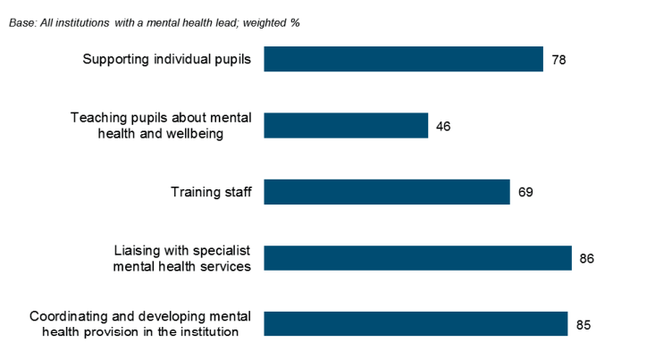
Figure 1: Mental Health Outlook of Harrow
Source: (London Borough of Harrow, 2024)
Cultural diversity as a characteristic trait of the people in the Harrow community also has demonstrated multiple health-oriented disparities leading them to confront limited life expectancy and diverse disabilities. Statistics have showcased the mental health issues to be highly prominent in the Harrow residents with every 1 in 6 adults being affected by the issue amounting to 22700 people confronting common mental health problems at large (Office for National Statistics, 2023). However, to mitigate these mental health issues by safeguarding the Harrow Community, the Harrow council has taken up the initiative/program named “Child and Young People’s Mental Health Green Paper 2017”.
This policy intervention or initiative has considerably focused on mental health issues of both the children and young people, where 3.3% of children were diagnosed with anxiety, 0.9% with depression, 5.8% had conduct disorder followed by 1.5% had hyperkinetic disorder by further pinpointing 28% of them having emotional disorder causing to the extent of causing self-harm (Nikopaschos et al., 2023). Along with this, the young people specifically detached from education and employment or training (NEETs) have faced mental illness including mental health issues and substance misuse problems, which has consequently led them to severe mental health problems like increased educational disruptions, engagement in criminal activities followed by growing dependence on drugs as a major issue in the Harrow community (London Borough of Harrow, 2022). In the present context, however, the UK government by partnering with NHS England has provided rapid advice and support, proper and in-time multi-agency assessment followed by evidence-based treatment as a financial incentive to safeguard the young people of Harrow’s mental health outcomes more effectively. For the children, however, the Future in Mind initiative has helped the UK government to take up better healthcare, education, justice, and care followed by the support to SEND children in terms of Education, Health, and Care (EHC) planning to promote more inclusive special educational needs to them (NHS England, 2021). For the Harrow-based children and young people, school and college support also has been overwhelmed by the Harrow Council including the creation of a linkage between the NHS mental health services and the schools or colleges followed by the action in tackling the poor behavior including bullying and generating self-help support productively.
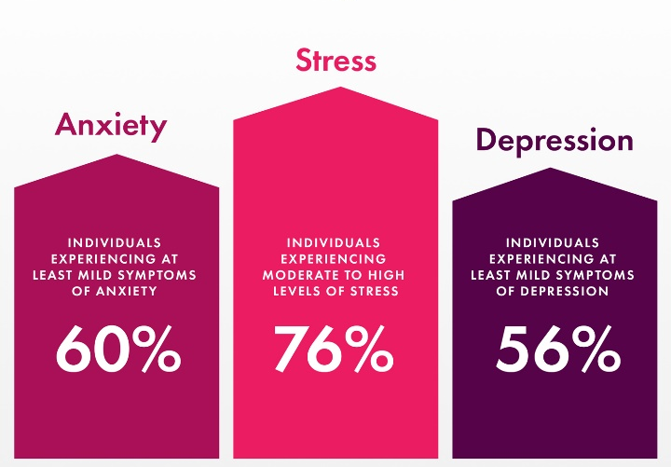
Figure 2: Mental Health Statistics of the UK
Source: (Noltemeyer et al., 2021)
The future betterment approach of this initiative also is overwhelming since it commits to the incorporation of three pillars including Designated senior leads for mental health in schools and colleges, generating mental health support teams, and reducing waiting time for receiving the service. This initiative also has undertaken a trailblazer approach in implementing local innovation and differentiation to ensure sound delivery of mental healthcare services both to the children and the young people in Harrow (Mind in Harrow, 2024). Further, by providing mental health awareness training to children and young people, this initiative can help teachers and frontline professionals with the opportunity to spot common triggers and signs of mental health issues to ensure a sound helping guide to them in mitigating these issues more effectively (GOV.UK, 2017). Thus, this initiative has been highly effective in mitigating the considerable mental healthcare needs of the children and the young people in Harrow to safeguard them in a culture rich in religious and ethnic diversity.

Application of Digital media to community development of Harrow
In a world dominated by digital media, the 5-15-year-old age group in Harrow is found to be spending 15 hours online each week, and half of the 12-year-olds have a social media profile. As suggested by Lachapelle (2020), social media has a blend of positive effects, negative, and mixed effects; while the positive ones include improvement of lives for both children and young people who are extensively suffering from mental health issues; the negative ones include social isolation, growing competitive pressure and increased rate of vulnerability and likelihood of cyberbullying and exploitation (Harrow Council, 2024). To mitigate this, however, the Harrow Council has published the Internet Safety Strategy Green paper that helps set out the responsibilities between the companies and others by fostering better technological solutions and supporting children to ensure online safety by effectively tackling digital media harms.
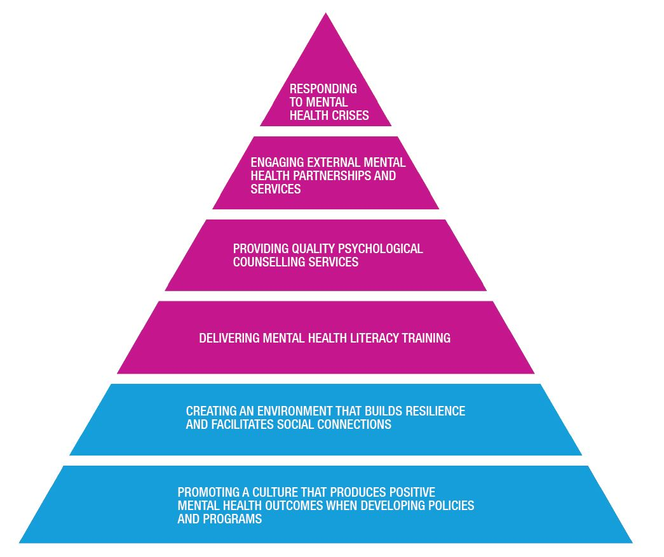
Figure 3: Mental Health and Well-being Strategy
Source: (Girves, 2022)
However, the Harrow Council has used diverse mediums in communicating these initiatives through several campaigns and practices to ensure their psychological safety grounds for the development of Children and young people. Harrow talking therapies have been one of the most significant communication mediums which is an NHS England initiative to provide free psychological treatments to individuals with anxiety and depressive disorders (NHS England, 2024). These are fundamentally counselling services to safeguard people with low mood, anxiety, and specific fears to cope with the daily chores at large. Further to encourage being safeguarded from the growing anxiety and depressive issues, online counselling and workshops can be high-end impactful since they can help promote access to educational content that helps them understand mental health and self-care strategies more viably (London Borough of Harrow, 2024). Adding to this, digital literacy for both children and young people need to be highlighted since it helps in viably strengthening community support networks. The NHS apps library further provides quality-assured digital tools that enhance self-help support through the NHS endorsement process. Further, a Digital Development Lab was established by NHS England to provide the viability of six mental health applications for children and young people of Harrow. Diverse mobile applications like Talkspace, Headspace, and Calm have been used by young people to lower their anxiety and stress levels followed by social media strategies (Facebook and Instagram) by using influencers to quote self-motivation tips to young people and children to help them cope with growing mental health issues (Girves, 2022). Zoom as a video chatting platform, also has been utilised by the Harrow Council in terms of helping them lead a quality life through vivid psychological therapy and counselling sessions. Along with this, to communicate the campaigning message more profoundly, Harrow Council and Young Harrow Foundation have collaborated to create a proactive online hub for the local young residents to help them browse diverse healthcare services according to their needs and preferences to help them stay safeguarded from physical or mental abuses, suicidal thoughts, or violent outbreaks (Girves, 2022). Thus, digital media profoundly helps the Harrow community to ensure their mental stability, health, and safety.

Connectivity between Maslow’s Need Hierarchy Theory and Community Health Development of Harrow
Maslow’s Hierarchy of Needs theory as propounded by Abraham Maslow, provides a set of innate needs that need to be satisfied for the individuals to help them achieve the actualization point by realizing their full potential. While the psychological needs of the individuals are considered the fundamental requirements, unmitigated psychological safety also leads to a direct profound impact on an individual’s psychological health outcomes since lack of access to food and housing safety can increase anxiety and depression followed by high stress (James, 2016). Safety needs include physical safety, emotional security, and stability which can be tampered with due to the lack of protection, housing safety, and the growing cost of living crisis across the UK that can enhance anxiety and stress levels of the children and young people in Harrow. Regarding love and belonging needs, however, loneliness and social isolation can lead children and young people to contribute to growing mental health challenges like sadness, low self-worth, or feelings of anxiety (Santosh, 2023). Following this, regarding self-esteem and mental health, struggles towards self-esteem can lead to considerable mental health challenges since lack of recognition can lead to feeling inadequacy leading to conditions like extreme depression. The final stage of Maslow’s need hierarchy theory i.e., self-actualization also leads to a profound sense of contentment as well as fulfilment where the persuasion of one’s passion can lead to creating a powerful antidote to mitigate the psychological health issues of the individual in Harrow (Bell, 2021).
In the context of Harrow residents, there have been several barriers identified in mitigating Maslow’s Need Hierarchy standards, specifically for children and young people. Research by Bowen (2021) has found fatigue as the physiological barrier to the treatment whereas inadequate housing (18.2%), security issues (13.2%), and safety issues (9.1%) have been popularized followed by limited social support being the love needs barrier for the people of Harrow (Noltemeyer et al., 2021). This research further highlighted the esteem needs of the young people and children in Harrow by identifying low self-esteem and low confidence to be the barriers to treating the mental health of the children and the young people. Thus, it proves that Maslow’s hierarchy of needs theory has a deeper connotation on the psychological health of the individuals living in Harrow.

Causes of investment in digital media campaign and digital initiatives in Harrow
In the context of Harrow, mental health disorders are being prioritized based on the ongoing stress anxiety, and depression of the children and young people due to the current marketplace scenario of the UK with its sound contribution to increased morbidity, mortality, disability, and healthcare expenditure at large. Although biomedical and psychological research has undergone a longer process to ensure effective treatment measures for the children and young people, affected by mental health issues in the UK, its access has still been unavailable to the people of Harrow (London Borough of Harrow, 2023). Further, over the years, the community of Harrow has been deprived of accessing mental health and emotional well-being support from the government and respective organizations which has resulted in 65% anxious people among which 30% reporting to be often nervous and less confident at times (Kruzan et al., 2022). In this scenario, the provision of health equality and potential support have been necessitated for the Harrow Council to provide to the children and young adults of the community.

Conclusion
This report has detailed the proneness of the Harrow community towards psychological health issues including anxiety, stress, and depression with the changing trends of the country’s economic and social frameworks that have lowered their confidence and self-esteem needs over the years. In this scenario, the Harrow Council and the UK government have come up with an initiative named “Child and Young People’s Mental Health Green Paper 2017” which has helped address the growing mental disorders among the young people and children of Harrow. Further, with the profound use of digital media like Facebook and Instagram followed by several mobile applications, these individuals can be counselled and safeguarded from the growing risks of psychological disorders by providing them with potential guidance to healthcare outcomes.

References
Bell, L., 2021. Helping people overcome suicidal thoughts, urges and behavior: suicide-focused intervention skills for health and social care professionals. Routledge.
Bowen, B., 2021. The matrix of needs: Reframing Maslow’s hierarchy. Health, 13(5), pp.538-563.
Faria, M., Zin, S.T.P., Chestnov, R., Novak, A.M., Lev-Ari, S. and Snyder, M., 2023. Mental Health for All: The Case for Investing in Digital Mental Health to Improve Global Outcomes, Access, and Innovation in Low-Resource Settings. Journal of Clinical Medicine, 12(21), p.6735.
Girves, R. (2022) UK partners with Talkspace to expand efforts to address mental health, UKNow. Available at: https://uknow.uky.edu/student-news/uk-partners-talkspace-expand-efforts-address-mental-health (Accessed: 18 April 2024).
Girves, R. (2022a) How Talkspace makes mental health conversations easy for students, UKNow. Available at: https://uknow.uky.edu/student-news/how-talkspace-makes-mental-health-conversations-easy-students (Accessed: 18 April 2024).
GOV.UK (2017) Transforming Children and young people’s mental health ..., GOV.UK. Available at: https://assets.publishing.service.gov.uk/media/5a823518e5274a2e87dc1b56/Transforming_children_and_young_people_s_mental_health_provision.pdf (Accessed: 18 April 2024).
Harrow Council (2024) Harrow’s Digital Infrastructure, London Borough of Harrow. Available at: https://www.harrow.gov.uk/council/harrow%E2%80%99s-digital-infrastructure (Accessed: 18 April 2024).
Harrow Council (2024) Our Harrow, our community – equality profile annual data, Harrow Council UK. Available at: https://www.harrow.gov.uk/downloads/file/23835/annual-equalities-data-2017-18.pdf (Accessed: 18 April 2024).
Harrow Council (2024a) Mental Health and Wellbeing, London Borough of Harrow. Available at: https://www.harrow.gov.uk/adult-social-care/mental-health/3 (Accessed: 18 April 2024).
James, K., 2016. Barriers to Treatment and the Connection to Maslow’s Hierarchy of Needs. Counselor Education Capstone, 18, pp.1-35.
Kim, J., 2024. Connecting equity, community well-being, and quality of life via system elements and a common narrative of community development. In Social (In) equality, Community Well-being, and Quality of Life (pp. 49-78). Edward Elgar Publishing.
Kruzan, K.P., Fitzsimmons-Craft, E.E., Dobias, M., Schleider, J.L. and Pratap, A., 2022. Developing, deploying, and evaluating digital mental health interventions in spaces of online help and information-seeking. Procedia computer science, 206, pp.6-22.
Lachapelle, P., 2020. Assessing the potential of community foundation leadership through a new conceptual lens. Community Development, 51(2), pp.93-106.
London Borough of Harrow (2020) Harrow Council Digital Infrastructure Strategy, London Borough of Harrow. Available at: https://moderngov.harrow.gov.uk/documents/s174499/Draft%20Digital%20Infrastructure%20Strategy%20-%20Appendix%201.pdf (Accessed: 18 April 2024).
London Borough of Harrow (2022) Harrow Health and Wellbeing Strategy 2022 - 2030, Harrow Health and Wellbeing Strategy. Available at: https://moderngov.harrow.gov.uk/documents/s180715/2b.FINAL%20DRAFT%20HEALTH_AND_WELLBEING_STRATEGY_v6.pdf (Accessed: 18 April 2024).
London Borough of Harrow (2023) Health Inequalities Strategy Implementation Plan 2021-24, London Borough of Harrow. Available at: https://www.london.gov.uk/publications/health-inequalities-strategy-implementation-plan-2021-24 (Accessed: 18 April 2024).
Mind in Harrow (2021) Implementation of a co-production approach for mental ..., Mind in Harrow. Available at: https://www.mindinharrow.org.uk/wp-content/uploads/2021/03/Implementation-of-a-Co-production-approach-Jan2021-1.pdf (Accessed: 18 April 2024).
NHS England (2021) Harrow Community Mental Health Teams exceed their physical health check target, NHS England. Available at: https://www.cnwl.nhs.uk/news/harrow-community-mental-health-teams-exceed-their-physical-health-check-target (Accessed: 18 April 2024).
NHS England. 2024. Harrow Talking Therapies, NHS England. Available at: https://www.cnwl.nhs.uk/services/mental-health-services/adult-and-older-adult/harrow-talking-therapies (Accessed: 18 April 2024).
Nikopaschos, F., Burrell, G., Clark, J. and Salgueiro, A., 2023. Trauma-Informed Care on mental health wards: the impact of Power Threat Meaning Framework Team Formulation and Psychological Stabilisation on self-harm and restrictive interventions. Frontiers in Psychology, 14, p.1145100.
Noltemeyer, A., James, A.G., Bush, K., Bergen, D., Barrios, V. and Patton, J., 2021. The relationship between deficiency needs and growth needs: The continuing investigation of Maslow’s theory. Child & Youth Services, 42(1), pp.24-42.
Ocloo, J., Garfield, S., Franklin, B.D. and Dawson, S., 2021. Exploring the theory, barriers, and enablers for the patient and public involvement across health, social care, and patient safety: a systematic review of reviews. Health research policy and systems, 19, pp.1-21.
Office for National Statistics (2023) How life has changed in Harrow: Census 2021, Office for National Statistics. Available at: https://www.ons.gov.uk/visualisations/censusareachanges/E09000015/ (Accessed: 18 April 2024).
Reid, R.J., Reid, M.R. and Murillo, X.L., 2022. Place-Based Philanthropy: Who is that in my backyard? Local Development & Society, pp.1-28.
Santosh, R. (2023) Patient care and needs through the lens of Maslow’s hierarchy of needs, LinkedIn. Available at: https://www.linkedin.com/pulse/patient-care-needs-lens-maslows-hierarchy-santhosh-r/ (Accessed: 18 April 2024).

