
Learning in the Digital Era
ACCA4025

July 6, 2026
Name: MInaze Amini- 2533666
Lecturer: Malik Mehmood
UWTSD Quay place- Birmingham

Welcome page- E-portfolio link 2
2
1A – Essential Academic and Employability Skills in the Digital Era 3
Task 1B- Similarity score Reflection 4
Task 2A - Key considerations of effective teamwork- Mind Map 5
Task 2B- Professional Academic Poster ‘Life is a Team Sport’ 6
Task 3A Unit 3 -Virtual Collaboration- Topic 4- Lights, Camera, Action 7
Task 3B- Use of RefWorks 8
Task 4-E-Portfolio 10

Welcome page- E-portfolio link

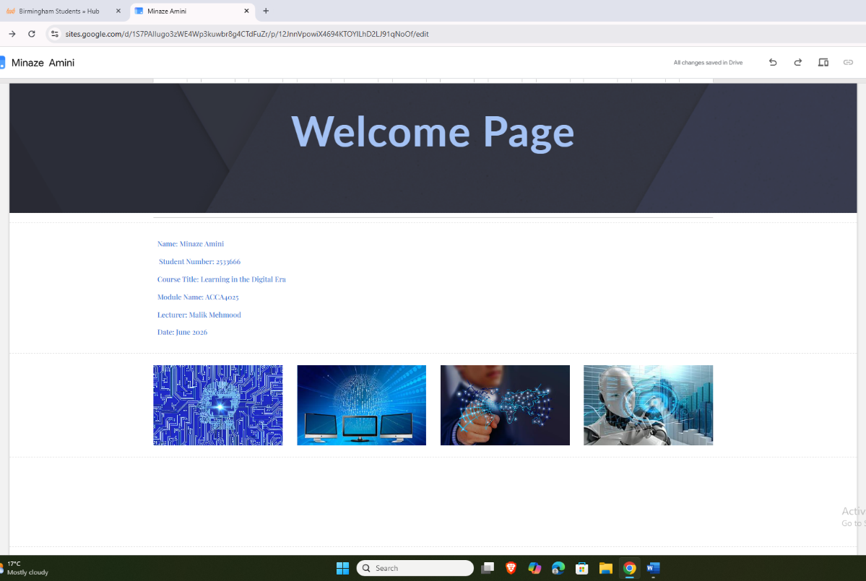

1A – Essential Academic and Employability Skills in the Digital Era
Technology is a major part of daily life, and it's constantly changing how people learn and work. As a computing student, I think having technical knowledge is very important, but not enough on its own. To fit into the digital era, we need skills such as digital literacy, communication, problem-solving, and the effective and responsible use of AI.
Digital literacy is a very important skill in today's generation. It means being able to use technology easily and effectively. Reedy and Parker explain that digital literacy is more than just using a computer; it also includes finding, understanding, and sharing information using digital tools [1]. As most learning now takes place online, digital literacy has become an important skill for studying and jobs. In my studies and life, I have used platforms like Moodle, Microsoft Teams, and cloud storage, which have helped me become better and given me confidence using technology and connecting with others.
Communication is another valuable skill in computing. People often mistake computing for being all about using computers, but without communication, it wouldn't work as effectively. Whether it be talking to team members, team leaders or customers, being able to discuss things clearly always avoids confusion and makes a workplace run more smoothly. Woods and Murphy highlight the importance of digital and communication skills in helping students become more employable [2].
Problem-solving is a skill that is used all the time in computing. Technology is not basic and does not always work as we want it to, so being able to find solutions and identify problems is important. Khalid and Husnin suggest that graduates need both wider employability skills and digital skills to meet the needs of the modern workplace [3].
AI sources are being used everywhere in the world right now; it's helpful and groundbreaking software. Instead of following strict and straightforward rules, AI can learn from examples, guess what comes next, and sometimes spot patterns as humans do. Using AI tools has shown me how technology can support learning and research when used properly [4].
So, taking all this into account, digital literacy, communication, problem-solving, and AI are all very important in the digital Era. Developing and improving these skills during my
computing degree will help me prepare for opportunities in the future. Technology changes so quickly that learning doesn't stop after university. I will need to keep developing my skills and learning new things throughout my career [5].

Task 1B- Similarity score Reflection
I am very pleased with my Turnitin similarity score of 11%. I feel this matches how I have tried to work and produce my work with honesty and in my own words, except when referencing. In the assignment, I improved my engagement with literature by searching through sources, including books, journals, and websites. I also developed and still am developing my referencing skills by learning how to use RefWorks and apply the IEEE correctly. In my upcoming assignments, I will continue improving these skills and try to improve the presentation of my references.
Below is a GAC chart and marks out of 100% I would award myself.

Criteria | Estimated Mark (%)
Engagement with Literature | 70%
Knowledge & understanding | 70%
Cognitive & Intellectual Skills | 70%
Practical Skills | 60%
Transferable Skills | 80%
Overall Average | 70%

Task 2A - Key considerations of effective teamwork- Mind Map

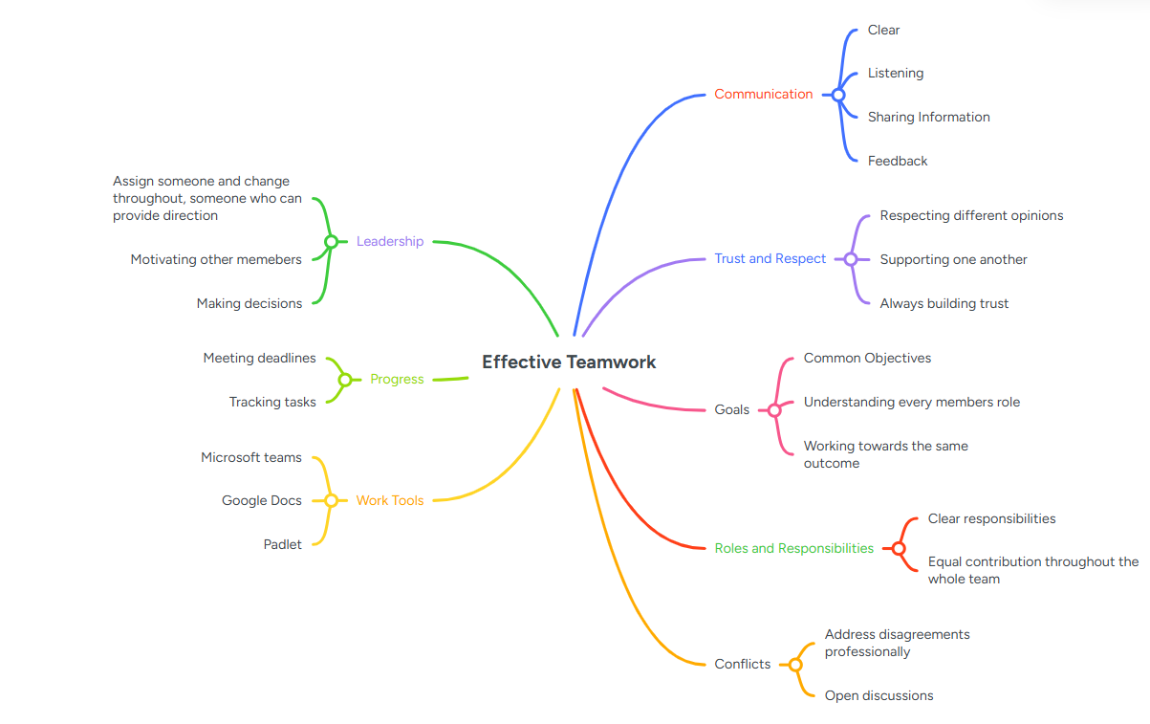

https://www.mindmeister.com/app/map/4027181439?t=j7xc2KoTJj

Task 2B- Professional Academic Poster ‘Life is a Team Sport’

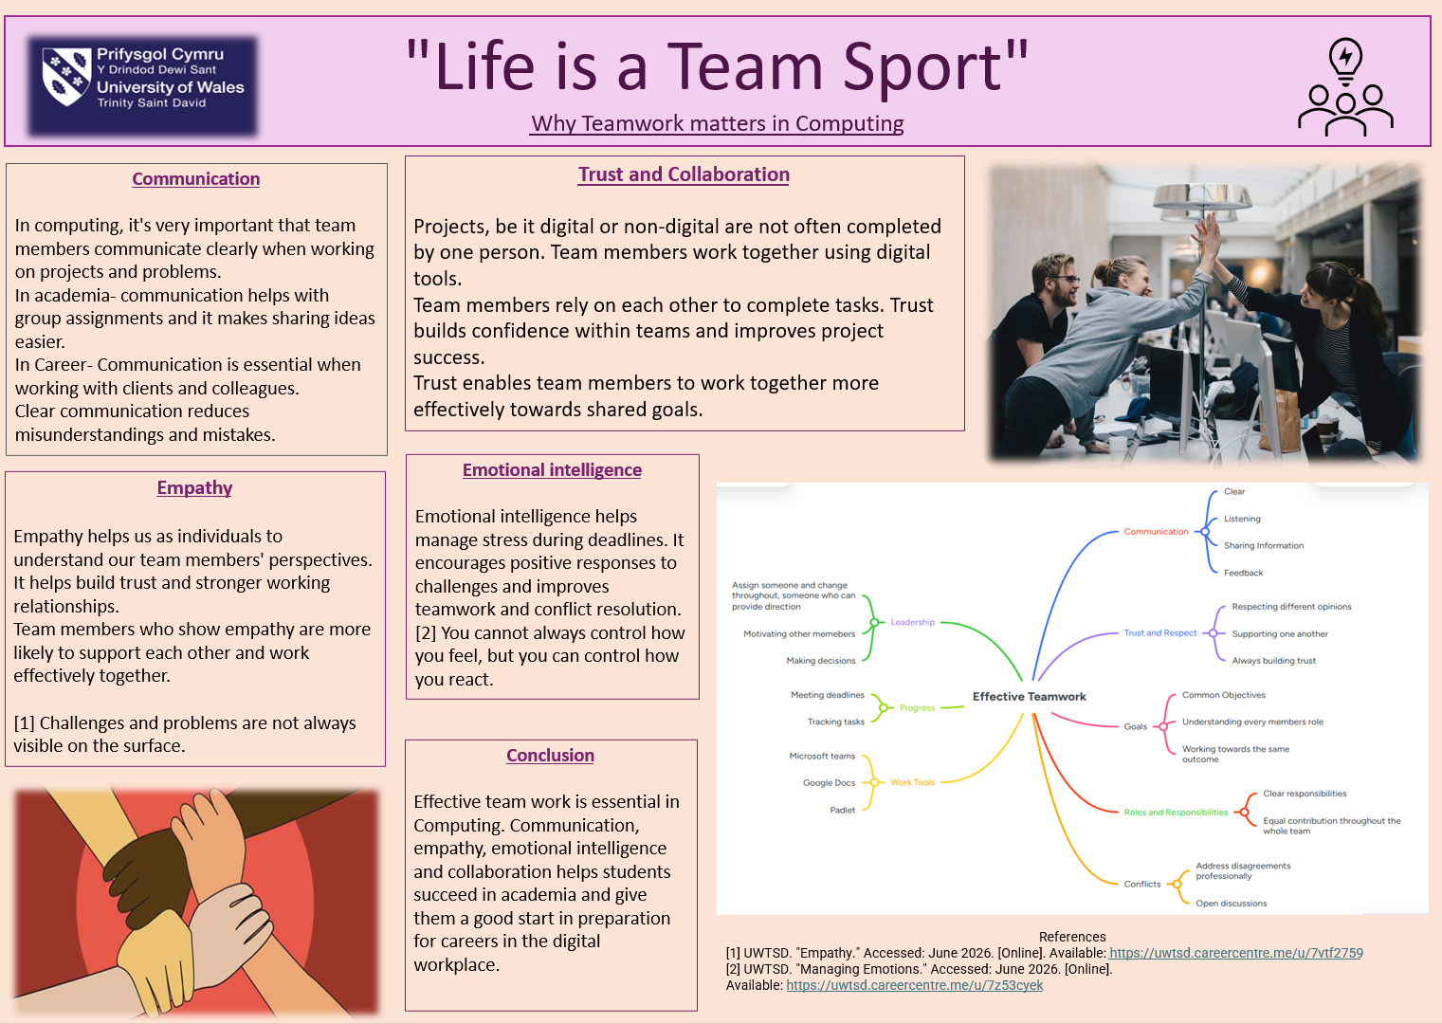

Life is a team sport.pptx

Task 3A Unit 3 -Virtual Collaboration- Topic 4- Lights, Camera, Action

Virtual collaboration or working together online is becoming more common at work and in places of education. We use computers and the internet to complete projects as a team, even when we are in different locations. I have chosen ‘Lights, Camera, Action’ as my topic because it’s basically the stage where a team is working well together, performing and getting results.
One of the main theories discussed in the topic is Tuckman's stages of team development. According to Tuckman and Jensen [6], teams move through a few stages before they become effective. When a team is first formed, the members get to know each other and learn what they need to do. This is called the forming stage. Next comes the storming stage, where some might disagree with ideas because they may have different ideas. After that comes the norming stage, where members of the team start to work better as they have got to know each other and built trust. The last stage is the performing stage, where the team starts working effectively and reaches the required goals.
Another important concept is Lencioni's Five Dysfunctions of a Team [7]. Lencioni explains that teams can struggle when there is no trust between team members. Teams can sometimes have problems. If the team members do not trust each other, they may not work well or share their ideas. This can make it difficult for the team to finish projects or tasks and achieve optimal results. Communication, trust, and teamwork are very important.
The topic also highlighted the importance of monitoring progress within a team. Monitoring deadlines, maintaining engagement, etc., are essential for successful teamwork [8]. It's important to keep track of progress. Team members should have a clear understanding of what tasks need to be completed and when they are due. This helps everyone stay motivated and effective.
Technology can help teams work together. Tools like Microsoft Planner, Trello, and Padlet help organise tasks, share information and see what has been completed and what is left to do.
In conclusion, successful online teamwork only happens when people trust each other, communicate clearly, and work towards the same goal together. Using teamwork skills and technology can make projects and tasks successful and easier.

Task 3B- Use of RefWorks

I used RefWorks to help me keep track of the books and websites I used. I created an account on RefWorks and registered with it under UWTSD. On RefWorks, I manually input details of my sources, and RefWorks puts them in the right order. It helped me make a Bibliography automatically using the IEEE UWTSD style. I found it easy to use and understand and thought it was straightforward with a little help from my lecturer.
The screenshots show a step-by-step process of how I used Reworks: manually inputting the sources, choosing the IEEE UWTSD style, and creating a Bibliography for my assignment.

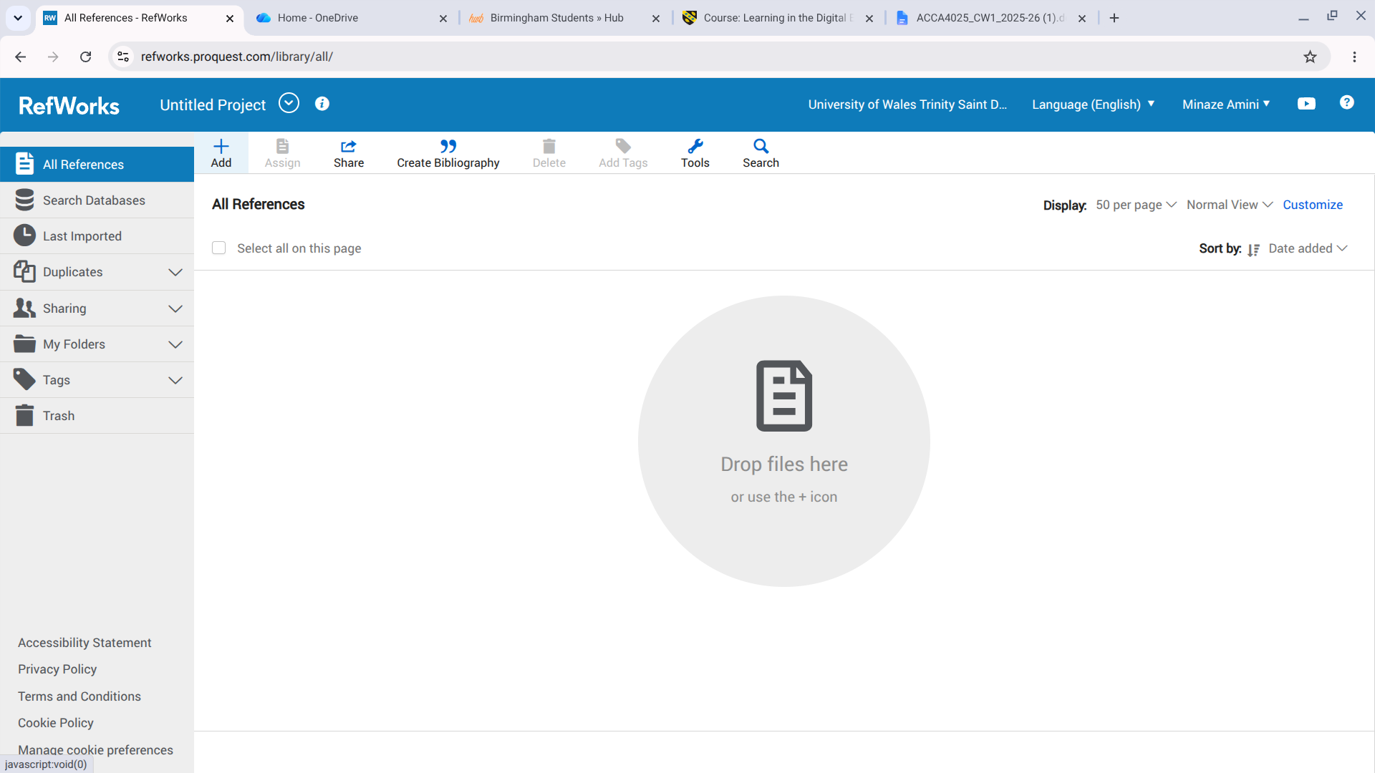
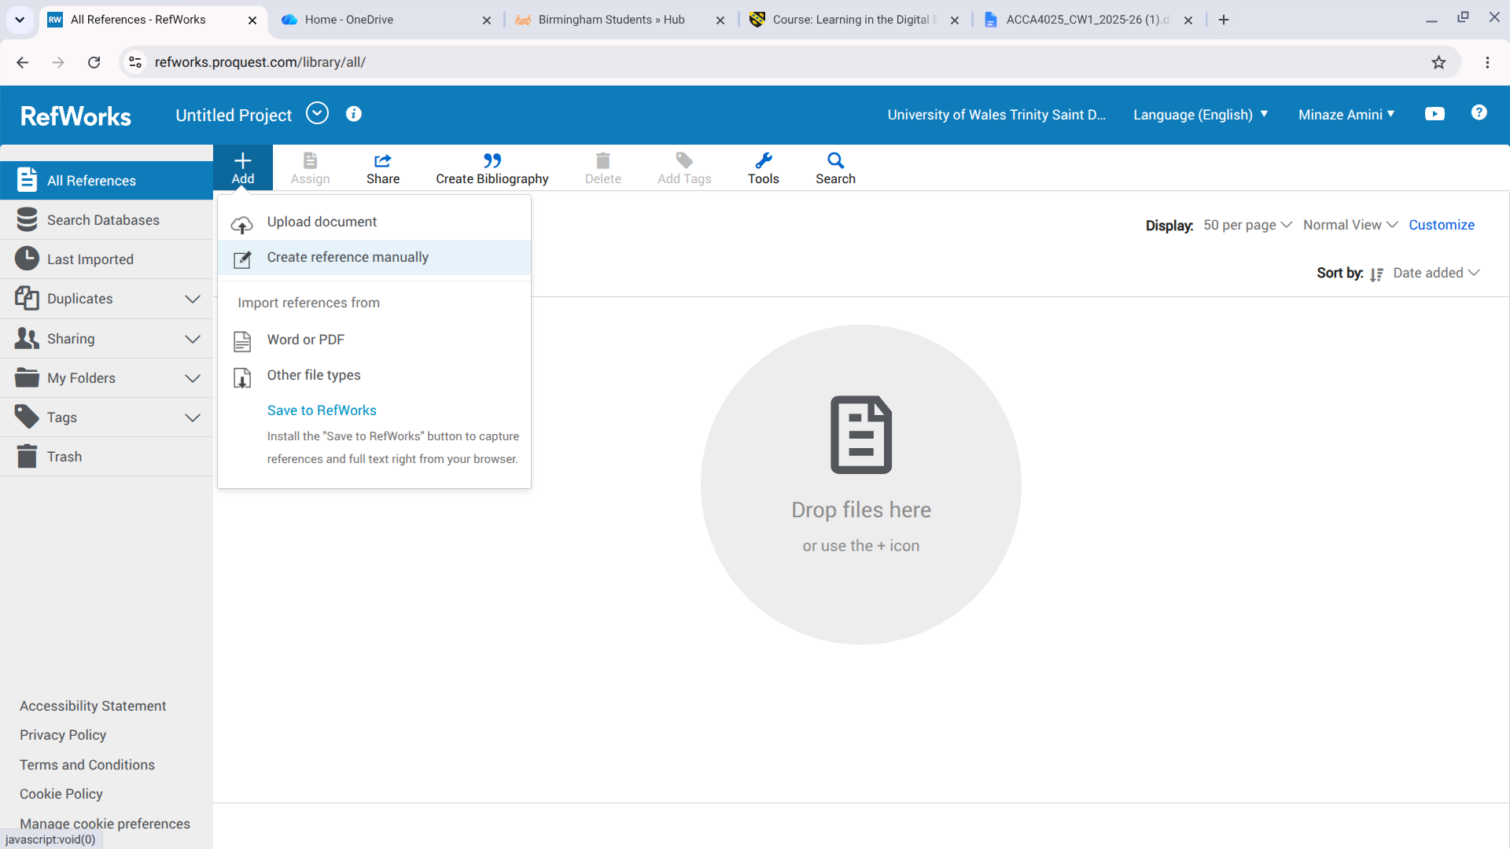

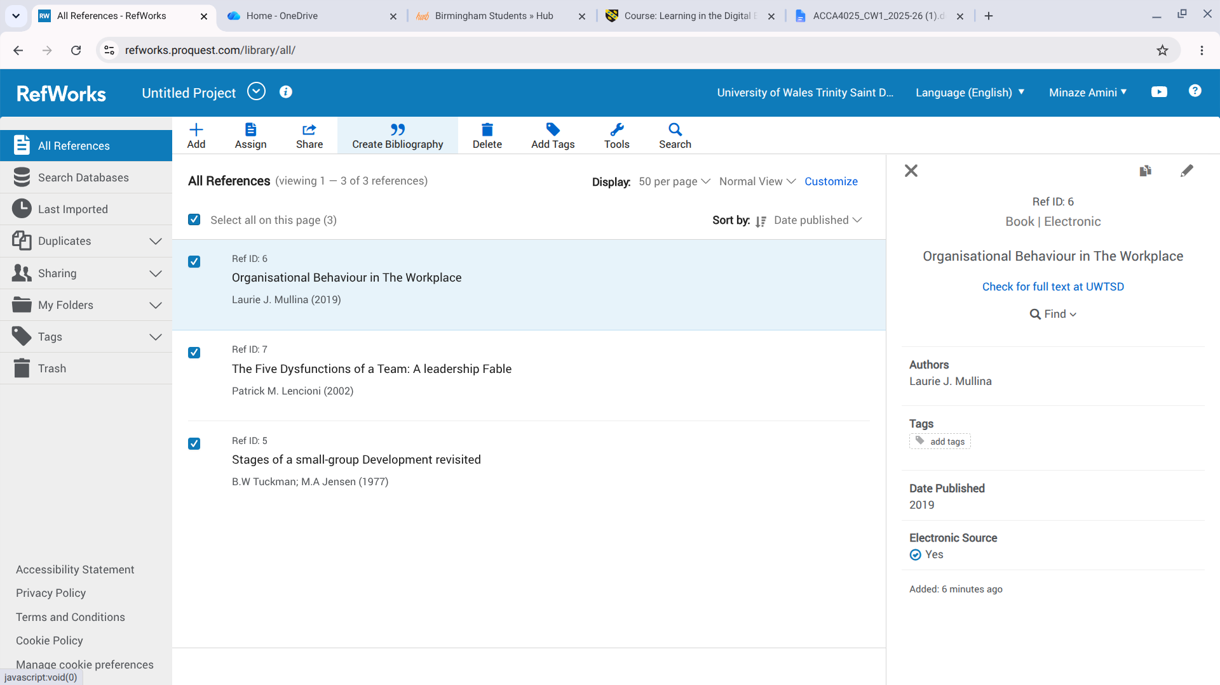

Task 4-E-Portfolio
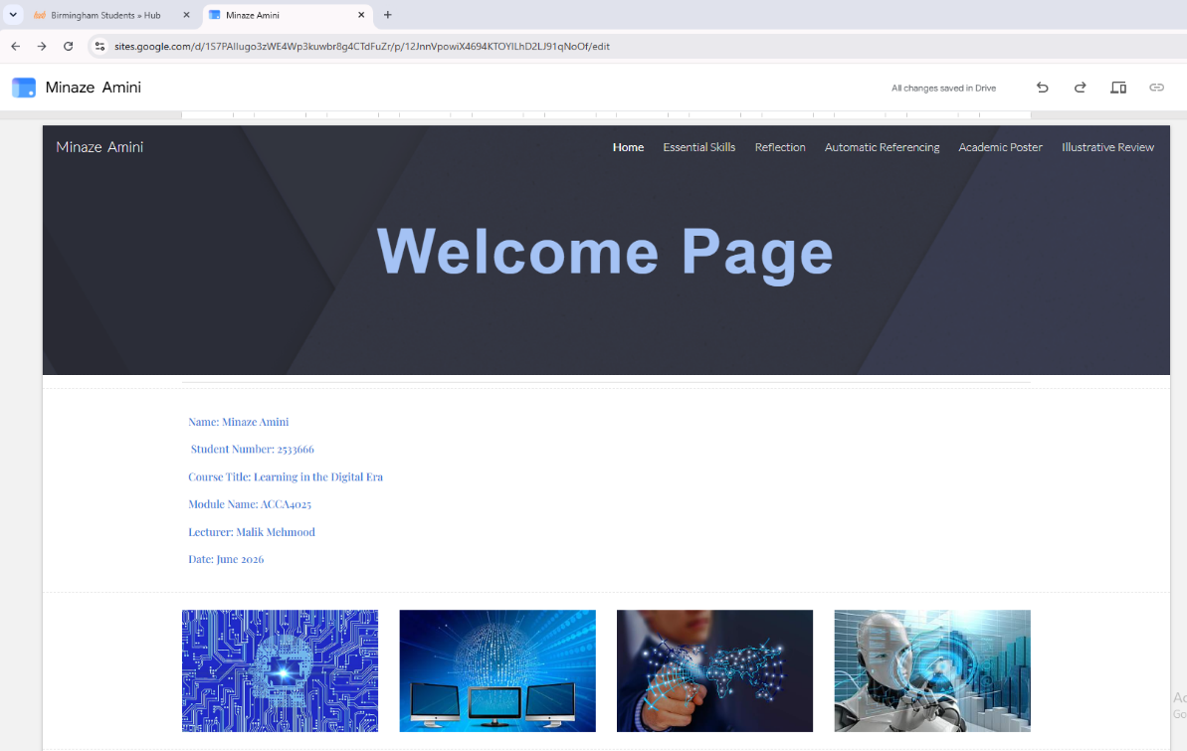
The pictures below show each page of my E-portfolio:

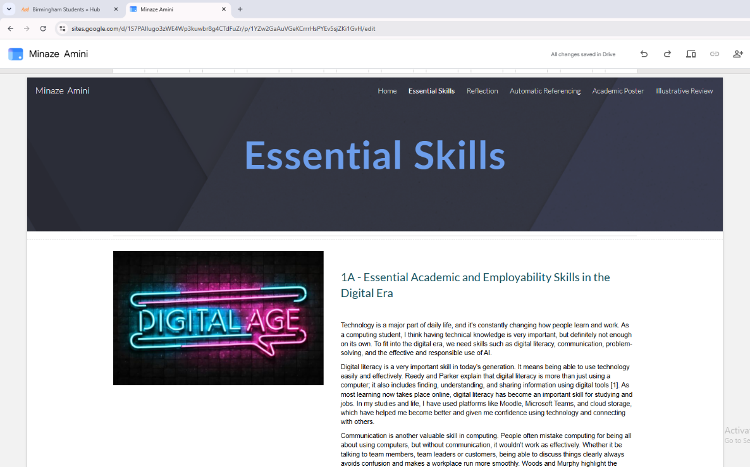

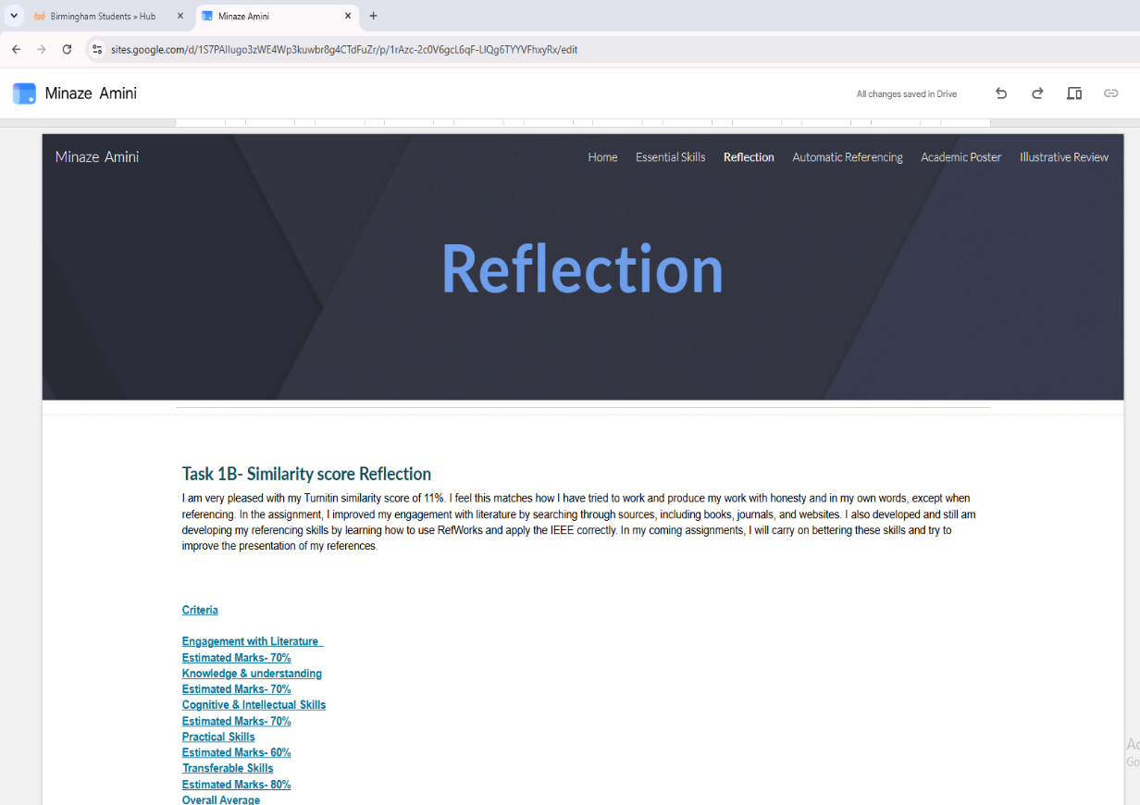

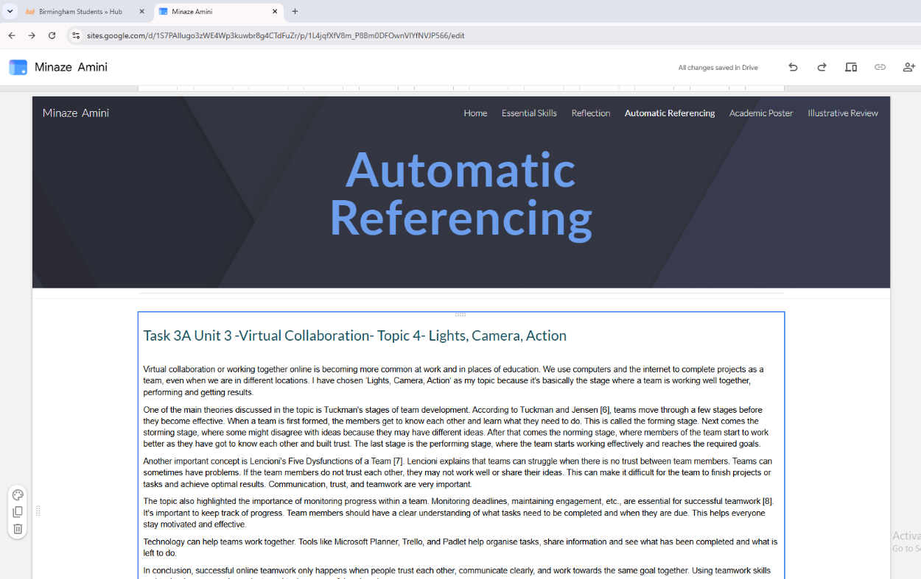

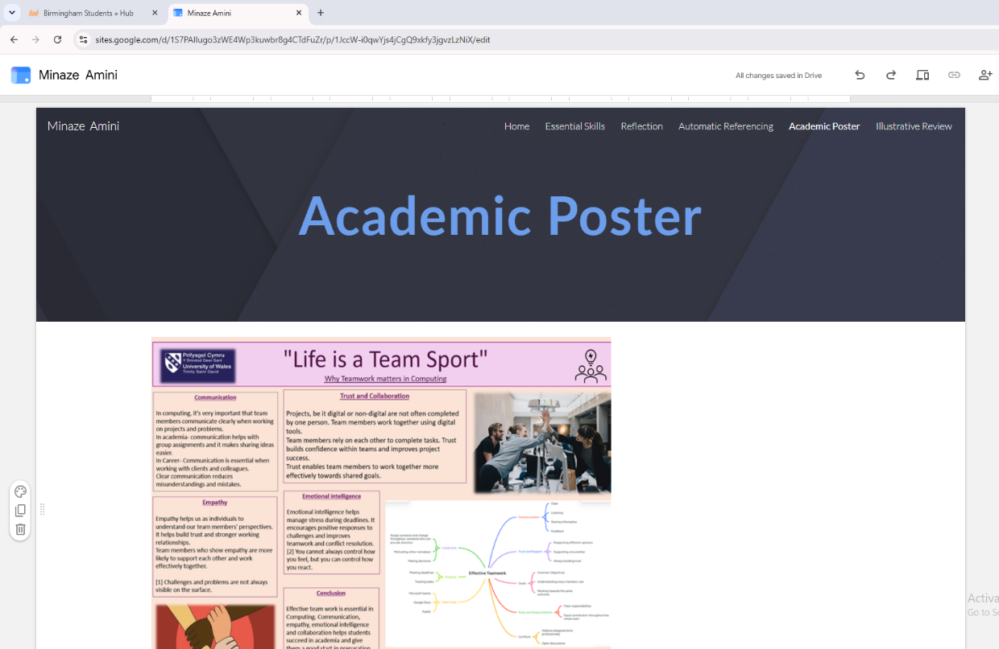

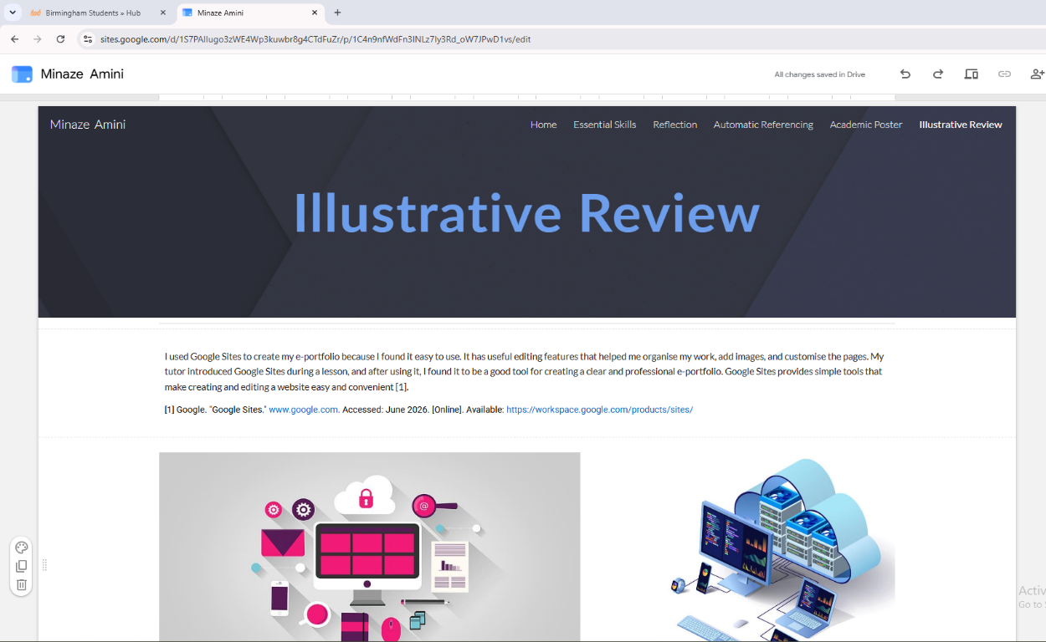

References
[1] MN Khuraisah, Khalid Fariza and Husnin Hazrati, "Preparing graduates with digital literacy skills toward fulfilling employability needs in 4l era," vol. 11, 2020,
[2] R. Katherine, Digital Literacy unpacked, 2018.
[3] Woods Emma, "Get the digital Edge: A digital literacy and employability skills day for students," vol. 7, 2013,
[4] OpenAI. "Discussion on essential skills for employability." Accessed: June 2026. [Online]. Available: https://chatgpt.com/
[5] The Open University. "Digital skills: Succeeding in a Digital world." Accessed: 1 June 2026. [Online]. Available: https://www.open.edu/openlearn/openlearn/digital-computing/digital-skills-succeeding-digital-world?active-tab=description-tab
[6] B.W Tuckman and M.A Jensen, "Stages of a small-group Development revisited," 1977,
[7] Patrick M. Lencioni, The Five Dysfunctions of a Team: A leadership Fable, 2002.
[8] Laurie J. Mullina, Organisational Behaviour in The Workplace, 2019.

