

Name: Jaimin Limbachiya
Student ID: 2527056
Module no: LCHS7009
Module Name: Population Health and Digital Health Promotion
Lecturer: Dr. Raheela Sheikh

Contents
Blog 1: Digital Health Promotion for Coronary Artery Disease in South Asian Communities in the UK 1
1.1. Why Coronary Artery Disease is a Public Health Concern 1
1.2. Digital Technology in Health Promotion: Mobile Health Applications 2
1.3. Critical Discussion: Advantages and Disadvantages 2
1.4. Disadvantages and Shortfalls 3
1.5. Addressing the Shortfalls 3
Blog 2: HeartWise SA – A Culturally Tailored Digital Health App for Preventing Coronary Artery Disease in South Asian Communities in the UK 3
2.1. HeartWise SA: My Designed Digital Health Technology 4
2.2. HeartWise SA combines: 5
2.3. How the Technology Promotes Health 5
2.4. Advantages 6
2.5. Limitations and Shortfalls 7
2.6. Addressing the Shortfalls 7
1.6. References blog 1 7
2.7. References blog 2 10

Blog 1: Digital Health Promotion for Coronary Artery Disease in South Asian Communities in the UK

Why Coronary Artery Disease is a Public Health Concern

Coronary artery disease (CAD) is a leading cause of death in the UK and occurs when fatty deposits narrow the coronary arteries, reducing blood flow and increasing the risk of heart attack and stroke. Millions of people in the UK are living with cardiovascular disease (British Heart Foundation, 2025). South Asian populations, including Indian, Pakistani, Bangladeshi, and Sri Lankan groups, are disproportionately affected compared with White British populations (Bhopal, 2019; Patel et al., 2021). Evidence shows South Asians are almost twice as likely to develop CAD than White Europeans (British Heart Foundation, 2024). The LOLIPOP study also found higher long-term incidence in South Asians (17.4%) compared with White Europeans (10.8%) (Kooner et al., 2024).

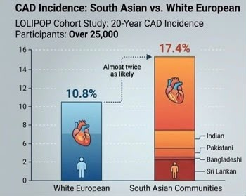

Figure 1. Higher Risk of Coronary Artery Disease among South Asians Compared with White Europeans
Source: BHF (2024)
Global evidence also shows that modifiable risk factors such as diabetes, hypertension, unhealthy diet and physical inactivity contribute substantially to cardiovascular disease burden (Yusuf et al., 2020; World Health Organization, 2023).

Digital Technology in Health Promotion: Mobile Health Applications
Mobile health (mHealth) applications, such as the NHS App and wearable devices, are widely used in health promotion to monitor blood pressure, heart rate, activity, diet, and medication adherence (NHS England, 2025; OHID, 2025). These tools support cardiovascular disease prevention in the UK by encouraging behaviour change through reminders, tracking, and personalised advice (Khanji et al., 2023). Digital interventions also improve self-management and accessibility, especially for South Asian communities through multilingual resources (Gupta et al., 2022). Evidence shows improvements in physical activity, adherence, and early detection, while telehealth has expanded access to care post-COVID-19 (Widmer et al., 2015; NHS England, 2025).

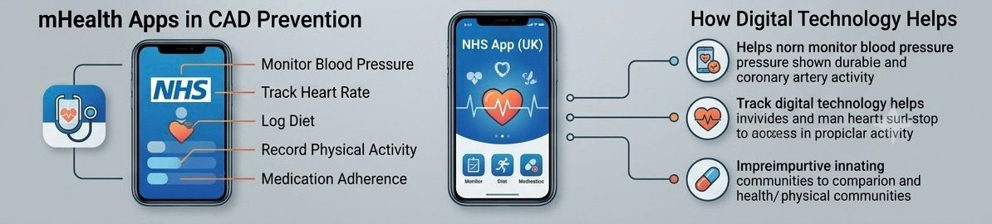

Figure 2. Mobile Health Applications Supporting Cardiovascular Disease Prevention

Source: NHS England (2024); Office for Health Improvement and Disparities (2025)

Critical Discussion: Advantages and Disadvantages

Advantages
- Improved accessibility to health information and services
- Continuous monitoring of cardiovascular risk factors
- Early identification of symptoms and prevention strategies
- Increased patient engagement and self-management
- Reduced healthcare costs and hospital admissions (WHO, 2024; Khanji et al., 2023; NHS England, 2025)

Disadvantages and Shortfalls

- Older adults in South Asian communities may have low digital literacy, making it difficult to use health apps (Ali et al., 2021).
- Economic inequalities can limit access to smartphones, internet, and wearable devices (NHS England, 2025).
- Language barriers and lack of culturally tailored content may reduce engagement (Gupta et al., 2022).
- Privacy and data security concerns may discourage users from sharing personal health information (NICE, 2023).
- NHS Digital data highlight ongoing inequalities in cardiovascular outcomes, showing the need for equitable access to digital health services (NHS Digital, 2022).

Addressing the Shortfalls

Healthcare organisations should improve effectiveness by offering digital literacy training for older and disadvantaged groups. Apps should include culturally tailored content, multilingual support, and simple design (Gupta et al., 2022). Community leaders can help build trust. The NHS should invest in digital inclusion and ensure services complement traditional care, supported by personalised cardiovascular prevention strategies (NICE, 2023; UK Biobank, 2025).

Blog 2: HeartWise SA – A Culturally Tailored Digital Health App for Preventing Coronary Artery Disease in South Asian Communities in the UK

Coronary artery disease (CAD) is a major public health issue and a leading cause of premature death in the UK. It occurs when fatty plaques build up in the coronary arteries, reducing blood flow to the heart. South Asian communities, including Indian, Pakistani, Bangladeshi, and Sri Lankan groups, have a significantly higher risk of CAD than White British populations (Gupta et al., 2022; Kooner et al., 2024). The British Heart Foundation (2025) reports over 7.6 million people in the UK live with cardiovascular disease. Higher risk in South Asians is linked to diabetes, hypertension, obesity, and genetics (Patel et al., 2021; Yusuf et al., 2020).


Figure 1. Increased Risk of Coronary Artery Disease in UK South Asian Communities

Source: British Heart Foundation (2025); Kooner et al. (2024).

2.1. HeartWise SA: My Designed Digital Health Technology

HeartWise SA (South Asian) is a proposed smartphone application specifically designed to prevent CAD among South Asian adults living in the UK.

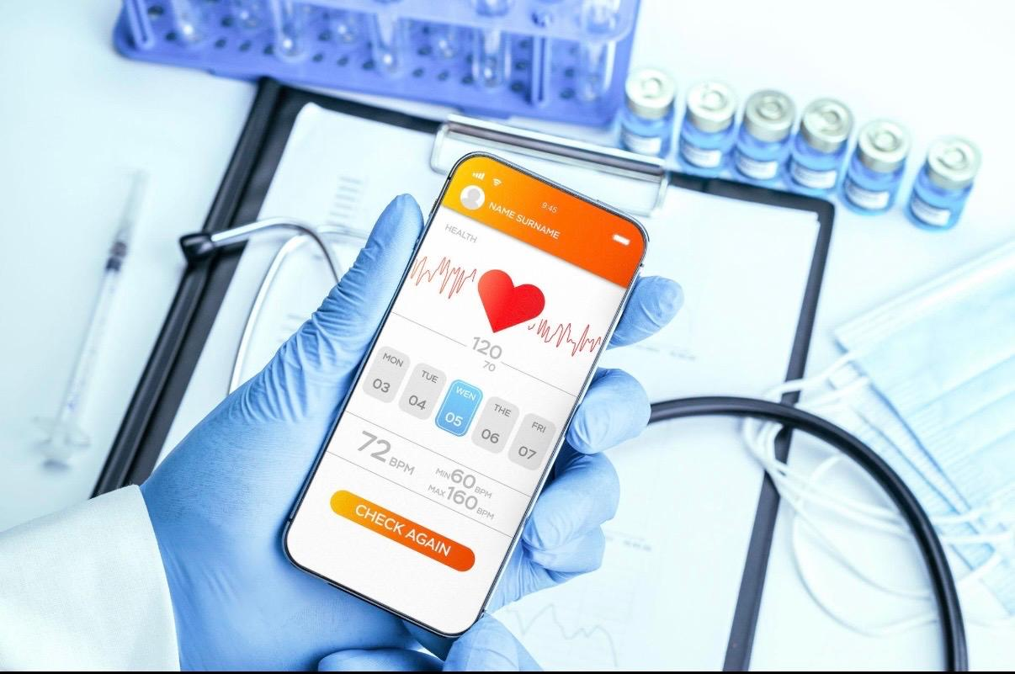
Figure 2. Concept Design of the HeartWise SA Mobile Health Application
Source (Self Created)

2.2. HeartWise SA combines:

- AI-driven cardiovascular risk assessment
- Multilingual support
- Culturally tailored dietary advice
- Physical activity tracking
- Medication reminders
- Wearable device integration
- Family-based health challenges
- NHS-linked virtual screening

2.3. How the Technology Promotes Health

HeartWise SA would collect information on age, blood pressure, cholesterol levels, diabetes status, smoking habits and physical activity to generate a personalised CAD risks score using validated algorithms (Zhao et al., 2025).
Then provides:

- Daily lifestyle recommendations
- Heart-healthy South Asian recipes
- Exercise plans
- Educational videos
- Automated screening reminders
- Community support

Figure 3. How HeartWise SA Supports Coronary Artery Disease Prevention

Source: Adapted from NHS England (2025); Office for Health Improvement and Disparities (2025).

The design aligns with the NHS strategy to increase preventive healthcare through digital technologies and remote monitoring (Public Health England, 2025). Recent NHS developments have expanded digital communication through the NHS App, supporting appointment reminders, health information delivery and preventive care initiatives (NHS England, 2025a; NHS England, 2025b; NHS England, 2025c; NHS England, 2025d).

2.4. Advantages

- Provides culturally tailored advice on South Asian foods, improving relevance and engagement in diet and lifestyle change.
- Multilingual support reduces language barriers and improves access to preventive care for ethnic minority groups.
- Wearable integration and digital tools support self-management, improving medication adherence, physical activity, and health literacy (Widmer et al., 2015).
- Early risk detection is supported through remote cardiovascular assessment (Gidlow et al., 2025).

2.5. Limitations and Shortfalls

- Digital exclusion may limit use among older adults with low digital literacy (Ali et al., 2021).
- Privacy and cybersecurity concerns may discourage users from sharing personal health data (NICE, 2025).
- Inequalities in access to smartphones, internet, and wearable devices can restrict availability (WHO, 2024).
- Long-term user engagement often declines after initial download and short-term use of health apps.

2.6. Addressing the Shortfalls

- Community-based digital literacy workshops (Ali et al., 2021)
- Partnerships with GP practices and South Asian community organisations (Public Health England, 2023)
- Strong GDPR-compliant privacy safeguards (NICE, 2025)
- Voice-assisted navigation for older adults (Gupta et al., 2022)
- Gamification features and reward systems (Khanji et al., 2023)
- Integration with NHS services and health records (Gidlow et al., 2025)
- HeartWise SA uses culturally tailored education, personalised risk assessment, and community engagement to reduce inequalities and support NHS prevention. It complements traditional care as a hybrid model (WHO, 2024).

References blog 1

- Ali, S. et al. (2021) ‘Health inequalities in UK South Asian populations’, Public Health, 196, pp. 82–89. Available at: https://www.sciencedirect.com/journal/public-health (Accessed: 25 May 2026).
- Bhopal, R. (2019) Epidemiology of cardiovascular disease in ethnic minorities. Oxford: Oxford University Press. Available at: https://global.oup.com/academic/ (Accessed: 25 May 2026).
- British Heart Foundation (2024) South Asians almost twice as likely to develop coronary heart disease than White Europeans. London: British Heart Foundation. Available at: https://www.bhf.org.uk/what-we-do/news-from-the-bhf (Accessed: 25 May 2026).
- British Heart Foundation (2025) Heart & circulatory disease statistics 2025. London: British Heart Foundation. Available at: https://www.bhf.org.uk/what-we-do/our-research/heart-statistics (Accessed: 25 May 2026).

- Gupta, M. et al. (2022) ‘Cardiovascular risk in South Asians’, Journal of the American College of Cardiology, 79(9), pp. 898–914. Available at: https://www.jacc.org/ (Accessed: 25 May 2026).
- Heart (2024) ‘South Asians and coronary disease: systematic review and meta-analysis’, Heart, 99(10), pp. 729–740. Available at: https://heart.bmj.com/ (Accessed: 25 May 2026).
- Kooner, A. et al. (2024) ‘Cumulative incidence of coronary heart disease among UK South Asians’, Heart, 110(Suppl. 3), pp. A213–A214. Available at: https://heart.bmj.com/ (Accessed: 25 May 2026).
- National Institute for Health and Care Excellence (NICE) (2023) Cardiovascular disease prevention guidelines. London: NICE. Available at: https://www.nice.org.uk/guidance (Accessed: 25 May 2026).
- NHS Digital (2022) Mortality from coronary heart disease. Leeds: NHS Digital. Available at: https://digital.nhs.uk/data-and-information (Accessed: 25 May 2026).
- NHS England (2024) Digital health and cardiovascular care strategy. London: NHS England. Available at: https://www.england.nhs.uk/digitaltechnology/ (Accessed: 25 May 2026).
- Office for Health Improvement and Disparities (2025) Cardiovascular disease profiles. London: Office for Health Improvement and Disparities. Available at: https://fingertips.phe.org.uk/profile/cardiovascular (Accessed: 25 May 2026).
- Patel, J.V. et al. (2021) ‘Coronary heart disease risk among South Asians’, Heart, 107(5), pp. 389–396. Available at: https://heart.bmj.com/ (Accessed: 25 May 2026).
- UK Biobank (2025) A healthy heart looks different in South Asian and White people. Available at: https://www.ukbiobank.ac.uk/learn-more-about-uk-biobank/news (Accessed: 25 May 2026).
- Widmer, R.J. et al. (2015) ‘Digital health interventions for prevention of cardiovascular disease’, Mayo Clinic Proceedings, 90(4), pp. 469–480. Available at: https://www.mayoclinicproceedings.org/article/S0025-6196(15)00111-5/fulltext (Accessed: 25 May 2026).
- World Health Organization (2023) Cardiovascular diseases (CVDs) fact sheet. Geneva: World Health Organization. Available at: https://www.who.int/news-room/fact-sheets/detail/cardiovascular-diseases-(cvds) (Accessed: 25 May 2026).
- Yusuf, S. et al. (2020) ‘Modifiable risk factors and cardiovascular disease’, The Lancet, 395(10226), pp. 795–808. Available at: https://www.thelancet.com/journals/lancet (Accessed: 25 May 2026)

2.7. References blog 2
- Ali, S., McKeigue, P. and Fischbacher, C. (2021) ‘Health inequalities and cardiovascular disease among ethnic minorities in the UK’, Public Health, 196, pp. 82–89. Available at: https://doi.org/10.1016/j.puhe.2021.05.017
- British Heart Foundation (2025) UK factsheet: Heart and circulatory diseases statistics. London: British Heart Foundation. Available at: https://www.bhf.org.uk/what-we-do/our-research/heart-statistics (Accessed: 25 May 2026).
- Gidlow, C.J. et al. (2025) ‘Feasibility study of a digital NHS Health Check’, BMC Digital Health, 3(34), pp. 1–15. Available at: https://bmcdigitalhealth.biomedcentral.com/
- Gupta, M., Singh, N. and Verma, S. (2022) ‘South Asian cardiovascular risk: epidemiology and prevention’, Journal of the American College of Cardiology, 79(9), pp. 898–914. Available at: https://www.jacc.org/
- Khanji, M.Y. et al. (2023) ‘Digital technologies for cardiovascular disease prevention’, European Heart Journal – Digital Health, 4(2), pp. 101–110. Available at: https://academic.oup.com/ehjdh
- Kooner, J. et al. (2024) ‘Cumulative incidence of coronary heart disease among UK South Asians’, Heart, 110(Suppl. 3), pp. A213–A214. Available at: https://heart.bmj.com/
- National Institute for Health and Care Excellence (NICE) (2025) Digital technologies for cardiac rehabilitation. London: NICE. Available at: https://www.nice.org.uk
- NHS Digital (2025) Cardiovascular Disease Prevention Audit (CVDPREVENT). Leeds: NHS Digital. Available at: https://digital.nhs.uk/services/cvdprevent
- NHS England (2025a) Digital First patient communications. London: NHS England. Available at: https://www.england.nhs.uk
- NHS England (2025b) Managing healthcare easy as online banking with revamped NHS App. London: NHS England. Available at: https://www.england.nhs.uk/2025/
- NHS England (2025c) NHS App management information statistics. London: NHS England. Available at: https://www.england.nhs.uk/statistics/statistical-work-areas/nhs-app/
- NHS England (2025d) NHS App roadmap. London: NHS England. Available at: https://transform.england.nhs.uk/nhs-app/
- Office for Health Improvement and Disparities (2025) Cardiovascular disease profiles. London: Office for Health Improvement and Disparities. Available at: https://fingertips.phe.org.uk/profile/cardiovascular

- Public Health England (2023) Cardiovascular disease prevention profile. London: Public Health England. Available at: https://fingertips.phe.org.uk/profile/cardiovascular
- Widmer, R.J. et al. (2015) ‘Digital health interventions for cardiovascular disease prevention’, Mayo Clinic Proceedings, 90(4), pp. 469–480. Available at: https://www.mayoclinicproceedings.org/article/S0025-6196(15)00111-5/fulltext
- World Health Organization (2024) Cardiovascular diseases (CVDs) fact sheet. Geneva: World Health Organization. Available at: https://www.who.int/news-room/fact-sheets/detail/cardiovascular-diseases-(cvds)
- Yusuf, S. et al. (2020) ‘Modifiable risk factors, cardiovascular disease and prevention’, The Lancet, 395(10226), pp. 795–808. Available at: https://www.thelancet.com/
- Zhao, Y. et al. (2025) ‘Digital twins and personalised cardiovascular prevention’, Journal of Digital Health, 5(1), pp. 20–31.

