Task 1: Locating Sources
Identify and locate three different sources (a report, a journal article, and a website) related to the question
“What employability skills do business graduates need to succeed in the modern workplace?”
Show how you used keywords, search terms, and Boolean operators to find them, and explain how you know which type of source each one is and why it is appropriate for the research question.

Source Type & Why It Is Appropriate | URL/DOI | What search engine did you use? Google/Online Library/Library AI Assistant | Keywords/Boolean Operators Used
Article  Appropriate as it talks about relevant information | file:///C:/Users/howel/Downloads/WIL_and_business_graduate_skil.pdf | Library | Employability skills AND " business graduates" "workplace"
Jornal | https://www.tandfonline.com/doi/pdf/10.1080/08832323.2019.1610346?needAccess=true | Library | Employability skills AND " business graduates" "workplace"

Task 2: Evaluating Information (CRAAP Test)
Your colleague has forwarded you a source from a peer reviewed journal, and they are not sure whether it is appropriate to use and has asked for your help. Your task is to evaluate the source by using the CRAAP Test to assess its appropriateness.
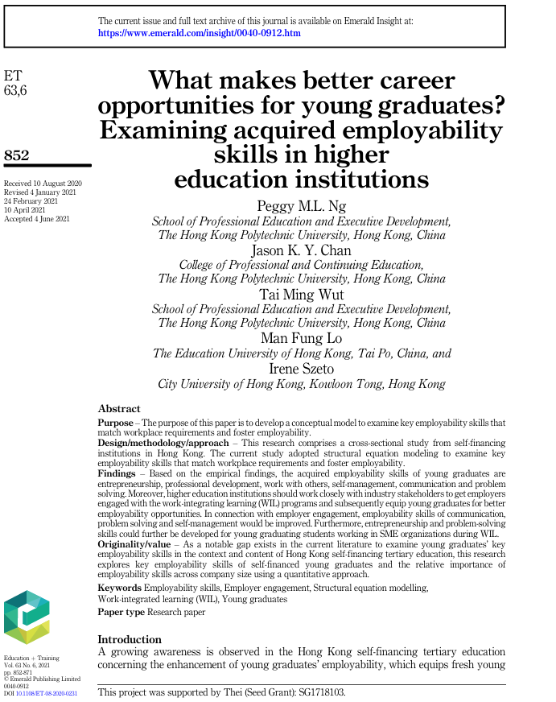

CRAAP Test
Currency | The journal is not current as it is out of the 5 year window. This journal was received in 2020 which puts it 6 years ago.
Relevance | This journal is relevant as it is talking about relevant information, it talks about employability skills of young graduates.
Authority | The source of the information has come from Emerald publishing limited which is under education and training.
Accuracy | I believe that this information is accurate as it is giving you a website page to access to see the information on the website and has names of the people where the information has come from.
Purpose | This information exists to talk to graduates about what makes better opportunity in career for young graduates.

Task 3: Source Analysis
Your manager has provided you with a short extract from a source and has asked you to analyse the source by Identifying one strength, one weakness, and providing a brief explanation of the strength and weakness identified.
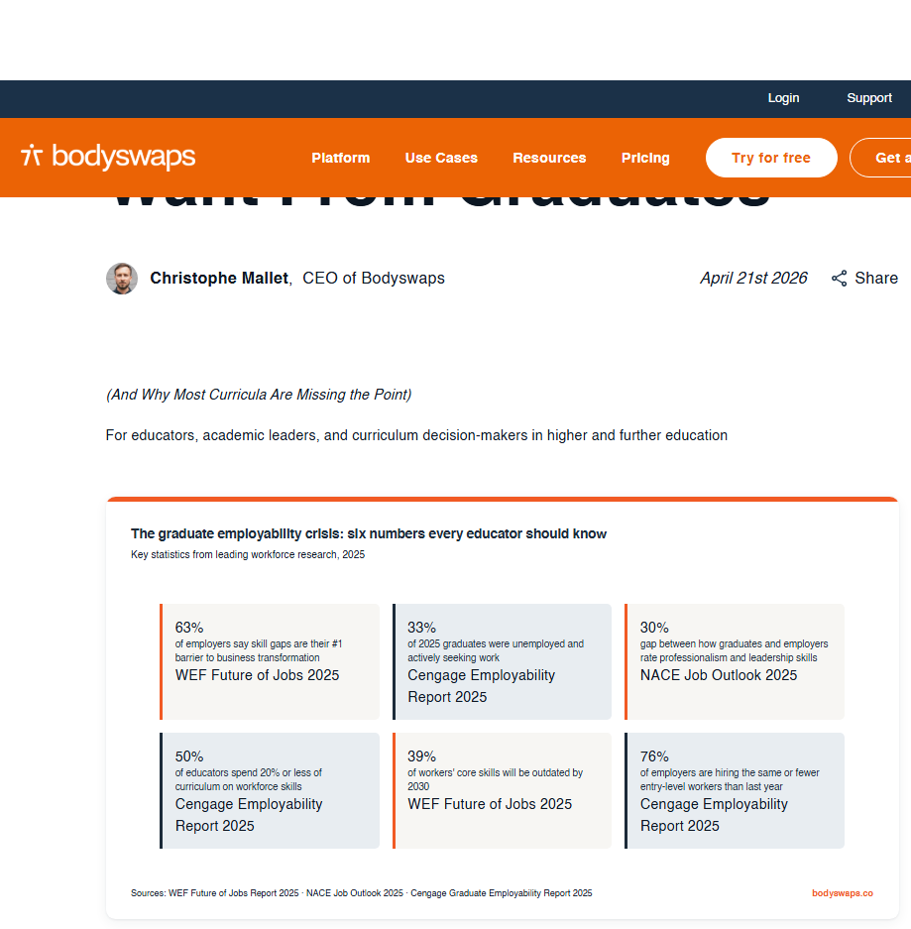
.

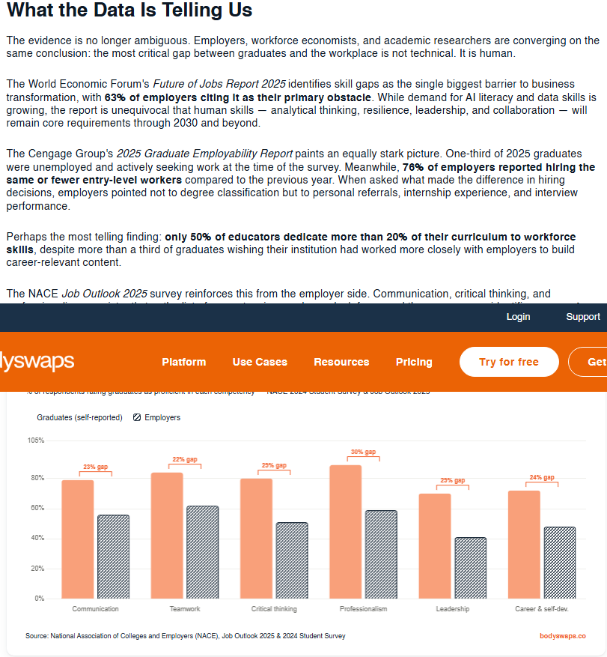
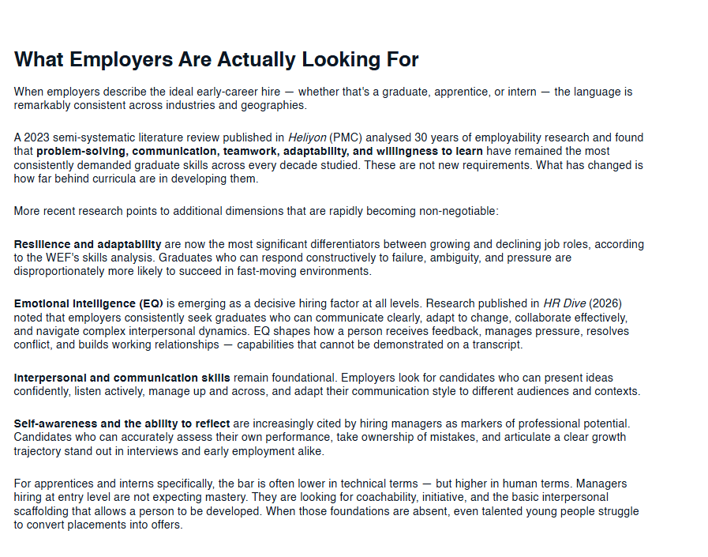

Please click the link, if you wish to read the article online.
What Employers Actually Want From Graduates

Strength of the Source:

The strength of this source would be that it has been published in April 2026 which shows that the information is current, the information gathered is from 2025 which is within the 5-year threshold. So this information is useful as it is current so it is more reliable information to use.

Weakness of the Source:

The weakness of this data is that the evidence is no longer ambiguous, this hasn’t just come from one person it has come from a number of people ranging from employers, workforce economists and academic researchers who have all come to the same conclusion in saying that the critical gap between graduates and the workplace is not technical but it is human.

