Most Commonly Used Digital Tools for Collaboration at UWTSD

Research Report
Student’s Name: Sevdalina Velinova
Student number: 2017540
Module title: Digital skills and research methods
Module code: BMSW4003_BIRM
Lecturer’s name: Munodzinesa Zuwirai

Table of Contents

1 Abstract..............................................................................................3
2 Introduction ........................................................................................3
3 Research Design.................................................................................4
3.1 Research Question.....................................................................4
3.2 Research Method ………………….….…….............….…..........5
3.3 Ethical Consideration…...……………………….........................6
4 Results……………………………………….…………………….….......6
5 Discussion…………………………………………………………….......11
6 Conclusion……………………………………………………….….…....13
7 Reference List...................................................................................15
8 Appendix A - A blank copy questionnaire ........................................16

- Abstract

Digital media and devices have become the new trend to collaborate among students and teachers for learning and education patterns. The report aims to investigate the most commonly used digital tool for collaboration at UWTSD; the more commonly used of which are Microsoft Teams, Blackboard/student portal, University social media, and student email. The data of the primary research is based on the responses of the questionnaire from 27 participants in total, male and female. Results were presented in pie charts, bar graphs and tables.
The most commonly used digital tool at UWTSD is the Microsoft team. Participants also stated that digital tools are beneficial to the learning process and increase collaboration between the participants.
Conclusively, collaborative digital tools play an important role in effective learning especially in education institutions and that investing in this further would be a very productive step in the long run.

2. Introduction

Innovations in technology, just like in all other spheres of work, have led to a swift change in the handling of imparting knowledge within educational institutions as well. Communication and a platform for effective collaboration is one of the main requirements for effective learning today. It not only augments the level of knowledge sharing and dissemination, but also improves the quality of information retained in the minds of the students through team interaction.
The existing literature by Olson and Olson (2012) have highlights that effective collaboration happens when the tools needed are available and used appropriately by the collaboration. Also according to La Rocca, Marotiri, and Capobianco( 2014 ) understanding the link between collaborative learning and peer tutoring in the university environment can positively influence students to maintaining a constant motivation and affection towards their study; they also help to reduce the drop-out and encourage greater regularity in the academic career .Finding from this literatures review expose opportunities for my research and data collection to reach out which digital technology is most used at UWTSD.
There are commonly used collaborative digital tools include Microsoft Teams, the University's social media, blackboard/student portal, and student mail. The use of these tools is not an even preference among the students. Some of them prefer one digital tool over the other depending on its effectiveness and user-friendly nature.
The challenges imposed by tools probably have changed the view aspects of students with newer digital tools. My hypothesis are previous ones are now outdated or simply the newer versions of digital tools have changed the student preferences. Also, the information saved is no more a reliable option and consumes more time than saving. With the advancement of technology and e-learning, the faculties have introduced better digital tools to enhance collaborative activities among students and the contribution of this research may be assistance of impact on student learning, the success of the collaboration and education outcome.

- Research Design

3.1 Research question
The report addresses the digital tools in aiding collaboration and preference for increasing collaboration in university (Salavati, 2016) The assessment of the use of digital tools is done by collect primary data at UWTSD to determine the most preferable collaboration tool among the participants of various faculties. The most widely used digital tool is surveyed in this research by analyzing the rate of the tools used and the challenges that come up while using all the digital tools which are Microsoft Teams, Blackboard, University social media, and student mail. The research project answers the following question: “What is the most commonly used digital tool for collaboration at UWTSD?”

3.2 Research method
The chapter discusses the methods chosen to design the research and collect data. This study used a quantitative method for primary research by structured questionnaire to collect data. Primary data collection because it is more objective and specific to our research purpose. The reason why secondary research was not chosen because the constructed questionnaire addressed the main intention of the report (see. Appendix I) to help identify critical themes for conducting the proper primary research (Stemler, 2015) . It identified key terms such as collaboration, social media, student email, interaction, and digital tools.
The 27 participants who responded to the questionnaire were enrolled on a random basis and was supposed to be submitted by the participants within ten days. The time needed to collect the data was ideal in this case and so other methodologies were ruled out. Some questions required yes/no answers while at the same time some questions had ranges to cater for solution that were not definitive. The method was helpful because it gained insights and helped in deriving meaningful conclusions The questions aimed at resourcing the answers about the frequency of digital tool utilization during studies, purposes besides studies and the challenges and preferences of these digital tools.
The analysis from the data collected is then done by compiling and categorizing the information in the form of bar graphs, pie charts and tables. Report have been conducted to determine the factors that may hinder the implementation of digitals tools in the learning process (Fakis et al., 2014).

3.3 Ethical considerations
The study was conducted under strict ethical considerations. None of the participants were forced or even offered incentives to participate. The responses were kept anonymous, and the participants were completely informed of the procedure. The primary objective of the study was well communicated to the participants and all relevant permission were obtained before commencing writing the report. All responses were recorded in privacy form and personal information was protected.

- Results
The results shows that most commonly used digital tool for collaboration in the UWTSD is Microsoft Team (89%) while the other tree tools at 4% each. (Fig.1) The results undoubtedly showed that almost all the participants were completely in favor of using digital tools for collaboration at UWTSD since it makes collaboration effective and easier.
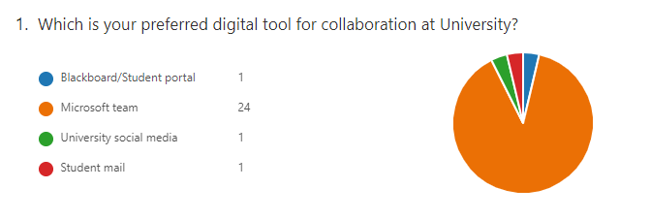
Figure1: Preferred digital tool for collaboration at UWTSD
Most of the participants (96%) said that the digital tools in use were secure enough (Fig.2).
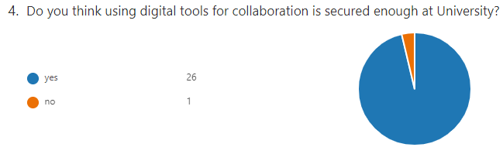 Figure 2: Security of digital use at university

Another 25 of the participants (93%) agreed that digital tools were helpful in smart time saving and data sharing and knowledge dissemination became more effective with their use (Fig. 3).

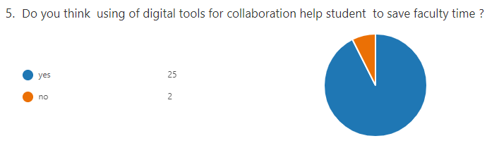 Figure 3: Digital tool on Faculty Time Management
Surprisingly Blackboard and social media were the digital tools least used by the participants (37%) while the remaining students used it only rarely. Microsoft teams was the tool which was used by 78% of the students on a weekly basis. (Fig.4)
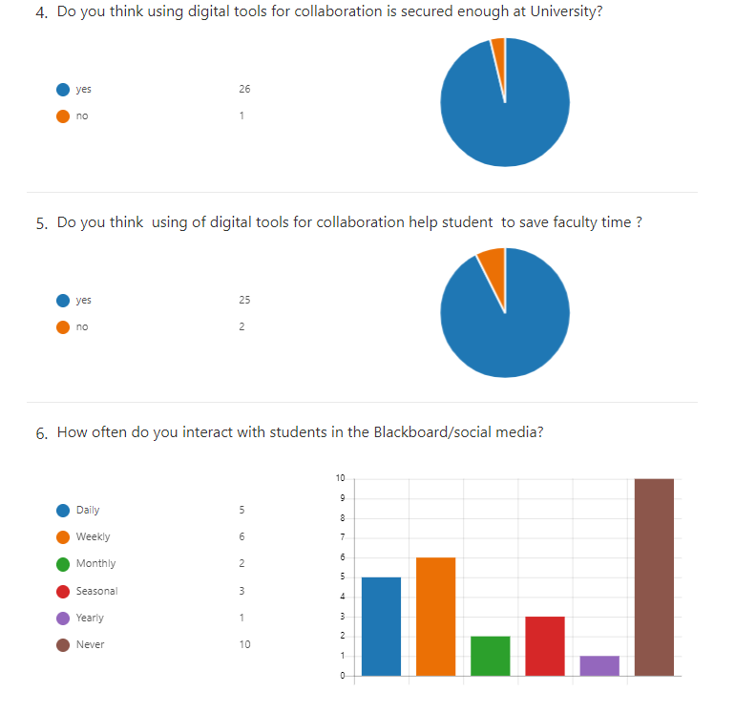
Figure 4 Interaction with Blackboard
The graph shows numbers of participants 4 out of the 27 who had never actually used Microsoft teams. (Fig .5)

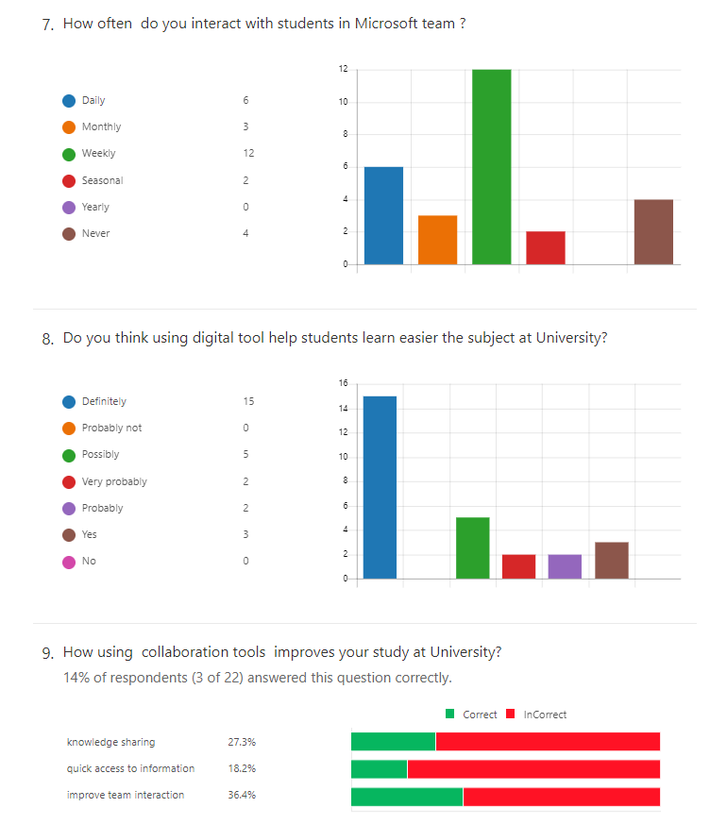 Figure 5: Interaction with Microsoft Team

27.3% of the participants said that digital tools contributed to improved knowledge sharing, 18.2% said that it allowed quicker access to information and the remaining 36.4% claimed that it played a role in better team interaction. (Fig.7)
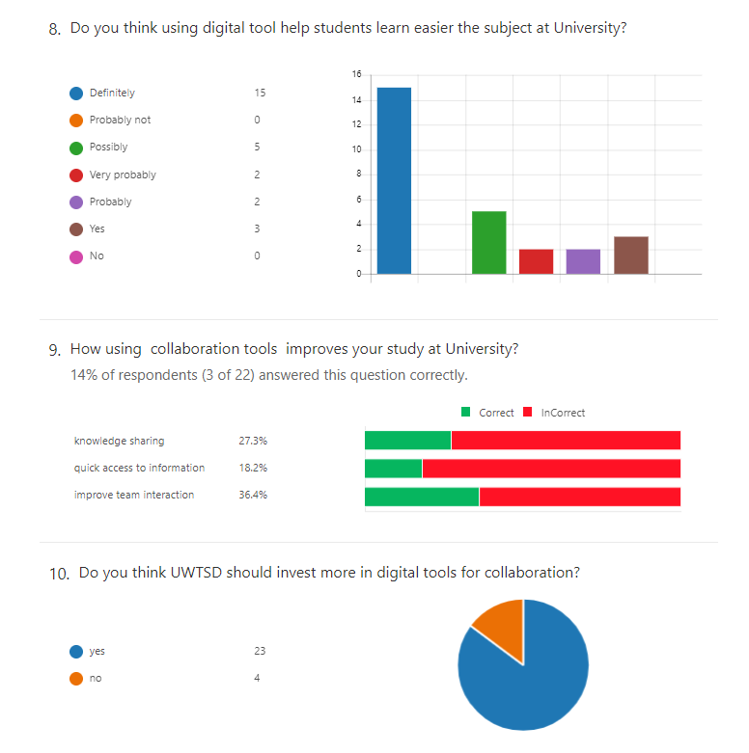
Figure 7 How using digital tools improves study at university (Knowledge sharing, quick access to information and improve team interaction)

23out of 27 (85%) participants mentioned that UWTSD should totally invest in the latest digital tools in order to improve collaborative outcomes (Fig. 8).
In the present most students highly prefer Microsoft Teams (85%) as the main collaborative tool since the research shows it has the highest frequency of usage from daily to weekly. Other tools like Blackboard, social media and student emails are rather used at a lesser rate (15%).

Figure 8: Need of investment on digital tool at university

The questionnaire form recorded all ten questions and participants’ responds (See Appendix I). Results are set out in diagrammatical form at the end of the report.

- Discussion

The questionnaire results undoubtedly showed that all 27 participants were completely in favor of using digital tools for collaboration at UWTSD since it makes collaboration effective and easier.
Microsoft Teams has taken over the student market because of its primary service of communication platform and enough storage capacity that facilitates the students with virtual conference meetings with several channels. The tool is probably a preference among participants because it links all the data directly with their Microsoft accounts.
The study clearly shows how the digital tools, especially the Microsoft Team, has been contributing to helping the students with study related matters. The students can easily pass on information and rely on these tools when they need to communicate with their study fellow groups. Not only these are a thorough form of communication media but also give a platform for submitting and sharing their assignments and uploading helpful material that can be shared with a whole group of class. The teacher-student interaction becomes smoother, and the faculty can make a way of networking apart from the face-to-face class interaction. Pacheco et al. (2018) mentions in his research that although these tools are effective, they can also impart their use dependence on the students restricting them from working physically and independently.
Students at UWTSD claim that the digital tools have made their learning process a lot simpler than it would have been through mere physical classes. The Blackboard and student portal have facilitated them with easier communication patterns. Students are able to organize their study patterns and interact whenever convenient
Based on questionnaire responses it was possible to create measures of collaborative technology tool implementation. In my opinion based of results from questionnaire more investment in digitalization of education and collaboration is a preferable beneficial step.
Results also show security has always been a concern for students, especially when we date back to times when emails were the only communication medium for students. Today, the student emails, social media platforms and blackboard again takes a back edge because the students do not consider it as secure and reliable as the Microsoft team platform.

- Conclusion
The report focuses on the impact of digital tools in education and learning and how does it affect interaction and collaboration. Using digital tools and
technological competencies students are capable of maintaining a
better working relationship to achieve the academic objectives (Rafi, 2019).

Knowledge sharing, and team interactions become a lot more reliable with tools like Microsoft Teams and the use of secure platforms help students develop trust on the technologically advanced systems introduced at the institution.

It means that universities may encourage innovation and ensure that the use of digital tools is increased and that funds are geared towards meeting digital tools' experiences. It has become a compulsion for tertiary institutions to make investments in digital tools to compete with the highly organized groups and teaching quality an institution with polished digital tools would have. The technologies do not merely support learning; they transform how we learn and how we come to interpret learning (Säljö R. ,2010). Security, accessibility, and user-friendliness remains the top work priorities for successful technological system installation within the institution.
Privacy issues are likely to be biggest concern and needs to be carefully planned. Advantages of that would be keep student collaboration save and increase their level of satisfaction.Therefore, the university needs to focus more on Microsoft Teams since the students are more accustomed to its use and introduce similar digital tools in the future to make learning easier and promote collaboration among the students of UWTSD.

- Reference List
Fakis, A., Hilliam, R., Stoneley, H., & Townend, M. (2014). Quantitative analysis of qualitative information from interviews: A systematic literature review. Journal of Mixed Methods Research, 8(2), 139-161.

La Rocca, Concetta & Margottini, Massimo & Capobianco, Rosa. (2014). Collaborative Learning in Higher Education. Open Journal of Social Sciences. 02. 61-66. 10.4236/jss.2014.22009.

Olson, Gary M. and Olson, Judith S. (2000) 'Distance Matters', Human-Computer Interaction, 15:2, 139 - 178

Pacheco,RR., Rochman, A.G., Vega,A.V.D.L.,Ornelas,E.L., Gonzales , O.M. and Serrano, F.V., (2018).Design of the digital collaborative tool to improve mobility in the universities. In conference on Sustainable Urban Mobility (pp.591-598)

Rafi, Muhammad & Jianming, Zheng & Ahmad, Khurshid. (2019). Technology integration for students' information and digital literacy education in academic libraries. 10.1108/IDD-07-2019-00

Rodríguez-Abitia, G., & Bribiesca-Correa, G. (2021). Assessing digital transformation in universities. Future Internet, 13(2), 52.

Salavati, S. (2016). Use of digital technologies in education: The complexity of teachers' everyday practice (Doctoral dissertation, Linnaeus University Press).

Säljö R. (2010). Digital tools and challenges to institutional traditions of learning: technologies, social memory and the performative nature of learning. Wiley Online Library.

8.Appendix A – A blank copy questionnaire

Appendix I: Questionnaire
- Which is your preferred digital tool for collaboration at university?
- Do you think digital tools help you for collaboration at university?
- Do you think using digital tools makes collaboration more effectively at university?
- Do you think using digital tools for collaboration is secured enough at university?
- Do you think using of digital tools for collaboration help student to save faculty time?
- How often do you interact with students in the Blackboard/social media?
- How often do you interact with students in Microsoft team?
- Do you think using digital tool help students learn easier the subject at university?
- How using collaboration tools improves your study at university?
- Do you think UWTSD should invest more in digital tools for collaboration?

https://forms.office.com/Pages/AnalysisPage.aspx?AnalyzerToken=ssnXylRqCR03zOBSa8fUd6ZLtfNZBZ0o&id=-REPTm4EBUWcuNshUjEeISBOZ-lT8MdAl271Sdb7UE9UN1g3RzFHUExFTVlDN1JKTEJJU0pKMjdRWi4u

PDF : https://1drv.ms/p/s!AueOHNXLgmGAdQh9ofJmiIdlu2Y?e=dOsE2u

